

NEMOTRON VOICE AGENT
  - Current Architecture & Operations Manual
Astra + NVCF deployed pipeline / engineer handoff guide

Document status | CURRENT DEPLOYED ARCHITECTURE — HANDOFF MANUAL
Architecture snapshot | 2026-08-19
Manual version | 1.0
SSOT SHA-256 | 40923ce9bb445fa1…

CURRENT DEPLOYMENT TRUTH
The retained UI is operationally live and points to the production NVCF function, but the UI is physically deployed in Astra stg infrastructure. A true Astra prd promotion is still outstanding.

CONFIDENTIALITY NOTE
Credential names and injection boundaries are documented. Secret values are intentionally omitted.

A. How to use this manual
This is the operator and engineer handoff manual for the currently retained Nemotron Voice Agent deployment. It is written so that a new engineer can orient themselves, trace a request, operate the system, diagnose a failure, and understand which source file owns each behavior without reading the entire repository first.

Intended audience
- Application engineers working on FastAPI, Pipecat, prompts, tools, media, or capture.
- Platform engineers operating Astra, NVCF, Helm, Kubernetes, Redis, SeaweedFS, NIMs, or NGC.
- SQA engineers qualifying real voice, tool calls, multimodal behavior, concurrency, and archive publication.
- Incident responders who need a boundary-by-boundary isolation path and a common session correlation key.

Evidence labels
Label | Meaning | Use
LIVE-VERIFIED | Read-only observation against retained deployment on 2026-08-19. | Use as current operational evidence.
RENDERED | Derived from exact checked-in Helm chart 0.1.94, reported by active function version. | Use as deployed-template evidence.
HISTORICAL | Preserved from earlier qualification reports or chart history. | Do not treat as a fresh guarantee.
DESIGN CONTRACT | Directly encoded in application/module behavior. | Validate again after code or artifact changes.

MAINTENANCE CONTRACT
The Markdown SSOT remains authoritative. Regenerate this manual after changing active function/version, Astra environment, chart/image tags, examples, replicas, shared-state topology, capture contract, secret names, readiness behavior, or qualification outcome.

Document map
- Sections 1–4: rapid orientation and component inventory.
- Sections 5–9: request routing and the two voice experiences.
- Sections 10–13: concurrency, Redis, SeaweedFS, and exactly-once capture.
- Sections 14–18: readiness, secrets, observability, deployment, and verification.
- Sections 19–23: troubleshooting, onboarding, risks, glossary, and source map.

B. Table of contents
The table below is a Word field. Open in Microsoft Word and choose Update Field / Update entire table if page numbers are not populated automatically.
Right-click and choose Update Field to build the clickable table of contents.

Figures
Figure 1. End-to-end system overview
Figure 2. Trust boundaries and request routing
Figure 3. Start-session request sequence
Figure 4. Generic Assistant pipeline
Figure 5. Omni Subagents worker architecture
Figure 6. Multi-replica data sharing
Figure 7. Session capture flow
Figure 8. Deployment promotion flow
Figure 9. Failure-isolation map

1. 10-minute orientation

The shortest correct mental model
- Astra is the credential-bearing UI proxy. It serves the React SPA and adds the NVCF invocation credential and function ID to server-side upstream calls.
- NVCF is the runtime. Its Helm release contains five CPU application replicas, six GPU inference deployments consuming seven H100 GPUs, Redis, SeaweedFS, and a prewarmer.
- A voice call stays on one app replica. The WebSocket, Pipecat processors, conversation context, and Omni WorkerBus are process-local for the lifetime of that socket.
- Redis makes ancillary requests replica-safe. It shares session config, attachments, webcam frames, capture requests, capture flags, and owner-token locks.
- SeaweedFS makes capture artifacts visible across pods. It stages session logs, transcript, and per-turn WAVs through an S3-compatible interface.
- NGC is the durable archive. Exactly one app replica packages and publishes a resource version named with the session ID.
- Generic and Omni are different agent shapes. Generic is cascaded ASR→LLM/tools→TTS. Omni is one in-process Pipecat worker graph with Speaker, Media Analyzer, Webcam, and Thinker roles.
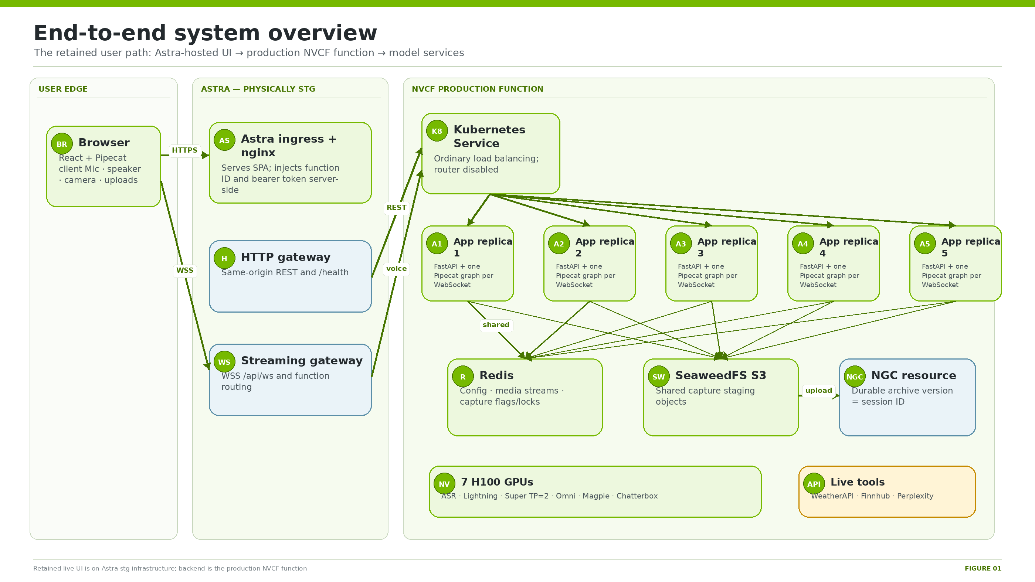
Figure 1. End-to-end overview of the retained live path.
TERMINOLOGY GUARDRAIL
Application replicas are Kubernetes pods serving FastAPI/Pipecat. NVCF function instances are platform allocations that contain the whole Helm release. Omni workers are in-process Pipecat roles created per Omni WebSocket. They are not interchangeable scaling units.

2. Current deployed environment

Retained deployment snapshot
Item | Current value | Evidence
NVCF function | nemotron-voice-agent | Live-verified
Function ID | 81862ff8-4931-4f1e-9655-caa5b0bc5911 | Live-verified; identifier, not a credential
Active version | bc9de165-d8d1-456f-872c-c15b68959827 | Live-verified
Deployment ID | 6e4c3e95-6113-4453-98fe-7fd5be18c2bf | Live-verified
Backend / GPU instance | nvcf-dgxc-k8s-oci-nrt-prd12-1 / OCI.GPU.H100_8x | Live-verified
NVCF scale | min 1 / max 1 function instance; max request concurrency 100 | Live-verified; not a capacity guarantee
Helm chart / app image | 0.1.94 / nemotron-voice-agent:2.0.25 | Active-version and rendered evidence
Retained Astra app | nemotron-voice-agent-deploy | Live UI identity
Astra infrastructure | stg / astrastg01-ocp-pdx04 | Checked-in and previously live-verified
Selectable examples | Generic Assistant; Omni Assistant Subagents | Live advertisement
Capture | enabled, consent required, S3 backend, NGC destination configured | Live-verified at snapshot

ASTRA ENVIRONMENT TRUTH
Operational shorthand calls the retained pair “production” because it serves users and points to the production NVCF function. Physically, the Astra UI still uses stg ingress, stg Vault paths, the stg cluster, and stg roles. True Astra prd requires a separate promotion to astraprd01-ocp-pdx04.

Advertised service choices
Experience | LLM / model | ASR | TTS | Extra capability
Generic | Nemotron 3.5 Lightning or Nemotron 3 Super 120B | Nemotron ASR Streaming English | Magpie or Chatterbox Multilingual | Per-session tools
Omni Subagents | Nemotron 3 Nano Omni 30B A3B Reasoning NVFP4 | Internal audio understanding | Magpie or Chatterbox Multilingual | Attachments and webcam

3. System context, security, and trust boundaries
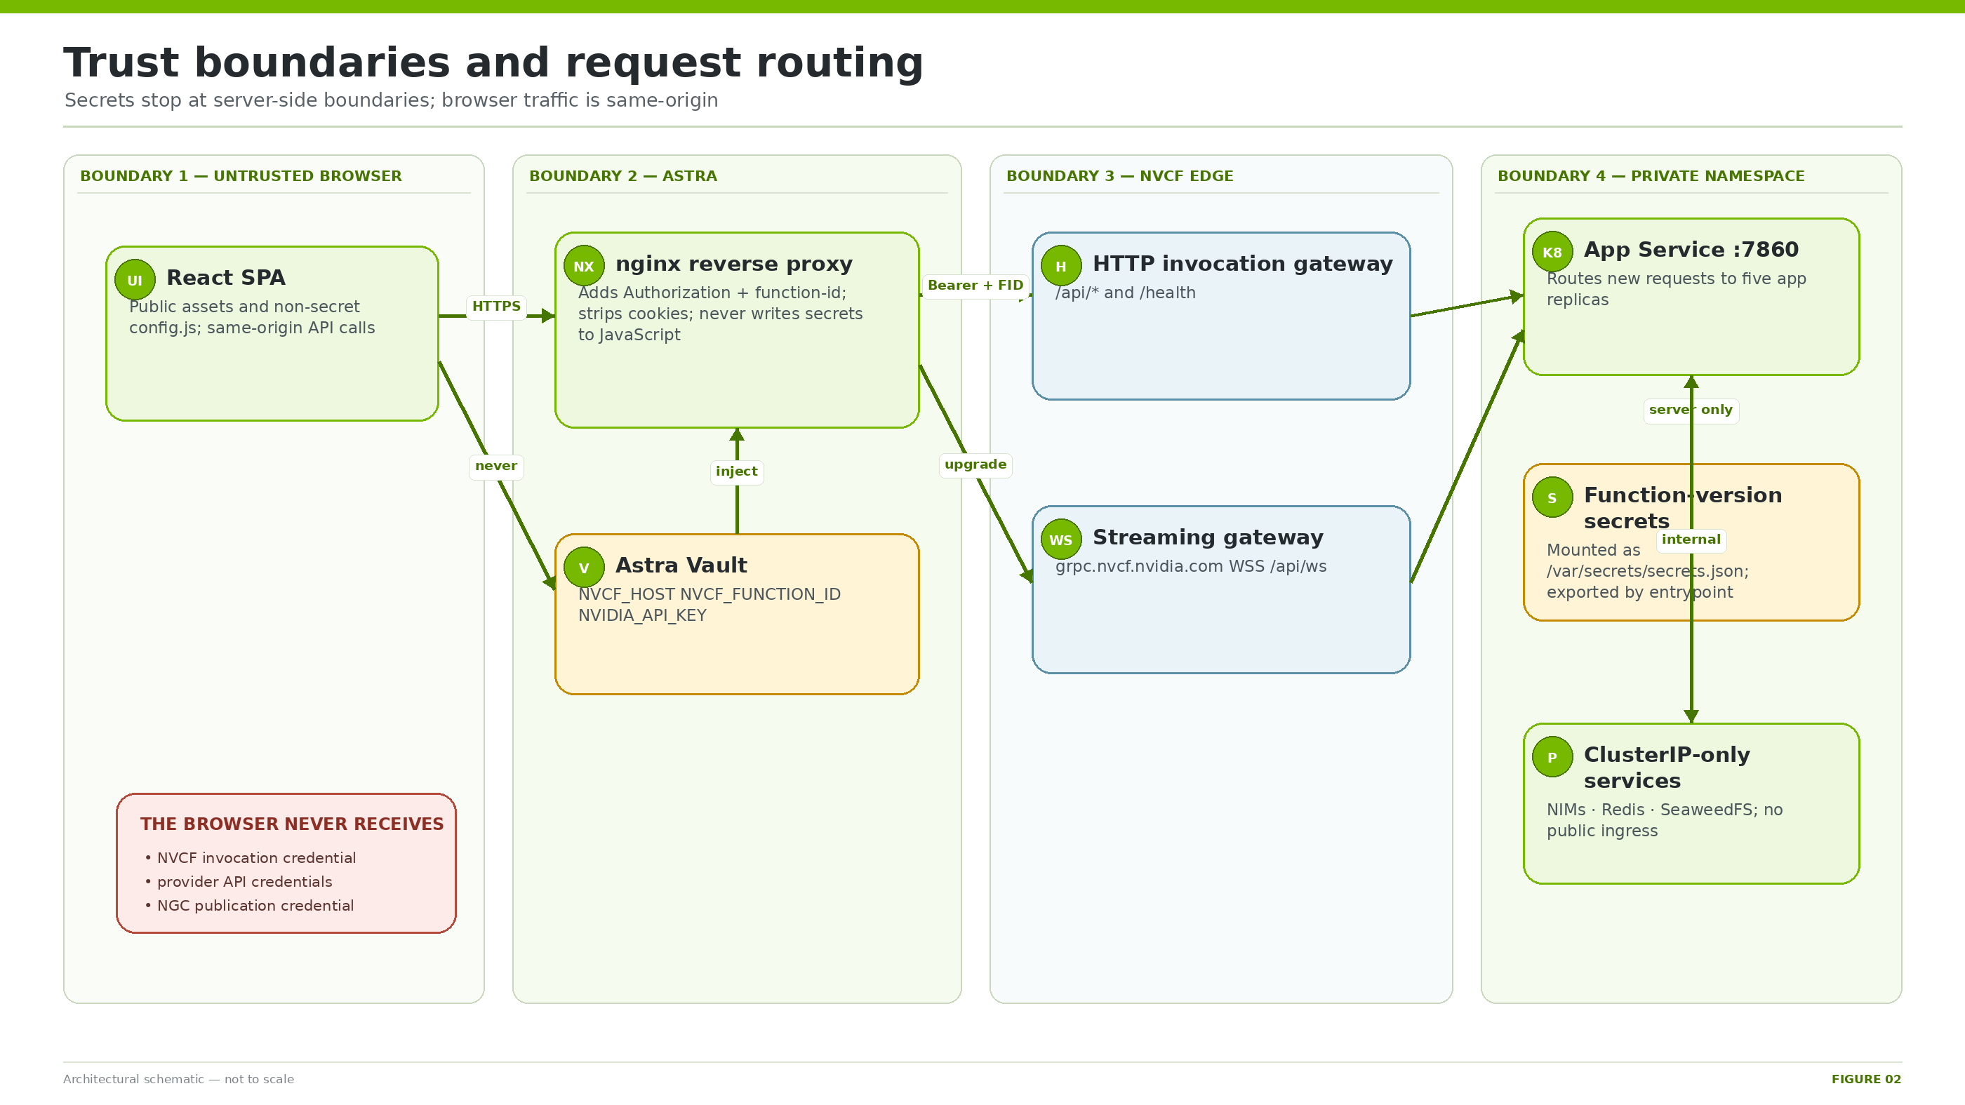
Figure 2. Browser, Astra, NVCF edge, and private namespace trust boundaries.

Boundary rules
- Browser input, microphone, camera frames, uploads, prompt overrides, and selection values are untrusted and validated server-side.
- config.js contains deployment timestamp and public demo settings only; it must never contain provider or invocation credentials.
- Astra nginx injects Authorization and function-id headers, strips incoming Cookie, hides upstream Set-Cookie, and routes WebSockets to the streaming gateway.
- NVCF secrets arrive in /var/secrets/secrets.json. The app shell exports named environment variables before Python starts.
- Redis, SeaweedFS, and NIM services are ClusterIP-only. Their protection currently depends on namespace/network isolation; SeaweedFS identity enforcement is not configured.
- Session IDs are server-generated 12-character hexadecimal values and are sanitized again before object-path use.

Why the design looks this way
Constraint | Design response
Browser WebSocket API cannot add custom authorization headers | Use same-origin Astra nginx and a dedicated NVCF streaming-gateway location.
Only app port 7860 is publicly reachable | Keep all NIMs, Redis, and SeaweedFS private behind ClusterIP services.
NVCF RWO block volumes caused fresh-zone scheduling stalls | Use ephemeral Redis/SeaweedFS and publish successful archives durably to NGC.
Affinity router required fragile StatefulSet stable DNS | Park the router; use ordinary load balancing plus Redis/shared object storage.
Function-version secrets are immutable/version-scoped | Repeat the complete secret set for every newly created function version.

4. Component catalog and ownership
Component | Where / scale | Owns | Does not own
React astra_client | Browser / per user | UX, selections, media, transcript, capture consent | Credentials or inference
Astra nginx | Astra / one CPU pod | SPA, same-origin proxy, auth/header injection | Agent logic
NVCF gateways | Managed edge | Authentication and function routing | Session state
Application | NVCF / five CPU pods | FastAPI API, per-WebSocket Pipecat graph, tools, capture finalizer | Model weights or durable archive
Redis | NVCF / one CPU pod | Shared config/media/capture coordination | Durable data
SeaweedFS | NVCF / one CPU pod | Shared S3-compatible capture staging | Durable archive
ASR NIM | One GPU | Streaming English transcription | LLM/TTS
Lightning | One GPU | Generic default LLM/tool choice | Tool execution
Super 120B | Two GPUs, TP=2 | Selectable Generic LLM | ASR/TTS
Omni vLLM | One GPU | Audio/vision/reasoning for Omni workers | Audio synthesis
Magpie / Chatterbox | One GPU each | External speech synthesis | ASR/LLM
Prewarmer | One CPU pod | Direct NIM warm and keepalive | User sessions
NGC resource | Managed registry | Durable versioned session archives | Live state

GPU budget
Workload | H100 count
Nemotron ASR | 1
Lightning | 1
Super TP=2 | 2
Omni | 1
Magpie | 1
Chatterbox | 1
Total | 7

CAPACITY INTERPRETATION
Seven of eight H100 GPUs are requested. The unused eighth GPU is headroom, not a hidden service. Five application replicas do not remove the single-replica inference bottlenecks.

5. Astra frontend and proxy behavior

What the UI is
- React + TypeScript built with Vite.
- Pipecat Client SDK with WebSocket transport.
- Built in docker/Dockerfile.nvcf-ui and served by nginx-unprivileged on port 7860.
- OpenShift-compatible non-root filesystem and group permissions.
- Curated runtime UI for Generic and Omni only.

Route contract
Browser path | Upstream | Reason
/ and static assets | Local nginx web root | Serve SPA and public runtime config.
/api/ws | https://grpc.nvcf.nvidia.com | Preserve WebSocket upgrade and function routing.
/api/* and /health | https://${NVCF_HOST} | Per-function HTTP invocation path.
/feedback | Configured external form upstream | Optional; keeps upstream target private.

STALE-COOKIE MITIGATION
nginx strips incoming Cookie and hides Set-Cookie. This prevents an old nvcf-request-id from being reused after function rollover and producing dead-session 404 / WebSocket 1006 failures.

UI startup and session lifecycle
- Container entrypoint creates browser-readable config.js from non-secret settings.
- User selects example, service IDs, voice, reasoning, and optional tools.
- UI POSTs sanitized choices to /api/session-config and receives the server-minted session ID.
- UI opens WSS /api/ws?session_id=<sid> through the same origin.
- During a session it sends mic audio, optionally streams webcam frames or attachments, and renders RTVI transcripts/events.
- At teardown SessionCaptureReporter best-effort posts consent and a bounded transcript using keepalive.

6. NVCF function and Kubernetes topology

Rendered workloads
Chart 0.1.94 renders ten Deployment objects: the five-replica application Deployment, ASR, Lightning, Super, Omni, Magpie, Chatterbox, prewarmer, Redis, and SeaweedFS. The public function entrypoint targets the nemotron-voice-agent Service on port 7860 and /api/ws. In-chart ingress is disabled.
Internal service | Endpoint | Primary consumer
nemotron-voice-agent | :7860 | NVCF edge
nemotron-asr-streaming-english | gRPC :50052 / health :9001 | Generic app and prewarmer
nemotron-lightning | HTTP :8000/v1 | Generic app
nemotron-3-super | HTTP :8000/v1 | Generic app and prewarmer
nvidia-llm-vllm-omni | HTTP :8002/v1 | Omni workers and prewarmer
tts-service | gRPC :50051 / health :9000 | Both experiences and prewarmer
chatterbox-tts-service | gRPC :50051 / health :9000 | Both experiences and prewarmer
redis | :6379/0 | All application replicas
seaweedfs | S3 :8333 | All application replicas

ROUTER STATUS
router.enabled=false. The application is a Deployment, not a StatefulSet. New HTTP and WebSocket requests use ordinary Kubernetes load balancing; no chart-layer consistent hash exists.

Scale terms that must not be confused
Term | Count now | Boundary
NVCF function instance | 1 minimum / 1 maximum | One platform allocation containing the entire Helm release and 8-GPU node shape.
Application replica | 5 | Five Kubernetes pods accepting REST and/or WebSockets.
Pipecat pipeline | One per connected voice session | Processors and conversation context inside the accepting app process.
Omni workers | Multiple per Omni pipeline | Speaker, Media Analyzer, Webcam, Thinker coordinated by one in-process WorkerBus.
Inference service replica | One per service | Shared model service endpoint; Super consumes two GPUs.

7. Backend API and request routing
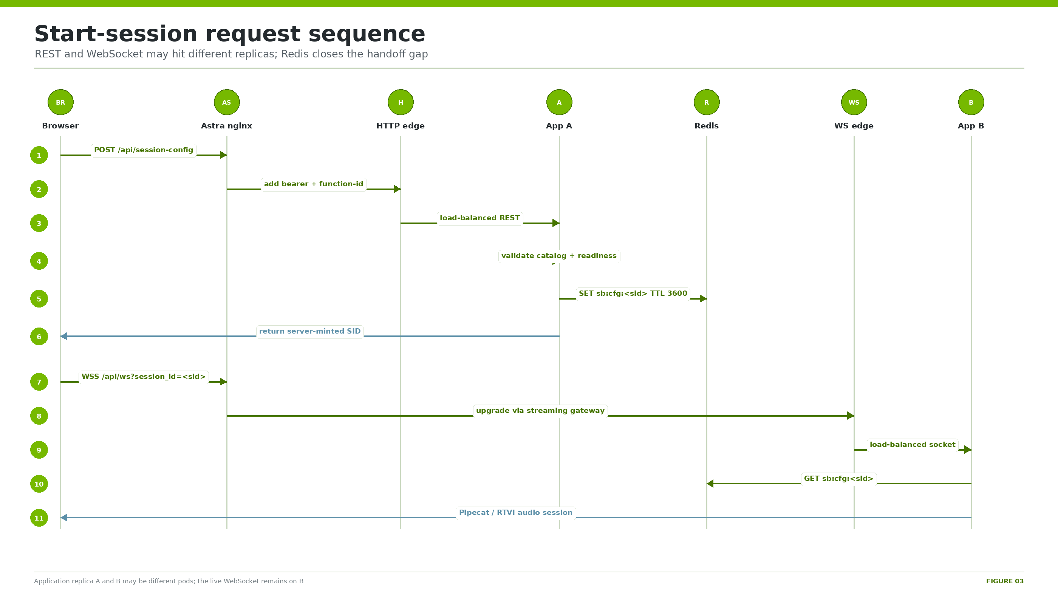
Figure 3. Session configuration can be written by one app replica and consumed by another through Redis.

Public API surface
Route | Protocol | Purpose
/health | GET | Shallow FastAPI health.
/api/deployment | GET | Visible examples, defaults, capabilities, transports.
/api/prompts /api/tools /api/subagents | GET | Example-local catalogs for UI.
/api/services /api/tts-config | GET | Reachable service and voice metadata.
/api/session-config | POST | Validate choices, readiness-check services, mint SID, persist config.
/api/ws | WebSocket | Curated NVCF Pipecat/RTVI voice path.
/api/sessions/{sid}/attachments | POST | Capability-gated media upload.
/api/sessions/{sid}/webcam/frames | POST | Low-resolution live webcam frames.
/api/sessions/{sid}/webcam/capture | POST | Consume one high-resolution request token.
/api/session-capture | POST | Teardown consent and transcript.
/api/session-capture/status | GET | Capture configuration and pending/error summary.

Session-config algorithm
- Parse JSON and constrain the requested example to the mounted visible registry.
- Supply the example default prompt when no prompt key/content is present.
- Drop unknown session fields; hydrate stable service IDs from example-local catalogs.
- Check the selected local LLM, ASR, and TTS readiness.
- Mint uuid4().hex[:12].
- Store an in-process fast path plus Redis sb:cfg:<sid> with TTL.
- Return the SID; the WebSocket replica reads local state first and Redis second, then sanitizes overrides again.
CAPABILITY ENFORCEMENT
Generic sessions receive 403 for Omni-only media routes. Unknown SIDs receive 404. Upload bodies are bounded; images must pass extension and JPEG/PNG magic-byte checks.

8. Generic Assistant walkthrough
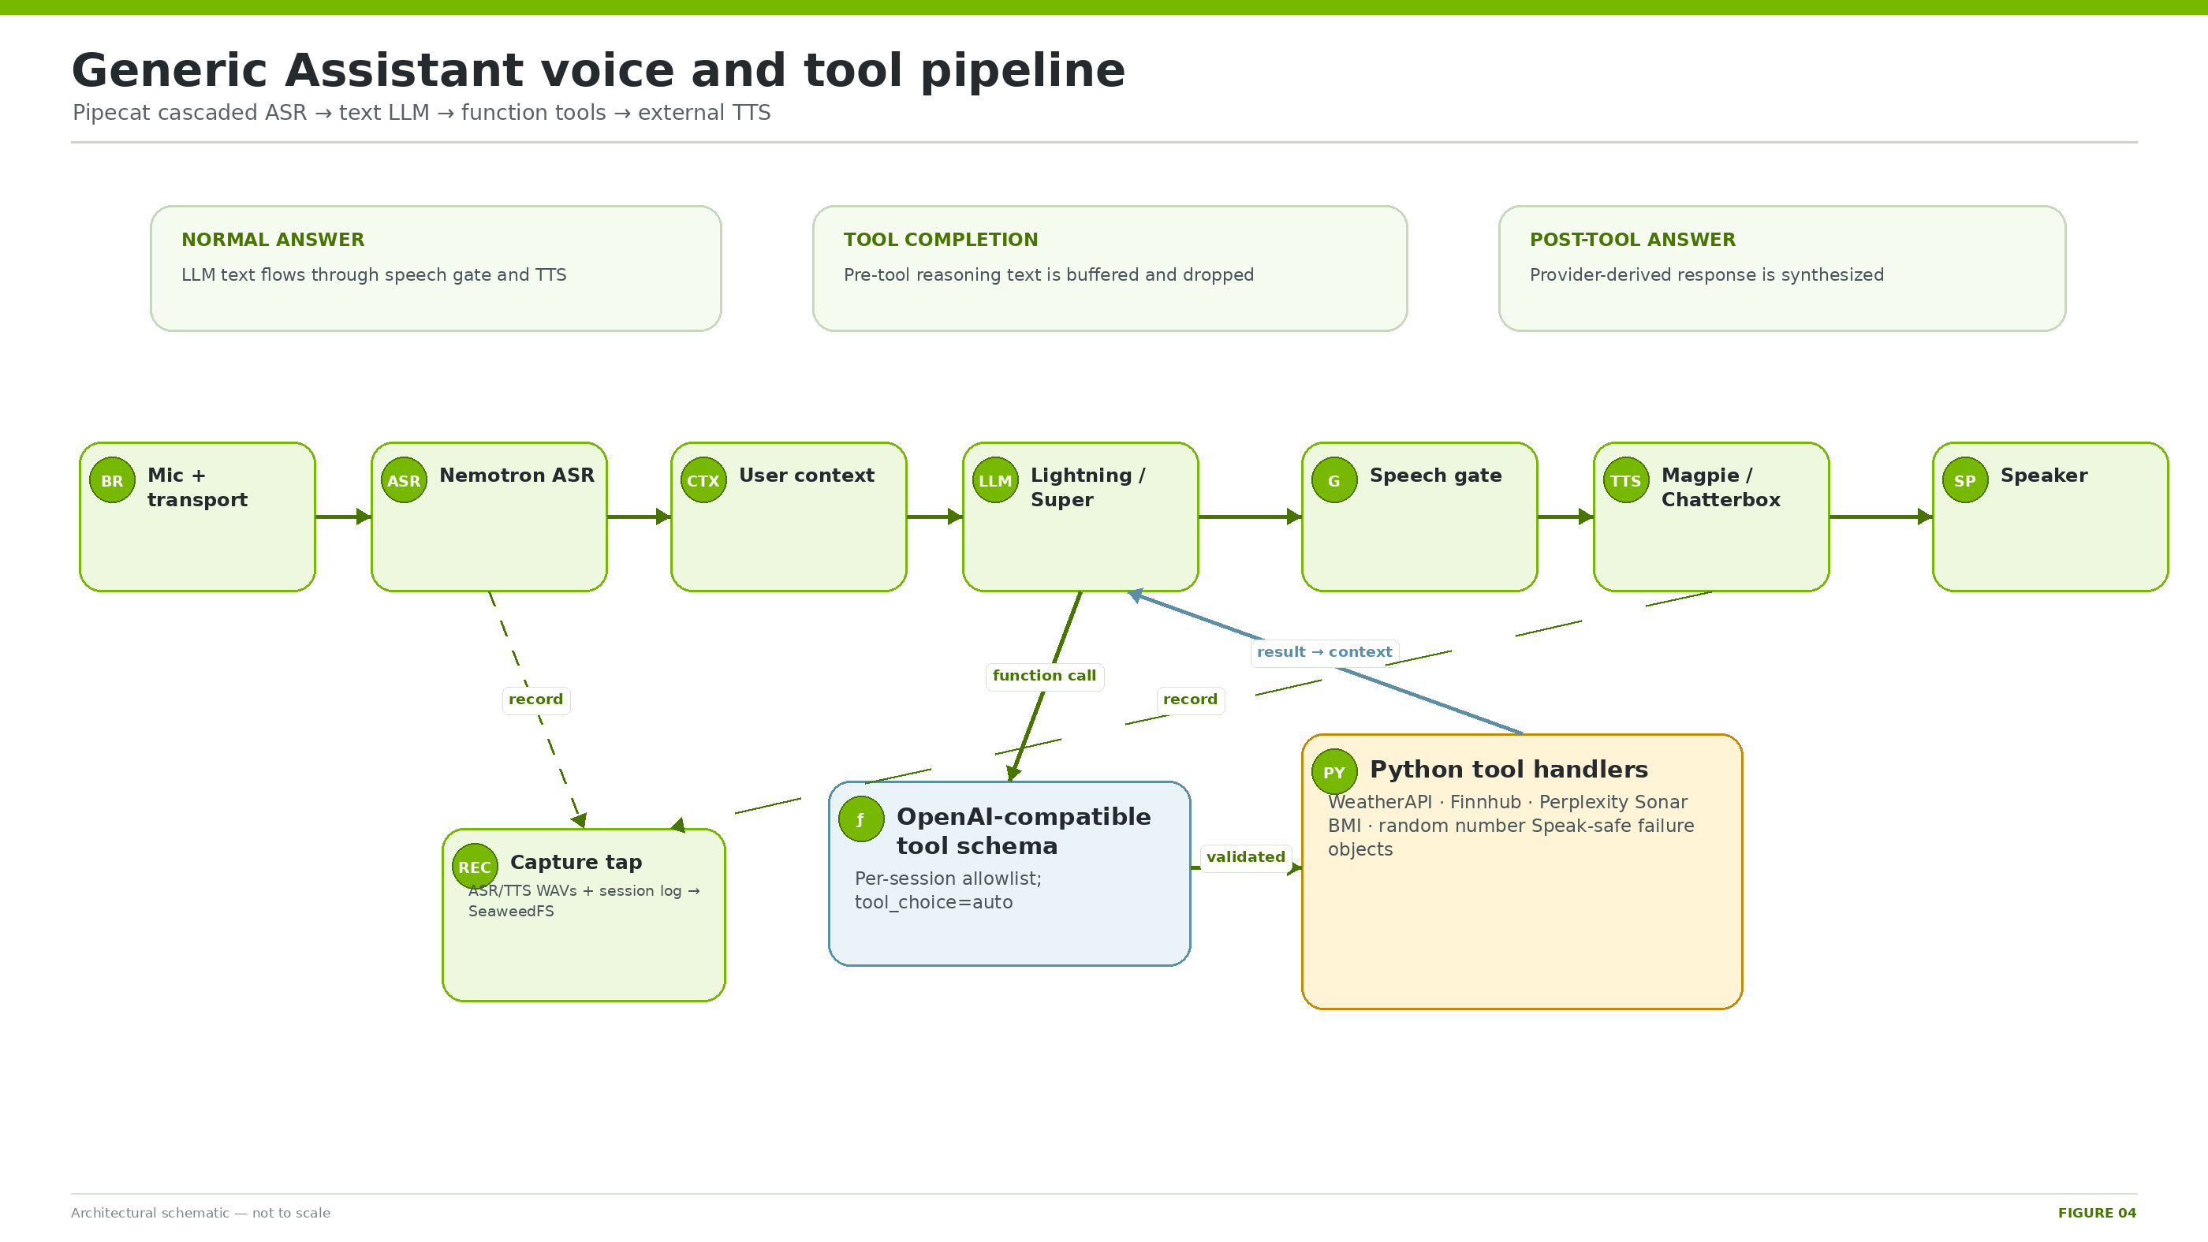
Figure 4. Generic Assistant cascaded Pipecat voice and function-calling path.

Agent model
Generic Assistant is a Pipecat cascaded voice pipeline. React is only the client. Agentic behavior comes from an OpenAI-compatible NVIDIA text LLM that receives validated JSON function schemas and uses tool_choice=auto. Pipecat invokes registered Python handlers and returns their structured result to the LLM for the final spoken answer.

Processor order
transport.input → NvidiaSTTService → user context aggregator → NvidiaLLMService
→ ToolCallSpeechGate → NvidiaTTSService → transport.output
→ optional activity checker → optional audio recorder → assistant context aggregator

Prompt policy
- Friendly voice identity and brief spoken style.
- Current weather routes to get_weather; future/forecast weather routes to web_search.
- Current stock price routes to get_stock_price; other current facts route to web_search.
- Never invent live data; report provider unavailability safely.
- BMI and random-number tools have narrow explicit use.
- Default output is one short sentence without markdown; exact tool results may be longer.

Tool catalog
Tool | Provider / execution | Credential name | Failure policy
get_weather | WeatherAPI current endpoint | WEATHERAPI_KEY | Friendly unavailable object; no fake weather.
get_stock_price | Finnhub search + quote | FINNHUB_API_KEY | Unavailable/not-found object; no fake price.
web_search | Perplexity Sonar via NVIDIA gateway | PERPLEXITY_API_KEY | One transient retry, then safe unavailable.
calculate_bmi | Local Python | None | Validate numeric positive inputs.
generate_random_number | Local Python | None | Validate integer range.

Why the speech gate matters
The speech gate buffers a completion. If the same completion contains a function call, it drops every text frame in that completion so hidden reasoning or “let me check” filler does not reach TTS. Only the post-tool-result completion is spoken. Chatterbox additionally uses a 240-character chunk aggregator.

9. Omni Assistant Subagents walkthrough
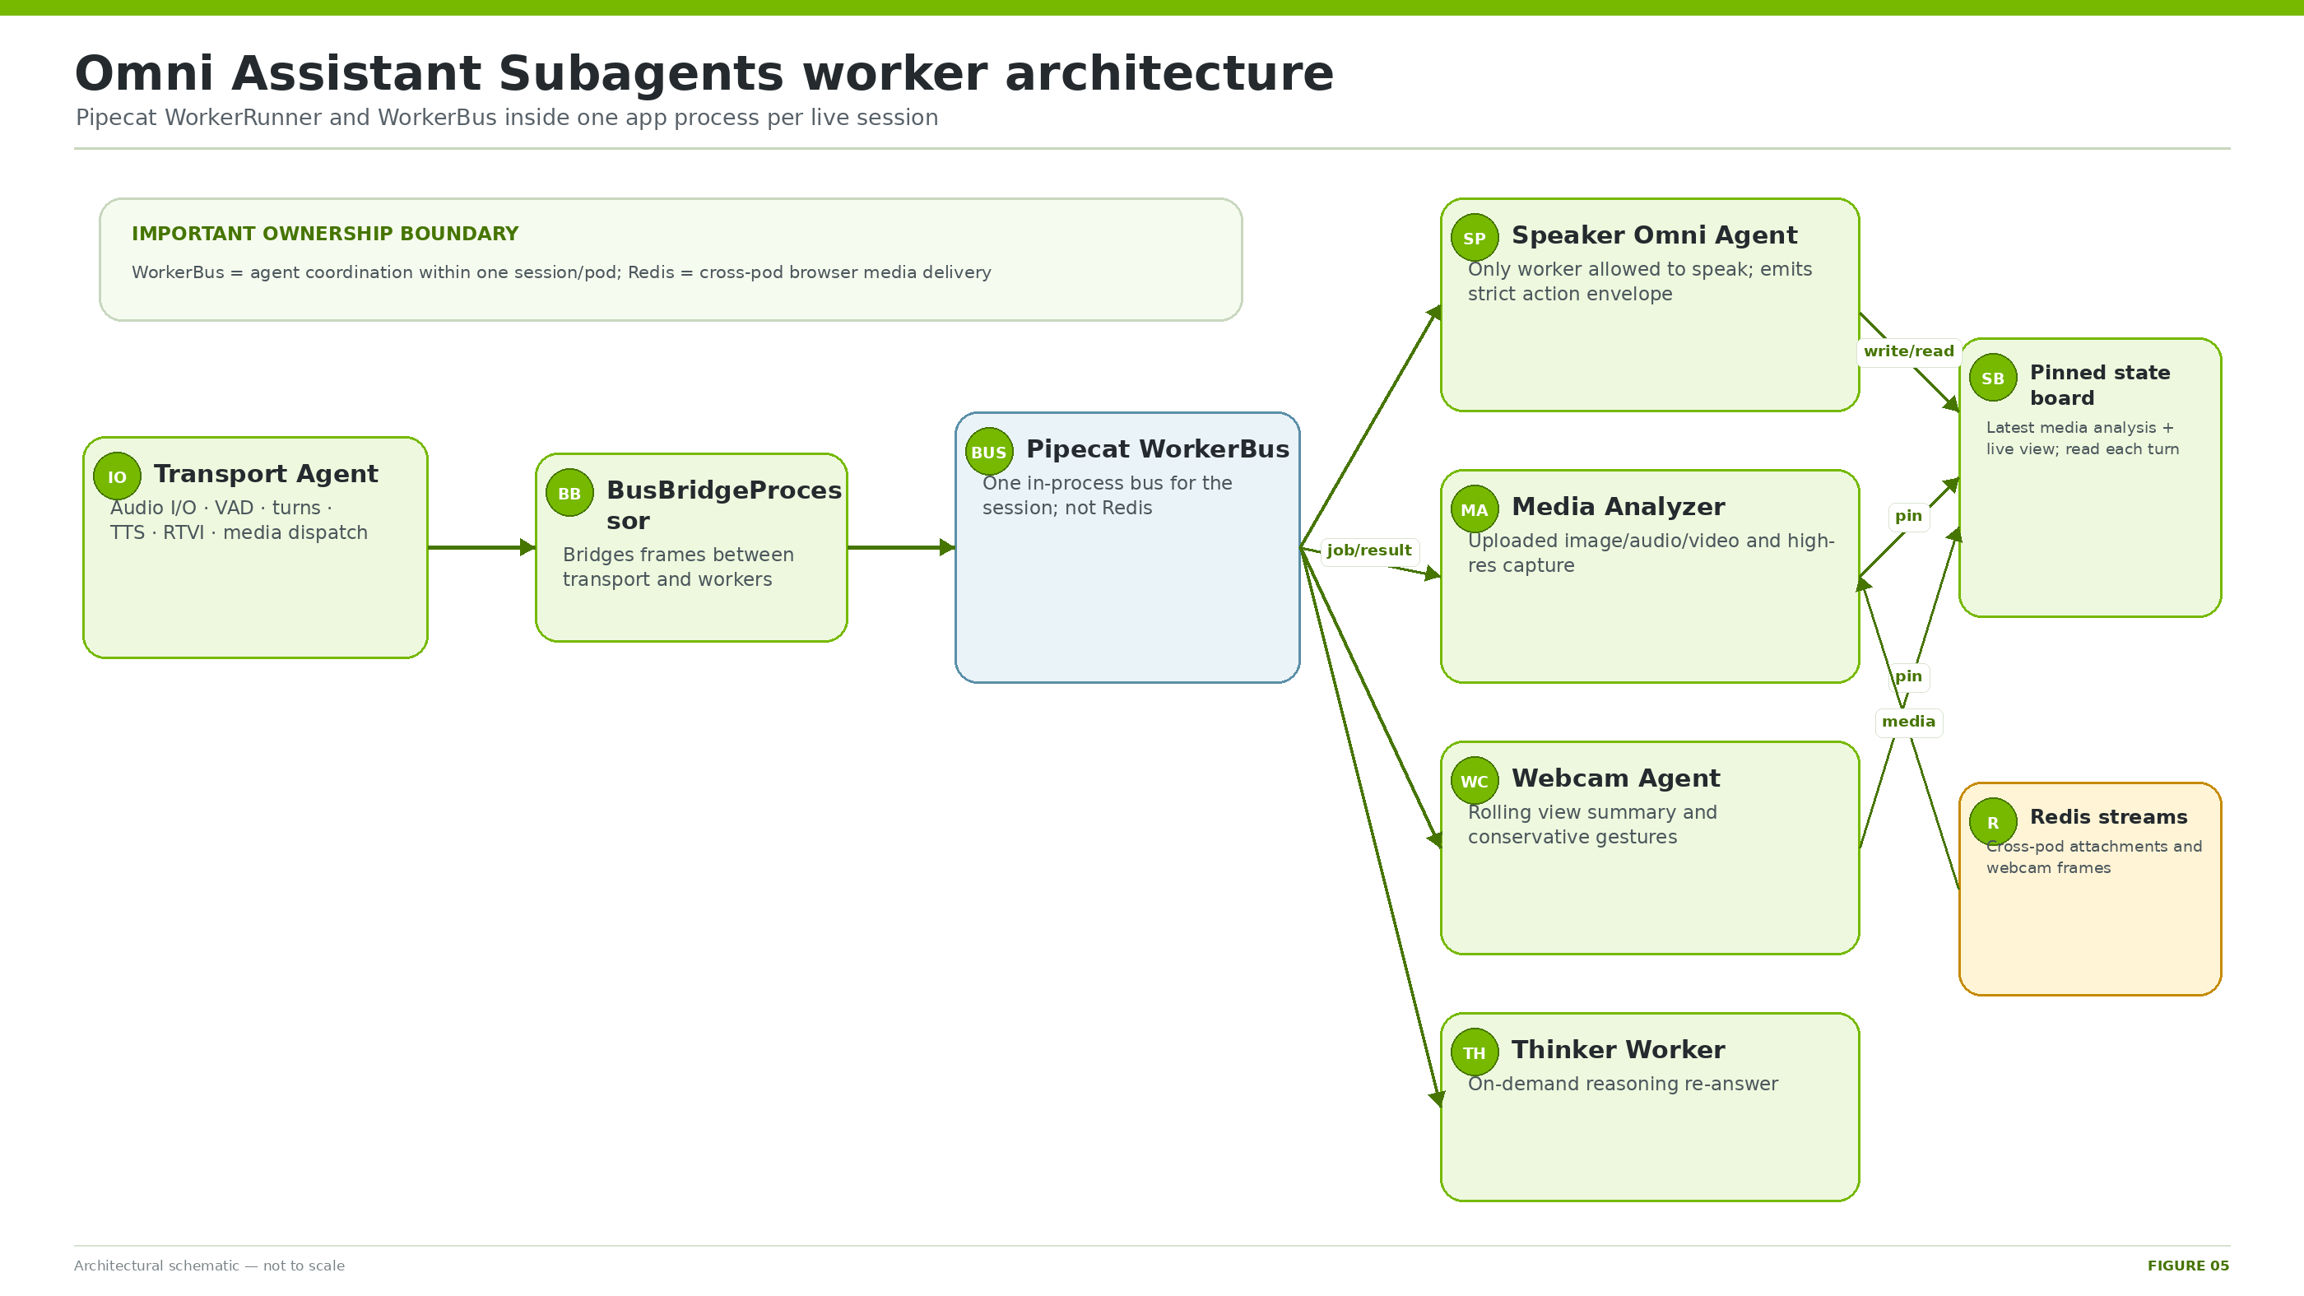
Figure 5. Omni worker graph inside one application process and live session.

Agent model
Omni Subagents uses Pipecat WorkerRunner, one shared in-process WorkerBus, multiple PipelineWorker instances, and a BusBridgeProcessor. The Transport Agent owns physical audio, VAD, user turns, TTS, RTVI, and media dispatch. The Speaker is the only worker allowed to speak. It reads the pinned board and emits a strict action envelope.
{
"transcript": "verbatim audio transcript",
"turn_action": "respond|think|analyze_attachment|capture_highres|clarify",
"response": "spoken response or acknowledgement",
"selected_input_source": "uploaded_attachment|none",
"media_analysis_action": "new|rerun|none",
"media_analysis_prompt": "self-contained task or empty",
"highres_query": "specific live capture question or empty"
}

Turn ownership
Action | Owner | Effect
respond | Speaker | Answer immediately.
clarify | Speaker | Ask one precise question; queue no worker.
analyze_attachment | Media Analyzer | Acknowledge first, then dispatch uploaded-file analysis.
capture_highres | Browser + Media Analyzer | Request one token-bound native-resolution frame, then analyze.
think | Thinker | Acknowledge and queue a reasoning-on re-answer.

Uploaded media path
- Browser POST may land on any app replica.
- Receiver XADDs bytes and metadata to sb:att:<sid>.
- Voice-session replica’s blocking XREAD listener wakes and marks the pinned board PENDING.
- Speaker chooses analyze_attachment and speaks a short acknowledgement.
- Media Analyzer reads the chosen attachment from Redis, performs analysis, pins detailed context, and returns concise speech.

Webcam and high-resolution capture
Compressed webcam frames arrive roughly once per second, up to 640 pixels wide at JPEG quality 0.7, in a ring-limited Redis stream. The Webcam Agent builds short temporal context and pins a conservative view/gesture summary. If detail is insufficient, the Speaker offers a later-turn high-resolution capture. A random request ID is stored in Redis and atomically consumed by compare-and-delete when the browser uploads the native-resolution frame.
SOURCE SEPARATION
Uploaded attachments and the rolling live webcam view remain distinct. The pending upload becomes the referent for “this image”; after analysis it becomes past context and live webcam context resumes.

10. Concurrency model
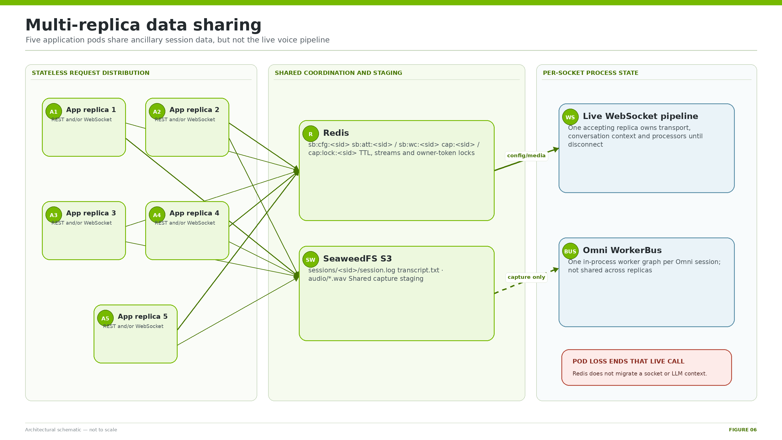
Figure 6. Shared and process-local state across five application replicas.
State / data | Location | Cross-pod? | Lifetime
Active socket and Pipecat processors | Application process | No | Socket/session
LLM conversation context | Application process | No | Socket/session
Sanitized session config | Local dict + Redis | Yes | TTL 3600 s
Attachments / webcam frames | Redis Streams | Yes | TTL/ring-limited
High-res capture request | Redis key | Yes | TTL 3600 s
Capture flags / attempts | Redis hash | Yes | TTL 3600 s
Finalize lock | Redis key | Yes | 900 s
Capture log/transcript/audio | SeaweedFS S3 | Yes | Until success/cleanup/restart
Final tarball | NGC resource version | Yes / durable | Registry retention

FAILURE SEMANTICS
Redis enables REST/media requests to land on a different replica from the voice socket. It does not migrate a live socket, Pipecat graph, or conversation context. If the owning pod dies, that call ends and the browser must reconnect.

Capacity boundaries
- NVCF maxRequestConcurrency=100 is only an edge admission setting.
- Five app replicas share one ASR, Lightning, Super, Omni, Magpie, and Chatterbox deployment each.
- Omni maxNumSeqs=4, model KV/sequence limits, provider quotas, and TTS latency bound throughput.
- Redis has 256 MiB maxmemory with allkeys-lru and carries binary media.
- SeaweedFS is one pod; capture finalization has four threads per app process.
- Safe concurrency is a measured SQA result, not a value derived from platform configuration.

11. Redis session bus

Deployment contract
- One private Bitnami Redis Deployment at redis:6379/0.
- No AOF or RDB persistence; 256 MiB maxmemory; allkeys-lru eviction.
- Readiness/liveness uses redis-cli ping; empty password inside the namespace.
- App entrypoint blocks on PING before starting Python when REDIS_URL is configured.
Key pattern | Type | Purpose
sb:cfg:<sid> | JSON string | Sanitized session config.
sb:wc:<sid> | Stream | Webcam metadata and bytes.
sb:seq:wc:<sid> | Integer | Webcam sequence.
sb:att:<sid> | Stream | Attachment metadata and bytes.
sb:seq:att:<sid> | Integer | Attachment sequence.
sb:capreq:<sid> | String | Only valid high-resolution request ID.
cap:<sid> | Hash | Pipeline/consent signals, attempts, errors and update time.
cap:lock:<sid> | String | Finalize owner token.

Cross-pod listener behavior
- Blocking XREAD starts at cursor 0 so pre-listener writes are not missed.
- Block interval is 5000 ms; socket timeout is 15 s.
- Idle timeout becomes an empty read; transient Redis/network errors retry with bounded backoff.
- Callback failure is isolated and does not kill the listener.
OUTAGE BEHAVIOR
A Redis restart loses active session config, media, capture flags, and locks. Existing sockets may continue voice from local context, but cross-pod REST/media/capture correctness is not reliable until Redis recovers.

12. SeaweedFS shared session store

Purpose and shape
SeaweedFS is a second shared subsystem because Redis coordination does not contain the complete capture archive. The finalizing pod must be able to read the log, transcript, and WAV objects written by another pod. The current chart runs one combined SeaweedFS server with S3 API on port 8333 and bucket nva-session-capture.
sessions/<sid>/session.log
sessions/<sid>/transcript.txt
sessions/<sid>/audio/asr_000.wav
sessions/<sid>/audio/tts_000.wav
sessions/<sid>/audio/asr_001.wav
sessions/<sid>/audio/tts_001.wav

- Backend abstraction supports put, get, list, delete, delete_prefix, and exists.
- Same object keys can target local files, SeaweedFS, MinIO, or real S3.
- Current data directory is a 20 GiB emptyDir.
- Placeholder signing credentials satisfy boto3; current chart does not generate SeaweedFS identities.
DURABILITY BOUNDARY
SeaweedFS is shared staging, not the archive of record. Pod reschedule/restart can erase in-flight or retained source objects. A successfully uploaded NGC version is durable.

13. Session capture and NGC publication
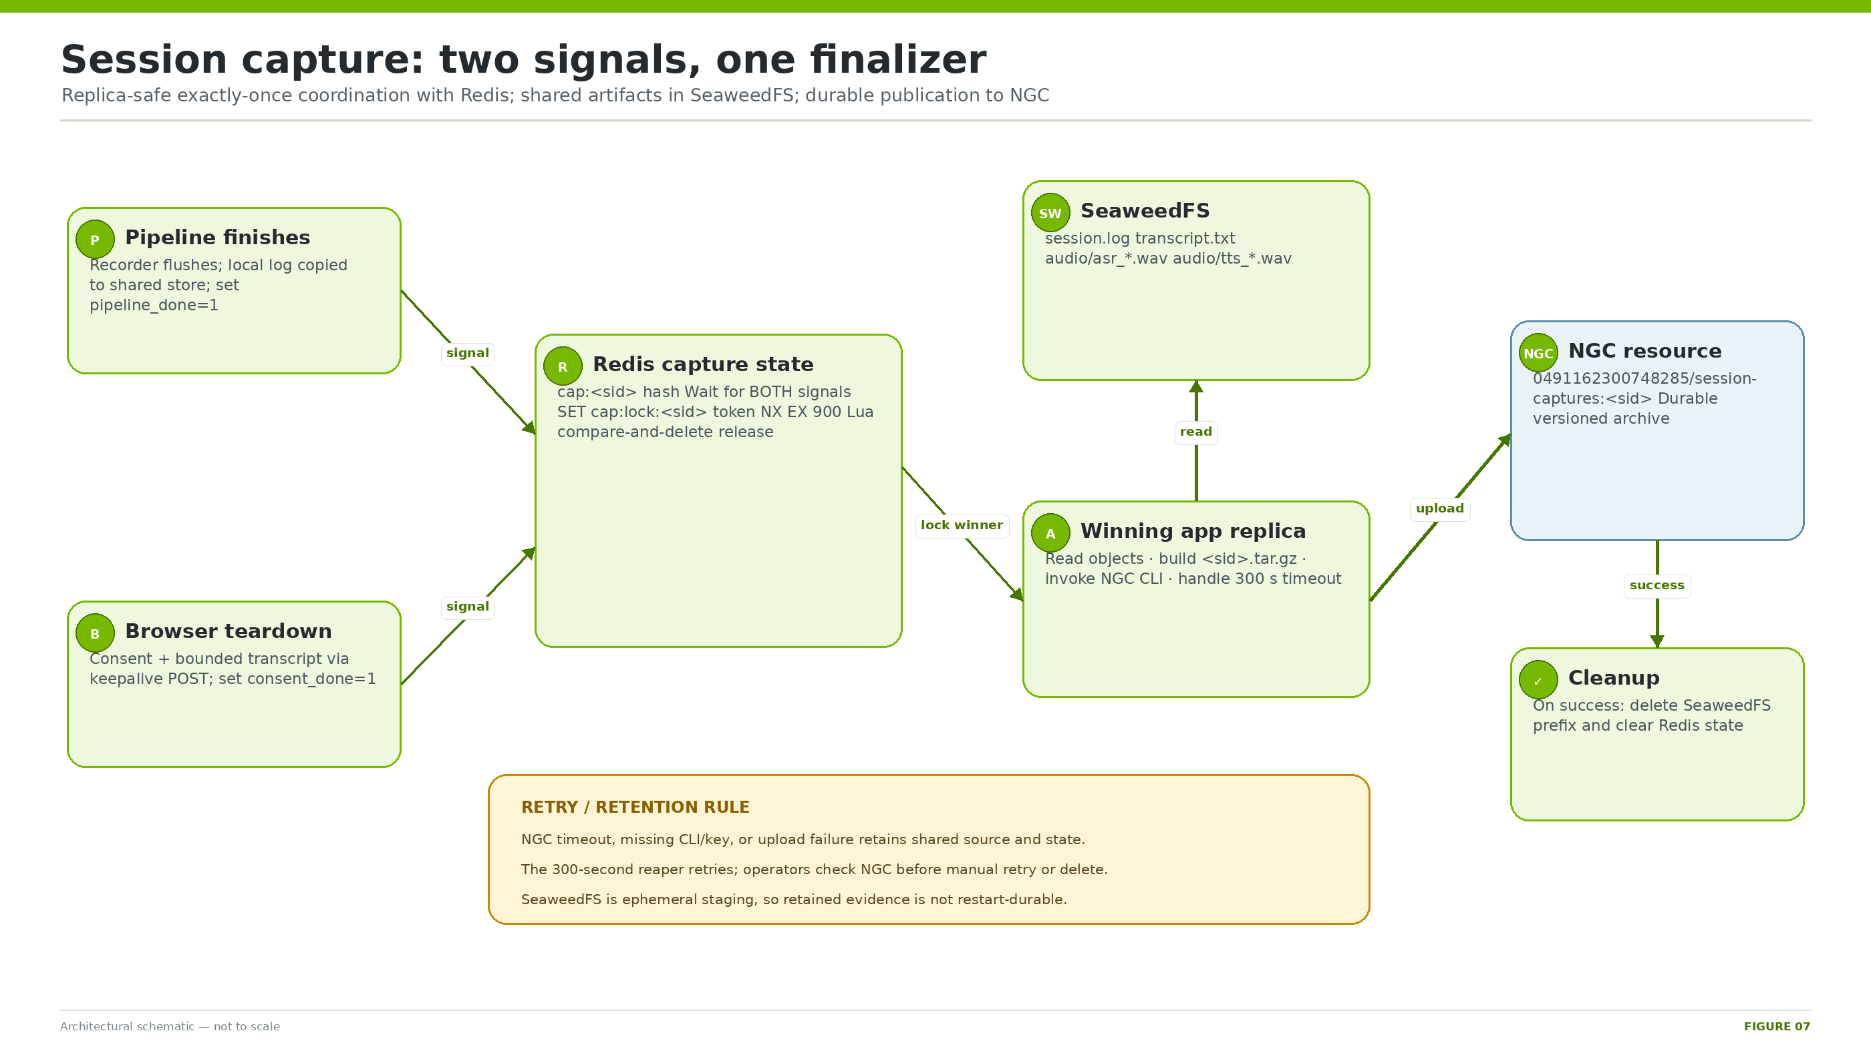
Figure 7. Two-signal, owner-token-locked capture finalization and NGC publication.

Capture contents
- Per-session application log correlated by SID.
- Browser-rendered user/assistant transcript, capped at 200,000 characters.
- Per-turn ASR input WAVs and TTS output WAVs.

State machine
State / event | Meaning | Next action
Waiting | Neither independent signal present. | Do nothing.
PipelineOnly / ConsentOnly | One signal present. | Wait; reaper may abandon after 900 s.
Ready | Both signals present. | Attempt SET lock NX with random token and 900 s TTL.
Locked | This replica owns token. | Read shared objects, tar, upload/discard.
Archived | NGC upload succeeded. | Delete store prefix and clear Redis.
Retryable | Store/tar/config/upload failed. | Retain evidence; later signal/reaper retries.
RetainedFailure | NGC-related failure exhausted attempts. | Operator review; do not blindly delete.
Abandoned | Only one stale signal. | Delete orphaned objects/state.

Exactly-once mechanics
- Pipeline uploads local log before setting pipeline_done so no finalizer can race ahead of the object.
- Browser teardown records consent_done and transcript through any replica.
- SET cap:lock:<sid> <random-token> NX EX 900 elects one finalizer.
- Lua compare-and-delete releases only the caller’s token, preventing an expired old worker from removing a new lock.
- Winning process builds a temporary <sid>.tar.gz and invokes ngc registry resource upload-version.
- On success it deletes the SeaweedFS prefix, clears Redis, and removes the local tar.

Retry policy
Control | Value
Reaper interval | 300 s
Orphan threshold | 900 s
Capture state TTL | 3600 s
Lock TTL | 900 s
Maximum attempts | 5
NGC subprocess timeout | 300 s
Finalize executor | 4 threads per app process

AMBIGUOUS TIMEOUT
NGC may accept an upload even when the client times out. Before retrying or deleting any retained session, query NGC for the version named with that exact SID.

14. Startup, readiness, and prewarming

Application startup gates
- Wait indefinitely for Redis PING when REDIS_URL is configured.
- Wait for SeaweedFS HTTP when SESSION_STORE_BACKEND=s3.
- Read /var/secrets/secrets.json and export named credentials.
- Start src/server.py only after shared dependencies are reachable.

Probe semantics
Signal | What it proves | What it does not prove
Kubernetes /health probes | FastAPI process is responsive. | All NIMs and providers work.
NVCF ACTIVE | Platform rollout is registered. | First real model call is warm.
/api/session-config success | Selected local LLM/ASR/TTS passed deeper readiness. | Quality under load or live provider success.
Real audio SQA | End-to-end speech path and expected behavior. | All future concurrency levels.

ASR, Super, Magpie, and Chatterbox can report Kubernetes-ready from lightweight container/process checks because nimReadyImmediate remains true. Lightning and Omni use explicit health probes. Per-session readiness and real voice tests are the functional gate.

Prewarmer
- Calls model services directly, never the app.
- Warms Super and Omni with tiny chat completions; Omni uses JSON response format to precompile guided decoding.
- Warms ASR, Magpie, and Chatterbox through bundled Riva clients.
- Retries every 15 seconds until success and repeats every 300 seconds.
KNOWN PREWARM GAP
Lightning is the default Generic LLM but is absent from current prewarmer targets. Its real readiness probe gates availability, yet first-generation latency/compile work may reach a user.

15. Secrets and credential ownership
NO VALUES IN DOCUMENTATION
Only credential names, consumers, and injection boundaries belong in this manual. Never paste actual API keys, bearer tokens, or contents of secrets.json into reports, commits, screenshots, or shell transcripts.

Name | Consumer | Purpose
NVIDIA_API_KEY | App/NVIDIA clients; NGC fallback only | Inference/API invocation where applicable.
NGC_API_KEY | NIM startup and capture uploader | Model registry and dedicated capture publication.
PERPLEXITY_API_KEY | Generic web_search | Perplexity Sonar request.
WEATHERAPI_KEY | Generic get_weather | WeatherAPI request.
FINNHUB_API_KEY | Generic get_stock_price | Finnhub request.
SESSION_CAPTURE_NGC | Capture module | <org>/<resource> destination name.
NVCF_HOST / NVCF_FUNCTION_ID | Astra nginx | Backend target and function route.

Injection paths
- NVCF: function-version secrets → /var/secrets/secrets.json → app shell export → Python/tool handlers/NGC CLI.
- Astra: stg Vault path → ExternalSecret/SecretStore → nginx environment → private rendered nginx configuration.
- NIM deployments use startup-specific NGC access for model weights.
- Every new immutable NVCF version must be created with the complete secret set again.

Credential separation
An Astra-to-NVCF invocation key, an NGC registry key, a personal key for instance log access, a Perplexity key, and provider-specific WeatherAPI/Finnhub keys are different capabilities. Do not assume one credential works across boundaries. Capture prefers the dedicated NGC_API_KEY and reports the chosen source name, never its value.

16. Observability and evidence
Signal | Useful proof | Limit
NVCF ACTIVE | Platform deployment exists. | Not model correctness.
Astra /health 200 | Proxy reaches FastAPI. | Not tools/capture.
/api/deployment | Catalog resolves. | Not audio quality.
/api/session-capture/status | Capture config/backend/key names/pending state. | Not specific NGC success.
RTVI events | Transcript, tool call, subagent and latency reached client. | Not upstream provider truth alone.
Captured session.log | Detailed server path for one SID. | Absent if finalization never completes.
NGC version | Durable archive for exact SID. | Quality requires archive inspection.
Pod/instance logs | Startup/runtime evidence. | May be constrained by NVCF access.

Correlation strategy
Use the 12-hex session ID everywhere. The WebSocket binds loguru with stream_id=<sid>. The same value names Redis keys, the SeaweedFS sessions/<sid>/ prefix, the capture archive root, and the NGC resource version. Start every incident note with timestamp, browser/session ID, selected example/model/TTS, and expected behavior.

Historical qualification evidence
- Five application replicas without observed cross-talk.
- Mixed eight-session browser/audio concurrency.
- Five cross-replica attachment sessions correctly analyzed a known image.
- Live WeatherAPI, Finnhub, and Perplexity credentials exercised.
- Consented captures reached NGC.
EVIDENCE FRESHNESS
Those results came from staging chart 0.1.90. Production 0.1.91–0.1.94 added webcam/capture teardown hardening, catalog changes, and NGC diagnostics. Historical evidence informs confidence but never replaces fresh testing after artifact changes.

17. Deployment and promotion
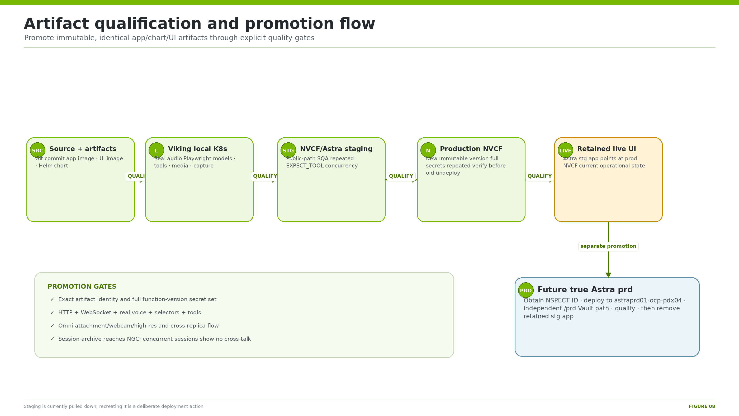
Figure 8. Immutable artifact qualification and promotion flow, including the outstanding true Astra prd boundary.

Standard pathway
- Build and push exact app and Astra UI images; bump/package/push the Helm chart.
- Deploy to Viking local Kubernetes and run astra_client locally.
- Use Playwright with real audio and independent ASR to understand TTS output.
- Validate selectors, tools, media, webcam, capture, and concurrent sessions.
- Create immutable NVCF staging version with the exact chart and complete secrets; deploy exact UI tag to Astra preview.
- Repeat the full public-path SQA/concurrency matrix and obtain user acceptance.
- Create production NVCF version from identical artifacts; verify before removing the old version unless explicitly accepting downtime for GPU capacity.
- Point retained Astra UI to the qualified production target and exact UI image.
CURRENT STAGING STATE
NVCF staging and Astra preview are pulled down. Recreating them requires deliberate deployment of both sides. Inactive immutable function versions may remain as history.

True Astra prd promotion
- Obtain a valid NSPECT ID.
- Deploy through the production Fusion control plane to astraprd01-ocp-pdx04.
- Create/populate an independent Vault path ending /prd.
- Generate and verify prd ingress, environment, JWT, role, and shared-secret path values.
- Deploy the exact qualified UI image and production function target.
- Repeat HTTP, WebSocket, voice, tool, media, concurrency, and capture qualification.
- Only then delete the retained Astra stg incarnation.

Rollback units
Layer | Rollback
Astra UI | Restore previous JFrog image tag and ArgoCD/Fusion sync.
NVCF | Redeploy known immutable function version/chart; repoint Vault if FID changes.
Secrets | Restore Vault values or create a corrected immutable NVCF version.
Data | Redis/SeaweedFS are not rollback stores; NGC versions are durable capture records.

18. Qualification and verification runbooks

Public smoke checks
BASE=https://nemotron-voice-agent-deploy-backend.stg.astra.nvidia.com
curl -fsS "$BASE/health"
curl -fsS "$BASE/api/deployment"
curl -fsS "$BASE/api/services?pipeline_mode=generic-assistant"
curl -fsS "$BASE/api/session-capture/status"
curl -fsS "$BASE/config.js"

Real voice matrix
- Open a clean browser context and assert a unique SID.
- Generic + Lightning + reasoning on + Magpie: static question, weather, stock, web search.
- Repeat expected-tool prompts across batches; assert RTVI tool event, provider-derived result, final speech, no socket/console error.
- Generic + Super and Chatterbox selection checks.
- Omni voice, attachment, webcam, conservative gesture, and high-resolution capture flows.
- Overlap Generic and Omni sessions; assert no cross-talk/SID reuse.
- End sessions cleanly and verify pending capture count returns to zero.

Capture acceptance
- Record /api/session-capture/status before test.
- Run consented session with at least one user and one bot turn; retain SID.
- Poll until SID is no longer pending.
- Require NGC version <sid> status UPLOAD_COMPLETE.
- Download/extract read-only and require session.log, transcript.txt, and expected ASR/TTS WAVs.
- Run declined-consent control and confirm no NGC version.

Minimum concurrency matrix
Dimension | Minimum assertion
Generic live tools | Weather, stock, and web search; multiple batches, not one lucky call.
Overlap | Six browsers per batch when matching historical test; include mixed Generic/Omni.
Configuration | Submitted reasoning, service IDs, tool allowlist and transcript match intent.
Isolation | Every browser has unique SID, no response/media/capture cross-talk.
Capture | Concurrent sessions finalize and pending queue returns to zero.
Cross-replica media | When pod evidence exists, upload and voice socket can be on different replicas.

19. Troubleshooting and failure isolation
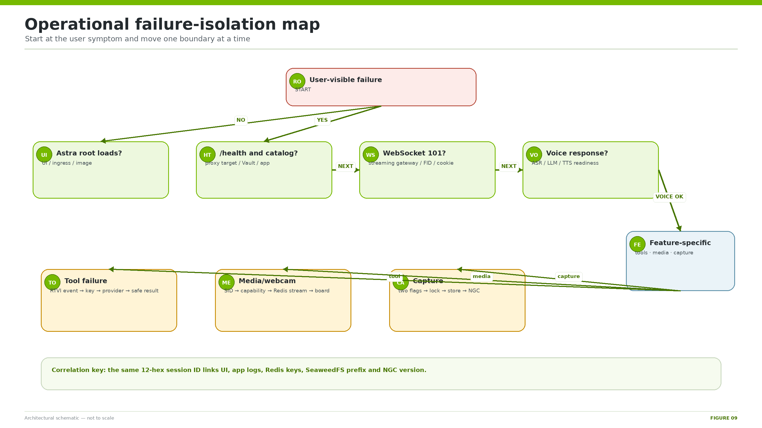
Figure 9. Boundary-by-boundary failure isolation path.
Symptom | Likely boundary | First checks / mitigation
UI loads; API 401/403 | Astra Vault/invocation key | Patch Vault; restart/sync UI; recheck catalog.
WS 200 not 101 or browser 1006 | Streaming route/FID/cookie | Check grpc.nvcf route, headers, rendered nginx, cookie stripping.
App waits before Python | Redis or SeaweedFS | Inspect shared deployments/services first.
Wrong/default example | Redis config handoff | Check sb:cfg:<sid>, TTL, exact SID propagation.
Attachment uploaded; no analysis | Redis stream/listener | Inspect sb:att:<sid>, XREAD warnings and capability.
Camera appears off despite 200 uploads | SID/listener/board state | Check webcam RTVI state and sb:wc:<sid>.
Tool not called | Model/prompt/history | Check submitted reasoning and RTVI EXPECT_TOOL event repeatedly.
Tool called but unavailable | Credential/provider | Verify named key exists on every app replica/version and provider status.
Capture POST succeeds; no NGC version | Two-signal/store/upload | Inspect status, cap:<sid>, lock, Seaweed objects and NGC.
NGC upload timeout | Ambiguous registry/network | Query exact NGC version before retry/delete.
Function ACTIVE; first call slow | Cold/relaxed readiness | Check NIM health; remember Lightning prewarm gap.
Redis eviction/cross-feature breakage | 256 MiB allkeys-lru | Reduce media/ring/concurrency or increase capacity.

Fast isolation questions
- What exact SID, timestamp, example, model, TTS, tools, and reasoning flag were submitted?
- Did /api/session-config succeed or return 503 readiness?
- Was the same SID used for WebSocket, media, and capture?
- Which RTVI event is the last correct evidence?
- Is the failed boundary model selection, provider execution, speech, Redis propagation, SeaweedFS, or NGC?
- Does a fresh session reproduce it under repeated concurrency?

20. Operational failure-isolation matrix
Dependency loss | Existing socket | New REST / media | Capture | Recovery expectation
One app pod | That pod's calls end | Kubernetes routes elsewhere | Shared state allows another pod/reaper to finish if artifacts/signals exist | Client reconnect; inspect lost one-signal state.
Redis | Local voice may continue | Cross-pod config/media unsafe or fails | Flags/locks unavailable | Restore Redis; active ephemeral state was lost.
SeaweedFS | Voice can continue | Most session/media unaffected | New/finalize capture fails; retained source may be lost on restart | Restore store; understand emptyDir loss.
One NIM | Affected inference stage fails | Session config may return 503 | Capture unrelated except call may end | Restore NIM; prewarm; qualify real voice.
External provider | Voice still works | Specific live tool returns safe unavailable | Capture unrelated | Restore key/quota/provider; repeat EXPECT_TOOL.
NGC | Voice still works | Unrelated | Upload retries and retains source/state | Check version before retry; avoid Seaweed restart.
Astra proxy | New browser path unavailable | No public access | In-flight server work may continue | Restore app/ingress/Vault; public smoke.

DO NOT INFER HEALTH
NVCF ACTIVE, Kubernetes Ready, and Astra /health=200 are necessary but shallow. A user-ready release requires session-config readiness plus real speech and feature-specific verification.

21. New-engineer pickup checklist

Day 1 — establish the mental model
- Read Sections 1, 6, 7, 10 and 13; explain the three scaling units back to a teammate.
- Locate the two example pipelines and trace one Generic and one Omni turn in source.
- Trace POST /api/session-config and /api/ws from React through Astra nginx to src/server.py.
- Map one SID across local log context, Redis keys, SeaweedFS prefix and NGC version.
- Confirm why Redis and SeaweedFS are separate dependencies.

Day 2 — reproduce the system safely
- Render chart 0.1.94 and compare workloads/services with the component catalog.
- Run unit/service tests relevant to the intended change.
- Deploy to Viking local cluster using non-production credentials supplied out-of-band.
- Run a clean Generic audio session and a clean Omni media session.
- Exercise consented and declined capture controls without publishing keys in logs.

Before changing code
- State the owning module, cross-pod implications, and data lifetime.
- Decide whether the change affects app image, UI image, chart, function secrets, or more than one immutable artifact.
- Add unit coverage plus a real-audio/public-path acceptance criterion.
- Identify failure behavior and whether evidence is retained or deleted.
- Update the Markdown SSOT and rebuild this manual if deployed architecture changes.

Before promotion
- Record Git SHA, app/UI tags, chart version and function version.
- Confirm complete function-version secret names are present without printing values.
- Run repeated expected-tool and mixed concurrency matrices.
- Validate selectors, webcam/high-res/attachments, and capture archive contents.
- Obtain user acceptance at staging; explicitly authorize any H100-driven downtime cutover.
- Verify the new live path before removing old NVCF/Astra deployment units.

22. Known risks and decision log
Risk | Impact | Current response
Astra still stg | Operational live UI is not a true Astra prd deployment. | Promote separately with NSPECT and independent prd Vault path.
Lightning tool nondeterminism | Automatic tool choice depends on model/history/reasoning. | Keep reasoning-on baseline and repeated EXPECT_TOOL matrix.
No live-session migration | Router disabled; Pipecat context process-local. | Client reconnect; use Redis only for ancillary cross-pod state.
Redis single ephemeral pod | Correctness/capacity dependency; 256 MiB binary-media pressure. | Measure; tune payload/ring/memory; consider HA/persistence if SLA changes.
SeaweedFS single ephemeral pod | Failed-upload evidence can disappear on restart. | Avoid restart during recovery; consider durable shared store.
Network-only Seaweed security | No generated identity config. | Maintain namespace isolation; add auth if threat model expands.
Shallow app health | FastAPI health does not prove model paths. | Deep session readiness and real voice SQA.
Relaxed NIM readiness | Some workloads look ready before full model endpoint. | Prewarm and test each selected model.
Lightning prewarm gap | Default model lacks direct prewarmer target. | Add/qualify warm call in a future chart change.
Single inference replicas | Five app pods share each NIM bottleneck. | Measure capacity; scale/model-shape only with GPU budget.
Best-effort browser capture POST | Sudden browser death can leave one signal. | Reaper abandons orphans; archive test normal teardown.
Ambiguous NGC timeout | Upload may succeed server-side despite local timeout. | Query version before manual retry/delete.
Tracing disabled | No Phoenix/OpenTelemetry UI. | Use SID, RTVI, logs, Redis/store and NGC evidence.

23. Glossary and authoritative source map

Glossary
Term | Meaning
Astra | NVIDIA application hosting/OpenShift environment for the UI proxy.
NVCF | NVIDIA Cloud Functions hosting the Helm release and public function gateways.
NIM | NVIDIA Inference Microservice runtime/image.
Pipecat | Real-time audio pipeline and worker framework used by Python app.
RTVI | Pipecat client/server event protocol over /api/ws.
FID | NVCF function ID; route identifier, not itself the bearer credential.
Function version | Immutable NVCF artifact/configuration under one FID.
Function instance | Platform allocation containing the complete Helm release.
Application replica | One FastAPI/Pipecat Kubernetes pod.
Omni worker | In-process role inside one Omni session's WorkerBus.
SID | 12-hex session identifier linking config, socket, media, capture and NGC.
Session bus | Redis-backed live state/media sharing.
Session store | Object backend for capture artifacts.
Pinned board | Omni Speaker context with subagent findings/live view.
Operational production | Retained user-facing Astra stg UI + production NVCF function.
Astra prd | Actual production Astra control plane/cluster; not yet the retained UI.

Source map
Concern | Authoritative source
Architecture SSOT | docs/current-deployed-pipeline-architecture.md
Chart/version defaults | nvcf_helm/Chart.yaml; nvcf_helm/values.yaml
Workloads/services/config | nvcf_helm/templates/
Example registry | examples_registry.yaml; src/examples_registry.py; Helm ConfigMap
Backend API/routing | src/server.py
Generic graph/prompt/tools | src/examples/generic/pipeline.py; prompts.yaml; tools.yaml; tool_handlers.py
Omni graph/ownership | src/examples/omni_assistant_subagents/pipeline.py; prompts.yaml; subagents/
Redis shared state | src/session_bus/
Capture state/finalizer/reaper | src/session_capture/
Shared object storage | src/session_store/
Browser session/capture | astra_client/src/hooks/useVoiceSession.ts; astra_client/src/demo/SessionCaptureReporter.tsx
Astra proxy image | docker/Dockerfile.nvcf-ui; docker/nginx-nvcf.conf.template; UI entrypoint
Retained Astra values | nemotron-voice-agent-values.yaml
SQA | tests/sqa/
This manual build | docs/architecture-manual/build_manual.py

PRECEDENCE RULE
When prose conflicts with executable configuration, the active immutable artifact and corresponding source/template win. Preserve evidence date and class; never silently turn historical observation into a current guarantee.

C. Document control
Field | Value
Manual version | 1.0
Architecture snapshot | 2026-08-19
Generated UTC | 2026-08-19T07:44:31Z
SSOT file | docs/current-deployed-pipeline-architecture.md
SSOT SHA-256 | 40923ce9bb445fa12afd22d77de4a6f473d5ddc9a9ba8be85d6656176421ee77
Diagram count | 9
Secrets policy | Credential names only; values prohibited
Rebuild command | See docs/architecture-manual/README.md

Change triggers
- Active function/version/backend/chart/app image.
- Astra app/environment/URL/UI tag/Vault path.
- Examples, models, voices, tools, replicas, or transport.
- Router/Redis/SeaweedFS topology or data lifetimes.
- Capture contract, NGC destination, secret names or readiness/prewarmer behavior.
- Qualification result or accepted production risk.
End of manual.

