NEMOTRON VOICE AGENT
Top 5 Things — Nemotron Voice Agent Deployment
Nikhil Kulkarni · nikkulkarni@nvidia.com · September 17, 2026
Mission The Nemotron Voice Agent is a speech-to-speech assistant built on NVIDIA Nemotron speech and language models. The standing charter is to keep it running end to end on NVIDIA infrastructure, with no dependency on hosted third-party inference.
Aim To stand up an experience deployment of that agent on Astra and NVIDIA Cloud Functions (NVCF) — an instance opened to NVIDIA employees specifically to enable wider internal trials and gather feedback — with every model served from inside the cluster and many people talking to it at the same time.
Try it https://nemotron-voice-agent-deploy-backend.prd.astra.nvidia.com/
Feedback forms.gle/AcsBtqa8FxmQyPZcA Session analysis https://docs.google.com/document/d/173BBLx9cuJyyyphwgbEaJu82DAZLp1Tf_1-tZuBiPfM/edit

1 | Deployment: a hosted experience on Astra and NVCF
A prototype that held one conversation at a time on a single workstation was rebuilt as a hosted service: a new web interface on Astra, in front of one Helm release that carries the application and every model it uses on an eight-GPU NVCF backend.
▪ Delivery. Anyone at NVIDIA can open one link in a browser, sign in, and talk to the agent — no installation, no configuration, and no local GPU. The interface is a new React single-page application deployed on Astra behind a non-root nginx container; the agent and its models run as an NVCF function behind it.
▪ Two experiences. The deployment exposes exactly two examples. The Generic Frontend/Backend Assistant demonstrates grounded tool use through the two-model design described in Section 3. The Nemotron Omni Assistant Subagents demonstrates a multi-agent pipeline, in which separate transport, speaker, media-analyzer, webcam and thinker agents divide the work so the spoken conversation stays responsive while uploaded images and live webcam frames are analysed.
▪ One chart, one node. The application, every NVIDIA Inference Microservice (NIM) and the supporting services are bundled into a single Helm chart. Six model deployments consume seven of the eight H100 GPUs on the NVCF backend: Nemotron ASR Streaming 1.2.0 for automatic speech recognition (ASR); Nemotron 3.5 Lightning 30B-A3B 2.0.9 and Nemotron 3 Super 120B-A12B 2.0.5 for language, which become the Lightning Talker and Super Thinker of Section 3; Magpie TTS Multilingual 1.10.0 and Chatterbox TTS Multilingual 1.1.0 for text-to-speech (TTS); and Nemotron 3 Nano Omni 30B-A3B, served with vLLM rather than as a NIM, for the multimodal experience.
▪ No remote inference. Every model resides in the cluster, and the deployment blanks each example's cloud service catalogue so that no request can fall back to a hosted endpoint. What a user hears is produced entirely by NVIDIA models on NVIDIA infrastructure.
▪ Credential handling. The browser never holds a credential. Astra draws the NVCF host, function identifier and API key from Vault, the credential store, and the nginx layer attaches them to each upstream request. Model-download, archive-publication and third-party tool credentials are injected into the function separately, so no key is baked into an image or reaches the client.
▪ Prompt guardrails. The deployed prompts were tuned against four failure classes. Prompt leaking: the assistant declines to describe its operating instructions, function inventory or model roles, and does not echo an internal term even while declining. Prompt injection: user speech, uploaded content, web results and tool output are all treated as untrusted data, and instructions embedded inside them are ignored. Fabrication: live values are never invented, and an unavailable, partial or failed result is never reported as a success. Safety: equal-dignity framing on protected characteristics, refusal of weapons and violent wrongdoing, emergency and self-harm responses that direct the listener to professional help, and calm correction of dangerous misinformation.
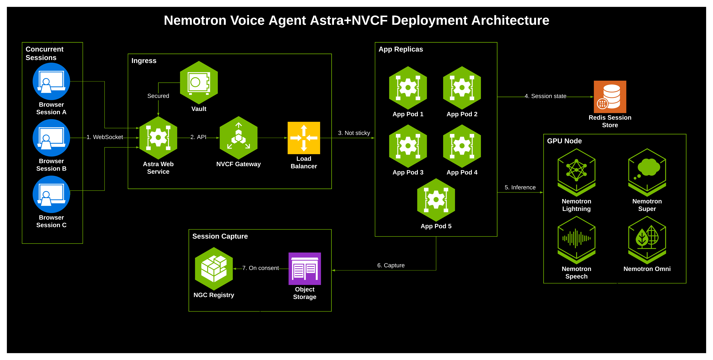
Request path: the browser reaches Astra, Astra invokes the NVCF function, and the function hands the session to whichever App Pod is free. That pod reads and writes the Redis Session Store, calls the models on the GPU node, and — on consent — stages the conversation for archiving to NGC (NVIDIA GPU Cloud).
2 | Concurrency: shared state across replicas
Opening the deployment to many people at once meant running several copies of the application, and that broke an assumption the single-process prototype had made — that everything belonging to a conversation lived in the process that started it.
▪ Horizontal scale. The application runs as five replicas (App Pod 1–5 in the diagram), and the platform deliberately does not pin a user to one of them. Any replica may receive any request.
▪ Split requests. A voice session is not a single request. The browser first posts a session configuration and receives a session identifier, then opens the audio stream as a separate WebSocket request. With several replicas the two can land on different pods, and the pod holding the stream had no access to the configuration the other pod had just stored.
▪ The same fault in media. The Omni Subagents experience compounds it. Uploaded attachments, webcam frames and high-resolution capture requests each arrive on their own HTTP endpoints, so a frame could be delivered to a pod that was not running the conversation it belonged to.
▪ Root cause. Each replica held session configuration and media in ordinary in-process dictionaries. Nothing written by one process was visible to another, so only one replica could safely run and every user had to be served from it.
▪ Shared session state. A Redis Session Store was introduced. Session configuration, attachments, webcam frames, capture flags and consent are now keyed by session identifier and readable by every replica. Any pod can resolve what it needs for a session it did not start, which is what made replication possible and the deployment replica-agnostic.
▪ Consent-gated capture. Archiving had the same shape of problem. With consent, each replica writes its conversation's audio, transcript and log to a shared object store, while two independent signals — the pipeline has ended, and the user has answered the consent prompt — are recorded in the shared session store. Either signal may arrive on a different replica from the other. Where consent is declined, all material is deleted immediately.
▪ Single-writer archiving. Once both signals are present, every replica that sees them is a candidate to publish. A token-owned lock in the shared session store guarantees that exactly one assembles the archive and publishes it to NGC under the session identifier; the others detect the lock and step aside, and a sweeper retries any conversation left stranded by a failure or a restart.
▪ Verification. Testing used real audio through physical microphones at up to 30 simultaneous conversations, confirming no cross-talk between sessions, no dropped connections, and exactly one archive per conversation.
3 | Generic Frontend / Backend Agent: fast conversation, grounded answers
The assistant that fronts the deployment was redesigned so that a reply is both immediate and correct, instead of those two goals competing for the same model.
▪ What it is. The Generic Frontend / Backend Agent splits one assistant across two models. A fast conversational model, the Nemotron 3.5 Lightning Talker, owns the conversation and does all the speaking. A separate reasoning model, Nemotron 120b Super, plans any work that needs live data, tools or analysis. The Talker holds exactly two functions, call_backend and cancel_backend, and calls no external service itself.
▪ What it is built on. It is one Pipecat voice pipeline inside the Nemotron Voice Agent repository — a FastAPI server, Pipecat processors and NVIDIA speech and language services — with a React client that is only a user interface. All orchestration is ordinary Python; no external agent framework is involved.
▪ Highlights. One bounded plan per request rather than an open-ended tool loop; a hard boundary between the model that talks and the model that decides; and domain behaviour supplied by configuration rather than by code.
▪ The problem. The earlier single-model generic assistant ran its language model with reasoning disabled. Reasoning produces markedly better tool-call plans and handles questions that need analysis: on the repository's published BigBench Audio reference runs, enabling reasoning raised in-pipeline answer accuracy from 60.3% to 81.3% for Nemotron Super and from 50.4% to 75.6% for the 30B model. It also raises time to first token, which in a spoken conversation is heard directly as a pause.
▪ The resolution. Splitting the pipeline removes the trade-off. The Talker answers stable conversational turns itself with reasoning off, and delegates anything that needs live data or analysis. The reasoning pass then runs asynchronously in the backend while the Talker stays live — speaking a short progress phrase, continuing to listen, and handling barge-in and cancellation. The result is reasoning-quality planning without the conversation paying reasoning latency.
▪ Planning without execution. The reasoning model returns a plan and never executes it. Ordinary Python checks every step against an allow-list, validates each argument, and bounds the work at three planning rounds, so a later step can depend on an earlier result without becoming an open loop.
▪ Deterministic reply. The spoken reply is assembled from the validated arguments and the real service response. An unavailable, partial or failed result is never converted into a successful answer, and the agent cannot introduce a value the tool did not return.
▪ Origin and generalisation. The design already existed in the repository as an airline booking example. It was generalised into a domain-configurable agent: the domain profile, the hidden backend prompt and the permitted tool set are bound from a YAML registry, so a new domain is added by configuration and no browser session can widen what it is allowed to call.
▪ Tools today. The ToolSpec Registry as deployed holds weather, stock price, web search, body-mass index and random number. Each entry declares a tool's schema, its validation, its execution and how its result should be spoken.
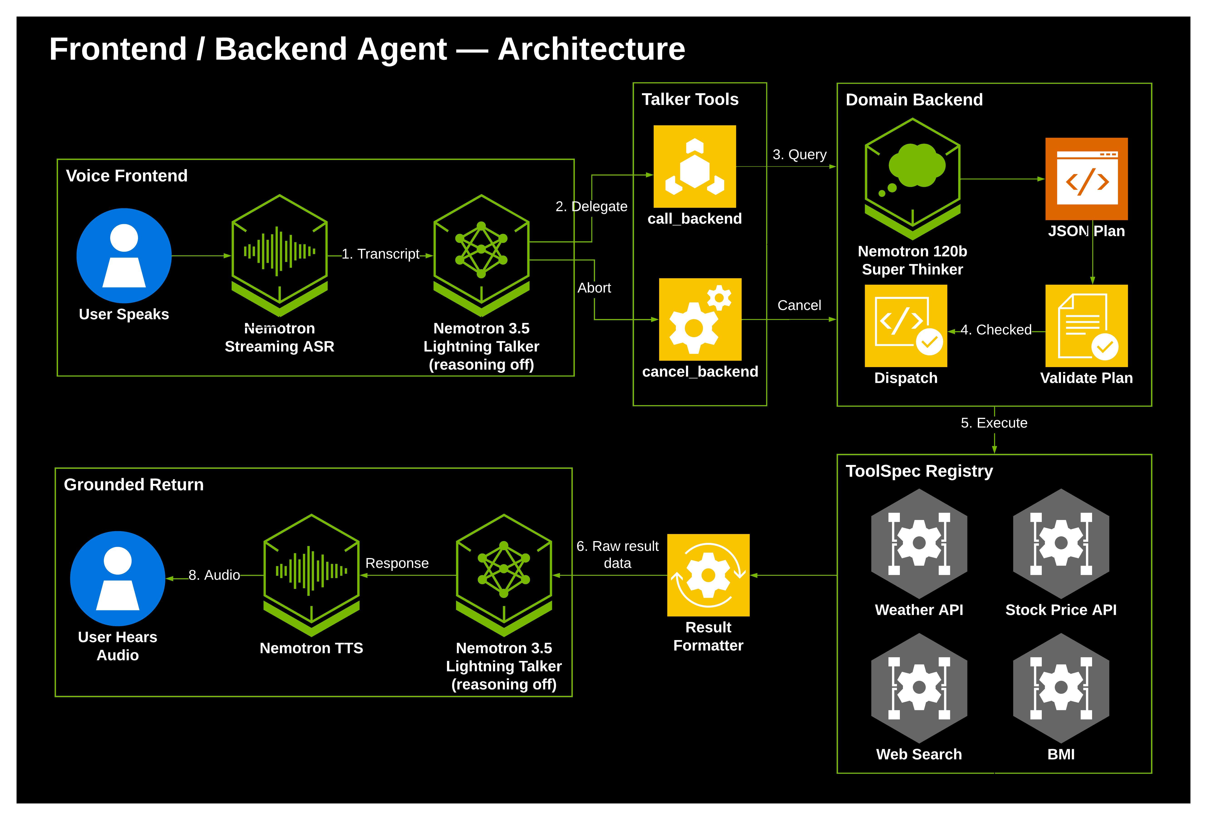
Path through the agent: speech is transcribed by streaming ASR and reaches the Lightning Talker, which either answers directly or calls call_backend. The Super Thinker returns one JSON plan; Python validates it and dispatches only allow-listed tools from the ToolSpec Registry; the returned values are assembled deterministically and spoken back.
4 | Planned work: standard realtime interfaces for the Generic Agent
The next step makes the agent usable by voice clients that were never written for it.
▪ Objective. Expose the Generic Frontend / Backend Agent behind an OpenAI-compatible realtime API — the interface many voice clients already target — so those clients can point at Nemotron and operate unchanged, making the agent a component inside other products rather than only a destination of its own.
▪ Existing groundwork. A Realtime-shaped gateway already exists in the repository, and the hand-off design is effectively the single tool such an interface expects, so the agent's core contract does not require change.
▪ In progress. An adaptor that makes the Generic Frontend / Backend Agent compatible with the OpenAI Realtime API schema is being built on top of @Punit's branch.
▪ Remaining gaps. Three items remain on that path: allowing clients to declare their own tools, which the gateway ignores today; giving the realtime path the same shared session store the main path already uses; and adding a revision counter, so that a late answer is never spoken after the user has moved on.
▪ Under analysis. The GPT-Live API schema has also been studied. It supports delegating a request to a backend in the same shape as this design, and an assessment of making the Generic Frontend / Backend Agent compatible with it is under way. The voice POC proposals document covers both paths in detail.

Usage and feedback The first four days of open access were analysed end to end: 48 genuine user conversations, from which four defects not surfaced by testing are now tracked fixes. Every conversation captured with consent becomes evidence for the next release. The feedback form below is the fastest route for reporting behaviour that appeared incorrect, and the full session analysis is linked with it.
Links
▪ Try the agent https://nemotron-voice-agent-deploy-backend.prd.astra.nvidia.com/
▪ Share feedback https://forms.gle/AcsBtqa8FxmQyPZcA
▪ Session analysis (first four days of open access) https://docs.google.com/document/d/173BBLx9cuJyyyphwgbEaJu82DAZLp1Tf_1-tZuBiPfM/edit
▪ Voice POC proposals — LiveBridge (GPT-Live) and PromptSplit proposals/voice-poc-proposals.pdf in the nemotron-voice-agent repository

