Table of Contents

Oracle Single Row Functions 2

String SRFs 2

Numeric SRFs 3

Date and Time SRFs 3

Other SFR functions 4

Reference : <https://www.techonthenet.com/oracle/index.php>

# **Oracle Single Row Functions**

## **String SRFs**

* CONCAT(String1,String2) – concatenate String1 and String2

Example : select concat(concat(‘A’,’B’),’C’) from dual;

Output : ABC

* Concatenate using || - String1 || String2 || String3

Select ‘Dave ’ || ‘Anderson’ from dual;

Output: ‘Dave Anderson’

* Length(String1) – returns length of String1

Select length(‘William Kates’) from dual;

Output : 13

* Lower(String1) – returns lower characters of String1. It can also be used in ‘Where Filter condition’

Select lower(‘HELLO’) from dual;

Output: hello

* upper(String1) – returns upper characters of String1. It can also be used in ‘Where Filter condition’

Select upper(‘hello’) from dual;

Output: HELLO

* Initcap(String1) – Returns first character of each word as capital letter

Select initcap(‘hello my name is dave’) from dual;

Output: Hello My Name is Dave

* LPAD(String1,FinalLength1,Character1) – pad character1 to left of String1 and make final length to be FinalLength1. Character1 is optional and if its not there then spaces will be added.

Select lpad(‘HELLO’,10,’$) from dual;

* RPAD(String1,FinalLength1,Character1) – pad character1 to right of String1 and make final length to be FinalLength1. Character1 is optional and if its not there then spaces will be added.

Select rpad(‘HELLO’,10,’$) from dual;

* LTRIM(String1,Character1) – Trim left most Character1 occurences from String1 and return result. Character1 is optional and if it is not there then all spaces will be removed from beginning of string

Select ltrim(‘hhhhhhello’,’h’) from dual;

Output: ello

* RTRIM(String1,Character1) – Trim right most Character1 occurences from String1 and return result. Character1 is optional and if it is not there then all trailing spaces will be removed

Select rtrim(‘hellohhhhh’,’h’) from dual;

Output: hello

* REPLACE(String1, String_to_replace,[ReplacementString]) – All occurences of ‘String_to_replace’ are replaced by ReplacementString. ReplacementString is optional and if not present, then all occurences of String_to_replace will be removed

Select replace(‘123tech123’,’123’,’456’) from dual;

Output: 456tech456

* TRANSLATE function replaces a sequence of characters in a string with another set of characters. However, it replaces a single character at a time.

For example, it will replace the 1st character in the string_to_replace with the 1st character in the replacement_string. Then it will replace the 2nd character in the string_to_replace with the 2nd character in the replacement_string, and so on.

TRANSLATE(String1,String_to_replace,replacement_String)

select TRANSLATE('222tech', '2ec', '3it') from dual;

Output: 333tith

* SUBSTR(String1, StartPosition1,Length1) – return substring starting and including StartPosition1 and for the Length1. Length is optional and if omitted then entire string is returned

Select substr(‘Hello’,2,2) from dual;

Output: el

## **Numeric SRFs**

* ROUND(Number, precision) – Number is rounded to the precision. If Precision is missing, then whole number is returned, and decimal digits are ignored

Select round(3.225,2) from dual;

Output: 3.23

* TRUNC(Number,[decimal places]) – Number is truncated to the precision. If [decimal places] is missing, then the whole number is returned and fraction is ignored

Select TRUNC(125.815,2) from dual;

Output: 125.81

## **Date and Time SRFs**

* Select sysdate from dual;

Output example: 09/14/2020

* Select systimestamp from dual;

Output example: 14-SEP-20 02.01.28.009804 AM +00:00

* Select add_months(‘11/15/2020’,3) from dual;

Output example: 02/15/2021

* Select add_months(‘12/27/2020’,-3) from dual;

Output example: 09/27/2020

* Select add_months(sysdate,3) from dual;

Output example: 12/14/2020

* TRUNC(date,[format]) – Truncates date field to the first of a day or first of a month or starting of a week

Select TRUNC(sysdate,’MONTH’) from dual;

Output: 09/01/2020

## Other SFR functions

* to_char(value,[format],[language])

A number or date that will be converted to a string.

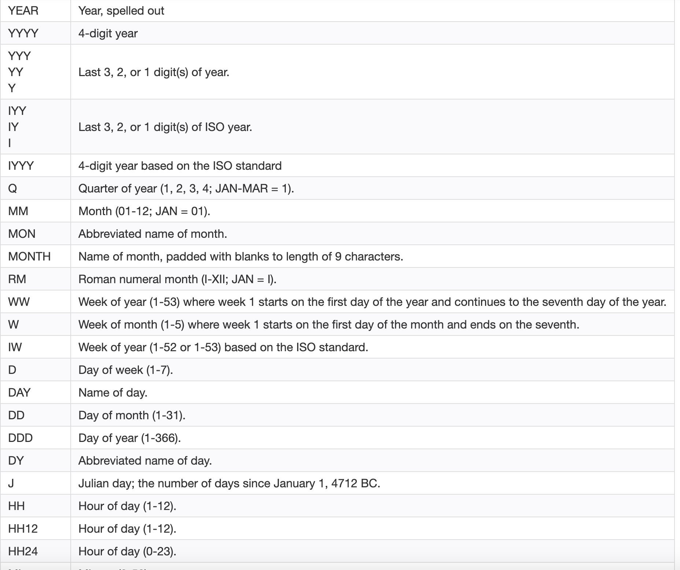

Select to_char(sysdate,'yyyy-mm-dd') from dual;

Output: 2020-09-14

Select TO_CHAR(sysdate, 'MON DDth, YYYY') from dual;

Output: SEP 14TH, 2020

Select to_char(sal,’$99,999’) from emp;

Output example: $1,350

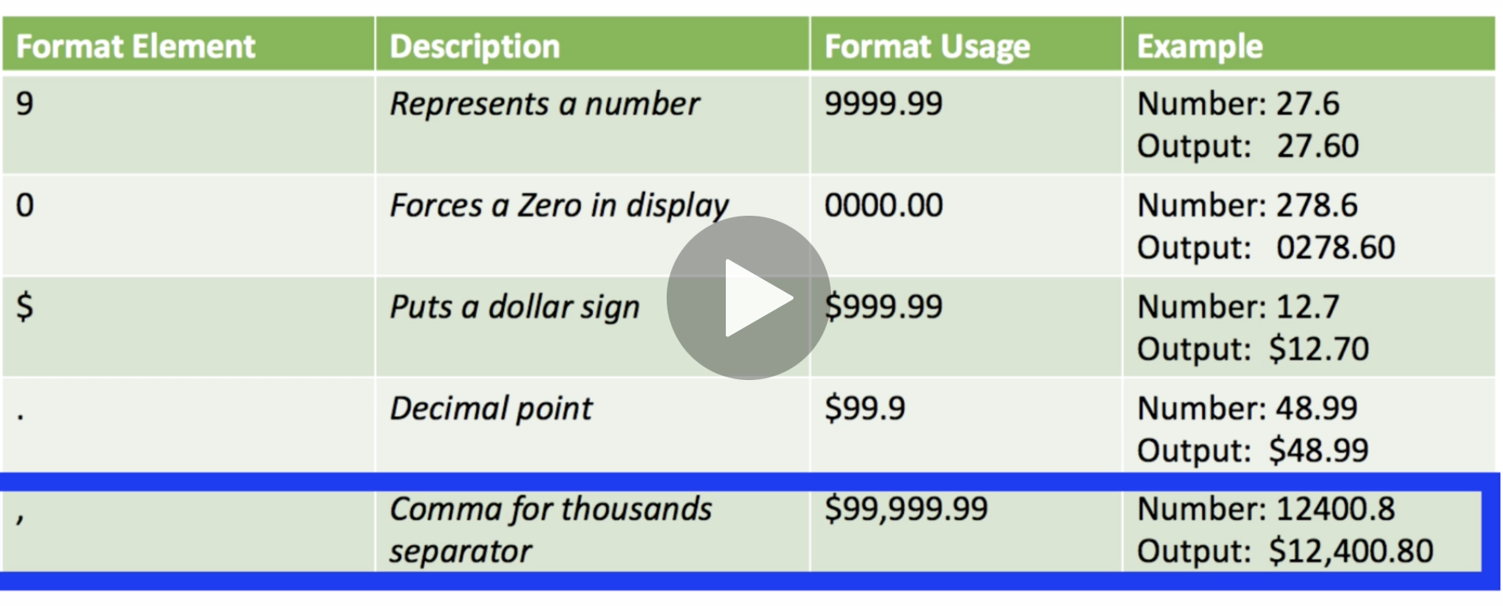

* NVL(string1,replace_with) – the replace_with is the returned value if string1 is null. NVL operations returns something when field values are null

Select NVL(sal,0) from emp;

Outout: 0 if sal is null