Jeffrey Viner

jnickviner@gmail.com

Abstract

Hydrotools is an extension written for excel designed for the advanced user to be able to quickly perform operations common in the field of surveying.

Hydrotools excel extension

User Manual

Table of Contents

1.0 Notice to User 3

2.0 Loading Hydrotools 4

3.0 Tool Guide 4

3.1 Global Tools 4

3.1.1 Speed of Sound 5

3.1.2 Calculator 5

3.1.3 About 5

3.1.4 Close 5

3.2 Calculators 5

3.2.1 Conversion Tools 6

3.2.2 Calculation Tools 7

3.3 Forward/Inverse Calculations 8

3.4 Tide Conversion 9

3.4.1 Create Blank Tide File 9

3.4.2 Load Current Tide File 9

3.4.3 Access NOAA Water Levels 9

3.4.4 Preliminary vs. Final 10

3.4.5 Update Tides 10

3.5 Offset Calculator 10

3.6 Hydrotools AutoLogger 11

3.6.1 Notice to User (READ THIS BEFORE USING) 11

3.6.2 Generate Log File 12

3.6.3 Load Log File 12

3.6.4 Save Log File 12

3.6.5 Logging Tools 12

3.7 Mag Data Analyst 13

3.7.1 Load Mag File 13

3.7.2 Format Mag CO File 13

4.0 Hydrotools VB Function Library 14

4.1 getRange 14

4.2 delCharByChar 14

4.3 delCharByIndex 14

4.4 random 15

4.5 getListLength 15

4.6 isActiveWorkbook 15

# 1.0 Notice to User

Hydrotools is a program written in Visual Basic (VB) which accompanies Microsoft’s Office Excel 2015 suite as a Userform which can be used in conjunction with the basic toolset provided in the vanilla environment. While Hydrotools can be imported and used in any spreadsheet, it by default comes stored within a Private Workbook which can be run and edited at anytime without effecting the default Excel environment.

While many of the tools within Hydrotools are of generic use and require no caution by the end user, there are many components whose effectiveness is based on the knowledge of the user. Specifically, many of the data processing tools will only work with specific brands of hardware (these will be specified within the Hydromap Userform). When used properly, Hydrotools can significantly reduce the time spent processing and analyzing various datasets. However, if one uses this program without the prerequisite knowledge, the risk of ruining files is present. It is paramount that all datasets are backed up and proper research is done before using this tool as Hydrotools is still in its development phase.

I (“I” referring to the writer of Hydrotools) am not responsible for any lost data or corrupt files incurred by the user while using Hydrotools.

# 2.0 Loading Hydrotools

All of Hydrotools features are stored in a single folder. When the tool is initially loaded, it will automatically determine its own file path, allowing it to be run from any internal directory or external hard-drive/flash-drive. To run Hydrotools, first ensure that your version of Microsoft Excel is up to date (Hydrotools has confirmed compatibility with Excel 2013 and 2015). Then open the Private Workbook file (*.xlsb) named “HydroTools_Active” located in the source folder. You installed version of Excel will open along with the Hydrotools extension in the form of a Windows Userform (Figure 1.).

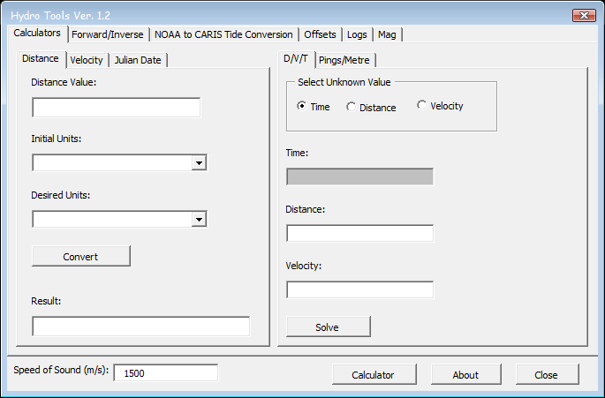

Figure 1. Primary Hydrotools window.

If the tool did not open with the Workbook, it is likely that macro’s have not been enabled on your system. If that is the case, there should be a yellow bar stretching the length of your main Excel window asking you if you wish to enable Macros (select “Yes”). If the aforementioned yellow bar did not appear, you can change your security settings via File > Options > Trust Center > Trust Center Settings > Macro Settings.

If the Userform is closed, it can be reopened by either closing or running the Private Workbook again, or via the Custom Hydrotools tab in the Private Workbook (It may have to be activated via the Customize Ribbon tool).

# 3.0 Tool Guide

## 3.1 Global Tools

There are four commands available regardless of your location within the Hydrotools Userform: Speed of Sound, Calculator, About, and Close.

### 3.1.1 Speed of Sound

This text box allows the user to enter in a value for the speed of sound which can then be used by any of the Userforms tools, rather than binding it to a single tool.

### 3.1.2 Calculator

This opens up a new window containing a basic calculator (Figure 2).

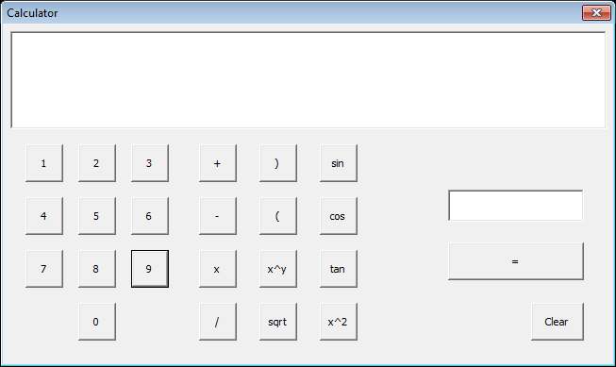

Figure 2. The Hydrotools calculator tool.

### 3.1.3 About

This button opens up a small window with information on Hydrotools as well as an inspirational quote.

### 3.1.4 Close

This button closes Hydrotools.

## 3.2 Calculators

Hydrotools contains a number of basic calculation utilities (Figure 3) which would commonly be used in the field. Sections 3.2.1 through 3.2.5 cover these tools.

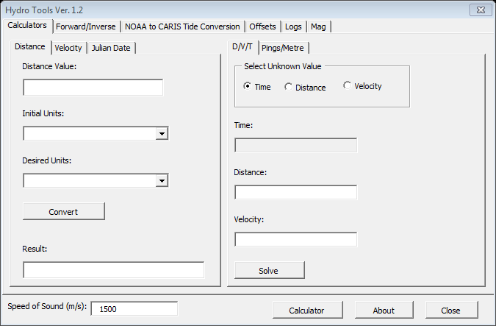

Figure 3. Hydrotools calculations tab.

### 3.2.1 Conversion Tools

The set of tabs on the left side of the Calculators window contain unit conversions calculators.

#### 3.2.1.1 Distance

Allows the user to enter in a distance value, select the units of the current value, then select the units to which the value should be converted to. Once the convert button is clicked, the result will appear in the textbox at the bottom of the tab. The currently available units are as follows:

* Metres
* Centimetres
* Feet
* Inches
* Nautical Miles
* Miles

#### 3.2.1.2 Velocity

Allows the user to enter in a velocity value, select the units of the current value, then select the units to which the value should be converted to. Once the convert button is clicked, the result will appear in the textbox at the bottom of the tab. The currently available units are as follows:

* Metres per Second
* Kilometres per Hour
* Miles per Hour
* Nautical Miles per Hour (Knots)

#### 3.2.1.3 Julian Date

Allows the user to input a Gregorian calendar date, such as April 16th, 2016, and convert it to a Julian calendar date. It should be noted that false days such as September 31st will be accepted and calculated by this tool so some common sense on the user-end is required. With that said, if a date such as September 31st is entered, the result will be the Julian date equivalent of October 1st.

### 3.2.2 Calculation Tools

These tools allow the user to perform some commonly used calculations quickly and correctly.

#### 3.2.2.1 DVT

The DVT Calculator utilizes the equation $Time= {Distance}/{Velocity}$ to allow the user to solve for any of the three variables provided they know two of them. The unknown variable can be selected by clicking on one of the three radio buttons in the DVT tab (Figure 4).

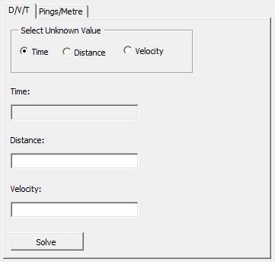

Figure 4. Hydrotools DVT calculator.

When the two known values are entered and the Solve button is clicked, the unknown value will appear in its respective field. It should be noted that the user will be unable to enter values in the text box corresponding to the selected radio button.

#### 3.2.2.2 Pings/Metre

The Pings/Metre calculator (Figure 5) outputs sounder pings per metre given a vessel speed and average depth value. It can also be set to limit the value, provided a ping rate value from the echosounder is known.

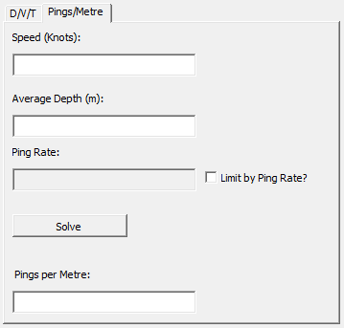

Figure 5. Pings/Metre Calculator.

## 3.3 Forward/Inverse Calculations

As its namesake suggests, the Forward/Inverse Calculator (Figure 6) performs basic vector calculations given sets of coordinates, distances, and azimuths. 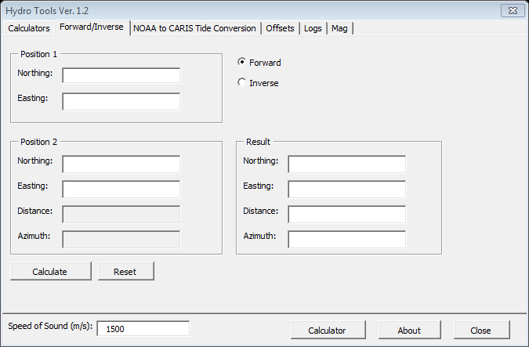

Figure 6. Forward/Inverse Calculator.

## 3.4 Tide Conversion

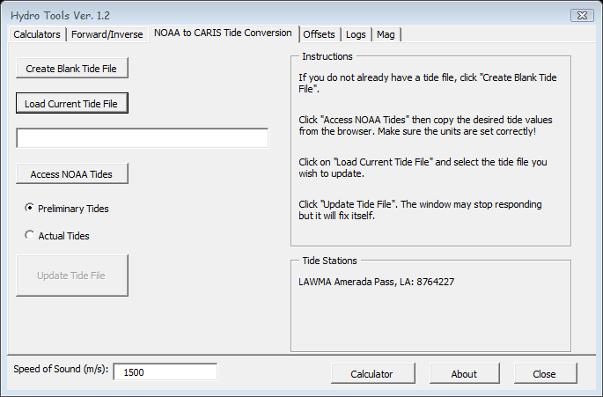

Figure 7. HydroTools Tide Tab.

### 3.4.1 Create Blank Tide File

The first task in the workflow for generating a valid tide file for CARIS is to make a properly formatted tide file. The file must be a text based file with the extension *.tid and it must contain at least 8 hyphens on the first line. When the “Create Blank Tide File” button is clicked, the user will be prompted to enter a name for their new tide file as well as to select the target directory, once that is done the new tide file is will be ready to be loaded into Hydrotools.

### 3.4.2 Load Current Tide File

At this point you can either load an already created tide file which needs to be updated or the newly created tide file from section 3.4.1. Once the “Load Current Tide File” button is clicked, the user will be prompted to select the desired tide file and load it. Once loaded, the tide file will appear in Excel and the address of the file will appear in the textbox below the button. Also, once a file is successfully loaded, the “Update Tide File” button will be enabled.

### 3.4.3 Access NOAA Water Levels

Rather than having to navigate through the NOAA website to find their water level tables, if you know the number of the tide station you wish to download data from, you can click the “Access NOAA Water Levels” button. The user will be prompted to enter in the tide station number and then the default browser will open and take the user directly to the water levels page (data scraping isn’t well supported in VBA so this will be the method used until Hydrotools is rewritten in a different language). Once on the webpage, highlight the required data and copy it. There are two things the user will have to note when getting this data: Firstly, ensure that no secondary data is copied such as other text on the website. Secondly, take note of whether you are copying preliminary or finalized tides.

### 3.4.4 Preliminary vs. Final

Depending on how recent the tide data you are loading is, you will either be loading preliminary or finalized tides. It is important to note which one you are using when you are copying them from the NOAA website as outlined in section 3.4.3. Simply select which type of tide data you are using from one of the two appropriately labeled radio buttons.

### 3.4.5 Update Tides

Once the desired tide data has been copied from the NOAA site, the user should now click on the “Update Tides” button. A prompt will appear asking the user if they have copied the data from NOAA Water Levels, if the user clicks no, another prompt will appear asking for the tide station number and will then take the user to the NOAA Water Levels page. If the user clicks yes, the tide data will be pasted into the appropriate location in the tide file, formatted, saved, and closed.

## 3.5 Offset Calculator

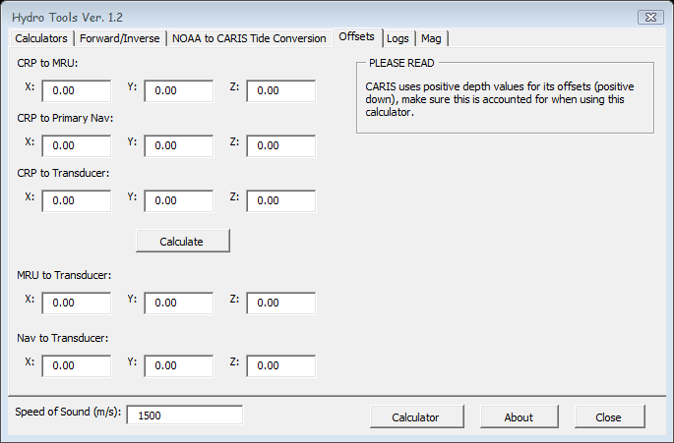

Figure 8. Hydrotools offset calculator for CARIS.

This tool will calculate vessel offsets for the user. Simply enter in the required values as specified (Figure 8), and click calculate.

## 3.6 Hydrotools AutoLogger

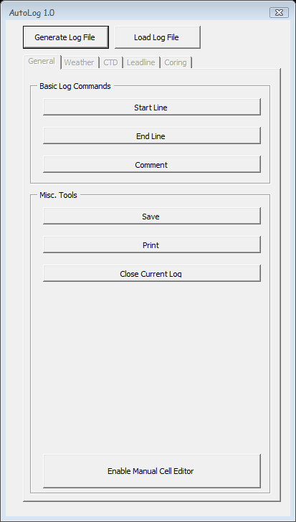

Figure 9. AutoLog main window.

### 3.6.1 Notice to User (READ THIS BEFORE USING)

When using AutoLog, it is extremely important to ensure that only logs generated by AutoLog should be used. There is an invisible checksum value “#” at the bottom of each log page which are required for the proper functioning of the program. Any log not containing this, or containing the improper number of rows/columns will simply not work.

### 3.6.2 Generate Log File

If a log file is not already prepared for the user, they can have Hydrotools generate a new log for them. Once the “Generate Log File” button is clicked, the user will be prompted to enter a variety of data which is required on a log sheet. Once the required data has been entered, a log will be generated in a separate workbook in Excel. It is important to note that AutoLog will modify data in the active workbook (which after loading or generating a new log, will be the workbook containing the logs) however, as a safeguard, it will not modify the main Hydrotools workbook. It should be noted that the spreadsheet can be manually edited at any point which AutoLog is open. It should also be noted that if the currently active cell is not the correct one as required by the program, Autolog will change the active cell to the correct address to minimize error as a result of the user.

### 3.6.3 Load Log File

If a log already exists, one can load it by clicking the “Load Log File” button. Once loaded ensure that the selected cell is in the row where you want your log entry to be, if not, simply select it.

### 3.6.4 Save Log File

This button acts exactly like the generic “Save” button in all Microsoft Office products. The user should take care that the highlighted cell is directly below the last entry in the log file before saving. It will make things easier when the file is loaded back up in the future.

### 3.6.5 Logging Tools

All of the various logging options (EOL, SOL, CTD, etc.) work the same way. The user will be prompted to enter the required data and, once entered, AutoLog will populate the correct cells as well as make new pages when needed.

#### 3.6.5.1 General

The general tab of Autolog contains the more commonly logged instances such as SOL, EOL, and Comments. It also allows the user to save, print, and close the opened log file directly from the Autolog GUI.

#### 3.6.5.2 Weather

Contains fields required for generating a weather report.

#### 3.6.5.3 CTD

Contains fields required for generating a CTD report.

#### 3.6.5.4 Leadline

Contains fields required for generating a Leadline

## 3.7 Mag Data Analyst

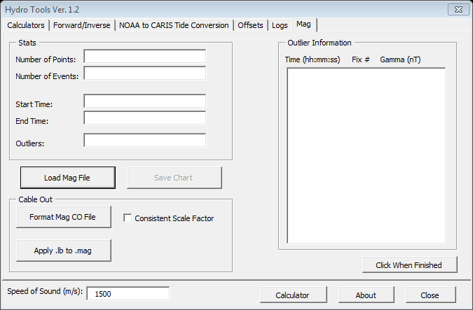

Figure 10. Hydrotools Mag Data Tab with sample data.

### 3.7.1 Load Mag File

Hydrotools is capable of importing and analysing data from a Geometrics G-880 Magnetometer Wingfrog output string from MagLog (compatibility for more strings will be added in the future). The accepted file format is *.mag. Once a mag file is loaded, statistics on the dataset will be computed and displayed on the Mag Data tab (Figure 9). A chart will also be generated and displayed on the accompanying spreadsheet. Hydrotools uses a slope analysis algorithm to detect changes in the slope of the curve which can be used to detect outliers with moderate success. The outlier table is a means of support to the user when analyzing the generated chart and should never be used as a standalone data source. Once analysis is complete, the chart can then be saved as a separate Excel file to be used for future reference.

### 3.7.2 Format Mag CO File

The Cable out file which accompanies the Mag data may require formatting before it can be used in processing geophysical data. Once the “Format Mag CO File” button is clicked, the user will be prompted to load a Mag Cable Out file (retrieved from Hydromap). Once the file has been selected, Hydrotools will parse the file into individual documents each containing data for a single line. The user will be prompted with a save window for each line performed. Hydrotools will automatically name the files so the user simply must confirm the name and click “Save”. The user will also be prompted to enter in a scale factor for each line (See magnetometer processing SOP). The output files are of the format *.lb, if any changes are needed in the extension, they can easily be applied post-generation.

### 3.7.3 Apply .lb to .mag

With the generation of .lb files from section 3.7.2, the raw mag data file can now be updated with the adjusted XYZ position of the magnetometer by applying vessel offsets and layback (found in the .lb file). Once the “Apply .lb to .mag” button is clicked, a small form will be opened as shown below.

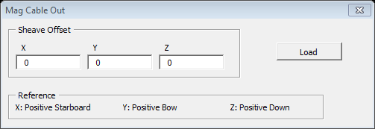

The user may enter in any present offsets into the form and then click “Load”. The user will then be prompted to select an .lb file and then its corresponding raw mag file. Hydrotools will then apply the information in the .lb file to the .mag file and output a .mag.proc file.

# 4.0 Hydrotools VB Function Library

Along with the aforementioned tools, Hydrotools contains a library of functions which are made available to the user with knowledge of VB in the excel environment via the Hydrotools module.

## 4.1 getRange

The getRange() function allows the user to store an A1 format range value into a string variable. The function requires the user to select the range using a custom textbox which will appear upon program execution.

Syntax: *Value as string =* getRange()

Sample:

Dim p as string

P = hydrotools.getRange()

## 4.2 delCharByChar

The delCharByChar() function allows the user to remove all instances of a specified character within a string value.

Syntax: *Value as String = hydrotools.*deleteCharByChar(*inputString As String, charDel As String)*

Sample:

Dim p as string

P = “The Holy Grail”

P = hydrotools.deleteCharByChar(p, “G”)

*Debug.print* p

>> “The Holy rail”

## 4.3 delCharByIndex

The delCharByIndex() function allows the user to remove a specified character within a string based on its index within the string. It should be noted that in VBA, indexes begin at 1 whereas most other languages follow the convention of beginning all indices at 0.

Syntax: *Value as string = hydrotools.*delCharByIndex (*inputString As String, indexDel As Integer)*

Sample:

Dim p as string

P = “Knights of Ni”

P = hydrotools.delCharByIndex(p, 7)

*Debug.print* p

>> “Knight of Ni”

## 4.4 random

As Excel VBA lacks a simple random number generator (the built-in Excel function, Rnd, is rather bulky), the random() function is a quick way to allow the user to generate a random integer value within a specified range. It should be noted that the Hydrotools random function utilizes the built-in Rnd function, it just packages it in a more user friendly manner.

Syntax (Rnd): *Value as integer =*Int((*Max Value – Min Value* + 1) * Rnd – *Min Value*)

Syntax(Hydrotools): *Value as integer = hydrotools.random*(*minValue*, *maxValue*)

Sample:

Dim p as integer

P = hydrotools.random(1,10)

*Debug.print* p

>> *Some number between 1 and 10*

## 4.5 getListLength

The getListLength() function returns an integer value specifying the length of a single column list. If there is a break in the list (ie. An empty cell) then the tool will highlight the empty cell and notify the user. The user will then have to highlight the first cell in the list once again and rerun the function.

Syntax: *Value as Integer =* hydrotools.getListLength(*topOfListRange* As String)

Sample:

|  |  |  |
| --- | --- | --- |
| A1 | B1 | C1 |
| A2 | B2 | C2 |
| A3 | B3 | C3 |

Dim p as integer

P = hydrotools.getListLength(“A1”)

*Debug.print p*

*>>* 3

## 4.6 isActiveWorkbook

The isActiveWorkbook() function returns True or False depending on the state of the primary Hydrotools workbook (HydroTools_Active.xlsb). If the active workbook is Hydrotools, the function will return True, if any other workbook is active, the function will return false. This is used in AutoLog to ensure that the primary Hydrotools workbook is not compromised.

Syntax: *Value as Boolean =* hydrotools.isActiveWorkBook()

Sample:

If hydrotools.isActiveWorkbook() = True Then

Debug.print “Hydrotools is the active workbook”

Else

Debug.print “Hydrotools is not the active workbook”

End if

## 4.7 selectLeft

The selectLeft function simply takes in the current activecell address and, if it is not currently in the “A” column, shifts it over until it is in the “A” column. This is used primarily in the Autolog feature as way to minimize error due to the user selecting improper cell ranges. This function does not take in any values.

Syntax: hydrotools.selectLeft

## 4.8 correctLogRange

The correctLogRange function is used by Autolog to check the current address of the active cell and determine if it is valid for the purpose of inputting the log entries. If it is determined that the current address is invalid, correctLogRange will adjust the address to the proper address. This function does not take in any values

Syntax: hydrotools.correctLogRange