Capstone Project: Deployment of Online Food Ordering and Delivery Application
- Github repo with the code:

Fork this repo : https://github.com/staragile2016/FoodAppZomato.git

- Setup GITHUB WEBHOOK TRIGGER

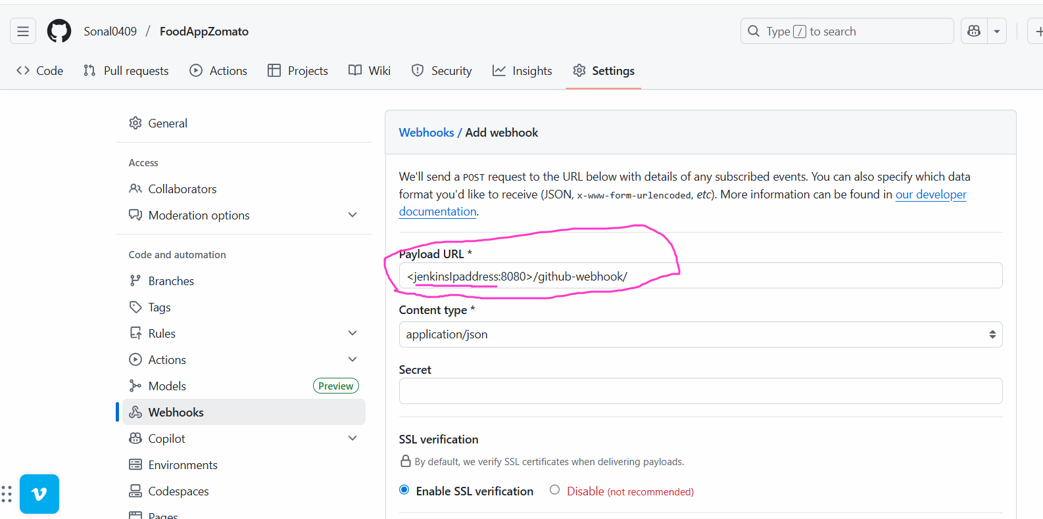

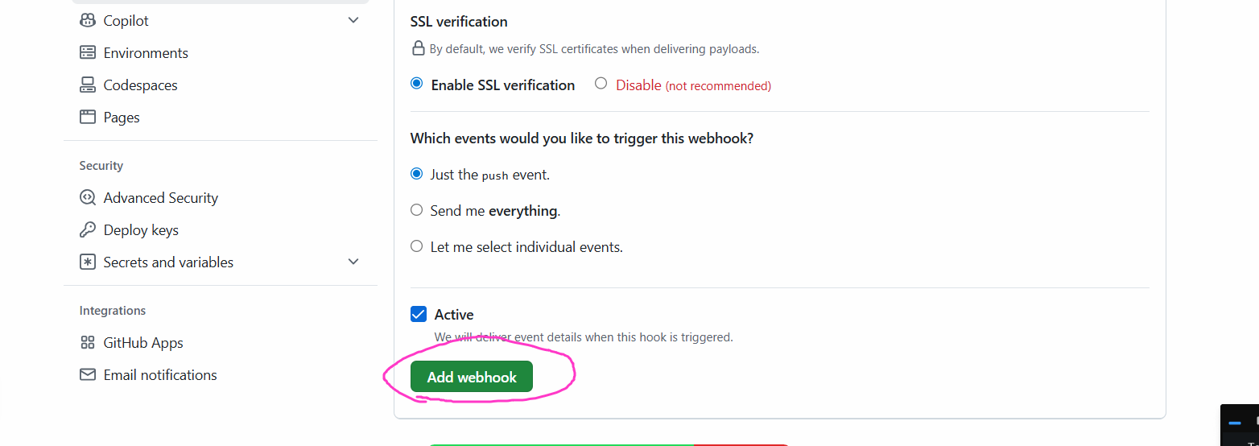

- Create an AWS EC2 server with Ubuntu 22 OS, t2.medium

Install java and Jenkins

Install docker

// run the command on terminal
# chmod 777 /var/run/docker.sock

Connect to Jenkins dashboard

Create a new job of type pipeline

pipeline{
agent any
stages{
stage('Clone Code'){
steps{
git 'https://github.com/Sonal0409/FoodAppZomato.git'
}
}
// run the command on the terminal chmod -R 777 /var/run/docker.sock
stage('Build docker image'){
steps{
sh 'docker build -t zomato .'
}
}

stage('Loginto dockerhub'){
steps{
sh 'docker login -u <username> -p <password>'
}
}

stage('push image to dockerhub'){
steps{
sh 'docker tag zomato <dockerhub-username>/zomato'
sh 'docker push <dockerhub-username>/zomato'
}
}

}
}

Run this command before you run the pipeline

# chmod 777 /var/run/docker.sock

- Create an AWS EKS Cluster by using steps given in below document:

https://docs.google.com/document/d/1bU5-c9LCzy0cjVhKUYMt-2IagsWRqw0y/edit

Deploy the following code in it

# deployment and High availability and Service YAMls

apiVersion: apps/v1
kind: Deployment
metadata:
name: zomato
labels:
app: zomato
spec:
replicas: 1
selector:
matchLabels:
app: zomato
template:
metadata:
name: zomatopod
labels:
app: zomato
spec:
containers:
- name: zomato
image: <dockerhub-username>/zomato
resources:
limits:
cpu: 10m

---
apiVersion: v1
kind: Service
metadata:
name: zomato-svc
spec:
type: ClusterIP ## this is default if we do not type in service definition
selector:
app: zomato
ports:
- protocol: TCP
port: 3000
targetPort: 3000

---
apiVersion: autoscaling/v1
kind: HorizontalPodAutoscaler
metadata:
name: zomato-hpa
spec:
scaleTargetRef:
apiVersion: apps/v1
kind: Deployment
name: zomato
minReplicas: 1
maxReplicas: 10
targetCPUUtilizationPercentage: 5

Install Helm on Kubernetes cluster:

$ curl -fsSL -o get_helm.sh https://raw.githubusercontent.com/helm/helm/main/scripts/get-helm-4
$ chmod 700 get_helm.sh
$ ./get_helm.sh

Install using Helm
===========================
Add helm repo

# helm repo add prometheus-community https://prometheus-community.github.io/helm-charts

Update helm repo

# helm repo update

Install Prometheus helm chart

# helm install prometheus prometheus-community/prometheus

Expose Prometheus Service

This is required to access prometheus-server using your browser.

# kubectl expose service prometheus-server --type=NodePort --target-port=9090 --name=prometheus-server-ext

In the kubernetes master node run the queries

# kubectl get pods

# kubectl get svc

Go to the browser:

take the public ip of the masternode and nodeport number

example: http://34.170.213.215:31753/

You will see prometheous dashboard

Now Execute below queries to complete assignment:

kube_pod_container_resource_limits

Grafana:

Install using Helm
Add helm repo
helm repo add grafana https://grafana.github.io/helm-charts

Update helm repo
helm repo update

Install helm
helm install grafana grafana/grafana

Username is admin and get password by running below command:

kubectl get secret --namespace default grafana -o jsonpath="{.data.admin-password}" | base64 --decode ; echo

j3aRcXeVdYD0SpDPSwZdhj15u7GhFysihlebiXPP

Expose Grafana Service
kubectl expose service grafana --type=NodePort --target-port=3000 --name=grafana-ext

Loginto grafana: username will be admin and password will be the text that we copied earlier

Step 1: In grafana we will now setup the Data source:
==================================
Click on Data source --> scroll down -- to add prometheous URL field. Copy the prometheous dashboard URL -> https://ipaddress:portnumber

Scroll down --> click on save and test

Grafana will now be able to fetch data from prometheous

Step 2: Import dashboard to display the Data

Go to Homepage of grafana --> click on Dashboards --> Click on Import dashboard --> the id of dashboard is 16734 and click on load

Scroll down and select prometheous data source -> click on Import

Assignment 1:
====================
Use dashboard, 16734 and add the alert

Assignment 2: Create your own dashboard
=====================
Panel 1 - CPU utilization

avg(100 - (avg by (node) (rate(node_cpu_seconds_total{mode="idle"}[5m])) * 100))

Panel 2: Memory

(sum (node_memory_MemTotal_bytes) - sum (node_memory_MemAvailable_bytes)) / sum (node_memory_MemTotal_bytes) * 100

panel 3- file storage

node_disk_filesystem_info

Panel 4: memory usage by namespace

bar gauge

sort_desc(sum by (namespace) (container_memory_working_set_bytes{pod!="",container!="POD", container!=""}))

Panel 5: total deployments

sum(kube_deployment_status_replicas{namespace=~"kube-system"})

panel 6 :number of pods running
sum(kube_pod_status_phase{namespace=~"$namespace", phase="Running"})

panel 7: Pods failed

sum(kube_pod_status_phase{namespace=~"$namespace", phase="Failed"})

