Câu 11:

a;

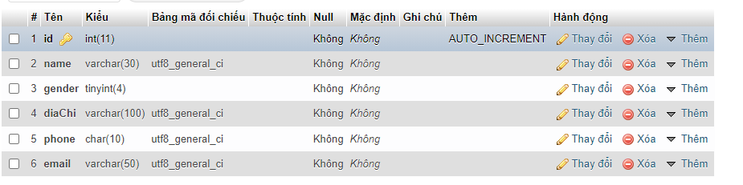

b;

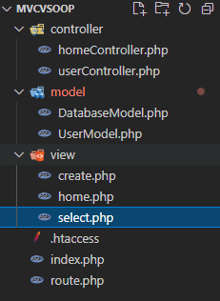

route:

<?php

// Xử lý các yêu cầu từ đường dẫn

// Chỉ được nhúng controller

require_once "controller/homeController.php";

require_once "controller/userController.php";

$controller = "";

if (isset($_GET["controller"])) {

    $controller = $_GET["controller"];

}

switch ($controller) {

    case "":

    case 'home':

        homeController::viewHome();

        break;

    case 'select':

        userController::select();

        break;

    case 'create':

        userController::create();

        break;

    case 'createProcess':

        userController::createProcess();

        break;

    default:

        echo "Không có trang này";

        break;

}

view:

<!DOCTYPE html>

<html lang="en">

<head>

    <meta charset="UTF-8">

    <meta http-equiv="X-UA-Compatible" content="IE=edge">

    <meta name="viewport" content="width=device-width, initial-scale=1.0">

    <title>Document</title>

</head>

<body>

    <form action="createProcess" method="POST">

        name: <input type="text" name="name" id=""><br>

        gioi tinh: <input type="radio" name="gender" value="1" id="">nam

        <input type="radio" name="gender" value="0" id="">nu <br>

        dia chi: <input type="text" name="diaChi" id=""><br>

        dien thoai: <input type="text" name="phone" id=""><br>

        email: <input type="text" name="email" id=""><br>

        <button>them</button>

    </form>

</body>

</html>

Controller:

<?php

require_once 'model/userModel.php';

class userController

{

    // Hiển thị home

    static function select()

    {

        $user = new UserModel();

        $listClass = $user->readAllData();

        require_once "view/select.php";

    }

    static function create()

    {

        require_once "view/create.php";

    }

    static function createProcess()

    {

        // Khởi tạo dữ liệu

        $class = new UserModel();

        $class->name = $_POST["name"];

        $class->gender = $_POST["gender"];

        $class->diaChi = $_POST["diaChi"];

        $class->phone = $_POST["phone"];

        $class->email = $_POST["email"];

        $class->createNewClass();

        header("Location: select");

    }

}

Model:

<?php

require_once 'model/DatabaseModel.php';

class UserModel extends DatabaseModel

{

    public $id;

    public $name;

    public $gender;

    public $diaChi;

    public $phone;

    public $email;

    public function readAllData()

    {

        // Mở kết nối

        $con = $this->connect();

        $sql = "SELECT * FROM khach_hang";

        $result = mysqli_query($con, $sql);

        // Đóng kết nối

        $this->close($con);

        $userArray = [];

        foreach ($result as $each) {

            $user = new UserModel();

            $user->id = $each["id"];

            $user->name = $each["name"];

            $user->gender = $each["gender"];

            $user->diaChi = $each["diaChi"];

            $user->diaChi = $each["phone"];

            $user->email = $each["email"];

            // Đẩy đối tượng vào mảng

            array_push($userArray, $user);

        }

        return $userArray;

    }

    public function createNewClass()

    {

        $con = $this->connect();

        $sql = "INSERT INTO khach_hang(name, gender, diaChi, phone, email) VALUES ('$this->name','$this->gender','$this->diaChi','$this->phone','$this->email')";

        mysqli_query($con, $sql);

        $this->close($con);

    }

}

c;

view;

<!DOCTYPE html>

<html lang="en">

<head>

    <meta charset="UTF-8">

    <meta http-equiv="X-UA-Compatible" content="IE=edge">

    <meta name="viewport" content="width=device-width, initial-scale=1.0">

    <title>Document</title>

</head>

<body>

    <a href="create"> thêm khách hàng</a>

    <table>

        <tr>

            <th>id</th>

            <th>name</th>

            <th>gender</th>

            <th>dia chi</th>

            <th>sdt</th>

            <th>email</th>

        </tr>

        <?php foreach ($listClass as $user) : ?>

            <tr>

                <td><?= $user->id ?></td>

                <td><?= $user->name ?></td>

                <td><?= $user->gender ?></td>

                <td><?= $user->diaChi ?></td>

                <td><?= $user->phone ?></td>

                <td><?= $user->email ?></td>

            </tr>

        <?php endforeach ?>

    </table>

</body>

</html>