If you see a Master Lock 6825 in a yellow color like this, do not attempt to remove it. Be aware that someone has equipment energy sources locked out for their protection as well as yours. This is the designated lock for work that could involve the unexpected energizing of equipment undergoing repair or service. OSHA refers to this as a Lock Out/Tag Out program and requires it to prevent potentially serious injuries to employees servicing equipment. If the equipment being serviced affects your job or tasks, then those involved in Lock Out/Tag Out activities are responsible to inform your or your supervisor about this activity.
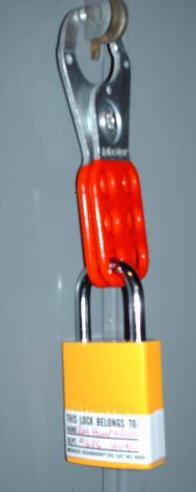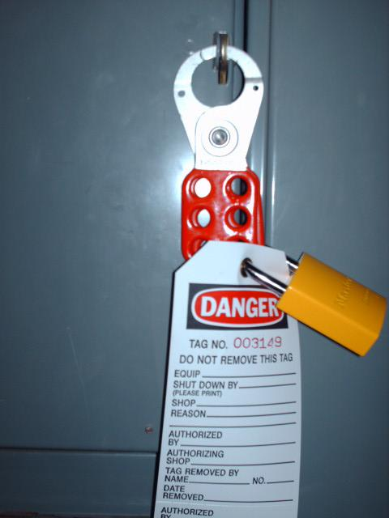
Master Lock Model 6835 in a yellow color may only be used for Lock Out/Tag activities at ASU. This model and color of lock may not be used for any other purpose.
The Lock will be accompanied by a label or tag similar to those pictured above. As an employee affected by this work, please adhere to these precautions to ensure the safety of those involved in the Lock Out/Tag Out activity.
Stay clear of the area as much as possible.
Never attempt to assist. Only authorized employees may work on equipment that is locked out.
Never interfere or tamper with a lock or tag.
Report any unusual situation to your supervisor.
For more detailed information visit the EH&S website at www.asu.edu/uagc/EHS/

