Uncomfortable with your computer workstation? Try ErgoSmart

Take advantage of the ErgoSmart web site available to ASU employees at http://www.asu.edu/uagc/EHS/ErgoSmart/index.htm. Increase your comfort at your workstation by reviewing sections of this program. The design of this web site is flexible so from the main menu you can explore sections that relate to your immediate need such as "How to Setup Your VDT" and "VDTs and Your Health."
Another aspect of the web site is the self-evaluation feature available by selecting “VDT Workstation Evaluation”. This self -help program identifies problems and will assist you in focusing on possible causes of discomfort. Recommendations follow the completion of the self-evaluation that will be helpful to improving workstation issues and work practices.
If problems persist and additional assistance is needed, contact EHS 5-1823 or ASKEHS@asu.edu.

Common Problems
Computer users are increasingly required the mouse to a great extent due to the need for internet browsing, text editing, and graphics programs. Mouse use is becoming a major source of discomfort to computer users. One common problem is placing the mouse too far from the user and not at the same level as the keyboard. The result is an unsafe posture that is not in a neutral position and causes discomfort to the shoulder, forearm, and wrist.

The neutral posture consists of:
- Keeping you wrists straight
- Forearms bent between 90 and 120 degrees.
- Shoulders should be relaxed and remain at your sides and without interference from chair arms.
- Feet are fully supported by floor or footrest.
- Back is fully supported with appropriate lumbar support when sitting vertical or leaning back slightly.
- Thighs and hips parallel to the floor, hips slightly above the knees.
- Knees at a 90 degree posture.
The "neutral posture" is recommended to minimize stress and strain to soft tissues and prevent injury.

Solutions
Position the mouse at the same level as the keyboard and not at a location that causes contact stress to the forearm and wrist. If the neutral posture cannot be attained on the desk surface, consider a keyboard tray. The keyboard tray should include an area for the mouse, be adjustable vertically and able to be used in a negative slope tilting downward from the body. Tray designs are also available that allow the mouse to be positioned above the 10-key pad. This design is limited for users not regularly using the tho10-key pad. However, the shoulder and arm are able to be positioned closer to the body.

Figure 2: Problem: Mouse position causes reaching (Photos from OSHA eTool) | Figure 3: Solution:Appropriate mouse placement
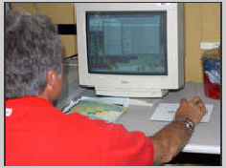 | 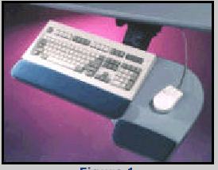

Under the “VDTs and Your Health” section try some to the exercises at you desk to relieve stiffness and aching. Exercises relieve stress from prolonged static positions and give your body a chance to repair itself. Taking a short break to conduct these exercises will also help to prevent fatigue. Below is an example of the neck stretch exercise designed to relieve stiffness and discomfort to the head and shoulders.

Figure 4: Exercise example from the ErgoSmart Web Site
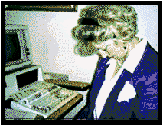 | Neck Stretch  Relax your shoulders.  Lower your chin to your chest and count to 10.  Rotate your head placing your left ear on your left shoulder and count to 10.  Rotate your head placing your right ear on your right shoulder and count to 10.  Relax and repeat.

Where to Find ASU Approved Furniture

Are you in need of a chair or keyboard tray? Set up an appointment to visit the contract furnishings showroom located in the University Services Building at 1551 S. Rural. This is a chance to try seating and view furniture systems. The showroom provides samples of furniture that are designed to promote comfort while providing efficient and productive layouts. Contact ASU Purchasing Furniture Group, Liz Chandler at 965-0578 (http://www.asu.edu/purchasing/stores/furniture/info.html)

