SerialBuffer for orienteering radio transmission

- TBD:
  - MeOs reports error in punch, but the reconstructs it.
  - Use RTS or CTS from TinyMesh? the doc is not quite clear? Works with CTS (pin 6)
  - Interrupt driven operation, at least for the Rx side, if necessary for speed.
  - Improved LED indications: sine heartbeat when idle, long ON and OFF pulses for Tx/Rx
  - Consider routing the TinyMesh module's Tx to SRR Rx through the Pico module, to facilitate later communication to the Pico or modifying the communication to the SRRs.
  - Debug output on UART1 TXD, copying all input and output data.
- Background
  - The serial Buffer is a new HW/SW component in the FIF TinyMesh box that interfaces one or two SRRs to the Radio Module.
  - The Serial Buffer solves a problem with the SRR to Radio Module data path: the SRR does not respond to the serial channel handshake signals, so the Radio Module cannot throttle data, and the arrival of two events close in time can cause loss of data. The radio module forces pauses in the data transmission for compliance with regulations, and data arriving during the pause can be lost.
  - The solution is a RaspberryPi Pico module, connectng to multiple SRR modules, buffering and combining the data streams to one TinyMesh radio module.
  - The SerialBuffer in context:
input queue (chars)
Output queue
(single punch)
Rx UART1 Tx
SRR0
Radio
SRR1
input queue (chars)
Output queue
(single punch)
Rx UART0 Tx
- Dev Project:
  - The IDE is Visual Studio Code on a RspberryPi RP400 minicomputer. The RP400 is also used as a test station, simulating the SRR and the TinyMesh radio via two serial channels.
  - The Pico code is in C for speed, the test program is in Python.
  - https://www.mathaelectronics.com/raspberry-pi-pico-a-complete-guide/
  - Based on the uart_advanced example
  - Started a new workspace, pico-projects, copy of the pico-examples workspace
  - Based on the uart_advanced example, but substituted the interrupt-driven UART R/W with a poll loop.
  - The RP400 is connected directly to the DBG pins, so no additional Pico as debug interface is required.

- SerialBuffer structure
  - Single channel, character based
    - A FIFO buffer queue between Rx and Tx. The one used is not thread and interrupt safe, so need a better one.
    - The queue is character based,not analyzing package structure.
    - CTS/RTS: At the very least you will have to enable the CTS and RTS GPIO. You will then have to connect those GPIO to the external device.
      - CTS is available on GPIO16.
      - RTS is available on GPIO17.
      - For UART 0 (I guess ttyS0) you will have to place those GPIO in mode ALT3. For UART 1 you will have to place those GPIO in mode ALT5.
      - See page 102 of BCM2835 ARM Peripherals
      - https://raspberrypi.github.io/pico-sdk-doxygen/group__hardware__gpio.html#ga2af81373f9f5764ac1a5bd6097477530
    - Only enabling the handshake for the Pico Tx, since we assume that the Rx must aways be ready.
  - Dual input channel, package based
    - Dual FIFO buffers in two layers: a large, byte-based input buffer, followed by a small package based output buffer. The package buffers are multiplexed to the serial output UART, maintaining contiguous punches from both channels.
    - Poll based, in a single execution loop, unless the test shows that the loop is too slow, missing input punches from an SRR.
    - Writes into the input queue are not monitored for content.
    - Continuous reads from the main large buffers into a secondary single-package buffer. When a package buffer holds a complete punch, it is sent to the UART in a contiguous stream. The punch is defined by the header byte 0xD3 and the length in the LEN field. Any chars before the header are transmitted, in particular, the 0x2 byte that precedes the header in the new record format.
    - No control of record length or CRC is done.
    - A state machine keeps track of the punches in each channel, collecting a complete punch in a queue before seizing the output UART and sending a complete punch. Note that the order of the punches is not guaranteed.
    - The state machne controlling each channel:
Serial buffer states
waitForHeader
Detected header
getLength
AssemblePayload
Transmit
Tx queue full
Payload done
Tx queue empty
    - Visual indictor: The LED blinks rapidly 10 times on power on. Then it will turn ON on Rx, OFF on Tx
    - Internal pull-ups are enabled on the Pico RXD inputs, to enable operation with a single SRR.

- Connections:
SRR[0]
Tx
Rx
SRR[1]
Tx
Rx
SerialBuffer Pico

Rx2
Rx0
Tx0
TinyMesh
Rx
Tx
RTS
CTS
Serial buffer inserted between SRR units and the TinyMesh radio module

RP400  function | RP400  pin | SRR  function | SRR  pin | Pico  function | Pico  pin | TinyMesh  function | TinyMesh pin
DBG SWDIO | 18 | - | - | SWDIO | debug - SWDIO | - | -
DBG GND | 20 | - | - | GND | debug - GND | - | -
DBG CLK | 22 | - | - | CLK | debug - SWCLK | - | -
UART0 Rx | 10 | - | - | UART0 Tx (GP0) | 1 | RXD | 2
UART0 Tx | 8 | (SRR0) Tx | 2 | UART0 Rx (GP1) | 2 | -
UART0 RTS | 11 | - |  | UART0 CTS, (GP2) | 4 | RTS (CTS?) | 5 (6?)
UART2 Tx | 27 | (SRR1) Tx | 2 | UART1 Rx (GP4) | 7 | -
 | - |  |  | UART 1 Tx (GP5) | 6 | -
UART2 Rx | 28 |  |  | - | (unused) | -
UART2 RTS | -
GND |  | GND | 1 | GND (signal) | 3,8,13,18,23,28,33 | GND | 1
- | - |  |  | GND (Power) | 38 | GND
- | - | VCC | 7 | Power: VSYS, 2 - 5.5 V | 39 | VCC | 7
- | - | - | - | - | - | CONFIG | 4
 |  |  |  |  |  | CTS | 6

- Test:
  - The RP400 used as test machine
  - A Python script "SerialTest" sends data packages, blocking the Rx channel to force filling the buffer. Then It reads the whole buffer, comparing the Rx data to an internal test buffer.
  - various buffer levels are tested, ending with an overfilled buffer to force the test to fail, validating the test method.
  - By default, the primary UART (UART0) is assigned to the Linux console. If you wish to use the primary UART for other purposes, you must reconfigure Raspberry Pi OS. This can be done by using raspi-config
  - For 2-channel test, the RP400 UART2 is used, since it is identical to UART1, whereas UART1 is a reduced functionality type. UART2 is used to transmit half of the punches (randomised).
    - In order to use UART2, add the following line to /boot/config.txt: dtoverlay=uart2. Then it can be accessed as /dev/ttyAMA1

RP400 pinout:

GPI # | Pin # | ALT0 | ALT1 | ALT2 | ALT3 | ALT4 | ALT5
0 |  | SDA0 | SA5 | PCLK | SPI3_CE0_N | TXD2 | SDA6
1 |  | SCL0 | SA4 | DE | SPI3_MISO | RXD2 | SCL6
2 |  | SDA1 | SA3 | LCD_VSYNC | SPI3_MOSI | CTS2 | SDA3
3 |  | SCL1 | SA2 | LCD_HSYNC | SPI3_SCLK | RTS2 | SCL3
4 |  | GPCLK0 | SA1 | DPI_D0 | SPI4_CE0_N | TXD3 | SDA3
5 |  | GPCLK1 | SAO | DPI_D1 | SPI4_MISO | RXD3 | SCL3
6 |  | GPCLK2 | SOE_N | DPI_D2 | SPI4_MOSI | CTS3 | SDA4
7 |  | SPI0_CE1_N | SWE_N | DPI_D3 | SPI4_SCLK | RTS3 | SCL4
8 |  | SPI0_CE0_N | SDO | DPI_D4 | _ | TXD4 | SDA4
9 |  | SPI0_MISO | SD1 | DPI_D5 | _ | RXD4 | SCL4
10 |  | SPI0_MOSI | SD2 | DPI_D6 | _ | CTS4 | SDA5
11 |  | SPI0_SCLK | SD3 | DPI_D7 | _ | RTS4 | SCL5
12 |  | PWM0 | SD4 | DPI_D8 | SPI5_CE0_N | TXD5 | SDA5
13 |  | PWM1 | SD5 | DPI_D9 | SPI5_MISO | RXD5 | SCL5
14 |  | TXD0 | SD6 | DPI_D10 | SPI5_MOSI | CTS5 | TXD1
15 |  | RXD0 | SD7 | DPI_D11 | SPI5_SCLK | RTS5 | RXD1
16 |  | FL0 | SD8 | DPI_D12 | CTS0 | SPI1_CE2_N | CTS1
17 |  | FL1 | SD9 | DPI_D13 | RTS0 | SPI1_CE1_N | RTS1
18 |  | PCM_CLK | SD10 | DPI_D14 | SPI6_CE0_N | SPI1_CE0_N | PWM0
19 |  | PCM_FS | SD11 | DPI_D15 | SPI6_MISO | SPI1_MISO | PWM1
20 |  | PCM_DIN | SD12 | DPI_D16 | SPI6_MOSI | SPIl_MOSI | GPCLK0
21 |  | PCM_DOUT | SD13 | DPI_D17 | SPI6_SCLK | SPI1_SCLK | GPCLK1
22 |  | SD0_CLK | SD14 | DPI_D18 | SD1_CLK | ARM_TRST | SDA6
23 |  | SD0_XMD | SD15 | DPI_D19 | SD1_CMD | ARM_RTCK | SCL6
24 |  | SD0_DATO | SD16 | DPI_D20 | SD1_DAT0 | ARM_TDO | SPI3_CE1_N
25 |  | SD0_DAT1 | SD17 | DPI_D21 | SD1_DAT1 | ARM_TCK | SPI4_CE1_N
26 |  | SD0_DAT2 | TE0 | DPI_D22 | SD1_DAT2 | ARM_TDI | SPI5_CE1_N
27 |  | SD0_DAT3 | TE1 | DPI_D23 | SD1_DAT3 | ARM_TMS | SPI6_CE1_N

Pico pinout

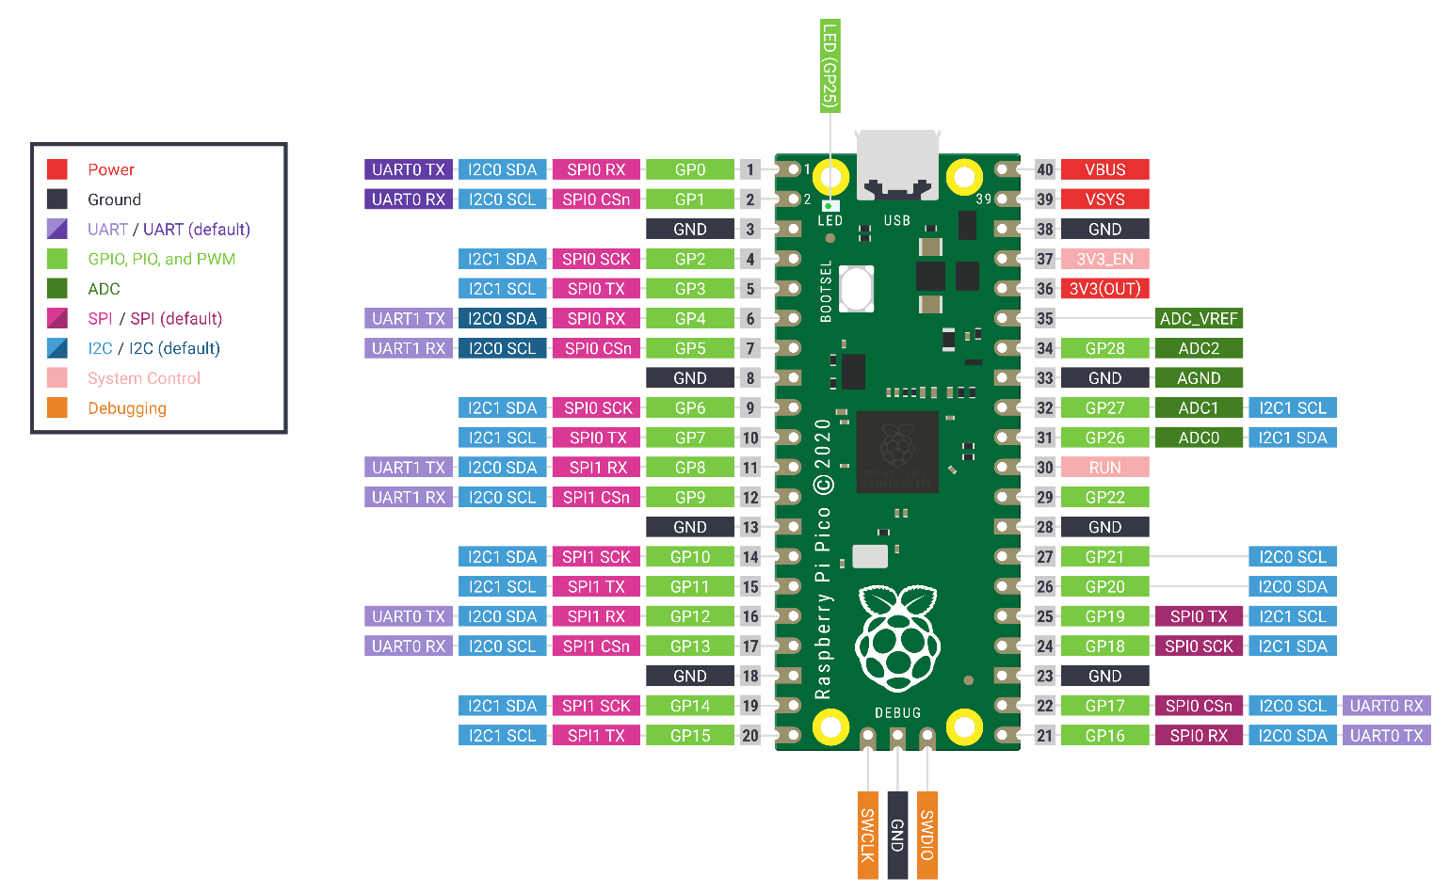

Pico I/O
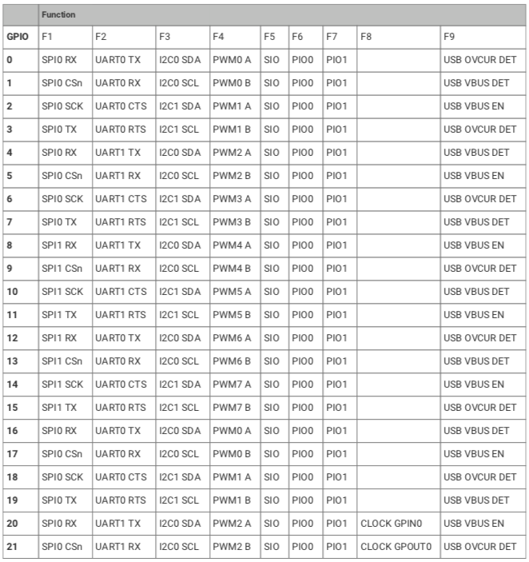
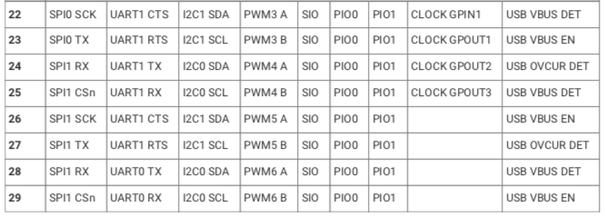

SRR Protocol
Message structure:

SIAC: 0xD3 - LEN - CNH - CNL - SIID3 - SIID2 - SIID1 - SIID0 - CNH/AM/PM -TH - TL - TSS - MODE - CNTR - CNTT - CRC1 - CRC0

Oskar: "\x02\xD3\x0D\x00\x2A\x00\x1F\x87\x68\x0A\x81\x03\xD0\x00\x01\x10\xF3\x65\x03"

Nr | Oskar | Siac
0 | 0x02 |  | Only in new formats
1 | 0xD3 | D3 | Header byte, constant
2 | LEN | LEN | Always 0x0D = 13
3 | 0x00 | CNH | Station ID
4 | 0x27 | CNL
5 | 0x00 | SIID3 | Chip ID
6 | 0x00 | SIID2
7 | SI1 | SIID1
8 | SI0 | SIID0
9 | 0x05 | CNH/AM/PM | Time
10 | 0x5E | TH
11 | 0xB2 | TL
12 | 0x59 | TSS
13 | 0x00 | MODE
14 | 0x0E | CNTR
15 | 0x68 | CNTT
16 | CRC1 | CRC1 | CRC
17 | CRC0 | CRC0 | CRC
 | 0x03 |  | Only in new format?

