# Interview

<https://www.youtube.com/watch?v=5Iuqcc0vI6Y>

<https://www.youtube.com/watch?v=G4InPfhVkRs&t=118s>

Questions to interview:

1. What is your name?

2. What is your profession?

3. Do you know anything about smart home?

4. are you at smart home?

5. How much do you think is the price of a smart home?

6. What functions do you see in smart home?

7. Do you find it difficult or problematic to use its features?

8. What functions are you satisfied with?

9. Do you have to make any changes to your smart home when you install or modify? Is it difficult?

10. Smart home do you know how to maintain it? and maintenance like?

# Observed image

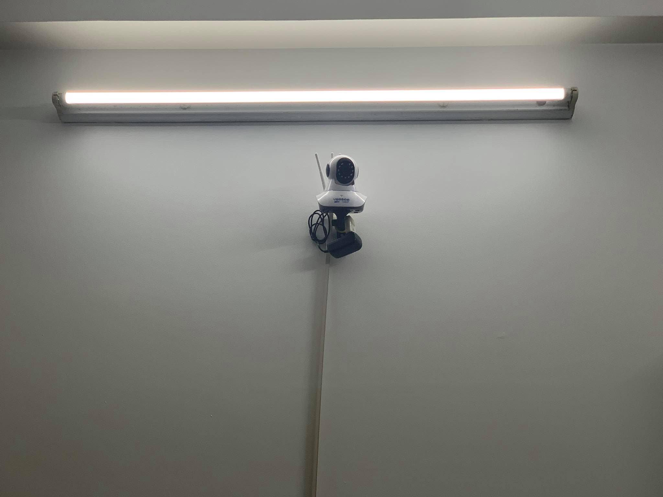

Figure . remote control surveillance camera

This is a smart camera that users can observe from a distance without having to be at home, users can see their house from anywhere through their smart phone. They can control the camera remotely from just the phone, not only that, users can also review the photos or activities of the house from the previous day due to being stored in the camera.

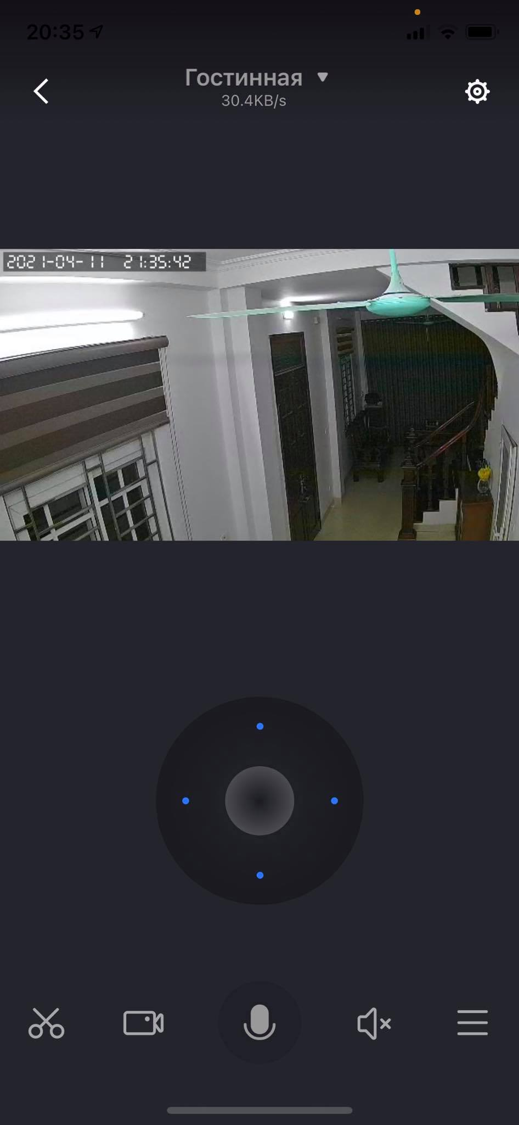

Figure . Camera control interface by phone

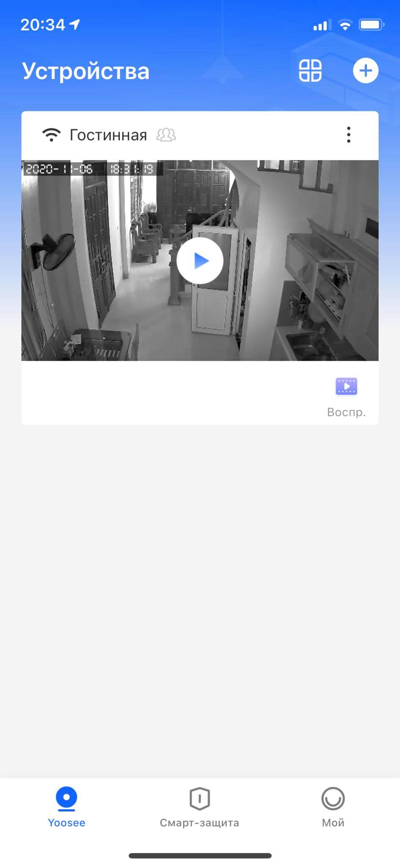

Figure . Video saved from camera

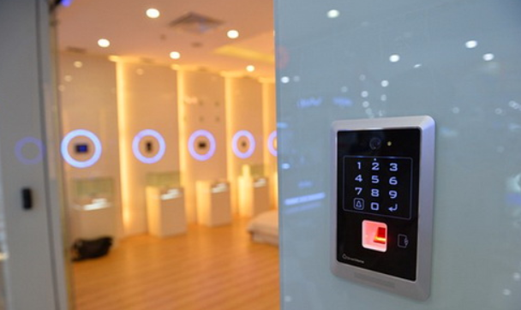

Figure . External ACS-Out access control unit

ACS-Out has the function of controlling user access and doorbell function with sound and video. The manufacturer has arranged touch buttons along the vertical axis: the top is camera with flash, microphone; followed by the code button system. These buttons take up quite a large area but will be very convenient for the elderly or those with large fingers to press. The fingerprint scanner box and the RFID magnetic card reader are located below. According to the manufacturer, the ACS-Out panel can work well in extreme weather conditions outdoors with temperatures up to 60 degrees Celsius, as well as water resistance that made me quite surprised.