UCMS – System Diagrams
University Club Management System · Group 1 · SE1939-NJ · generated 2026-10-19 from docs/03-diagrams
Contents
- 1. Context diagram (1 figure)
- 2. Use case diagram (9 figures)
- 3. Screen flow (1 figure)
- 4. Entity relationship diagram (2 figures)
- 5. Package diagram (2 figures)
- 6. Class diagram (not available)

1. Context diagram
System boundary and data flows between UCMS, its 4 actors and 3 external systems.
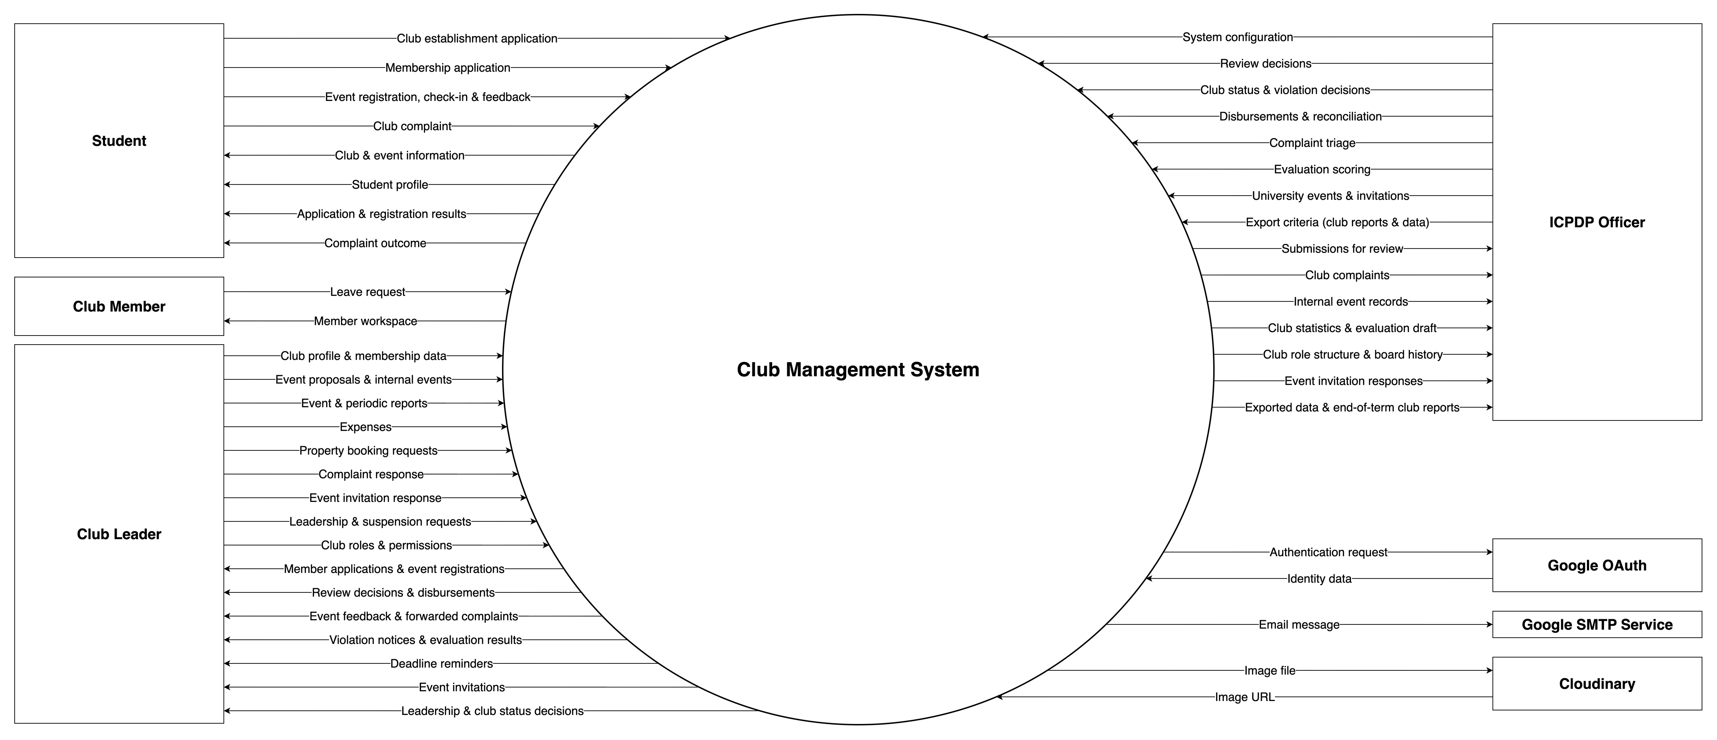
Figure 1: Context diagram

2. Use case diagram
Use cases UC01–UC55 and UC58, one page per actor group.
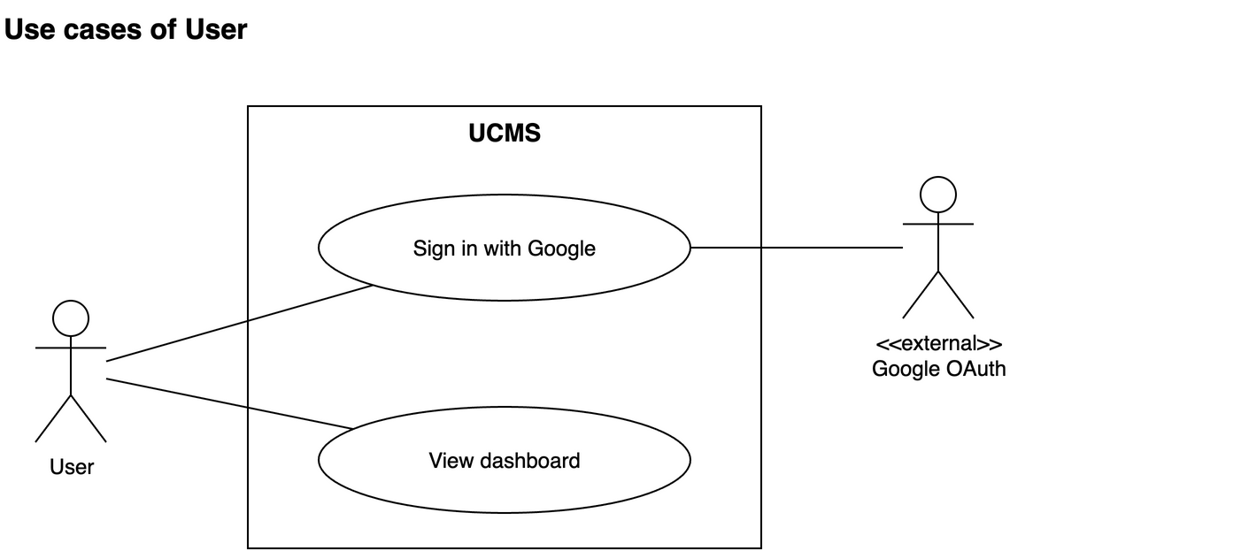
Figure 2: Use case diagram – User

Use case diagram – Student
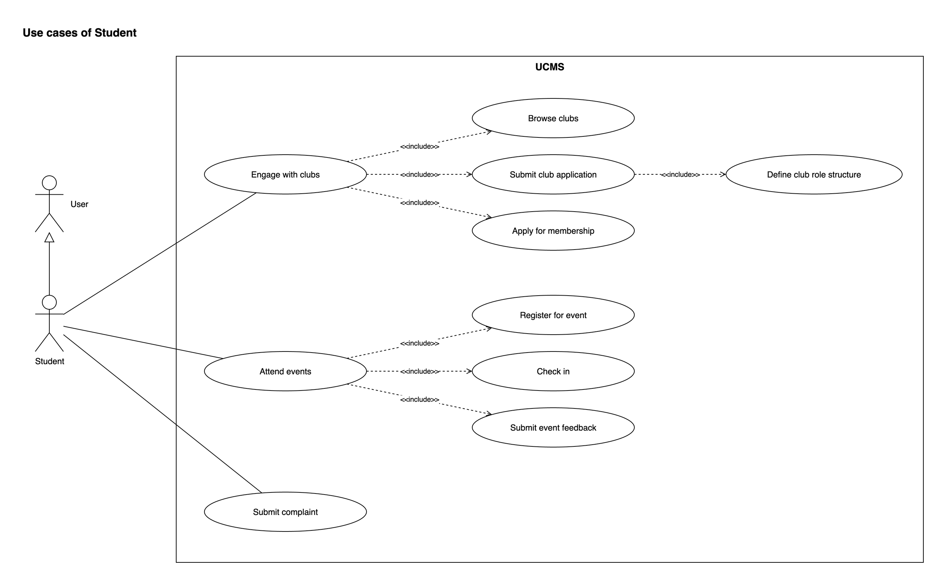
Figure 3: Use case diagram – Student

Use case diagram – Club Member: events & bookings
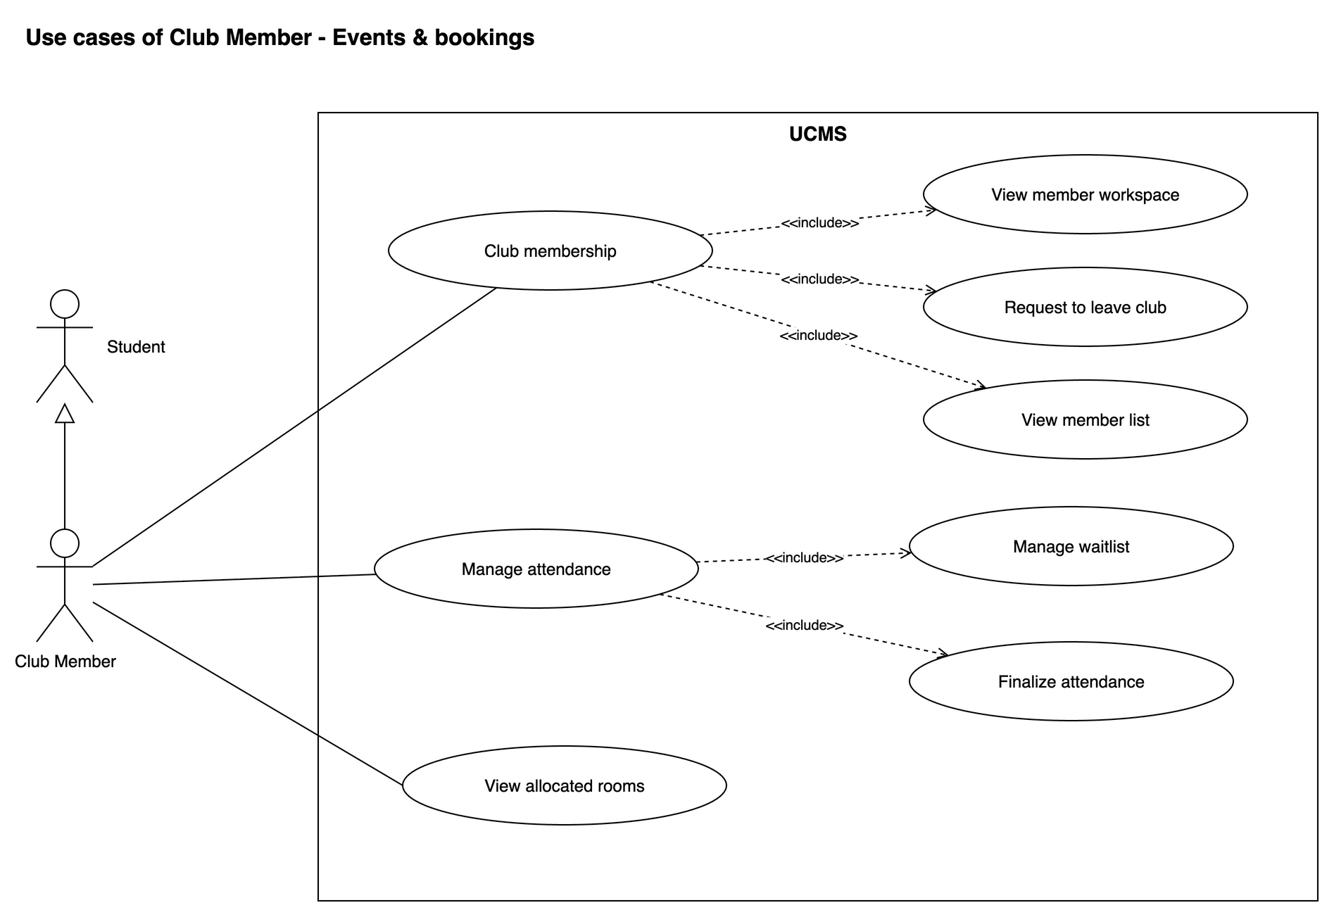
Figure 4: Use case diagram – Club Member: events & bookings

Use case diagram – Club Leader
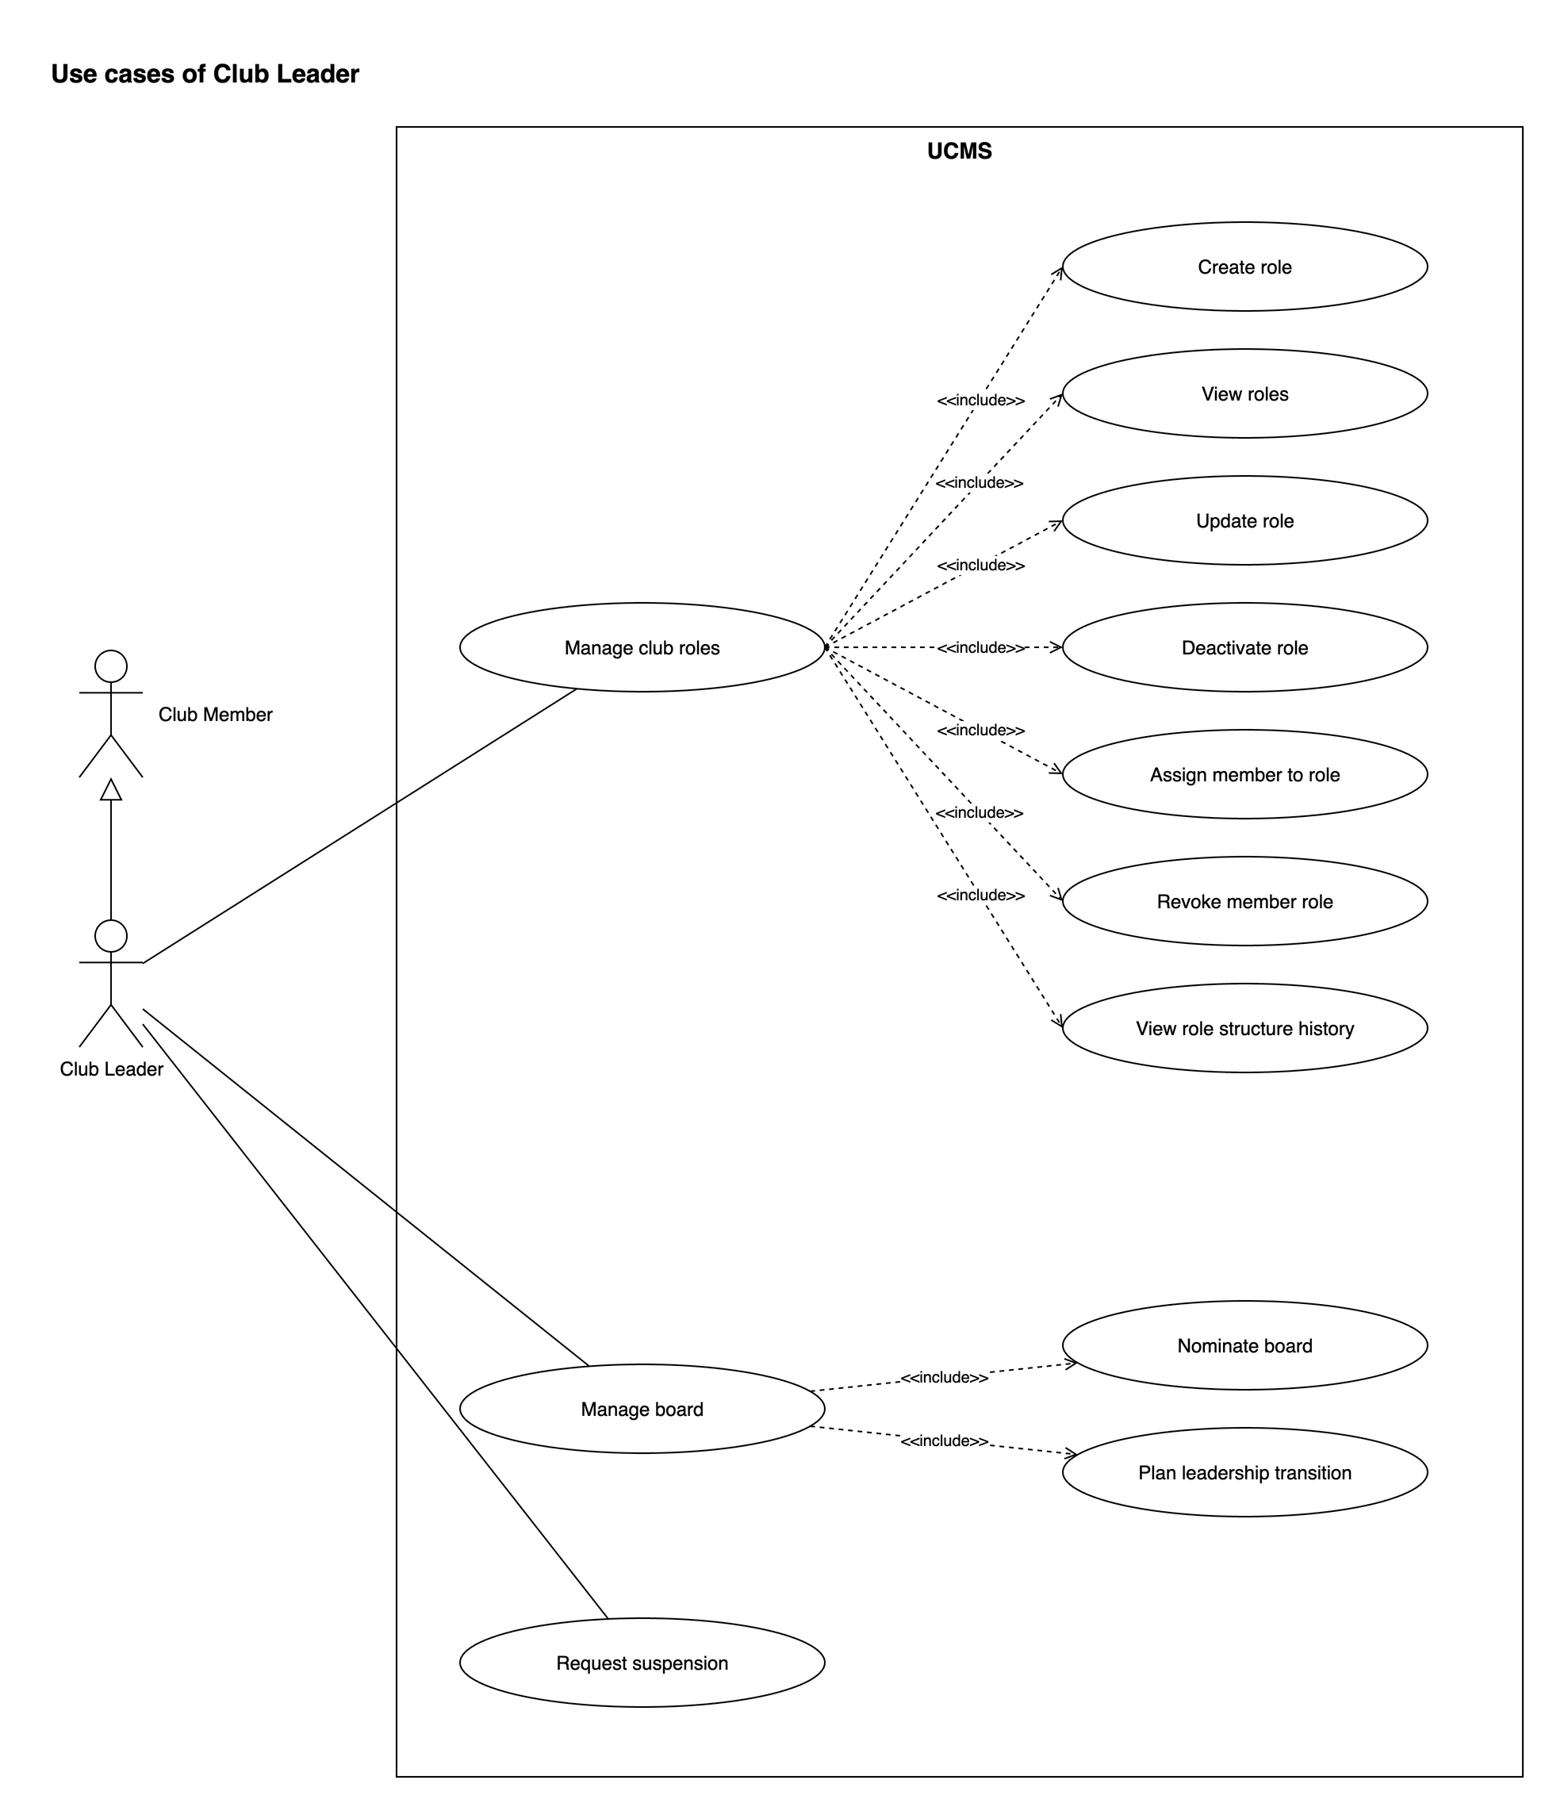
Figure 5: Use case diagram – Club Leader

Use case diagram – Club Leader: club & recruitment
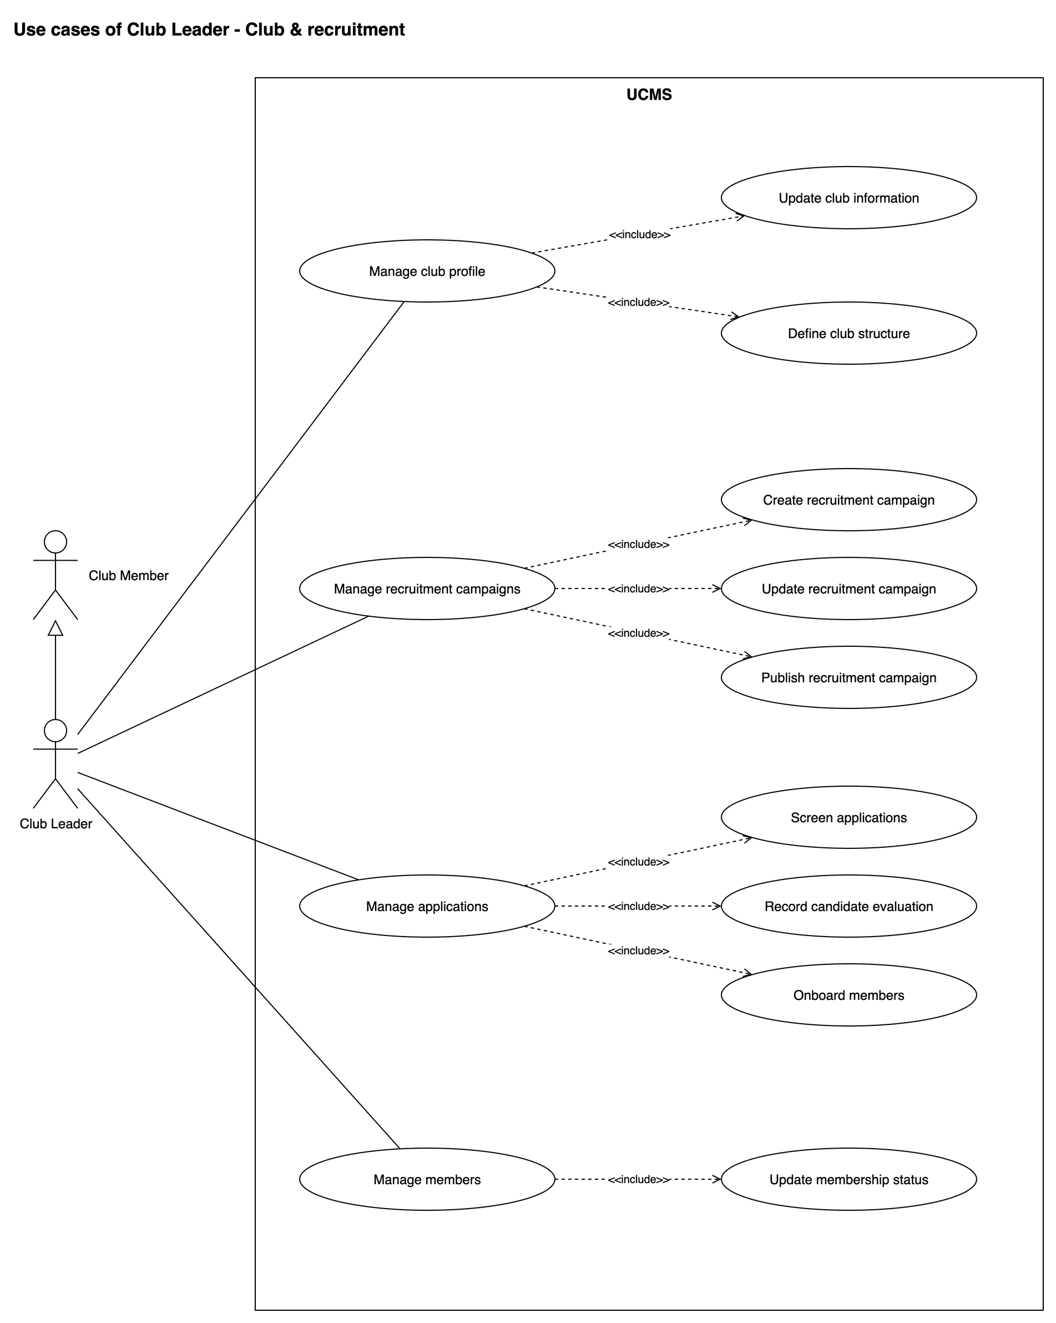
Figure 6: Use case diagram – Club Leader: club & recruitment

Use case diagram – Club Leader: events, bookings & finance
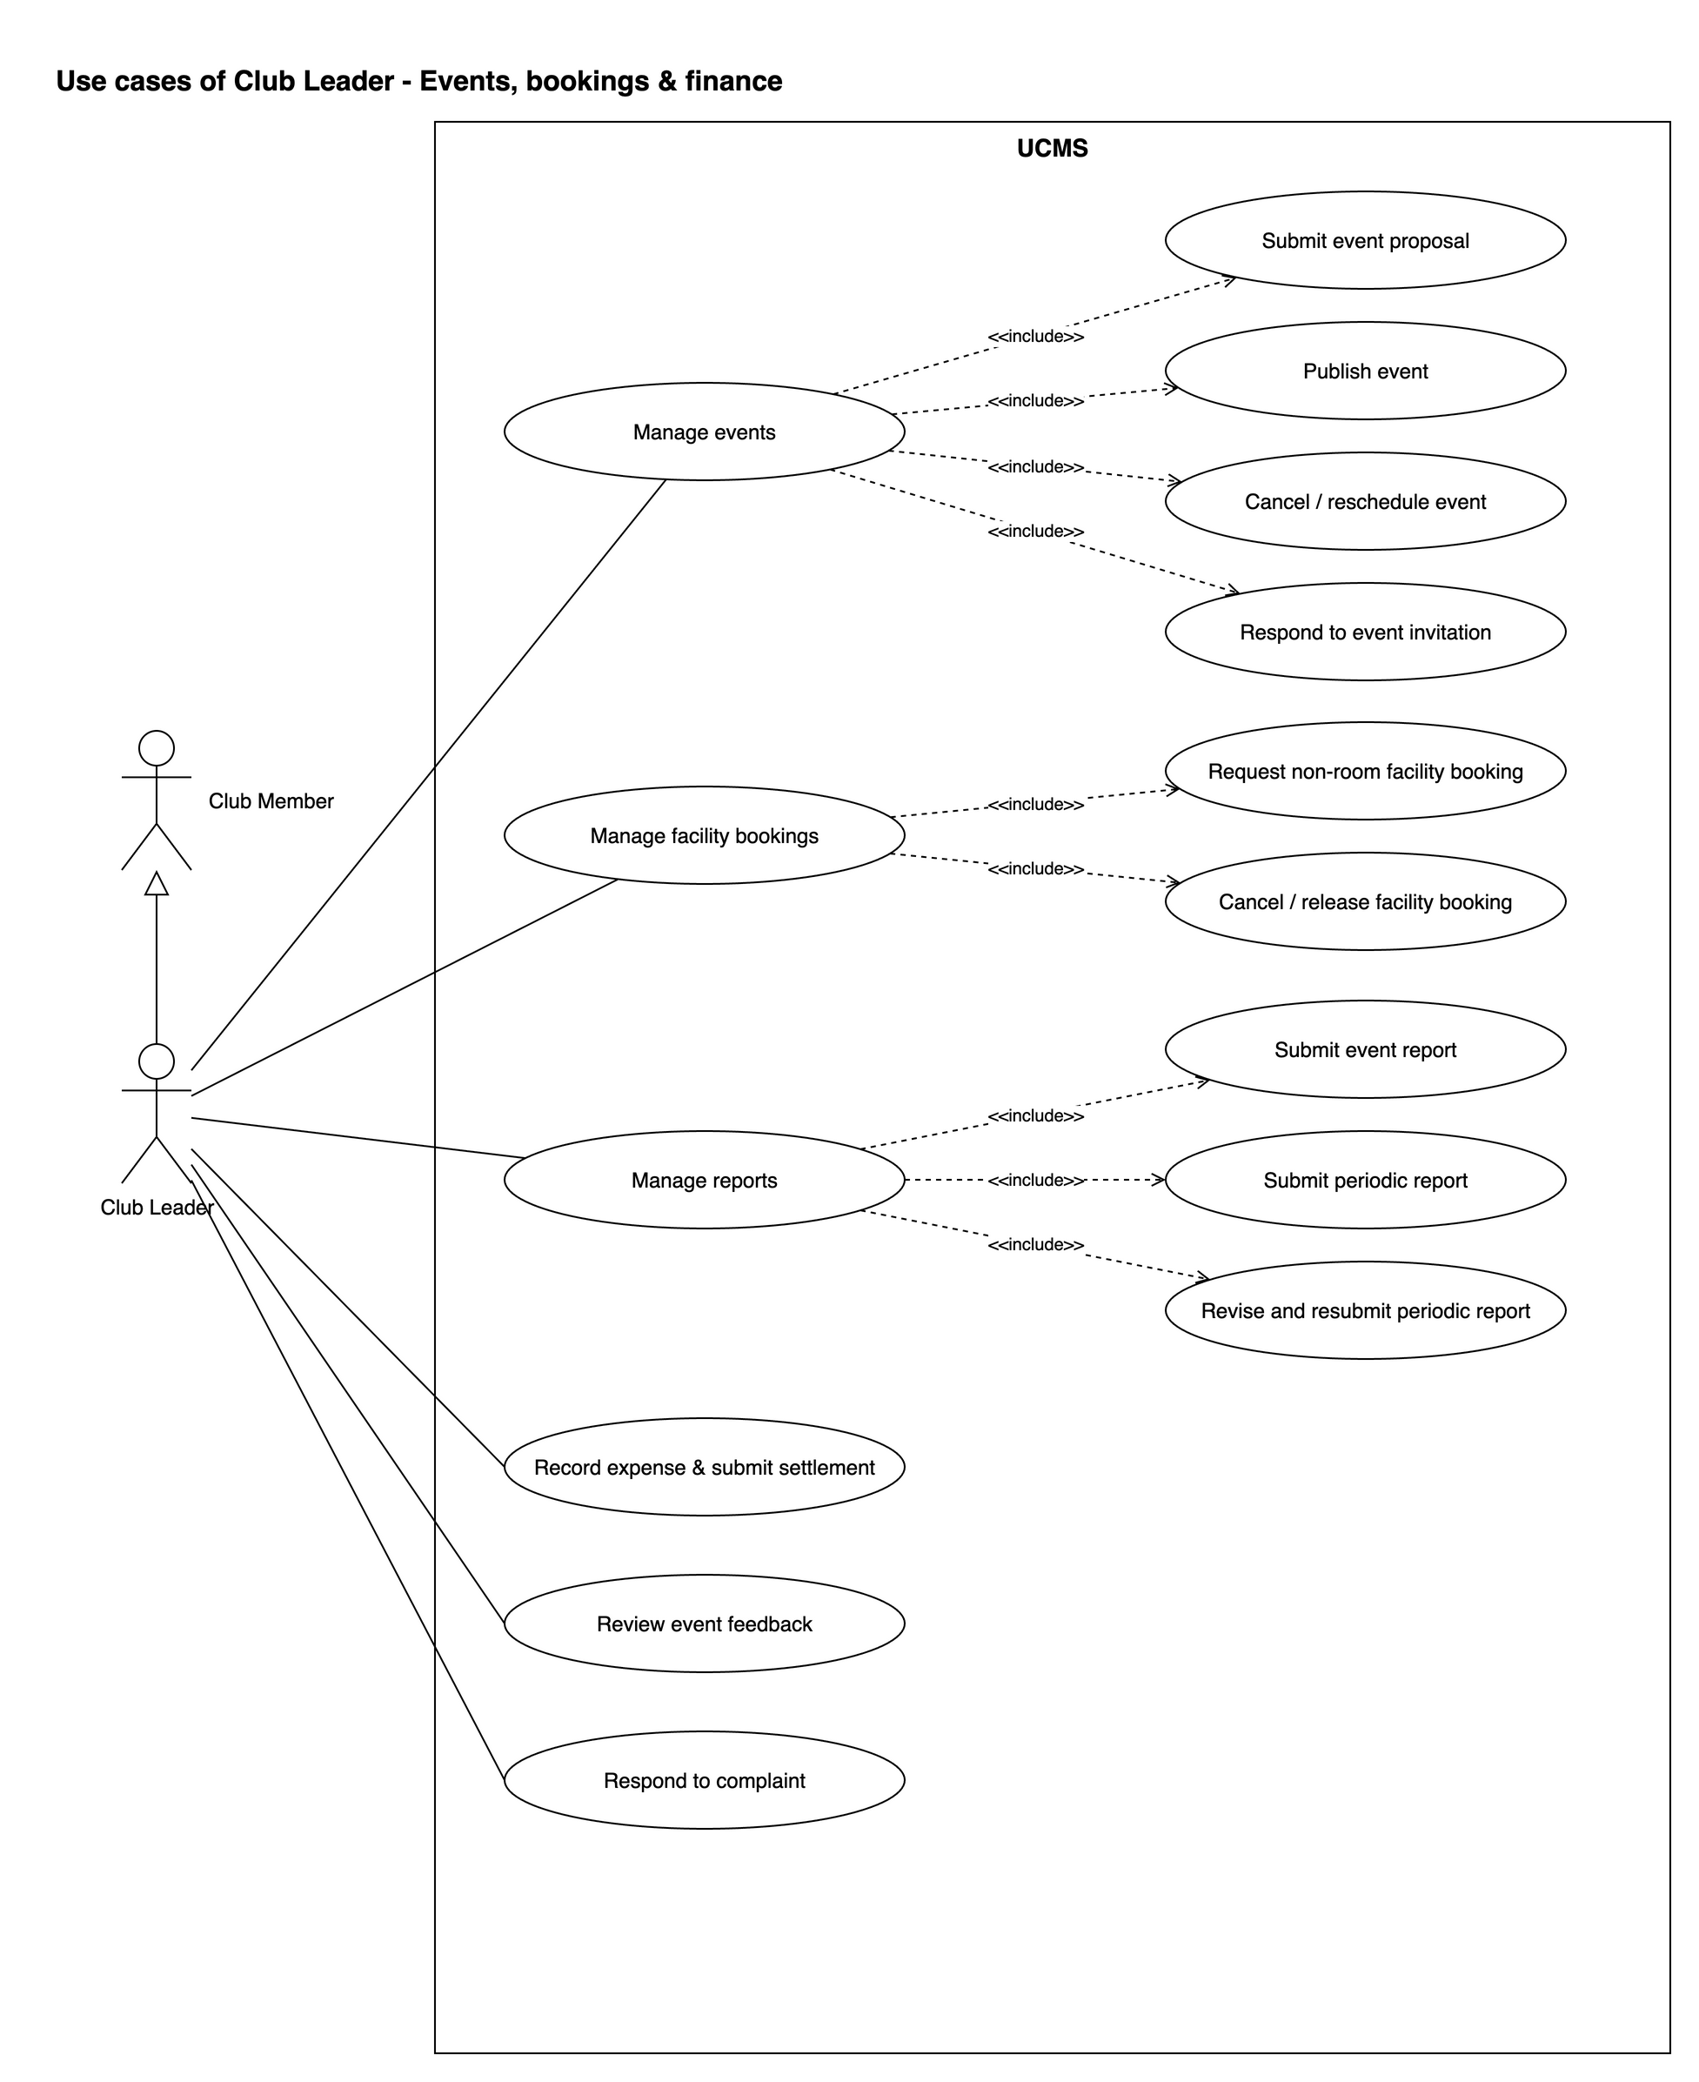
Figure 7: Use case diagram – Club Leader: events, bookings & finance

Use case diagram – ICPDP (1): access & club lifecycle
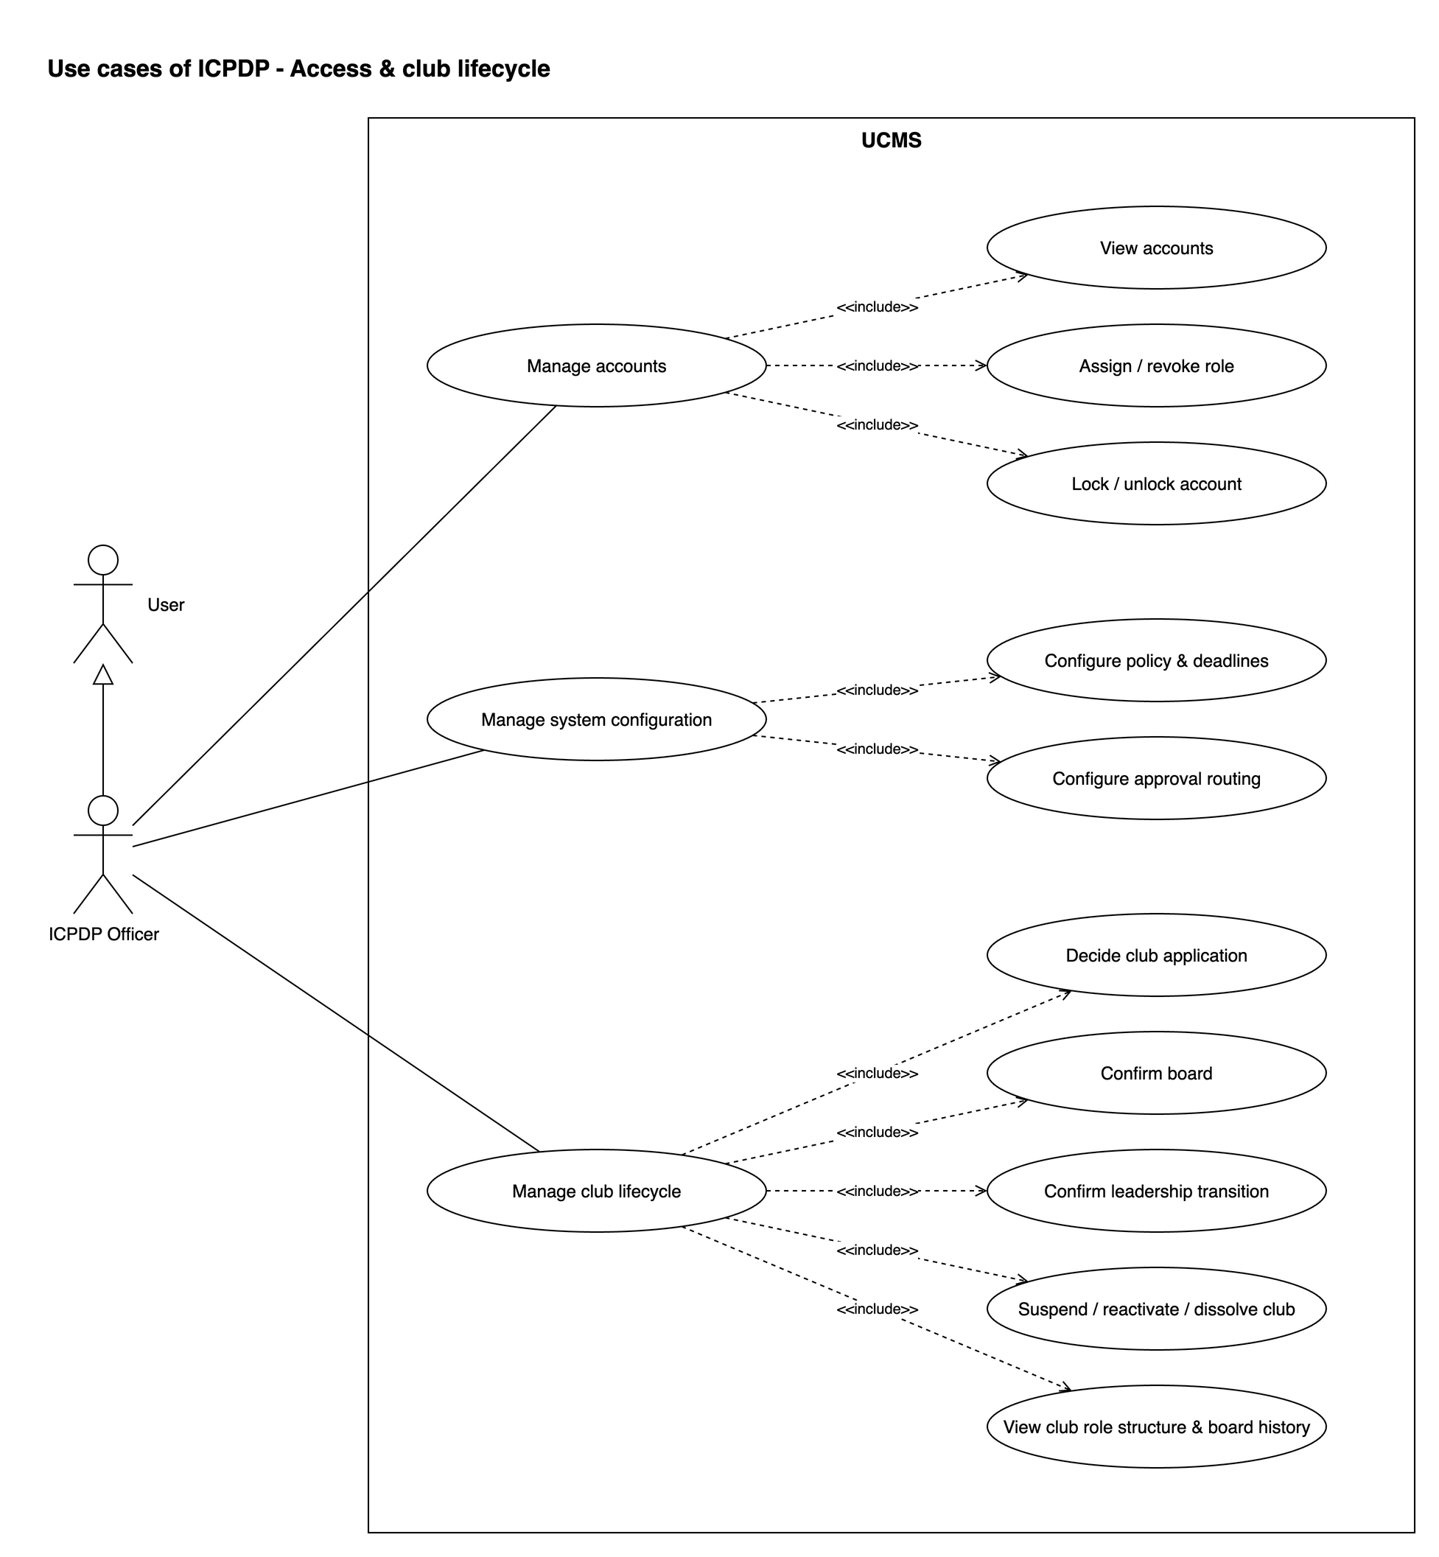
Figure 8: Use case diagram – ICPDP (1): access & club lifecycle

Use case diagram – ICPDP (2): events, bookings & finance
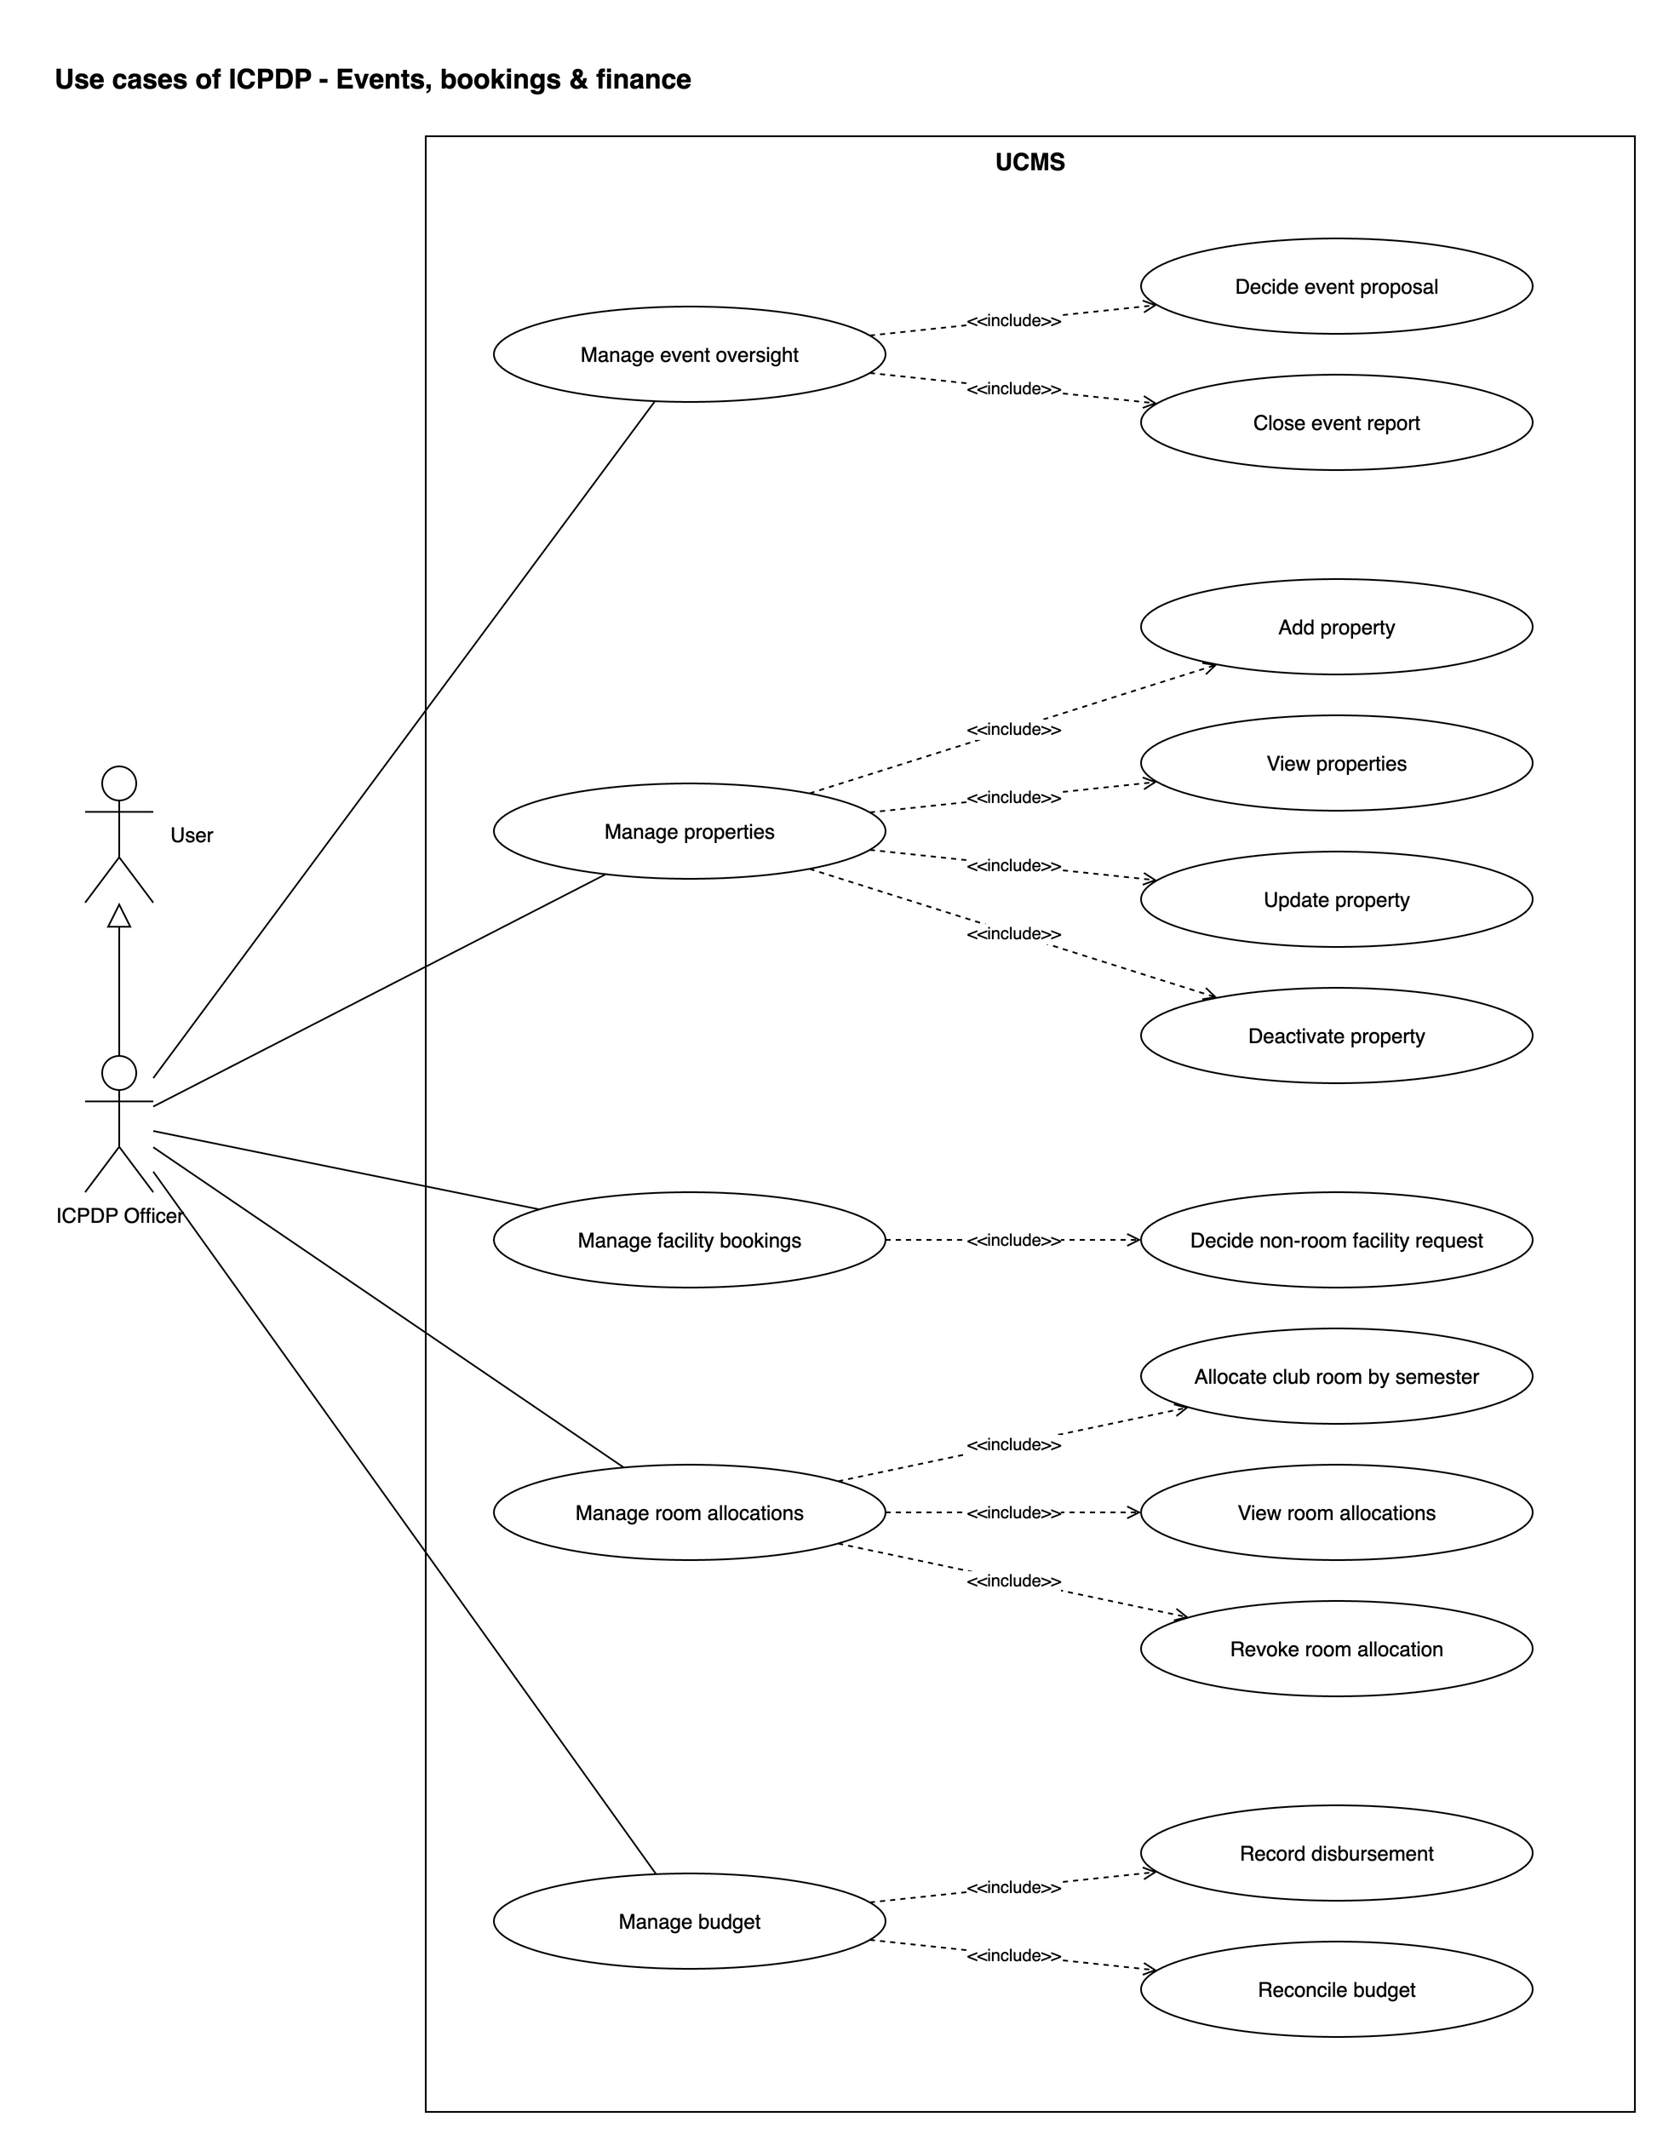
Figure 9: Use case diagram – ICPDP (2): events, bookings & finance

Use case diagram – ICPDP (3): compliance & evaluation
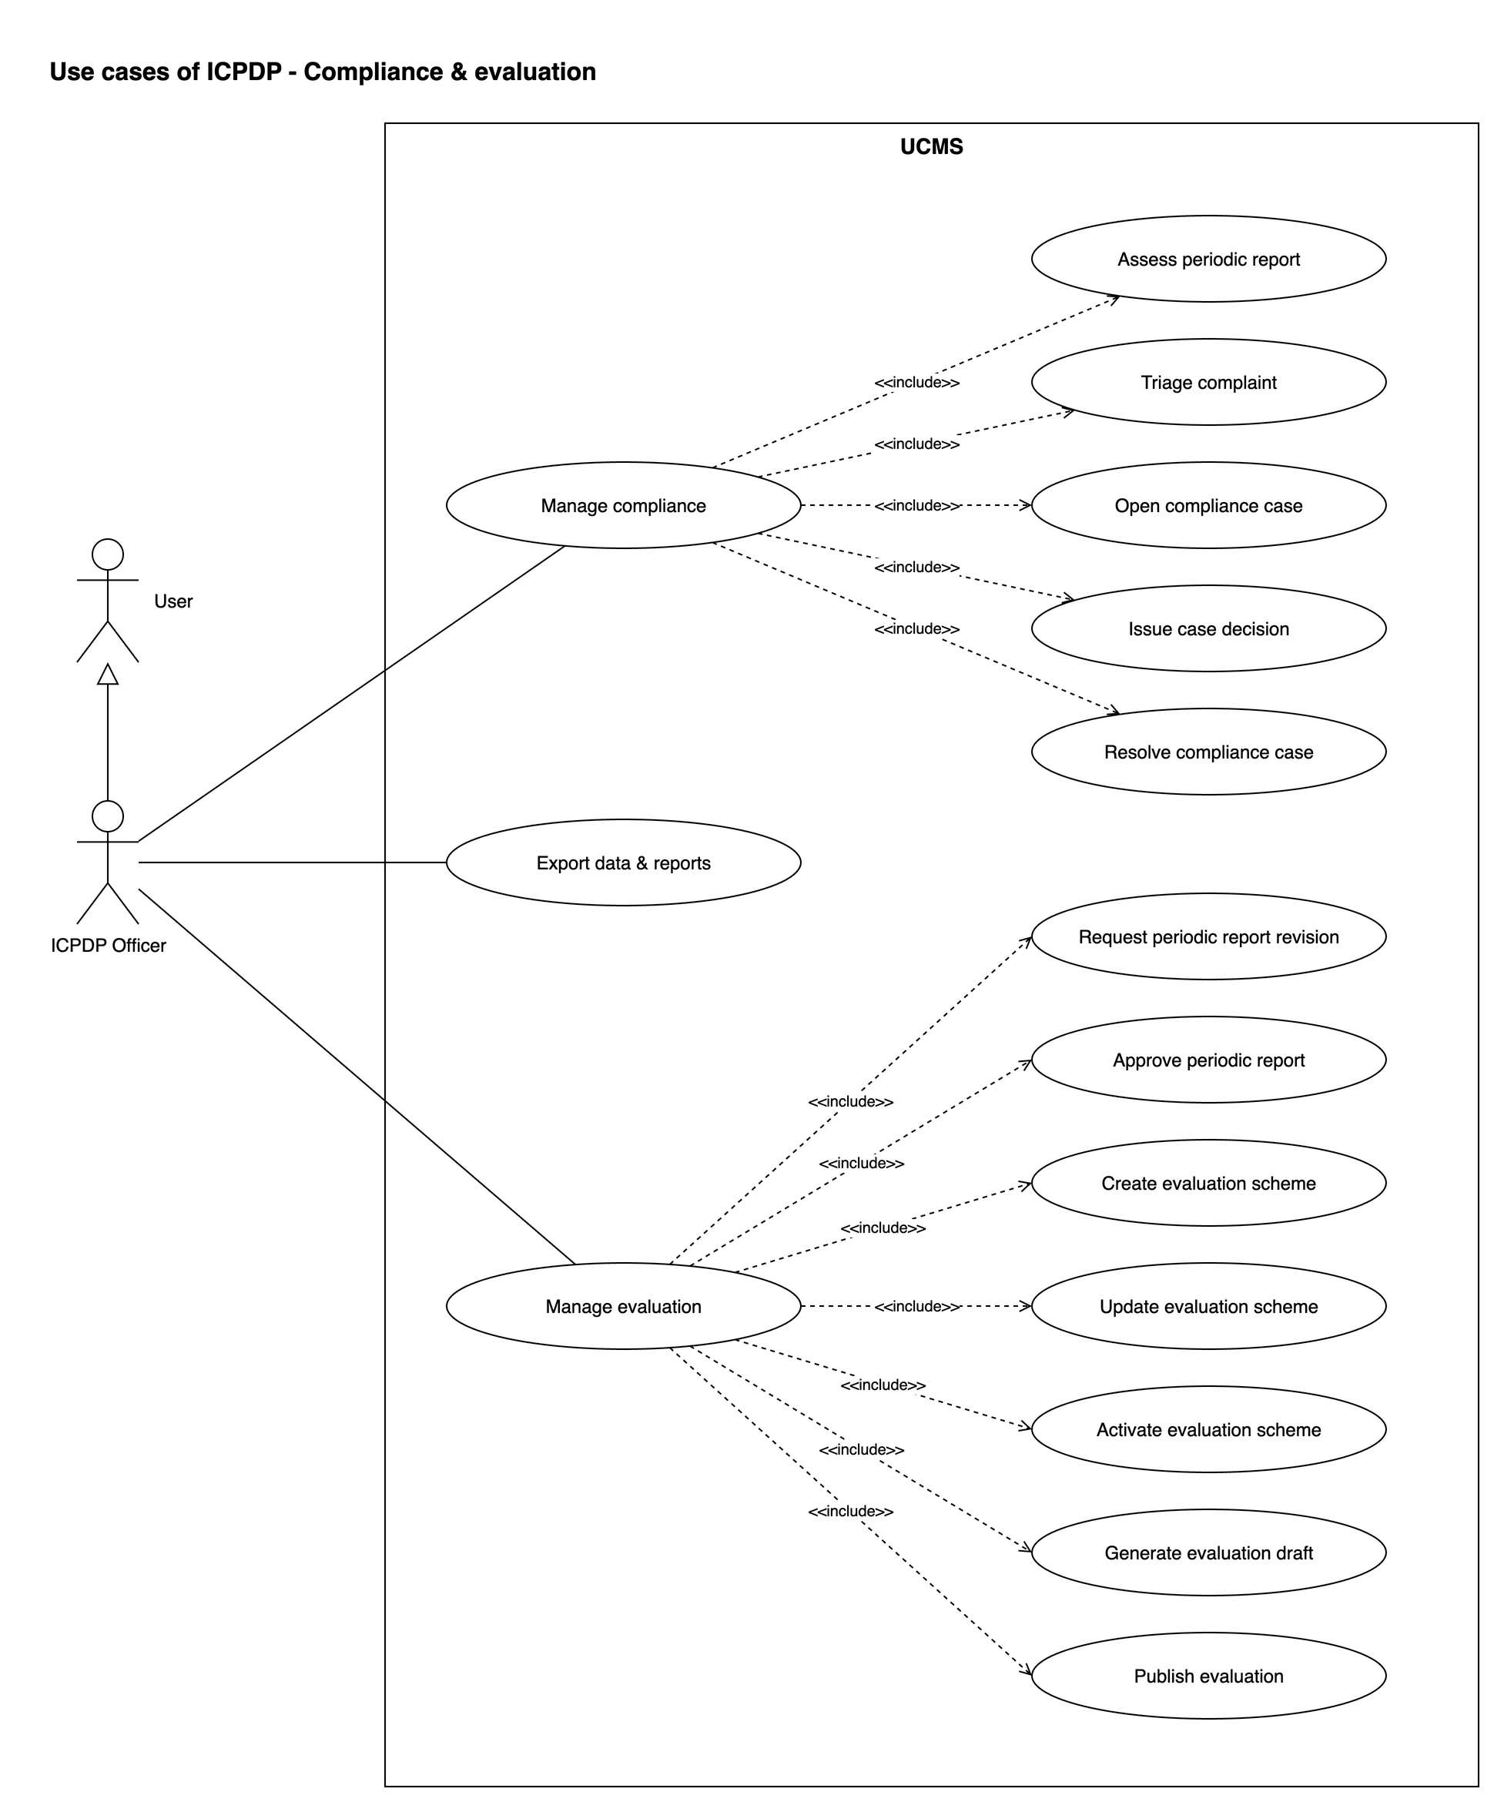
Figure 10: Use case diagram – ICPDP (3): compliance & evaluation

3. Screen flow
All 73 screens grouped by layout (Entry, Public area, Student, Club and ICPDP workspaces); box colour = actor.
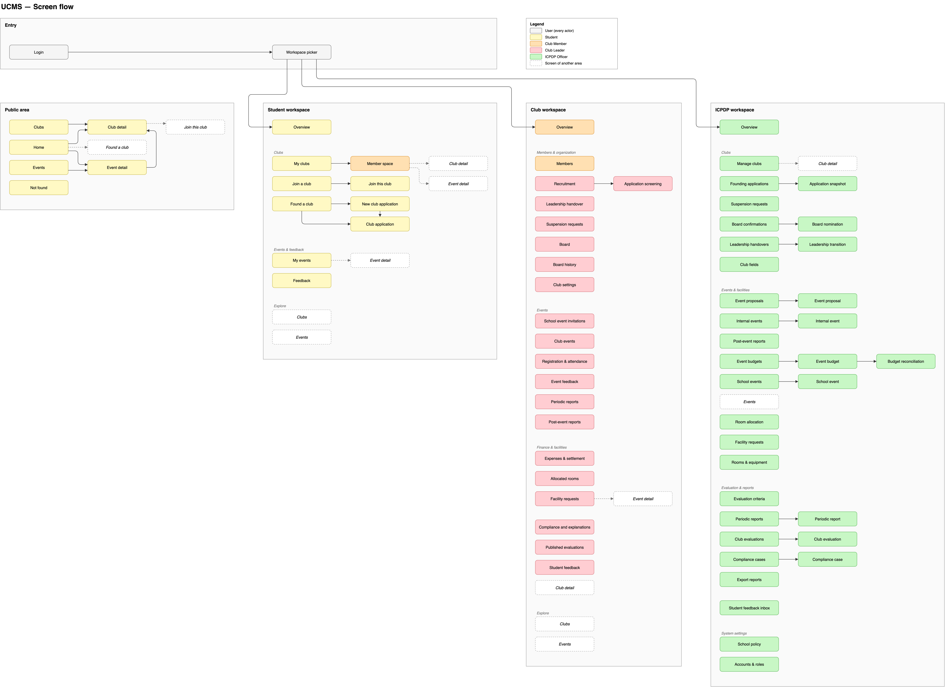
Figure 11: Screen flow

4. Entity relationship diagram
Conceptual model, 33 entities; the same content in two notations.
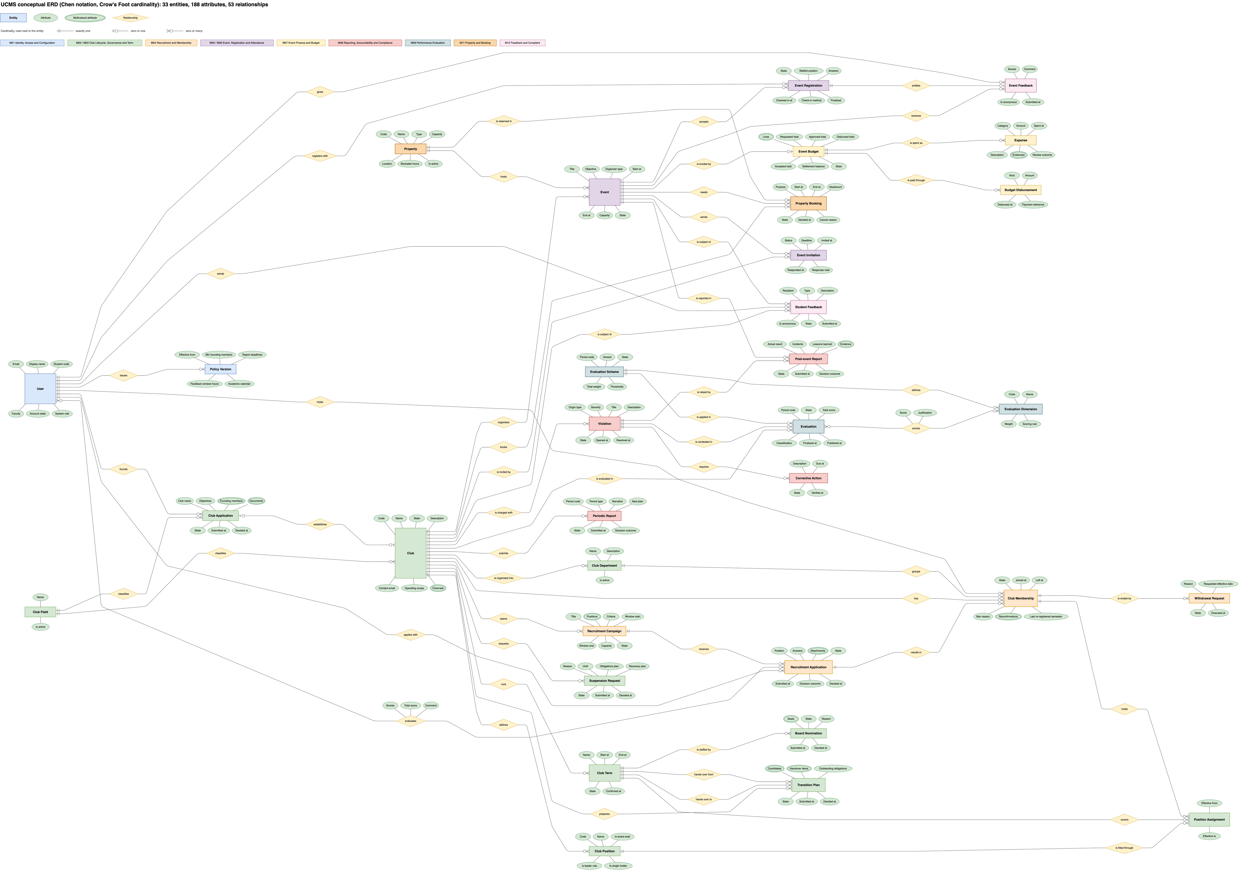
Figure 12: ERD – Chen notation (Crow's Foot cardinalities)

ERD – Crow's Foot notation
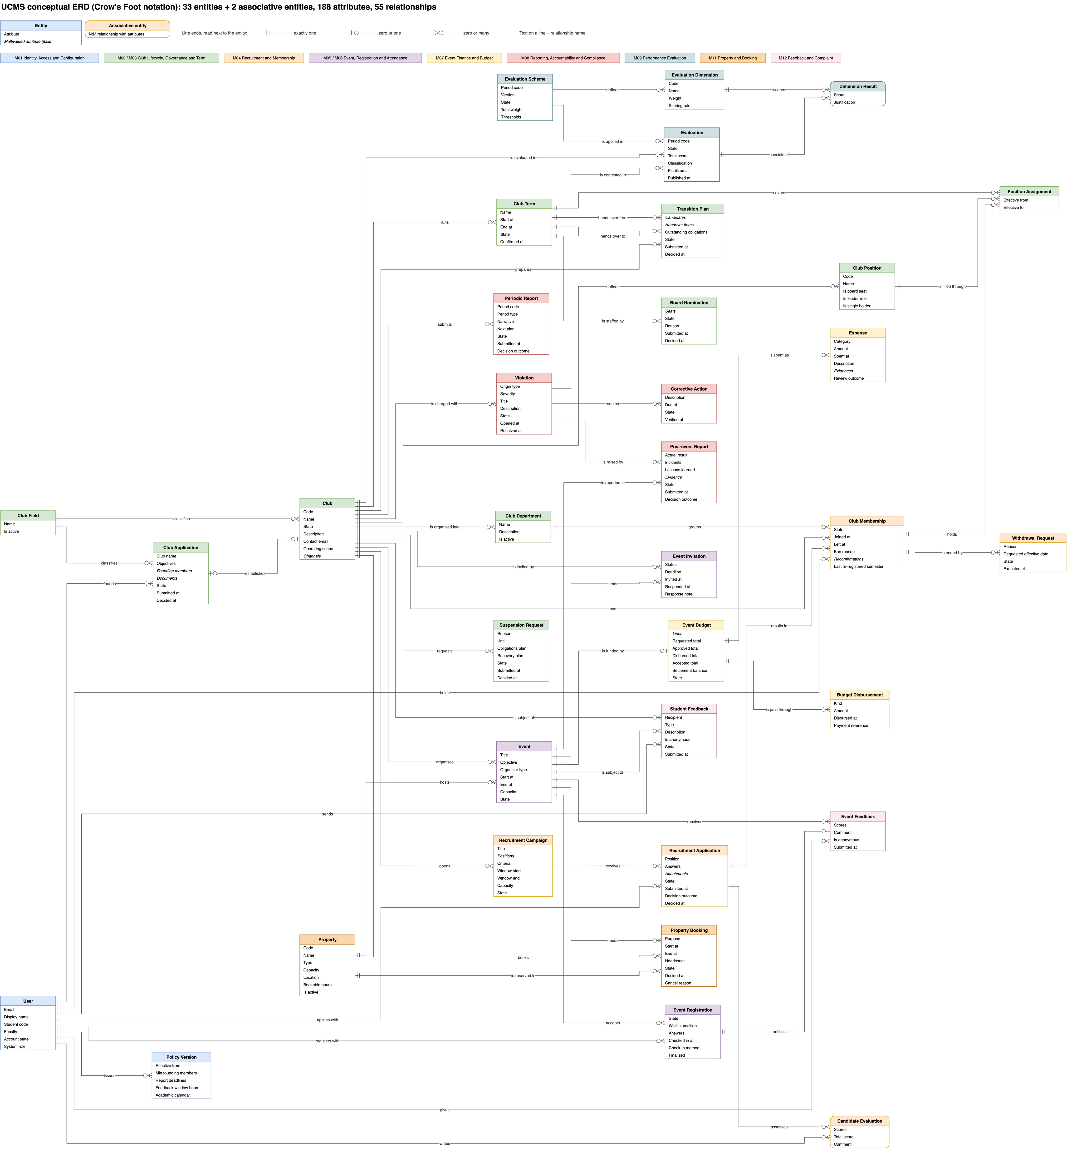
Figure 13: ERD – Crow's Foot notation

5. Package diagram
Front-end (client/src) and back-end (server/src) packages as they exist in the code.
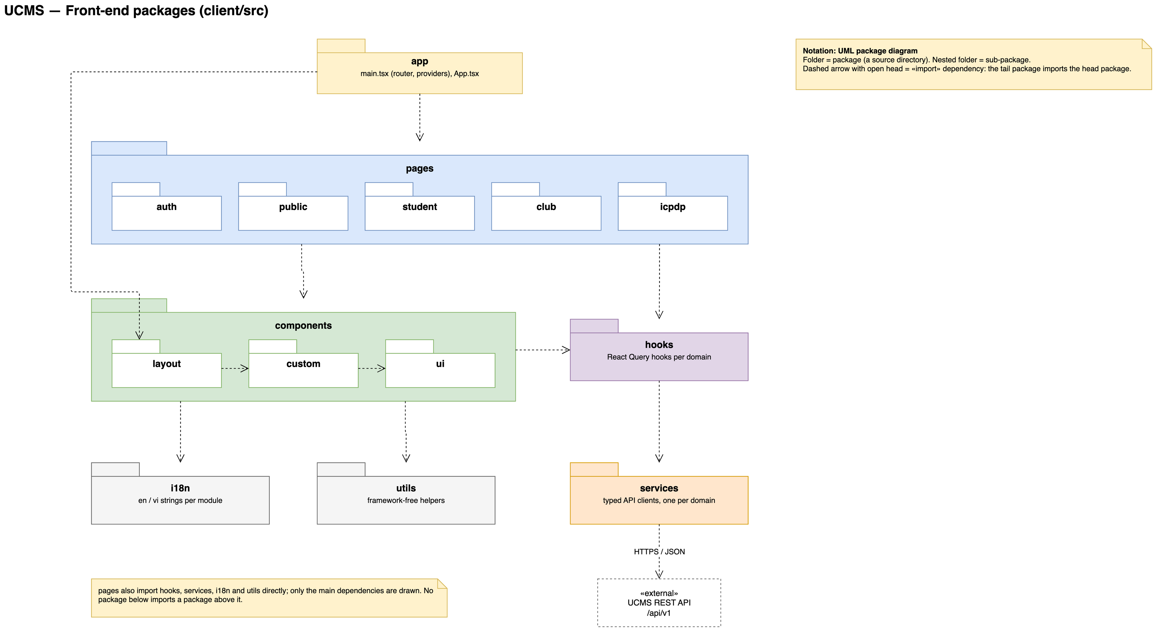
Figure 14: Package diagram – Front-end

Package diagram – Back-end
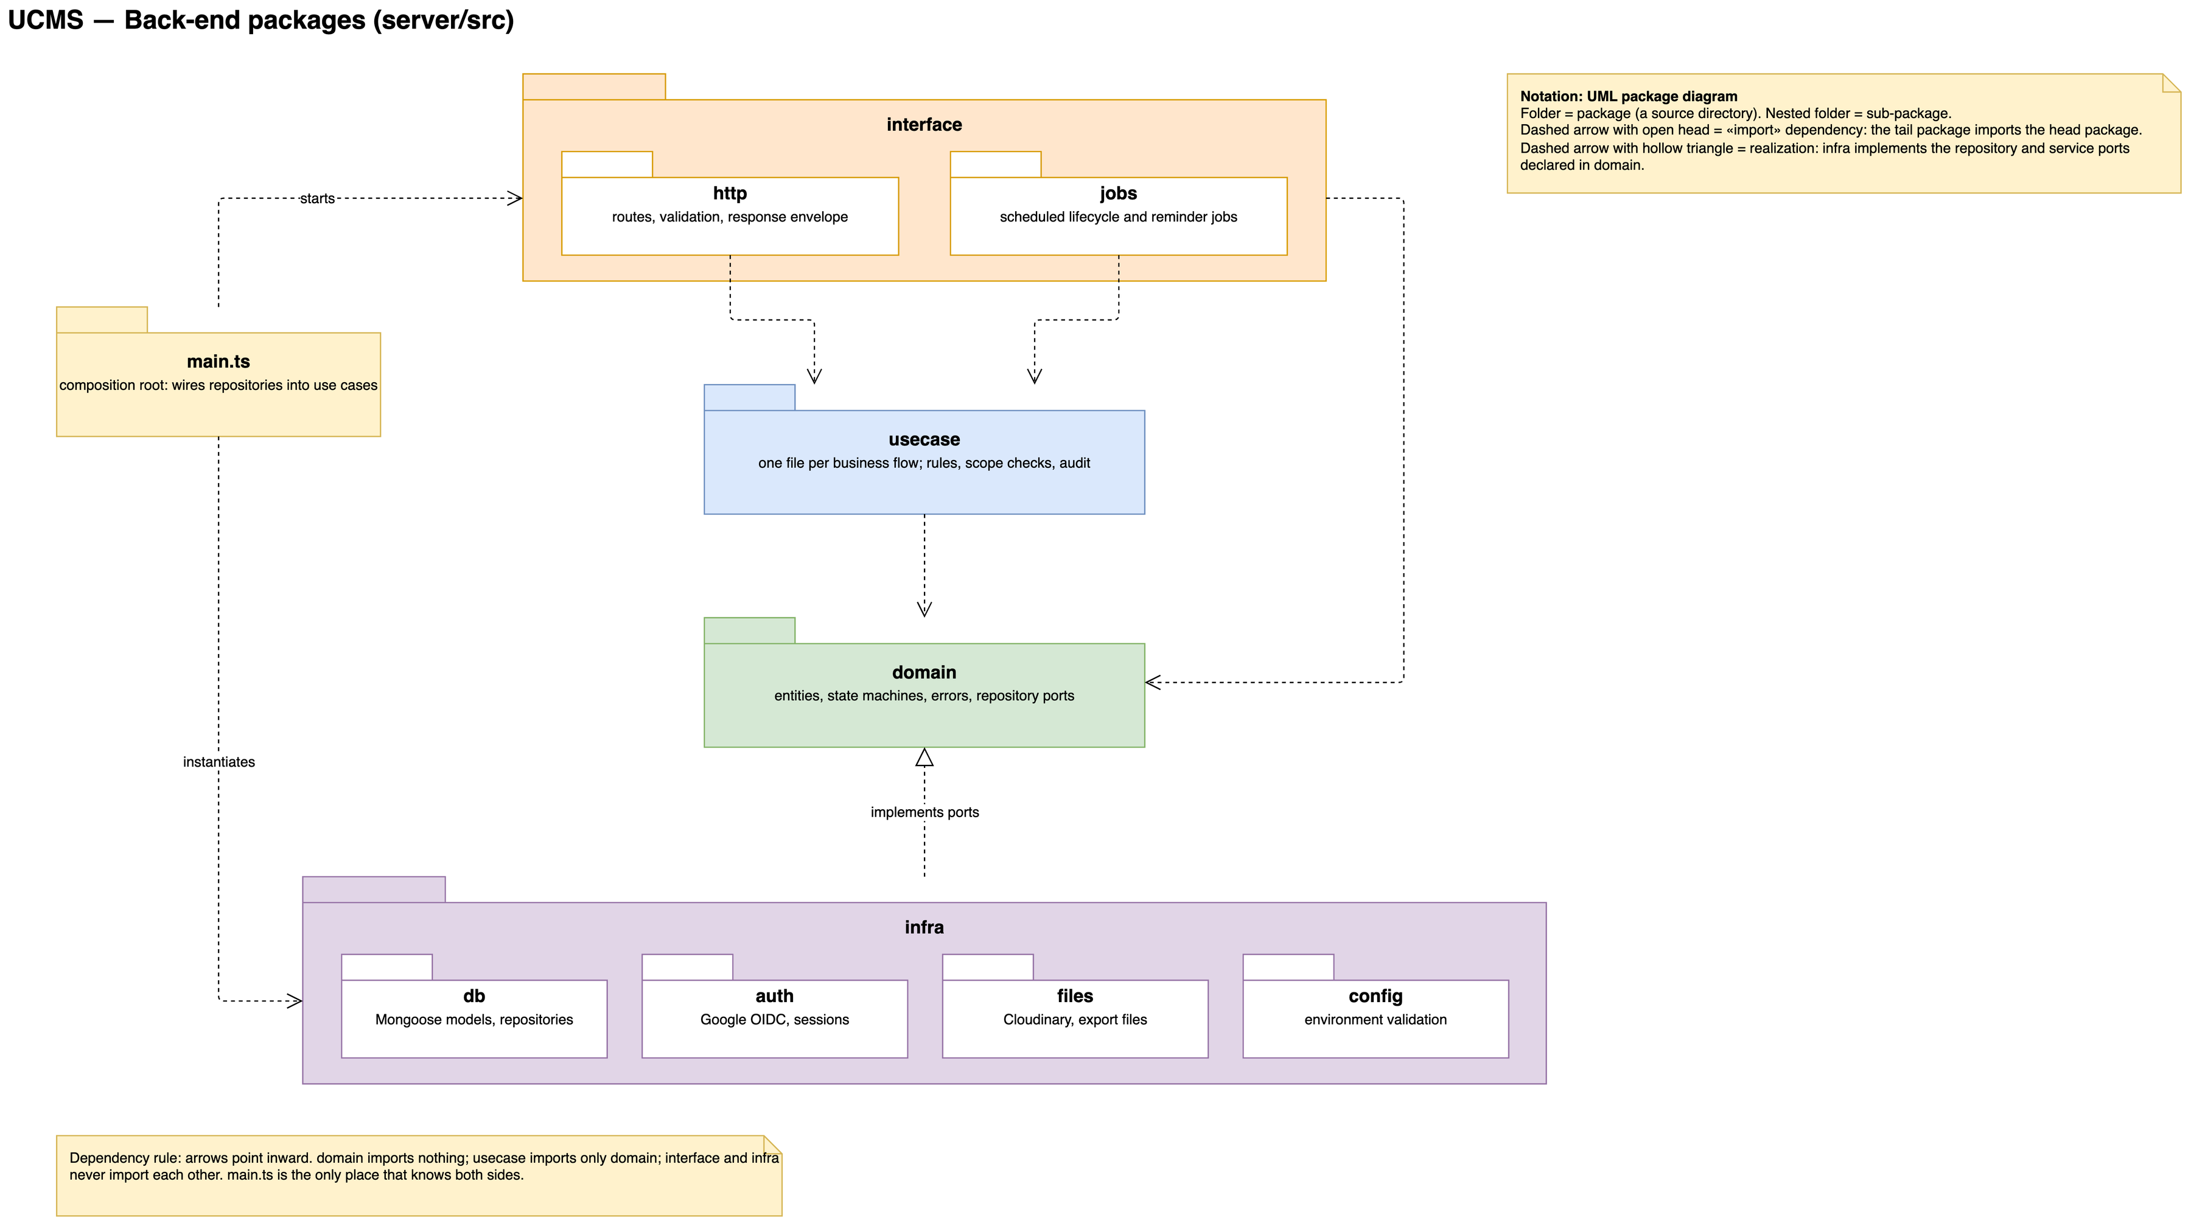
Figure 15: Package diagram – Back-end

6. Class diagram
No class diagram exists in the repository yet (docs/03-diagrams has no class diagram source). Add it here once it is drawn.

