
Final Project Report
Project: University Club Management System
Group Members & Lecturer
Group Members | Nguyễn Vũ Đăng Khánh | HE194342 (Leader)
Group Members | Nguyễn Đình Phong | [TBD]
Group Members | Nguyễn Quang Huy | [TBD]
Group Members | Nguyễn Hoàng Anh | HE176236
Group Members | Trần Ngọc Huy | [TBD]
Group Members | Lê Đức Anh | HE190104
Supervisor / Lecturer | Mr. Lê Thanh Hải
SE1939_NJ_G1 · WDP301 · FA26
September 2026

Table of Contents
Definition and Acronyms 3
I. Project Introduction 4
1. Overview 4
1.1 Project Information 4
1.2 Project Team 4
1.3 Stakeholders 5
2. Product Background 5
3. Existing Systems 5
4. Business Opportunity 6
5. Software Product Vision 7
II. Project Management Plan 8
1. Overview 8
1.1 Scope & Estimation 8
1.2 Project Objectives 9
1.3 Project Risks 10
2. Management Approach 12
2.1 Project Process 12
2.2 Quality Management 13
2.3 Training Plan 14
3. Project Deliverables 14
4. Responsibility Assignments 15
4.1 Team & Structures 15
4.2 Roles & Responsibilities 15
5. Communications Plan 16
6. Configuration Management 16
6.1 Document Management 16
6.2 Source Code Management 17
6.3 Tools & Infrastructures 17
III. Software Requirement Specification 18
1. Product Overview 18
2. User Requirements 20
2.1 Actors 20
2.2 Use Cases 21
3. Functional Requirements 36
3.1 System Functional Overview 36
3.2 Feature Description 55
4. Non-Functional Requirements 163
4.1 External Interfaces 163
4.2 Quality Attributes 164
5. Requirement Appendix 166
5.1 Business Rules 166
5.2 Application Messages List 169
5.3 Entity State Diagrams 170
IV. Software Design Description 175
1. System Design 175
1.1 System Architecture 175
1.2 Package Diagram 177
2. Database Design 179
3. Detailed Design 182
3.1 Design principles applied in every module 183
3.2 Design of the workflow, notification and audit services (M10) 183
3.3 Event Management 184
3.4 Periodic Reporting and Compliance Management 196
3.5 Club Evaluation Management 199
3.6 Design summary of the remaining modules 201
V. Testing Documentation 203
1. Scope of Testing 203
1.1 Testing Stages 203
1.2 Range of Testing 204
2. Test Strategy 205
2.1 Testing Types 205
2.2 Test Levels 205
2.3 Supporting Tools 205
3. Test Plan 207
3.1 Human Resources 207
3.2 Test Environment 207
VI. Release Package & User Guides 208
1. Deliverable Package 208
2. Installation Guides 208
2.1 System Requirements 208
2.2 Deployment steps 208
3. User Manual 209
3.1 Overview 209
3.2 Role: Guest 209
3.3 Role: Student 210
3.4 Role: Club Member and Club Leader 210
3.5 Role: ICPDP Officer 212

Definition and Acronyms
Table 0.1 lists the acronyms and domain terms used throughout this report.
Acronym | Definition
AT | Acceptance Testing
BA | Business Analysis / Business Analyst
BR | Business Rule
CMB | Club Management Board — collective name for the club side: the Club Leader and the Club Members whose roles carry the permission (actors Club Leader and Club Member)
ERD | Entity Relationship Diagram
FR | Functional Requirement
ICPDP | The university department governing student club activity; the single approval authority for every request a club or student submits to the university
IT | Integration Testing
OAuth | Open Authorization — the Google sign-in protocol used by the system
PM | Project Manager
RBAC | Role-Based Access Control
SDD | Software Design Description
SMTP | Simple Mail Transfer Protocol — used through Google SMTP for outbound e-mail
SPMP | Software Project Management Plan
SRS | Software Requirement Specification
ST | System Testing
UC | Use Case
UCMS | University Club Management System
UI | User Interface
UT | Unit Test
WBS | Work Breakdown Structure
Table 0.1: Definition and acronyms

I. Project Introduction

1. Overview

1.1 Project Information
Project name: University Club Management System
Project code: UCMS
Group name: SE1939_NJ_G1
Software type: Web-based Application (a public student-facing portal plus three authenticated role workspaces — Student, Club Management Board and ICPDP Officer)
Timeline: 14/09/2026 – Now

1.2 Project Team
# | Full Name | Role | Email
1 | Nguyễn Vũ Đăng Khánh | Leader, PM, BA, Tester, Full-stack Developer | khanhnvd07@gmail.com
2 | Nguyễn Đình Phong | Tester, Full-stack Developer | [TBD]
3 | Nguyễn Quang Huy | BA, Tester, Full-stack Developer | [TBD]
4 | Nguyễn Hoàng Anh | Tester, Full-stack Developer | hn54707@gmail.com
5 | Trần Ngọc Huy | Technical Leader, Tester, Full-stack Developer | tnh.t1k30.ht@gmail.com
6 | Lê Đức Anh | Tester, Full-stack Developer | ducanhdeptraile651@gmail.com
Table I.1: Team members

1.3 Stakeholders
Full Name | Email | Title
Lê Thanh Hải | hailt@fe.edu.vn | Lecturer / Supervisor
ICPDP Office | — | Product owner of the club governance process (domain stakeholder)
Club Management Boards | — | Primary operational users of the system
University students | — | End users of the public portal and the member workspace
Table I.2: Stakeholders

2. Product Background
The university student club ecosystem is a governance domain in which a single administrative body — the ICPDP — oversees dozens of independent student organizations differing widely in size, field of activity and operating rhythm. The defining characteristic of this domain is that every club follows a long, strictly staged lifecycle: establishment and approval, operation, recruitment, activity execution, finance, facility use, reporting, compliance and end-of-term performance evaluation, and finally leadership transition or dissolution. Each stage produces records that the next stage depends on.
As the number of clubs and the volume of their activity scale up, traditional manual administration — or the reliance on scattered, disconnected tools such as Word documents, Google Forms, Drive folders, e-mail threads and end-of-term spreadsheets — reveals severe limitations. The lack of synchronization between an approved event and its registration, attendance, expense and report records, combined with the absence of a single place where a request has a state and an accountable owner, makes governance reactive rather than preventive. The university cannot tell in real time which clubs are legitimately operating, which requests are waiting, which obligations are overdue, or which money was spent without evidence.

3. Existing Systems
Club operations currently rely on manual methods or standalone, disconnected tools. A club drafts an event plan in a Word file, e-mails it to ICPDP, revises it and resends it until approval arrives — also by e-mail — so neither side can tell at a glance what state a request is in or what changed between two versions. Registration is then collected through a separate Google Form, attendance is ticked off in an Excel sheet, invoices are dropped into a Drive folder, and the final report is written in another Word file. Event A therefore exists in six unrelated artefacts with no formal relationship between them.
Internally, membership rosters, leadership terms and handover records are maintained ad hoc, so the university cannot state how many active members a club has or who is formally authorized to represent it. Budget requests, disbursements, expenses and invoices sit in separate files with no automated linkage, so overspending and missing evidence surface only during a manual end-of-term reconciliation — if at all. Room and equipment requests travel by e-mail with no shared calendar, so two clubs can be granted the same room for the same hour.
Crucially, the gap between student-facing channels and internal records hinders governance at scale. Published information lives on static pages updated by hand and quickly drifts out of sync with the approved reality, forcing staff to re-enter the same data elsewhere. Students have no official channel to raise a complaint that does not pass through the club being complained about, and no structured way to give feedback that could be used as evaluation data. Without a centralized platform, ICPDP cannot monitor in real time which clubs are Active or Suspended, which requests are waiting, or which clubs are drifting into risk.

4. Business Opportunity
Governance workflow standardization: giving every significant record an explicit state machine, a version history that is never overwritten, a single accountable approver and a full audit trail replaces ad hoc e-mail approvals with a process the university can enforce and reconstruct when a decision is disputed.
Accountability and resource optimization: linking budget, disbursement, expense and evidence end-to-end produces an automatic reconciliation that exposes overspending and missing documentation as it occurs, while conflict detection over a shared facility calendar prevents double allocation and reveals rooms granted but never used.
Enhanced student engagement and transparency: a single entry point — public discovery, authenticated action — for discovering active clubs, applying to recruitment campaigns, tracking application status, registering and checking in for events, submitting feedback and raising complaints directly to ICPDP removes the dependence on informal channels and gives every submission a visible state.
Data-driven strategic decisions: a centralized dashboard combined with a configurable evaluation engine turns operational records into scored, traceable results across activity execution, member engagement, reporting discipline, financial compliance, governance and risk, enabling ICPDP to intervene during the term rather than after it.

5. Software Product Vision
The University Club Management System was created from the desire of the ICPDP to govern student club activity from a single source of truth. The system is a comprehensive solution designed to change the way the university manages its club ecosystem across the full lifecycle — from establishment and recruitment through events, finance, facilities, reporting and performance evaluation, to leadership transition and dissolution.
For the ICPDP Officer — the sole representative of the university and the highest authority in the system — the shift is from consolidating end-of-term spreadsheets to a centralized, real-time dashboard covering pending approvals, approval aging, scheduling conflicts, budget exposure, overdue obligations, open complaints and club health, making it straightforward to approve, suspend or dissolve with the reasoning permanently on the record.
For the Club Management Board, the system replaces a folder of drafts and an inbox of threads with one workspace in which every submission has a state, every deadline is visible before it is missed, and the post-event report is pre-populated from data the club has already produced.
For the Student, it becomes one place — public discovery, authenticated action — to discover clubs, apply, track an application, register for an event, check in, give feedback and raise a complaint that reaches the university directly.

II. Project Management Plan

1. Overview

1.1 Scope & Estimation
Table II.1 breaks the work down into three complexity levels (Simple, Normal, Complex) and estimates the total effort of each item in man-days (1 man-day = 8 working hours).
WBS ID | WBS Item | Complexity | Est. Effort (man-days)
1. Project Management
1.1 | Project initiation | Normal | 1
1.2 | Project planning | Complex | 2
 | Total: |  | 3
2. Project Designing
2.1 | Requirement gathering and business process modelling (club lifecycle flows) | Normal | 4
2.2 | Create project introduction document | Simple | 1.5
2.3 | Define project scope and objectives | Complex | 1
2.4 | Use case model, use case specification and business rule catalogue | Complex | 5
2.5 | System architecture and MongoDB schema design | Complex | 2
2.6 | UI/UX wireframing and screen-flow design | Normal | 4
2.7 | Create project timeline and schedule | Normal | 5
2.8 | Designing basis of layout (concept, feature, requirement) | Complex | 5
2.9 | Identify and mitigate project risks | Normal | 3
2.10 | Creating test plan | Normal | 2
 | Total: |  | 32.5
3. Project Development
3.1 | Prototyping project structure (clean architecture skeleton) | Complex | 5
3.2 | Develop UI front-end prototype | Complex | 7
3.3 | Conduct product testing and validation | Complex | 5
3.4 | Develop UI front-end (Student, Club Admin and ICPDP workspaces) | Complex | 15
3.5 | Develop back-end core functions (identity, club lifecycle, recruitment, event, attendance) | Complex | 25
3.6 | Develop back-end advanced functions (finance, booking, compliance, evaluation, notification outbox) | Complex | 20
3.7 | Implement security measures (Google OAuth, RBAC scope checks, audit log) | Complex | 5
3.8 | Create tests (UT, IT, ST) along coding | Normal | 10
 | Total: |  | 92
4. Quality Assurance & Testing
4.1 | Conduct functional and GUI testing | Normal | 5
4.2 | Conduct usability and performance testing | Normal | 5
4.3 | Testing and fixing bugs | Normal | 5
 | Total: |  | 15
 | Total Estimated Effort (man-days) |  | 142.5
Table II.1: Scope & estimation

1.2 Project Objectives

1.2.1 Project management
Table II.2 describes the project management objectives.
No | Objectives
1 | The software product and the final report are fully completed and ready for release before the course deadline.
2 | Complete UI/UX wireframes, screen flows and layout designs are delivered after the first two sprints.
3 | All established sprint goals and functional product increments are completed without carry-over to the next sprint.
4 | The released product removes at least 80% of the manual steps in the current club governance process (e-mail approvals, spreadsheet consolidation, manual deadline tracking).
5 | Every one of the 52 use cases in the requirement baseline is traceable to a business rule and at least one test case, and every use case that changes a state is traceable to the lifecycle of its entity.
Table II.2: Project management objectives

1.2.2 Allocated effort
Table II.3 describes the effort each member allocates to the project.
# | Member | Weekdays | Weekends
1 | Nguyễn Vũ Đăng Khánh | 2 hours | 4 hours
2 | Nguyễn Quang Huy | 2 hours | 4 hours
3 | Nguyễn Hoàng Anh | 2 hours | 4 hours
4 | Trần Ngọc Huy | 2 hours | 4 hours
5 | Lê Đức Anh | 2 hours | 4 hours
6 | Nguyễn Đình Phong | 2 hours | 4 hours
Table II.3: Allocated effort

1.3 Project Risks
Table II.4 describes the possible risks of the project. The risk taxonomy used here is the standard five-category model:
- People risk is the human factor: a teammate falling ill, an accident, late arrival, or communication difficulty between members or with stakeholders.
- Process risk emerges from project management itself: budget or schedule overrun, inadequate quality assurance, unclear ownership.
- System risk is associated with technical issues such as failure of hardware, software or network infrastructure that could impact performance, data integrity or security.
- External event risk covers events outside the team such as an outage of an external provider, an institutional policy change, or a pandemic.
- Legal and compliance risk arises from legal or regulatory requirements, such as the handling of student personal data.
# | Risk Description | Impact | Possibility | Response Plans
1 | Requirement changes: the ICPDP governance rules (approval routing levels, evaluation weights, report deadlines) are still being confirmed and may shift after implementation starts. | Medium | High | Keep every such value configurable (UC04, UC05, UC41) instead of hard-coding it, so a policy change is a data change. Confirm the nine configurable values with the lecturer before the configuration screen is frozen.
2 | Team conflicts: members disagree over cross-module API contracts and ownership of shared aggregates (approval task, notification outbox, audit log). | Medium | Medium | Define clear module boundaries (M01–M12) and agree the shared ApprovalTask, Notification and AuditLog contracts up front; every cross-module write goes through the owning use case.
3 | Technical skill gaps: members lack experience with Google OAuth, clean architecture layering and MongoDB aggregation for the evaluation engine. | High | Medium | Run targeted internal training sessions (see §2.3), pair the weaker areas with the technical leader, and keep the use case layer free of framework code so it can be unit-tested without the database.
4 | Scope risk: 52 use cases across 12 modules is large for a six-person team in one semester. | High | Medium | Build by closed loops, not by half-features: finish the High loops first, then Medium and Low, and never leave an entity in a state no use case can leave. No use case is cut; all 54 ship in one release.
5 | External dependency failure: Google OAuth or Google SMTP becomes unavailable, blocking sign-in or notifications. | High | Low | Send e-mail from a persisted outbox with retry so a delivery failure never breaks a committed transaction; degrade sign-in gracefully with a clear message and create no partial user record.
6 | Data integrity failures: concurrent registration or booking requests produce double allocation of a seat or a room. | High | Low | Protect capacity and slot allocation with a unique index plus a guarded atomic update rather than read-check-write; add stress tests for the check-in and registration paths.
7 | Legal and compliance risk: complaints and feedback contain personal data of students. | Medium | Low | Restrict complaint visibility to ICPDP until it is forwarded, show feedback to clubs only in aggregate, and hide any aggregate below the configured minimum respondent count.
Table II.4: Project risks

2. Management Approach

2.1 Project Process
Figure II.5 describes the process the project follows.
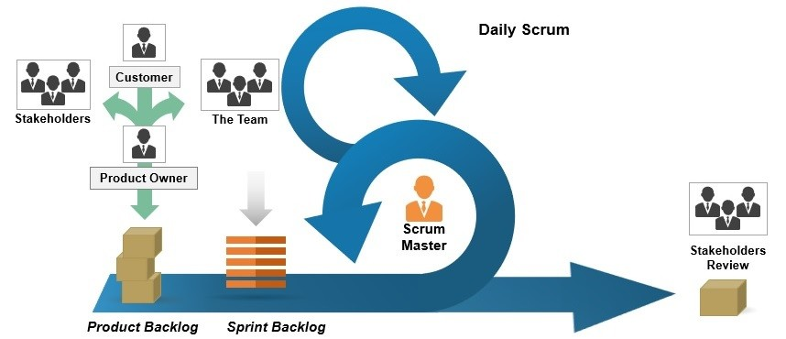
Figure II.5: Project process
Following an evaluation of several software engineering methodologies, the team selected the Agile-Scrum framework. Operating on an iterative and incremental development cycle, Scrum provides the structural flexibility, rapid adaptability and cross-functional collaboration necessary to meet the tight constraints of a one-semester project whose requirements are still being confirmed with the domain stakeholder.

2.2 Quality Management

2.2.1 Defect Prevention
- Immediate notification: upon detecting an anomaly, the discovering team member must immediately log it and notify the owner of the affected module to minimize the impact radius.
- Impact assessment: every identified defect is evaluated on two dimensions — severity (the risk to the state machines, the audit trail or data integrity) and effort estimate (the time required for remediation).
- Clear SLA for bug fixes: resolution deadlines are defined per severity tier so that defects do not accumulate silently in the pipeline.
- Risk contingency plan: the team maintains backup strategies for critical, systemic errors at any stage, including a rollback path for each release.

2.2.2 Reviewing
- Objective code reviews: reviewers give unbiased, constructive feedback based strictly on the technical standards of the project and on this requirement baseline.
- Immediate notification: reviewers notify the developer responsible for the affected module as soon as an anomaly is identified.
- Centralized defect tracking: all verified issues are logged with complete technical details, reproducible steps and a clear priority.
- Remediation and accountability: the module owner takes full responsibility for the defect and implements a permanent fix within the scheduled timeframe.
- Definition of Done: a change is done when the constitution check, the linter, the type check and the test suite are all green.

2.3 Training Plan
Table II.6 describes the training plan of the project.
Training Area | Participants | When, Duration | Waiver Criteria
Node.js stack (React + Express) | All members | 1 day | Mandatory
Clean architecture layering (domain / usecase / interface / infra) | All members | 2 hours | Mandatory
MongoDB and Mongoose | All members | 30 minutes | Mandatory
Google OAuth integration | Back-end developers | 1 hour | Mandatory for back-end
GitHub workflow | All members | 30 minutes | Mandatory
Postman | All members | 15 minutes | Mandatory
Meeting note discipline | All members | 15 minutes | Mandatory
Table II.6: Training plan

3. Project Deliverables
Figure II.7 describes the delivery approach of the project.
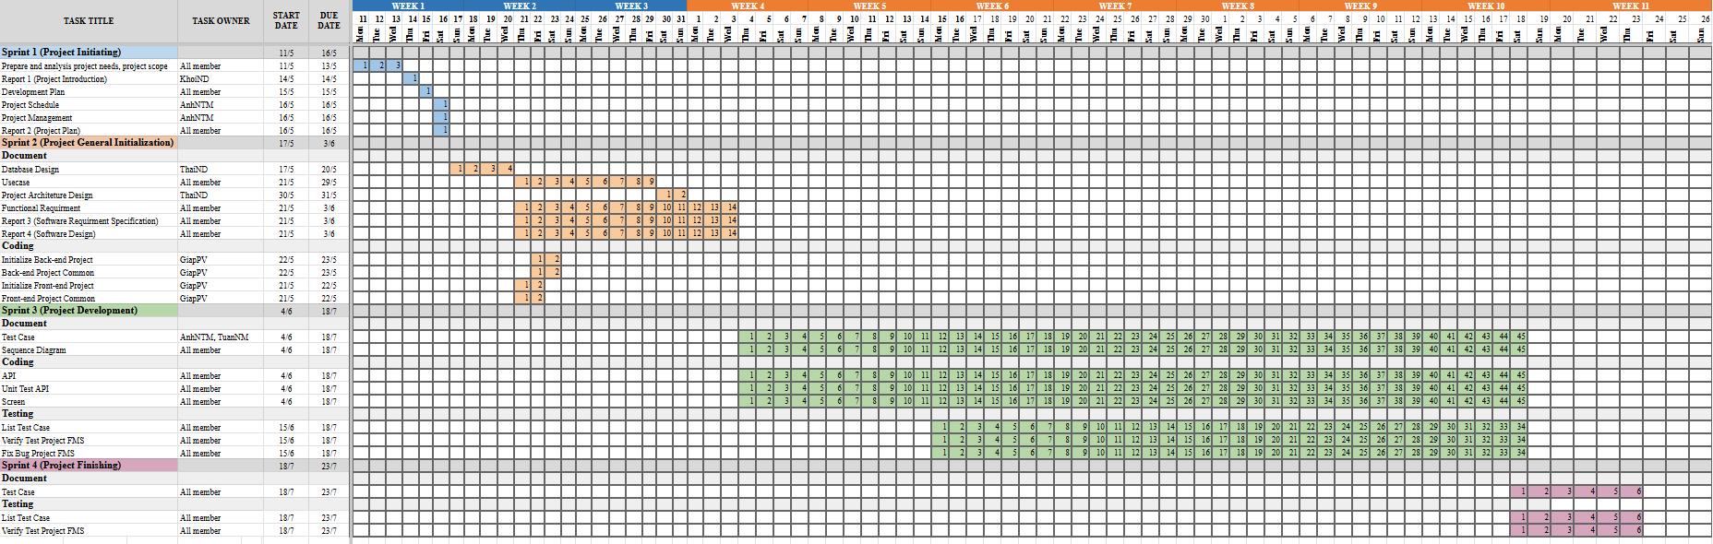
Figure II.7: Project delivery
The project uses a sprint plan to manage tasks and to estimate the work of each new sprint every week. Each sprint closes with a demonstrable increment mapped to one of the delivery loops defined in the requirement baseline.

4. Responsibility Assignments

4.1 Team & Structures
Table II.8 describes the team and its structure.
# | Member | Role
1 | Nguyễn Vũ Đăng Khánh | PM, BA, Tester, Full-stack Developer
2 | Nguyễn Quang Huy | BA, Tester, Full-stack Developer
3 | Nguyễn Đình Phong | Tester, Full-stack Developer
4 | Trần Ngọc Huy | Technical Leader, Tester, Full-stack Developer
5 | Lê Đức Anh | Tester, Full-stack Developer
6 | Nguyễn Hoàng Anh | Tester, Full-stack Developer
Table II.8: Team & structures

4.2 Roles & Responsibilities
Table II.9 describes the roles and responsibilities in the project.
Role | Responsibility
Project Manager | Planning, developing schedules, coordinating communication, keeping the team on track and reporting progress to the supervisor.
BA | Analyze requirements, define scope, produce and maintain the SRS, the use case model and the business rule catalogue, design the domain model and the state machines.
Technical Leader | Define the high-level architecture based on the SRS, own the layer boundaries, implement configuration and deployment, review technical designs.
Full-stack Developer | Implement the product across client and server and review the code of other developers.
Tester | Create the testing document template, define the test strategy, write and execute test cases, log and re-verify defects.
Table II.9: Roles & responsibilities

5. Communications Plan
Table II.10 describes the communication plan of the project.
Communication Item | Who / Target | Purpose | When, Frequency | Type, Tool, Method
Team meeting | All team members | Review project progress, discuss assigned tasks, update design, coding, testing and documentation | Twice a week | Online — Google Meet
Weekly meeting with the lecturer | All team members | Report progress, clarify requirements, receive feedback and define the next week's goals | Once a week | Offline
On-going assessment meeting | All team members | Evaluate the project after every iteration | Once every 3 weeks | Offline
Requirement discussion meeting | BA, PM, development team | Analyze and clarify business requirements, use cases and system features | Whenever requirements change | Online — Google Meet
Project documentation review | All team members | Review and update the SRS, SDD, test reports and the final documentation | Every milestone | Google Docs, Google Drive
Unscheduled meeting | All team members | Discuss and resolve blocking problems | When a member raises a blocker | Online — Google Meet
Table II.10: Communications plan

6. Configuration Management

6.1 Document Management
Document tools: Microsoft Office, Google Docs and Google Sheets. Markdown sources of the requirement baseline are version-controlled in the repository under docs/, so a requirement change is reviewable as a diff.
File management: Google Drive for the submitted deliverables; Git for every source document that drives the code.

6.2 Source Code Management
Source code is managed with Git on GitHub. Work is done on feature branches, merged by pull request, and the Definition of Done (constitution check, lint, type check and tests) must pass before a merge.

6.3 Tools & Infrastructures
Table II.11 describes the tools and infrastructure of the project.
Category | Tools / Infrastructure
Technology | React 19 + Vite (TypeScript), Express 5 (Node.js ≥ 22.9)
Database | MongoDB with Mongoose
Authentication / E-mail | Google OAuth 2.0, Google SMTP
IDEs / Editors | Visual Studio Code
Diagramming | draw.io, Visual Paradigm
Documentation | Microsoft Office, Google Docs / Sheets / Slides, Markdown in the repository
Version control | GitHub (source code), Google Drive (submitted documents)
Project management | Google Sheets (schedule, tasks, defects), GitHub (pull requests, code review)
Testing | Vitest (unit and integration), Postman (API), Google Chrome (GUI), Firefox / Safari / Edge (GUI smoke test), Microsoft Excel (test cases)
Deployment | Docker Compose (MongoDB, API, static client host)
Table II.11: Tools & infrastructures

III. Software Requirement Specification

1. Product Overview
The context diagram in Figure III.1 illustrates the University Club Management System designed to replace the current fragmented workflow built on separate Word documents, Google Forms, Excel sheets and e-mail threads. The system centralizes the entire club lifecycle on a unified platform, connecting four human actors — Students (club applications, recruitment, event registration, check-in, feedback, complaints), Club Members (club profile, membership, events, finance, bookings, reports, responses to university event invitations), Club Leaders (club roles and permissions, leadership and suspension requests) and ICPDP Officers (every approval, configuration, compliance and evaluation decision, university events and data export) — with three external systems, Google OAuth, Google SMTP and Cloudinary.
Instead of event data being scattered across unlinked files, the system maintains a continuous business context from proposal through approval, registration, attendance, reporting and evaluation. Google OAuth handles authentication so the university stores no password, and Google SMTP carries every notification that needs to leave the system, and Cloudinary stores every uploaded image, making the process transparent, consistent and traceable across the whole club management workflow. The diagram carries 46 data flows. Each flow is a group of related data drawn as its own arrow, so a submission that travels from the club to the ICPDP appears once as Submissions for review instead of twice, and every flow is produced or consumed by at least one of the 55 use cases.
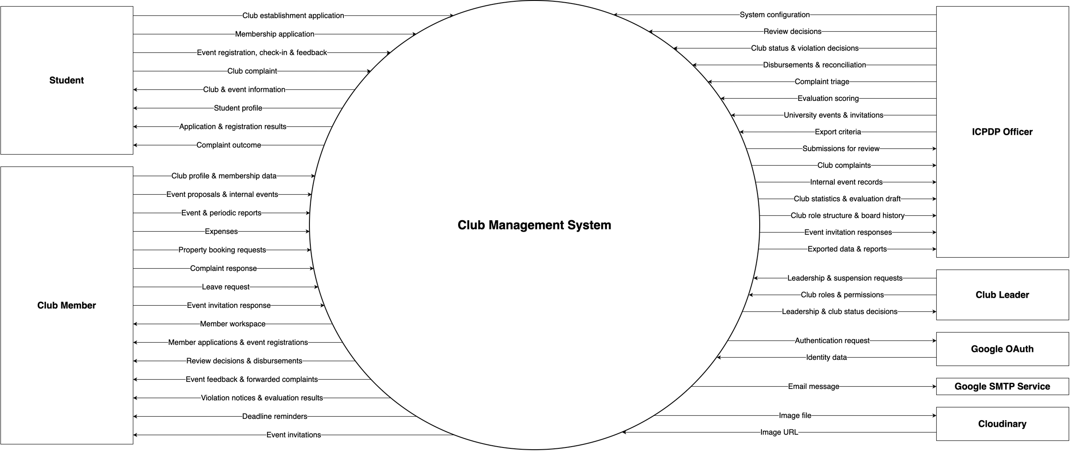
Figure III.1: Context diagram

1.1 Organization Structure
Figure III.2 shows the organization that UCMS serves and how each position maps to an actor or a role of the system. The university runs the club programme through the ICPDP, the single approval authority for every request sent to the university (BR31). Inside the ICPDP, officers hold the ICPDP_OFFICER role and review, decide, disburse and reconcile; a head holds the ICPDP_HEAD role and acts as the second approval level for the requests that the routing rules of UC05 escalate (BR16). Finance, Facilities, Security and faculty advisers do not use the system: the ICPDP consults them outside it and records their opinion in its review note.
Each club runs one active term. The President is the Club Leader, whose seat the ICPDP confirms (UC11, UC13); the holders of the executive board roles — vice-president and heads of department — are confirmed by the ICPDP as well (UC10, UC11, UC13). Departments are declared in UC09, and ordinary roles such as treasurer or event coordinator are managed by the Club Leader without the ICPDP (UC23, BR55). Every onboarded member holds the default Members role (UC20, BR56). Students who are not members apply, attend events, give feedback, complain or found a new club.
Club permissions come only from a position in the active term (BR47), so leaving the position or reaching the end of the term removes them. Every change of the role structure is a new version (BR56), and obligations — reports, settlements, refunds and violation cases — belong to the club, not to the people who hold its positions.
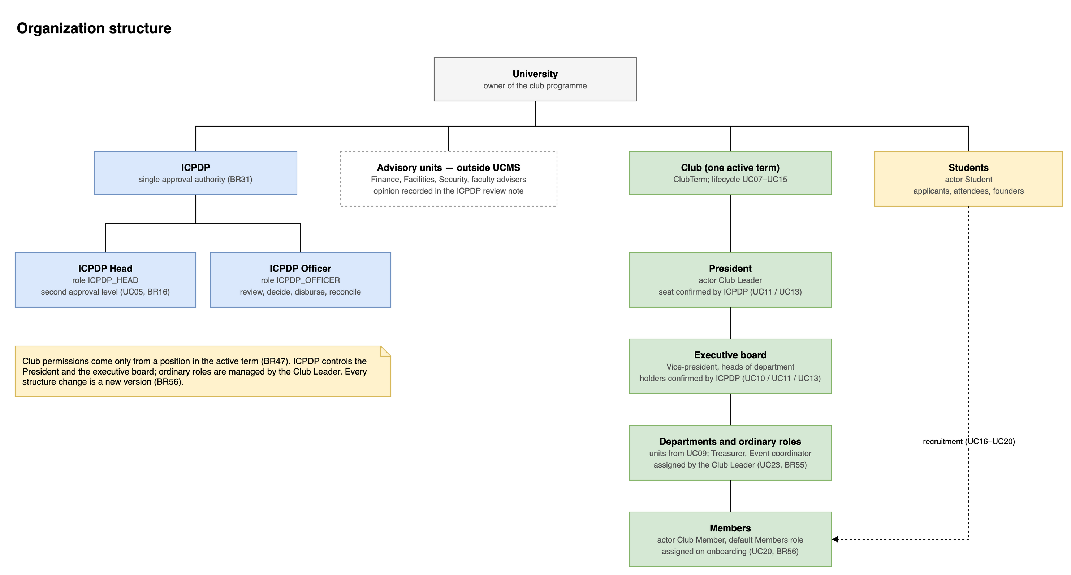
Figure III.2: Organization structure

2. User Requirements

2.1 Actors
Table III.1 describes the actors of the system. UCMS has four human actors, related by generalization: a Club Member is a Student and a Club Leader is a Club Member (Figure III.3.1). "CMB" (Club Management Board) remains the collective name for the club side — the Club Leader and the Club Members whose roles carry the permission — in notifications, dashboards and data flows; Google OAuth, Google SMTP and Cloudinary participate in the data flow but decide nothing and own no business outcome, so they are modelled as external systems rather than as business actors.
# | Actor | Type | Description
1 | Student | Human actor | Any authenticated university student: a non-member browsing clubs, a candidate, a club member or a founding applicant. Students submit club establishment applications, apply to recruitment campaigns, track their applications, register for events, check in, submit post-event feedback and raise complaints.
2 | Club Member | Human actor | A Student with an Active membership in a club (Inactive members keep the member workspace). Every club member uses the member workspace and may request to leave. The operating work of the club — profile, recruitment, roster, events, waitlist, attendance, reports, budget and expenses, bookings, feedback and complaint answers — belongs to this actor, but each use case runs only when one of the member's roles in that club carries the matching permission (BR54).
3 | Club Leader | Human actor | The club president: the holder of the President seat confirmed by the ICPDP in UC11 or UC13 (or the founding applicant's temporary seat while the club is Pending Setup). A Club Leader is a Club Member with every club permission and alone holds four permissions no role can receive: manage club roles and permissions (UC23), nominate the board (UC10), plan the transition (UC12) and request a suspension (UC14).
4 | ICPDP Officer | Human actor | The only university-side actor and the single approval authority for every request submitted to the university; decisions internal to a club stay with its CMB. Every governance decision ends here: establishment, club status, board confirmation, transition, event approval, budget approval and disbursement, reconciliation, property allocation, complaint triage, compliance cases, evaluation and all configuration. Multi-level approval is internal to ICPDP and expressed through RBAC.
5 | Google OAuth | External system | Identity provider. UCMS sends an authentication request and receives the authentication data (e-mail, full name, avatar). No password is ever stored by UCMS.
6 | Google SMTP Service | External system | Outbound e-mail channel. UCMS sends a send-email request for every notification that carries an e-mail channel; delivery is retried from a persisted outbox and logged.
7 | Cloudinary | External system | Image storage. UCMS uploads every image a user attaches and receives the image URL, which it stores in place of the file.
Table III.1: Actors
Guest is not a business actor. A guest is an unauthenticated visitor who can only read the public area of UC06 (club directory, club pages, open recruitment campaigns and upcoming public events). A guest owns no use case and creates no data; every action (applying, registering, proposing a club) requires UC01, after which the user is a Student. The rule is: public discovery, authenticated action.

2.2 Use Cases

2.2.1 Use case diagrams
Figure III.3 presents the use case diagrams of the system. They are drawn per actor and split by concern, so that each diagram stays readable on a single page. Each actor is associated with a few "Manage …" use cases, and each of them <<include>>s its sub-functions (catalogue-style use cases are broken down into their create, view, update and deactivate operations); the sub-functions map to the use cases specified in section 3.2.
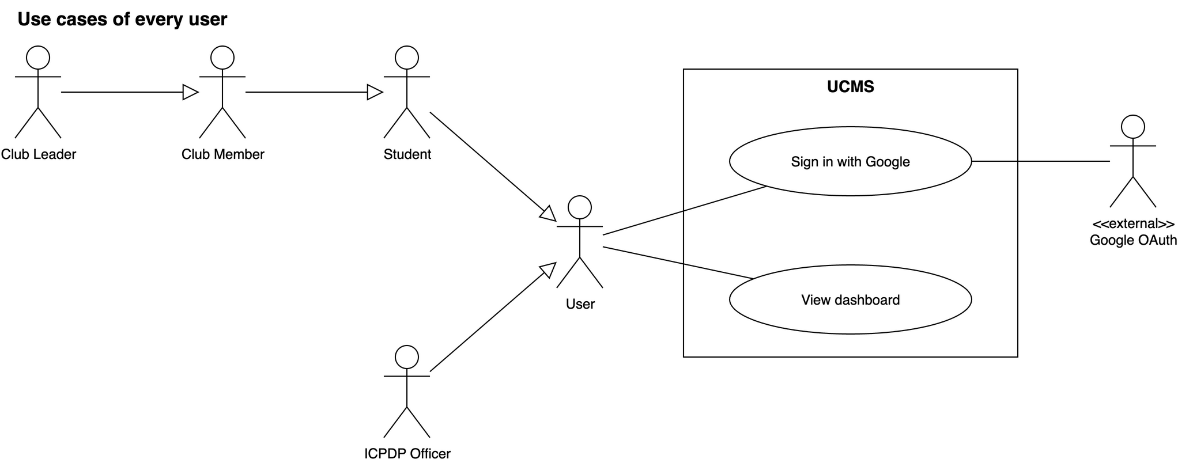
Figure III.3.1: Use cases shared by all users, with the actor generalization
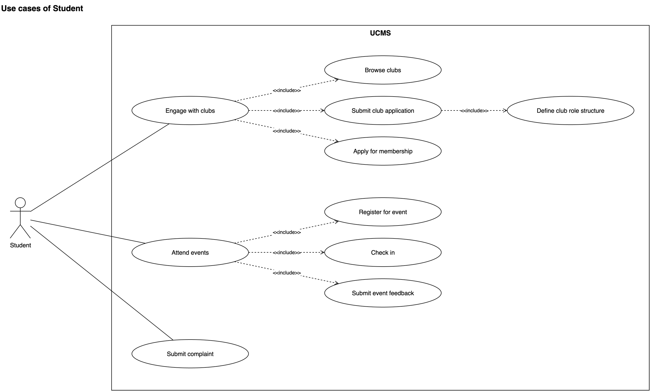
Figure III.3.2: Use cases of the Student
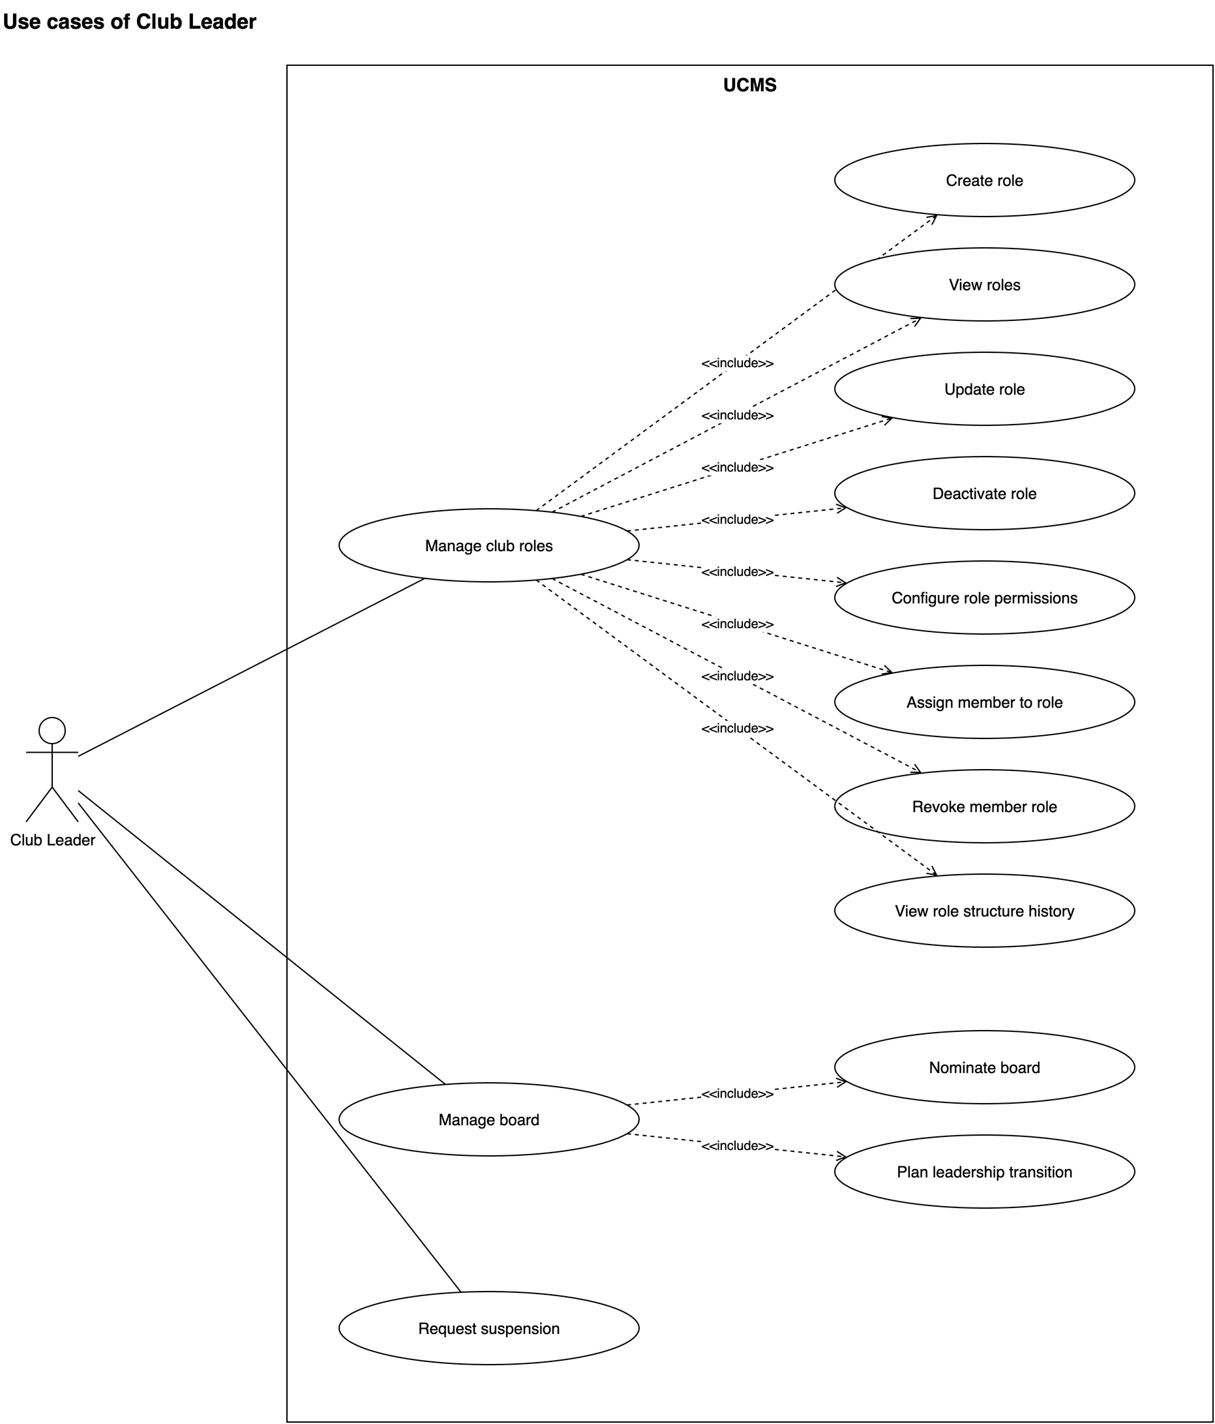
Figure III.3.3: Use cases of the Club Leader
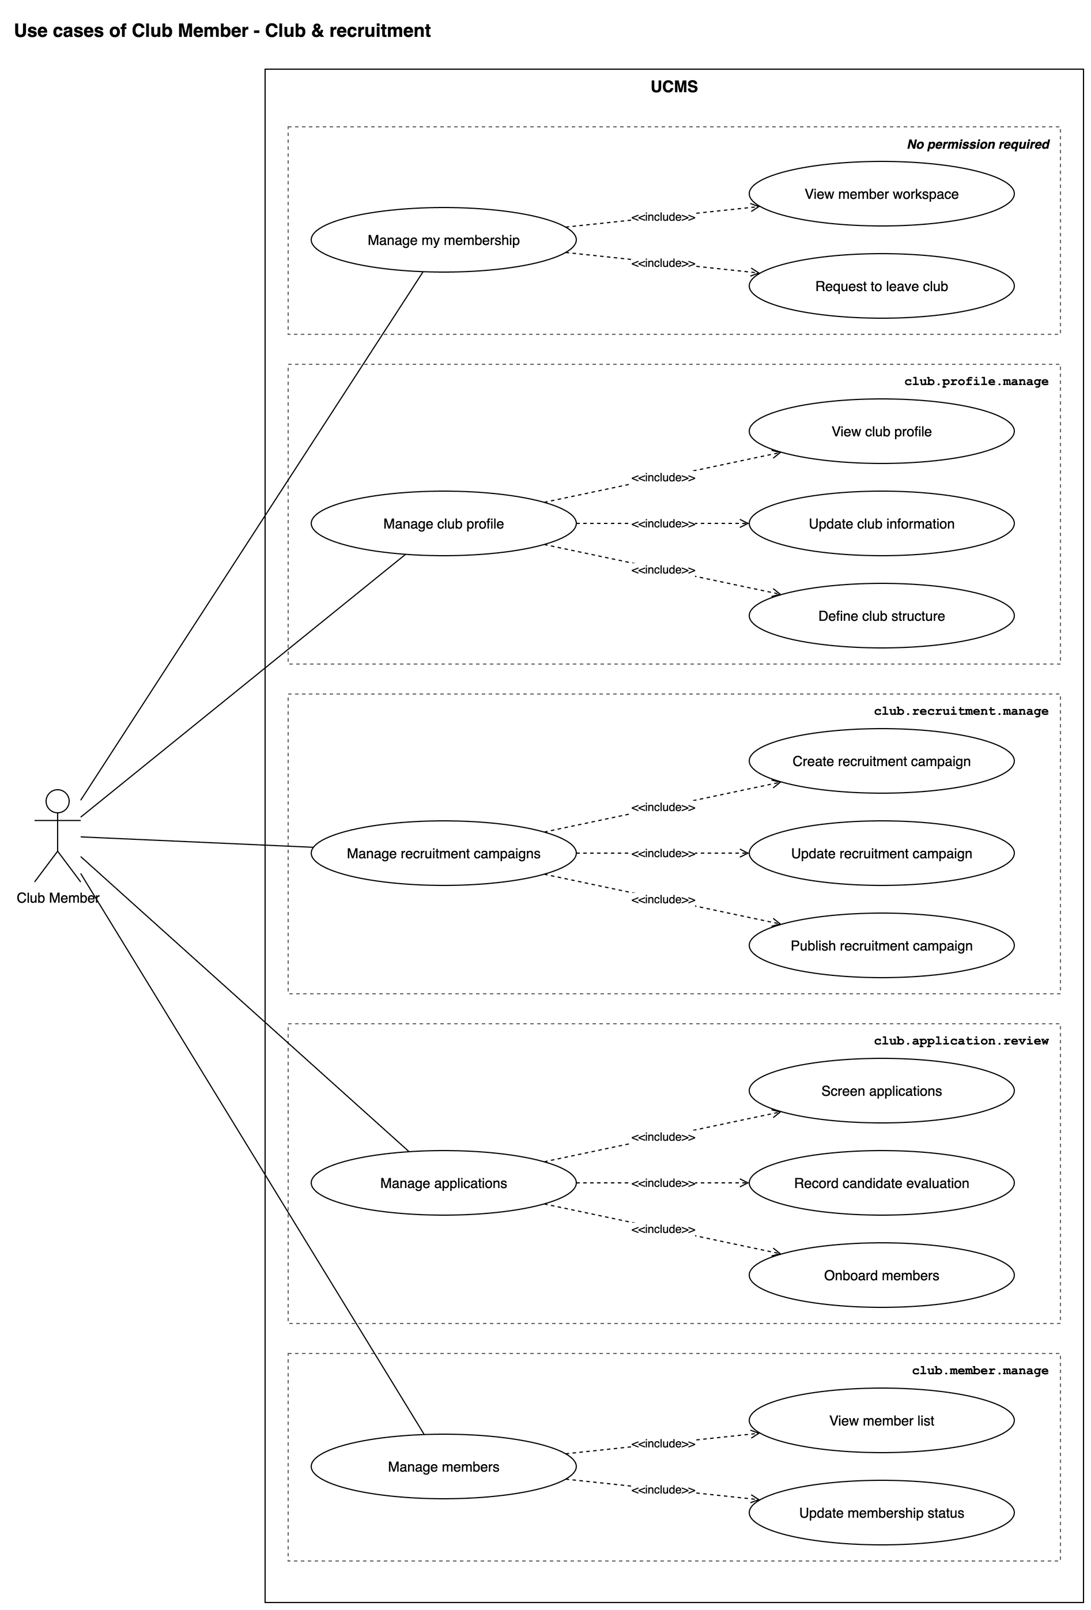
Figure III.3.4: Use cases of the Club Member — club & recruitment
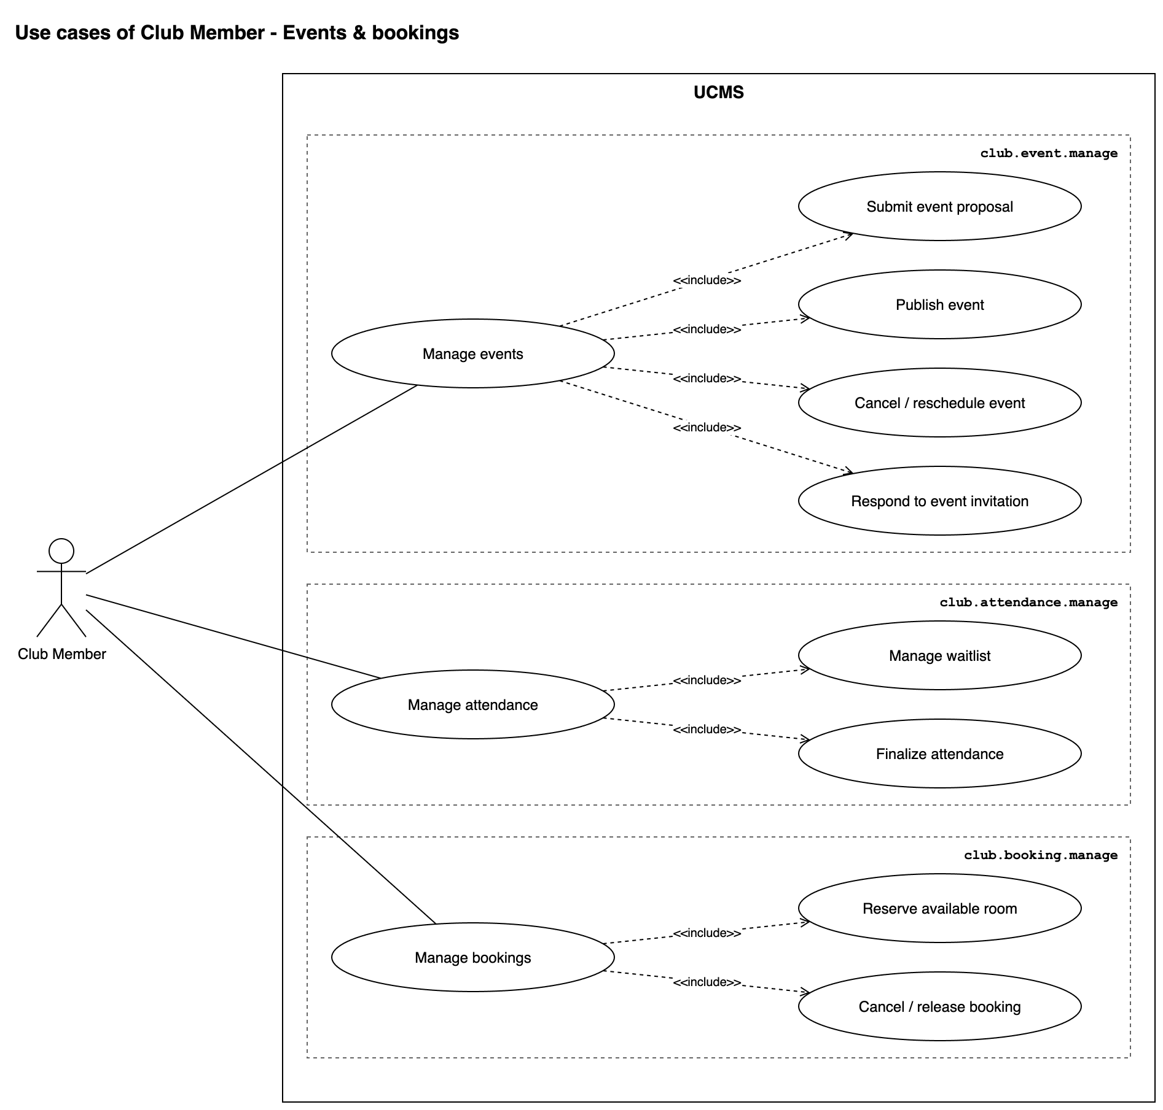
Figure III.3.5: Use cases of the Club Member — events & bookings
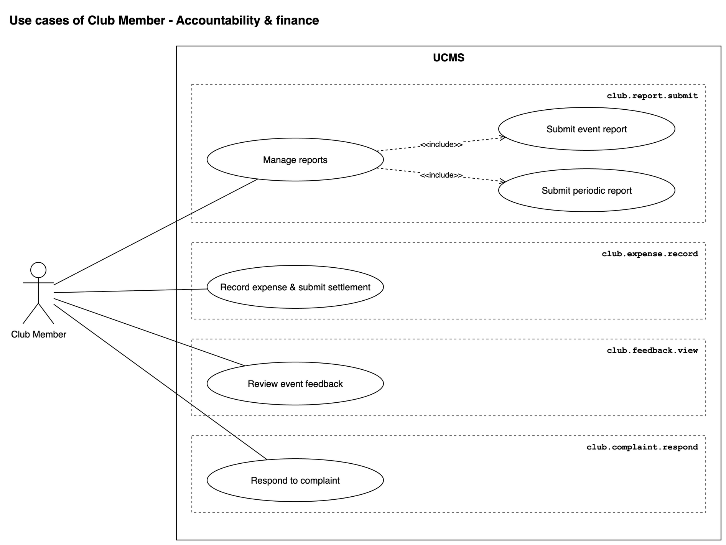
Figure III.3.6: Use cases of the Club Member — accountability & finance
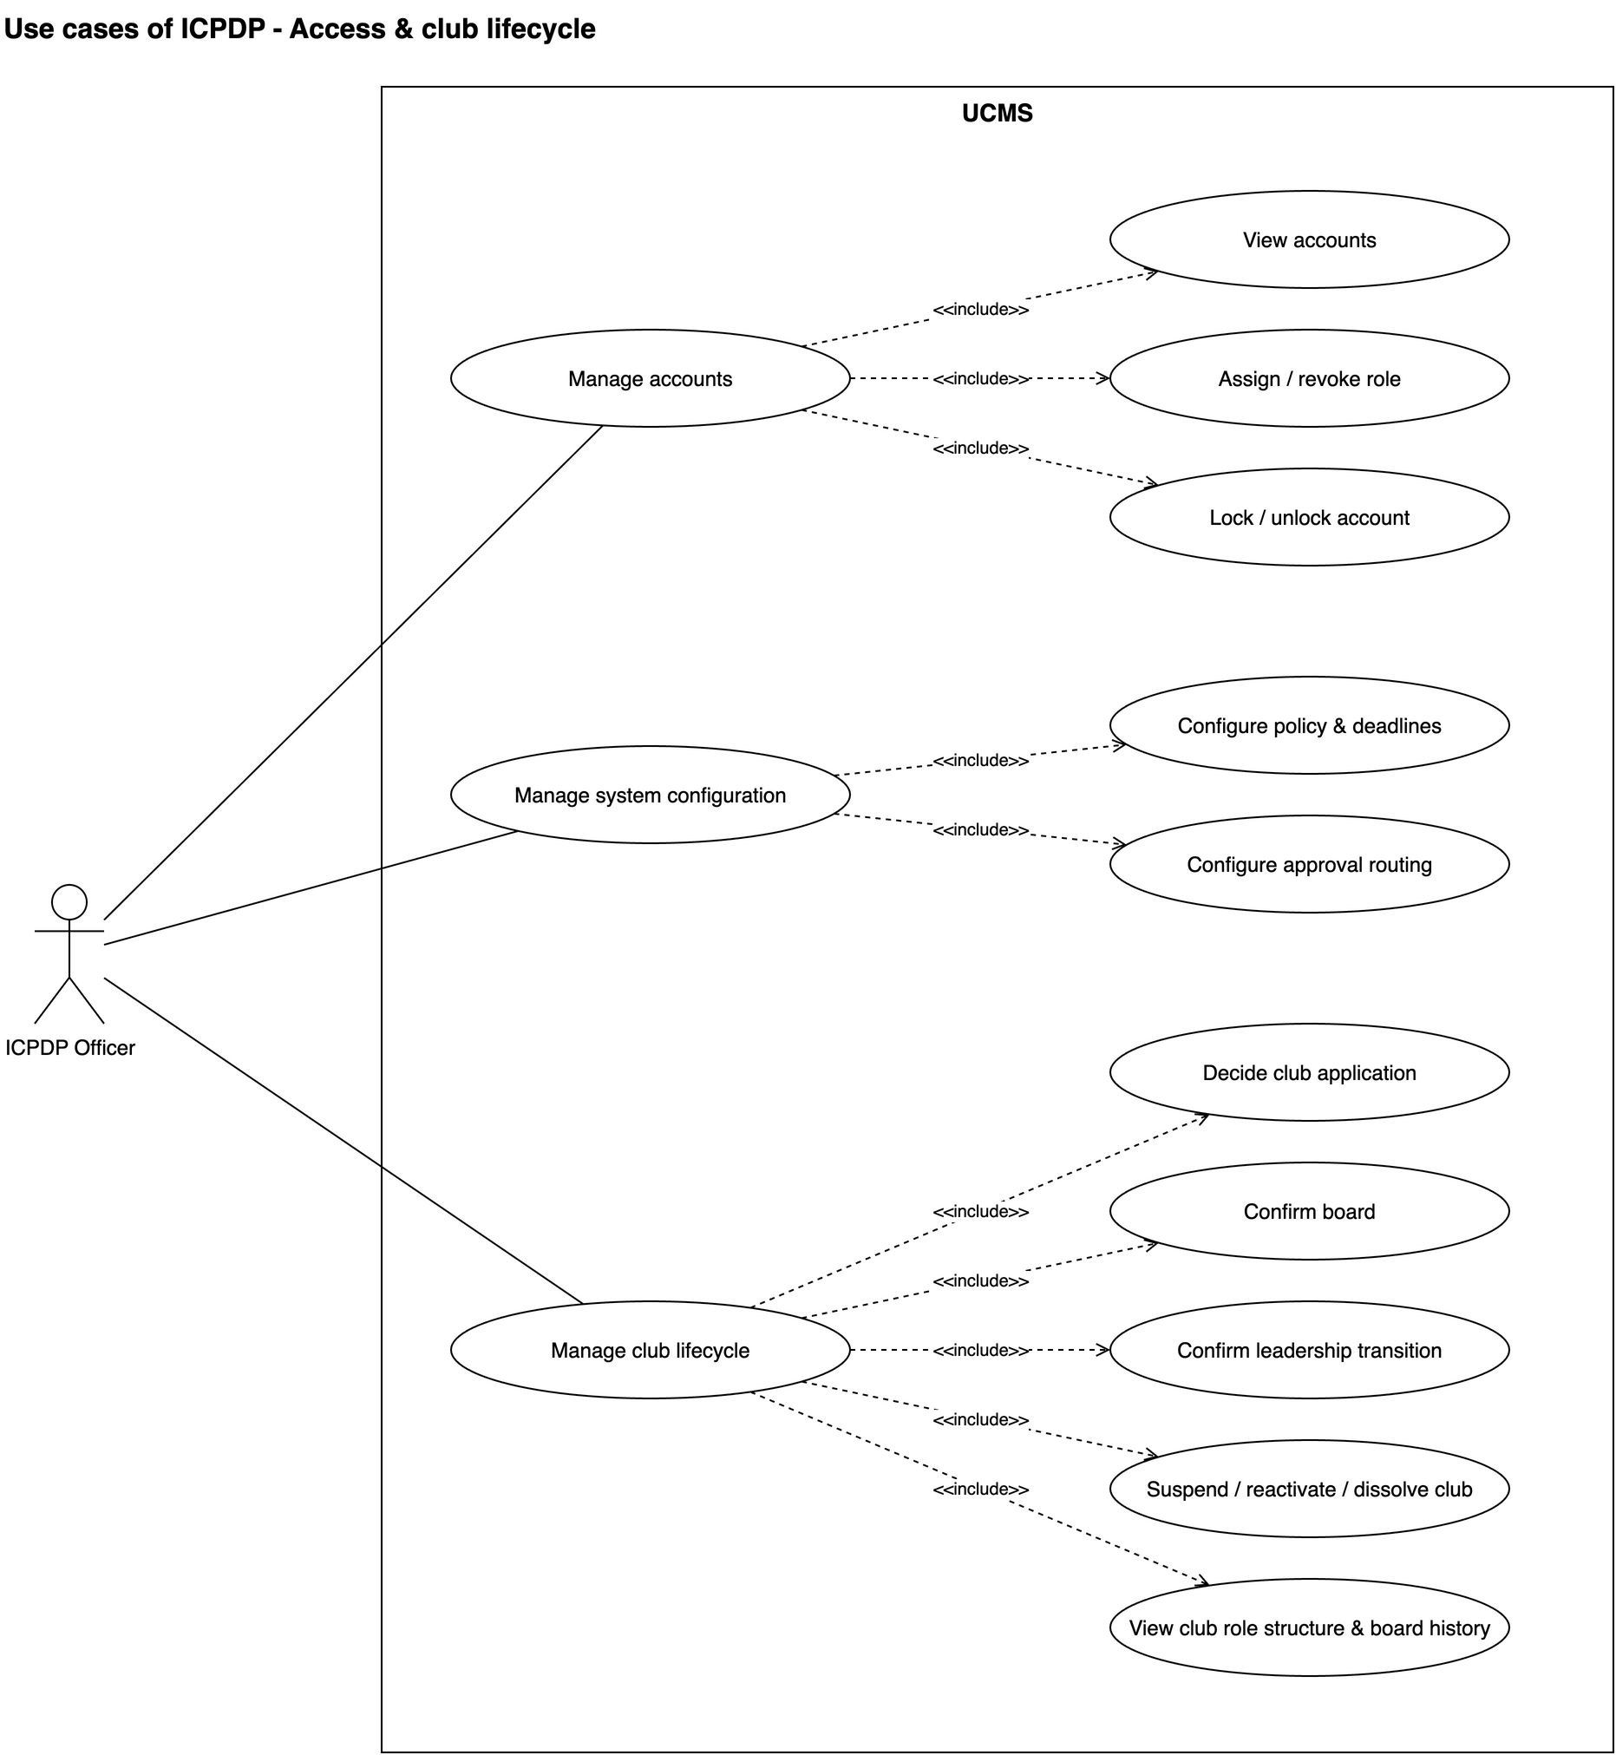
Figure III.3.7: Use cases of the ICPDP Officer — access & club lifecycle
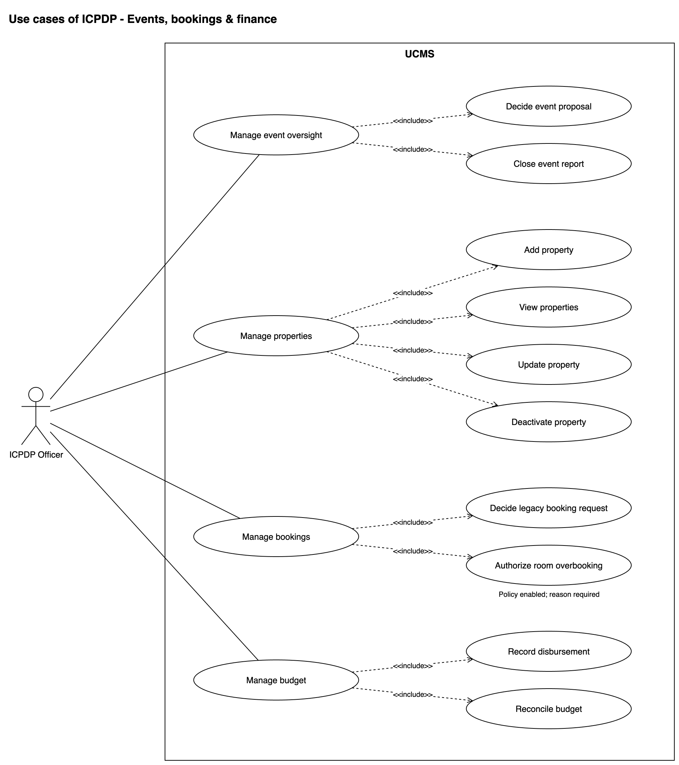
Figure III.3.8: Use cases of the ICPDP Officer — events, bookings & finance
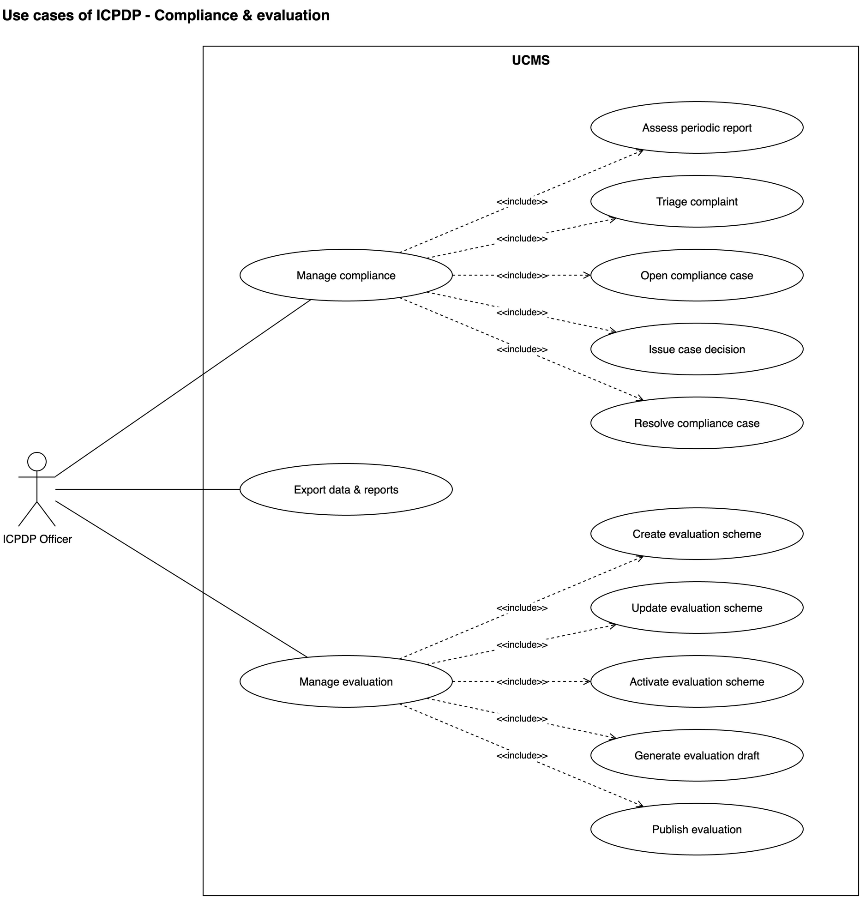
Figure III.3.9: Use cases of the ICPDP Officer — compliance & evaluation

2.2.2 Use case descriptions
Table III.2 lists the 52 business use cases of the system, the actor accountable for each and what it produces. Every use case has exactly one primary actor; UC31 is the only one with a supporting actor.
ID | Use Case | Actor(s) | Use Case Description
01 | Authenticate via Google OAuth and enter the role workspace | Student / Club Member / Club Leader / ICPDP Officer | Any university user signs in through Google OAuth. The system validates the e-mail domain, maps the account to a User, loads the active role set and routes the user to the workspace of that role.
02 | Open my role dashboard | Student / Club Member / Club Leader / ICPDP Officer | Each role opens one screen that answers two questions: what needs my action, and what happened to what I submitted. Every figure is a live query against the module that owns the data.
03 | Manage accounts and role assignments | ICPDP Officer | The officer grants or revokes an ICPDP role or the special role of BR19, and locks or unlocks an account, controlling who may act in the system independently of who may sign in to it.
04 | Configure institutional policy and deadlines | ICPDP Officer | The officer edits the nine institutional values the system treats as policy — allowed domain, founding headcount, mandatory documents, report deadlines and reminder offsets, conflict threshold, feedback window and minimum respondents, overbooking policy, enforcement switches and the academic calendar.
05 | Configure the approval routing rules | ICPDP Officer | The officer defines which requests need a second level of approval inside ICPDP, expressed as conditions over request type, amount, event risk, property class and club compliance history.
06 | Discover clubs and open activity | Student | The student browses or searches clubs, opens a club page and continues into a recruitment application or an event registration. This is the entry point of the whole product.
07 | Submit a club establishment application | Student | A founding student enters the club identity, declares the founding members, uploads the mandatory documents and submits the application. A resubmission after a revision request writes a new immutable version.
08 | Assess and decide the club establishment application | ICPDP Officer | One review session that ends in exactly one of three outcomes — request revision, approve or reject — with the reasoning, the actor and the timestamp on the record.
09 | Configure the club profile and organization structure | Club Member | The board completes the operating information of a recognized club and models its internal units — boards, departments and the positions each may hold.
10 | Nominate the club management board | Club Leader | The club proposes, seat by seat, the members who will hold the board positions of a term, and submits the nomination for confirmation.
11 | Confirm the management board | ICPDP Officer | ICPDP confirms the nominated board, which activates the term, grants the matching permissions and lets a founding club leave Pending Setup.
12 | Plan the leadership transition | Club Leader | The outgoing board prepares the handover: the new term, the candidates, and the outstanding events, budgets and reports the club must carry across the boundary.
13 | Confirm the leadership transition | ICPDP Officer | ICPDP approves the handover, which closes the old term, activates the new one and moves the permissions across in a single audited step.
14 | Request club activity suspension | Club Leader | The board asks ICPDP to pause the club formally, stating the reason, the period and how the outstanding obligations will be handled.
15 | Suspend, reactivate or dissolve a club | ICPDP Officer | The officer controls the club lifecycle from one place. Suspension takes effect at once; dissolution is scheduled — the club finishes the current semester, spends the next one in Dissolving, and is archived at its end.
16 | Create and publish a recruitment campaign | Club Member | The club defines the positions, criteria, application window, capacity, selection steps and application form, then publishes the campaign so students can find it in UC06.
17 | Submit a club membership application | Student | The student picks an open campaign, fills in its form, attaches what the campaign asks for and submits; the application is linked to the membership it may lead to.
18 | Screen and decide membership applications | Club Member | One session takes a campaign's applications from Submitted through screening and shortlisting to a decision of Accepted, Rejected or Waitlisted, with the reasoning kept.
19 | Record candidate evaluation | Club Member | A reviewer scores a shortlisted candidate against the rubric configured for the campaign and adds a comment; the evaluation becomes immutable once the decision is taken.
20 | Onboard accepted candidates | Club Member | Confirming an acceptance creates the ClubMembership with a default role and a join date, and gives the new member access to the member workspace.
21 | Manage membership status | Club Member | The club keeps the roster true: Active and Inactive are reversible, Left and Banned are final, every change carries an effective date and a ban always carries a reason.
22 | Request to leave a club | Club Member | The member files a withdrawal request with a reason and a requested date; the club executes it in UC21, so the student initiates and the club records.
23 | Manage club roles and permissions | Club Leader | The Club Leader creates the roles of the club, configures the permissions of each role from the fixed catalogue and assigns members to roles; changes take effect at once, need no ICPDP confirmation outside the board seats, and are audited.
24 | Use my member workspace | Club Member | A member sees their membership record and position, the roster and board, the upcoming events with their registration state, their attendance history and their outstanding obligations.
25 | Submit an event proposal | Club Member | The club submits an event proposal; the system evaluates the event conflict rule. New room reservations are made independently through UC45 and are automatically confirmed.
26 | Assess and decide the event proposal | ICPDP Officer | The officer decides the event proposal and its budget section. Room reservation is independent: new rooms are reserved directly in UC45, while UC46 handles legacy booking requests only.
27 | Publish the event and open registration | Club Member | The club sets the registration window, audience scope and public details of an approved event and publishes it; the event becomes Upcoming and visible to its audience.
28 | Cancel or reschedule an event | Club Member | The club cancels or reschedules an approved event with a reason; the linked booking is released or updated, registrants are notified and the report and budget obligations are recomputed.
29 | Register for an event | Student | The student registers against the event record itself; the system validates the window, the audience scope, duplication and capacity in a single guarded write.
30 | Manage capacity and the waitlist | Club Member | The club adjusts the capacity or promotes a waitlisted student; promotion follows the policy defined in the policy document and the waitlist order is preserved.
31 | Check in to an event | Student (supporting actor: CMB) | The participant presents or scans the event code at the venue; the system verifies the registration and the time window, creates exactly one attendance record and opens the feedback window for that participant.
32 | Finalize event attendance | Club Member | The club reviews the abnormal check-ins, corrects or confirms each one with a reason, and locks the dataset that the post-event report and the evaluation rely on.
33 | Submit the post-event report | Club Member | The system preloads the approved proposal, the finalized attendance, the budget and expenses and the feedback summary; the club adds the actual result, the incidents and the lessons learned and submits.
34 | Assess and close the event report | ICPDP Officer | The officer compares plan against actual and either accepts the report and closes the event, returns it for correction, or records a finding that opens a compliance case.
35 | Record disbursement | ICPDP Officer | The officer records every money flow of an approved event budget — advances before the event, a top-up after reconciliation and refunds from the club — as tracking only; the advanced and topped-up total never exceeds the approved amount without an amendment.
36 | Record expenses and submit the settlement | Club Member | The club records actual spending against the advanced event budget with the evidence each category requires, and after the event ends or is cancelled submits the settlement before its deadline.
37 | Reconcile budget and spending | ICPDP Officer | The officer accepts or rejects each expense of the settlement; the system fixes the accepted spending and the settlement balance, which closes the budget, triggers a top-up, or puts the unsubstantiated advance into recovery.
38 | Submit the periodic activity report | Club Member | The system preloads the events, membership figures, attendance and finance position of the period; the club adds the narrative, the plan for the next period and any external evidence.
39 | Assess the periodic activity report | ICPDP Officer | The officer checks the report against the figures the system itself holds and accepts it, or returns it for correction with structured comments.
40 | Manage violation and compliance cases | ICPDP Officer | A breach is handled as a case with a state, an owner and a trail: Open, Under Investigation, Awaiting Club Response, Decision Issued, Corrective Action, Resolved.
41 | Configure the evaluation scheme | ICPDP Officer | The officer defines the dimensions, weights and classification thresholds of an evaluation period and activates exactly one scheme for it.
42 | Generate the club performance evaluation draft | ICPDP Officer | The system collects a period of operational data across every module, applies the active scheme and produces a scored draft in which each dimension carries the evidence behind it.
43 | Review, finalize and publish the evaluation | ICPDP Officer | The officer resolves the anomalies, adds the manual dimensions the scheme permits, finalizes the result and publishes it to the clubs; a published evaluation is never edited in place.
44 | Manage the property catalogue | ICPDP Officer | ICPDP defines what clubs may book: code, name, type, capacity, location, attached equipment, bookable hours, blackout periods and the active state.
45 | Reserve a club room directly | Club Member | A member with club.booking.manage chooses an active room, date and campus slot. The system checks availability and creates an Approved reservation immediately, with the responsible Club Leader snapshotted; no review task is created.
46 | Authorize room overbooking and review legacy requests | ICPDP Officer | ICPDP may create an overlapping room reservation for a selected club only when allowOverbooking is enabled and a reason is entered. The system rechecks policy, role, conflicts, room/club state and the responsible leader in one transaction, records the exception in the audit log and notifies the leader. ICPDP also handles existing legacy review tasks; ordinary new club reservations are confirmed automatically.
47 | Track and cancel or release a booked property | Club Member | The club frees a resource it no longer needs; a booking whose event is cancelled is released automatically, and a late cancellation is recorded as a compliance signal.
48 | Submit post-event feedback | Student | A participant who checked in scores the event per criterion and adds a comment, optionally anonymously; the record is immutable and CMB sees it only in aggregate.
49 | Review event feedback | Club Member | The club reads the per-criterion average, the distribution and the comments of an event and carries the conclusion into the post-event report.
50 | Submit a complaint about a club | Student | The student raises a complaint about a club or one of its activities; it goes straight to ICPDP and the club gains access only if ICPDP forwards it.
51 | Triage a complaint | ICPDP Officer | The officer classifies the severity and validity of a complaint and chooses one of three outcomes: dismiss with a reason, forward it to the club for a response, or escalate it into a compliance case.
52 | Respond to a forwarded complaint | Club Member | The club answers a forwarded complaint on the record, attaching evidence and naming any action taken; ICPDP then closes or escalates it.
Table III.2: Use case descriptions

3. Functional Requirements

3.1 System Functional Overview

3.1.1 Business Flow
Figure III.4 summarizes the ten main business flows of the system; every use case belongs to at least one of them. Authentication (UC01) and the role dashboard (UC02) are the common entry point of every flow and are not repeated.
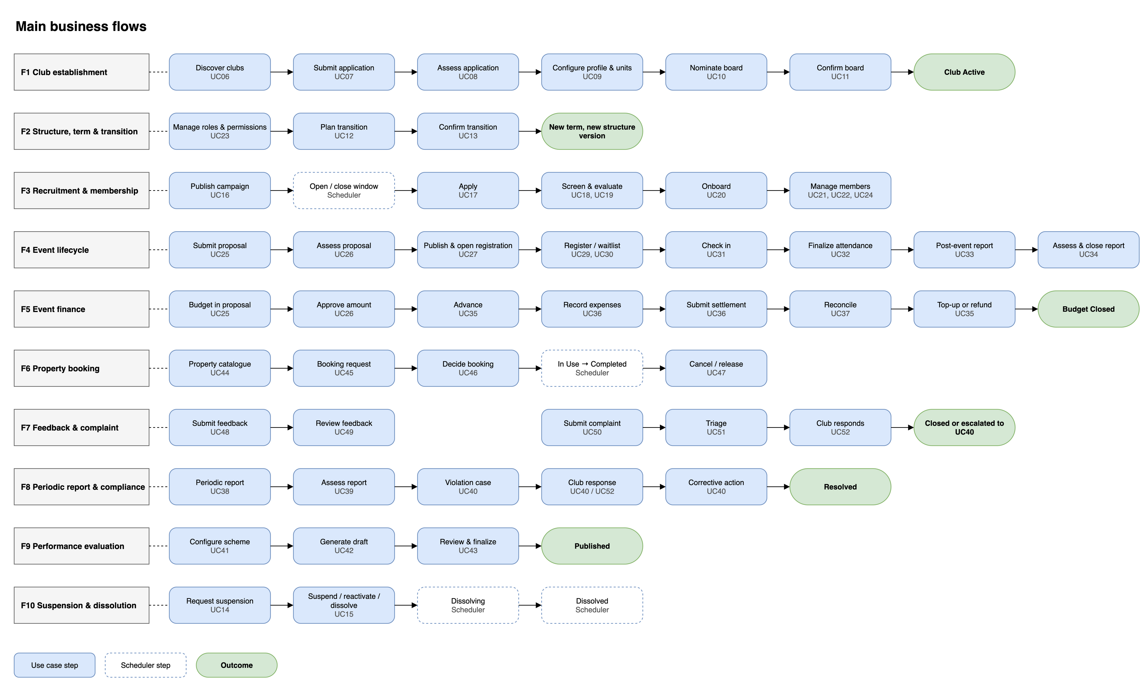
Figure III.4: Main business flows
F1 Club establishment — a student discovers clubs (UC06) and submits the application with the founding members, the documents and the proposed role structure (UC07); the ICPDP requests a revision, rejects or approves it (UC08). Approval creates the club in Pending Setup with role structure version 1; the founder configures the profile and the departments (UC09) and nominates the board (UC10), and the ICPDP confirmation (UC11) makes the club Active.
F2 Structure, term and transition — the Club Leader manages roles and permissions (UC23); at the end of a term the Leader plans the transition (UC12) and the ICPDP confirms it (UC13), which closes the old term, opens the new one, moves the permissions and records a new structure version when the executive board roles change.
F3 Recruitment and membership — the club publishes a campaign (UC16); the scheduler opens and closes the application window; students apply (UC17); the club screens and evaluates the candidates (UC18, UC19) and onboards the accepted ones (UC20), who become Active members with the Members role; membership is then managed through UC21, UC22 and UC24.
F4 Event lifecycle — the club submits a proposal with an optional budget section and booking request (UC25); an Internal event without a budget is recorded directly (BR53), any other is decided by the ICPDP (UC26). The approved event is published (UC27), students register (UC29, UC30), the scheduler starts and ends it, attendees check in (UC31), the club finalizes attendance (UC32) and submits the post-event report (UC33), which the ICPDP assesses and closes (UC34). UC28 cancels or reschedules the event.
F5 Event finance — the budget is requested in the proposal and approved with it (UC25, UC26); the ICPDP advances part or all of it before the event (UC35); the club records every expense with its evidence and, after the event, submits the settlement before its deadline (UC36, BR57); the ICPDP accepts or rejects each expense (UC37), then tops up the club or recovers the unsubstantiated advance (UC35, BR58) before the budget closes.
F6 Property booking — ICPDP maintains the catalogue (UC44); the club selects an active room, date and campus slot (UC45); the system reserves it immediately as Approved and snapshots the responsible Club Leader. UC46 processes legacy requests only. The scheduler moves reservations to In Use and Completed; UC47 handles cancellation and release.
F7 Feedback and complaint — attendees who checked in give feedback (UC48) and the club reads the aggregated summary (UC49); a student complains about a club (UC50), and the ICPDP triages the complaint (UC51): it dismisses it, forwards it to the club for a response (UC52) or escalates it to a violation case.
F8 Periodic report and compliance — the club submits the periodic activity report (UC38) and the ICPDP assesses it (UC39); late reports, overdue settlements or refunds, escalated complaints and late cancellations open a violation case (UC40) that runs through the club response, the decision and the corrective action to Resolved; overdue obligations may block new proposals (BR21).
F9 Performance evaluation — the ICPDP configures the scheme (UC41), the system generates the draft from the operational data (UC42), and the ICPDP reviews, finalizes and publishes it (UC43).
F10 Suspension and dissolution — the Club Leader requests a suspension (UC14) and the ICPDP suspends, reactivates or dissolves the club (UC15); a dissolution takes effect by schedule: Dissolving at the start of the next semester and Dissolved at its end.
Figures III.5 to III.8 detail four of these flows.
Figure III.5 shows the main functional overview flow for establishing and setting up club operations.
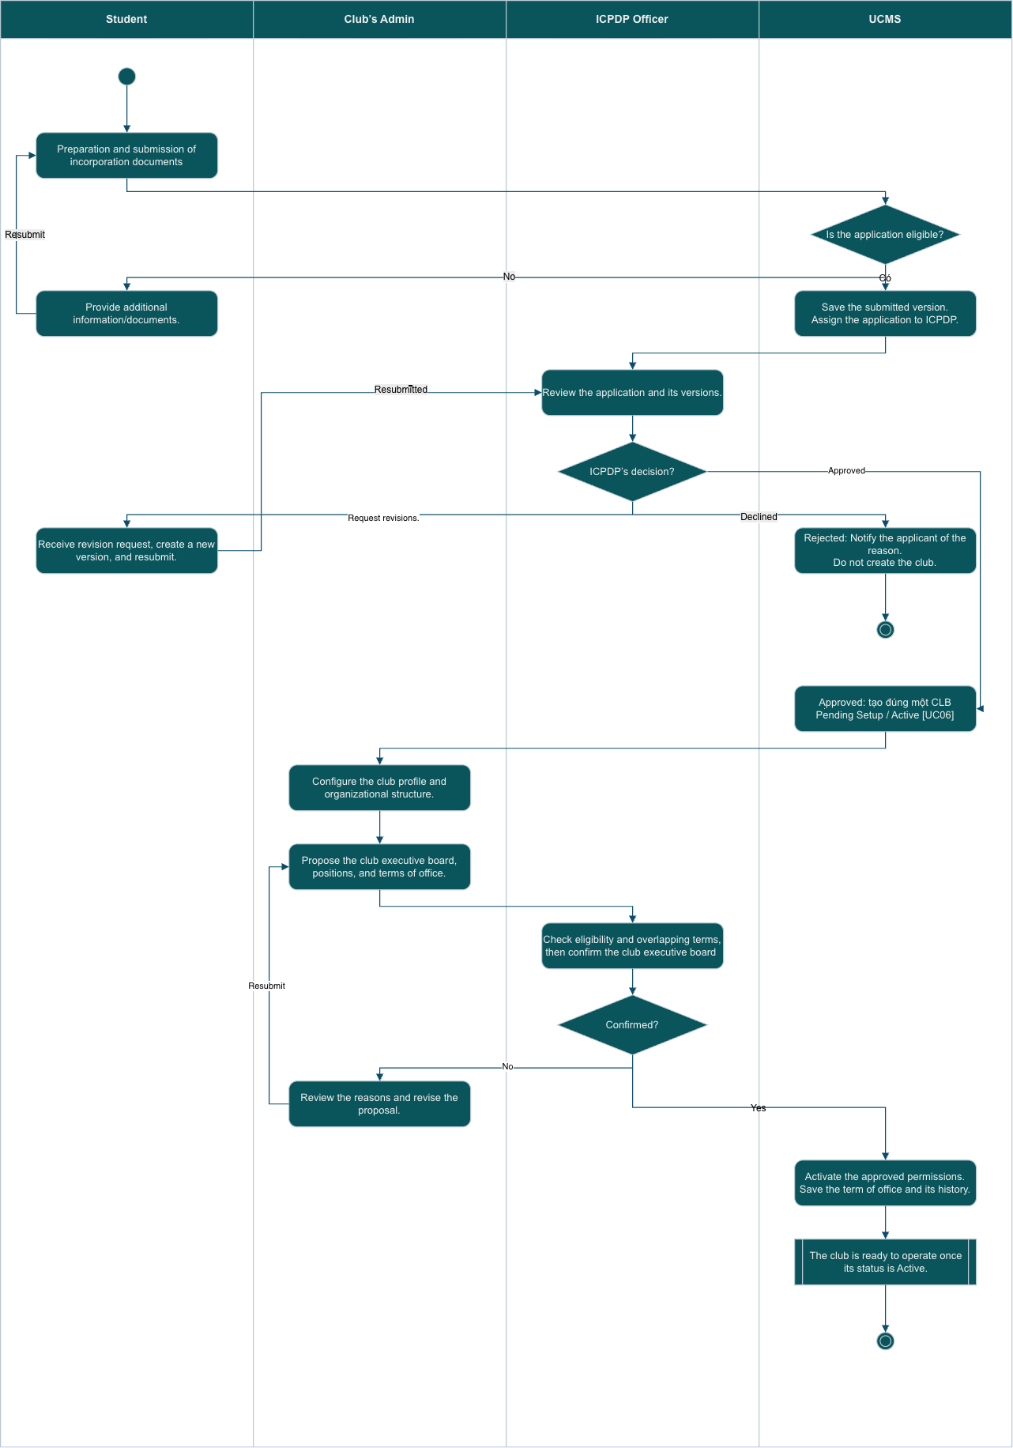
Figure III.5: Club establishment and operational setup flow
Figure III.6 shows the main functional overview flow of club member recruitment.
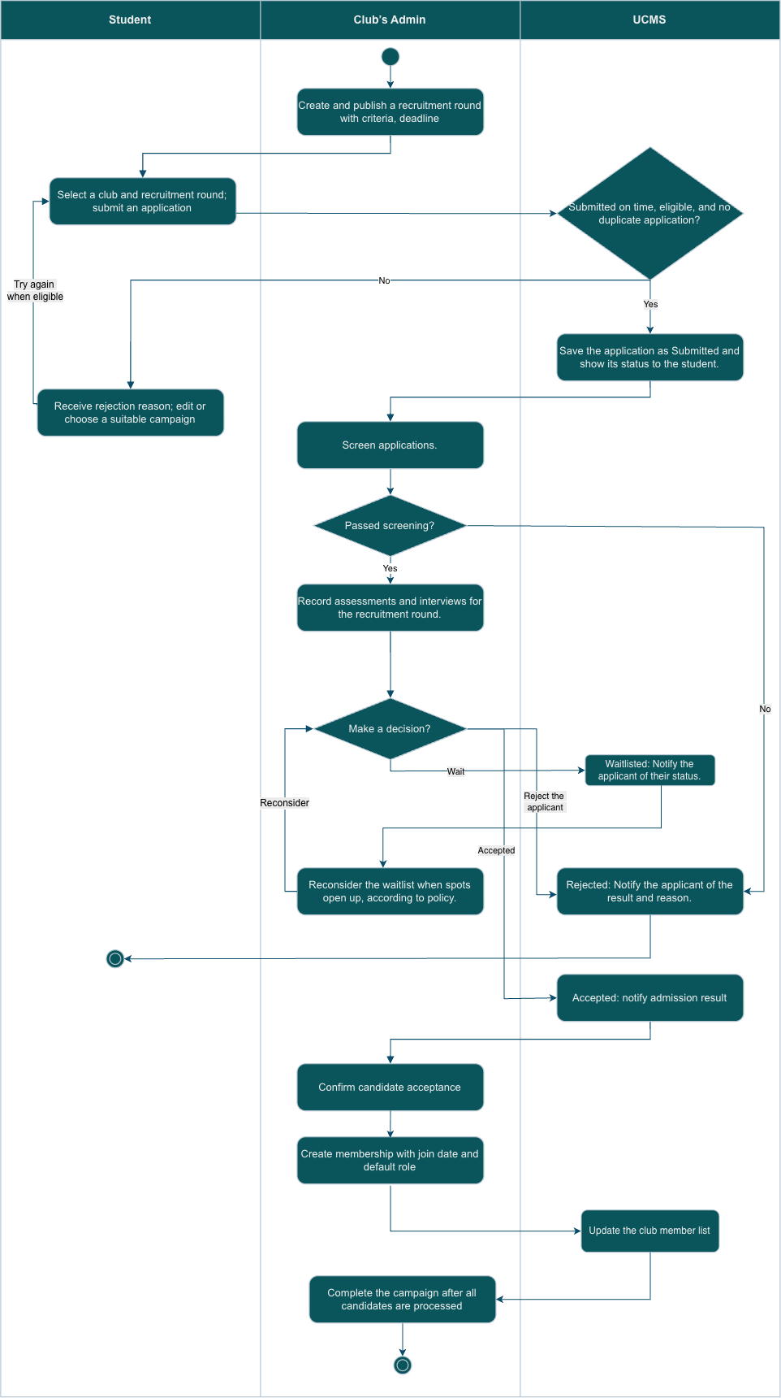
Figure III.6: Club member recruitment flow
Figure III.7 shows the main functional overview flow of event proposal and approval.
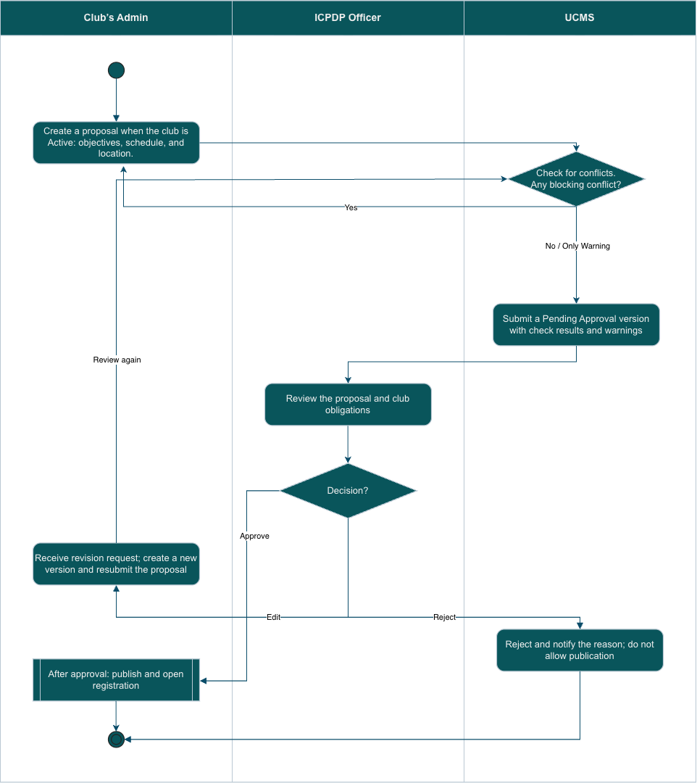
Figure III.7: Event proposal and approval flow
Figure III.8 shows the main functional overview flow of the termination of a membership.
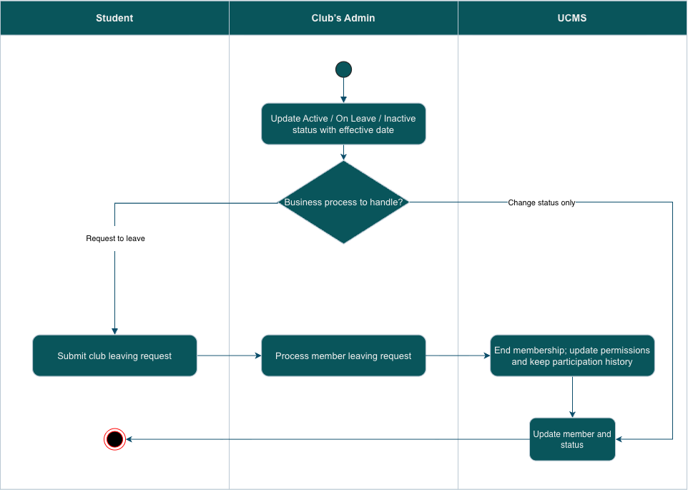
Figure III.8: Termination of membership flow

3.1.2 Screen Flows
The screen flows below show how each role moves between the screens of the system. The three widest flows are printed on landscape pages so that every screen name stays legible.

3.1.2.1 Student flow
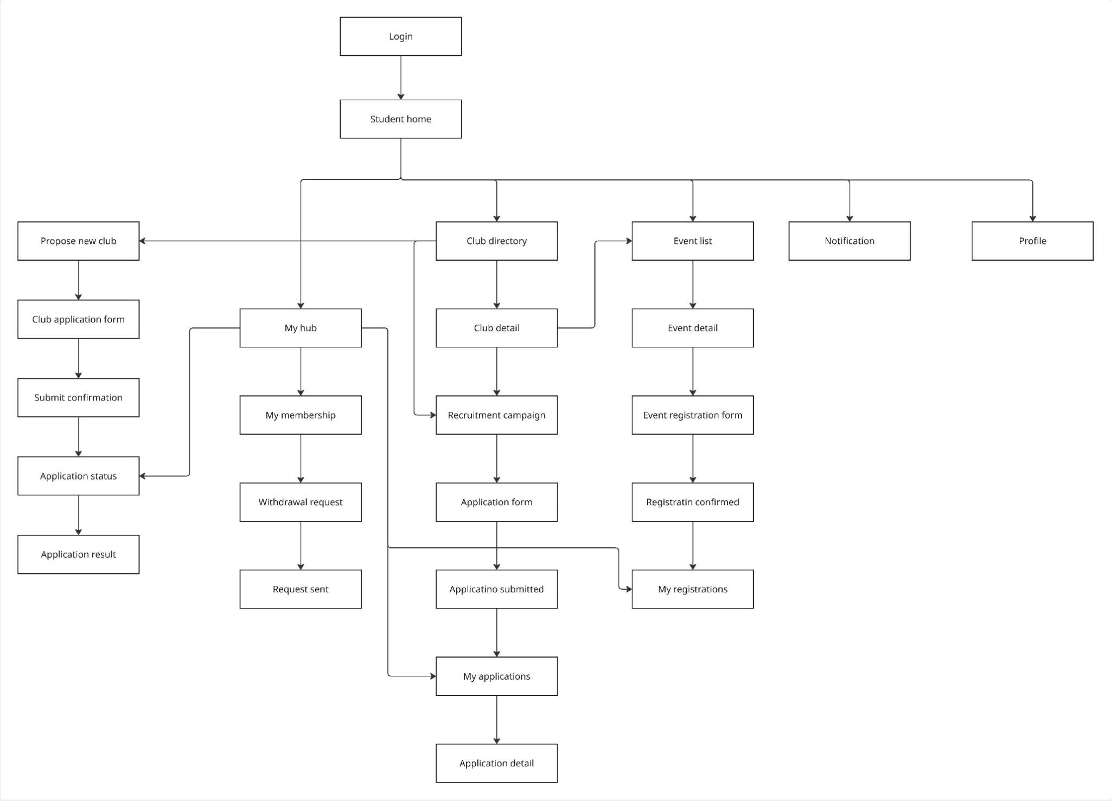
Figure III.9: Student screen flow

3.1.2.2 Club Admin flow
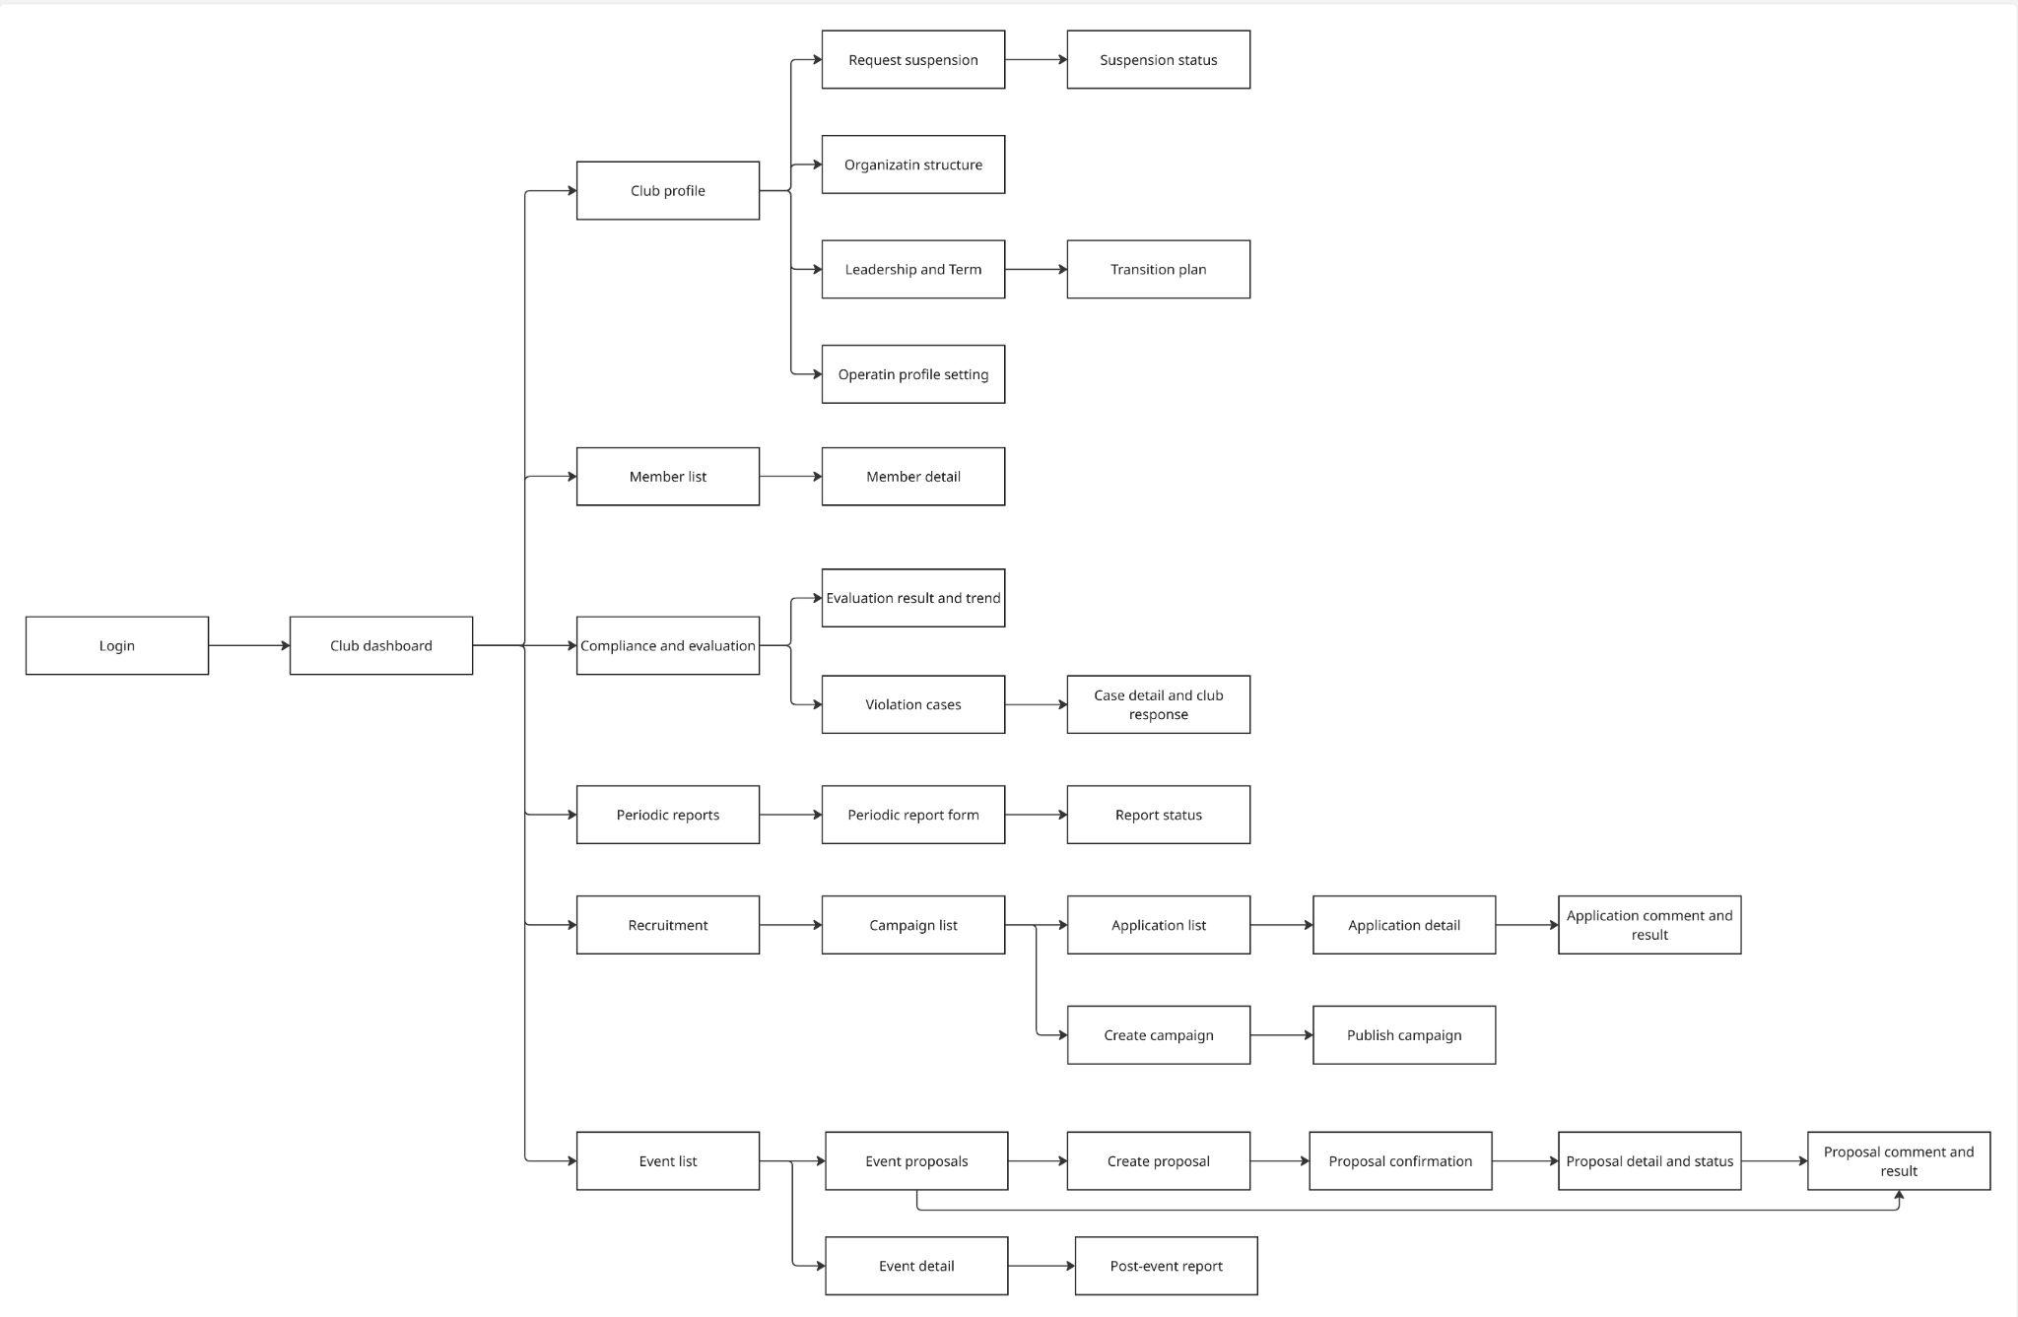
Figure III.10: Club Admin screen flow

3.1.2.3 ICPDP Officer flow
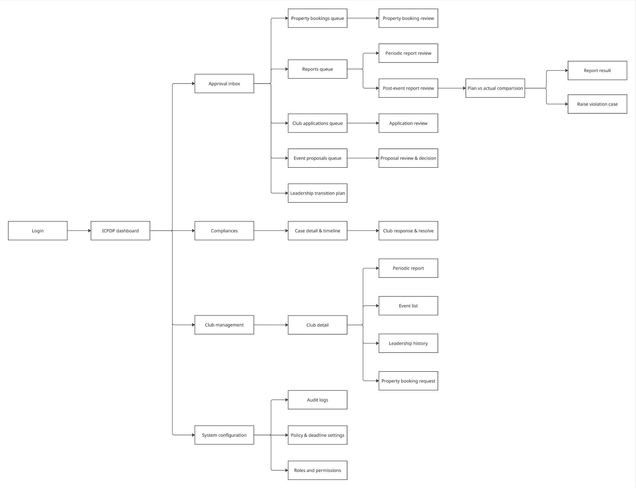
Figure III.11: ICPDP Officer screen flow

3.1.2.4 Guest flow
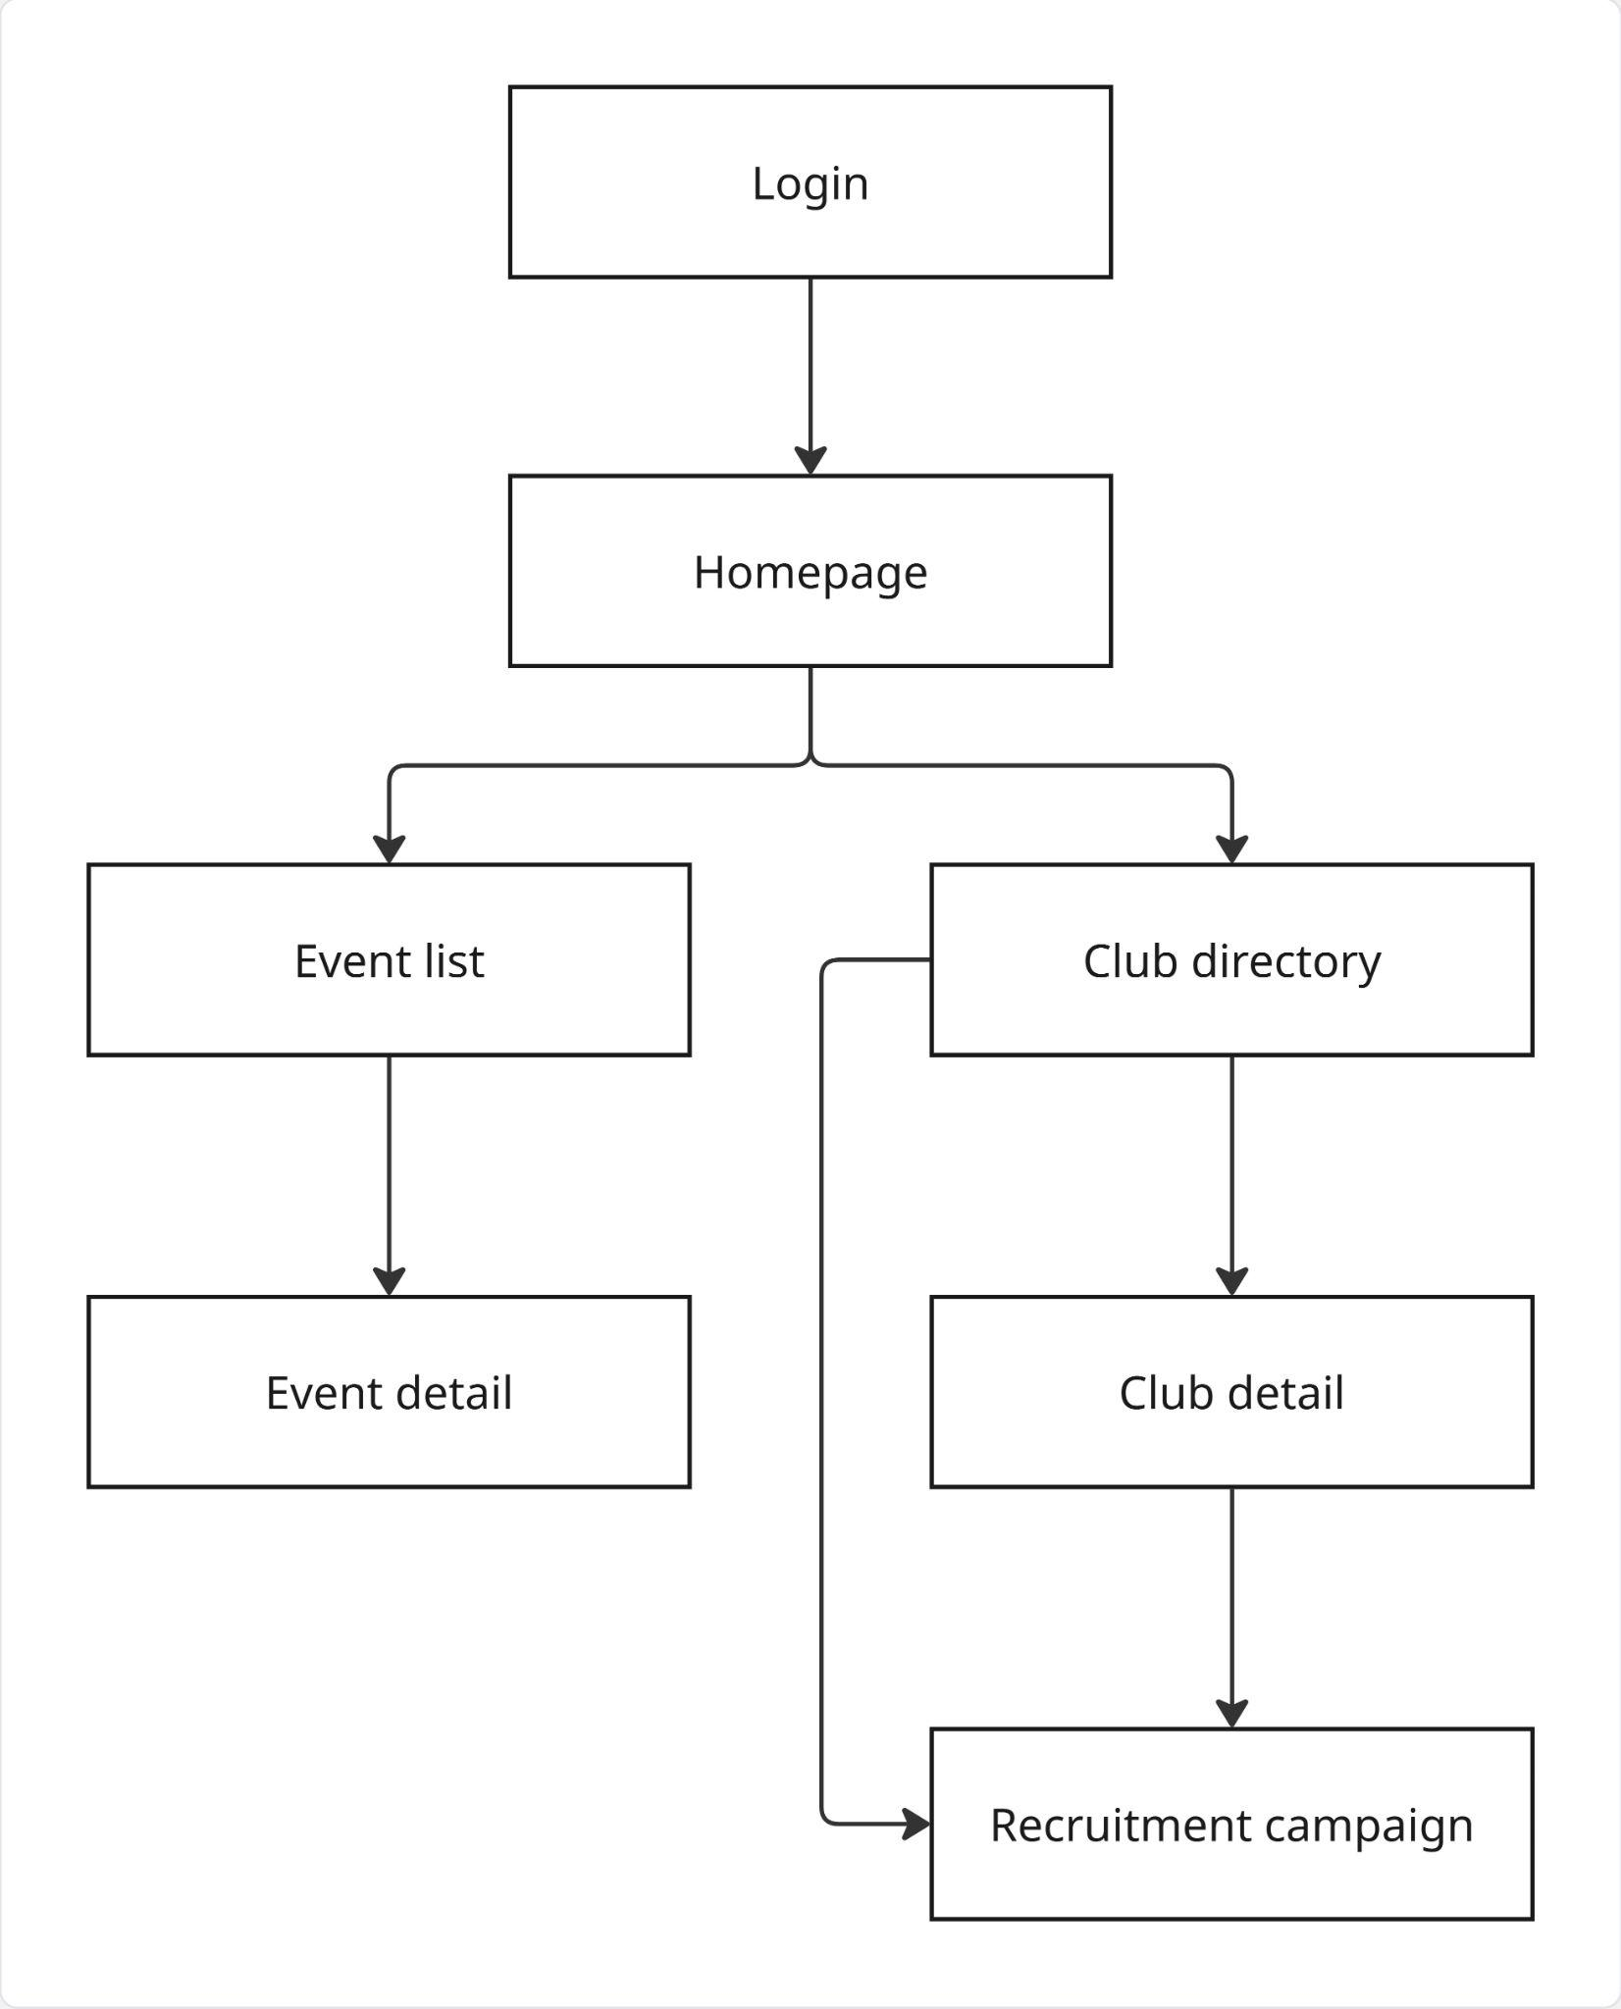
Figure III.12: Guest screen flow

3.1.3 Screen Descriptions
Table III.3 lists every screen of the system and the use case it serves, so that no use case is left without an entry point and no screen exists without a use case or a non-functional requirement behind it.
# | Screen | Description | Use case
1 | Login | Sign in to the system with a university Google account | UC01
2 | Homepage | Public landing page, navigation to events and clubs | UC06
3 | Event list | Public list of published events, filterable by club or time | UC06
4 | Event detail | Details of a single event: time, location, content, capacity | UC06
5 | Club directory | List of Active and Suspended clubs in the university | UC06
6 | Club detail | Club overview: mission, board members, activity history | UC06
7 | Recruitment campaign (public) | Information on a club's currently open recruitment drive | UC06
8 | Propose new club | Start a new club establishment application | UC07
9 | Club application form | Enter founding details: mission, founding members, documents | UC07
10 | Submit confirmation | Confirm before submitting the club application | UC07
11 | Application status | Track the review status of the club application | UC02, UC07
12 | Application result | Final outcome: approved, rejected or revision requested, with reason | UC08
13 | My hub | Student dashboard summarizing applications, memberships, registrations, complaints | UC02
14 | My membership | List of clubs the student is a member of | UC24
15 | Member workspace | Membership record, roster, board, upcoming events, attendance history, outstanding obligations | UC24
16 | Withdrawal request | Submit a request to leave a club | UC22
17 | Request sent | Confirmation that the withdrawal request was sent | UC22
18 | Recruitment campaign detail | View a campaign before applying | UC06, UC17
19 | Application form (membership) | Fill out an application to join a club | UC17
20 | Application submitted | Confirmation that the membership application was submitted | UC17
21 | My applications | List of membership applications submitted by the student | UC02
22 | Application detail (student) | Details of one application and its review status | UC02, UC18
23 | Event registration form | Register to attend a specific event | UC29
24 | Registration confirmed | Confirmation that event registration succeeded | UC29
25 | My registrations | List of registered events, used as the entry point for check-in | UC29, UC31
26 | Event check-in | Scan or enter the event code at the venue to record attendance | UC31
27 | Event feedback form | Score the event per criterion and comment, optionally anonymously | UC48
28 | Submit complaint | Raise a complaint about a club or one of its activities | UC50
29 | My complaints | List and status of the complaints raised by the student | UC02, UC50
30 | Notification | List of in-app notifications sent to the user | UC02
31 | Profile | Personal account information synchronized from Google | UC01
32 | Club dashboard | CMB overview screen and entry point to all club modules | UC02
33 | Club profile | Operating profile: general information, structure, term | UC09
34 | Operating profile setting | Edit the club's operating information | UC09
35 | Organization structure | Club organizational chart, departments and positions | UC09
36 | Position assignment | Assign an internal position to an active member | UC23
37 | Leadership and term | Manage the board nomination and the term duration | UC10
38 | Transition plan | Plan the handover of leadership at the end of a term | UC12
39 | Request suspension | Submit a request to suspend club operations | UC14
40 | Suspension status | Track the status of the suspension request | UC02, UC14
41 | Member list | Roster of all club members with state and position | UC21
42 | Member detail | Member information, position and status history | UC21
43 | Recruitment | Recruitment management landing screen | UC16
44 | Campaign list | List of recruitment campaigns of the club | UC16
45 | Create / publish campaign | Create and publish a new recruitment campaign | UC16
46 | Application list (campaign) | List of applications received for a campaign | UC18
47 | Application detail (reviewer) | View a candidate's application details | UC18
48 | Candidate evaluation | Score a shortlisted candidate against the rubric | UC19
49 | Application comment and result | Record the decision on a candidate and the reason | UC18
50 | Onboard candidates | Turn accepted candidates into club memberships | UC20
51 | Club event list | List of events organized by the club | UC27
52 | Event proposals | List of submitted event proposals and their revisions | UC25
53 | Create proposal | Draft a new event proposal, with conflict feedback | UC25
54 | Proposal confirmation | Confirm before submitting the event proposal | UC25
55 | Proposal detail and status | Track the review status of the event proposal | UC02, UC25
56 | Proposal comment and result | View reviewer comments and the decision | UC26
57 | Publish event | Set the registration window, audience scope and public details | UC27
58 | Cancel / reschedule event | Cancel or reschedule an approved event with a reason | UC28
59 | Registration and waitlist | Registration list, capacity adjustment and waitlist promotion | UC30
60 | Attendance finalization | Review abnormal check-ins and lock the official attendance dataset | UC32
61 | Post-event report | Report actual results after the event ends | UC33
62 | Feedback summary (club) | Aggregated per-criterion score, distribution and comments of an event | UC49
63 | Event budgets | Approved event budgets of the club with their disbursed and spent totals | UC36
64 | Proposal budget section | Enter the budget lines and the requested total of an event proposal | UC25
65 | Expenses and settlement | Record an expense with its evidence and submit the settlement after the event | UC36
66 | Budget position | Approved, advanced, spent, supported and remaining figures of the club, and any amount to refund | UC02, UC37
67 | Direct room reservation | Choose an available room and date/slot; reserve immediately with the responsible Club Leader recorded | UC45
68 | My bookings | Track, cancel or release the bookings of the club | UC47
69 | Periodic reports | List of periodic reports due or submitted | UC38
70 | Periodic report form | Form to enter the periodic report content | UC38
71 | Report status | Review status of the periodic report | UC02, UC39
72 | Compliance and evaluation (club) | Overview of compliance cases and performance evaluation of the club | UC02
73 | Evaluation result and trend | Published evaluation results of the club over time | UC43
74 | Violation cases (club) | List of compliance cases recorded against the club | UC40
75 | Case detail and club response | Case details and the response of the club | UC40
76 | Forwarded complaint | Read a forwarded complaint and answer it on the record | UC52
77 | ICPDP dashboard | Overview screen and entry point to all review modules | UC02
78 | Approval inbox | Unified inbox of every item pending an ICPDP decision | UC02
79 | Club applications queue | List of club establishment applications pending review | UC08
80 | Application review and decision | Review an establishment application and decide | UC08
81 | Board confirmation | Confirm or return a board nomination | UC11
82 | Leadership transition review | Review and confirm a leadership transition plan | UC13
83 | Club management / club detail | List of clubs and the detail of a single club | UC15
84 | Club lifecycle action | Suspend, reactivate or dissolve a club with a reason | UC15
85 | Leadership history | History of the past leadership terms of a club | UC13
86 | Event proposals queue | List of event proposals pending review | UC26
87 | Proposal review and decision | Review an event proposal and decide | UC26
88 | Reports queue | List of periodic and post-event reports pending review | UC34, UC39
89 | Post-event report review | Review a submitted post-event report | UC34
90 | Plan vs actual comparison | Compare planned against actual event outcome | UC34
91 | Periodic report review | Review and decide on a periodic report | UC39
92 | Report result | Outcome of the report review, visible to the club | UC34, UC39
93 | Raise violation case | Log a violation found during a report or audit review | UC40
94 | Compliance cases | Overview of the ongoing compliance cases | UC40
95 | Case detail and timeline | Case details and processing history | UC40
96 | Club response and resolve | Read the response of the club and finalize the decision | UC40
97 | Complaint queue | List of complaints awaiting triage | UC51
98 | Complaint triage | Classify a complaint and dismiss, forward or escalate it | UC51
99 | Event budgets queue | Event budgets awaiting an advance, a settlement review, a top-up or a refund | UC35, UC37
100 | Proposal budget review | Review the budget section of a proposal and set the approved amount | UC26
101 | Record money flow | Record an advance, a top-up or a refund from the club | UC35
102 | Reconciliation | Accept or reject each expense; approved, advanced, accepted spending, settlement balance and amount to recover | UC37
103 | Property catalogue | Define what clubs may book, with bookable hours and blackouts | UC44
104 | Legacy property booking queue | Existing requests pending decision; direct reservations do not create review tasks | UC46
105 | Legacy booking review and decision | Claim and decide an existing legacy booking request | UC46
106 | Evaluation scheme | Configure dimensions, weights and classification thresholds | UC41
107 | Evaluation drafts | Generate and inspect the evaluation draft of a period | UC42
108 | Evaluation publication | Finalize and publish the evaluation of a period | UC43
109 | System configuration | Configuration landing screen | UC04, UC05
110 | Policy and deadline settings | Configure the nine institutional policy values and the deadlines | UC04
111 | Approval routing settings | Configure which requests need a second ICPDP approval level | UC05
112 | Roles and permissions | Manage user accounts, roles and account locks | UC03
113 | Audit logs | System-wide, append-only activity log | SE-03
Table III.3: Screen descriptions

3.1.4 Screen Authorization
Table III.4 shows the screen authorization matrix. The matrix reflects the two-layer authorization model: the role determines which screens are reachable, while the use case layer additionally checks that the caller belongs to the club concerned, holds the position concerned and acts inside the current term. A Club Admin is also a student, so every student screen remains reachable for that actor.
# | Screen | Guest | Student | Club Member / Leader | ICPDP Officer
1 | Login | ✓ | ✓ | ✓ | ✓
2 | Homepage | ✓ | ✓ | ✓ | ✓
3 | Event list | ✓ | ✓ | ✓ | ✓
4 | Event detail | ✓ | ✓ | ✓ | ✓
5 | Club directory | ✓ | ✓ | ✓ | ✓
6 | Club detail | ✓ | ✓ | ✓ | ✓
7 | Recruitment campaign (public) | ✓ | ✓ | ✓ | ✓
8 | Propose new club |  | ✓ | ✓
9 | Club application form |  | ✓ | ✓
10 | Submit confirmation |  | ✓ | ✓
11 | Application status |  | ✓ | ✓
12 | Application result |  | ✓ | ✓
13 | My hub |  | ✓ | ✓
14 | My membership |  | ✓ | ✓
15 | Member workspace |  | ✓ | ✓
16 | Withdrawal request |  | ✓ | ✓
17 | Request sent |  | ✓ | ✓
18 | Recruitment campaign detail |  | ✓ | ✓
19 | Application form (membership) |  | ✓ | ✓
20 | Application submitted |  | ✓ | ✓
21 | My applications |  | ✓ | ✓
22 | Application detail (student) |  | ✓ | ✓
23 | Event registration form |  | ✓ | ✓
24 | Registration confirmed |  | ✓ | ✓
25 | My registrations |  | ✓ | ✓
26 | Event check-in |  | ✓ | ✓
27 | Event feedback form |  | ✓ | ✓
28 | Submit complaint |  | ✓ | ✓
29 | My complaints |  | ✓ | ✓
30 | Notification |  | ✓ | ✓ | ✓
31 | Profile |  | ✓ | ✓ | ✓
32 | Club dashboard |  |  | ✓
33 | Club profile |  |  | ✓
34 | Operating profile setting |  |  | ✓
35 | Organization structure |  |  | ✓
36 | Position assignment |  |  | ✓
37 | Leadership and term |  |  | ✓ | ✓
38 | Transition plan |  |  | ✓ | ✓
39 | Request suspension |  |  | ✓
40 | Suspension status |  |  | ✓ | ✓
41 | Member list |  |  | ✓
42 | Member detail |  |  | ✓
43 | Recruitment |  |  | ✓
44 | Campaign list |  |  | ✓
45 | Create / publish campaign |  |  | ✓
46 | Application list (campaign) |  |  | ✓
47 | Application detail (reviewer) |  |  | ✓
48 | Candidate evaluation |  |  | ✓
49 | Application comment and result |  |  | ✓
50 | Onboard candidates |  |  | ✓
51 | Club event list |  |  | ✓
52 | Event proposals |  |  | ✓
53 | Create proposal |  |  | ✓
54 | Proposal confirmation |  |  | ✓
55 | Proposal detail and status |  |  | ✓
56 | Proposal comment and result |  |  | ✓
57 | Publish event |  |  | ✓
58 | Cancel / reschedule event |  |  | ✓
59 | Registration and waitlist |  |  | ✓
60 | Attendance finalization |  |  | ✓
61 | Post-event report |  |  | ✓
62 | Feedback summary (club) |  |  | ✓
63 | Event budgets |  |  | ✓
64 | Proposal budget section |  |  | ✓
65 | Expenses and settlement |  |  | ✓
66 | Budget position |  |  | ✓
67 | Direct room reservation |  |  | ✓
68 | My bookings |  |  | ✓
69 | Periodic reports |  |  | ✓ | ✓
70 | Periodic report form |  |  | ✓
71 | Report status |  |  | ✓ | ✓
72 | Compliance and evaluation (club) |  |  | ✓ | ✓
73 | Evaluation result and trend |  |  | ✓ | ✓
74 | Violation cases (club) |  |  | ✓ | ✓
75 | Case detail and club response |  |  | ✓ | ✓
76 | Forwarded complaint |  |  | ✓
77 | ICPDP dashboard |  |  |  | ✓
78 | Approval inbox |  |  |  | ✓
79 | Club applications queue |  |  |  | ✓
80 | Application review and decision |  |  |  | ✓
81 | Board confirmation |  |  |  | ✓
82 | Leadership transition review |  |  |  | ✓
83 | Club management / club detail |  |  |  | ✓
84 | Club lifecycle action |  |  |  | ✓
85 | Leadership history |  |  | ✓ | ✓
86 | Event proposals queue |  |  |  | ✓
87 | Proposal review and decision |  |  |  | ✓
88 | Reports queue |  |  |  | ✓
89 | Post-event report review |  |  |  | ✓
90 | Plan vs actual comparison |  |  |  | ✓
91 | Periodic report review |  |  |  | ✓
92 | Report result |  |  | ✓ | ✓
93 | Raise violation case |  |  |  | ✓
94 | Compliance cases |  |  |  | ✓
95 | Case detail and timeline |  |  |  | ✓
96 | Club response and resolve |  |  |  | ✓
97 | Complaint queue |  |  |  | ✓
98 | Complaint triage |  |  |  | ✓
99 | Event budgets queue |  |  |  | ✓
100 | Proposal budget review |  |  |  | ✓
101 | Record money flow |  |  |  | ✓
102 | Reconciliation |  |  |  | ✓
103 | Property catalogue |  |  |  | ✓
104 | Legacy property booking queue |  |  |  | ✓
105 | Legacy booking review and decision |  |  |  | ✓
106 | Evaluation scheme |  |  |  | ✓
107 | Evaluation drafts |  |  |  | ✓
108 | Evaluation publication |  |  |  | ✓
109 | System configuration |  |  |  | ✓
110 | Policy and deadline settings |  |  |  | ✓
111 | Approval routing settings |  |  |  | ✓
112 | Roles and permissions |  |  |  | ✓
113 | Audit logs |  |  |  | ✓
Table III.4: Screen authorization

3.1.5 In / Out of scope
Table III.5 shows what the release covers and what is deliberately excluded.
# | In of Scope | Out of Scope
1 | Google OAuth authentication and term-scoped RBAC for three role workspaces | Any home-grown username / password authentication or a self-hosted mail server
2 | Club establishment, lifecycle, leadership and term management | Native mobile application (iOS / Android) development
3 | Recruitment, membership and the member workspace | Internal club messaging, chat and file sharing
4 | Event proposal, approval, publication, registration, check-in and attendance | Facial-recognition attendance and dedicated scanner hardware
5 | Property and facility booking for club activity, with conflict detection | A university-wide room booking engine replacing the institution's own system
6 | Event budget, disbursement, expense, evidence and reconciliation | A full accounting ERP, payroll, tuition processing or a payment gateway
7 | Periodic reporting, compliance cases and configurable performance evaluation | Predictive club-health scoring or any mandatory AI component
8 | Event feedback and student complaint intake with triage | A public social network or a rating platform open to non-participants
9 | In-app and e-mail notification, deadline reminders and escalation, audit log, role dashboards | Multi-department approval in which Finance, Facility or Security decide directly in the system
Table III.5: In / Out of scope

3.2 Feature Description
This section specifies all 52 use cases of the system. Each specification follows the same template: an identification block, the actor, the summary and goal, the trigger, the pre- and post-conditions, the main success scenario, the alternative scenarios, the exceptions and the business rules the use case enforces. The priority column reflects the build and demonstration order of the release loops: High loops are built and demonstrated first, then Medium, then Low. It is not a cut order; all 55 use cases ship in one release.

UC01 – Authenticate via Google OAuth and enter the role workspace
USE CASE-01
Use-case No. | UC01 | Use-case Version | 2.0
Use-case Name | Authenticate via Google OAuth and enter the role workspace
Author | Nguyễn Vũ Đăng Khánh (BA)
Date | 21/09/2026 | Priority | High
Actor | Student / Club Member / Club Leader / ICPDP Officer
Module | M01 Identity, Access & Configuration
Summary | Any university user signs in through Google OAuth. The system validates the e-mail domain, maps the account to a User, loads the active role set and routes the user to the workspace of that role.
Goal | Grant each user access only to the data and features matching their role, without the university storing any password in-house.
Triggers | User clicks 'Sign in with Google' on the UCMS landing page.
Preconditions | The user owns a Google account in a domain the university has configured as allowed (UC04).
Post Conditions | A valid session exists, the StudentProfile is synced from Google, the sign-in is audited, and the user is on the workspace of the selected role.
Main Success Scenario
Step | Actor Event |  | System response
1 | User clicks 'Sign in with Google'. |  | System builds an Authentication request and redirects to Google OAuth (ES1).
2 | User authenticates with Google and grants consent. |  | System receives the Authentication data (e-mail, full name, avatar).
3 |  |  | System checks the e-mail against the allowed-domain policy configured in UC04.
4 |  |  | System maps the e-mail to a User; on first sign-in it creates exactly one User and one StudentProfile.
5 |  |  | System loads the current role and permission set, including every club context, derived from ClubPositionAssignment within the active ClubTerm.
6 |  |  | System opens the signed, httpOnly session and routes the user to the matching workspace.
Alternative Scenario
# | Action |  | System response
6a.1 | The user holds several contexts at once (Student and Club Member or Club Leader of one or more clubs). |  | System shows a workspace picker, loads the permission set of the selected context and remembers the choice.
6b.1 | A returning user signs in again. |  | System re-syncs the StudentProfile from the OAuth payload, updating a changed display name or avatar without touching the role set.
Exceptions
Code | Message | Description
403 | Forbidden | The e-mail is outside the allowed university domain. System denies access, creates no User and no session, and writes an audit record of the attempt.
423 | Locked | The account was locked in UC03. System denies access, writes an audit record and shows the lock reason.
502 | Bad Gateway | Google OAuth is unreachable or returns an error. System shows a temporary-unavailable message and creates neither a session nor a partial User.
Business Rules
Code | Rule
BR32 | The system accepts sign-in only through Google OAuth with an e-mail in the configured domain.
BR47 | Club permissions are derived from the confirmed position the user holds in the club's active term, never from a role granted in UC03.

UC02 – Open my role dashboard
USE CASE-02
Use-case No. | UC02 | Use-case Version | 2.0
Use-case Name | Open my role dashboard
Author | Nguyễn Vũ Đăng Khánh (BA)
Date | 21/09/2026 | Priority | High
Actor | Student / Club Member / Club Leader / ICPDP Officer
Module | M01 Identity, Access & Configuration
Summary | Each role opens one screen that answers two questions: what needs my action, and what happened to what I submitted. Every figure is a live query against the module that owns the data.
Goal | Replace the scattered follow-up of e-mail and spreadsheets with one live view per role.
Triggers | The user lands in a workspace after UC01, or returns to it.
Preconditions | A valid session (UC01).
Post Conditions | None. The dashboard changes no state and persists no data.
Main Success Scenario
Step | Actor Event |  | System response
1 | User opens the workspace. |  | System resolves the caller's role and club context.
2 |  |  | System loads the pending actions, deadlines and states owned by that role.
3 |  |  | System renders the ICPDP content: pending approvals by type and age, clubs by state, overdue reports, unreconciled budgets, overdue settlements and refunds due, open cases, upcoming bookings, the recorded internal events of every club with their attendance (BR53), and for each club its current role structure, the history of its structure versions and the executive board history by term (BR56); all read-only.
4 |  |  | System renders the club-side content, limited to the permissions of the Club Member: our submissions and their states, upcoming deadlines, the event and booking calendar, roster size, budget position, feedback awaiting review; the Club Leader also sees the roles, their holders and the role structure history.
5 |  |  | System renders the Student content: my applications and their states, my registrations, my check-in history, my memberships, my complaints.
6 | User opens an item. |  | System routes into that item's own use case.
Alternative Scenario
# | Action |  | System response
3a.1 | The user has nothing pending. |  | System shows the entry points for that role (UC06 for a student, UC25 or UC45 for CMB) instead of an empty list.
3b.1 | The user holds several club contexts. |  | System switches club without re-authenticating.
Exceptions
Code | Message | Description
503 | Service Unavailable | A source module is unavailable. System reports the failure inside that panel and still renders the rest of the dashboard.
Business Rules
Code | Rule
BR49 | A user sees and acts only on clubs where they hold a membership or a position in the active term; ICPDP sees every club.
BR56 | The role structure is versioned; President and Members are fixed roles; ICPDP reads every version and the board history by term.

UC03 – Manage accounts and role assignments
USE CASE-03
Use-case No. | UC03 | Use-case Version | 2.0
Use-case Name | Manage accounts and role assignments
Author | Nguyễn Vũ Đăng Khánh (BA)
Date | 21/09/2026 | Priority | High
Actor | ICPDP Officer
Module | M01 Identity, Access & Configuration
Summary | The officer grants or revokes an ICPDP role or the special role of BR19, and locks or unlocks an account, controlling who may act in the system independently of who may sign in to it.
Goal | Keep the right to act separate from the right to sign in, and make every change attributable.
Triggers | A new officer joins, a role must be revoked, or an account must be locked.
Preconditions | The caller holds the account-administration permission.
Post Conditions | The role set or the account state is changed and audited; a locked account is refused at UC01.
Main Success Scenario
Step | Actor Event |  | System response
1 | Officer searches for the user by e-mail or name. |  | System shows the user's current roles, club contexts and account state.
2 | Officer grants or revokes an ICPDP role or the special role of BR19. |  | System offers no CMB permission here; club permissions come only from UC08, UC11, UC13 and UC23 (BR47).
3 | Officer locks or unlocks the account. |  | System requires a reason for a lock, an unlock or a revocation.
4 | Officer confirms. |  | System applies the change, invalidates the affected sessions immediately and writes the audit record.
Alternative Scenario
# | Action |  | System response
2a.1 | A compliance case (UC40) requires an emergency lock. |  | System locks the account without a role change and links the lock to the case.
Exceptions
Code | Message | Description
409 | Conflict | The officer attempts to revoke their own last administrative role. System refuses the change.
409 | Conflict | The officer tries to give a user CMB permissions. System refuses and points to UC10/UC11 or UC23 (BR47).
Business Rules
Code | Rule
BR19 | The special role that may unlock a finalized attendance dataset is granted here.
BR47 | This use case never grants CMB permissions; they come only from a confirmed position in the club's active term (UC08, UC11, UC13, UC23).

UC04 – Configure institutional policy and deadlines
USE CASE-04
Use-case No. | UC04 | Use-case Version | 2.0
Use-case Name | Configure institutional policy and deadlines
Author | Nguyễn Vũ Đăng Khánh (BA)
Date | 21/09/2026 | Priority | High
Actor | ICPDP Officer
Module | M01 Identity, Access & Configuration
Summary | The officer edits the nine institutional values the system treats as policy — allowed domain, founding headcount, mandatory documents, report deadlines and reminder offsets, conflict threshold, feedback window and minimum respondents, overbooking policy, enforcement switches and the academic calendar.
Goal | Change a business rule without a release, without rewriting a decision already made.
Triggers | A university regulation changes, or a new academic period starts.
Preconditions | The caller holds the policy-configuration permission.
Post Conditions | A new policy version is active from its effective date; decisions already made keep the values they were made under.
Main Success Scenario
Step | Actor Event |  | System response
1 | Officer opens the policy set for the current period. |  | System shows the nine configurable values with their current version.
2 | Officer edits one or more values. |  | System validates each value and rejects an internally inconsistent combination.
3 | Officer confirms. |  | System stores a new policy version with a stated effective date and audits it.
4 |  |  | System applies the new values to requests created from the effective date onward.
Alternative Scenario
# | Action |  | System response
3a.1 | The officer sets a future effective date. |  | System schedules the value and applies it only from that date.
Exceptions
Code | Message | Description
409 | Conflict | A value would invalidate a decision already taken. System refuses the change and lists the affected records.
Business Rules
Code | Rule
BR42 | The configuration screen exposes only the nine values listed above; every other policy value is a constant defined in the policy document: the founding eligibility (UC07), the leadership eligibility conditions (BR07) and the President overlap allowance (BR06), the minimum event lead time (UC25), the late-cancellation notice period (UC28, UC47), the waitlist promotion policy (UC30), the check-in window (UC31), the evidence required per expense category (BR25), the violation severity taxonomy (BR27), reporting periods other than a semester (UC38), the complaint types (UC50) and the complaint response deadline (UC52).
BR20 | Report deadlines and reminder offsets come from this use case and drive the scheduler described in §IV.3.2.

UC05 – Configure the approval routing rules
USE CASE-05
Use-case No. | UC05 | Use-case Version | 2.0
Use-case Name | Configure the approval routing rules
Author | Nguyễn Vũ Đăng Khánh (BA)
Date | 21/09/2026 | Priority | High
Actor | ICPDP Officer
Module | M01 Identity, Access & Configuration
Summary | The officer defines which requests need a second level of approval inside ICPDP, expressed as conditions over request type, amount, event risk, property class and club compliance history.
Goal | Reflect the real delegation of authority inside ICPDP without hard-coding thresholds in the source code.
Triggers | ICPDP changes its internal delegation of authority.
Preconditions | The caller holds the routing-configuration permission.
Post Conditions | An active routing rule set exists; UC08 and UC26 consult it on each decision. UC46 applies only to legacy booking tasks.
Main Success Scenario
Step | Actor Event |  | System response
1 | Officer opens the routing rule set. |  | System shows the active version and its rules.
2 | Officer adds or edits a rule: a condition and the approval level it requires, with an SLA. |  | System records the draft rule.
3 | Officer activates the rule set. |  | System validates that no two rules overlap; a request that matches no rule is decided at a single level (BR16).
4 |  |  | System versions and audits the rule set and routes new requests through it.
Alternative Scenario
# | Action |  | System response
3a.1 | The officer wants to see the impact first. |  | System simulates the draft rules against the last N decided requests and shows which would have needed a second level.
Exceptions
Code | Message | Description
409 | Conflict | Two rules overlap. System refuses activation.
Business Rules
Code | Rule
BR16 | Multi-level approval follows these rules; a request that matches no rule is decided at a single level.
BR31 | Every approval level is exercised by an ICPDP Officer, so ICPDP remains the single approval authority.

UC06 – Discover clubs and open activity
USE CASE-06
Use-case No. | UC06 | Use-case Version | 2.0
Use-case Name | Discover clubs and open activity
Author | Nguyễn Vũ Đăng Khánh (BA)
Date | 21/09/2026 | Priority | High
Actor | Student
Module | M02 Club Lifecycle & Governance
Summary | The student browses or searches clubs, opens a club page and continues into a recruitment application or an event registration. This is the entry point of the whole product.
Goal | Let a student find a club, a campaign or an event worth joining.
Triggers | The student wants to join a club or attend an activity.
Preconditions | None; a guest can browse read-only. Applying (UC17) or registering (UC29) requires a valid session (UC01).
Post Conditions | None; no state changes. Active and Suspended clubs are listed, a Suspended club is marked and shows no open campaign, and a Dissolved club is not listed.
Main Success Scenario
Step | Actor Event |  | System response
1 | Student browses or searches clubs by field or keyword. |  | System lists the matching clubs with their state and a summary.
2 | Student opens a club page. |  | System shows the profile, the board, the activity history, the open campaigns and the upcoming public events.
3 | Student chooses an action. |  | System continues into UC17 (apply to a campaign) or UC29 (register for an event); a guest is sent to UC01 first and returned to the same page.
Alternative Scenario
# | Action |  | System response
1a.1 | The student browses events instead of clubs. |  | System lists the upcoming public events across all clubs and lets the student reach the club from the event.
Exceptions
Code | Message | Description
404 | Not Found | No club matches the filters. System suggests removing filters and shows the newest active clubs.
Business Rules
Code | Rule
BR09 | A Suspended club may not open a new recruitment campaign.
BR14 | An event becomes public only once it is Approved and published (UC27).

UC07 – Submit a club establishment application
USE CASE-07
Use-case No. | UC07 | Use-case Version | 2.0
Use-case Name | Submit a club establishment application
Author | Nguyễn Vũ Đăng Khánh (BA)
Date | 21/09/2026 | Priority | High
Actor | Student
Module | M02 Club Lifecycle & Governance
Summary | A founding student enters the club identity, declares the founding members and the proposed role structure of the club, uploads the mandatory documents and submits the application. A resubmission after a revision request writes a new immutable version.
Goal | Propose a new club through one standard, traceable process instead of e-mailed files.
Triggers | A group of students wants to found a club.
Preconditions | Signed in and eligible under the founding eligibility defined in the policy document.
Post Conditions | The application, including its proposed role structure, is Submitted with an immutable version and an ICPDP review task.
Main Success Scenario
Step | Actor Event |  | System response
1 | Student enters the club name, field and objectives. |  | System validates the identity fields.
2 | Student declares the founding members and the proposed role structure: the roles (with the fixed President role and the default Members role), which roles belong to the executive board, and the permissions of each role from the fixed catalogue. |  | System checks the minimum founding headcount configured in UC04, that the President role exists and that no role carries a leader-reserved permission (BR55).
3 | Student uploads the mandatory documents. |  | System validates completeness against the configured document list.
4 | Student confirms the submission. |  | System creates version 1 of the application and sets the state to Submitted.
5 |  |  | System creates an ICPDP review task, visible in UC02, and notifies the applicant.
Alternative Scenario
# | Action |  | System response
1a.1 | The student is not ready to submit. |  | System saves the application as Draft and lets the student continue later.
4a.1 | The application is in Revision Requested and the applicant edits the flagged sections. |  | System creates a new version, returns the application to Submitted and keeps every previous version readable.
4b.1 | The applicant withdraws an undecided application. |  | System sets the application to Withdrawn and closes any open review task.
Exceptions
Code | Message | Description
400 | Bad Request | A mandatory document is missing. System refuses the submission and keeps the application in Draft.
400 | Bad Request | Fewer founding members than the configured minimum. System refuses the submission.
400 | Bad Request | A role of the proposed structure carries a leader-reserved permission. System refuses the submission.
409 | Conflict | A club with the same name is already active. System warns the applicant and leaves the decision to UC08.
Business Rules
Code | Rule
BR02 | The application must carry the mandatory documents configured by ICPDP.
BR03 | The minimum number of founding members is configurable.
BR04 | A submitted version, its role structure included, is never overwritten; a resubmission writes a new version.
BR55 | The club permission catalogue is fixed; the four leader-reserved permissions are never granted to a role. The initial role structure is reviewed by ICPDP with the establishment application (UC07 / UC08); afterwards the Club Leader edits it in UC23 without ICPDP confirmation, except executive board roles: their holders come only from UC10 / UC11 / UC13, and adding or removing one goes only through the transition UC12 / UC13.

UC08 – Assess and decide the club establishment application
USE CASE-08
Use-case No. | UC08 | Use-case Version | 2.0
Use-case Name | Assess and decide the club establishment application
Author | Nguyễn Vũ Đăng Khánh (BA)
Date | 21/09/2026 | Priority | High
Actor | ICPDP Officer
Module | M02 Club Lifecycle & Governance
Summary | One review session that ends in exactly one of three outcomes — request revision, approve or reject — with the reasoning, the actor and the timestamp on the record.
Goal | Decide the establishment of a club once, transparently, and create the club when approved.
Triggers | A review task from UC07.
Preconditions | The application is Submitted; the caller holds the review permission.
Post Conditions | The application is Revision Requested, Approved or Rejected; on approval a Club exists in Pending Setup with role structure version 1 and the applicant holds a temporary founding leader permission.
Main Success Scenario
Step | Actor Event |  | System response
1 | Officer opens the application. |  | System moves the application to Under Review.
2 | Officer checks the club information, the founding members, the proposed role structure, the documents and the version history. |  | System shows all versions side by side with the decision history.
3 | Officer records the assessment note, including any opinion gathered outside the system. |  | System stores the note with the review.
4 | Officer chooses Request revision. |  | System marks the flagged sections (the role structure included), stores the structured comments and the deadline, sets Revision Requested and notifies the applicant.
5 | Officer chooses Approve. |  | System sets Approved, creates exactly one Club in Pending Setup, creates its roles as role structure version 1 (BR56) and grants the applicant a temporary founding leader permission limited to UC09, UC10 and UC23.
6 | Officer chooses Reject and enters a reason. |  | System sets Rejected and creates no Club.
7 |  |  | System writes the audit record and notifies the applicant.
Alternative Scenario
# | Action |  | System response
4a.1 | The routing rules of UC05 require a second level. |  | System escalates the decision inside ICPDP before it takes effect.
Exceptions
Code | Message | Description
409 | Conflict | The applicant withdraws while the application is under review. System closes the review and marks the application Withdrawn.
408 | Request Timeout | The revision deadline passes with no resubmission. Scheduler moves the application to Expired; the applicant may start a new one.
Business Rules
Code | Rule
BR05 | Actor, timestamp and, where applicable, the reason are stored for every outcome.
BR31 | ICPDP is the only approval authority; the officer never edits the applicant data on their behalf.
BR56 | The structure approved here becomes version 1 of the club role structure.

UC09 – Configure the club profile and organization structure
USE CASE-09
Use-case No. | UC09 | Use-case Version | 2.0
Use-case Name | Configure the club profile and organization structure
Author | Nguyễn Vũ Đăng Khánh (BA)
Date | 21/09/2026 | Priority | High
Actor | Club Member
Module | M02 / M03 Club Lifecycle and Term
Summary | The club completes the operating information of a recognized club and models its internal units — boards and departments. The roles of the club are declared in the establishment application (UC07) and maintained in UC23.
Goal | Give the club a complete operating profile and an explicit internal structure.
Triggers | The club is created in Pending Setup, or its structure changes.
Preconditions | The club exists; the caller is a Club Member holding club.profile.manage (BR54), or holds the temporary founding permission from UC08 while the club is Pending Setup.
Post Conditions | The club profile and structure are current; the club can leave Pending Setup once UC11 confirms its board.
Main Success Scenario
Step | Actor Event |  | System response
1 | CMB opens the club profile. |  | System shows the current operating information and structure.
2 | CMB completes or edits the description, contact, charter, channels and operating scope. |  | System validates the editable fields.
3 | CMB defines the internal units — boards and departments. |  | System validates the units against the university template where one applies; the roles attached to a unit are managed in UC23.
4 | CMB saves. |  | System stores the change and writes the audit record.
Alternative Scenario
# | Action |  | System response
3a.1 | The club adopts the default units. |  | System applies the university's default units and lets the club edit from there.
Exceptions
Code | Message | Description
403 | Forbidden | An institutional field is edited. System refuses; those fields belong to ICPDP.
409 | Conflict | A unit that still has roles attached is deleted. System refuses until the roles are moved or deactivated in UC23.
Business Rules
Code | Rule
— | No rule of Table III.6 applies; changes are audited under SE-03.

UC10 – Nominate the club management board
USE CASE-10
Use-case No. | UC10 | Use-case Version | 2.0
Use-case Name | Nominate the club management board
Author | Nguyễn Vũ Đăng Khánh (BA)
Date | 21/09/2026 | Priority | High
Actor | Club Leader
Module | M03 Leadership & Term
Summary | The Club Leader proposes, seat by seat, the members who will hold the executive board roles of the role structure in force for a term, and submits the nomination for confirmation.
Goal | Propose leadership for a term through a recorded, checkable process.
Triggers | A club is newly approved, a term begins, or a board seat falls vacant.
Preconditions | The club exists; the caller is the Club Leader or holds the temporary founding permission from UC08; the nominees are members (or founding members, for the first board).
Post Conditions | The nomination is Pending Confirmation and an ICPDP task exists.
Main Success Scenario
Step | Actor Event |  | System response
1 | CMB opens the board nomination for a term. |  | System lists the executive board roles of the role structure in force (BR56) and the eligible members.
2 | CMB picks a member and a position for each seat. |  | System checks eligibility and any overlapping President term.
3 | CMB submits the nomination. |  | System sets Pending Confirmation and creates the ICPDP task.
Alternative Scenario
# | Action |  | System response
2a.1 | Only some seats are vacant. |  | System accepts a partial nomination and leaves the confirmed seats untouched.
Exceptions
Code | Message | Description
400 | Bad Request | A nominee is ineligible under the eligibility conditions defined in the policy document. System refuses that seat.
409 | Conflict | The nominee already holds an overlapping President term. System refuses unless the policy document allows the overlap.
Business Rules
Code | Rule
BR06 | No overlapping President in the same period unless the policy document allows it.
BR07 | The eligibility conditions for holding a leadership position are defined in the policy document.
BR56 | The seats to nominate are the executive board roles of the role structure in force.

UC11 – Confirm the management board
USE CASE-11
Use-case No. | UC11 | Use-case Version | 2.0
Use-case Name | Confirm the management board
Author | Nguyễn Vũ Đăng Khánh (BA)
Date | 21/09/2026 | Priority | High
Actor | ICPDP Officer
Module | M03 Leadership & Term
Summary | ICPDP confirms the nominated board, which activates the term, grants the matching permissions and lets a founding club leave Pending Setup.
Goal | Grant management authority to a named board for a named term.
Triggers | A nomination task from UC10.
Preconditions | The nomination is Pending Confirmation.
Post Conditions | The board is active for the term, permissions are in force, and the club is Active if this was its founding board.
Main Success Scenario
Step | Actor Event |  | System response
1 | Officer opens the nomination. |  | System shows the eligibility check, conflicts of interest and the term dates.
2 | Officer approves or rejects, with a reason where policy requires one. |  | System records the decision.
3 |  |  | System activates the board, creates or activates the ClubTerm, grants the permissions of each confirmed board role and records the holders in the executive board history (BR56).
4 |  |  | System revokes the temporary founding leader permission granted in UC08 and moves a founding club from Pending Setup to Active.
5 |  |  | System audits the decision and notifies the club.
Alternative Scenario
# | Action |  | System response
2a.1 | Only some seats are acceptable. |  | System confirms the individual seats and returns the others for re-nomination.
Exceptions
Code | Message | Description
409 | Conflict | The membership of a nominee ended between nomination and confirmation. System returns that seat to UC10.
Business Rules
Code | Rule
BR05 | Actor, timestamp and reason are stored for the confirmation.
BR47 | Permissions come from this confirmation, not from UC03, and expire with the term.

UC12 – Plan the leadership transition
USE CASE-12
Use-case No. | UC12 | Use-case Version | 2.0
Use-case Name | Plan the leadership transition
Author | Nguyễn Vũ Đăng Khánh (BA)
Date | 21/09/2026 | Priority | High
Actor | Club Leader
Module | M03 Leadership & Term
Summary | The Club Leader prepares the handover: the new term, the holder of every executive board role, any change to the list of executive board roles, and the outstanding events, budgets and reports the club must carry across the boundary.
Goal | Prepare a handover that carries its obligations instead of dropping them.
Triggers | The term is approaching its end.
Preconditions | An active term exists.
Post Conditions | The transition plan is Pending Confirmation and an ICPDP task exists.
Main Success Scenario
Step | Actor Event |  | System response
1 | CMB opens the transition plan. |  | System preloads the outstanding obligations from the event, finance and reporting modules.
2 | Club Leader names the holder of every executive board role for the new term and may add or remove executive board roles. |  | System validates that the candidates are members in good standing and that the President role is kept.
3 | CMB completes the handover list of assets and responsibilities. |  | System checks that every listed obligation has a named owner.
4 | CMB submits the plan. |  | System sets Pending Confirmation and notifies ICPDP.
Alternative Scenario
# | Action |  | System response
4a.1 | The board must hand over before the term ends. |  | System accepts an early transition with a stated reason.
Exceptions
Code | Message | Description
400 | Bad Request | An obligation has no owner in the new board. System refuses the submission until one is named.
Business Rules
Code | Rule
BR08 | New permissions take effect only when the leadership transition is confirmed.
BR55 | The club permission catalogue is fixed; the four leader-reserved permissions are never granted to a role. The initial role structure is reviewed by ICPDP with the establishment application (UC07 / UC08); afterwards the Club Leader edits it in UC23 without ICPDP confirmation, except executive board roles: their holders come only from UC10 / UC11 / UC13, and adding or removing one goes only through the transition UC12 / UC13.

UC13 – Confirm the leadership transition
USE CASE-13
Use-case No. | UC13 | Use-case Version | 2.0
Use-case Name | Confirm the leadership transition
Author | Nguyễn Vũ Đăng Khánh (BA)
Date | 21/09/2026 | Priority | High
Actor | ICPDP Officer
Module | M03 Leadership & Term
Summary | ICPDP approves the handover, which closes the old term, activates the new one and moves the permissions across in a single audited step.
Goal | Transfer authority without losing accountability.
Triggers | A transition task from UC12.
Preconditions | The transition plan is Pending Confirmation.
Post Conditions | The new term is active, the old term is closed and readable, and permissions reflect the new board.
Main Success Scenario
Step | Actor Event |  | System response
1 | Officer reviews the plan and the outstanding obligations. |  | System shows the plan beside the obligations it carries.
2 | Officer approves the plan. |  | System closes the old term and activates the new one.
3 |  |  | System revokes the previous permissions, grants the new ones, applies any change to the executive board roles as a new role structure version and persists the executive board history (BR56).
4 |  |  | System audits the transfer and notifies both boards.
Alternative Scenario
# | Action |  | System response
2a.1 | The officer approves with follow-up conditions. |  | System flags the obligations and shows them on the new board's dashboard (UC02).
2b.1 | The officer returns the plan. |  | System sends the plan back to UC12 with the reason recorded.
Exceptions
Code | Message | Description
409 | Conflict | The club is Suspended. System holds the transition until UC15 reactivates the club.
Business Rules
Code | Rule
BR08 | New permissions take effect only once the transition is confirmed.
BR05 | The transfer is audited with actor, timestamp and reason.
BR56 | A change to the executive board roles becomes a new role structure version when the transition is confirmed.

UC14 – Request club activity suspension
USE CASE-14
Use-case No. | UC14 | Use-case Version | 2.0
Use-case Name | Request club activity suspension
Author | Nguyễn Vũ Đăng Khánh (BA)
Date | 21/09/2026 | Priority | Medium
Actor | Club Leader
Module | M02 Club Lifecycle & Governance
Summary | The board asks ICPDP to pause the club formally, stating the reason, the period and how the outstanding obligations will be handled.
Goal | Let a club pause legitimately instead of going quiet.
Triggers | The club cannot operate for a period.
Preconditions | The club is Active.
Post Conditions | The request awaits the decision in UC15.
Main Success Scenario
Step | Actor Event |  | System response
1 | CMB opens the suspension request. |  | System shows the obligations that fall inside the requested period.
2 | CMB states the reason, the expected duration and the recovery plan. |  | System validates the period against the academic calendar.
3 | CMB submits the request. |  | System creates the ICPDP task and notifies the officer.
Alternative Scenario
# | Action |  | System response
2a.1 | The board wants to complete the request later. |  | System saves the request as a draft.
Exceptions
Code | Message | Description
200 | Warning | An approved future event or booking exists. System warns and lists them: if UC15 approves the suspension they are cancelled automatically (UC28 A1, UC47 A1); the board confirms and submits.
Business Rules
Code | Rule
BR09 | A Suspended club opens no new recruitment campaign.
BR10 | A Suspended club submits no new event proposal.

UC15 – Suspend, reactivate or dissolve a club
USE CASE-15
Use-case No. | UC15 | Use-case Version | 2.0
Use-case Name | Suspend, reactivate or dissolve a club
Author | Nguyễn Vũ Đăng Khánh (BA)
Date | 21/09/2026 | Priority | High
Actor | ICPDP Officer
Module | M02 Club Lifecycle & Governance
Summary | The officer controls the club lifecycle from one place. Suspension takes effect at once; dissolution is scheduled — the club finishes the current semester, spends the next one in Dissolving, and is archived at its end.
Goal | Control the club lifecycle with the reason on the record and without orphaning work in progress.
Triggers | A request (UC14), inactivity, a case outcome (UC40), or policy.
Preconditions | The club exists; the caller holds the lifecycle permission.
Post Conditions | The club is Suspended or Active, or carries a dissolution effective next semester and ends Dissolved; cancelled events and bookings have their slots freed as a system cascade.
Main Success Scenario
Step | Actor Event |  | System response
1 | Officer opens the club. |  | System shows the state, the outstanding obligations and the history.
2 | Officer chooses Suspend and enters a reason. |  | System sets Suspended, blocks new campaigns, event proposals and bookings, cancels undecided proposals and cancels approved future events and bookings through UC28 and UC47.
3 | Officer chooses Reactivate and enters a reason. |  | System returns the club to Active with its history intact.
4 | Officer chooses Dissolve and enters a reason. |  | System records the decision with its effective semester and cancels at once anything that would end after that semester.
5 |  |  | Scheduler moves the club to Dissolving at the start of the next semester: nothing new is created and CMB keeps access only to close outstanding work.
6 |  |  | Scheduler closes everything still open at the end of that semester, archives the governance history, revokes management access and sets Dissolved.
7 |  |  | System audits the decision and notifies the club.
Alternative Scenario
# | Action |  | System response
2a.1 | The decision is the corrective action of a compliance case. |  | System links the lifecycle decision to the case in UC40.
Exceptions
Code | Message | Description
409 | Conflict | Dissolution is decided while a budget is unreconciled. System warns the officer; the reconciliation is due before the end of the Dissolving semester.
500 | Internal Error | Part of the closing step fails. System leaves the club in Dissolving and alerts ICPDP.
Business Rules
Code | Rule
BR44 | An event starts and ends within one semester of the academic calendar.
BR45 | Once a dissolution is recorded, no event, proposal or booking of that club may end after its Dissolving semester.

UC16 – Create and publish a recruitment campaign
USE CASE-16
Use-case No. | UC16 | Use-case Version | 2.0
Use-case Name | Create and publish a recruitment campaign
Author | Nguyễn Vũ Đăng Khánh (BA)
Date | 21/09/2026 | Priority | High
Actor | Club Member
Module | M04 Recruitment & Membership
Summary | The club defines the positions, criteria, application window, capacity, selection steps and application form, then publishes the campaign so students can find it in UC06.
Goal | Recruit members through one linked process instead of a standalone form.
Triggers | The club needs members for a term or a department.
Preconditions | The club is Active; the caller holds the recruitment permission.
Post Conditions | The campaign is Published and accepts applications inside its window.
Main Success Scenario
Step | Actor Event |  | System response
1 | CMB creates the campaign and states the positions and criteria. |  | System validates the identity of the campaign.
2 | CMB sets the application window and the capacity. |  | System validates the window against the academic calendar policy of UC04.
3 | CMB defines the selection steps and the application form. |  | System stores the form schema and the rubric.
4 | CMB publishes. |  | System sets Published and lists the campaign in UC06.
5 |  |  | Scheduler opens the window (Accepting Applications) and closes it (Screening) at the configured times.
Alternative Scenario
# | Action |  | System response
4a.1 | The campaign is not ready. |  | System saves it as Draft and publishes it later.
4b.1 | The club cancels a published campaign. |  | System cancels it when no application exists, or closes it and notifies the applicants when applications exist.
Exceptions
Code | Message | Description
403 | Forbidden | The club is Suspended or Dissolving. System refuses creation and publication.
409 | Conflict | An overlapping campaign for the same positions exists. System warns the member, who confirms or merges.
Business Rules
Code | Rule
BR01 | Only an Active club may create a recruitment campaign.
BR11 | A campaign accepts applications only inside its application window.

UC17 – Submit a club membership application
USE CASE-17
Use-case No. | UC17 | Use-case Version | 2.0
Use-case Name | Submit a club membership application
Author | Nguyễn Vũ Đăng Khánh (BA)
Date | 21/09/2026 | Priority | High
Actor | Student
Module | M04 Recruitment & Membership
Summary | The student picks an open campaign, fills in its form, attaches what the campaign asks for and submits; the application is linked to the membership it may lead to.
Goal | Apply to a club through a channel that is linked to the membership it leads to.
Triggers | The student finds an open campaign in UC06.
Preconditions | The campaign is inside its application window; the student is eligible.
Post Conditions | The application is Submitted, visible to the club and trackable by the student in UC02.
Main Success Scenario
Step | Actor Event |  | System response
1 | Student picks a campaign. |  | System shows the positions, criteria and form.
2 | Student fills in the form and attaches the requested files. |  | System validates the required fields.
3 | Student submits. |  | System validates eligibility, the application window and duplication, then sets Submitted.
4 |  |  | System notifies the club and shows the application in the student dashboard.
Alternative Scenario
# | Action |  | System response
2a.1 | The student is not ready. |  | System saves the application as Draft to be completed before the window closes.
3a.1 | The student withdraws an undecided application. |  | System sets the application to Withdrawn.
Exceptions
Code | Message | Description
403 | Forbidden | The window has closed. System refuses the submission.
409 | Conflict | The student already applied to this campaign, or already holds an active membership of this club. System refuses the submission.
403 | Forbidden | The membership of this student in this club is Banned. System refuses the application.
Business Rules
Code | Rule
BR12 | A student may not submit a duplicate application to the same campaign.
BR46 | A student whose membership of a club is Banned may not apply to that club again.

UC18 – Screen and decide membership applications
USE CASE-18
Use-case No. | UC18 | Use-case Version | 2.0
Use-case Name | Screen and decide membership applications
Author | Nguyễn Vũ Đăng Khánh (BA)
Date | 21/09/2026 | Priority | High
Actor | Club Member
Module | M04 Recruitment & Membership
Summary | One session takes a campaign's applications from Submitted through screening and shortlisting to a decision of Accepted, Rejected or Waitlisted, with the reasoning kept.
Goal | Decide a whole campaign consistently, in one place, with a record of why.
Triggers | The application window closes, or applications accumulate.
Preconditions | The campaign has applications; the caller holds the recruitment permission.
Post Conditions | Every application carries a decision; the accepted ones are eligible for UC20.
Main Success Scenario
Step | Actor Event |  | System response
1 | CMB opens and filters the applications of the campaign. |  | System lists the applications with their state.
2 | CMB reviews an application against the criteria. |  | System moves the application to Screening.
3 | CMB shortlists or rejects it. |  | System records the outcome and the reason where policy requires one.
4 | CMB attaches an evaluation for a shortlisted candidate (UC19). |  | System shows the aggregate score on the application.
5 | CMB decides Accepted, Rejected or Waitlisted. |  | System records the decision, notifies the candidate and shows it in their dashboard.
6 |  |  | System moves the campaign to Completed when every application is decided.
Alternative Scenario
# | Action |  | System response
3a.1 | Several applications share one outcome. |  | System applies a bulk reject or bulk shortlist with one shared reason.
5a.1 | A place frees up after the decisions. |  | System lets the club accept a waitlisted candidate.
Exceptions
Code | Message | Description
409 | Conflict | Acceptances would exceed the campaign capacity. System blocks the surplus and offers the waitlist.
410 | Gone | The candidate withdrew the application. System closes it without a decision.
Business Rules
Code | Rule
BR11 | Only applications received inside the window are screened.
BR05 | Every decision stores the actor, the timestamp and the reason where policy requires one.

UC19 – Record candidate evaluation
USE CASE-19
Use-case No. | UC19 | Use-case Version | 2.0
Use-case Name | Record candidate evaluation
Author | Nguyễn Vũ Đăng Khánh (BA)
Date | 21/09/2026 | Priority | Medium
Actor | Club Member
Module | M04 Recruitment & Membership
Summary | A reviewer scores a shortlisted candidate against the rubric configured for the campaign and adds a comment; the evaluation becomes immutable once the decision is taken.
Goal | Make the selection defensible with a structured assessment.
Triggers | A shortlisted candidate is interviewed or tested.
Preconditions | The application is Shortlisted.
Post Conditions | The evaluation is attached to the application and feeds the decision in UC18.
Main Success Scenario
Step | Actor Event |  | System response
1 | Reviewer opens the shortlisted application. |  | System shows the rubric configured for the campaign.
2 | Reviewer scores each criterion and adds a comment. |  | System validates the score range.
3 | Reviewer saves. |  | System stores the evaluation against the application and the reviewer and shows the aggregate in UC18.
Alternative Scenario
# | Action |  | System response
2a.1 | Several reviewers assess the same candidate. |  | System files one evaluation per reviewer and shows the spread.
Exceptions
Code | Message | Description
404 | Not Found | The campaign defines no rubric. System records a free-text assessment instead.
Business Rules
Code | Rule
BR05 | The evaluation is attributable to its reviewer and becomes immutable once the decision is taken.

UC20 – Onboard accepted candidates
USE CASE-20
Use-case No. | UC20 | Use-case Version | 2.0
Use-case Name | Onboard accepted candidates
Author | Nguyễn Vũ Đăng Khánh (BA)
Date | 21/09/2026 | Priority | High
Actor | Club Member
Module | M04 Recruitment & Membership
Summary | Confirming an acceptance creates the ClubMembership with the default Members role and a join date, and gives the new member access to the member workspace.
Goal | Turn an acceptance into a real membership record with no duplicate data entry.
Triggers | The club confirms the acceptance of an accepted candidate.
Preconditions | The application is Accepted.
Post Conditions | An active ClubMembership exists and the roster count changes.
Main Success Scenario
Step | Actor Event |  | System response
1 | CMB opens the accepted candidates of the campaign. |  | System lists them with their decision.
2 | CMB confirms the acceptance and sets the join date and department. |  | System creates the ClubMembership in Active state and gives the member the default Members role (BR56).
3 |  |  | System moves the application to Onboarded and grants access to UC24.
4 |  |  | System notifies the new member and updates the roster count.
Alternative Scenario
# | Action |  | System response
2a.1 | An authorized member onboards someone without a campaign. |  | System creates the membership with the reason recorded.
2b.1 | The candidate informs the club that they decline; CMB records it. |  | System moves the application to Declined (final); the free place can be filled by promoting a waitlisted candidate (UC18).
Exceptions
Code | Message | Description
409 | Conflict | An active membership already exists for that student and club. System refuses the creation.
403 | Forbidden | The membership of this student in this club is Banned. System refuses onboarding, including manual onboarding.
Business Rules
Code | Rule
BR13 | A membership is created only from an accepted candidate or an authorized manual onboarding.
BR46 | A Banned student is never onboarded into that club again.
BR56 | Every member holds the default Members role from onboarding.

UC21 – Manage membership status
USE CASE-21
Use-case No. | UC21 | Use-case Version | 2.0
Use-case Name | Manage membership status
Author | Nguyễn Vũ Đăng Khánh (BA)
Date | 21/09/2026 | Priority | High
Actor | Club Member
Module | M04 Recruitment & Membership
Summary | The club keeps the roster true: Active and Inactive are reversible, Left and Banned are final, every change carries an effective date and a ban always carries a reason.
Goal | Keep the roster true at any point in time, including ending a membership.
Triggers | A semester begins, a member stops participating, is forced out, or asked to leave (UC22).
Preconditions | The membership exists; the caller holds the membership permission.
Post Conditions | The membership carries the new status with its effective date, and the history is readable.
Main Success Scenario
Step | Actor Event |  | System response
1 | CMB opens the roster. |  | System lists the memberships with their state and history.
2 | CMB changes a membership between Active and Inactive with an effective date. |  | System applies the change and audits it.
3 | CMB sets Banned with a mandatory reason. |  | System ends the membership permanently and records the reason and the actor.
4 |  |  | System revokes any position held (UC23) and notifies the affected member.
Alternative Scenario
# | Action |  | System response
2a.1 | A withdrawal was requested in UC22. |  | System moves the membership to Left and links it to the request.
2b.1 | A new semester starts. |  | System moves every unconfirmed Active membership to Inactive and every confirmed Inactive one to Active, effective from the semester start.
Exceptions
Code | Message | Description
409 | Conflict | The member holds a confirmed board position. System refuses Inactive, Left or Banned until UC10/UC11 replaces them.
409 | Conflict | A backdated effective date would change an already finalized attendance or evaluation. System refuses the date.
Business Rules
Code | Rule
BR46 | Left and Banned are final; a Banned student cannot rejoin that club.
BR19 | A change that would alter finalized data requires the special role and is audited.
BR52 | A member holding a confirmed board seat must be replaced through UC10/UC11 before their membership can end.

UC22 – Request to leave a club
USE CASE-22
Use-case No. | UC22 | Use-case Version | 2.0
Use-case Name | Request to leave a club
Author | Nguyễn Vũ Đăng Khánh (BA)
Date | 21/09/2026 | Priority | Medium
Actor | Club Member
Module | M04 Recruitment & Membership
Summary | The member files a withdrawal request with a reason and a requested date; the club executes it in UC21, so the student initiates and the club records.
Goal | Let a member end their membership on the record instead of disappearing.
Triggers | The member no longer wants to take part.
Preconditions | An Active or Inactive membership.
Post Conditions | A withdrawal request is pending; the membership changes only in UC21.
Main Success Scenario
Step | Actor Event |  | System response
1 | Student opens the membership in the member workspace. |  | System shows the membership record and the withdrawal action.
2 | Student requests withdrawal with a reason and a date. |  | System records the request and notifies the club.
3 |  |  | System shows the pending request in the student dashboard (UC02).
Alternative Scenario
# | Action |  | System response
2a.1 | The student changes their mind before the club executes it. |  | System cancels the pending request.
Exceptions
Code | Message | Description
409 | Conflict | The student holds a confirmed board position. System accepts the request but applies it only once UC10/UC11 replaces them.
Business Rules
Code | Rule
BR52 | A member holding a confirmed board seat must be replaced through UC10/UC11 before their membership can end.
BR05 | Every approval or rejection stores the actor, the timestamp and, where applicable, the reason.

UC23 – Manage club roles and permissions
USE CASE-23
Use-case No. | UC23 | Use-case Version | 2.0
Use-case Name | Manage club roles and permissions
Author | Nguyễn Vũ Đăng Khánh (BA)
Date | 21/09/2026 | Priority | High
Actor | Club Leader
Module | M03 / M04 Leadership and Membership
Summary | The Club Leader maintains the role structure approved with the establishment application: creates roles, ticks their permissions from the fixed catalogue and assigns members; every change creates a new structure version that ICPDP can read.
Goal | Let the club president organize the club: define roles, decide what each role may do and give roles to members.
Triggers | The club needs to hand work to members (treasurer, event lead, …) or to change what a role may do.
Preconditions | The caller is the Club Leader of the club (BR47); the club is Active, or Pending Setup with the founding applicant's temporary seat.
Post Conditions | A new role structure version is stored; members holding a role have exactly its permissions; every change has an audit record.
Main Success Scenario
Step | Actor Event |  | System response
1 | The Club Leader opens the roles of the club. |  | System lists the roles, their permissions and their holders.
2 | The Club Leader creates or edits a role: name, description, unit, single or multiple holders. |  | System validates the role and saves it as a new role structure version (BR56).
3 | The Club Leader ticks the permissions of the role. |  | System shows the fixed permission catalogue without the leader-reserved permissions, saves the selection as a new role structure version and audits it (BR55, BR56).
4 | The Club Leader assigns one or more Active members to the role, optionally for a period. |  | System applies the permissions at once, audits the assignment, notifies the members and shows the role in UC24.
Alternative Scenario
# | Action |  | System response
2a.1 | The club was just approved. |  | System starts from role structure version 1 approved with the application in UC08, including the fixed President role and the default Members role.
2b.1 | The role is a board seat (for example Vice president). |  | The Club Leader configures its permissions here, but its holders come only from UC10 / UC11, never from this use case.
2c.1 | The Club Leader adds, removes or re-flags an executive board role during a running term. |  | System refuses the change here; it goes through the transition plan (UC12 / UC13) or is recorded for the next term (BR55).
3a.1 | The Club Leader changes the permissions of a role that has holders. |  | System applies the change at once to every holder and audits it before and after.
4a.1 | The Club Leader revokes a role from a member. |  | System removes the permissions at once, audits the revocation and notifies the member.
1a.1 | The Club Leader opens the structure history. |  | System lists every role structure version with its date, author and changes, and the executive board holders by term.
Exceptions
Code | Message | Description
409 | Conflict | The member is not Active. System refuses the assignment.
409 | Conflict | The position is single-holder and already occupied. System refuses the second holder.
403 | Forbidden | A leader-reserved permission is selected for a role, or the caller is not the Club Leader. System refuses the change (BR55).
409 | Conflict | The role still has holders or is a confirmed board seat. System refuses to deactivate it until the holders are revoked or replaced through UC10 / UC11.
409 | Conflict | The President or Members role is deleted, or the Members role is assigned by hand. System refuses; Members is given automatically in UC20.
Business Rules
Code | Rule
BR47 | Club permissions come only from a position in the active term of that club: the confirmed President seat (UC11 / UC13) makes the Club Leader, with every club permission; the founding applicant's temporary seat (UC08) gives the leader permissions for UC09, UC10 and UC23 only while the club is Pending Setup; another confirmed board seat or a role assigned in UC23 gives exactly the permissions of that role. UC03 never grants club permissions.
BR49 | A user sees and acts only on clubs where they hold a membership or a position in the active term; ICPDP sees every club.
BR54 | Every club operating use case checks that the caller holds the matching permission in that club; a member holding several roles has the union of their permissions, and the Club Leader has every club permission.
BR55 | The club permission catalogue is fixed; the four leader-reserved permissions are never granted to a role. The initial role structure is reviewed by ICPDP with the establishment application (UC07 / UC08); afterwards the Club Leader edits it in UC23 without ICPDP confirmation, except executive board roles: their holders come only from UC10 / UC11 / UC13, and adding or removing one goes only through the transition UC12 / UC13.
BR56 | The role structure is versioned; President and Members are fixed roles; ICPDP reads every version and the board history by term.

UC24 – Use my member workspace
USE CASE-24
Use-case No. | UC24 | Use-case Version | 2.0
Use-case Name | Use my member workspace
Author | Nguyễn Vũ Đăng Khánh (BA)
Date | 21/09/2026 | Priority | Medium
Actor | Club Member
Module | M04 Recruitment & Membership
Summary | A member sees their membership record and position, the roster and board, the upcoming events with their registration state, their attendance history and their outstanding obligations.
Goal | Give membership a reason to exist inside the system.
Triggers | The member opens a club they belong to.
Preconditions | An Active or Inactive membership in that club.
Post Conditions | None; the screen is read-only and introduces no new data.
Main Success Scenario
Step | Actor Event |  | System response
1 | Student opens a club where they hold a membership. |  | System shows the membership record and position; an Inactive membership is marked as inactive this semester and keeps the link to UC22.
2 |  |  | System shows the club roster and board.
3 |  |  | System shows the upcoming events with the registration state of the caller and their attendance history.
4 |  |  | System shows the outstanding obligations: feedback not yet submitted and any pending withdrawal.
5 | Student follows a link. |  | System navigates to UC29, UC31, UC48 or UC22 as a standalone use case.
Alternative Scenario
# | Action |  | System response
1a.1 | The student belongs to several clubs. |  | System lets the student switch between them.
Exceptions
Code | Message | Description
403 | Forbidden | The membership ends (Left or Banned). System drops access back to the public view of UC06.
Business Rules
Code | Rule
BR37 | Feedback the member submitted is never editable from here.
BR49 | A user sees and acts only on clubs where they hold a membership or a position in the active term; ICPDP sees every club.

UC25 – Submit an event proposal
USE CASE-25
Use-case No. | UC25 | Use-case Version | 2.0
Use-case Name | Submit an event proposal
Author | Nguyễn Vũ Đăng Khánh (BA)
Date | 21/09/2026 | Priority | High
Actor | Club Member
Module | M05 Event & Activity
Summary | The club submits an event proposal; the system evaluates the event conflict rule. New room reservations are made independently through UC45 and are automatically confirmed.
Goal | Request permission to hold an event through one traceable workflow.
Triggers | The club plans an activity.
Preconditions | The club is Active and the caller holds the event permission.
Post Conditions | The proposal is Pending Approval with an immutable revision and a review task; an internal event recorded under BR53 is Approved and visible to the ICPDP.
Main Success Scenario
Step | Actor Event |  | System response
1 | CMB chooses the scope (Public or Internal) and enters the objective, time, venue, audience, capacity, plan, risk category, facility needs and, when money is needed, the budget section: budget lines (category, amount, purpose, expected expenses) and the requested total. |  | System validates completeness and the minimum lead time defined in the policy document.
2 |  |  | System evaluates the conflict rule and shows No Conflict, Warning or Blocking Conflict, storing the analysis with the proposal.
3 | CMB may reserve a room independently through UC45. |  | The direct room reservation does not collect an eventId or attach a booking request to the proposal.
4 | CMB submits. |  | System sets Pending Approval, creates the revision and creates the ICPDP review task.
Alternative Scenario
# | Action |  | System response
4a.1 | The proposal is not ready. |  | System saves it as Draft.
4b.1 | The proposal is in Revision Requested and the member edits it. |  | System creates a new revision and returns the proposal to Pending Approval without overwriting the previous revision.
1a.1 | The activity repeats. |  | System accepts a series as one proposal with its occurrences listed.
4c.1 | The event is Internal (members only) and has no budget section. |  | System records the event directly as Approved without a review task and lists it on the ICPDP dashboard (BR53). Room reservations are handled independently; new reservations do not wait for UC46.
Exceptions
Code | Message | Description
409 | Conflict | A blocking conflict exists while policy forbids overlap. System refuses the submission.
403 | Forbidden | A mandatory obligation (report, settlement or refund) is overdue and enforcement is on, or the club is Suspended. System refuses the submission and names the obligation.
400 | Bad Request | The event does not start and end within one semester, or it would end after the Dissolving semester of a dissolving club. System refuses the submission.
Business Rules
Code | Rule
BR15 | An overlap in time on the same property where an approved event or booking blocks it yields a Blocking Conflict; a soft overlap yields a Warning.
BR22 | A budget exists only as the budget section of an event proposal and is decided with it in UC26; there is no budget outside an event.
BR44 | An event starts and ends within one semester; BR45 forbids an event ending after the Dissolving semester.
BR53 | An Internal event with no budget section is recorded, not reviewed: it goes straight to Approved, is audited, is visible to the ICPDP, needs no post-event report and closes when attendance is finalized.

UC26 – Assess and decide the event proposal
USE CASE-26
Use-case No. | UC26 | Use-case Version | 2.0
Use-case Name | Assess and decide the event proposal
Author | Nguyễn Vũ Đăng Khánh (BA)
Date | 21/09/2026 | Priority | High
Actor | ICPDP Officer
Module | M05 Event & Activity
Summary | The officer decides the event proposal and its budget section. New room reservations are independent and automatically confirmed in UC45; UC46 handles legacy booking requests only.
Goal | Decide an event once, with the reasoning of the university on the record.
Triggers | A review task from UC25.
Preconditions | The proposal is Pending Approval.
Post Conditions | The proposal is Revision Requested, Approved or Rejected; only an approved event can be published in UC27.
Main Success Scenario
Step | Actor Event |  | System response
1 | Officer opens the proposal. |  | System moves it to Under Review.
2 | Officer reviews compliance, venue, time, the budget section (eligibility, remaining allocation, duplication), risk category, overdue obligations and the attached booking request. |  | System shows the conflict result and the obligation status of the club.
3 | Officer records the review note, including any Facility, Security or Finance opinion gathered outside the system. |  | System stores the note.
4 | Officer chooses Request revision with mandatory structured comments. |  | System sets Revision Requested and notifies the club.
5 | Officer chooses Approve. |  | System sets Approved; for a proposal with a budget section it stores the approved amount and creates the event budget in Approved. Any attached booking is not approved here.
6 | Officer chooses Reject with a mandatory reason. |  | System sets Rejected.
7 |  |  | System audits the decision and notifies the club.
Alternative Scenario
# | Action |  | System response
4a.1 | The event is high-risk or large. |  | System routes the decision to a second ICPDP level per the rules of UC05.
5a.1 | The approval carries conditions. |  | System stores the conditions, which are checked again in UC34.
5b.1 | Policy allows a reduced amount. |  | System stores an approved amount lower than the requested total, with the reason.
Exceptions
Code | Message | Description
409 | Conflict | The club is suspended or dissolved between submission and decision. System cancels the proposal through UC15.
408 | Request Timeout | The revision deadline passes. Scheduler moves the proposal to Expired and the club must submit a new one.
Business Rules
Code | Rule
BR14 | An event becomes public only once it is Approved and published (UC27).
BR16 | A proposal above the configured risk, size or budget threshold routes to a second ICPDP level; BR31 keeps ICPDP the single authority.
BR22 | The budget is decided with the proposal; the approved amount may be lower than the requested total where policy allows.

UC27 – Publish the event and open registration
USE CASE-27
Use-case No. | UC27 | Use-case Version | 2.0
Use-case Name | Publish the event and open registration
Author | Nguyễn Vũ Đăng Khánh (BA)
Date | 21/09/2026 | Priority | High
Actor | Club Member
Module | M05 Event & Activity
Summary | The club sets the registration window, audience scope and public details of an approved event and publishes it; the event becomes Upcoming and visible to its audience.
Goal | Let the audience see the event and take part in it.
Triggers | The event is approved.
Preconditions | The event is Approved.
Post Conditions | The event is Upcoming and publicly visible to its audience scope.
Main Success Scenario
Step | Actor Event |  | System response
1 | CMB opens the approved event. |  | System shows the approved proposal and the publication fields.
2 | CMB sets the registration window, the audience scope, the capacity and the public details. |  | System validates the window against the event times.
3 | CMB publishes. |  | System sets Upcoming and lists the event in UC06 and UC24.
4 |  |  | Scheduler moves the event to Ongoing at its start time and Completed at its end time.
Alternative Scenario
# | Action |  | System response
2a.1 | The event is for members only. |  | System limits the audience scope to club members and shows it only in UC24.
2b.1 | The event needs no registration. |  | System publishes it without a registration window; check-in still applies.
Exceptions
Code | Message | Description
403 | Forbidden | The event is not Approved. System refuses publication.
400 | Bad Request | The registration window ends after the event starts. System refuses the window.
Business Rules
Code | Rule
BR14 | Only an Approved event can be published.
BR50 | Registration Open and Registration Closed are derived from the registration window set in UC27, never stored as event states.

UC28 – Cancel or reschedule an event
USE CASE-28
Use-case No. | UC28 | Use-case Version | 2.0
Use-case Name | Cancel or reschedule an event
Author | Nguyễn Vũ Đăng Khánh (BA)
Date | 21/09/2026 | Priority | High
Actor | Club Member
Module | M05 Event & Activity
Summary | The club cancels or reschedules an approved event with a reason; the linked booking is released or updated, registrants are notified and the report and budget obligations are recomputed.
Goal | Change an approved event without losing its trail or leaking a booked room.
Triggers | The club cannot hold the event as approved.
Preconditions | The event is Approved, Upcoming or Ongoing.
Post Conditions | The event is Cancelled, or rescheduled with its booking and registrants updated; the reason is audited.
Main Success Scenario
Step | Actor Event |  | System response
1 | CMB opens the event and chooses Cancel or Reschedule. |  | System asks for a reason.
2 | CMB enters the reason and, for a reschedule, the new time and venue. |  | System re-evaluates the conflict rule and returns the event to UC26 where policy requires a fresh decision.
3 |  |  | System updates or releases the linked property booking through UC47.
4 |  |  | System notifies every registrant and recomputes the report and budget obligations.
5 |  |  | System audits the reason and the resulting state.
Alternative Scenario
# | Action |  | System response
1a.1 | A lifecycle decision forces the cancellation. |  | System cancels the event as a consequence of UC15 or UC40, records that decision as the reason, links to it and still releases the booking and notifies registrants.
Exceptions
Code | Message | Description
409 | Conflict | The event already has finalized attendance. System refuses the cancellation; the event is closed through UC33 and UC34 instead.
200 | Recorded | The cancellation falls inside the notice period defined in the policy document. System records it as a compliance signal for UC40.
Business Rules
Code | Rule
BR35 | Cancelling an event releases its approved booking.
BR15 | A reschedule is re-evaluated against the conflict rule before it is accepted.

UC29 – Register for an event
USE CASE-29
Use-case No. | UC29 | Use-case Version | 2.0
Use-case Name | Register for an event
Author | Nguyễn Vũ Đăng Khánh (BA)
Date | 21/09/2026 | Priority | High
Actor | Student
Module | M06 Registration & Attendance
Summary | The student registers against the event record itself; the system validates the window, the audience scope, duplication and capacity in a single guarded write.
Goal | Record participants against the event itself, not in a separate form.
Triggers | The student finds a published event in UC06 or UC24.
Preconditions | The event is Upcoming and inside its registration window.
Post Conditions | A registration exists in Confirmed or Waitlisted state.
Main Success Scenario
Step | Actor Event |  | System response
1 | Student opens the event and chooses to register. |  | System shows the registration form of the event.
2 | Student completes the form and submits. |  | System validates the window, the audience scope, duplication and the remaining capacity.
3 |  |  | System creates the registration as Confirmed in one guarded atomic write.
4 |  |  | System confirms to the student and shows the registration in UC02 and UC24.
Alternative Scenario
# | Action |  | System response
3a.1 | The event is full and a waitlist is enabled. |  | System creates the registration as Waitlisted; promotion is handled in UC30.
4a.1 | The student cancels before the event starts. |  | System frees the place and, where a waitlist exists, triggers promotion.
Exceptions
Code | Message | Description
403 | Forbidden | The window has closed, or the student is outside the audience scope. System refuses the registration.
409 | Conflict | Capacity is reached and no waitlist exists. System closes registration and tells the student.
Business Rules
Code | Rule
BR17 | Confirmed registrations never exceed capacity unless policy allows overbooking.
BR48 | A student holds at most one registration per event.
BR50 | Registration Open and Registration Closed are derived from the registration window set in UC27, never stored as event states.

UC30 – Manage capacity and the waitlist
USE CASE-30
Use-case No. | UC30 | Use-case Version | 2.0
Use-case Name | Manage capacity and the waitlist
Author | Nguyễn Vũ Đăng Khánh (BA)
Date | 21/09/2026 | Priority | Medium
Actor | Club Member
Module | M06 Registration & Attendance
Summary | The club adjusts the capacity or promotes a waitlisted student; promotion follows the policy defined in the policy document and the waitlist order is preserved.
Goal | Fill the room when registrations churn, without unrecorded manual preference.
Triggers | A place frees up, or the club changes the capacity.
Preconditions | The event is Upcoming, inside its registration window, and has a waitlist.
Post Conditions | The confirmed list matches the capacity and the waitlist order is preserved.
Main Success Scenario
Step | Actor Event |  | System response
1 | CMB opens the event's registration list. |  | System shows the confirmed count, the capacity and the waitlist order.
2 | CMB adjusts the capacity or promotes a waitlisted student. |  | System applies the promotion policy defined in the policy document.
3 |  |  | System notifies everyone affected.
Alternative Scenario
# | Action |  | System response
2a.1 | A confirmed registration is cancelled. |  | System promotes the first waitlisted student automatically.
Exceptions
Code | Message | Description
409 | Conflict | The capacity is reduced below the confirmed count. System refuses and names the registrations that would have to be cancelled.
Business Rules
Code | Rule
BR17 | Capacity is the hard cap unless policy allows overbooking.
BR05 | Every approval or rejection stores the actor, the timestamp and, where applicable, the reason.

UC31 – Check in to an event
USE CASE-31
Use-case No. | UC31 | Use-case Version | 2.0
Use-case Name | Check in to an event
Author | Nguyễn Vũ Đăng Khánh (BA)
Date | 21/09/2026 | Priority | High
Actor | Student (supporting actor: CMB)
Module | M06 Registration & Attendance
Summary | The participant presents or scans the event code at the venue; the system verifies the registration and the time window, creates exactly one attendance record and opens the feedback window for that participant.
Goal | Prove attendance at the event where it happens.
Triggers | The participant arrives at the venue.
Preconditions | The event is Ongoing or inside the check-in window defined in the policy document; the student holds a confirmed registration, or the event is open-attendance.
Post Conditions | Exactly one attendance record exists for that participant and event, and their feedback window is open.
Main Success Scenario
Step | Actor Event |  | System response
1 | Student opens the event and scans or enters the check-in code. |  | System verifies the registration and the check-in time window.
2 |  |  | System creates the timestamped attendance record.
3 |  |  | System opens the feedback window for that participant.
Alternative Scenario
# | Action |  | System response
1a.1 | The participant cannot scan. |  | A CMB member with the permission checks the participant in by lookup, and the record stores who performed it.
1b.1 | An unregistered student arrives at an event that allows walk-ins. |  | System creates the registration alongside the attendance record.
Exceptions
Code | Message | Description
409 | Conflict | Duplicate check-in. System creates no second record and the first one stands.
403 | Forbidden | The check-in is outside the window, or there is no registration for a registration-only event. System refuses; a reasoned manual check-in is the only route.
Business Rules
Code | Rule
BR18 | One official attendance record per participant per event.
BR36 | The feedback window opens at the check-in of that participant and closes at the configured offset after the event ends.

UC32 – Finalize event attendance
USE CASE-32
Use-case No. | UC32 | Use-case Version | 2.0
Use-case Name | Finalize event attendance
Author | Nguyễn Vũ Đăng Khánh (BA)
Date | 21/09/2026 | Priority | High
Actor | Club Member
Module | M06 Registration & Attendance
Summary | The club reviews the abnormal check-ins, corrects or confirms each one with a reason, and locks the dataset that the post-event report and the evaluation rely on.
Goal | Produce the official attendance dataset.
Triggers | The event has ended.
Preconditions | The event is Completed; attendance is not yet finalized.
Post Conditions | The official attendance dataset is locked and becomes the input of UC33 and UC42.
Main Success Scenario
Step | Actor Event |  | System response
1 | CMB opens the event's attendance list. |  | System flags the abnormal records: no-shows, walk-ins, manual check-ins and out-of-window entries.
2 | CMB corrects or confirms each flagged record with a reason. |  | System records each correction with its reason.
3 | CMB finalizes. |  | System locks the dataset and refuses further changes.
Alternative Scenario
# | Action |  | System response
3a.1 | A correction is needed after finalization. |  | A holder of the special role unlocks the dataset with a reason and the unlock is audited.
3b.1 | The event is an internal event recorded under BR53. |  | System moves the event from Completed to Closed at finalization; no post-event report is required and the locked dataset is the activity record the ICPDP sees on the dashboard.
Exceptions
Code | Message | Description
409 | Conflict | A flagged record has neither a correction nor a confirmation with a reason. System refuses to finalize until every flagged record is handled.
Business Rules
Code | Rule
BR19 | Finalized attendance may be unlocked only by the special role granted in UC03.
BR36 | Finalization does not control the feedback window, which opened at check-in.
BR53 | An internal event recorded without review closes when its attendance is finalized.

UC33 – Submit the post-event report
USE CASE-33
Use-case No. | UC33 | Use-case Version | 2.0
Use-case Name | Submit the post-event report
Author | Nguyễn Vũ Đăng Khánh (BA)
Date | 21/09/2026 | Priority | High
Actor | Club Member
Module | M08 Reporting, Accountability & Compliance
Summary | The system preloads the approved proposal, the finalized attendance, the budget and expenses and the feedback summary; the club adds the actual result, the incidents and the lessons learned and submits.
Goal | Close the accountability loop on an approved event.
Triggers | The event is Completed, or its report deadline approaches.
Preconditions | Attendance is finalized (UC32).
Post Conditions | The event is Report Submitted, the report's preloaded figures are frozen, and an ICPDP task exists.
Main Success Scenario
Step | Actor Event |  | System response
1 | CMB opens the report of a completed event. |  | System preloads the approved proposal, the finalized attendance, the budget and expenses and the feedback summary.
2 | CMB enters the actual result against the objective, the incidents and the lessons learned. |  | System validates the mandatory narrative fields.
3 | CMB attaches the evidence. |  | System stores the evidence with the report.
4 | CMB submits. |  | System sets Report Submitted, freezes the preloaded figures and creates the ICPDP task.
Alternative Scenario
# | Action |  | System response
3a.1 | The report is not ready. |  | System saves it as Draft to be completed before the deadline.
4a.1 | UC34 returned the report for correction. |  | System accepts the edited report as a new version.
Exceptions
Code | Message | Description
409 | Conflict | Attendance is not finalized. System refuses the submission.
200 | Recorded late | The deadline has passed. System still accepts the report but flags it late, feeding the enforcement rule and the evaluation.
Business Rules
Code | Rule
BR20 | The post-event report deadline is configurable in UC04.
BR21 | An overdue mandatory report may block new event proposals where enforcement is enabled.

UC34 – Assess and close the event report
USE CASE-34
Use-case No. | UC34 | Use-case Version | 2.0
Use-case Name | Assess and close the event report
Author | Nguyễn Vũ Đăng Khánh (BA)
Date | 21/09/2026 | Priority | High
Actor | ICPDP Officer
Module | M08 Reporting, Accountability & Compliance
Summary | The officer compares plan against actual and either accepts the report and closes the event, returns it for correction, or records a finding that opens a compliance case.
Goal | Establish whether the approved event actually happened as approved, and end its lifecycle.
Triggers | A report task from UC33, or the report deadline passes with no report filed (1a).
Preconditions | The event is Report Submitted, or its report deadline has passed with no report filed (1a).
Post Conditions | The event is Closed, or the report is back with the club; a finding feeds UC40 and UC42.
Main Success Scenario
Step | Actor Event |  | System response
1 | Officer opens the report. |  | System shows plan against actual: attendance, budget, objective and the conditions attached in UC26.
2 | Officer chooses Accept. |  | System closes the event.
3 | Officer chooses Return for correction. |  | System returns the event to Completed and sends the report back to UC33.
4 | Officer chooses Record a finding. |  | System accepts the report with the finding and opens a case in UC40.
5 |  |  | System audits the decision and notifies the club.
Alternative Scenario
# | Action |  | System response
1a.1 | No report was filed at all. |  | System records the failure to report, which feeds the enforcement rule and the evaluation.
Exceptions
Code | Message | Description
409 | Conflict | The figures contradict the finalized attendance. System requires the officer to return the report rather than accept it.
Business Rules
Code | Rule
BR05 | The decision stores the actor, the timestamp and the reason.
BR21 | A failure to report feeds the enforcement rule and the evaluation.

UC35 – Record disbursement
USE CASE-35
Use-case No. | UC35 | Use-case Version | 2.0
Use-case Name | Record disbursement
Author | Nguyễn Vũ Đăng Khánh (BA)
Date | 21/09/2026 | Priority | Medium
Actor | ICPDP Officer
Module | M07 Finance & Budget
Summary | The officer records every money flow of an approved event budget: advances before the event, a top-up after reconciliation, and refunds from the club when funds are recovered; tracking only.
Goal | Know the advanced, topped-up and refunded totals, which make the settlement and the reconciliation computable.
Triggers | Funds are released to the club, or the club returns funds.
Preconditions | The event budget is Approved or Disbursed (advance), Reconciled (top-up) or Recovery Pending (refund).
Post Conditions | The advanced total is known and feeds UC36 and UC37; after a top-up or a full refund the event budget is Closed.
Main Success Scenario
Step | Actor Event |  | System response
1 | Officer opens the approved event budget. |  | System shows the approved amount and any previous disbursement.
2 | Officer records the advance — part or all of the approved amount — with the date and the payment reference, before the event. |  | System checks the cumulative total against the approved amount (BR23).
3 |  |  | System sets the event budget to Disbursed and notifies the club with the settlement deadline (BR57).
Alternative Scenario
# | Action |  | System response
2a.1 | The money is advanced in instalments. |  | System accumulates several advances against one approval, each recorded separately; the state stays Disbursed.
1b.1 | The event budget is Reconciled with accepted spending above the advance (UC37). |  | Officer records the top-up equal to the settlement balance; System sets Closed (BR26) and notifies the club.
1c.1 | The event budget is Recovery Pending (UC37). |  | Officer records the refund received from the club; when refunds reach the amount to recover, System sets Closed (BR26, BR58), otherwise it shows the amount still due.
Exceptions
Code | Message | Description
409 | Conflict | The advanced and topped-up total would exceed the approved amount. System refuses the entry without an amendment.
400 | Bad Request | A top-up differs from the settlement balance, or a refund exceeds the amount still due. System refuses the entry.
Business Rules
Code | Rule
BR23 | The advanced and topped-up total never exceeds the approved amount without an amendment.
BR26 | An event budget closes only when it is reconciled and its settlement balance is cleared by a top-up or a full refund.
BR58 | Advanced funds not substantiated by accepted spending are recovered: the club refunds them by the deadline defined in the policy document; an overdue refund is an overdue obligation (BR21) and grounds for a violation case (UC40).

UC36 – Record expenses and submit the settlement
USE CASE-36
Use-case No. | UC36 | Use-case Version | 2.0
Use-case Name | Record expenses and submit the settlement
Author | Nguyễn Vũ Đăng Khánh (BA)
Date | 21/09/2026 | Priority | Medium
Actor | Club Member
Module | M07 Finance & Budget
Summary | The club records actual spending against the advanced event budget with the evidence its category requires, then, after the event ends or is cancelled, submits the settlement for reconciliation.
Goal | Substantiate the spending of the advance and settle it in full after the event.
Triggers | The club spends money; the event ends or is cancelled, or the settlement deadline approaches.
Preconditions | The event budget is Disbursed or Reconciliation Pending; the caller holds the finance permission.
Post Conditions | The event budget is Settlement Submitted with a locked set of expenses, which feeds UC37.
Main Success Scenario
Step | Actor Event |  | System response
1 | CMB records the expense against a line of the approved event budget, with category, amount, date and description. |  | System validates the category against the approval.
2 | CMB attaches the evidence the category requires. |  | System stores the evidence with the uploader and the timestamp, referencing exactly one expense.
3 |  |  | System flags an out-of-category expense as an exception.
4 | Once the event is Completed or Cancelled, CMB opens the settlement. |  | System shows the advanced amount, the total spent, the unspent balance and the unsupported and flagged expenses, and warns that unsupported expenses will be rejected.
5 | CMB confirms the submission. |  | System sets Settlement Submitted, locks the expenses and creates a task for the ICPDP (BR57).
Alternative Scenario
# | Action |  | System response
2a.1 | The evidence is not available yet. |  | System records the expense and shows it as unsupported until the evidence arrives; at reconciliation an unsupported expense is rejected.
1a.1 | An expense must be corrected before the settlement is submitted. |  | System applies the correction and audits the change.
5a.1 | The settlement was returned by UC37 (Reconciliation Pending). |  | CMB adds the requested evidence and resubmits; System sets Settlement Submitted again.
Exceptions
Code | Message | Description
200 | Flagged | The expense exceeds the remaining approved amount. System records it and flags it as an exception.
400 | Bad Request | Evidence is uploaded without an expense. System refuses; evidence always references exactly one expense.
409 | Conflict | The settlement is submitted before the event has ended or been cancelled. System refuses the submission.
200 | Late | The settlement deadline has passed. System accepts the settlement, marks it late and feeds BR21, unless UC37 has already closed the review on the evidence at hand.
Business Rules
Code | Rule
BR24 | An expense outside the approved category is flagged as an exception.
BR25 | The evidence required per expense category is defined in the policy document.
BR57 | An advanced budget must be settled by the club, with every expense and its evidence, within the deadline defined in the policy document, counted from the end or cancellation of the event; a late settlement is an overdue obligation (BR21).

UC37 – Reconcile budget and spending
USE CASE-37
Use-case No. | UC37 | Use-case Version | 2.0
Use-case Name | Reconcile budget and spending
Author | Nguyễn Vũ Đăng Khánh (BA)
Date | 21/09/2026 | Priority | Medium
Actor | ICPDP Officer
Module | M07 Finance & Budget
Summary | The officer accepts or rejects each expense of the submitted settlement; the system fixes the accepted spending and the settlement balance against the advance, which closes the budget, triggers a top-up or puts the difference into recovery.
Goal | Establish that approved, advanced, spent and supported tell the same story, and who owes whom.
Triggers | A settlement task from UC36, or the settlement deadline passes without a settlement.
Preconditions | The event budget is Settlement Submitted, or Disbursed / Reconciliation Pending past the settlement deadline.
Post Conditions | The event budget is Reconciled (awaiting a top-up), Recovery Pending (awaiting a refund) or Closed; the result feeds UC40 and UC42.
Main Success Scenario
Step | Actor Event |  | System response
1 | Officer opens the settlement. |  | System computes and displays approved, advanced, recorded expenses, supported expenses, unsupported expenses and the unspent balance.
2 | Officer reviews each expense, especially the exceptions flagged by UC36, and accepts or rejects it with a reason. |  | System rejects every unsupported expense.
3 | Officer confirms the review. |  | System fixes the accepted spending (capped at the approved amount) and the settlement balance = accepted spending − advanced.
4 |  |  | Balance zero: System sets Reconciled, then Closed (BR26). Positive: Reconciled, awaiting the top-up in UC35. Negative: Recovery Pending with the amount to recover and the refund deadline (BR58). The club is notified and sees the result in UC02.
Alternative Scenario
# | Action |  | System response
2a.1 | Evidence is missing. |  | System leaves the case in Reconciliation Pending and requests the missing evidence until the club resubmits in UC36.
1a.1 | The settlement deadline has passed without a settlement. |  | Officer closes the review on the expenses already supported; the rest of the advance becomes the amount to recover and System sets Recovery Pending (BR57, BR58).
Exceptions
Code | Message | Description
409 | Conflict | The advanced amount exceeds the approved amount and no amendment exists. System refuses the reconciliation.
200 | Overdue | The refund deadline passes without a full refund. System marks the refund an overdue obligation (BR21) and lets the officer open a violation case in UC40 (BR58).
Business Rules
Code | Rule
BR26 | An event budget closes only when it is reconciled and its settlement balance is cleared by a top-up or a full refund.
BR23 | The advanced and topped-up total never exceeds the approved amount without an amendment.
BR57 | An advanced budget must be settled by the club, with every expense and its evidence, within the deadline defined in the policy document, counted from the end or cancellation of the event; a late settlement is an overdue obligation (BR21).
BR58 | Advanced funds not substantiated by accepted spending are recovered: the club refunds them by the deadline defined in the policy document; an overdue refund is an overdue obligation (BR21) and grounds for a violation case (UC40).

UC38 – Submit the periodic activity report
USE CASE-38
Use-case No. | UC38 | Use-case Version | 2.0
Use-case Name | Submit the periodic activity report
Author | Nguyễn Vũ Đăng Khánh (BA)
Date | 21/09/2026 | Priority | Medium
Actor | Club Member
Module | M08 Reporting, Accountability & Compliance
Summary | The system preloads the events, membership figures, attendance and finance position of the period; the club adds the narrative, the plan for the next period and any external evidence.
Goal | Fulfil the reporting obligation from the data the system already holds.
Triggers | The reporting period ends, or its deadline approaches.
Preconditions | The club is Active, or Suspended with obligations; the period is a semester of the academic calendar (UC04) or another period defined in the policy document.
Post Conditions | The report is Submitted with its preloaded figures frozen and an ICPDP task exists.
Main Success Scenario
Step | Actor Event |  | System response
1 | CMB opens the report for the period. |  | System preloads the events, the membership figures, the attendance and the finance position.
2 | CMB adds the narrative, the plan for the next period and the external evidence. |  | System validates the mandatory sections.
3 | CMB submits. |  | System sets Submitted, freezes the preloaded figures and creates the ICPDP task.
Alternative Scenario
# | Action |  | System response
3a.1 | The report is not ready. |  | System saves it as Draft to be completed before the deadline.
3b.1 | UC39 returned the report. |  | System accepts the corrected report as a new version.
Exceptions
Code | Message | Description
200 | Recorded late | The deadline has passed. System still accepts the report but flags it late, feeding the enforcement rule and the evaluation.
Business Rules
Code | Rule
BR20 | Deadlines and reminder offsets come from UC04 and drive the scheduler.
BR21 | A late or missing report feeds the enforcement rule and the evaluation.

UC39 – Assess the periodic activity report
USE CASE-39
Use-case No. | UC39 | Use-case Version | 2.0
Use-case Name | Assess the periodic activity report
Author | Nguyễn Vũ Đăng Khánh (BA)
Date | 21/09/2026 | Priority | Medium
Actor | ICPDP Officer
Module | M08 Reporting, Accountability & Compliance
Summary | The officer checks the report against the figures the system itself holds and accepts it, or returns it for correction with structured comments.
Goal | Validate the report so it can serve as evaluation input.
Triggers | A task from UC38.
Preconditions | The report is Submitted.
Post Conditions | An accepted report becomes evaluation input for UC42.
Main Success Scenario
Step | Actor Event |  | System response
1 | Officer opens the report. |  | System shows it beside the figures of the same period held by the system.
2 | Officer accepts the report. |  | System marks it accepted and makes it evaluation input.
3 | Officer returns the report with structured comments. |  | System sends it back to UC38 as a correction.
4 |  |  | System audits the outcome and notifies the club.
Alternative Scenario
# | Action |  | System response
2a.1 | The officer accepts with a reservation. |  | System records an observation carried into the evaluation.
Exceptions
Code | Message | Description
404 | Not Found | No report was filed by the deadline. System lets the officer record the failure, which feeds the enforcement rule and the evaluation.
Business Rules
Code | Rule
BR05 | The decision stores the actor, the timestamp and the reason.
BR21 | A missing report feeds the enforcement rule and the evaluation.

UC40 – Manage violation and compliance cases
USE CASE-40
Use-case No. | UC40 | Use-case Version | 2.0
Use-case Name | Manage violation and compliance cases
Author | Nguyễn Vũ Đăng Khánh (BA)
Date | 21/09/2026 | Priority | Low
Actor | ICPDP Officer
Module | M08 Reporting, Accountability & Compliance
Summary | A breach is handled as a case with a state, an owner and a trail: Open, Under Investigation, Awaiting Club Response, Decision Issued, Corrective Action, Resolved.
Goal | Give compliance a structured history instead of scattered warnings.
Triggers | An escalated complaint (UC51), a report finding (UC34), an overdue report, an overdue refund (UC37), an unauthorized event, or a late booking cancellation (UC47).
Preconditions | The caller holds the compliance permission.
Post Conditions | The case is Resolved or closed, and its history feeds UC42.
Main Success Scenario
Step | Actor Event |  | System response
1 | Officer opens a case and records its origin and severity. |  | System links the case to the record that caused it, including the complaint when the origin is UC51.
2 | Officer gathers evidence. |  | System moves the case to Under Investigation.
3 | Officer asks the club to respond. |  | System moves the case to Awaiting Club Response and notifies the club.
4 | The club responds here or through UC52. |  | System records the response against the case.
5 | Officer issues a decision with a reason and evidence. |  | System moves the case to Decision Issued.
6 | Officer records the corrective action and its deadline. |  | System moves the case to Corrective Action and sets Resolved once the action is verified.
Alternative Scenario
# | Action |  | System response
5a.1 | The corrective action is a suspension or dissolution. |  | System applies it through UC15 and links the lifecycle decision to the case.
5b.1 | The investigation finds no breach. |  | System closes the case without action, with the reason recorded.
Exceptions
Code | Message | Description
408 | Request Timeout | The club does not respond by the deadline. System lets the officer proceed and records the non-response.
Business Rules
Code | Rule
BR27 | The violation severity taxonomy is defined in the policy document.
BR28 | A violation decision carries a reason and evidence, and every case records its origin.

UC41 – Configure the evaluation scheme
USE CASE-41
Use-case No. | UC41 | Use-case Version | 2.0
Use-case Name | Configure the evaluation scheme
Author | Nguyễn Vũ Đăng Khánh (BA)
Date | 21/09/2026 | Priority | Low
Actor | ICPDP Officer
Module | M09 Performance Evaluation
Summary | The officer defines the dimensions, weights and classification thresholds of an evaluation period and activates exactly one scheme for it.
Goal | Define how clubs are scored, before anything is scored.
Triggers | A new evaluation period, or a change to the scoring policy.
Preconditions | The caller holds the evaluation-configuration permission.
Post Conditions | Exactly one scheme is active per period.
Main Success Scenario
Step | Actor Event |  | System response
1 | Officer creates or opens a scheme version. |  | System shows the six dimensions with their weights and thresholds.
2 | Officer sets the dimensions, the weights and the classification thresholds. |  | System records the draft scheme.
3 | Officer activates the scheme for a period. |  | System validates the total weight before activation.
4 |  |  | System versions and audits the scheme.
Alternative Scenario
# | Action |  | System response
1a.1 | The previous period had a workable scheme. |  | System clones it and lets the officer adjust the copy.
Exceptions
Code | Message | Description
400 | Bad Request | The total weight is invalid. System refuses the activation.
409 | Conflict | The scheme is already used by a published evaluation. System creates a new version instead of editing it.
Business Rules
Code | Rule
BR29 | The total evaluation weight must be valid before a scheme is activated.
BR51 | An evaluation scheme that has been used is locked; a change creates a new version, and an evaluation uses the version in force for its period.

UC42 – Generate the club performance evaluation draft
USE CASE-42
Use-case No. | UC42 | Use-case Version | 2.0
Use-case Name | Generate the club performance evaluation draft
Author | Nguyễn Vũ Đăng Khánh (BA)
Date | 21/09/2026 | Priority | Low
Actor | ICPDP Officer
Module | M09 Performance Evaluation
Summary | The system collects a period of operational data across every module, applies the active scheme and produces a scored draft in which each dimension carries the evidence behind it.
Goal | Turn operational data into governance data without manual consolidation.
Triggers | The evaluation period closes.
Preconditions | An active scheme (UC41); the reports of the period are assessed (UC39).
Post Conditions | An evaluation draft exists per club, in Data Ready, with its evidence and data lineage.
Main Success Scenario
Step | Actor Event |  | System response
1 | Officer starts the generation for a period. |  | System collects activity, attendance, membership, finance, reports, violations, feedback, complaint outcomes and booking compliance.
2 |  |  | System applies the active scheme and computes a score per dimension.
3 |  |  | System stores the evidence and the data lineage behind every dimension result.
4 |  |  | System moves the draft to Data Ready.
Alternative Scenario
# | Action |  | System response
1a.1 | A single club needs regeneration after a late correction. |  | System regenerates the draft for that club only.
Exceptions
Code | Message | Description
206 | Partial Content | A data source is incomplete. System marks the dimension Insufficient data rather than scoring it zero.
Business Rules
Code | Rule
BR51 | An evaluation scheme that has been used is locked; a change creates a new version, and an evaluation uses the version in force for its period.
BR30 | A published evaluation is never edited in place; a revision or snapshot is created.

UC43 – Review, finalize and publish the evaluation
USE CASE-43
Use-case No. | UC43 | Use-case Version | 2.0
Use-case Name | Review, finalize and publish the evaluation
Author | Nguyễn Vũ Đăng Khánh (BA)
Date | 21/09/2026 | Priority | Low
Actor | ICPDP Officer
Module | M09 Performance Evaluation
Summary | The officer resolves the anomalies, adds the manual dimensions the scheme permits, finalizes the result and publishes it to the clubs; a published evaluation is never edited in place.
Goal | Publish an official result that the club can read and contest.
Triggers | A draft is Data Ready.
Preconditions | The draft exists for the period.
Post Conditions | A published evaluation exists per club for the period, with its history.
Main Success Scenario
Step | Actor Event |  | System response
1 | Officer reviews the draft and its source data. |  | System shows each dimension with its evidence and lineage.
2 | Officer handles the anomalies and the Insufficient data dimensions. |  | System records each resolution.
3 | Officer adds the manual dimensions the scheme permits, each with a justification. |  | System validates that the scheme permits them.
4 | Officer finalizes and then publishes. |  | System sets Finalized then Published, notifies the clubs and audits the publication.
Alternative Scenario
# | Action |  | System response
4a.1 | A correction is needed after publication. |  | System creates a new revision or snapshot and keeps the published one readable.
Exceptions
Code | Message | Description
409 | Conflict | A club contests the result. System handles the contest as a case in UC40 and any correction becomes a new revision.
Business Rules
Code | Rule
BR30 | A published evaluation is never edited in place.

UC44 – Manage the property catalogue
USE CASE-44
Use-case No. | UC44 | Use-case Version | 2.0
Use-case Name | Manage the property catalogue
Author | Nguyễn Vũ Đăng Khánh (BA)
Date | 21/09/2026 | Priority | High
Actor | ICPDP Officer
Module | M11 Property & Facility Booking
Summary | ICPDP defines what clubs may book: code, name, type, capacity, location, attached equipment, bookable hours, blackout periods and the active state.
Goal | Define what can be booked, which is the missing precondition of every booking request.
Triggers | The university releases a room or equipment to club activity, or its details change.
Preconditions | The caller holds the property-administration permission.
Post Conditions | The catalogue reflects what can be booked, and from when; changing bookable hours never invalidates a decision already taken.
Main Success Scenario
Step | Actor Event |  | System response
1 | Officer adds a property or opens an existing one. |  | System shows its code, name, type, capacity, location and attached equipment.
2 | Officer sets the bookable hours and the blackout periods. |  | System validates the hours against the institutional calendar.
3 | Officer activates the property. |  | System makes it selectable in UC45.
Alternative Scenario
# | Action |  | System response
3a.1 | A property may no longer be booked. |  | System deactivates it and leaves existing approved bookings standing.
2a.1 | A period must be blocked for maintenance. |  | System blacks out the period and surfaces the requests that conflict with it.
Exceptions
Code | Message | Description
409 | Conflict | Deletion is attempted while approved future bookings exist. System refuses and offers deactivation instead.
Business Rules
Code | Rule
BR41 | A property with approved future bookings may not be deleted, only deactivated.

UC45 – Reserve a club room directly
USE CASE-45
Use-case No. | UC45 | Use-case Version | 2.0
Use-case Name | Reserve a club room directly
Author | Nguyễn Vũ Đăng Khánh (BA)
Date | 21/09/2026 | Priority | High
Actor | Club Member
Module | M11 Property & Facility Booking
Summary | A member with club.booking.manage selects an active ROOM and one campus date/slot. The system checks availability, snapshots the active confirmed Club Leader as the responsible person, and immediately creates an Approved reservation without an ICPDP review task.
Goal | Reserve an available club room and retain a traceable responsible leader.
Triggers | The club needs a room for a club activity.
Preconditions | The caller holds club.booking.manage; the club is Active, or Dissolving within its permitted semester; the room is active and an active confirmed Club Leader can be resolved.
Post Conditions | The room reservation is Approved and locks the slot. BOOKING_RESERVED records the reservation and responsible leader snapshot; no submission version, approval task or approval decision is created.
Main Success Scenario
Step | Actor Event |  | System response
1 | CMB chooses a date, campus slot and active room from UC44. |  | System shows room availability and the responsible leader name and email.
2 | CMB selects the room and confirms the reservation. |  | System validates the room, slot, club state and responsible leader. Purpose is Club room reservation; headcount is 1; equipment is empty; no eventId is collected.
3 |  |  | System checks approved bookings and events and rechecks availability atomically before reserving.
4 | CMB confirms Reserve. |  | The room reservation is Approved and locks the slot. BOOKING_RESERVED records the reservation and responsible leader snapshot; no submission version, approval task or approval decision is created.
Alternative Scenario
# | Action |  | System response
4a.1 | The member closes the form before confirming. |  | System creates no booking. The direct reservation form has no Draft action.
1a.1 | The club needs a room for an event. |  | The member reserves the room independently. The direct reservation form does not collect or attach an eventId.
4b.1 | The member needs to change an Approved reservation. |  | The member cancels it through UC47, where permitted, and creates a new reservation. The direct form has no edit or revision/resubmission action.
Exceptions
Code | Message | Description
409 | Conflict | The club selects a slot with a schedule conflict, or a blackout applies. System refuses the direct club reservation even when allowOverbooking is enabled. Only ICPDP may authorize an overlapping reservation with enabled policy and a reason.
409 | Conflict | No active confirmed Club Leader can be resolved. System refuses the reservation; the member cannot choose another responsible person.
403 | Forbidden | The club is Suspended, or the booking would end after its Dissolving semester. System refuses the request.
Business Rules
Code | Rule
BR33 | A club may reserve only available rooms. Only ICPDP may authorize overlapping room bookings, and only when allowOverbooking is enabled and a nonempty reason (maximum 2000 characters) is provided. Record the officer, reason, time and conflicting schedules atomically; blackouts and room/club/time restrictions remain mandatory.
BR34 | A Suspended club receives no new property booking.

UC46 – Authorize room overbooking and review legacy requests
USE CASE-46
Use-case No. | UC46 | Use-case Version | 2.0
Use-case Name | Authorize room overbooking and review legacy requests
Author | Nguyễn Vũ Đăng Khánh (BA)
Date | 21/09/2026 | Priority | High
Actor | ICPDP Officer
Module | M11 Property & Facility Booking
Summary | ICPDP may create an overlapping room reservation for a selected club only when allowOverbooking is enabled and a reason is entered. The system rechecks policy, role, conflicts, room/club state and the responsible leader in one transaction, records the exception in the audit log and notifies the leader. ICPDP also handles existing legacy review tasks; ordinary new club reservations are confirmed automatically.
Goal | Allocate university resources under control, with the reason on the record.
Triggers | ICPDP chooses to authorize an overlapping room reservation, or opens an existing Requested booking with a legacy task.
Preconditions | Caller is ICPDP. Direct overbooking requires an occupied slot, enabled allowOverbooking policy, a nonempty reason and an active confirmed club leader; legacy assessment requires an open task.
Post Conditions | The booking is Approved, Rejected or Revision Requested; an approved booking locks the slot.
Main Success Scenario
Step | Actor Event |  | System response
1 | Officer claims the legacy request. |  | System moves it to Under Review.
2 | Officer checks the club state, the purpose, the conflicts and the overdue obligations. |  | System shows the conflict analysis and the obligation status.
3 | Officer chooses Request revision, Approve or Reject with a reason. |  | System applies the outcome and, on approval, locks the time slot.
4 |  |  | System audits the decision and sends the booking status to the club.
Alternative Scenario
# | Action |  | System response
3a.1 | A different slot would work. |  | ICPDP may authorize a direct overlapping reservation by choosing a club, room, date and campus slot and entering a reason. Policy must be enabled. System creates Approved and records BOOKING_RESERVED with officer/reason/time/conflicts and the leader snapshot; notification to the leader is in the same transaction. For legacy approvals, an explicit overbookingReason is required to override a conflict. Legacy alternative suggestions remain in decision history.
Exceptions
Code | Message | Description
409 | Conflict | Another booking was approved for the same slot in the meantime. System returns the request as conflicting.
Business Rules
Code | Rule
BR31 | Available rooms are reserved automatically by clubs. Only ICPDP may authorize overbooking with enabled policy and a reason, or decide legacy booking review tasks.
BR34 | A Suspended club receives no new booking, and an approved booking locks the slot against overlap.

UC47 – Track and cancel or release a booked property
USE CASE-47
Use-case No. | UC47 | Use-case Version | 2.0
Use-case Name | Track and cancel or release a booked property
Author | Nguyễn Vũ Đăng Khánh (BA)
Date | 21/09/2026 | Priority | Medium
Actor | Club Member
Module | M11 Property & Facility Booking
Summary | The club frees a resource it no longer needs; a booking whose event is cancelled is released automatically, and a late cancellation is recorded as a compliance signal.
Goal | Free a resource that is no longer needed so another club can book it.
Triggers | The event is cancelled or rescheduled (UC28), or the club no longer needs the property.
Preconditions | The booking is Requested or Approved, or In Use when the cancellation comes from UC15 or UC40 (2a).
Post Conditions | The booking is Cancelled or Released and the slot is free.
Main Success Scenario
Step | Actor Event |  | System response
1 | CMB opens the booking. |  | System shows its state and the linked event.
2 | CMB chooses Cancel and enters the reason. |  | System frees the time slot immediately.
3 |  |  | System notifies ICPDP and makes the slot available again in UC45.
Alternative Scenario
# | Action |  | System response
2a.1 | The related event is cancelled in UC28. |  | System releases the booking without manual action, and releases an In Use booking too when the cancellation comes from UC15 or UC40.
Exceptions
Code | Message | Description
409 | Conflict | The booking is already In Use or Completed. System refuses the manual cancellation.
200 | Recorded | The cancellation falls inside the notice period defined in the policy document. System records it as a compliance signal for UC40.
Business Rules
Code | Rule
BR35 | A booking whose event is cancelled is released automatically.

UC48 – Submit post-event feedback
USE CASE-48
Use-case No. | UC48 | Use-case Version | 2.0
Use-case Name | Submit post-event feedback
Author | Nguyễn Vũ Đăng Khánh (BA)
Date | 21/09/2026 | Priority | Low
Actor | Student
Module | M12 Feedback & Complaint
Summary | A participant who checked in scores the event per criterion and adds a comment, optionally anonymously; the record is immutable and CMB sees it only in aggregate.
Goal | Collect the assessment of the participant as improvement and evaluation data.
Triggers | The feedback window opens at the check-in of the participant.
Preconditions | The student holds an attendance record for that event.
Post Conditions | An immutable EventFeedback record exists and the aggregate is updated.
Main Success Scenario
Step | Actor Event |  | System response
1 | Student opens an event they attended, from UC02 or UC24. |  | System offers the feedback form only to a caller holding an attendance record.
2 | Student fills in the score per criterion and the comment. |  | System validates the score range.
3 | Student submits. |  | System stores the feedback immutably and updates the aggregate statistics.
Alternative Scenario
# | Action |  | System response
2a.1 | The student wants to stay anonymous. |  | System hides the identity from CMB and keeps an internal link for anti-spam purposes only.
Exceptions
Code | Message | Description
409 | Conflict | Feedback was already submitted for that event. System refuses the second submission.
403 | Forbidden | The window has closed, or no attendance record exists. System refuses and does not offer the form.
Business Rules
Code | Rule
BR36 | One feedback per participant per event, accepted from check-in until the configured window closes.
BR37 | Feedback is never edited or deleted and is visible to CMB only in aggregate; BR40 hides the aggregate below the minimum respondent count.

UC49 – Review event feedback
USE CASE-49
Use-case No. | UC49 | Use-case Version | 2.0
Use-case Name | Review event feedback
Author | Nguyễn Vũ Đăng Khánh (BA)
Date | 21/09/2026 | Priority | Low
Actor | Club Member
Module | M12 Feedback & Complaint
Summary | The club reads the per-criterion average, the distribution and the comments of an event and carries the conclusion into the post-event report.
Goal | Use the assessment of the participants to improve the next activity.
Triggers | The feedback window closes, or the club prepares the post-event report.
Preconditions | The event has feedback and the respondent count reaches the configured minimum.
Post Conditions | None; the screen is read-only and the lesson learned is recorded in UC33.
Main Success Scenario
Step | Actor Event |  | System response
1 | CMB opens the aggregated view for an event. |  | System shows the per-criterion average, the distribution and the comments.
2 | CMB reads the result. |  | System keeps every individual response non-editable and, where anonymity was chosen, unattributed.
3 | CMB carries the conclusion into the post-event report. |  | System makes the summary available to UC33 and UC42.
Alternative Scenario
# | Action |  | System response
1a.1 | The club wants a trend. |  | System compares the aggregate across the events of that club over a period.
Exceptions
Code | Message | Description
403 | Forbidden | Fewer respondents than the configured minimum. System shows only that feedback exists, never its content.
Business Rules
Code | Rule
BR37 | CMB may not edit or delete participant feedback.
BR40 | No aggregate is shown below the configured minimum respondent count.

UC50 – Submit a complaint about a club
USE CASE-50
Use-case No. | UC50 | Use-case Version | 2.0
Use-case Name | Submit a complaint about a club
Author | Nguyễn Vũ Đăng Khánh (BA)
Date | 21/09/2026 | Priority | Low
Actor | Student
Module | M12 Feedback & Complaint
Summary | The student raises a complaint about a club or one of its activities; it goes straight to ICPDP and the club gains access only if ICPDP forwards it.
Goal | Give students an official escalation channel with a processing trail.
Triggers | A student has an issue with a club or one of its activities.
Preconditions | A valid session (UC01).
Post Conditions | The complaint is Submitted and trackable by the complainant in UC02.
Main Success Scenario
Step | Actor Event |  | System response
1 | Student selects the club, and the event where one applies. |  | System shows the complaint types.
2 | Student chooses a type, describes the issue and attaches evidence. |  | System validates the mandatory fields.
3 | Student submits. |  | System sets Submitted, routes the complaint to ICPDP only and creates the triage task.
4 |  |  | System shows the complaint and its progress in the student dashboard.
Alternative Scenario
# | Action |  | System response
3a.1 | The student withdraws before triage decides. |  | System sets the complaint to Withdrawn.
Exceptions
Code | Message | Description
409 | Conflict | The same student files a duplicate complaint on the same facts. System links the complaints and triages them together.
Business Rules
Code | Rule
BR38 | A complaint goes straight to ICPDP; the club gains access only after UC51 forwards it.
BR39 | Every decision on the complaint carries a reason and is audited.

UC51 – Triage a complaint
USE CASE-51
Use-case No. | UC51 | Use-case Version | 2.0
Use-case Name | Triage a complaint
Author | Nguyễn Vũ Đăng Khánh (BA)
Date | 21/09/2026 | Priority | Low
Actor | ICPDP Officer
Module | M12 Feedback & Complaint
Summary | The officer classifies the severity and validity of a complaint and chooses one of three outcomes: dismiss with a reason, forward it to the club for a response, or escalate it into a compliance case.
Goal | Filter complaints and open a case only where there are grounds.
Triggers | A task from UC50.
Preconditions | The complaint is Submitted.
Post Conditions | The complaint is Dismissed, Forwarded, Escalated or Closed; on escalation a Violation exists and links back.
Main Success Scenario
Step | Actor Event |  | System response
1 | Officer opens the complaint. |  | System moves it to Under Triage.
2 | Officer classifies its severity and validity. |  | System records the classification.
3 | Officer chooses Dismissed with a reason. |  | System closes the complaint and notifies the complainant.
4 | Officer chooses Forwarded. |  | System hands the complaint to the club for a response through UC52.
5 | Officer chooses Escalated. |  | System opens a case in UC40 and links it back to the complaint.
6 |  |  | System audits the decision and notifies the complainant.
Alternative Scenario
# | Action |  | System response
4a.1 | The response of the club satisfies the officer. |  | System closes the forwarded complaint; otherwise the officer escalates it.
Exceptions
Code | Message | Description
410 | Gone | The complaint concerns a dissolved club. System records and closes it, keeping the history.
Business Rules
Code | Rule
BR39 | Every triage decision carries a reason and is audited; only ICPDP dismisses or escalates.
BR38 | The identity of the complainant is disclosed to the club only as policy allows.

UC52 – Respond to a forwarded complaint
USE CASE-52
Use-case No. | UC52 | Use-case Version | 2.0
Use-case Name | Respond to a forwarded complaint
Author | Nguyễn Vũ Đăng Khánh (BA)
Date | 21/09/2026 | Priority | Low
Actor | Club Member
Module | M12 Feedback & Complaint
Summary | The club answers a forwarded complaint on the record, attaching evidence and naming any action taken; ICPDP then closes or escalates it.
Goal | Let the club answer on the record instead of being judged unheard.
Triggers | ICPDP forwards a complaint in UC51.
Preconditions | The complaint is Forwarded.
Post Conditions | The complaint is Club Responded and back with ICPDP.
Main Success Scenario
Step | Actor Event |  | System response
1 | CMB opens the forwarded complaint. |  | System shows the content and discloses the identity of the complainant only as policy allows.
2 | CMB enters the response and attaches evidence. |  | System validates the mandatory response field.
3 | CMB submits. |  | System sets Club Responded and returns the complaint to ICPDP for UC51.
Alternative Scenario
# | Action |  | System response
2a.1 | The response names a concrete action. |  | System records the action so ICPDP may verify it before closing the complaint.
Exceptions
Code | Message | Description
408 | Request Timeout | The response deadline passes. System records the non-response as a compliance signal for UC40.
Business Rules
Code | Rule
BR38 | The club never edits, dismisses or closes the complaint itself.
BR39 | The response is audited and a response is due within the period defined in the policy document.

4. Non-Functional Requirements

4.1 External Interfaces

4.1.1 User interfaces
UI-01: The web application shall display correctly, without layout defects, on current versions of Chrome, Firefox, Safari and Edge.
UI-02: Every screen shall be reachable from the dashboard of the role that owns it in no more than three clicks.
UI-03: The system shall show clear, user-friendly messages for user mistakes and system faults, and shall never display raw error codes or stack traces to an end user.
UI-04: The interface shall be responsive and usable at 375, 768, 1024 and 1440 pixels of width, with no horizontal page scrolling.
UI-05: Contrast shall meet WCAG 2.1 AA — at least 4.5:1 for text and 3:1 for meaningful borders — in both the light and the dark theme.
UI-06: A domain state shall always be conveyed by text or an icon together with colour, never by colour alone.
UI-07: The interface shall be available in English and Vietnamese, and the layout shall tolerate Vietnamese strings that are 30–60% longer.

4.1.2 Hardware interfaces
HI-01: The system requires no dedicated hardware. Event check-in uses a code or a QR code rendered in the browser of a standard laptop, tablet or smartphone camera.
HI-02: The system shall not depend on any peripheral device; where a camera is unavailable, a manual check-in performed by an authorized CMB member is the supported alternative.

4.1.3 Software interfaces
SI-01: The system shall authenticate users through Google OAuth 2.0 using the Authorization Code flow and shall store no password, password hash or password-reset path of its own.
SI-02: The system shall send every e-mail notification through Google SMTP, from a persisted outbox drained asynchronously, and shall log the delivery status of each attempt.
SI-03: The back end shall communicate with MongoDB through the Mongoose ODM, and every input shall be validated with a schema at the edge before any database query is issued.

4.1.4 Communication interfaces
CI-01: All data transmission between the browser and the server shall be encrypted with HTTPS/TLS in every deployed environment.
CI-02: The back end shall expose REST APIs under /api/v1 that exchange JSON exclusively, wrap successful responses in a data envelope, and publish their contract as OpenAPI at /docs.

4.2 Quality Attributes

4.2.1 Usability
US-01: Navigation shall be organized by role workspace so that a user reaches any primary function of their role in no more than three clicks.
US-02: Every list screen shall support pagination and filtering by the states defined in the entity lifecycles.
US-03: A destructive or irreversible action shall require an explicit confirmation that states its consequence.

4.2.2 Reliability
RE-01: The system shall be available at least 99% of the time during the university working day.
RE-02: The database shall be backed up daily, and a restore shall be verified at least once per sprint.
RE-03: A failure to deliver an e-mail shall never roll back or block a business transaction that has already been committed.
RE-04: A scheduler run that fails part-way shall leave the entity in its previous state and alert ICPDP; it shall never leave a club half-dissolved.
RE-05: The server shall fail fast at start-up when its configuration is missing or invalid.

4.2.3 Performance
PE-01: An interactive action — opening a list, saving a form, submitting a decision — shall complete within 1.5 seconds under normal load.
PE-02: A dashboard panel shall resolve in one indexed query; no screen shall issue one query per row.
PE-03: Registration and check-in shall complete in a single guarded atomic write so that a burst at the venue door produces neither a duplicate record nor an overfilled event.
PE-04: The system shall sustain 100 concurrent users without degradation, which covers the expected load of a few hundred students and tens of clubs.
PE-05: Generation of the evaluation draft is a batch operation; it shall report progress rather than block a screen.

4.2.4 Security
SE-01: The system shall enforce two authorization checks: a coarse permission check at the route, and a scope check inside the use case verifying that the actor belongs to this club, holds this position and acts inside the current term. An unauthorized attempt shall return 403 and shall be audited.
SE-02: The system shall store no credential of its own; authentication is delegated entirely to Google OAuth, and the session is carried in a signed, httpOnly, SameSite cookie marked Secure outside development.
SE-03: The system shall maintain an append-only audit log recording entity, action, actor, role, before and after state, reason, correlation identifier and timestamp for every state-changing action, including rejected sign-in attempts.
SE-04: A complaint shall be visible only to ICPDP until it is forwarded, and the identity of the complainant shall be disclosed to the club only as policy allows.
SE-05: Event feedback shall be visible to a club only in aggregate, and no aggregate shall be shown below the configured minimum respondent count.
SE-06: Secrets shall live only in environment variables validated at start-up; they shall never be committed to the repository and never written to a log.

4.2.5 Safety
SA-01: The system shall require a confirmation dialogue before any destructive or irreversible action, such as banning a member, cancelling an approved event, dissolving a club, finalizing attendance or publishing an evaluation.
SA-02: The system shall fail gracefully: a crash or a lost connection shall not corrupt an in-progress submission, and a draft shall remain recoverable.
SA-03: No record that has entered a workflow shall be hard-deleted; lifecycle states such as Cancelled, Withdrawn, Rejected and Dissolved replace deletion so the history stays readable.

5. Requirement Appendix

5.1 Business Rules
Table III.6 lists the business rule catalogue. Rules are enforced in the use case layer, not only in the user interface, so they hold for every entry point. BR43 has been withdrawn and its number is not reused, leaving 57 rules in force.
ID | Rule Definition | Enforced in
BR01 | Only an Active club may create a recruitment campaign or a new event proposal. | UC16, UC25
BR02 | A club establishment application must carry the mandatory documents configured by ICPDP. | UC07, UC04
BR03 | The minimum number of founding members is a configurable value. | UC07, UC04
BR04 | A submitted application version is never overwritten; a resubmission writes a new version. | UC07, UC08, UC25, UC45
BR05 | Every approval or rejection stores the actor, the timestamp and, where applicable, the reason. | UC08, UC11, UC13, UC26, UC34, UC39, UC46
BR06 | No two overlapping President terms in the same period unless the policy document allows it. | UC10
BR07 | The eligibility conditions for holding a leadership position are defined in the policy document. | UC10, UC11
BR08 | New permissions take effect only when the leadership transition is confirmed. | UC13
BR09 | A Suspended club may not open a new recruitment campaign. | UC15, UC16, UC06
BR10 | A Suspended club may not submit a new event proposal. | UC15, UC25
BR11 | A campaign accepts applications only inside its application window. | UC16, UC17
BR12 | A student may not submit a duplicate application to the same campaign. | UC17
BR13 | A membership is created only from an accepted candidate or an authorized manual onboarding. | UC20, UC17
BR14 | An event becomes public only once it is Approved and published (UC27). | UC26, UC27
BR15 | Conflict rule: an overlap in time on the same property, where an existing approved event or booking blocks it, yields a Blocking Conflict; a soft overlap yields a Warning. The threshold is configured in UC04. | UC25, UC45, UC28
BR16 | Multi-level approval follows the routing rules of UC05; a request matching no rule is decided at a single level, and every level is exercised by an ICPDP Officer. | UC05, UC08, UC26, UC46
BR17 | Confirmed registrations never exceed capacity unless policy allows overbooking. | UC29, UC30
BR18 | One official attendance record per participant per event. | UC31, UC32
BR19 | Finalized attendance may be unlocked only by a special role, granted in UC03. | UC32, UC03
BR20 | The post-event and periodic report deadlines are configurable. | UC04, UC33, UC38
BR21 | A club overdue on a mandatory obligation — a report, a settlement (BR57) or a refund (BR58) — may be blocked from new events where policy enables enforcement. | UC04, UC25, UC34, UC36, UC37, UC39
BR22 | A budget exists only as the budget section of an event proposal (UC25) and is decided with the proposal in UC26; there is no budget outside an event. | UC25, UC26
BR23 | The advanced and topped-up total never exceeds the approved amount without an amendment. | UC35, UC37
BR24 | An expense outside the approved category is flagged as an exception. | UC36, UC37
BR25 | The evidence required per expense category is defined in the policy document. | UC36
BR26 | An event budget closes only when it is reconciled and its settlement balance is cleared by a top-up or a full refund. | UC35, UC37
BR27 | The violation severity taxonomy is defined in the policy document. | UC40
BR28 | A violation decision carries a reason and evidence. | UC40
BR29 | The total evaluation weight must be valid before a scheme is activated. | UC41, UC42
BR30 | A published evaluation is never edited in place; a revision or snapshot is created. | UC43
BR31 | ICPDP is the single approval authority for every request a club or student submits to the university; decisions internal to a club are taken by its CMB within its scope. | UC08, UC26, UC46, UC51
BR32 | Sign-in is accepted only through Google OAuth with an e-mail in the configured domain. | UC01, UC04
BR33 | A club may reserve only available rooms. Only ICPDP may authorize overlapping room bookings, and only when allowOverbooking is enabled and a nonempty reason (maximum 2000 characters) is provided. Record the officer, reason, time and conflicting schedules atomically; blackouts and room/club/time restrictions remain mandatory. | UC45, UC46
BR34 | A Suspended club receives no new property booking. | UC15, UC45, UC46
BR35 | Available rooms are reserved automatically. Only ICPDP may overbook when policy is enabled and a reason is recorded; ICPDP also decides legacy tasks. An event-linked booking is released when its event is cancelled. | UC46, UC28, UC47
BR36 | One feedback per participant per event, accepted from the check-in of that participant until the configured window closes. | UC31, UC48
BR37 | CMB may not edit or delete event feedback and sees it only in aggregate. | UC48, UC49
BR38 | A student complaint goes straight to ICPDP; the club gains access only once ICPDP forwards it. | UC50, UC51, UC52
BR39 | Every complaint decision (dismiss, forward, escalate) carries a reason and is audited. | UC51
BR40 | A feedback aggregate is shown only once the respondent count reaches the configured minimum; below it, only the existence of feedback is shown. | UC48, UC49, UC04
BR41 | A property with approved future bookings may not be deleted, only deactivated. | UC44
BR42 | The configuration screen covers only the nine values listed in UC04; every other policy value is a constant defined in the policy document: the founding eligibility (UC07), the leadership eligibility conditions (BR07) and the President overlap allowance (BR06), the minimum event lead time (UC25), the late-cancellation notice period (UC28, UC47), the waitlist promotion policy (UC30), the check-in window (UC31), the evidence required per expense category (BR25), the violation severity taxonomy (BR27), reporting periods other than a semester (UC38), the complaint types (UC50) and the complaint response deadline (UC52); the settlement deadline after an event (BR57); the refund deadline of a recovered amount (BR58). | UC04
BR43 | Withdrawn. It kept a first release independent of deferred use cases; all use cases now ship in one release. The number is not reused. | —
BR44 | An event starts and ends within one semester of the academic calendar. | UC25, UC15
BR45 | Once a dissolution is recorded for a club, no event, proposal or booking of that club may end after its Dissolving semester. | UC15, UC25, UC45
BR46 | A student whose membership of a club is Banned may not apply to, or be onboarded into, that club again. | UC17, UC20, UC21
BR47 | Club permissions come only from a position in the active term of that club: the confirmed President seat (UC11 / UC13) makes the Club Leader, with every club permission; the founding applicant's temporary seat (UC08) gives the leader permissions for UC09, UC10 and UC23 only while the club is Pending Setup; another confirmed board seat or a role assigned in UC23 gives exactly the permissions of that role. UC03 never grants club permissions. | UC01, UC03, UC08, UC11, UC13, UC23
BR48 | A student holds at most one registration per event. | UC29
BR49 | A user sees and acts only on clubs where they hold a membership or a position in the active term; ICPDP sees every club. | UC02, UC23, UC24
BR50 | Registration Open and Registration Closed are derived from the registration window set in UC27, never stored as event states. | UC27, UC29
BR51 | An evaluation scheme that has been used is locked; a change creates a new version, and an evaluation uses the version in force for its period. | UC41, UC42
BR52 | A member holding a confirmed board seat must be replaced through UC10/UC11 before their membership can end. | UC21, UC22
BR53 | An Internal event with no budget section is recorded directly as Approved in UC25 (BR53). An Internal event with a budget follows UC26. New room reservations are automatically confirmed in UC45; only legacy booking requests follow UC46. | UC02, UC25, UC26, UC27, UC32, UC33
BR54 | Every club operating use case checks that the caller holds the matching permission in that club (permission → use case table); a member holding several roles has the union of their permissions, and the Club Leader has every club permission. | UC09, UC16, UC18–UC21, UC25, UC27, UC28, UC30, UC32, UC33, UC36, UC38, UC45, UC47, UC49, UC52
BR55 | The club permission catalogue is fixed; the four leader-reserved permissions are never granted to a role. The initial role structure is reviewed by ICPDP with the establishment application (UC07 / UC08); afterwards the Club Leader edits it in UC23 without ICPDP confirmation, except executive board roles: their holders come only from UC10 / UC11 / UC13, and adding or removing one goes only through the transition UC12 / UC13. | UC07, UC08, UC10, UC11, UC12, UC13, UC23
BR56 | The club role structure is versioned: version 1 is the structure approved in UC08, and every change in UC23 or UC13 creates a new version with an effective date that never overwrites the previous one. Every club has the fixed President role and the default Members role, which cannot be deleted and is given to every member in UC20. ICPDP can read every structure version and the executive board history by term. | UC02, UC07, UC08, UC13, UC20, UC23
BR57 | An advanced budget must be settled by the club, with every expense and its evidence, within the deadline defined in the policy document, counted from the end or cancellation of the event; a late settlement is an overdue obligation (BR21). | UC36, UC37
BR58 | Advanced funds not substantiated by accepted spending are recovered: the club refunds them by the deadline defined in the policy document; an overdue refund is an overdue obligation (BR21) and grounds for a violation case (UC40). | UC35, UC37, UC40
Table III.6: Business rules

5.2 Application Messages List
Table III.7 shows the application messages of the system.
# | Message code | Message type / position | Context | Content
1 | MSG01 | Inline, in red, above the Sign in with Google button | The e-mail returned by Google is outside the configured university domain | You must sign in with your university e-mail address
2 | MSG02 | Inline, inside a table | A list or a search returns no row | No matching data
3 | MSG03 | Popup message | An action completed successfully | Saved successfully
4 | MSG04 | Popup message | An unexpected error occurred | Something went wrong. Please try again.
5 | MSG05 | Popup confirmation | A destructive or irreversible action is about to run (ban a member, cancel an event, dissolve a club, finalize attendance, publish an evaluation) | This action cannot be undone. Do you want to continue?
6 | MSG06 | Inline, under the field | A mandatory field is empty | This field is required
7 | MSG07 | Inline, under the decision form | A revision request is submitted without a comment | Please state which sections must be revised
8 | MSG08 | Banner, above the proposal form | The conflict rule returns a warning | This time slot overlaps an existing activity. Review before submitting.
9 | MSG09 | Banner, above the proposal form, in red | The conflict rule returns a blocking conflict | This slot is already taken by an approved event or booking
10 | MSG10 | Popup message | The capacity of the event is reached and a waitlist is enabled | The event is full. You have been added to the waitlist.
11 | MSG11 | Popup message | A duplicate check-in is scanned | You have already checked in to this event
12 | MSG12 | Inline, on the feedback summary (club) | The respondent count is below the configured minimum | Feedback has been received but the summary is hidden until there are enough responses
13 | MSG13 | Popup message | A club that is Suspended attempts a blocked action | Your club is suspended. This action is not available.
14 | MSG14 | Inline, above the submit button | A mandatory report is overdue and enforcement is enabled | A mandatory report is overdue. Submit it before creating a new proposal.
15 | MSG15 | Popup message | The account is locked | Your account has been locked. Contact the ICPDP office.
16 | MSG16 | Toast | An e-mail notification could not be delivered and was queued for retry | The change was saved. The e-mail notification will be retried.
Table III.7: Application messages list

5.3 Entity State Diagrams
Figures III.13 to III.20 show the lifecycle of the eight entities whose state drives the business rules. Each transition is performed by exactly one use case or by the scheduler, and every transition is written to the audit log.

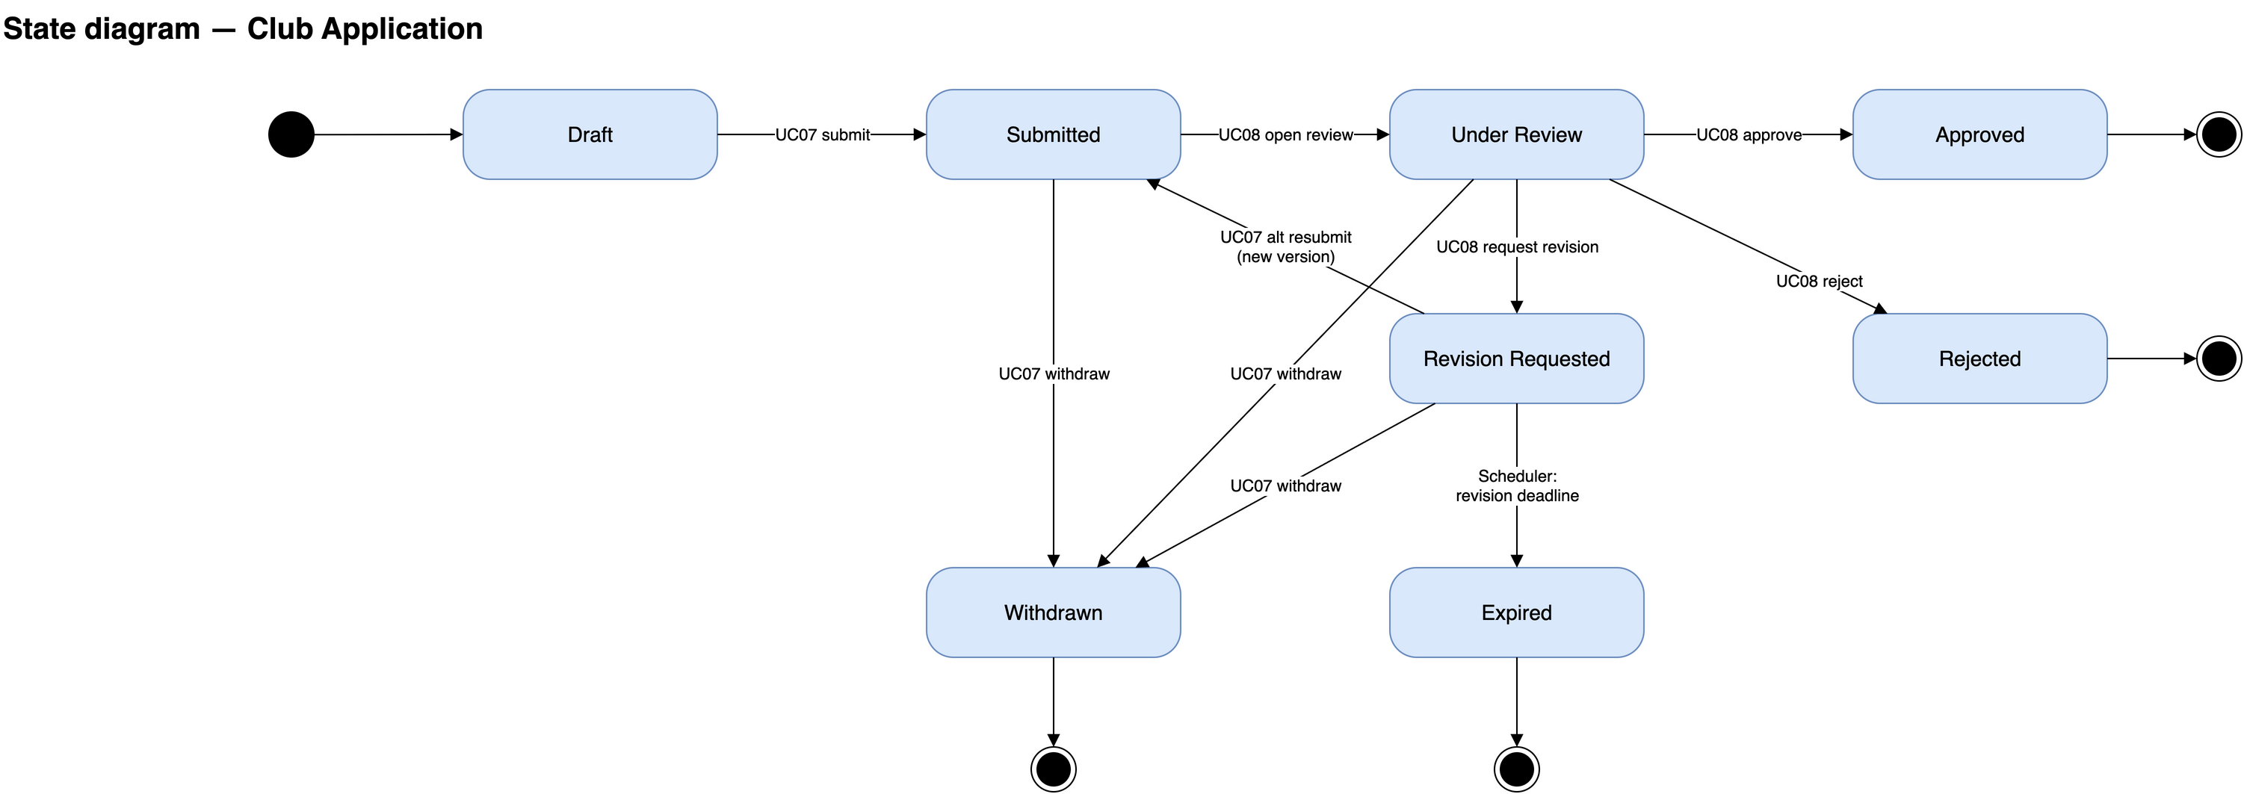
Figure III.13: Club establishment application state diagram
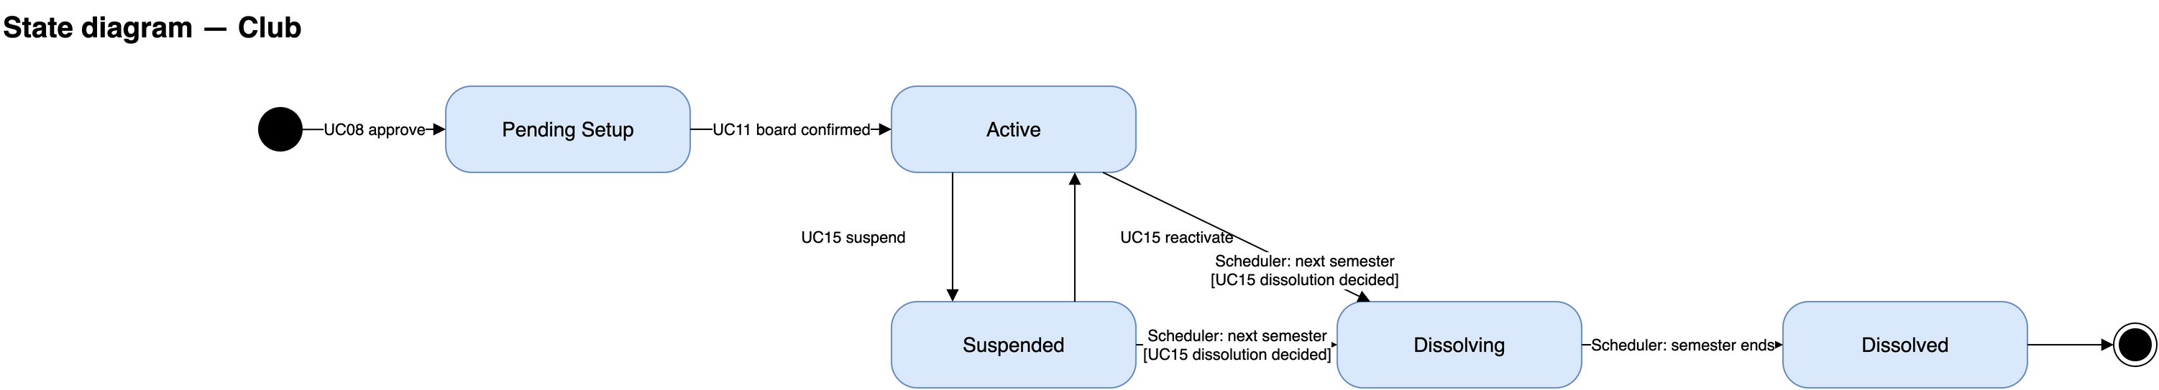
Figure III.14: Club state diagram

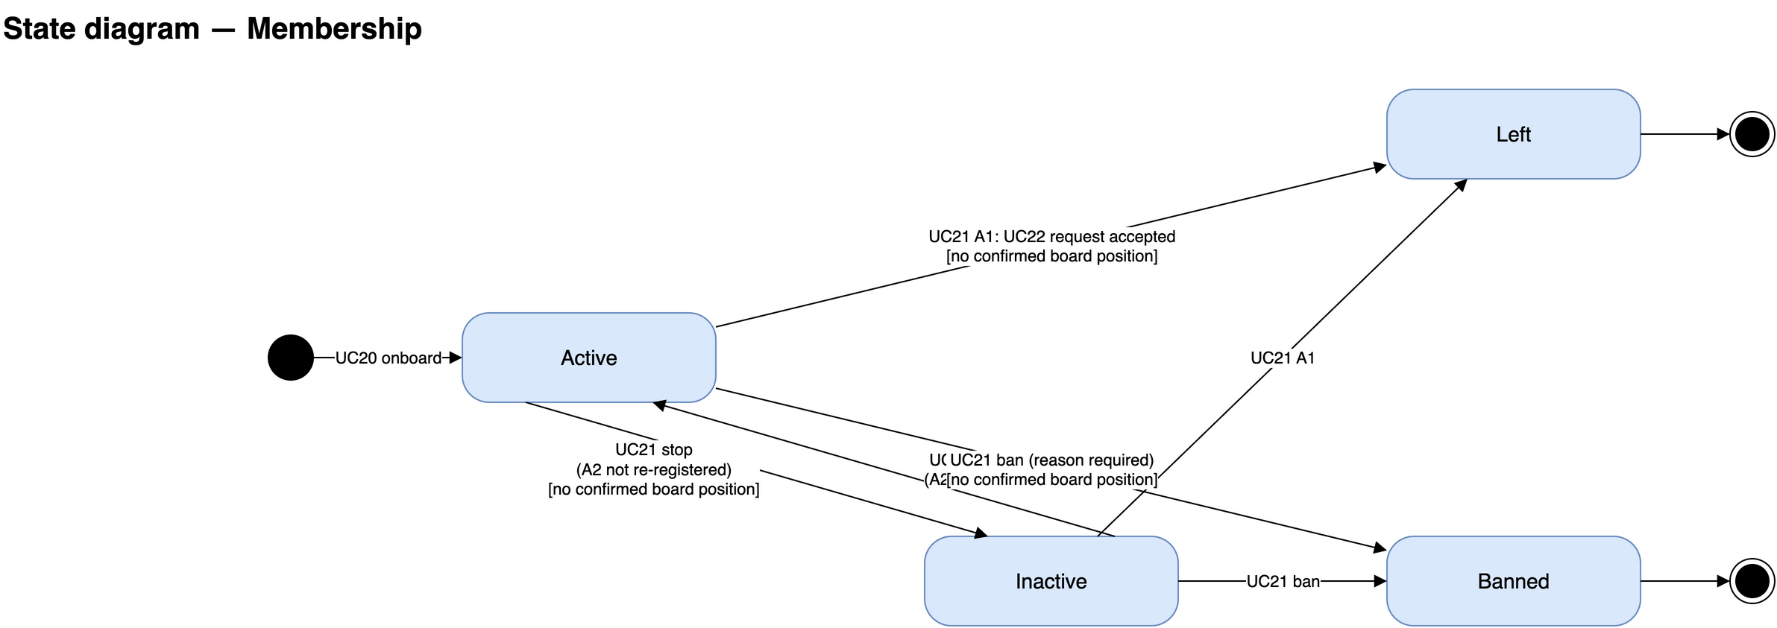
Figure III.15: Membership state diagram
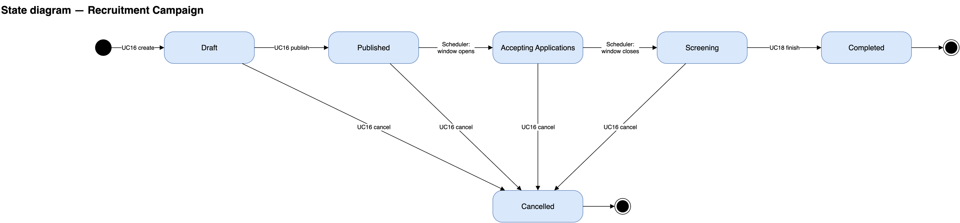
Figure III.16: Recruitment campaign state diagram

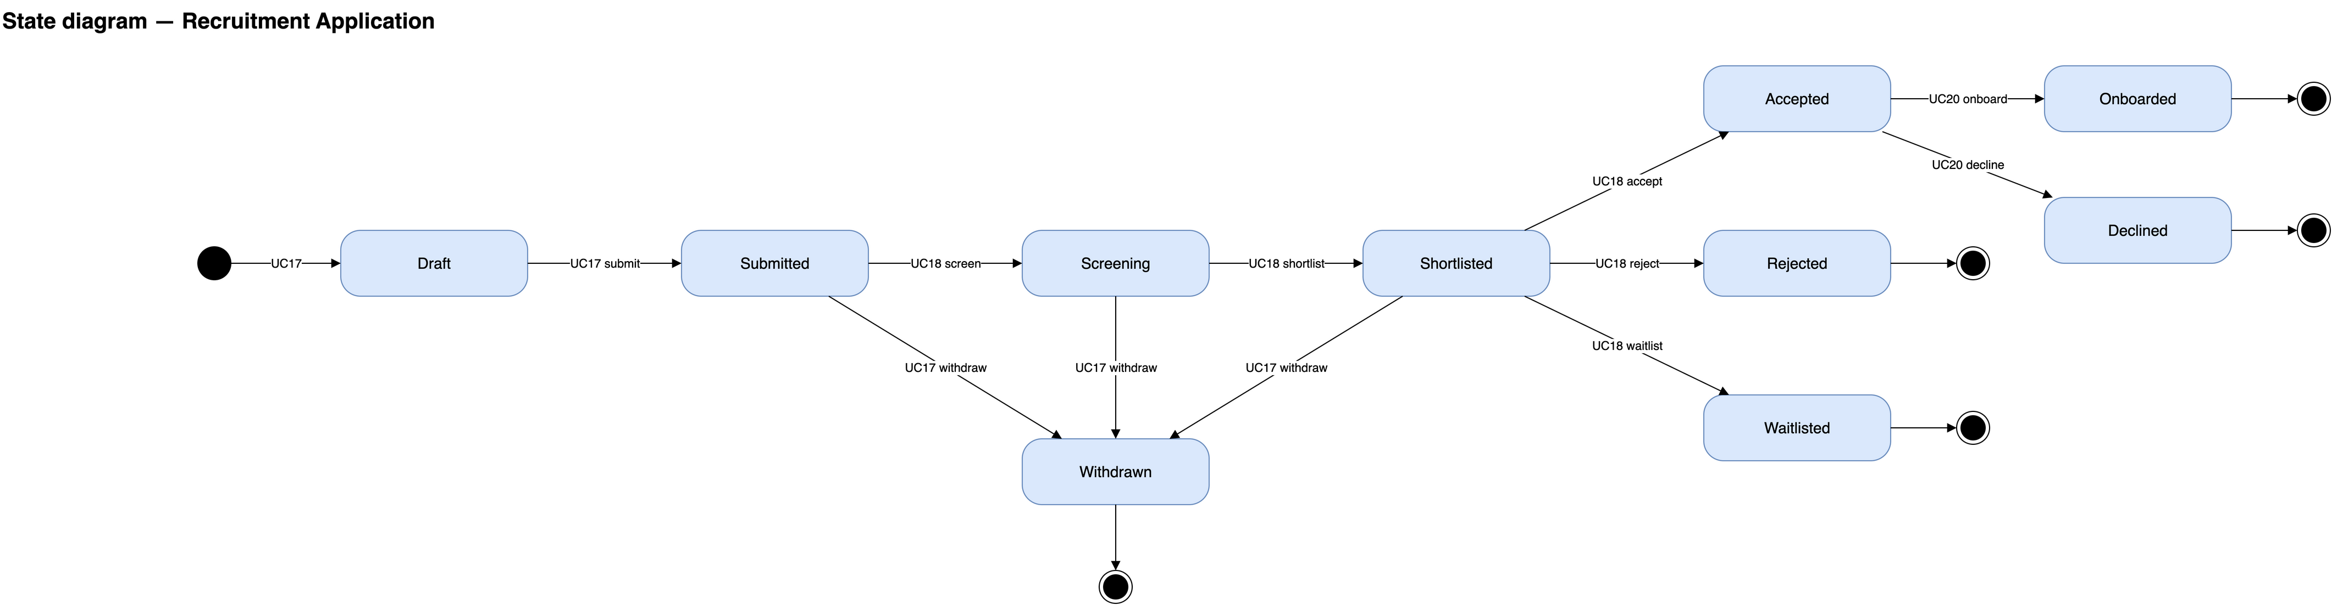
Figure III.17: Recruitment application state diagram
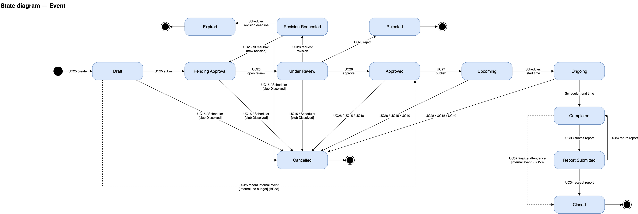
Figure III.18: Event state diagram

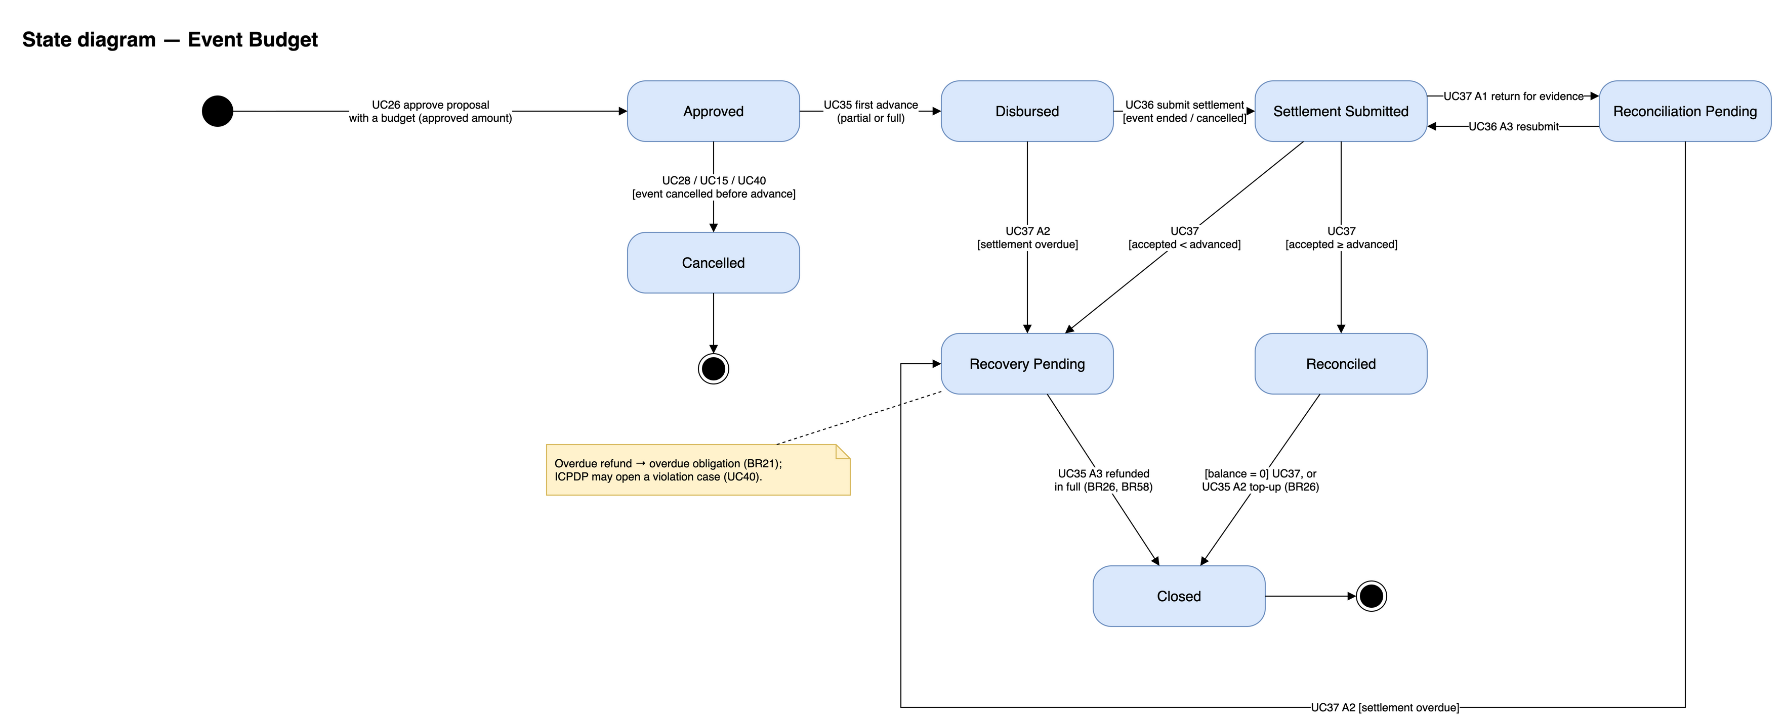
Figure III.19: Event budget state diagram
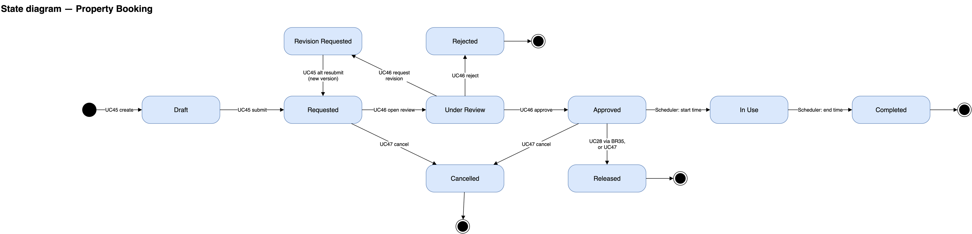
Figure III.20: Legacy property booking state diagram. Current direct reservation flow: choose room/date/slot → validate availability and responsible leader → Approved → In Use → Completed; Approved → Cancelled through UC47. Draft, Requested, Under Review and Revision Requested belong to the retained legacy workflow only.

IV. Software Design Description

1. System Design

1.1 System Architecture
The system is deployed as one application: a React single-page client, one Express API process and one MongoDB database. The API process also hosts the scheduler that drives every time-based transition and drains the notification outbox. Two external services are called out of process: Google OAuth for sign-in and Google SMTP for outbound e-mail.
Inside the API, the code is split into four layers with the dependency arrows pointing inward: the domain layer holds the entities, the state machines and the repository ports; the use case layer holds one file per business flow and is where every business rule and scope check is enforced; the interface layer parses and validates HTTP requests and calls a use case; the infrastructure layer implements the ports against MongoDB, Google OAuth and Google SMTP. This is what makes a use case testable without a database and what keeps a module a vertical slice rather than a new deployable.
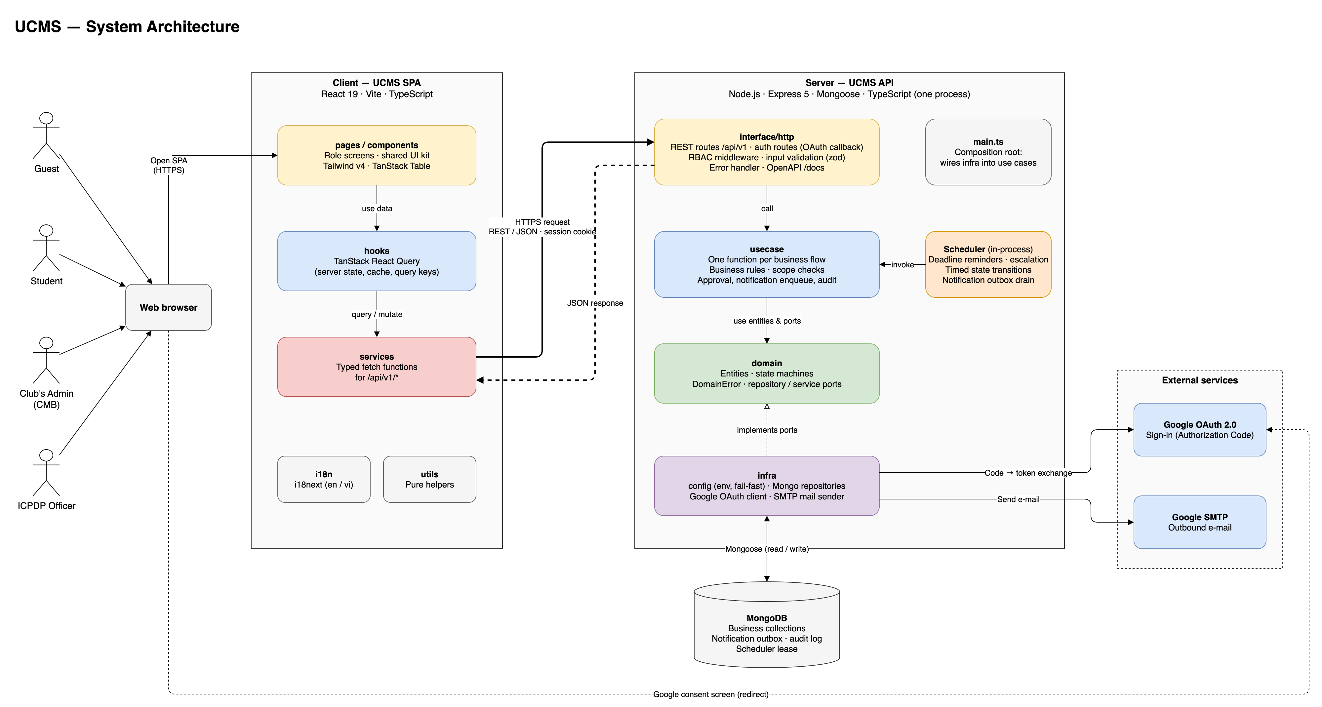
Figure IV.1: System architecture

1.2 Package Diagram
Figure IV.2 shows the organization of the front-end packages.
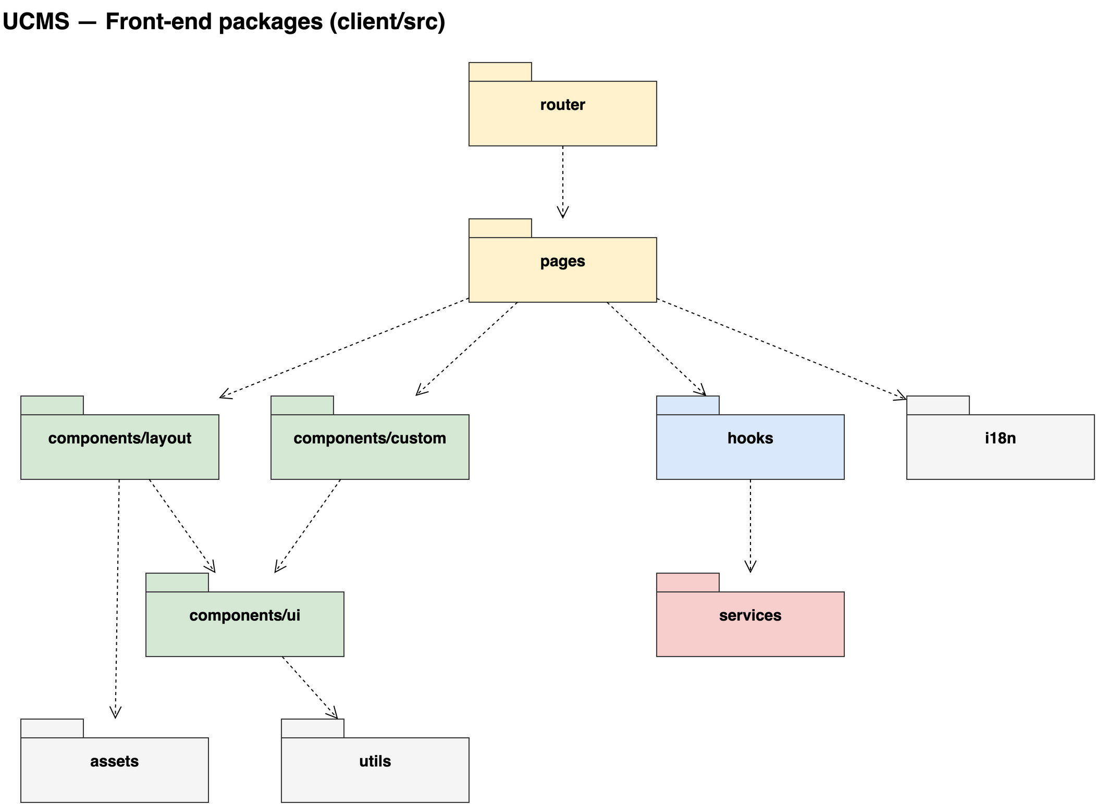
Figure IV.2: Front-end packages
Figure IV.3 shows the organization of the back-end packages.
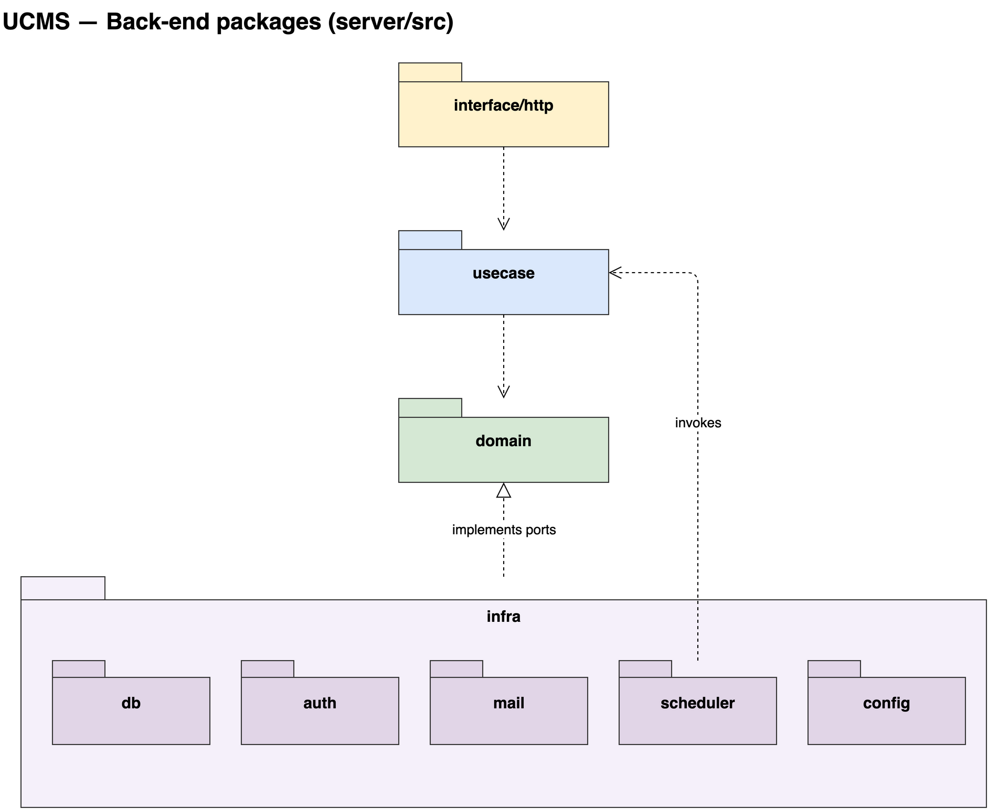
Figure IV.3: Back-end packages
Table IV.1 describes the packages of the project and the responsibility of each.
No | Project | Package | Description
1 | Front-end | services | One typed module per domain; owns the endpoint URLs and the request and response shapes. Contains no React code.
2 |  | hooks | React Query hooks; each owns its query key and the cache invalidation of its domain.
3 |  | pages | Screens grouped by role workspace: auth, student, club, icpdp.
4 |  | components/ui | Atomic, reusable interface elements (button, input, table, card, toast, skeleton, empty state).
5 |  | components/custom | Domain-aware components such as the status badge, the approval timeline and the conflict banner.
6 |  | components/layout | Workspace shells and role-aware navigation.
7 |  | router | Route definitions and role-aware route guarding.
8 |  | i18n | English and Vietnamese string files, split per module.
9 |  | utils | Framework-free helpers such as class merging and date formatting.
10 |  | assets | Static assets: logo, icons and fonts.
11 | Back-end | domain | Entities, value objects, state machines, business errors and the repository ports. Depends on nothing.
12 |  | usecase | One file per business flow; enforces the business rules and the scope checks, writes the audit record and enqueues notifications.
13 |  | interface/http | Route files (one per module), request validation schemas, the response envelope and the error mapping.
14 |  | infra/db | Mongoose models and the repository implementations of the domain ports, including index creation at boot.
15 |  | infra/auth | Google OAuth client, the callback handler and session issuing.
16 |  | infra/mail | Google SMTP adapter and the delivery log writer.
17 |  | infra/scheduler | The lease-guarded timer that drives the time-based transitions and drains the notification outbox.
18 |  | infra/config | The only place that reads the environment; validates it at start-up and fails fast.
Table IV.1: Package description

2. Database Design
The database is MongoDB. It holds 50 collections, one per aggregate, each owned by one module. References are stored as object identifiers, and denormalization is allowed only to keep a list screen to a single query. A unique index rejects duplicates such as a second registration of the same student for the same event, while event capacity and the slot of a property booking are protected by a conditional atomic update (findOneAndUpdate) rather than by a read-check-write sequence. Figure IV.4 shows the collections grouped by module with their primary key, their references, their unique fields and their lifecycle state; the full field list, the enumerations and every index are kept in the DBML design file of the project.
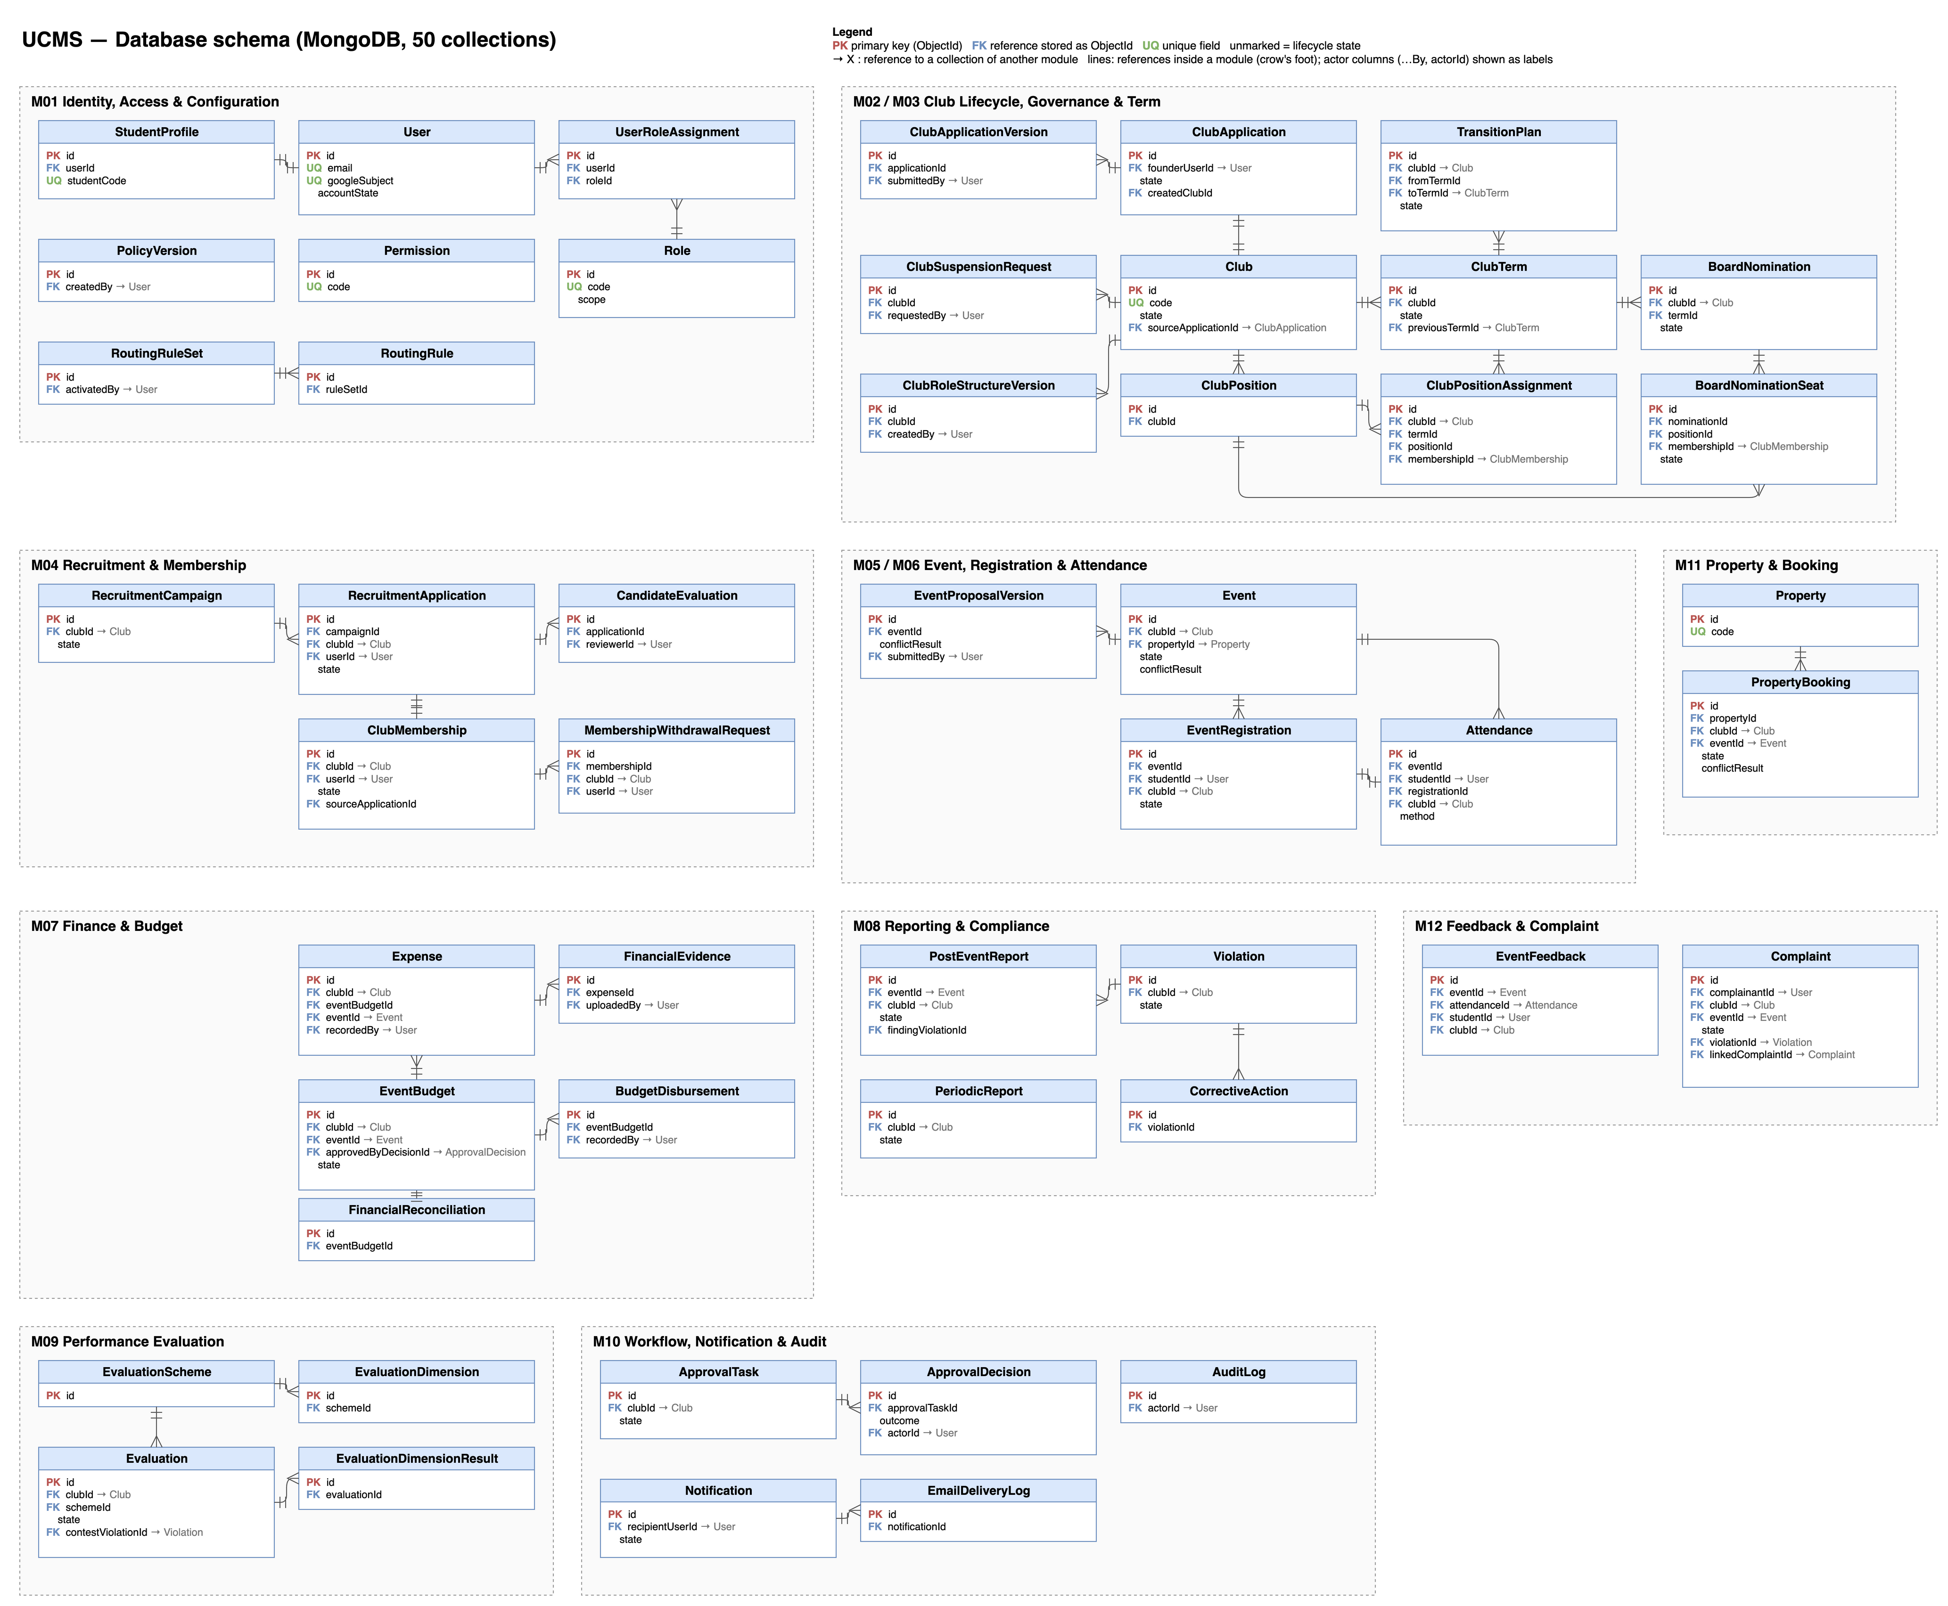
Figure IV.4: Database schema
Table IV.2 lists the collections of the system and what each one holds.
No | Collection | Description
1 | User | System account resolved from the Google identity; holds the account state (Active / Locked) and no password.
2 | StudentProfile | Profile of a user synchronized from the OAuth payload plus the university student data.
3 | Role | A system or club-scoped role with the set of permission codes it grants.
4 | Permission | An atomic permission code checked at the route and in the use case layer.
5 | UserRoleAssignment | The grant of a system-scoped role to a user, with who granted or revoked it and why. Club permissions are never granted here; they come from a position assignment inside an active term.
6 | PolicyVersion | An effective-dated snapshot of the nine configurable institutional values of UC04.
7 | RoutingRuleSet | A versioned set of approval routing rules deciding when a second ICPDP level is required.
8 | RoutingRule | One rule of a routing rule set: the request type, the matching conditions (amount, risk category, property class, compliance condition), the required approval level and the SLA.
9 | Club | A recognized student club with its lifecycle state and, when decided, its dissolution schedule.
10 | ClubApplication | An establishment application with its state and the decision history attached to it.
11 | ClubApplicationVersion | An append-only snapshot of a submitted application; a resubmission writes a new one.
12 | ClubSuspensionRequest | A request of the club board to suspend club activity, with its reason and review state; the suspension itself is decided on the club (UC15).
13 | ClubTerm | A time-boxed leadership period of a club, from which CMB permission is derived.
14 | ClubPosition | A position defined in the organization structure of a club, with its permissions.
15 | ClubPositionAssignment | The assignment of a position to a membership for an effective period.
16 | BoardNomination | A nomination of the management board of a club for a term, submitted by the club and confirmed or returned by ICPDP.
17 | BoardNominationSeat | One seat of a board nomination (a position and the nominated member), confirmed or returned seat by seat.
18 | TransitionPlan | A leadership handover plan with the obligations it carries across the term boundary.
19 | RecruitmentCampaign | A recruitment round with its window, capacity, selection steps, form schema and rubric.
20 | RecruitmentApplication | An application to a campaign with its state and decision.
21 | CandidateEvaluation | A rubric-based assessment of a shortlisted candidate, attributable to its reviewer.
22 | ClubMembership | The membership of a student in a club, with its state and full status history.
23 | MembershipWithdrawalRequest | A request of a student to leave a club, with its reason; it is held while the member still holds a confirmed board seat.
24 | Event | An event of a club with its schedule, capacity, risk category, conflict result and lifecycle state.
25 | EventProposalVersion | An append-only snapshot of a submitted event proposal.
26 | EventRegistration | The registration of a student for an event, Confirmed, Waitlisted or Cancelled.
27 | Attendance | One official attendance record per participant per event, lockable by finalization.
28 | PostEventReport | The report closing an event, with the figures frozen at submission.
29 | PeriodicReport | The periodic activity report of a club for a semester, an academic year or another period defined in the policy document.
30 | EventBudget | The budget of an approved event, created by UC26 from the budget section of the proposal, with the requested and approved amounts.
31 | BudgetDisbursement | A money flow of an event budget: an advance, a top-up or a refund from the club.
32 | Expense | Actual spending recorded against an event budget, flagged when out of category, and accepted or rejected at reconciliation.
33 | FinancialEvidence | A document substantiating exactly one expense, with uploader and timestamp.
34 | FinancialReconciliation | The reconciliation of a settlement: accepted spending, settlement balance and outcome (Reconciled or Recovery Pending).
35 | Property | A room, hall or item of equipment released to club activity, with bookable hours and blackouts.
36 | PropertyBooking | A reservation of a property for a period, with its lifecycle state.
37 | Violation | A compliance case with its origin, severity, evidence and decision.
38 | CorrectiveAction | An action required by a compliance decision, with its deadline and verification.
39 | EventFeedback | An immutable participant assessment of an event, optionally anonymous.
40 | Complaint | A student complaint about a club, with its triage decision and the response of the club.
41 | EvaluationScheme | A versioned scoring scheme: dimensions, weights and classification thresholds.
42 | EvaluationDimension | A dimension of a scheme with its scoring rule and weight.
43 | Evaluation | The evaluation of a club for a period, from draft to published, with its revisions.
44 | EvaluationDimensionResult | The score of one dimension with the evidence and lineage behind it.
45 | ApprovalTask | The shared reviewer work item of every submit-and-decide pair; the basis of the approval inbox.
46 | ApprovalDecision | One decision taken on an approval task, with its level, outcome, reason and actor.
47 | Notification | A queued notification with its recipients, channels, due date and delivery attempts.
48 | EmailDeliveryLog | The delivery status of one e-mail attempt through Google SMTP.
49 | AuditLog | An append-only record of a state change: entity, action, actor, before, after, reason, correlation id.
Table IV.2: Collection description
The minimum index set created at boot is: unique indexes on the user e-mail and the Google subject; on campaign and applicant for recruitment applications; on event and student for registrations, attendance and feedback; on club and user for the active membership (a partial index over Active and Inactive memberships); on club and period for periodic reports and on club, period and revision for evaluations; and on the parent and the version number of every append-only version collection. Non-unique compound indexes cover club and state for events, bookings and the other club-owned work items; property with start and end time for the conflict check; entity type and entity identifier for the audit log and the approval task; state, assignee role and SLA due date for the approval inbox; and state and due date for the notification outbox.

3. Detailed Design
Figure IV.5 shows the notation used in the diagrams of this section.
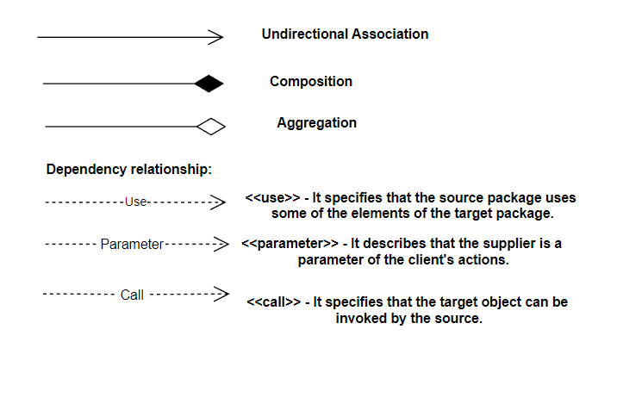
Figure IV.5: Notation of the UML diagrams

3.1 Design principles applied in every module
Every flow in this section follows the same shape, which is the reason the diagrams look alike: the route validates the request and resolves the caller, the use case performs the scope check and the business rules, the repository port persists the change, and the use case then writes the audit record and enqueues any notification. A cross-module effect — for example an event cancellation releasing a property booking — is invoked through the use case of the owning module, never by writing into its collection.

3.2 Design of the workflow, notification and audit services (M10)
Eight other business objects go through submit, review and decide: the club establishment application, board nomination, transition plan, club suspension request, event proposal, post-event report, periodic report and complaint. Legacy property booking requests retain their existing ApprovalTask and decision history. New direct room reservations create no approval task, submission version or approval decision.
A notification is enqueued inside the committed transaction and delivered asynchronously by the scheduler, which drains the outbox into in-app rows and into Google SMTP and writes a delivery log for each attempt. A failed delivery is retried with backoff and never rolls back the business change. Deadline escalation is the same scheduler scanning the due-date index and applying the reminder, due, overdue and escalation offsets configured in UC04.
Audit is written inside the use case, because the route does not know the name of the business action and the repository does not know the actor. Every record carries the entity, the action, the actor and role, the before and after state, the change difference, the reason and a correlation identifier that ties together every record produced by one request, including system cascades.

3.3 Event Management

3.3.1 Review Event Proposal
Sequence diagram of UC26.
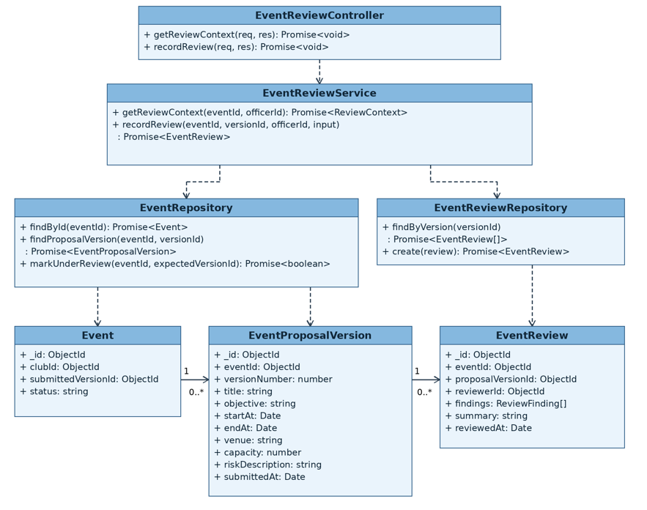
Figure IV.6: Review Event Proposal sequence diagram

3.3.2 Request Event Proposal Revision
Sequence diagram of UC26.
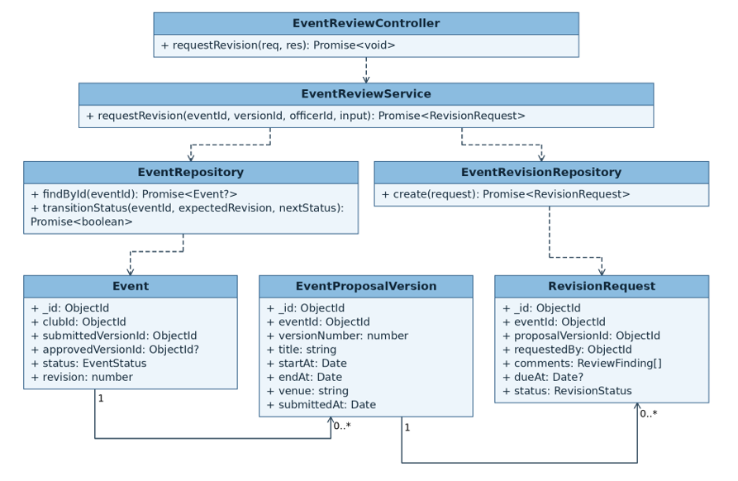
Figure IV.7: Request Event Proposal Revision sequence diagram

3.3.3 Resubmit Event Proposal
Sequence diagram of UC25.
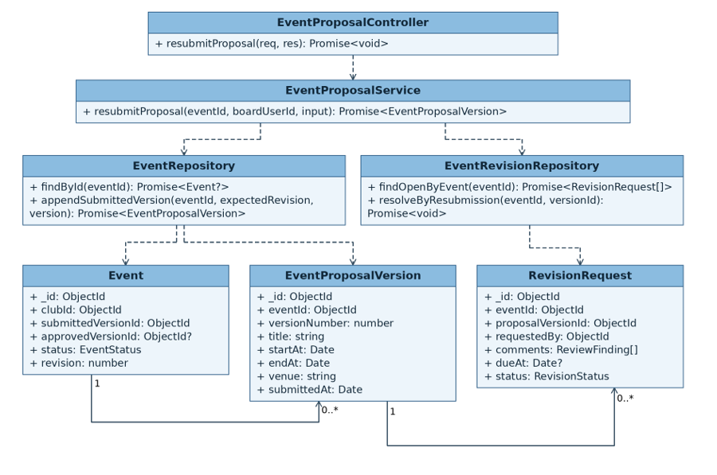
Figure IV.8: Resubmit Event Proposal sequence diagram

3.3.4 Approve or Reject Event Proposal
Sequence diagram of UC26.
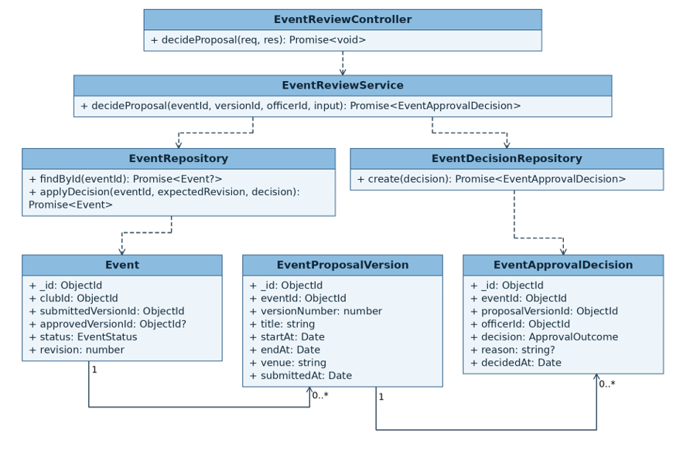
Figure IV.9: Approve or Reject Event Proposal sequence diagram

3.3.5 Publish Event and Open Registration
Sequence diagram of UC27.
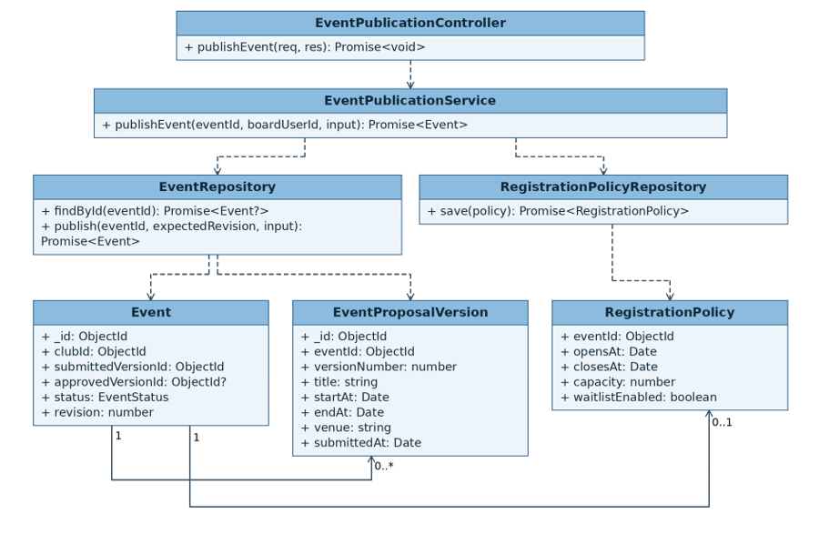
Figure IV.10: Publish Event and Open Registration sequence diagram

3.3.6 Register for Event
Sequence diagram of UC29.
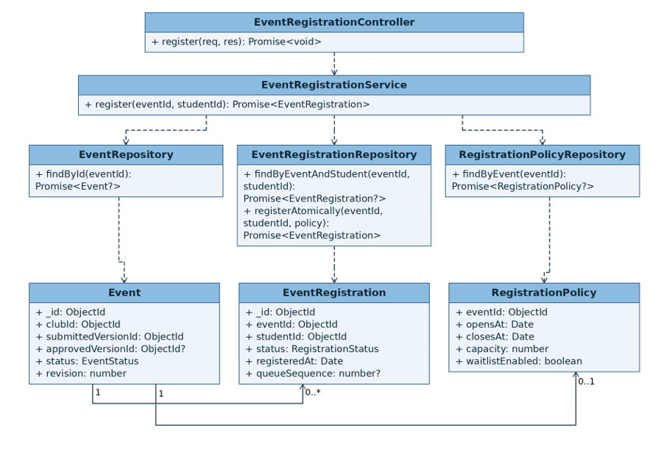
Figure IV.11: Register for Event sequence diagram

3.3.7 Manage Event Capacity and Waitlist
Sequence diagram of UC30.
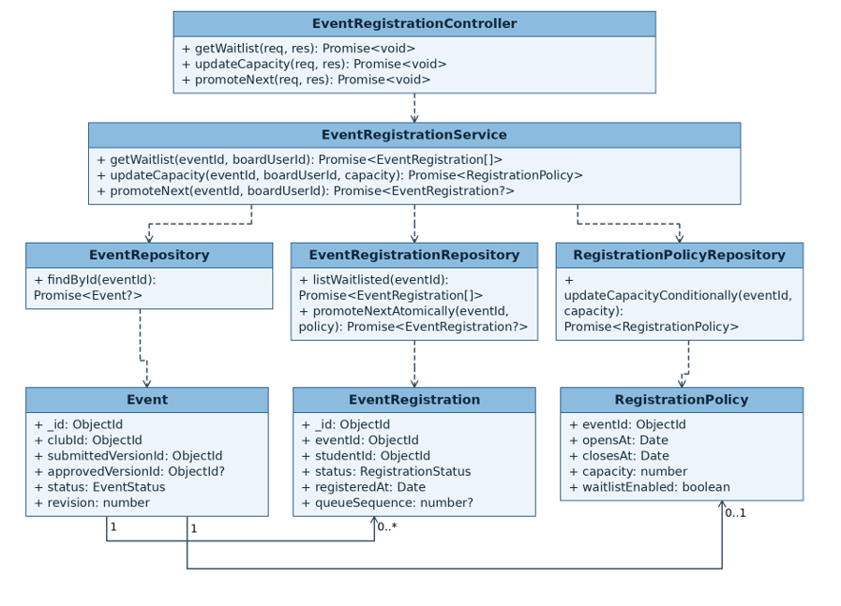
Figure IV.12: Manage Event Capacity and Waitlist sequence diagram

3.3.8 Check In Event Participants
Sequence diagram of UC31.
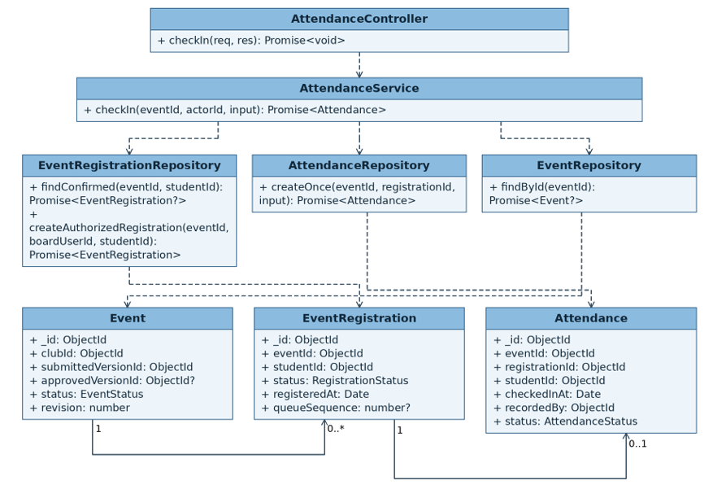
Figure IV.13: Check In Event Participants sequence diagram

3.3.9 Finalize Event Attendance
Sequence diagram of UC32.
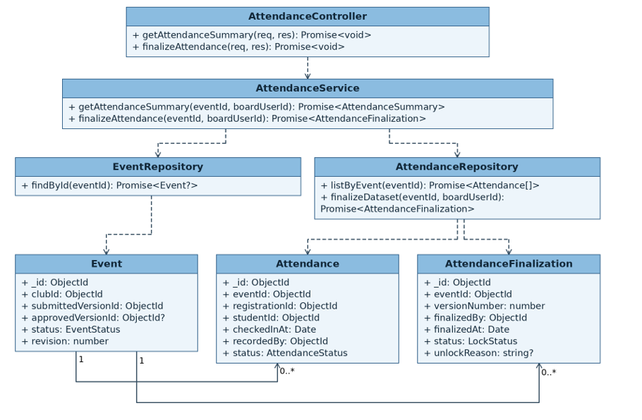
Figure IV.14: Finalize Event Attendance sequence diagram

3.3.10 Cancel or Reschedule Event
Sequence diagram of UC28.
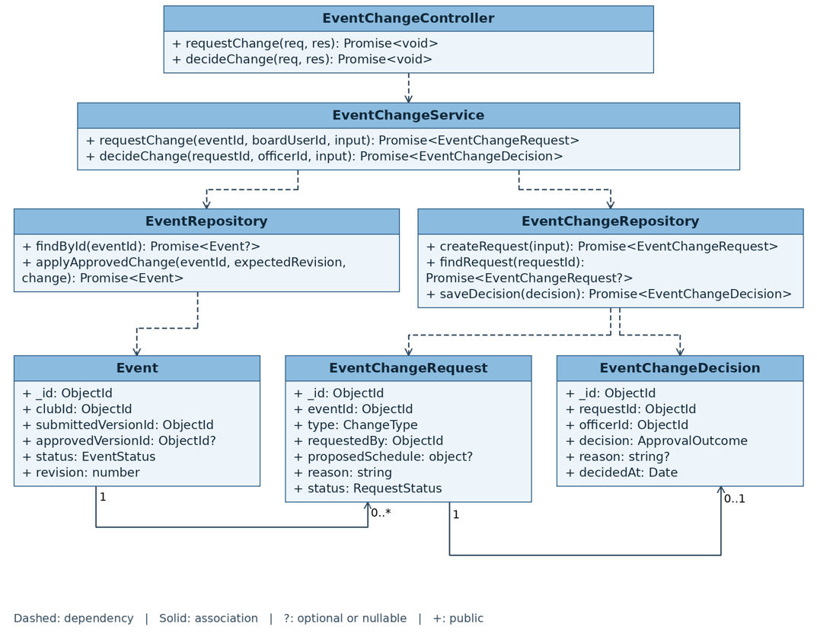
Figure IV.15: Cancel or Reschedule Event sequence diagram

3.3.11 Submit Post-event Report
Sequence diagram of UC33.
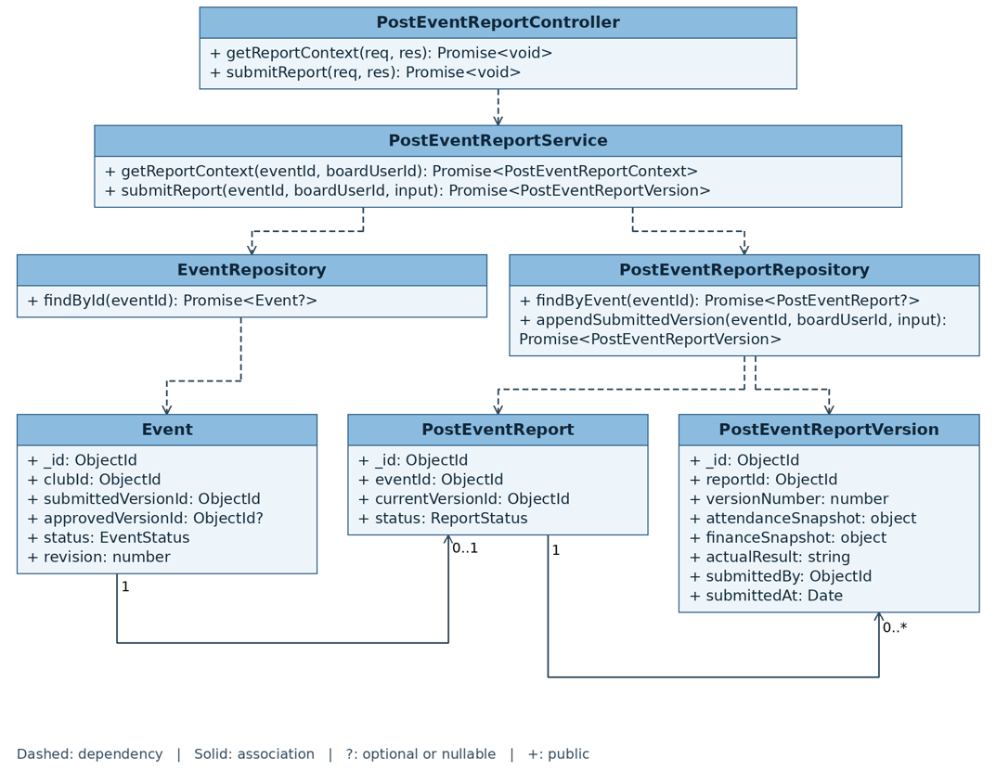
Figure IV.16: Submit Post-event Report sequence diagram

3.3.12 Review and Close Post-event Report
Sequence diagram of UC34.
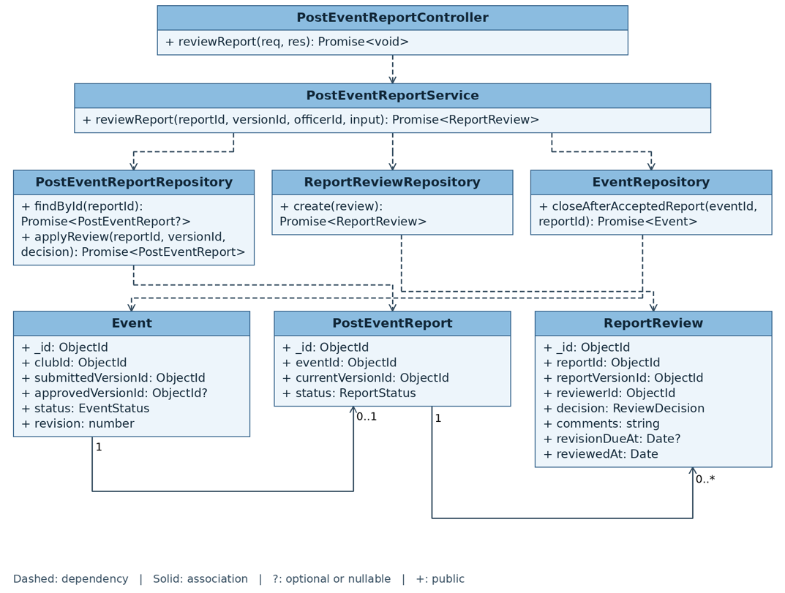
Figure IV.17: Review and Close Post-event Report sequence diagram

3.4 Periodic Reporting and Compliance Management

3.4.1 Submit Periodic Activity Report
Sequence diagram of UC38.
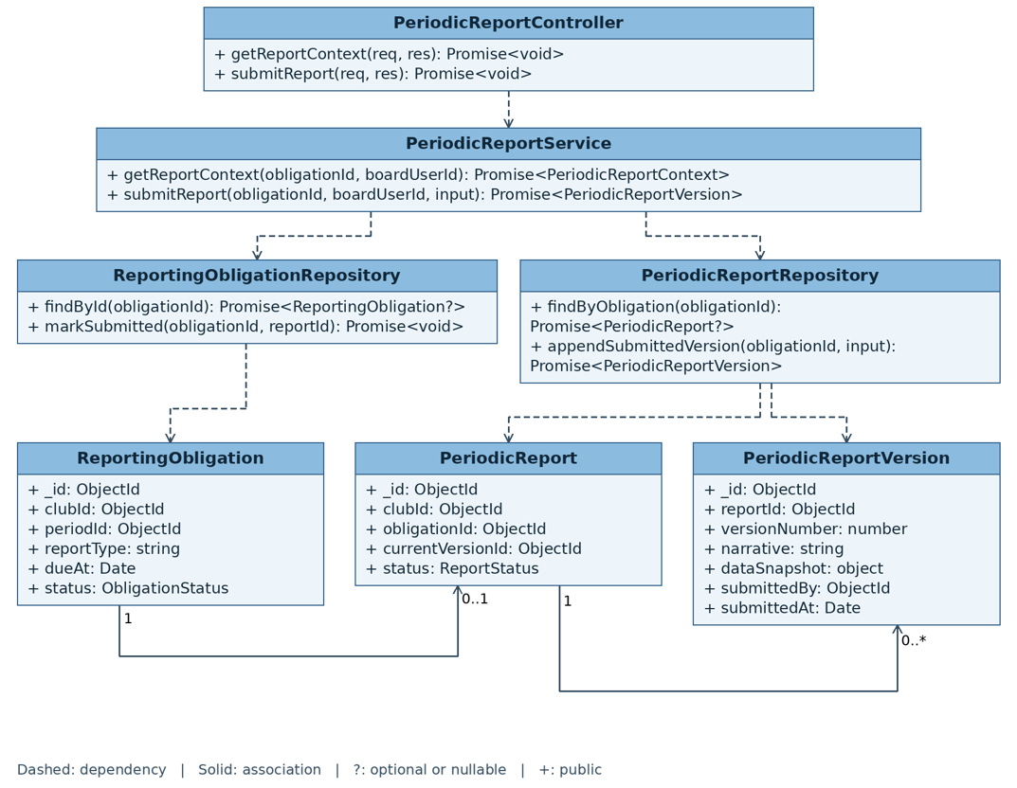
Figure IV.18: Submit Periodic Activity Report sequence diagram

3.4.2 Review Periodic Activity Report
Sequence diagram of UC39.
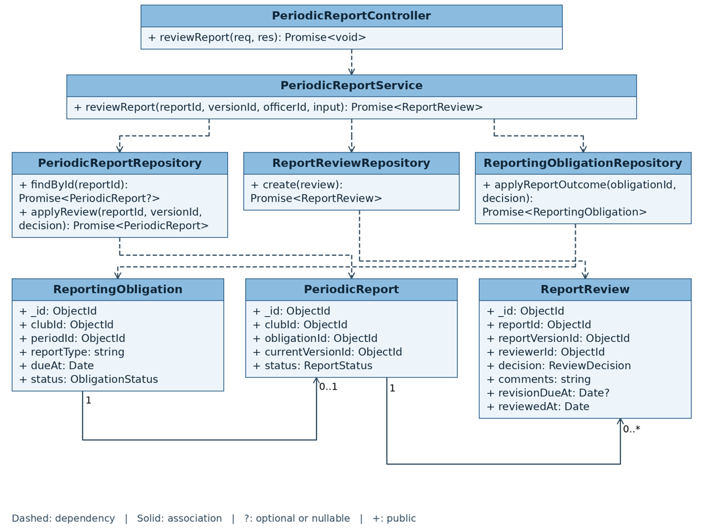
Figure IV.19: Review Periodic Activity Report sequence diagram

3.4.3 Manage Compliance Cases
Sequence diagram of UC40.
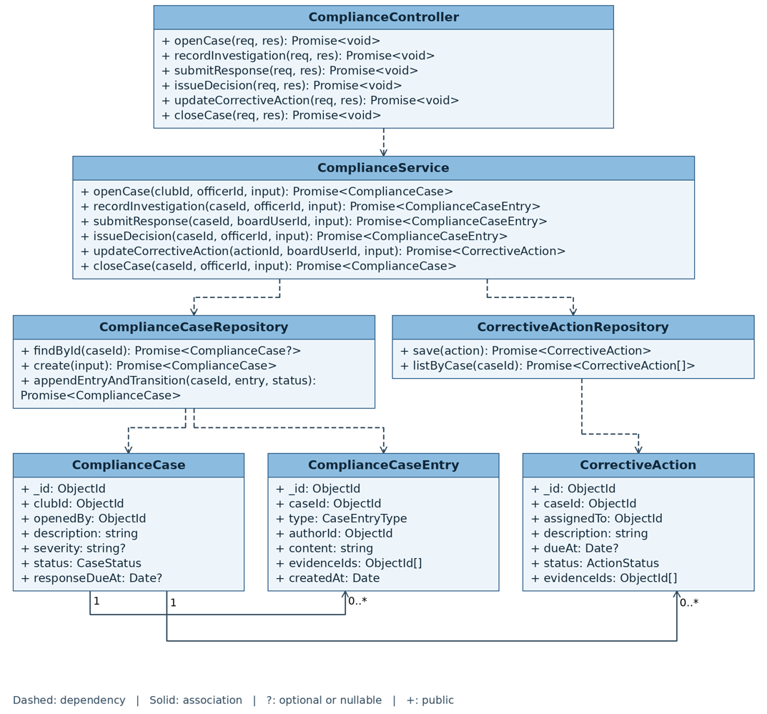
Figure IV.20: Manage Compliance Cases sequence diagram

3.5 Club Evaluation Management

3.5.1 Generate Club Evaluation Draft
Sequence diagram of UC42.
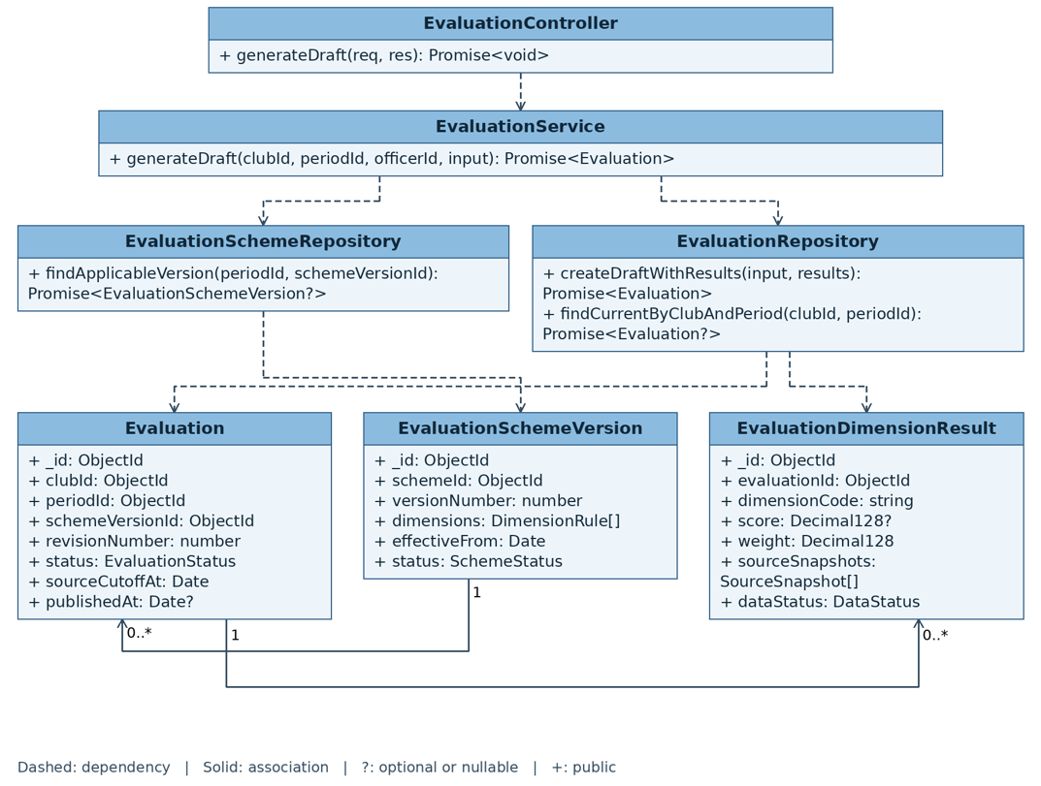
Figure IV.21: Generate Club Evaluation Draft sequence diagram

3.5.2 Review, Finalize and Publish Club Evaluation
Sequence diagram of UC43.
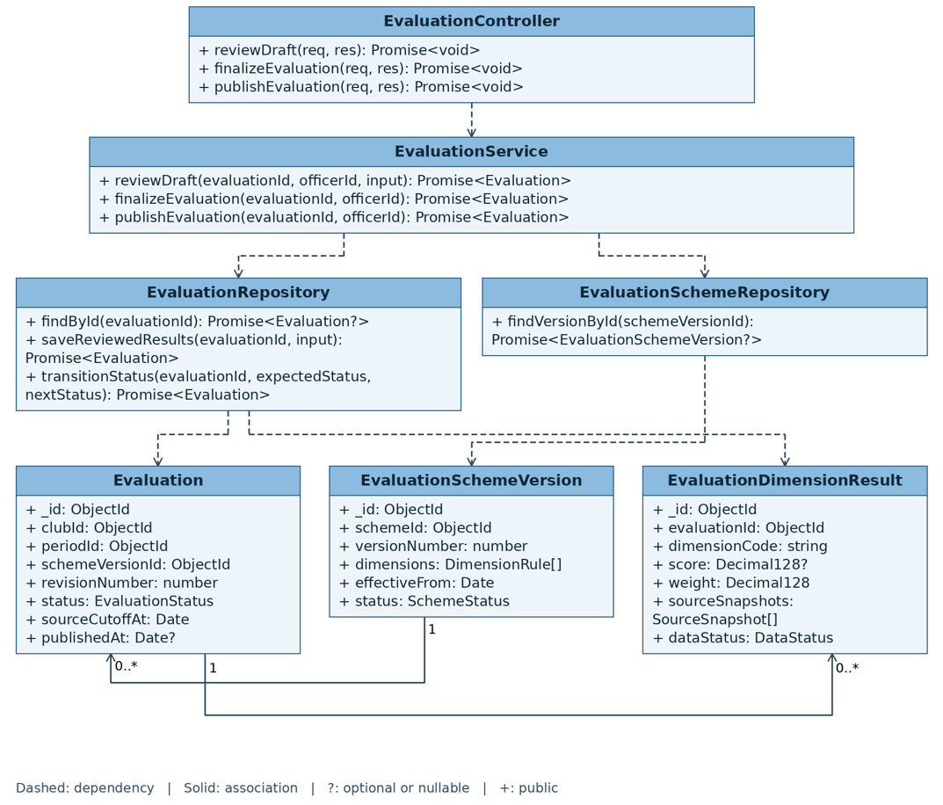
Figure IV.22: Review, Finalize and Publish Club Evaluation sequence diagram

3.6 Design summary of the remaining modules
Table IV.3 summarizes the detailed design of the modules whose flows follow the same pattern as the diagrams above: the use case that owns the flow, the components it touches and the collections it writes.
Module | Use cases | Main components | Collections written
M01 Identity, Access & Configuration | UC01–UC05 | auth-routes, oauth client, session issuer, rbac middleware, policy and routing use cases | User, StudentProfile, Role, Permission, UserRoleAssignment, PolicyVersion, RoutingRuleSet, RoutingRule, AuditLog
M02 Club Lifecycle & Governance | UC06–UC09, UC14, UC15 | club-routes, submitApplication, decideApplication, clubLifecycle use cases, scheduler jobs for dissolution | Club, ClubApplication, ClubApplicationVersion, ClubSuspensionRequest, ApprovalTask, AuditLog
M03 Leadership & Term | UC10–UC13, UC23 | term-routes, nominateBoard, confirmBoard, planTransition, confirmTransition, assignPosition | ClubTerm, ClubPosition, ClubPositionAssignment, BoardNomination, BoardNominationSeat, TransitionPlan, ApprovalTask, AuditLog
M04 Recruitment & Membership | UC16–UC22, UC24 | recruitment-routes, membership-routes, publishCampaign, screenApplications, onboard, changeMembershipStatus | RecruitmentCampaign, RecruitmentApplication, CandidateEvaluation, ClubMembership, MembershipWithdrawalRequest, AuditLog
M07 Finance & Budget | UC35–UC37 | finance-routes, recordDisbursement, recordExpense, submitSettlement, reconcile | EventBudget, BudgetDisbursement, Expense, FinancialEvidence, FinancialReconciliation, ApprovalTask, AuditLog
M10 Workflow, Notification & Audit | — (cross-cutting, §3.2) | approval-routes, notification-routes, audit-routes, approval inbox, notification outbox, scheduler, e-mail sender, audit writer | ApprovalTask, ApprovalDecision, Notification, EmailDeliveryLog, AuditLog
M11 Property & Facility Booking | UC44–UC47 | property-routes, manageCatalogue, reserveRoom, responsibleLeader, legacy submitBooking/decideBooking, releaseBooking, conflict rule evaluator | Property, PropertyBooking, AuditLog; ApprovalTask for legacy requests only
M12 Feedback & Complaint | UC48–UC52 | feedback-routes, complaint-routes, submitFeedback, aggregateFeedback, triageComplaint, respondComplaint | EventFeedback, Complaint, Violation, ApprovalTask, AuditLog
Table IV.3: Design summary of the remaining modules

V. Testing Documentation

1. Scope of Testing

1.1 Testing Stages
Figure V.1 describes the testing stages of the project following the V-model.
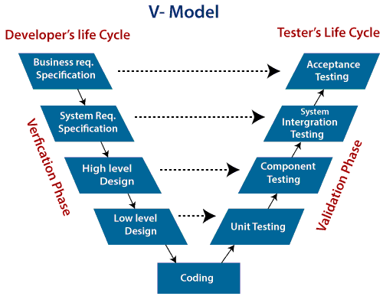
Figure V.1: Test stages based on the V-model
The testing process has four stages: unit testing, integration testing, system testing and acceptance testing.
No. | Test Stage | Description
1 | Unit Testing | Individual units are tested to determine whether they behave as specified. In this project a unit is a use case exercised through in-memory repository fakes, which is what makes every business rule and every refused state transition testable without a database.
2 | Integration Testing | Modules and components are tested together to verify that they behave correctly once combined: route, validation, use case, repository and MongoDB, including the index constraints that protect capacity and booking slots.
3 | System Testing | The system is tested as a whole against this requirement baseline, end to end, across the three role workspaces and the scheduler-driven transitions.
4 | Acceptance Testing | The supervisor and the domain stakeholder exercise the completed loops against the acceptance criteria to confirm the product does what the requirement says.
Table V.1: Description of the test stages

1.2 Range of Testing
All functions defined in this Software Requirement Specification are tested against the last version of the product. The coverage rule for the project is explicit: every business rule in Table III.6 has at least one unit test on the use case that enforces it, and every transition and every refused transition of the entity lifecycles has a test.

2. Test Strategy

2.1 Testing Types
The test team executes the following types of test on the Google Chrome browser. To cover UI-01, the GUI test cases are also run as a smoke test on the current releases of Firefox, Safari and Edge.
No. | Test Type | Description
1 | GUI Testing | Checks the graphical user interface against the design guidelines: layout at the four supported widths, contrast in both themes, focus rings, error placement, and the rule that a state is never conveyed by colour alone.
2 | Functional Testing | Black-box testing confirming that each function behaves as the use case specifies, including its alternative flows and every exception.
3 | Regression Testing | Verifies that a change has not broken behaviour that previously worked, run before every merge through the automated suite.
4 | Security Testing | Verifies the two-layer authorization: that a role cannot reach a screen it does not own, and that a user cannot act on a club they do not belong to even with a crafted request.
Table V.2: Description of the testing types

2.2 Test Levels
Table V.3 shows which type of test is executed at which level.
Type of Test | Unit | Integration | System | Acceptance
GUI Testing |  | ✓ | ✓ | ✓
Functional Testing | ✓ | ✓ | ✓ | ✓
Regression Testing | ✓ | ✓ | ✓
Security Testing | ✓ | ✓ | ✓
Table V.3: Description of the testing levels

2.3 Supporting Tools
Microsoft Excel: manages the test cases and the data index.

Figure V.2: Microsoft Excel
Google Sheets: manages the defects and their fix status.

Figure V.3: Google Sheets
Google Chrome: the browser against which the interface is tested.

Figure V.4: Google Chrome browser
In addition, Vitest runs the automated unit and integration suites, and Postman is used to exercise the REST API directly while a screen is still being built.

3. Test Plan

3.1 Human Resources
Table V.4 describes the human resources of the test plan.
Worker / Doer | Role | Specific Responsibilities
Nguyễn Vũ Đăng Khánh | Team lead, Tester | Create the test plan; write and execute the integration and system test cases; own the acceptance test session with the supervisor.
Nguyễn Quang Huy | BA, Tester | Derive the test cases from the use case specifications and the business rules; verify the traceability between requirement and test.
Nguyễn Đình Phong | Tester | Write and execute the unit test cases of the assigned modules; fix module-related defects on both sides of the stack.
Trần Ngọc Huy | Technical Leader, Tester | Own the automated suite and the test environment; review the tests protecting the state machines and the concurrency paths.
Lê Đức Anh | Tester | Write and execute the unit test cases of the assigned modules; fix module-related defects on both sides of the stack.
Nguyễn Hoàng Anh | Tester | Execute the GUI test cases at the four supported widths and in both themes and locales; log and re-verify interface defects.
Table V.4: Description of the human resources

3.2 Test Environment
Table V.5 describes the testing environment.
Purpose | Tool | Provider | Version
Unit testing | Vitest on Node.js | OpenJS Foundation | Node 22 LTS
Integration testing | Vitest with a MongoDB test instance | MongoDB Inc. | MongoDB 7
API testing | Postman | Postman Inc. | Current release
System testing | Google Chrome; Firefox, Safari, Edge (GUI smoke test) | Google; Mozilla, Apple, Microsoft | Current stable release
Acceptance testing | Google Chrome | Google | Current stable release
Table V.5: Description of the testing environment

VI. Release Package & User Guides

1. Deliverable Package
Table VI.1 describes the deliverables of the project.
No. | Deliverable Item | Description
1 | Source code | University-Club-Management-System.zip — the npm workspace containing the client and the server
2 | Database script | Data.zip — the seed collections exported as JSON
3 | Final report | Group1_SE1939-NJ_Report_Final_v2.docx — this document
4 | Requirement baseline | docs/SRS.md and the use case model and specification it consolidates
5 | Diagrams | Context diagram, use case diagrams, state diagrams and design diagrams in draw.io format with PNG exports
6 | Test cases | WDP_Test_Case_G1.xlsx — unit, integration and system test cases
Table VI.1: Deliverable package

2. Installation Guides

2.1 System Requirements
The following are the minimum requirements to run and deploy the application:
- CPU: 2.5 GHz dual core or better
- RAM: 8 GB
- Minimum free disk space: 10 GB
- Node.js 22.9 or later, and MongoDB 7 (locally or through Docker)
- Network: an internet connection, required because sign-in and e-mail are delegated to Google

2.2 Deployment steps
- Extract University-Club-Management-System.zip.
- Copy .env.example to .env and fill in MONGO_URI, SESSION_SECRET, GOOGLE_CLIENT_ID, GOOGLE_CLIENT_SECRET, the SMTP credentials, ALLOWED_DOMAIN (the allowed university e-mail domain) and BOOTSTRAP_ICPDP_EMAIL (the e-mail of the first ICPDP Officer). The server refuses to start with an incomplete configuration, which is deliberate.
- Register the callback URL of the deployment in the Google Cloud console. On its first start against an empty database the server seeds the first policy version from ALLOWED_DOMAIN and the first ICPDP account from BOOTSTRAP_ICPDP_EMAIL, so the first sign-in is not blocked by the domain check and no one has to hold the ICPDP role beforehand.
- Run docker compose up -d to start MongoDB, or point MONGO_URI at an existing instance.
- Run npm install at the root of the workspace.
- Extract Data.zip and import the JSON files into the database to obtain the seed data.
- Run npm run dev for development, which starts the API on port 3000 and the client on port 5173; or npm run build followed by npm start to serve the production build.
- Open the client URL in the browser and sign in with the Google account set in BOOTSTRAP_ICPDP_EMAIL, which already holds the ICPDP role, and complete the policy and routing configuration (UC04, UC05).

3. User Manual

3.1 Overview
The University Club Management System replaces a process spread over Word files, Google Forms, spreadsheets and e-mail with one platform in which every record has a state, an owner and a history. This manual is organized by role. A user signs in once with a university Google account and is routed to the workspace of the role they hold; a user who holds several contexts — for example a student who is also a board member — chooses the workspace and can switch at any time without signing in again.

3.2 Role: Guest
A guest is an unauthenticated visitor. The guest can browse the public area only and must sign in before taking any action.
- Open the landing page and browse the published events across all clubs.
- Open an event to see its time, venue, capacity and description.
- Browse the club directory; Active and Suspended clubs are listed, a suspended club is marked as such and shows no open recruitment campaign, and a dissolved club is not listed.
- Open a club page to read its mission, its board and its activity history.
- Click Sign in with Google to authenticate and continue as a student.

3.3 Role: Student
A student signs in with the university Google account and lands on the student dashboard, which answers two questions: what needs my action, and what happened to what I submitted.
- My hub — review the state of every application, registration, membership and complaint in one place.
- Propose a new club — complete the establishment form, declare the founding members, upload the mandatory documents and submit. If ICPDP requests a revision, edit the flagged sections and resubmit; the previous version stays readable and the review restarts from the new version.
- Apply to a club — open an open recruitment campaign, complete the application form, attach what the campaign asks for and submit. The state of the application is visible from the hub until the decision arrives.
- Register for an event — open a published event inside its registration window and register. If the event is full and a waitlist is enabled, the registration is waitlisted and is promoted automatically when a place frees up.
- Check in — at the venue, open the event from My registrations and scan or enter the event code. The check-in also opens the feedback window for that event.
- Give feedback — score the event per criterion and add a comment, optionally anonymously. Feedback can be submitted once and cannot be edited afterwards; the club sees it only in aggregate.
- Use the member workspace — for each club joined, see the membership record and position, the roster and board, the upcoming events with the personal registration state, the attendance history and any outstanding obligation.
- Leave a club — request a withdrawal with a reason; the board executes it, and a member holding a confirmed board seat must be replaced first.
- Raise a complaint — select the club and, where relevant, the event, choose a type, describe the issue and attach evidence. The complaint goes straight to ICPDP and the club sees nothing until ICPDP forwards it.

3.4 Role: Club Member and Club Leader
A board member lands on the club dashboard, which shows the submissions of the club and their state, the upcoming deadlines, the event and booking calendar, the roster size, the budget position and any feedback awaiting review.
- Set up the club — complete the operating profile and model the internal structure: boards, departments and the positions each may hold. A newly approved club must do this before it can leave Pending Setup.
- Manage club roles (Club Leader only) — create the roles of the club, tick for each role the permissions it carries from the fixed catalogue, and assign members to roles. A member sees and uses only the functions their roles allow; changes take effect at once and are audited.
- Nominate and hand over the board — nominate a member for each seat of a term and submit for confirmation; near the end of the term, prepare the transition plan, which preloads the outstanding events, budgets and reports so no obligation is dropped.
- Run recruitment — create a campaign with its window, capacity, selection steps and form, publish it, screen the applications, record candidate evaluations, decide, and onboard the accepted candidates into memberships.
- Keep the roster true — move a membership between Active and Inactive, execute a withdrawal requested by a student, or ban a member with a mandatory reason. A member holding a confirmed board seat must be replaced before their membership can end.
- Propose an event — complete the proposal and inspect the conflict result before submission. New room reservations are made independently through UC45.
- Publish and run the event — once approved, set the registration window, the audience scope and the public details and publish. Manage the capacity and the waitlist, then review the abnormal check-ins and finalize the attendance, which locks the official dataset.
- Close the event — submit the post-event report, which arrives pre-populated with the approved proposal, the finalized attendance, the budget and expenses and the feedback summary. Only the actual result, the incidents and the lessons learned are typed by hand.
- Manage money — add a budget section to the event proposal; once the event and its budget are approved and the ICPDP has advanced part or all of the money, record each expense against the event budget with the evidence its category requires. After the event ends or is cancelled, submit the settlement before its deadline; an expense without evidence is rejected, and any advance not covered by accepted spending must be refunded to the university.
- Manage facilities — choose a date, campus slot and available room, inspect the responsible Club Leader, and reserve immediately. No purpose, headcount, equipment or event field is collected. Cancel the reservation through UC47 when no longer needed.
- Report and respond — submit the periodic activity report, which is also pre-populated; read the aggregated feedback of an event; and answer a complaint that ICPDP has forwarded, on the record.

3.5 Role: ICPDP Officer
An officer lands on the ICPDP dashboard: pending approvals by type and age, clubs by state, overdue reports, unreconciled budgets, open cases and upcoming bookings. Every item opens into the review screen that owns it.
- Configure the institution — set the nine policy values (allowed e-mail domain, minimum founding members, mandatory documents, report deadlines and reminder offsets, conflict threshold, feedback window and minimum respondents, overbooking policy, enforcement switches and the academic calendar), and define which requests need a second approval level.
- Manage accounts — grant or revoke an ICPDP role or the special role, lock or unlock an account with a reason. Club permissions are never granted here: they come only from the board confirmed through the nomination flow, a confirmed term transition or a position assignment, and expire with the term.
- Decide a club establishment — open the application, read every version and the decision history, then request a revision with structured comments, approve — which creates the club in Pending Setup and gives the applicant a temporary founding permission — or reject with a reason.
- Govern the club lifecycle — confirm the board and the leadership transition; suspend, reactivate or dissolve a club. Suspension takes effect at once and cancels undecided proposals and approved future events and bookings; dissolution is scheduled so the club finishes the current semester, spends the next one closing its work, and is archived at its end.
- Decide events and legacy bookings — review event proposals and their budgets. UC46 handles only existing legacy booking tasks; new room reservations are automatically confirmed through UC45.
- Decide money — approve the budget together with the event proposal, possibly with a reduced amount, advance part or all of it before the event, then review the club's settlement: accept or reject each expense, top up the club when accepted spending exceeds the advance, or recover the difference when it falls short, and close the event budget only once that balance is cleared.
- Close events and reports — compare plan against actual for a post-event report and accept, return it for correction, or record a finding that opens a compliance case. Assess the periodic reports so they can serve as evaluation input.
- Handle complaints and compliance — triage each complaint as dismissed, forwarded to the club for a response, or escalated into a compliance case; run the case through investigation, response, decision and corrective action until it is resolved.
- Evaluate the clubs — configure the scheme with its dimensions, weights and thresholds, generate the draft for the period, resolve the anomalies and the dimensions marked insufficient data, then finalize and publish. A published evaluation is never edited in place; a correction is a new revision.
- Audit anything — every state change is recorded with the actor, the timestamp, the reason and the before and after state, and the decision history is readable inside the screen where the decision was taken.

