UCMS — Use Case Diagrams by Actor
University Club Management System · Group 1 SE1939-NJ
Figure III.3.1 Use cases of every user (generalization)
Figure III.3.2 Use cases of the Student
Figure III.3.3 Use cases of the Club Leader
Figure III.3.4 Use cases of the Club Member — Club & recruitment
Figure III.3.5 Use cases of the Club Member — Events & bookings
Figure III.3.6 Use cases of the Club Member — Accountability & finance
Figure III.3.7 Use cases of the ICPDP Officer — Access & club lifecycle
Figure III.3.8 Use cases of the ICPDP Officer — Events, bookings & finance
Figure III.3.9 Use cases of the ICPDP Officer — Compliance & evaluation

Figure III.3.1 — Use cases of every user (generalization)
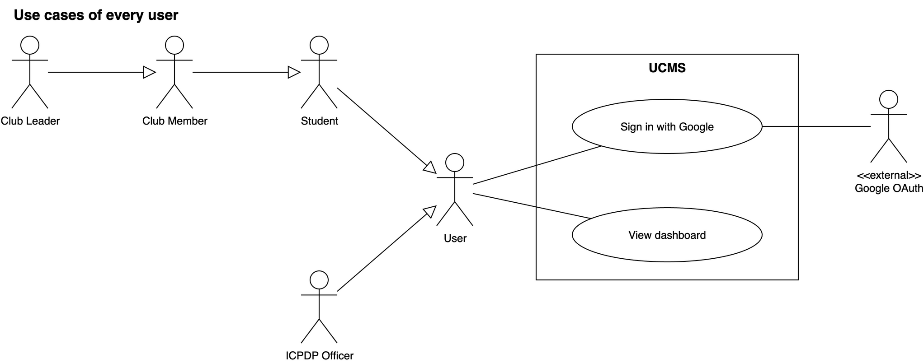
Figure III.3.1: Use cases of every user (generalization)

Figure III.3.2 — Use cases of the Student
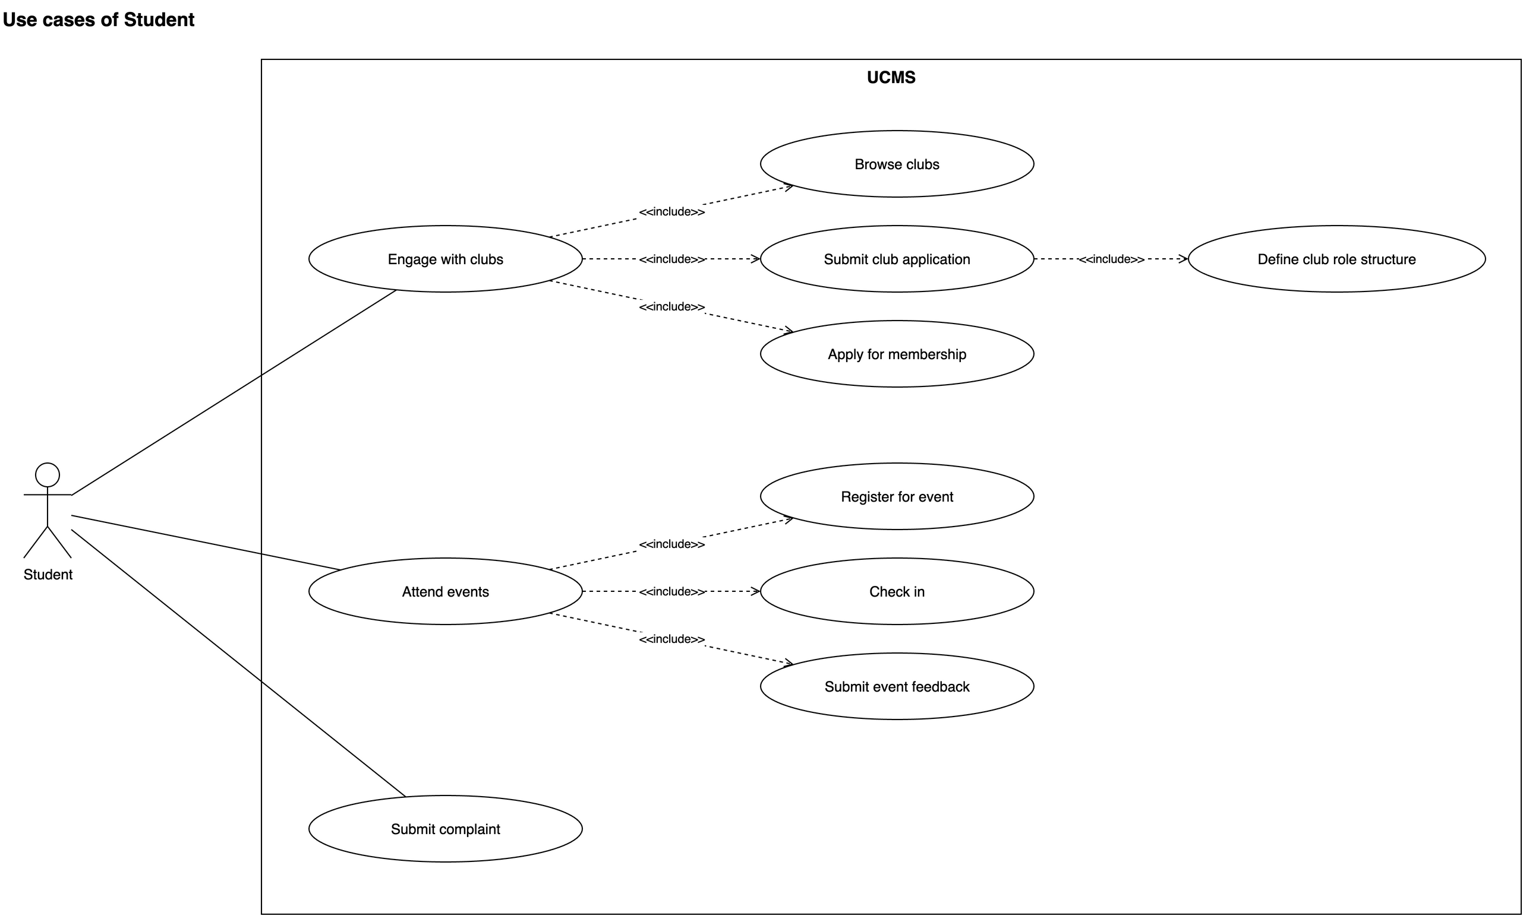
Figure III.3.2: Use cases of the Student

Figure III.3.3 — Use cases of the Club Leader
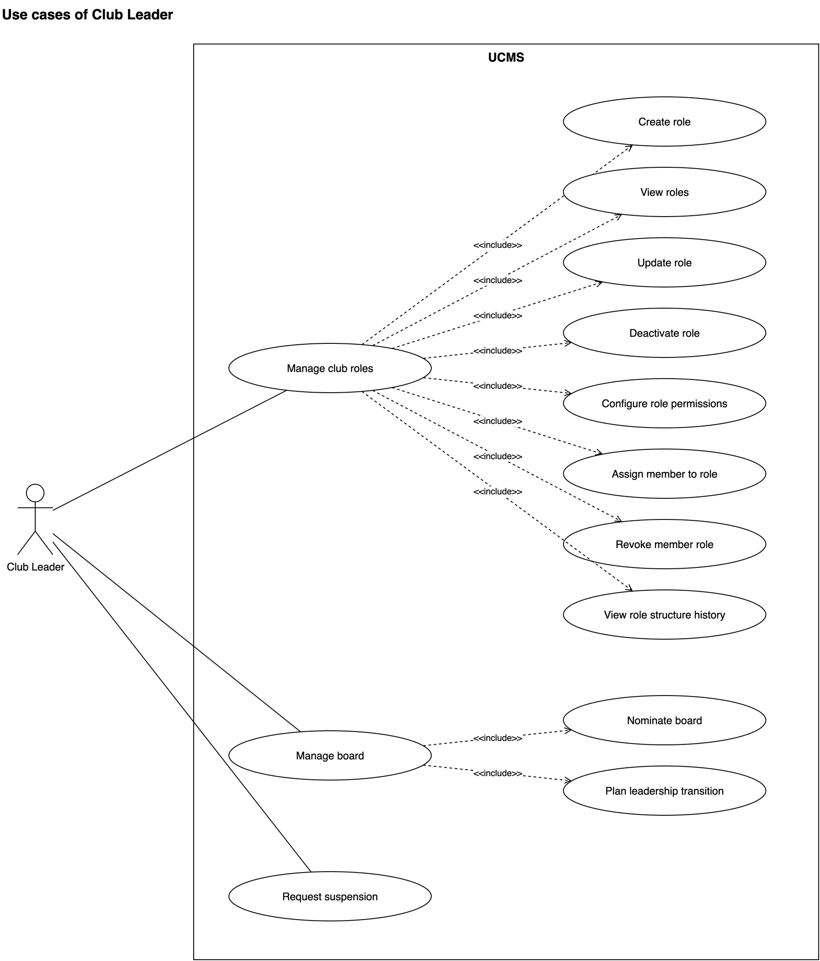
Figure III.3.3: Use cases of the Club Leader

Figure III.3.4 — Use cases of the Club Member — Club & recruitment
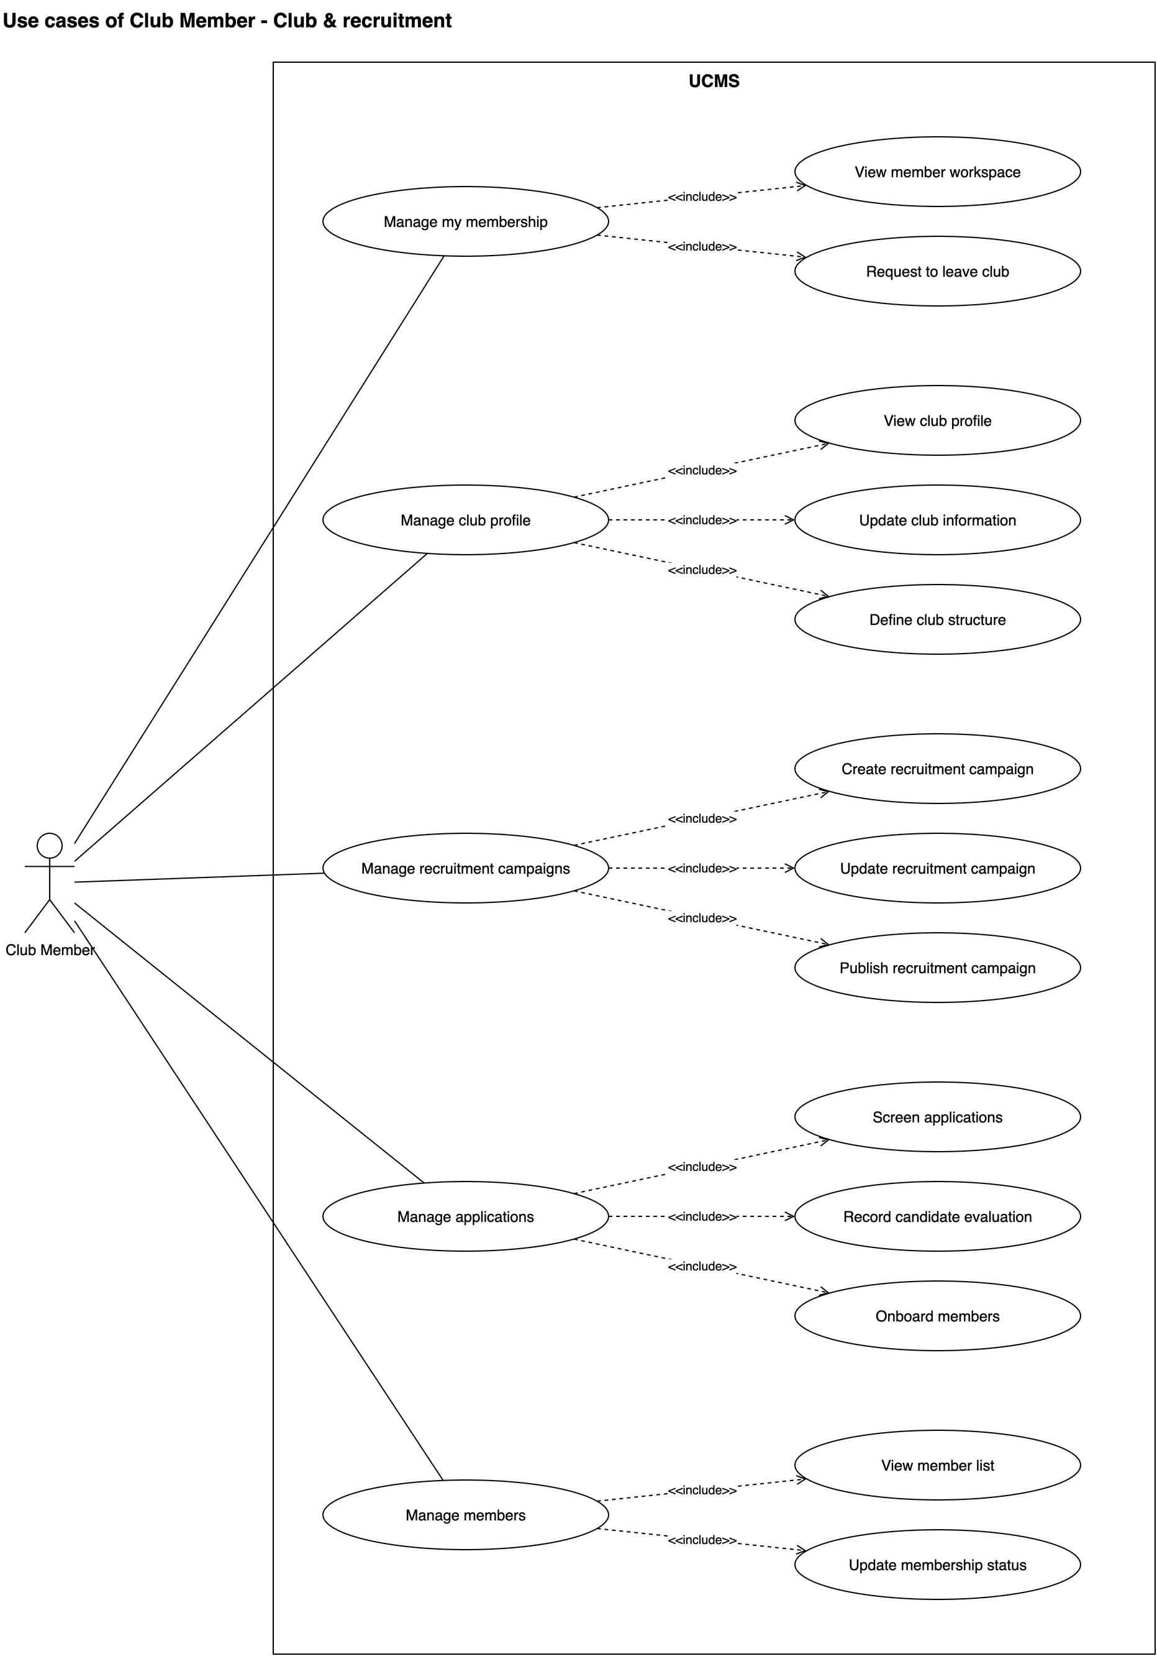
Figure III.3.4: Use cases of the Club Member — Club & recruitment

Figure III.3.5 — Use cases of the Club Member — Events & bookings
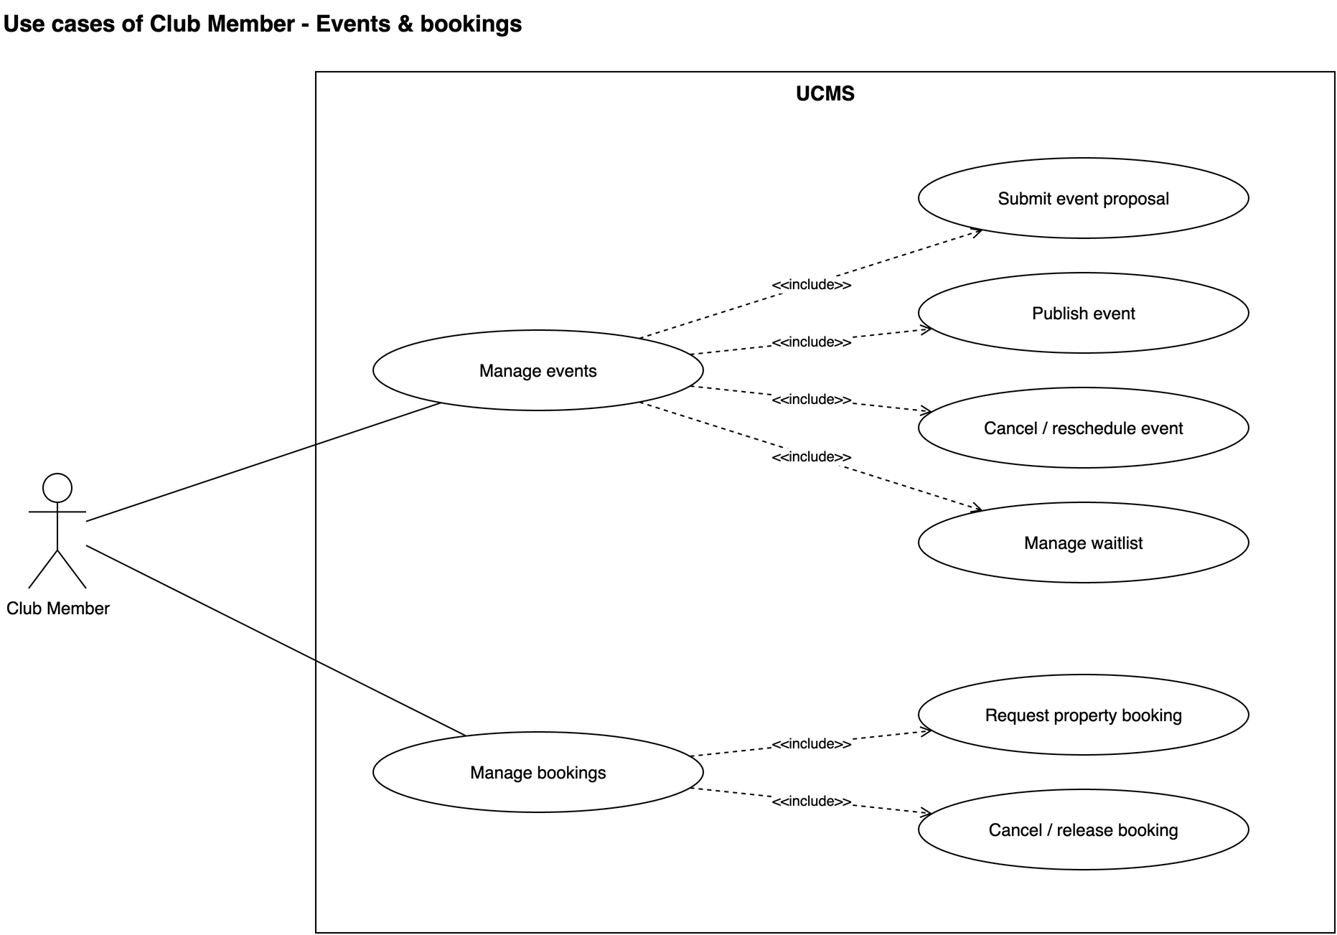
Figure III.3.5: Use cases of the Club Member — Events & bookings

Figure III.3.6 — Use cases of the Club Member — Accountability & finance
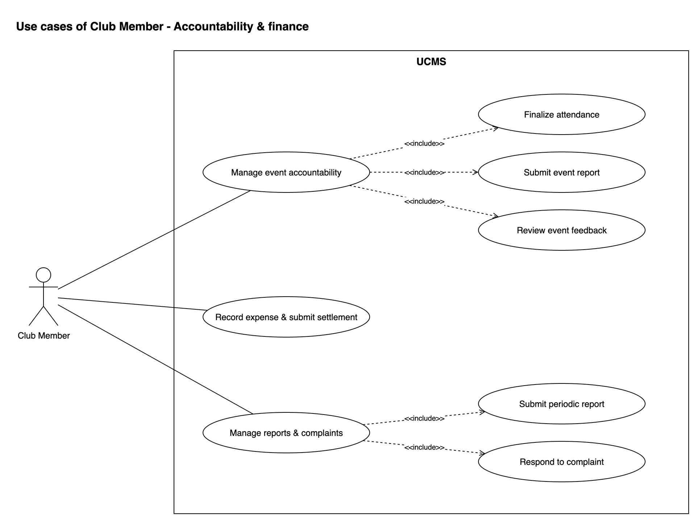
Figure III.3.6: Use cases of the Club Member — Accountability & finance

Figure III.3.7 — Use cases of the ICPDP Officer — Access & club lifecycle
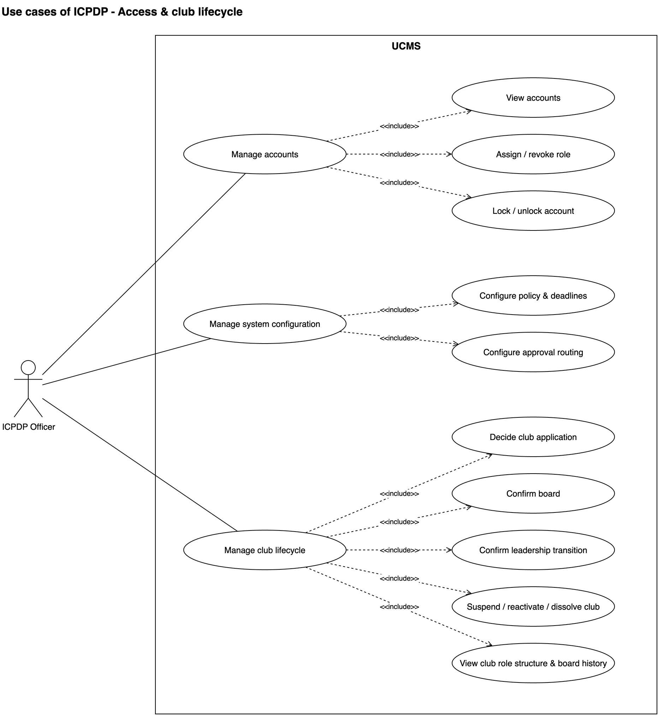
Figure III.3.7: Use cases of the ICPDP Officer — Access & club lifecycle

Figure III.3.8 — Use cases of the ICPDP Officer — Events, bookings & finance
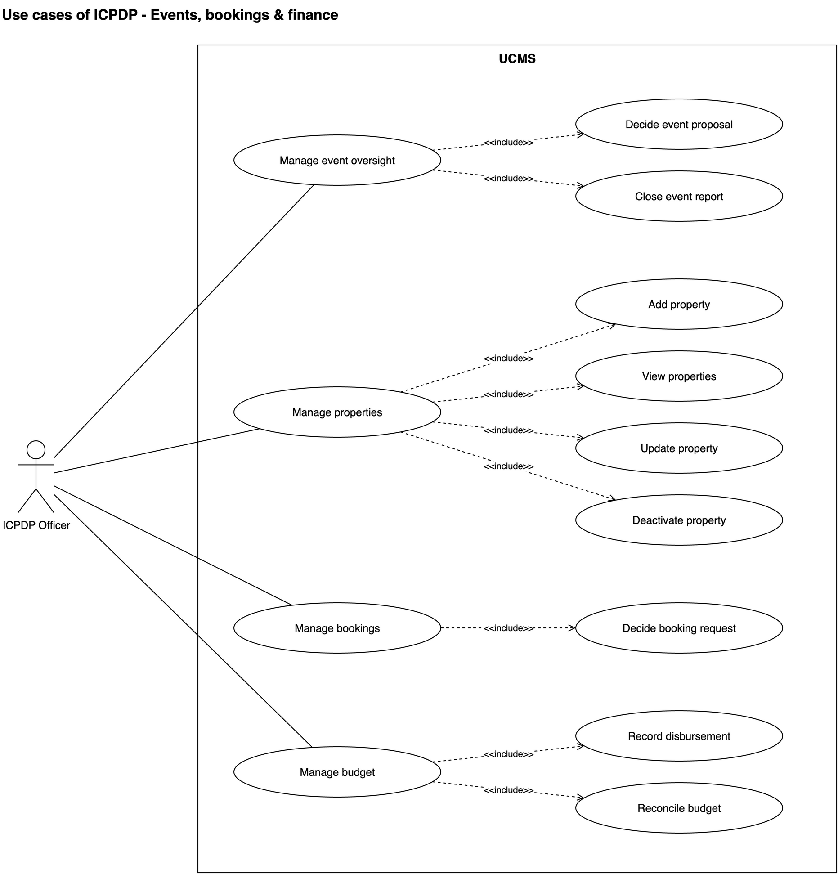
Figure III.3.8: Use cases of the ICPDP Officer — Events, bookings & finance

Figure III.3.9 — Use cases of the ICPDP Officer — Compliance & evaluation
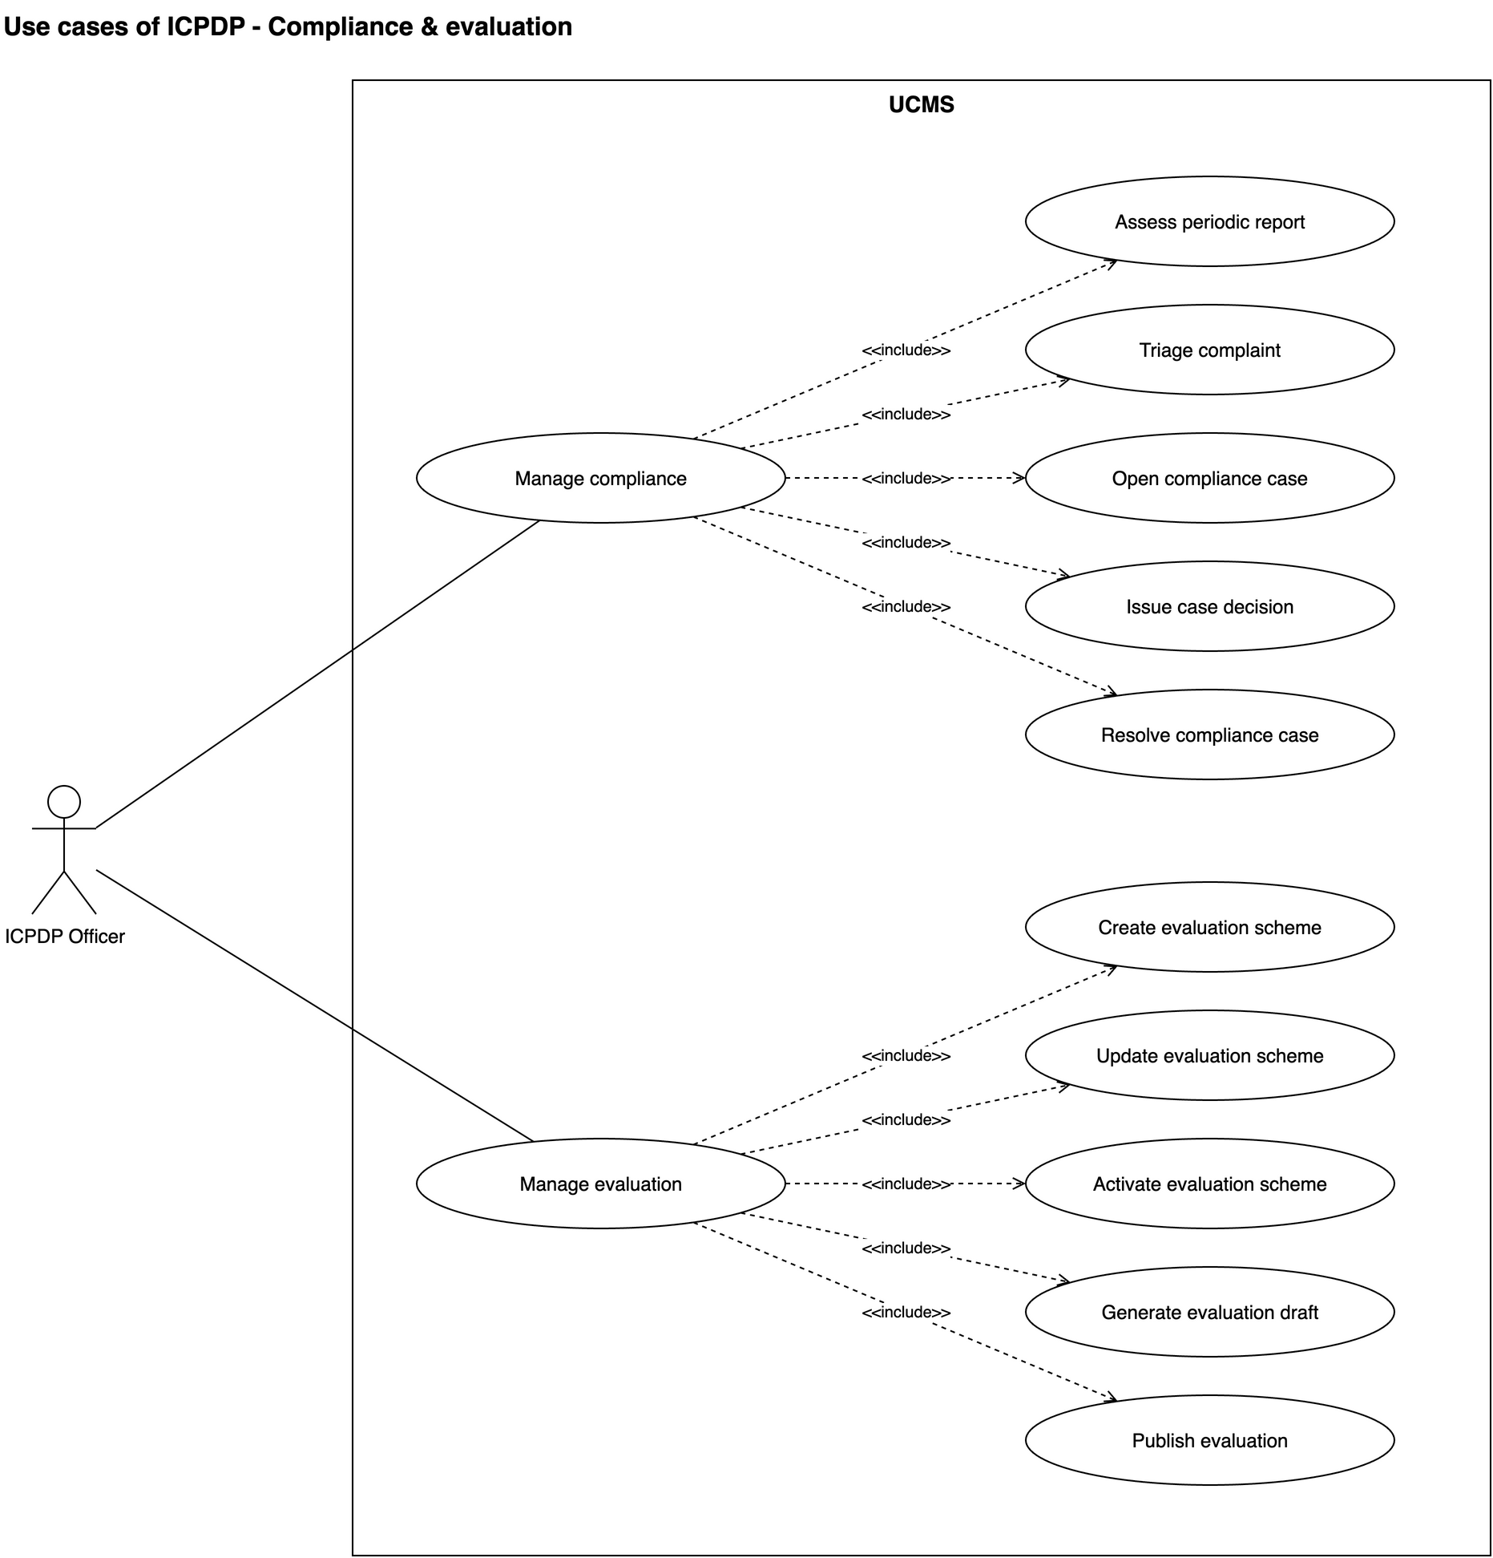
Figure III.3.9: Use cases of the ICPDP Officer — Compliance & evaluation

