**Automotive functional safety introduction**

original motivation of fusa in automotive

traditional application for electronic:

- steering, lighting, dashboard, airbags, braking, engine

traditional approach - vmodel

recall/updates requiring bring vehicle back to service center

Safety issues cause by Faults

HW: Random HW faults, systematic faults hw

SW: Systematic faults sw

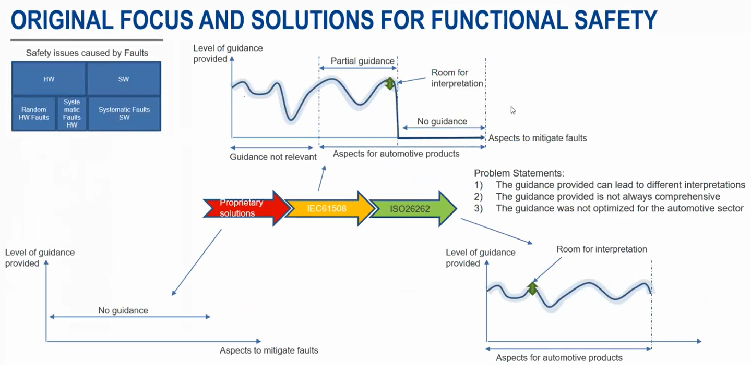

ISO26262 solve problem (3)

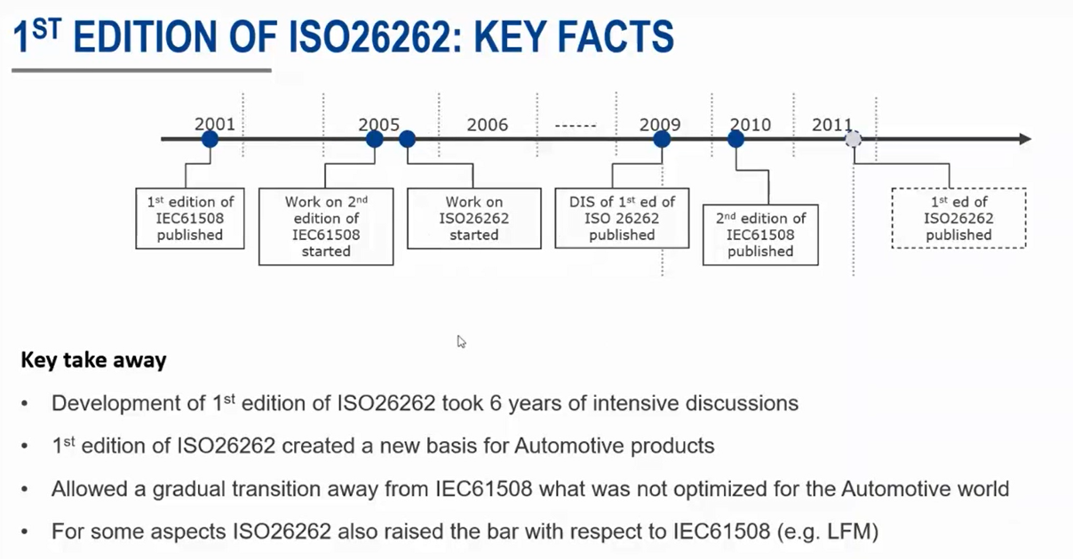

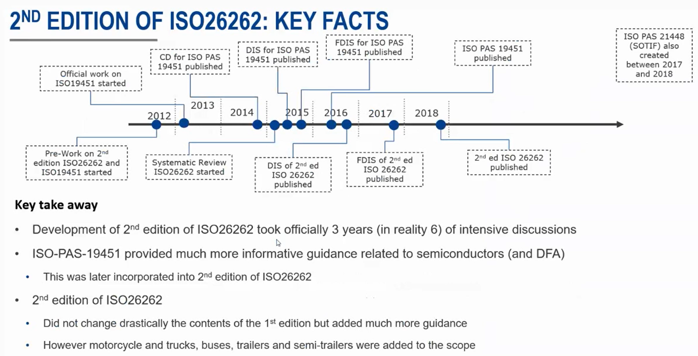

SOTIF: safety of the intended functionality

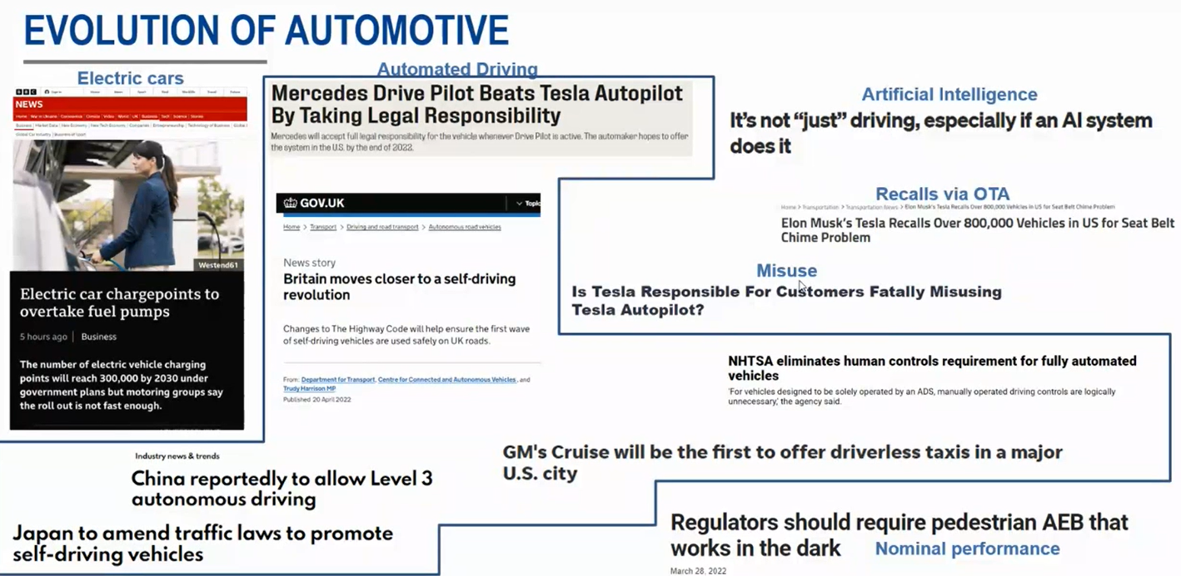

Electrification, Automated, Security/Shared, Connectivity

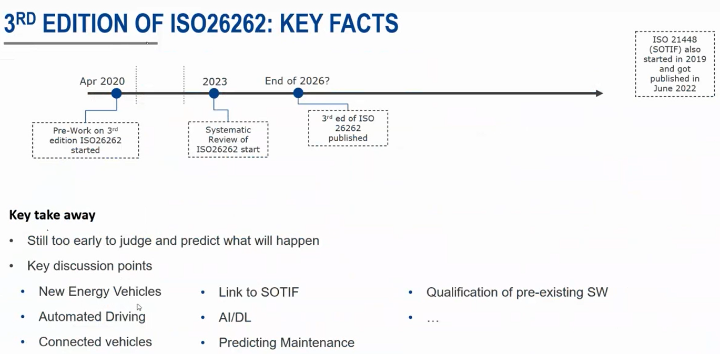

Derivation of Fault Tolerant Time Interval(FTTI) for safety goal

Guideline, process of deriving FTTI

FTTI only define at ITEM level

FHTI at component, system

