

CREATING ENJOYABLE APPS

www.makingsense.com– hello@makingsense.com- USA -Argentina

Selenium grid
Table of Contents

What is Selenium grid 4
Configuring a Selenium grid 5
Prerequisites 5
Terminologies used in Grid Configuration 5
Starting the hub (Windows) 7
Starting nodes (Windows) 8
Registering Firefox node (Windows) 9
Registering Chrome node (Windows) 9
Registering Internet explorer node (Windows) 10
Selenium node with a JSON configuration file 11
Starting node example 12
Selenium grid + Appium 14
Configuration json example 16
Test class example 16
Configuring a hub in Windows and Nodes in Mac 18
Chrome node 18
Safari node 19
Selenium grid – TestNg: Parallelization 21
Example: Parallel cross browser execution 22

What is Selenium grid

Selenium-Grid is used to run parallel executions in multiple machines at the same time, and to run Selenium WebDriver tests in parallel, we need to set up the Selenium Grid Server as a hub.
The Hub will provide the available capabilities to the webdriver and the registered nodes will connect to hub for parallel execution. Selenium Grid supports multiple operating systems like Windows, Mac, Linux and iOS. It also supports several browsers such as Chrome, IE, Firefox, Opera, Safari, and Android.
The Hub acts as a bridge, which receives the test execution request and distributes it to the available nodes or keeps them in queue until any stop sending or receiving requests from hub.
A grid consists of a single hub, and one or more nodes. Both are started using the selenium-server.jar executable. We’ve listed some examples in the following sections of this chapter.
The hub receives a test to be executed along with information on which browser and ‘platform’ (i.e. WINDOWS, LINUX, etc) where the test should be run. It ‘knows’ the configuration of each node that has been ‘registered’ to the hub. Using this information it selects an available node that has the requested browser-platform combination. Once a node has been selected, Selenium commands initiated by the test are sent to the hub, which passes them to the node assigned to that test. The node runs the browser, and executes the Selenium commands within that browser against the application under test.
You can find examples related to this document in https://github.com/nvega-ms/SeleniumGrid-AppiumExamples

Configuring a Selenium grid

Generally you would start a hub first since nodes depend on a hub. This is not abolutely necessary however, since nodes can recognize when a hub has been started and vice-versa.

Prerequisites

- Java IDE
- IEDriverServer.exe downloaded -> http://www.seleniumhq.org/download/
- ChromeDriver.exe downloaded -> http://www.seleniumhq.org/download/
- selenium-server-standalone.jar (Last version)

Terminologies used in Grid Configuration

To start/register hubs, and nodes, you can use the following attributes when you run the scripts
role = When launching a node, it will forward the parameter to server on the node like, -role node.
host = Though it not needed and determined automatically. For some network configuration, network with VPN, specifying the host might be necessary.
port = the port the remote/hub will listen on. Default to 4444.
throwIn Capability Not Present = Default value is true; if no proxy is currently registered hub will reject the test request. On contrast, the request queued until a node supporting the capability which is added to the grid.
new Session Wait_Timeout = Default to no timeout ( -1 )ms after which a new test waiting for a node to become available will timeout else test will throw an exception before starting a browser.
hubConfig = It defines the hub properties in JSON format.
nodeConfig = It defines the node properties in JSON format.
cleanupCycle = It will check the timeout thread in ms.
node Timeout = The timeout in seconds prior to hub automatically ends the test so that browser will be released for another test to run.
browser Timeout= The browser gets hang after defined timeout in ms.
hub = It used to post the registration request using url – <http://localhost:4444/grid/register>
proxy =This will be used to represent the node. By default org.openqa.grid.selenium.proxy.DefaultRemoteProxy.
maxSession = Maximum number of sessions to run multiple tests at same time independently in different browsers.
register Cycle = It defines how often registered node will try to register itself again in ms,however, without restarting the node command file.
nodePolling = How often the hub checks if the node is still alive in ms.

Starting the hub (Windows)

- Open a command prompt and navigate to the directory where we put the selenium-server-standalone file.

- Execute the script (This will work on all the supported platforms, Windows Linux, or Mac OSX):

java -jar selenium-server-standalone-2.46.0.jar -port 4444 -role hub

To check that the hub is running, go to http://localhost:4444/grid/console, you should the hub running.

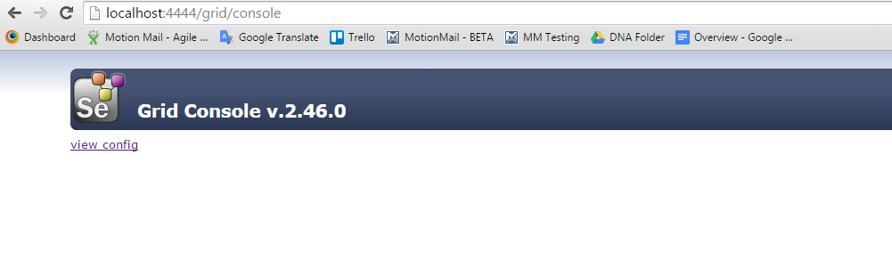
This starts a hub using default parameter values. Note that you will likely have to change the version number in the jar filename depending on which version of the selenium-server you’re using
The default port used by the hub is 4444. The port being referred to here, is the TCP/IP port used when the ‘client’, that is, the automated tests connect to the Selenium-Grid hub

Starting nodes (Windows)

A node is a machine that you register with your hub. By registering with the hub, the hub now knows about the node and any configuration information you used when you registered the node
To do this open a command prompt windows, navigate to the directory where we put the selenium-server-standalone file, and execute the script.

java -jar selenium-server-standalone-2.46.0.jar -role node -hub http://localhost:4444/grid/register ...

This assumes the hub has been started above. The default port the hub uses to listen for new requests is port 4444. This is why port 4444 was used in the URL for locating the hub. Also the use of ‘localhost’ assumes your node is running on the same machine as your hub. For getting started this is probably easiest. If running the hub and node on separate machines, simply replace ‘localhost’ with the hostname of the remote machine running the hub.

WARNING: Be sure to turn off the firewalls on the machine running your hub and nodes. Otherwise you may get connection errors.

Attributes:

-role: It’s define that the role of this element is a node role
-browser: It’s define the capabilities that the browser will have when the node is created
Browsername: name of the browser
version: You can define the value as ANY, to match with any version defined in the capabilities, or you can define an specific version.
maxInstances: You should define the max of instances to the node will allows. If you define more than one instances, you will see..
platform: OS to run the tests

- -port: You should define an available port to register the nodes, each node should be created in a different port.

Registering Firefox node (Windows)

To do this open a command prompt windows, navigate to the directory where we put the selenium-server-standalone file, and execute the script.

java -jar selenium-server-standalone-2.46.0.jar -role node -hub http://localhost:4444/grid/register -browser browserName=firefox,version=38.0.5,platform=WINDOWS,maxInstances=1 -port 5555

To check that the node is running, go to http://localhost:4444/grid/console, you should the node created

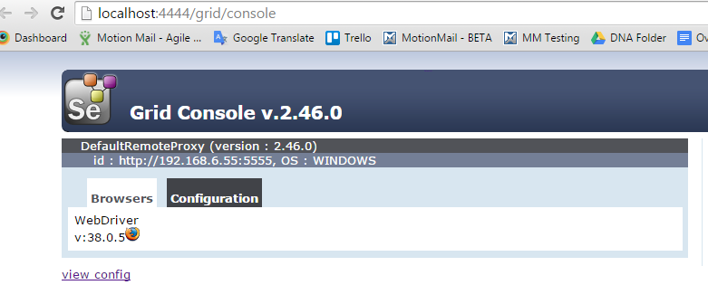

Registering Chrome node (Windows)

In order to register a Chrome node, you should download the ChromeDriver.exe file.

java -jar selenium-server-standalone-2.46.0.jar -role webdriver -hub http://localhost:4444/grid/register -browser browserName="chrome",version=43,platform=WINDOWS,maxInstances=5 -Dwebdriver.chrome.driver=C:\ <Path-to-file>\chromedriver.exe -port 5557
In this case, you should define the attribute Dwebdriver.chrome.driver, and provide the path of the chromedriver.exe file
To check that the node is running, go to http://localhost:4444/grid/console, you should the node created

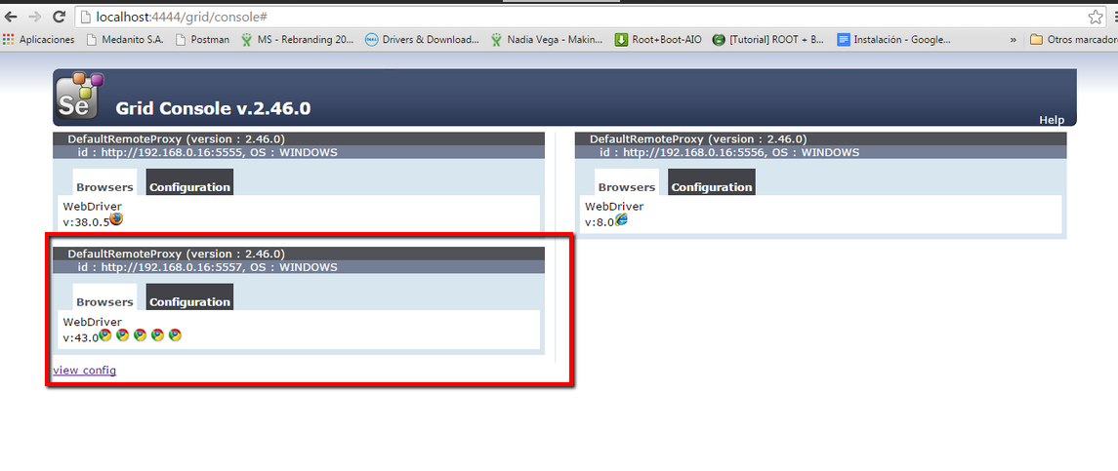

Registering Internet explorer node (Windows)

In order to register an IE node, you should download the IEDriverServer.exe file.

java -jar selenium-server-standalone-2.46.0.jar -role webdriver -hub http://localhost:4444/grid/register -browser browserName="internet explorer",version=8.0,platform=WINDOWS -Dwebdriver.ie.driver=C:\<Path-to-file>\IEDriverServer.exe -port 5556
In this case, you should define the attribute Dwebdriver.ie.driver, and provide the path of the IEDriverServer.exe file
To check that the node is running, go to http://localhost:4444/grid/console, you should the node created

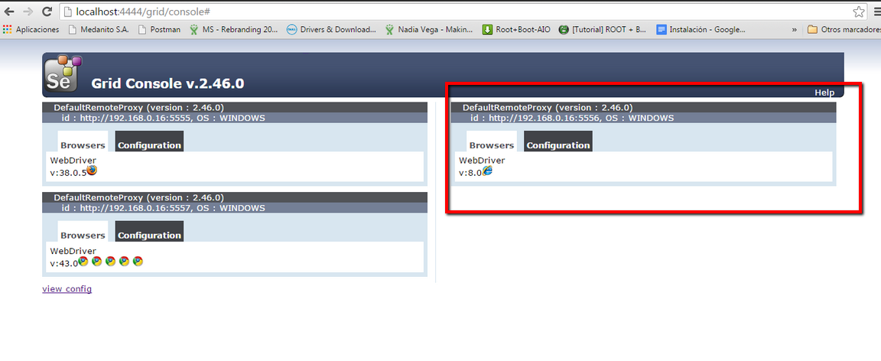

Selenium node with a JSON configuration file

We can also load a JSON file while launching the node, instead of specifying the browser parameter on the command line. We need to add the following parameter to the test: -nodeConfig node.json.
The contents of node.json may look like this
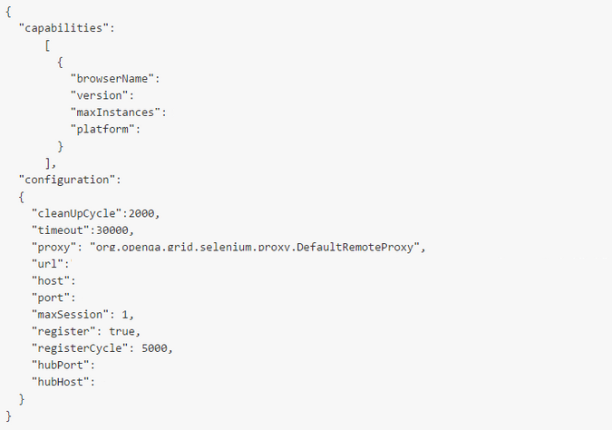

In the “Capabilities” section, you should define the capabilities desired for each browser. In the “Configuration” section, you should define the related to the hub and node configuration.
Details of Node: where to run the scripts
- url: nodeIp:port
- host: nodeIp
- port: port Node
Details of Grid:
- hubPort: Grid port number
- hubHost: Grid ip address
Find details about parameters here:
Grid Parameters properties: https://code.google.com/p/selenium/source/browse/java/server/src/org/openqa/grid/common/defaults/GridParameters.properties
Hub parameters properties: https://code.google.com/p/selenium/source/browse/java/server/src/org/openqa/grid/common/defaults/HubParameters.properties?name=selenium-2.21.0&r=8d9c8b0d91cadaeb130dd6d6c8af2fa0c98e1360&spec=svn876ea4d010daa9705fab77ab7ed932ae5e628678
Node Parameters properties: https://code.google.com/p/selenium/source/browse/java/server/src/org/openqa/grid/common/defaults/NodeParameters.properties?name=selenium-2.4.0&r=8d9c8b0d91cadaeb130dd6d6c8af2fa0c98e1360&spec=svn710332c9ccb940c81e2a9258a9217822588477f3

Starting node example

After start the hub, create a .json file as follow:
{
"capabilities":
[
{
"browserName":"firefox",
"maxInstances":5
},
{
"browserName":"chrome",
"maxInstances":5
},
{
"browserName":"internet explorer",
"platform":"WINDOWS"
}
],
"configuration":
{
"cleanUpCycle":2000,
"timeout":30000,
"proxy":"org.openqa.grid.selenium.proxy.DefaultRemoteProxy",
"maxSession":5,
"port": 5555,
"host": "localhost",
"register": true,
"hubPort" : 4444
}
}
After that, open a command prompt windows, navigate to the directory where we put the selenium-server-standalone file, and execute the script.

Java –jar selenium-server-standalone-2.46.0.jar –role node –nodeConfig C:/<Path-to-file>/<fileConfigName>.json

After execute the script, if you go to http://localhost:4444/grid/console, you will see the node created in the port specified.
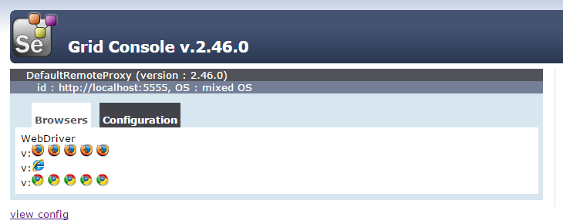
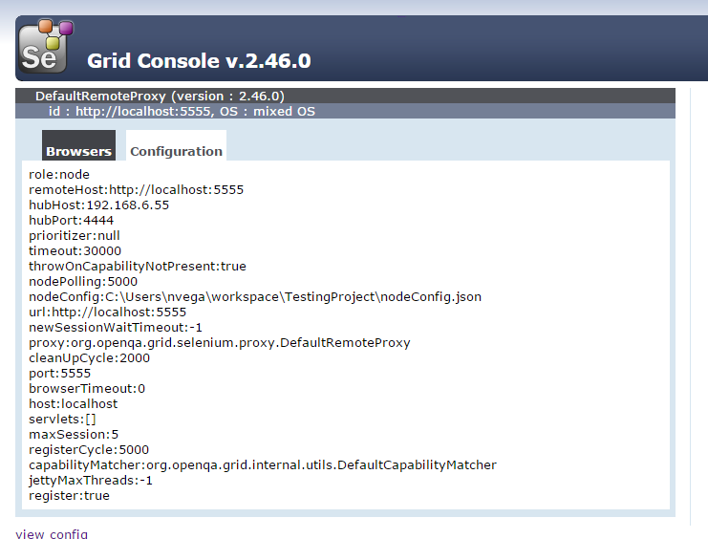

Selenium grid + Appium

Selenium grid and Appium can be integrated to execute test on real devices and emulator. The appium server should be configured and ran, then, a node should be registered. After that, the script will be run in the node defined.
Follow the next steps to integrate both tools:
- Open a command prompt windows, navigate to the directory where we put the selenium-server-standalone file, and execute the script:
java -jar selenium-server-standalone-2.46.0.jar -port 4444 -role hub
- Create a Json file as follow
  - Define the structure
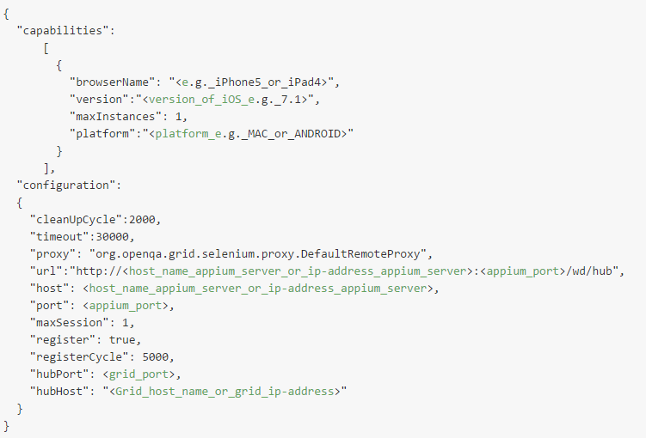
  - In the Configuration section, define the Url field taking into account the Appium server's address and port
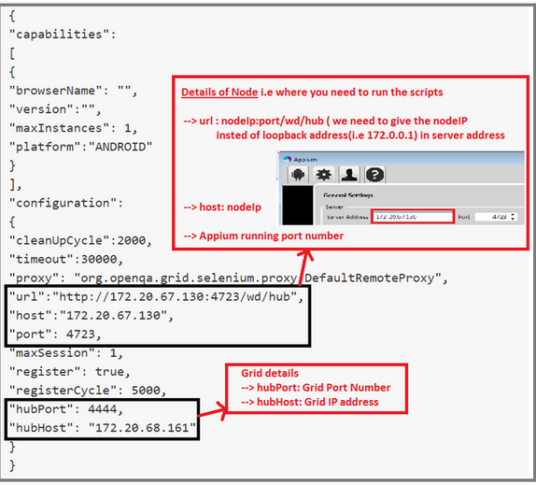
  - In the Configuration section, define the hubHost and hubPort fields taking into account the Grid port number and Grid Ip address. See image above.
  - In the Appium console, define the Selenium grid configuration field with the path of the Json file created before.
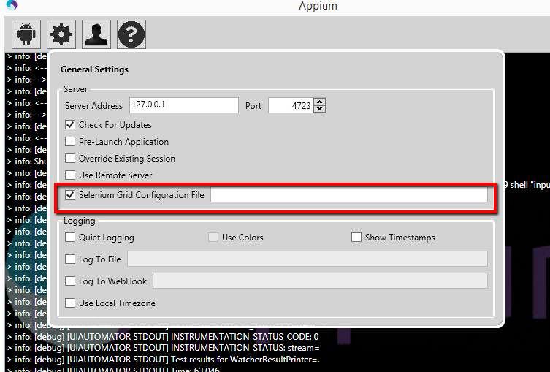
- Start the appium server
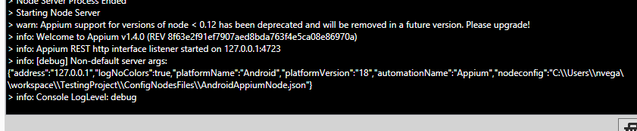

- Define a test class for the test related with the Android devices. Define the capabilities that you want to match with the node

Configuration json example

{
"capabilities":
[
{
"browserName": "Android",
"version":"4.4",
"maxInstances": 3,
"platformName":"ANDROID"

}
],
"configuration":
{
"cleanUpCycle":2000,
"timeout":30000,
"proxy":"org.openqa.grid.selenium.proxy.DefaultRemoteProxy",
"url" : "http://127.0.0.1:4723/wd/hub",
"host" : "127.0.0.1",
"port" : 4723,
"maxSession":5,
"register": true,
"hubPort" : 4444,
"hubHost" : "localhost"
}
}

Test class example

import io.appium.java_client.remote.MobileCapabilityType;
import java.net.URL;
import org.openqa.selenium.WebDriver;
import org.openqa.selenium.remote.DesiredCapabilities;
import org.openqa.selenium.remote.RemoteWebDriver;
import org.testng.Assert;
import org.testng.annotations.AfterClass;
import org.testng.annotations.BeforeClass;
import org.testng.annotations.Test;
import trainning.site.pages.HomePage;
import trainning.site.sections.MenuSection;

public class AndroidTest {

WebDriver driver;

MenuSection menuSection;

@BeforeClass
public void setUp() throws Exception {

DesiredCapabilities capabilities = DesiredCapabilities.android();
capabilities.setCapability("browserName","Android");
capabilities.setCapability("version","ANY");
capabilities.setCapability("platformName","ANDROID");
capabilities.setCapability("deviceName","4d00bfd7479f80c9");
capabilities.setCapability(MobileCapabilityType.APP_PACKAGE,"com.android.chrome");
driver = new RemoteWebDriver(new URL("http://127.0.0.1:4444/wd/hub"), capabilities);

}

@AfterClass
public void tearDown() throws Exception {
driver.manage().deleteAllCookies();
driver.quit();
}

@Test
public void isMenuPageComplete(){
HomePage home = new HomePage(driver);
home.goToMenu();
menuSection = new MenuSection(driver);
Assert.assertNotNull(menuSection.isCloseButtonDisplayed(), "The Close button should be displayed");
Assert.assertNotNull(menuSection.isGoToAboutUsDisplayed(), "The About us option should be displayed");
Assert.assertNotNull(menuSection.isGoToServicesDisplayed(), "The Services option should be displayed");
Assert.assertNotNull(menuSection.isGoToProductsDisplayed(), "The Products option should be displayed");
Assert.assertNotNull(menuSection.isGoToBlogDisplayed(), "The Blog option should be displayed");
Assert.assertNotNull(menuSection.isGoToCareersDisplayed(), "The Careers option should be displayed");
Assert.assertNotNull(menuSection.isGoToTalkToUsDisplayed(), "The Talk to Us option should be displayed");}

Configuring a hub in Windows and Nodes in Mac

In this section you can see an example to register a hub in Windows, and certain nodes registered in Mac.

Chrome node

- Download the ChromeDriver file from http://chromedriver.storage.googleapis.com/index.html?path=2.16/
- Download the selenium-server-standalone jar
- Open a Terminal windows, and go to the folder where is allocated the file downloaded in the step 2
- Start the hub: Execute script
java -jar selenium-server-standalone-2.46.0.jar -role hub
- Open a new Terminal windows, and go to the folder where is allocated the selenium-server-standalone file and the chromedriver file
- Register a Chrome node: Execute the script
java -jar selenium-server-standalone-2.46.0.jar -role node -hub http://localhost:4444/grid/register -maxSession 15 -browser browserName = "chrome",version=ANY, platform=MAC,maxInstance=5 -Dwebdriver.chrome.driver=chromedriver
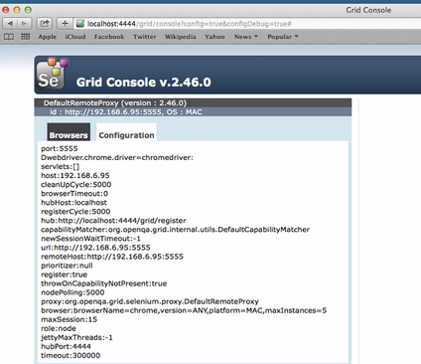
- From Eclipse (Windows), define a test class as follow:
  - Define desired capabilities for Chrome
  - The url defined for the RemoteWebDriver should be the ip address of the Mac machine
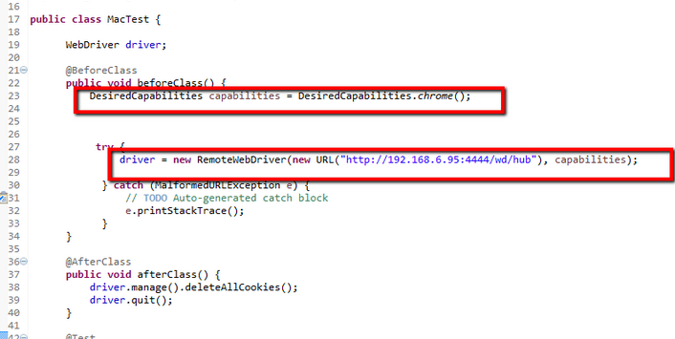

Safari node

- Download the selenium-server-standalone
- Open a Terminal windows, and go to the folder where is allocated the file downloaded in the step 1
- Start the hub: Execute script
java -jar selenium-server-standalone-2.46.0.jar -role hub
- Open a new Terminal windows, and go to the folder where is allocated the selenium-server-standalone file
- Register a Safri node: Execute the script
java -jar selenium-server-standalone-2.46.0.jar -role node -hub http://localhost:4444/grid/register -maxSession 15 -browser browserName = safari,version=ANY, platform=MAC,maxInstance=5
- From Eclipse (Windows), define a test class as follow:
- Define desired capabilities for Safari
- The url defined for the RemoteWebDriver should be the ip address of the Mac machine

Selenium grid – TestNg: Parallelization

Selenium Grid transparently distributes our tests across multiple physical or virtual machines so that we can run them in parallel, cutting down the time required for running tests. This dramatically speeds up testing, giving us quick and accurate feedback. With Selenium Grid, we can leverage our existing computing infrastructure. It allows us to easily run multiple tests in parallel, on multiple nodes or clients, in a heterogeneous environment where we can have mixture of OS and Browser support. Here is an example of the Selenium Grid architecture having capabilities to run tests on Linux, Windows, Mac, iOS, and Android platforms.
TestNG has a threading model to support running multiple instances of a same test using an XML-based configuration. Also, it’s allows us to create tests that can be executed in parallel. We can set up a group of tests or test suites and have parameters configured to run these tests in parallel. It uses a multithreading model to run tests in parallel. TestNG requires that we have an XML configuration file with details of configurations that are needed to run the tests in parallel.
- First we need to create a configuration file, which TestNG will need to run the tests in parallel. We will provide four parameters for tests, platform, browser, version, and URL. Create a conf.xml file in your projects source directory and add the following code to this file:
<!DOCTYPE suite SYSTEM http://testng.org/testng-1.0.dtd>
<suite name="Parallel Tests" verbose="1" thread-count="4"
parallel="tests">
</suite>
In order to use the parallel attribute. See Appendix1. The attribute thread-count allows you to specify how many threads should be allocated for this execution.
- Add the node for a test that will be executed
<tests>
<test name="Test name">
<parameters>
<parameter name="parameterName" value="Value" />
….
</parameters>
<classes>
<class name="ClassName" />
</classes>
</test>
</tests>
In the <test> element, you will define the classes that we can include in a certain test.

Example: Parallel cross browser execution

You should add a different node for each test class related to the browser test.
<?xml version="1.0" encoding="UTF-8"?>
<suite name="Test" parallel = "tests" thread-count="4">
<test name="TestFirefox">
<classes>
<class name = "parallel.test.FireFoxTest"></class>
</classes>
</test>
<test name="TestChrome">
<classes>
<class name = "parallel.test.ChromeTest"></class>
</classes>
</test>
<test name="TestInternetExplorer">
<classes>
<class name = "parallel.test.InternetExplorerTest"></class>
</classes>
</test>
<test name="TestMac">
<classes>
<class name = "parallel.test.MacTest"></class>
</classes>
</test>
<test name="TestAndroid">
<classes>
<class name = "appium.android.test.MenuPageTest"></class>
</classes>
</test>
</suite>
If you have defined a test class for each browser, you should use the xml defined above. If you have a parameterized test class as follow:
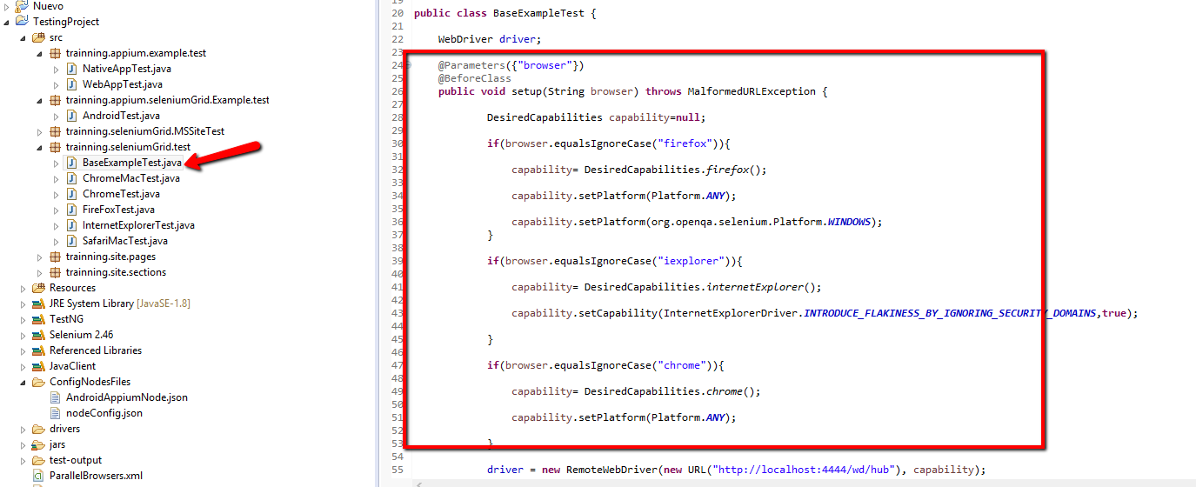
You should define a xml file as follow:
<?xml version="1.0" encoding="UTF-8"?>
<suite name="Test" parallel = "tests" thread-count="4">
<test name="TestFirefox">
<parameter name="browser" value="firefox" />
<classes>
<class name = "parallel.test.BaseTest"></class>
</classes>
</test>
<test name="TestChrome">
<parameter name="browser" value="chrome" />
<classes>
<class name = "parallel.test.BaseTest"></class>
</classes>
</test>
<test name="TestInternetExplorer">
<parameter name="browser" value="iexplorer" />
<classes>
<class name = "parallel.test.BaseTest"></class>
</classes>
</test>
</suite>
- Parallel methods, tests, classes
In testng.xml file, using the attribute parallel inside the suite tag instructs TestNG to runs tests in parallel in different threads. The attribute parallel accepts certain values as outlined below:
<suite name="mysuite" parallel="methods" thread-count="5">

<suite name="mysuite" parallel="tests" thread-count="5">

<suite name="mysuite" parallel="classes" thread-count="5">

<suite name="mysuite" parallel="instances" thread-count="5">
1. parallel=”methods”: TestNG will run all the test methods in parallel in different threads. The dependent methods will also run in different threads but would respect the order that was specified.
2. parallel=”tests”: TestNG will run all the methods in the same test in the same thread but each test will be run in separate threads. This allows to group the thread-safe classes in the same test so that they will run in the same thread while taking advantage of TestNG’s capability to run tests in several threads.
3. parallel=”classes”: TestNG will run all the test methods in the same class in the same thread and each class will be run in separate thread.
4. parallel=”instances”: TestNG will run all the test methods in the same instance in the same thread and each instance will be run in separate threads.

