1. Update the existing template with the current problem files and change the names where applicable with the names from our database in firebase. After that run “npm install”.

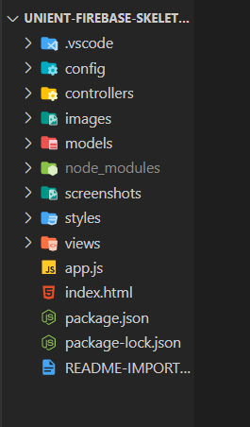

1. Cut the whole index.html file into handlebars templates.

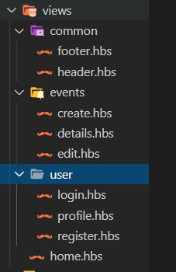

1. Start writing the paths in the app.js file, then the logic in the controllers and from there in the handlebars templates.

