SUPERCOOLA POS Specification Review

Prepared by: Anthony Nguyen

**Dear John Charles,**

Thank you for the opportunity to review your development requirements.

As per our conversation, this document outlines our proposal to build the **SUPERCOOLA POS** system.

The following estimate is based on our current understanding of your requirements from the information you have given us. Actual work may vary from the estimated times.

These estimates are valid for 30 days from date of issue. After this, the rates and estimates are subject to change.

The resources allocated to your project depend on availability. All efforts will be made to allocate the original resources used on the Spec Review, but that cannot be guaranteed.

I look forward to your feedback.

Yours sincerely,

Anthony Nguyen

Solution Architect

[www.ssw.com.au](http://www.ssw.com.au/)

# Relevant Parties

|  |  |  |  |
| --- | --- | --- | --- |
| Name | Company | Project Role | Contact |
| John Charles | SUPERCOOLA | Product Owner | [John@SUPERCOOLA.com](mailto:John@SUPERCOOLA.com) +61 433 333 222 |
| Anthony Nguyen | SSW | Project Manager | [anthony@ssw.com.au](mailto:anthony@ssw.com.au) +61 433 219 388 |
| Michael Smedley | SSW | Scrum Master | [michael@ssw.com.au](mailto:michael@ssw.com.au) +61 433 111 000 |

# High level design

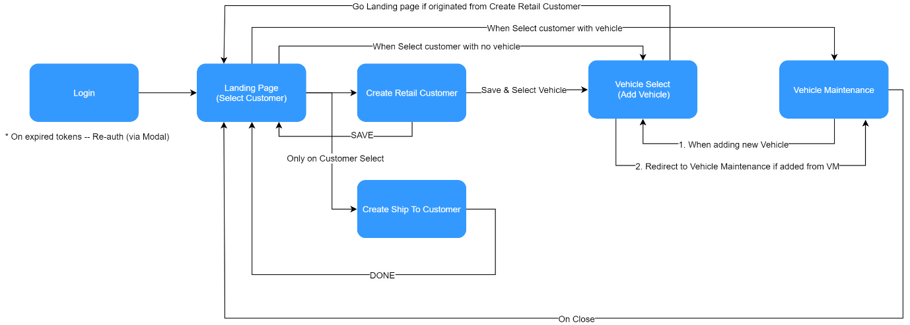

# Scope

**SUPERCOOLA POS** consists of the following functional areas

1. Login and Sign up page
2. Home page
3. Report
4. Checkout

Further requirements will be added later.

# Out of Scope

The following are identified as out of the scope of **SUPERCOOLA POS** project:

1. Payment gateway
2. Support after deployment

# Costing Summary

Note: All numbers are ex. GST

|  |  |  |  |  |
| --- | --- | --- | --- | --- |
| task | Est | Standard | Pre-paid 40h | is mvp |
| **Requirements** | **230 h** | **$33,400** | **$30,400** |  |
| Login screen | 16 h | $4,100 | $3,800 | Y |
| Sign up screen | 8 h | $2,100 | $1,800 | Y |
| Google Sign In | 16 h | $4,100 | $3,800 |  |