Software Quality Assurance
INSE- 6260

Software Requirements Specification

Online Banking System

Winter 2014

Instructor:

Dr. Rachida Dssouli

Due Date:

06-February-2014

Team Members:

Samia Hilal

Hung Viet Nguyen

Version 1.0
Table of Contents

1. Introduction 4
1.1 Purpose 4
1.2 Scope 4
1.3 Definitions, Acronyms, and Abbreviations. 5
1.4 References 5
1.5 Overview 5
2. The Overall Description 6
2.1 Product Perspective 6
2.1.1 System Interfaces 7
2.1.2 Interfaces 7
2.1.3 Hardware Interfaces 7
2.1.4 Software Interfaces 8
2.1.5 Communications Interfaces 8
2.1.6 Memory Constraints 9
2.1.7 Operations 9
2.1.8 Site Adaptation Requirements 9
2.2 Product Functions 10
2.3 User Characteristics 11
2.4 Constraints 11
2.4.1 Regulatory policies 11
2.4.2 Availability requirements 11
2.4.3 Reliability requirements 11
2.4.4 Scalability requirements 11
2.4.5 Safety and security considerations 11
2.5 Assumptions and Dependencies 12
2.6 Apportioning of Requirements. 12
3. Specific Requirements 13
3.1 External Actor Descriptions 13
3.1.1 Human Actors 13
3.1.2 Hardware Actors 13
3.1.3 Software System Actors 13
3.2 Use-Case Model 13
3.2.1 Actor-Goal List 13
3.2.2 Context Diagram 14
3.3 Use Case Descriptions 15
3.3.1 Use Case 1 15
3.3.2 Use Case 2 15
3.4 Performance Requirements 15
3.5 Design Constraints 15
3.5.1 Standards Compliance 15
3.6 Software system attributes 15
3.6.1 Reliability 15
3.6.2 Availability 15
3.6.3 Security 15
3.6.4 Maintainability 16
3.6.5 Portability 16
3.7 Logical Database Requirements 17
3.10 Other Requirements 17
4. Change Management Process 17
5. Document Approvals 18
6. Supporting Information 18

1. Introduction

Online banking has become a must have service for any bank or financial institution. Users are increasingly carrying-out their regular banking operations remotely and in the comfort of their homes or when away from home. Some banks invite elderly clients with limited mobility to come with their laptop or iPad and set them up for easy-to-learn and secure online banking. To summarize, there is tremendous business value to be gained from online banking and financial institutions have been putting a lot of effort to expand and innovate the services they offer online.

This document aims to gather, analyze, classify, organize and prioritize the requirements information pertinent to the Online Banking System such as it can provide a good basis for understanding the requirements, and proceeding with the system design.

This SRS has been created from a template that is adapted from the IEEE guide to Software Requirements Specifications (STD 830-1993)

1.1 Purpose

The purpose of this document is to present a complete and detailed description of the Online Banking system that can be used by the intended audience to gain a comprehensive understanding of the system. The intended audience of the SRS is composed of 2 types:
- Online banking system users or client stakeholders.
- Non-client stakeholders such as project team members including system designers, developers and testers.
The document has to be written at an appropriate level of detail that is adequate and clear for the understanding and intended goals of both communities of stakeholders.
For the project team, the SRS is intended to breakdown the system description into smaller functionalities while highlighting the dependencies, boundaries and constraints under which these functions have to operate. This will help the project team in defining scope, priorities and the order in which functionalities have to be developed. This gained understanding is essential for establishing the system’s design specifications.
As for the client/user stakeholders, the main purpose of the SRS is to understand the intended system, what it is going to achieve and provide the grounds for validating whether this future product will satisfy their needs.

1.2 Scope

The Online Banking System aims to provide its registered users with the key functionalities needed to remotely perform most of the banking operations available at their bank branch or ATM. These operations include the opening of a new bank account, cash and check deposit, cash withdraw, payment of bills and credit cards. In addition, the system shall allow its users to open and manage several types of investment accounts. These operations shall be carried out in an intuitive, reliable, and secure manner that will increase the users’ accessibility and manageability of their accounts.
In order to ensure the security of the clients and the system alike, some operations will still be carried-out in the traditional way by the bank. All operations that require background checking such as registering new clients or managing their financial profiles. Limitations will also be imposed on large-sum or suspicious transactions that will be reported to the bank for further verifications.

1.3 Definitions, Acronyms, and Abbreviations.

Term- Acronym | Definition
SRS-Software Requirements Specifications | The SRS is a specification for a particular software product, program, or set of programs that performs certain functions in a specific environment.  [IEEE STD 830-1998]
User Requirements | How the system is supposed to behave from the users’ point of view. In other words, what the users require the system to do.

1.4 References

1.5 Overview

The structure and organization of the SRS aims to gradually increase the reader’s understanding of the system by starting with the general concepts, motivation and a high-level overview of the system. Then it proceeds to the detailed system description and features.
The description provides a common definition for the hardware, software and communication interfaces as well as memory and operation constraints.
Section 2 will provide the product functions as well as user characteristics that are intended for the online banking customers and potential users without going into technical details. Section 3 is intended for the project team developers as it includes a more detailed elaboration of each requirement. Section 4 explains how changes are managed throughout the document. Finally, section 5 presents the document approvals by both the team and supervisor involved.

2. The Overall Description

This section provides a non-technical overview of the system and its functionality for non-technical users. Detailed technical requirements are presented in section 3.

The Online Banking system is a web-based application that allows registered users to perform most common banking operations remotely and that is accessible over the internet. There are 3 categories of system users:
- Online clients are bank clients who are registered for online banking and have one or more accounts that are accessible through the Online Banking System. Online clients use the system to accomplish their banking operations.
- Potential online clients who may or may not be actual bank clients but want to browse the system to see what it offers.
- System Administrator, not to be confused with an IT system or database administrator. While the system administrator has far more privileges and permissions than the average user, the system administrator remains a user of the system who cannot alter the behavior of a certain operation. A system administrator would have to request any system change to be implemented by the project maintenance team following the Change Management Process. The system administrator reviews operations that require human intervention or follow-up such as application to open a new account or request for appointment, user complaints, generating site usage reports and monitoring online user operations.

The remainder of this section describes the different aspects of the system that are pertinent to the above mentioned user categories.

2.1 Product Perspective

The Online Banking system is a web-based client-server application that is accessible over the internet. The system allows registered users to perform most common banking operations remotely over a secure website.
The System functionality is inspired by the online banking systems offered by many of the retail and virtual banks. However and due to limitation of schedule, only a subset of the functionality available with these systems is offered.

The system is composed of 2 major components:
- Front-End GUI: This major component is a graphic user interface (GUI) that allows users to interact with the system. This component handles the processing of user interaction events with the system and communicating them to the Back-End Component over an internet connection.
- Back-End Component: This major component handles all business logic and interacts with the bank database system. It also interfaces with services that are provided by a third-party such as Virtual Wallet Provider.

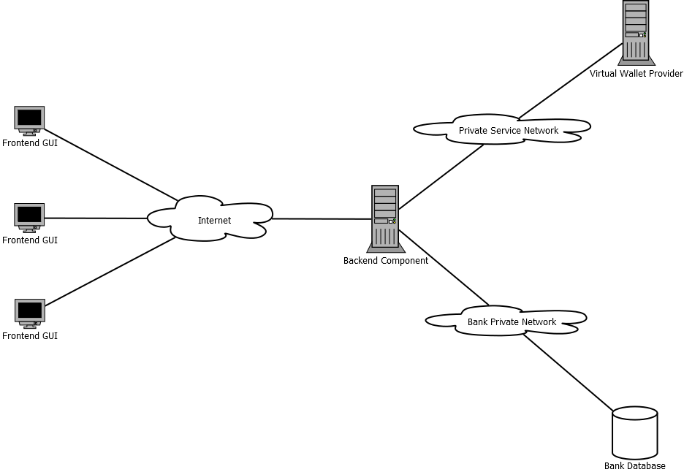

2.1.1 System Interfaces

The system should be able to interface with the Virtual Wallet Provider, a third-party providing Virtual Wallet service. Virtual Wallet Provider issues Virtual Wallet, a valuable card which is accepted at major shopping centers and department stores. By interfacing with Virtual Wallet Provider, Online Banking System allows its customers to withdraw from their accounts to top up Virtual Wallet cards or deposit to their accounts by subtracting values from Virtual Wallet cards.

2.1.2 Interfaces

Different interfaces are provided and can be accessed from different types of users.
- Customer interface: This interface allows customers of Online Banking System to carry out common banking & investment operations.
- Bank staff interface: This interface allows bank staff interacts with System.
- System administrator interface: This interface allow system administrators interact with System to carry out system administrator operations.

2.1.3 Software Interfaces

Back-End Component needs to interact with two external systems: Virtual Wallet Provider and the bank database server.

- Virtual Wallet Provider provide a proprietary API
- JDBC is used to interact with the bank database server which a POSTGRESQL server 9.2.

2.1.4 Memory Constraints

- The Front-End GUI should require no more than 2M bytes of memory to work properly.
- The Back-End Component should require no more than 2M bytes of memory to work properly.

2.1.5 Site Adaptation Requirements

- The bank private network should be an IP network.
- The Virtual Wallet Provider network should be an IP network.

2.2 Product Functions

This section presents a high-level summary of the major the major functions that the system will perform. In order to make the list of functions understandable to the customer or to anyone else reading the document for the first time, the functions shall be organized from the perspective of the users or what users shall be able to do with the system.

The following are the key categories:

- Manage User Profile
- Update profile
- Change password

- Manage Accounts:
- Open an account
- Close an account
- Deposit money into account
- Deposit a check
- Withdraw money from account
- Transfer money between accounts

- Pay Bills
Add/remove bills
Schedule automatic bill payments
Pay credit card

- View
Account transactions
View transactions with selected options
Organize statement as needed
Account balance
Monthly Statement

- Save
Store data from an account for future reference

- Communicate
Book appointment with bank representative
Order check books
Share any comments/complaints

- Administrator Management
View user activities
Reset account passwords
Process Requests: accounts, appointment, user complaints

2.3 User Characteristics

Using the system requires a minimum level of proficiency in web-browsing. All new online banking clients have to register at the bank for online access. At that time, the bank shall offer an optional basic training session to familiarize the users with web-browsing and online banking features.

2.4 Constraints

This section captures any applicable non-functional requirements in the customer’s language. A more formal presentation is included in section 3.

2.4.1 Regulatory policies

The system shall comply with all the regulatory requirements that are in effect at the parent bank and at the countries of operation.

2.4.2 Availability requirements

The system shall be available for 24/7 operation apart from normal prescheduled maintenance operations. Users shall be given an advance notice about any scheduled maintenance activities.

2.4.3 Reliability requirements

The system failure rate shall be less than 0.05%

2.4.4 Scalability requirements

The system shall be able to handle an increasing number of users without an observable or with minimal effect on response time.

2.4.5 Safety and security considerations

Different levels of system access privileges shall be implemented in order to prevent unauthorized access to the system.

2.5 Assumptions and Dependencies

It is assumed that the system can handle concurrent asynchronous user events simultaneously while maintaining data integrity. Data represented on the GUI of the user machine shall always be synchronized with the data on the server machine and database.

The system’s reliability and performance are dependent on the underlying hardware and operating system used for deployment.

2.6 Apportioning of Requirements.

This section divides the requirements into different sections for development and delivery. Remember to check with the customer – they should prioritize the requirements and decide what does and does not get done. This can also be useful if you are using an iterative life cycle model to specify which requirements will map to which interation.

3. Specific Requirements

3.1 External Actor Descriptions

This section provides a full description of the actors involved in the use-case model.

3.1.1 Human Actors

- Online user
- Potential online user
- System administrator

3.1.2 Hardware Actors

There are no hardware actors involved in the use-case model.

3.1.3 Software System Actors

VirtualWalletManager is a third-part system actor.

3.2 Use-Case Model

3.2.1 Actor-Goal List

Actor | Goals
Customer | - Update customer online account profile  - Login into the online banking system  - Open an online banking account  - Deposit money from Virtual Wallet to an account  - Withdraw money from an account and top up a Virtual Wallet  - Transfer money from customer accounts to any other bank accounts  - Request bill payments  - View account transactions  - View account balance  - View monthly statements  - Book appointment with bank representatives
Bank Staff | - Create an online banking account  - Process bill payment requests  - View requested appointments
System Administrator | - View user activities  - Reset account passwords
Virtual Wallet Provider  External/Secondary Actor | - Process Virtual Wallet serial number checking  - Process Virtual Wallet amount checking  - Process Virtual Wallet top up request  - Process Virtual Wallet withdraw request

3.2.2 Context Diagram

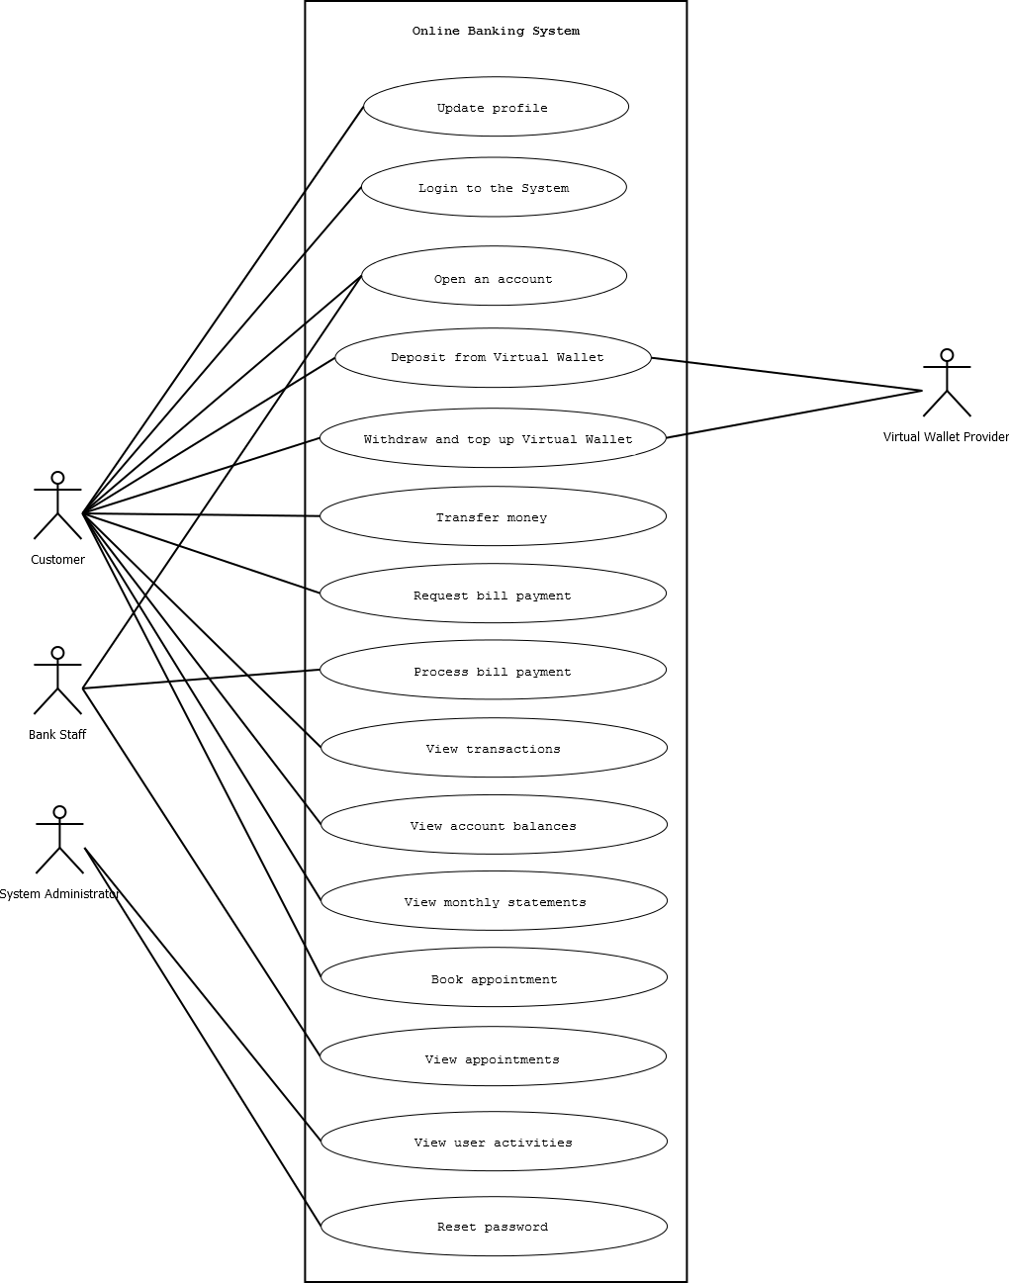

3.3 Use Case Descriptions

3.3.1 Use Case 1

3.3.2 Use Case 2

3.4 Performance Requirements

The online banking system shall handle up to 200 users concurrently and within an acceptable response time. 95% of the transactions shall be processed in less than 2 seconds. Average response time established at 3 seconds.

3.5 Design Constraints

3.5.1 Standards Compliance

The system shall comply with the following standards and regulations:
- The Personal Information Protection and Electronic Documents Act (PIPEDA). The system shall only permanently store customer data in the RDBMS. No temporary files or other storage media shall be used to store such data.
- The system shall comply with all the regulatory requirements that are in effect at the parent bank and at the countries of operation.
- Audit Tracing shall be used to trace processing activities. All changes to the accounts database must be recorded in a trace file with before and after values.

3.6 Software system attributes

The following software attributes are specified as requirements in order to be objectively verified and tested. These attributes are also knows as non-functional requirements or quality attributes.

3.6.1 Reliability

Reliability is defined as the probability that a device will perform its required function under stated conditions for a specific period of time.
The reliability of the system is constrained by the environment (software, hardware) in which it will be deployed. The Mean Time between Failures (MTBF) is calculated based on the MTBF of every software and hardware component in the environment.

The system failure rate shall be less than 0.05%

Specify the factors required to establish the required reliability of the software system at time of delivery. If you have MTBF requirements, express them here. This doesn’t refer to just having a program that does not crash. This has a specific engineering meaning.

3.6.2 Availability

The system shall be available for 24/7 operation apart from normal prescheduled maintenance operations. Users shall be given an advance notice about any scheduled maintenance activities. In the case of a software failure in the server’s end, the system has to be restarted manually and should not take more than 2 minutes. Software failure in the client-end shall be recoverable by reloading the web-page.

3.6.3 Security

Successful online banking is strongly related to high level of security. All authentications shall be performed by the user providing a username and password to the system. All user credentials entered for login and any data that is transferred after successful login shall be encrypted securely. All saved passwords shall be stored in the RDBMS only in hashed form. All credit card numbers are to be stored using symmetric key encryption.

At the application level, the system employs a Role-Based Access Control Architecture (RBAC) in order to prevent unauthorized access to the system. Different levels of system access privileges shall be assigned to different users based on their role.

3.6.4 Maintainability

The Software system shall provide mechanisms to enhance its maintainability. Modular programming, etc.

3.6.5 Portability

Some restrictions will be made on the development techniques such that the system software can be run on a variety of software/hardware environments.

- Code shall be developed in Java
- No native or host dependant code is included in the system.
- Code can run on JRE or compatible environment

Because Java is JIT-compiled and presents an extra abstraction layer, the system performance is not as good as with native code. However, the portability gains are considered more important.

3.6.6 Scalability

The system shall be able to handle an increasing number of users without an observable or with minimal effect on response time.

Log files of account transactions as well as errors relating to the system will be created for future references
b) Backing up of the entire System is mandatory. The system being heavily reliant on the use of a database to store transaction details it becomes paramount to have backups of these processes.

Once the relevant characteristics are selected, a subsection should be written for each, explaining the rationale for including this characteristic and how it will be tested and measured. A chart like this might be used to identify the key characteristics (rating them High or Medium), then identifying which are preferred when trading off design or implementation decisions (with the ID of the preferred one indicated in the chart to the right). The chart below is optional (it can be confusing) and is for demonstrating tradeoff analysis between different non-functional requirements. H/M/L is the relative priority of that non-functional requirement.

ID | Characteristic | H/M/L | 1 | 2 | 3 | 4 | 5 | 6 | 7 | 8 | 9 | 10 | 11 | 12
1 | Correctness | H
2 | Efficiency | M
3 | Flexibility | L
4 | Integrity/Security | H
5 | Interoperability | L
6 | Maintainability | M
7 | Portability | H
8 | Reliability | H
9 | Reusability | M
10 | Testability | H
11 | Usability | M
12 | Availability | H

Definitions of the quality characteristics not defined in the paragraphs above follow.

• Correctness - extent to which program satisfies specifications, fulfills user’s mission objectives
• Efficiency - amount of computing resources and code required to perform function
• Flexibility - effort needed to modify operational program
• Interoperability - effort needed to couple one system with another
• Reliability - extent to which program performs with required precision
• Reusability - extent to which it can be reused in another application
• Testability - effort needed to test to ensure performs as intended
• Usability - effort required to learn, operate, prepare input, and interpret output

3.7 Logical Database Requirements

The Online Banking system is a dynamic web application that is data-centric. The database is critical to the operation of the system. The database contains all the information about the different types of accounts, customer records and account information, and their transaction history. At any given time, there is a huge amount of information that is being changed and handled. Database techniques have to be employed to manage this information effectively.

Standard for Database write calls?
Aborting transactions safely in the case of software fault or system failure

3.10 Other Requirements

This section is used to describe functional requirements not covered by the use-cases.

Change Management Process

Change management will follow these steps:

- Request change.
- Identify the change.
- Analyze the change request.
- Perform impact analysis
- Approval of change.
- Plan change.
- Change implementation.
- Review change.

Document Approvals

Identify the approvers of the SRS document. Approver name, signature, and date should be used.

Supporting Information

