# USE CASE MODEL

## ACTOR-GOAL LIST

|  |  |
| --- | --- |
| **Actor** | **Goals** |
| Customer | * Update customer online account profile * Login into the online banking system * Open an online banking account * Deposit money from Virtual Wallet to an account * Withdraw money from an account and top up a Virtual Wallet * Transfer money from customer accounts to any other bank accounts * Request bill payments * View account transactions * View account balance * View monthly statements * Book appointment with bank representatives |
| Bank Staff | * Create an online banking account * Process bill payment requests * View requested appointments |
| System Administrator | * View user activities * Reset account passwords |
| Virtual Wallet Provider  (External Actor) | * Process Virtual Wallet serial number checking * Process Virtual Wallet amount checking * Process Virtual Wallet top up request * Process Virtual Wallet withdraw request |

## CONTEXT DIAGRAM

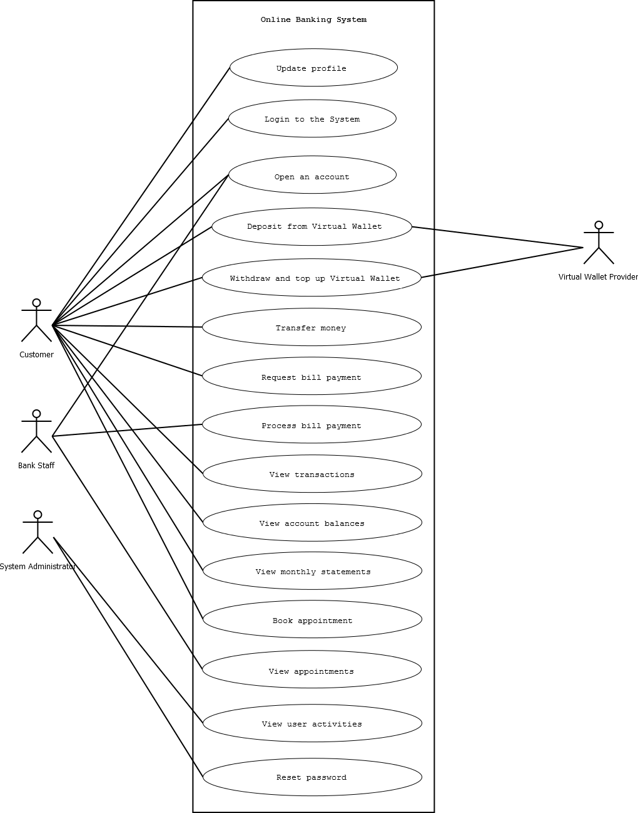

## PACKAGE : MAIN

### UC1 : Update profile

**Primary Actor**

* Customer

**Preconditions**

* Customer has logged into the system

**Postconditions**

* Success end condition
  + Changes on customer profile are stored in System
  + “Update profile” entry is added to user activities log in System
* Failure end condition
  + Nothing is changed in customer profile
* Minimal guarantee
  + Changes on customer profile are stored in System only when customer confirms the changes

**Main success scenario**

1. Customer needs to update their profile
2. Customer opens “Update Profile” screen
3. Customer modifies information on “Update Profile” screen, includes

* Address
* Telephone numbers
* Email address
* Personal phrase
* Personal images
* Three security questions and answers
* Password

1. Customer requests to save changes on the profile
2. System validates the profile changes
   1. If the changes are not valid, System shows invalid changes and information to guide customer make valid changes. Customer repeat step 3 to make changes on the profile
3. System asks customer to confirm changes
4. Customer confirm the changes
5. System updates the customer profile and adds an “Update profile” entry in user activities log

### UC2: Login to System

**Primary Actor**

* Customer

**Preconditions**

* Customer has an account with System

**Postconditions**

* Success end condition
  + Customer can use functionalities of System
  + “Customer login” entry is added to user activities log in System
* Failure end condition
  + Customer cannot use functionalities of System
  + “Customer login failure” entry is added to user activities log in System

**Main success scenario**

1. Customer needs to access System
2. Customer enter his/her primary account number and asks System to login
3. System shows Customer’s personal phrase and image and asks Customer to enter password
4. Customer enter password
5. System verifies the entered password
   1. If the entered password is not correct, System asks Customer to enter the correct password. Customer repeats step 4.
6. System randomly decides and chooses one of security questions and asks Customer to enter the answer
   1. Customer enters the answer
   2. System verifies the answer
      1. If the answer is not correct, System asks Customer to enter the correct answer. Customer repeats step 6.1
7. System shows “Account Summary” screen

### UC3: Open account

**Primary Actor**

* New customer
* Bank staff

**Postconditions**

* Succes end condition
  + Customer account is created in System
  + “Register account” entry is added to user activities log in System
  + “Create account” entry is added to user activities log in System
* Failure end condition
  + “Register account” entry is added to user activities log in Syste
  + “Cancel account registration” entry is added to user activities log in System
* Minimal garantiee
  + Customer account is created in System only when Bank Staff request customer account creation

**Main success scenario**

1. New customer needs to register an account
2. New customer requests to register an account
3. System asks new customer to fill in registration form with information:

* Full name
* Address
* Telephone numbers
* Email address
* Personal image
* Personal phrase
* 3 security questions and answers

1. New customer fills in the form and submit it
2. System validates the form
   1. If the form in invalid, System shows invalid filled in information and asks new customer to enter it with correct information
   2. New customer repeats step 3
3. System shows welcome message to customer and asks New customer to bring two identification with photos to a bank branch to complete the creation account process
   1. If new customer doesn’t bring two identification to a bank branch to complete the creation account process in 4 weeks, System will cancel the registration and adds “Cancel account registration” entry to user activities log
4. New customer brings two identification with photos to a bank branch
5. Bank staff check the identification
   1. If identification is not valid, Bank staff asks New customer to bring valid identification next time
   2. New customer repeats step 7
6. System creates customer account and add “Create account” entry in user activities log