HBCC: A Hybrid Local–Cluster Architecture for Lightweight Image Classification
Nguyen Viet Hung, Nguyen Ba Nam, Le Hoang Thai*
Faculty of Information Technology, University of Science, Vietnam National University Ho Chi Minh City, Ho Chi Minh City, Vietnam
{23122032, 23122043}@student.hcmus.edu.vn | lhthai@fit.hcmus.edu.vn
*Corresponding author
Abstract — Edge-device image classification demands a careful balance between accuracy and computational cost. Lightweight CNNs reduce cost but may sacrifice representational capacity, while Context Cluster (CoC) aggregates global context through clustering yet ignores local texture and risks token degeneracy on small images. This paper proposes HBCC (Hybrid Block Context Cluster), a four-stage hybrid architecture that applies LBPConv and DWConv at high-resolution stages and transitions to pure clustering thereafter. Stem stride, block depth, and stage-shrinking fold partitioning are co-designed to eliminate token degeneracy; knowledge distillation from a frozen ResNet-18 teacher is used to boost student accuracy at no additional inference cost. On CIFAR-10, HBCC-Medium+KD achieves 95.36% top-1 with 1.76M parameters and 138.8M MACs. On Food-101 at 224×224 resolution, HBCC-2.5M trained from scratch achieves 82.53% top-1 and 95.33% top-5, trailing ResNet-18 by only 0.38% and 0.16% while using 4.38× fewer parameters. On Tiny-ImageNet-200 (200 classes), HBCC-Medium+KD attains 58.90%, exceeding the ResNet-18 teacher (58.58%) with 6.26× fewer parameters. Operator profiling reveals that kernel fragmentation in clustering ops remains the bottleneck preventing the MAC reduction from fully translating into measured latency gains.
Keywords — Image classification, Context Cluster, hybrid local–cluster architecture, lightweight neural networks, knowledge distillation.

I. Introduction
Edge-device image classification requires a careful balance between accuracy and computational cost. Deep CNNs [1] and Vision Transformers [2] achieve strong representational power but routinely exceed the resource budgets of embedded platforms. MobileNetV2 [3] and ShuffleNetV2 [4] reduce computational cost through architectural streamlining, yet aggressive compression can limit the network's capacity to distinguish between visually similar categories.
Context Cluster (CoC) [5] offers a complementary perspective: it represents an image as a set of points and synthesizes global context through similarity-based clustering. However, pure clustering ignores local texture at high resolutions. On small images, aggressively reducing spatial resolution also risks token degeneracy — the state in which the number of active feature points per cluster is too small for the aggregation operator to carry meaningful information.
This work targets a lightweight architecture that combines local processing with context clustering, and studies how each mechanism should be allocated across resolution stages. We evaluate on small images (32×32) and standard-resolution (224×224) inputs within a strict parameter budget, addressing two research questions:
(RQ1) Can a hybrid architecture combining local processing and context clustering improve both accuracy and computational efficiency relative to both pure lightweight CNNs and pure clustering models?
(RQ2) Does the stage-wise local/cluster allocation strategy remain effective when scaling from small-image (32×32) to standard-resolution (224×224) input?
To answer these questions, we propose HBCC (Hybrid Block Context Cluster), a four-stage architecture that uses hybrid blocks at high-resolution stages and pure clustering blocks at later stages. Stem design and per-stage block depth are carefully chosen to prevent token degeneracy; knowledge distillation is applied during training without increasing student inference cost. For Food-101, a controlled extension to 2.57M parameters uses a 7×7 stem with stride 4 and uniform 7×7 fold tiles to preserve spatial structure on 224×224 input.
Paper structure: Section II surveys related work; Section III presents the proposed method; Section IV describes setup, results, and analysis; Section V states findings, limitations, and conclusions.

II. Related Work

A. CNN and Residual Learning
ResNet [1] introduced the residual connection y = F(x) + x, enabling gradient flow through arbitrarily deep networks and opening the door to 50–152-layer training. Standard 3×3 convolution with C_in input channels, C_out output channels, and kernel size k incurs cost proportional to C_in · k² · C_out, which causes ResNet-18 to require 556.7M MACs even on 32×32 images.
MobileNetV2 [3] replaces standard convolution with depthwise separable convolution, reducing total cost to O(C_in(k² + C_out)) — a 1/k² saving. ShuffleNetV2 [4] argues that FLOPs are poorly correlated with measured throughput and proposes four practical guidelines: balance input/output channel widths, avoid group convolution, avoid excessive branching, and minimize element-wise operations.

B. Vision Transformers and MetaFormers
ViT [2] divides an image into n patches and applies multi-head self-attention with complexity O(n² d_k). On a 32×32 image with 2×2 patches, n = 256 tokens; the O(256²) cost is prohibitive for lightweight models. By contrast, clustering with complexity O(n·K) and K = 4 centers is theoretically 64× cheaper than single-head attention. The MetaFormer abstraction demonstrates that the two-block structure (token mixer + MLP) is at least as important as the specific choice of mixer operator.
[EQ 1: Attn(Q,K,V) = softmax( QKᵀ / √d_k ) · V ]

C. Context Cluster
CoC [5] represents an image as a set of 5D points (R,G,B,x,y), embedding spatial coordinates directly into the feature space. Cluster centers are proposed parameter-free via AdaptiveAvgPool; each point is hard-assigned to its nearest center by cosine similarity at cost O(N·M·D). The main limitation of pure clustering is that it discards high-frequency information (edges, fine texture), causing the CoC baseline to reach only 88.34% on CIFAR-10. Furthermore, token degeneracy occurs when the feature map is too small relative to the number of cluster centers (analyzed in detail in Section III-G).

D. Local Binary Patterns
LBP [6] encodes local texture at pixel (x_c, y_c):
[EQ 2: LBP_{P,R}(x_c,y_c) = Σ_{p=0}^{P-1} s(g_p − g_c)·2^p, s(u) = 1 if u ≥ 0, 0 if u < 0 ]
where g_c is the intensity of the center pixel and g_p is the p-th neighbor on a circle of radius R with P equally spaced sampling points. The operation involves only subtractions and binary thresholding — near-zero MAC cost. LBPConv applies this formula channel-wise using a fixed, non-learned filter, making it ideal for capturing fine-grained texture at high-resolution feature maps without competing with the clustering branch for trainable parameters.

E. Knowledge Distillation
Hinton et al. [7] showed that a small student network learns more effectively when it mimics the soft probability distribution produced by a large teacher network. The combined loss function blends cross-entropy on hard labels with KL-divergence on temperature-softened teacher outputs (see Section IV-A-4 for details). Soft distributions carry inter-class relationship signals that are entirely absent from one-hot labels, making KD particularly effective for fine-grained multi-class problems.
In summary: lightweight CNNs exploit locality well but trade accuracy; self-attention captures global relations at quadratic token cost; CoC reduces complexity but discards local texture and risks token degeneracy on small images. No prior work has clearly characterized how to combine local processing with context clustering, or how to allocate these mechanisms across resolution stages under a strict parameter budget. This gap motivates the method proposed next.

III. Proposed Method

A. Pipeline Overview
Figure 1 illustrates the complete pipeline. Input image B×3×32×32 is augmented with spatial coordinates (Section III-B) and passed through a Stem convolution (stride 1), producing a 32×32×C₁ feature map. Four successive stages perform feature extraction at decreasing resolutions; between stages, a PointReducer (1×1 convolution, stride 2) downsamples and expands channels. A Global Average Pooling (GAP) layer followed by a Linear classifier produces the C-dimensional output vector (C = 10, 101, or 200).

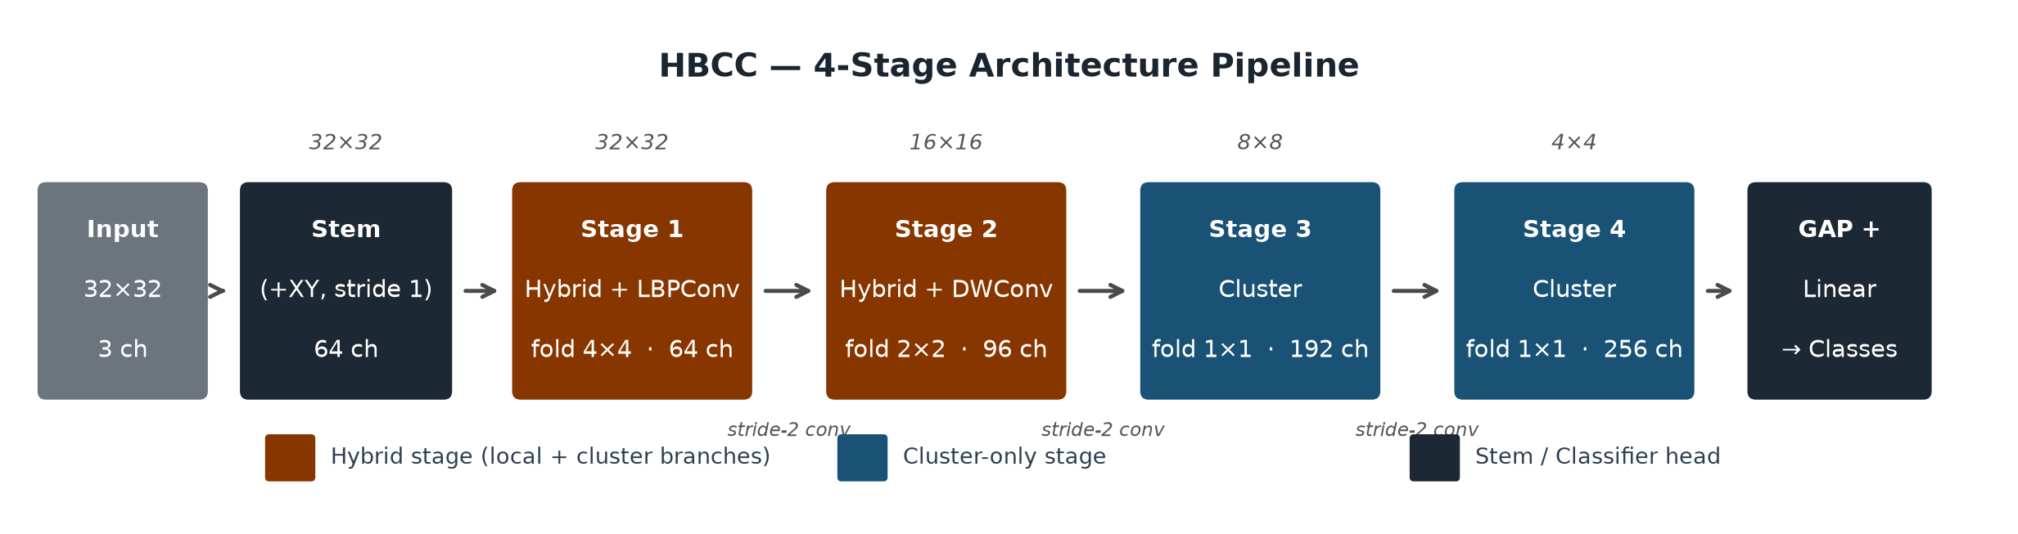
- Fig. 1. The four-stage HBCC pipeline. Blue: Hybrid stage (local branch + cluster branch in parallel). Red: Pure-cluster stage. Spatial resolution and channel count Cᵢ are annotated at each stage.

B. Spatial Coordinate Augmentation
Cosine similarity computed on RGB features alone cannot distinguish two points with identical color at different spatial positions. We therefore append two normalized coordinate channels:
[EQ 3: X = [I ; P_x ; P_y] ∈ ℝ^{B×5×H₀×W₀}, P_x[i,j] = j/(W₀−1), P_y[i,j] = i/(H₀−1) ]
This allows cluster centers to encode spatial position without requiring any explicit positional encoding.

C. Context Cluster Mechanism
Given a feature tensor X ∈ ℝ^{B×C×H×W}, the ContextClusterOp executes six steps (applied per head, then concatenated):
Step 1 — Dual projection:
[EQ 4: F = Conv_{1×1}(X), V = Conv_{1×1}(X) ]
F carries the similarity representation; V carries the values to be aggregated.
Step 2 — Cluster center proposal:
[EQ 5: F_c = AvgPool_{K_h×K_w}(F), V_c = AvgPool_{K_h×K_w}(V) ]
With (K_h, K_w) = (2,2), each fold tile yields K = 4 cluster centers. AvgPool is chosen because cluster centers must represent the centroid of their region, not an extremum; AvgPool over LBP activation maps also produces a soft histogram of texture patterns, which is far more informative than MaxPool.
Step 3 — Similarity and hard assignment:
[EQ 6: s_{ij} = σ( α · (f_{c_i}·f_j) / (‖f_{c_i}‖‖f_j‖) + β ) ]
[EQ 7: m_{ij} = 1[ i = argmax_k s_{kj} ] ]
where α, β ∈ ℝ are learnable scalars. Hard assignment (m_{ij}) ensures each point contributes to exactly one cluster.
Step 4 — Weighted aggregation:
[EQ 8: g_i = ( v_{c_i} + Σ_j m_{ij} s_{ij} v_j ) / ( 1 + Σ_j m_{ij} s_{ij} ) ]
The denominator 1 + Σs_{ij} normalizes including the center's self-weight, ensuring a stable output even when a cluster is empty.
Step 5 — Dispatch:
[EQ 9: ṽ_j = Σ_i g_i · m_{ij} · s_{ij} ]
Aggregated features are redistributed back to each point by similarity weight.
Step 6 — Output projection: Y = Conv_{1×1}(Ṽ).

D. Fold Partitioning
At high resolutions (32×32, 16×16), global clustering creates oversized clusters that smooth over local detail. We partition the feature map into F_h × F_w non-overlapping tiles:
[EQ 10: (B, C, F_h·h, F_w·w) ⟶ (B·F_h·F_w, C, h, w) ]
CoC is applied independently within each tile, then reshaped back. The fold count shrinks progressively: 4×4 (Stage 1, 32×32), 2×2 (Stage 2, 16×16), 1×1 (Stages 3–4, global).

E. Hybrid Cluster Block
Context clustering and local convolution are complementary: clustering captures global inter-region relationships but misses fine texture, while local convolution excels at high-frequency detail but is bounded by its receptive field. The Hybrid Cluster Block exploits both simultaneously by splitting the input channels into two parallel branches and fusing their outputs.
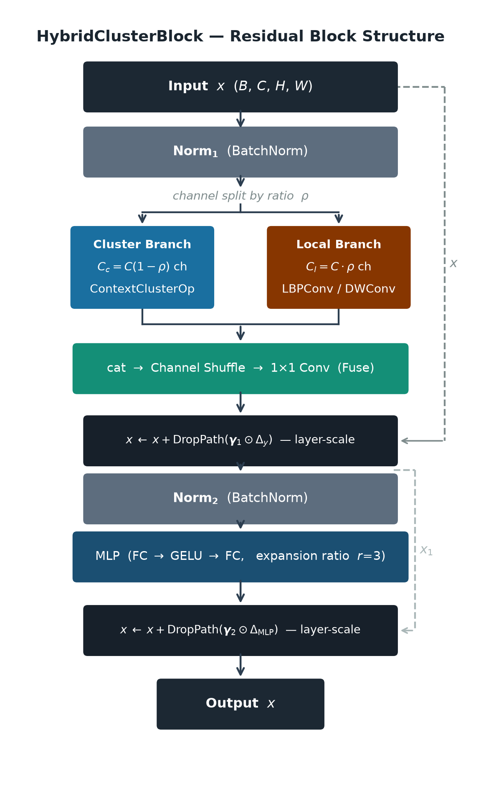
- Fig. 2. Hybrid Cluster Block structure. Blue branch: CoC (C_c = C(1−ρ) channels). Orange branch: local operator (C_l = Cρ channels). Branches are fused via Channel Shuffle and a 1×1 convolution. Layer-scale γ initialized at 10⁻⁵.
Given local ratio ρ ∈ [0,1]: the local branch processes C_l = ⌊Cρ⌈ channels; the cluster branch processes C_c = C − C_l channels. Stages 1–2 use ρ = 0.5 to split bandwidth equally; Stages 3–4 use ρ = 0 to commit fully to clustering.
Token mixing:
[EQ 11: [x_c ; x_l] = split( BN(x), [C_c, C_l] ) ]
[EQ 12: y = Fuse_{1×1}( Shuffle[ CoC(x_c) ; Local(x_l) ] ) ]
[EQ 13: x ← x + DropPath( γ₁ ⊙ y ) ]
MLP:
[EQ 14: x ← x + DropPath( γ₂ ⊙ MLP( BN(x) ) ) ]
where γ₁, γ₂ ∈ ℝ^C are layer-scale vectors initialized at 10⁻⁵. Channel Shuffle [4] interleaves features from both branches before the fuse convolution, enabling faster convergence. When ρ = 0 (Stages 3–4), the local branch, Channel Shuffle, and Fuse are all bypassed; the block reduces to a standard CoC block.

F. Local Branch Design
LBPConv (Stage 1, 32×32).
At Stage 1, feature maps retain full 32×32 resolution, where fine-grained texture (edges, contours, surface patterns) is most abundant. Three reasons favor LBPConv over a learned 3×3 convolution:
(i) Near-zero cost. LBPConv applies fixed filters consisting only of subtractions and binary thresholding — no multiply-accumulate operations — so it contributes almost nothing to the total MAC count.
(ii) No parameter competition. Because LBPConv has no learned convolution weights and processes each channel independently with the same fixed binary filter, the two branches do not compete for parameter capacity.
(iii) Natural compatibility with AvgPool. LBPConv produces near-binary activation maps. When cluster centers are proposed via AvgPool over these maps, the result is a soft histogram — the fraction of active bits per tile — which captures the distribution of texture patterns in each region.
DWConv (Stage 2, 16×16).
At Stage 2, after one downsampling step, the model benefits from a wider spatial receptive field to link nearby regions before transitioning to pure clustering. Depthwise 3×3 convolution processes each channel independently at cost O(k² C_in) instead of O(k² C_in C_out) for standard convolution — a 1/C_out reduction.
Pure Cluster (Stages 3–4, 8×8, 4×4).
At later stages, features have become sufficiently abstract that semantic inter-region relationships dominate. Global clustering with fold (1,1) exploits these relationships more effectively than any local convolution. Removing the local branch and Channel Shuffle eliminates their associated costs (ρ = 0).

G. Token Degeneracy and Stem Stride
The number of feature points per cluster within a fold tile is:
[EQ 15: r = ( H/F_h · W/F_w ) / ( K_h · K_w ) ]
For clustering to be meaningful, r ≥ 4 is necessary. With stem_stride=2 on 32×32 input:
- Stage 4: 2×2 = 4 points, proposals(2,2) yield 4 centers ⇒ r = 1 — each cluster contains exactly one point, making the clustering operator the identity function and preventing any learning.
- Stage 3: 4×4 = 16 points, fold(1,1), proposals(2,2) ⇒ r = 4 — barely sufficient.
Setting stem_stride=1 retains 32×32 = 1024 points after the stem. Combined with stage-wise fold shrinking, r = 16 is achieved consistently throughout the pipeline:
- Stage 1: fold(4,4) on 32×32: 8×8 = 64 points/tile, 4 centers ⇒ r = 16.
- Stage 2: fold(2,2) on 16×16: 8×8 = 64 points/tile, 4 centers ⇒ r = 16.
- Stage 3: fold(1,1) on 8×8: 64 points, 4 centers ⇒ r = 16.
- Stage 4: fold(1,1), proposals(1,1) on 4×4: 16 points, 1 center ⇒ r = 16.
Because stem_stride=1 quadruples the feature map area at every stage, the per-stage block count is reduced from [2,2,4,2] to [1,1,2,1] to keep total cost reasonable while ensuring the clustering operator functions correctly throughout.

H. Stage Configuration
Table I lists the full configuration. MLP expansion ratio is 3.0 throughout. Proposal size (K_h, K_w) = (2,2) at all stages (4 cluster centers per tile), except Stage 4 which uses (1,1) for global context.
- Table I. Stage configuration for HBCC-Small (S) and HBCC-Medium (M). d: blocks per stage; C: embedding dimension; ρ: local ratio.
Stage | Res. | Mode | Local op | ρ | Fold | d_{S/M} | C_S / C_M
1 | 32² | Hybrid | LBPConv | 0.5 | 4×4 | 1/1 | 48/64
2 | 16² | Hybrid | DWConv | 0.5 | 2×2 | 1/1 | 80/96
3 | 8² | Cluster | — | 0.0 | 1×1 | 2/2 | 160/192
4 | 4² | Cluster | — | 0.0 | 1×1 | 1/1 | 224/256

I. HBCC-2.5M Variant for Food-101
Applying the small-image configuration directly to 224×224 input would raise the Stage-1 token count to 224² = 50,176, making clustering prohibitively expensive. The Food-101 variant uses a 7×7 stem convolution with stride 4 and padding 3, producing a 56×56 feature map, which subsequent 3×3 stride-2 point reducers progressively halve. Fold sizes are set to 8×8, 4×4, 2×2, and 1×1 across four stages, so every fold tile spans a 7×7 spatial region at any resolution — keeping the local clustering problem scale-invariant as depth increases.
Each tile uses 2×2 proposals (four centers), cosine similarity, and hard assignment at all stages. Spatial coordinates (x,y) are appended to the input; GroupNorm replaces BatchNorm to reduce batch statistics dependence. Stages 1–2 are hybrid; Stage 3 is pure cluster; Stage 4 returns a 25% DWConv local branch to recover fine spatial detail in the final semantic representation. The four-stage configuration (C = 48/80/160/256, d = 2/2/3/2, folds 8²/4²/2²/1²) contains 2,566,391 parameters (2,562,935 learnable; the remainder are fixed LBP filter weights).

IV. Experiments

A. Experimental Setup

1. Datasets and Data Splits
We evaluate on three datasets spanning two resolution regimes. CIFAR-10 [8] (10 classes, 60,000 images at 32×32) is split into 45,000 training / 5,000 validation / 10,000 test images. Food-101 [9] (101 classes, 101,000 images) follows the official train/test split. To obtain a validation set without touching the test data, we stratified-sample 75 images per class from the official training set; the remaining 675 images per class are used for optimization. This yields 68,175 training / 7,575 validation / 25,250 test images with no overlap. Tiny-ImageNet-200 [10] (200 classes, 100,000 images at 64×64; 90,000 train / 10,000 validation / 10,000 test) has all images resized to 32×32 to maintain uniform resolution for the small-image configurations. All splits are fixed with random seed 42.

2. Training Recipe for Small-Image Datasets
- Table II. Training recipe shared by all models on CIFAR-10 and Tiny-ImageNet-200.
Hyperparameter | Value
Optimizer | AdamW
Learning rate | 1×10⁻³
Weight decay | 0.05
LR schedule | Cosine annealing
Warmup epochs | 5
Total epochs (CE) | 300
Total epochs (KD) | 250
Label smoothing | 0.1
RandAugment [11] | N = 2, M = 9
MixUp [12] α | 0.2
CutMix [13] α, p | 1.0; 0.5
Random Erasing [14] p | 0.25
AMP (mixed precision) | Yes
Drop path (Small / Med.) | 0.05 / 0.08
On CIFAR-10 and Tiny-ImageNet-200, all models — HBCC-Small, HBCC-Medium, and all four baselines (ResNet-18, MobileNetV2, ShuffleNetV2, CoC-baseline) — are trained with the identical recipe in Table II, ensuring a fair comparison. Drop path is the only HBCC-specific hyperparameter (0.05 for Small, 0.08 for Medium); baselines do not use drop path.

3. Food-101 Training Protocol
All images are resized to 224×224. Both models are initialized randomly and trained for 200 epochs (5-epoch warmup, cosine schedule, mixed-precision; batch 32 train / 64 eval; two 100-epoch sessions chained with full state restore; MixUp and CutMix disabled in the final phase). HBCC-2.5M uses AdamW (lr = 8×10⁻⁴, wd 0.03, gradient clip 1.0) with moderate augmentation (RandAugment (2,7), random erasing p = 0.05, MixUp α = 0.10, CutMix α = 0.50). ResNet-18 uses SGD–Nesterov (lr = 1.25×10⁻², wd 10⁻⁴) with stronger regularization, since it is 4.38× larger.

4. Knowledge Distillation
Teacher and student.
We use ResNet-18 as the teacher and HBCC (Small or Medium) as the student, following the Hinton et al. [7] framework. ResNet-18 is trained from scratch on the same training set, achieving 96.48% on CIFAR-10 and 58.58% on Tiny-ImageNet-200. With 11.17–11.27M parameters and 556.7M MACs, ResNet-18 far exceeds the representational capacity of HBCC (1.27–1.76M parameters) but is too heavy for direct edge deployment. The Food-101 experiment uses no knowledge distillation; ResNet-18 serves as an independent architectural baseline trained from random initialization, enabling a fair cross-entropy-only comparison of the two architectures.
At each training step, the combined loss mixes cross-entropy on hard labels with KL-divergence on the teacher's temperature-softened probabilities (T = 4.0, α = 0.5); the T² factor restores gradient scale. The teacher is kept frozen; the epoch count is reduced from 300 to 250 because each step incurs an additional teacher forward pass.

5. Performance Measurement
Parameters and MACs are measured automatically before training. Because the profiling tool does not fully account for certain operations in the clustering step (point assignment, sigmoid, aggregation), the reported MACs for HBCC are a lower bound.
Latency is measured on a Tesla T4 GPU at batch size 1 with 30 warmup runs followed by 100 timed iterations; the GPU is synchronized after each iteration to ensure that recorded times reflect true execution cost. Results represent single-sample inference latency.
Peak GPU memory is recorded throughout inference. Operator profiles are collected by tracing individual GPU operations to identify performance bottlenecks.

6. Baselines
- ResNet-18 [1]: for small-image experiments, the initial 7×7 stride-2 convolution is replaced by 3×3 stride-1 and the first max-pool is removed; also serves as the KD teacher. On Food-101, the standard 7×7 stride-2 stem and max-pool are retained; the final classification layer is replaced with 101 outputs and no pretrained weights are loaded.
- MobileNetV2 [3]: stem 3×3 stride-1, max-pool removed (small-image only).
- ShuffleNetV2-x1.0 [4]: analogous stem adjustment, first stride reduced to 1 (small-image only).
- CoC-baseline: pure global clustering (ρ = 0) at every stage, no local branch — the direct architectural counterpart of HBCC isolating the contribution of the local branch (small-image only).

B. Classification Results

1. CIFAR-10
Table III compares six models on CIFAR-10. HBCC-Medium+KD achieves 95.36% — the highest accuracy among all lightweight models, trailing ResNet-18 by only −1.12 pp while using 6.34× fewer parameters and 4.01× fewer MACs. HBCC-Small+KD gains +3.25% over ShuffleNetV2 at the same parameter budget; HBCC-Medium+KD gains +7.02% over CoC-baseline with fewer parameters and lower latency (8.09 ms vs. 11.71 ms), confirming the dual benefit of the local branch.
- Table III. Results on CIFAR-10. Bold: best among lightweight models. +KD: trained with knowledge distillation.
Model | Top-1(%) | Params(M) | MACs(M) | Lat.(ms) | Mem(MB)
ResNet-18 | 96.48 | 11.17 | 556.66 | 3.03 | 326.4
HBCC-Medium+KD | 95.36 | 1.76 | 138.81 | 8.09 | 481.4
HBCC-Small+KD | 94.93 | 1.27 | 92.34 | 8.41 | 363.6
ShuffleNetV2-x1.0 | 91.68 | 1.26 | 46.13 | 6.26 | 94.8
MobileNetV2 | 91.04 | 2.24 | 25.57 | 4.76 | 123.4
CoC-baseline | 88.34 | 2.40 | 34.37 | 11.71 | 71.8

2. Food-101
Table IV reports results after 200 training epochs. The checkpoint with the highest validation top-1 is selected before a single evaluation on the test set. HBCC's best state occurs at epoch 199 (the final epoch, indicating the model had not yet converged); ResNet-18's best state occurs at epoch 191.
- Table IV. Results on Food-101. Bold: best.
Model | Params (M) | Top-1 (%) | Top-5 (%)
ResNet-18 | 11.228 | 82.91 | 95.49
HBCC-2.5M | 2.566 | 82.53 | 95.33
Parameter efficiency.
HBCC achieves 82.53% top-1 and 95.33% top-5, trailing ResNet-18 by 0.38% and 0.16% respectively. HBCC uses only 2.566M parameters vs. ResNet-18's 11.228M — a 77.14% reduction (4.38× fewer). This places HBCC at a favorable accuracy-vs-size trade-off: a sub-half-point top-1 gap paired with a fourfold reduction in model weight. The gap is likely a lower bound: HBCC's best validation accuracy appeared at the final epoch, suggesting continued improvement with additional training budget.
MACs, latency, and peak memory were not measured for Food-101 under the same hardware conditions as the small-image benchmarks; these quantities are therefore not reported and should not be extrapolated from the 32×32 results.

3. Tiny-ImageNet-200
With 200 fine-grained semantic classes, Tiny-ImageNet-200 is the most challenging of the three datasets and also where HBCC achieves its most remarkable results (Table V).
Student surpasses teacher.
HBCC-Medium+KD reaches 58.90% top-1 and 81.41% top-5 — surpassing ResNet-18 by +0.32% top-1 and +1.01% top-5 while using only 6.26× fewer parameters (1.80M vs. 11.27M) and 4.01× fewer MACs (138.9M vs. 556.8M). This is the most significant result: on a 200-class problem, the teacher's soft distributions carry sufficient inter-class relationship information for the student to surpass the teacher on the test set. HBCC-Small+KD (57.56%) also exceeds ShuffleNetV2 (55.68%) by +1.88% with fewer parameters (1.32M vs. 1.46M).
- Table V. Results on Tiny-ImageNet-200. Bold: best overall (including ResNet-18). Arrows CE→KD indicate same-architecture pairs.
Model | Top-1(%) | Top-5(%) | Params(M) | MACs(M) | Lat.(ms) | Mem(MB)
ResNet-18 | 58.58 | 80.40 | 11.27 | 556.76 | 3.13 | 326.7
HBCC-Medium+KD | 58.90 | 81.41 | 1.80 | 138.86 | 7.57 | 481.6
HBCC-Small+KD | 57.56 | 80.76 | 1.32 | 92.38 | 7.50 | 363.7
HBCC-Medium (CE) | 56.80 | 79.13 | 1.80 | 138.86 | 8.20 | 481.6
HBCC-Small (CE) | 56.15 | 79.14 | 1.32 | 92.38 | 7.77 | 363.7
ShuffleNetV2-x1.0 | 55.68 | 79.32 | 1.46 | 46.32 | 6.04 | 95.6
MobileNetV2 | 49.97 | 75.35 | 2.48 | 25.80 | 4.66 | 124.3
CoC-baseline | 49.30 | 73.89 | 2.46 | 34.43 | 11.52 | 72.0
CE models are strong before KD.
Even without knowledge distillation, HBCC-Medium-CE (56.80%) and HBCC-Small-CE (56.15%) both exceed ShuffleNetV2 (55.68%), reflecting a natural fit between the hybrid local–cluster architecture and fine-grained multi-class classification. Tiny-ImageNet-200 is the only dataset where all four HBCC variants (CE and KD) outperform every lightweight baseline.
Why CoC-baseline and MobileNetV2 underperform.
CoC-baseline (49.30%) ranks lowest: without a local branch, pure context clustering cannot capture texture cues needed for 200 fine-grained classes. The +9.60% gap vs. HBCC-Medium+KD exceeds the CIFAR-10 gap (+7.02%), confirming that the local branch grows more valuable with classification complexity. Figure 3 visualizes the Pareto frontier.

C. Knowledge Distillation Effectiveness
Table VI compares CE and KD performance on Tiny-ImageNet-200, the dataset where both training regimes share the same architecture, enabling a clean isolated measurement of distillation gain (Δ). HBCC-Medium improves by +2.10 points and HBCC-Small by +1.41 points. The Medium gain is sufficient for HBCC-Medium+KD to surpass the ResNet-18 teacher itself on the test set.
- Table VI. Top-1 accuracy gain from KD (Δ = KD − CE, same architecture) on Tiny-ImageNet-200.
Model | CE (%) | KD (%) | Δ
HBCC-Medium | 56.80 | 58.90 | +2.10
HBCC-Small | 56.15 | 57.56 | +1.41

D. Performance Analysis

1. Pareto Analysis
Figures 3–5 plot accuracy vs. parameter count and accuracy vs. latency on the two small-image datasets. Both HBCC-Small+KD and HBCC-Medium+KD occupy the Pareto-dominant region on the parameter axis: higher accuracy at lower parameter counts than every lightweight baseline on both benchmarks. On Tiny-ImageNet-200 (Figure 3), HBCC-Medium+KD exceeds ResNet-18 in accuracy while maintaining only 1.80M parameters — the single point simultaneously above and to the left of ResNet-18 on both axes.
Figure 5 shows the parameter-only Pareto for Food-101: HBCC-2.5M and ResNet-18 represent two different trade-off points, with ResNet-18 0.38 percentage points higher in top-1 accuracy and HBCC using 4.38× fewer parameters.
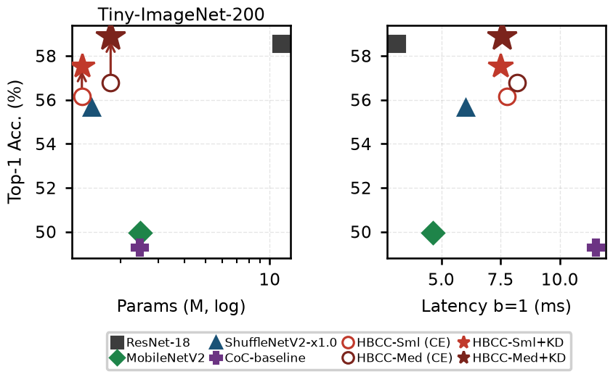
- Fig. 3. Pareto frontier on Tiny-ImageNet-200. Arrows: KD gains. HBCC-Medium+KD (★) surpasses ResNet-18 on both axes with 6.26× fewer parameters.
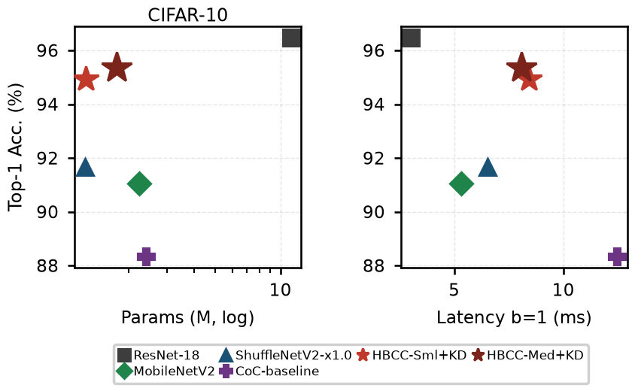
- Fig. 4. Pareto frontier on CIFAR-10. HBCC+KD occupies the Pareto-dominant region on both the parameter and latency axes relative to all lightweight baselines.
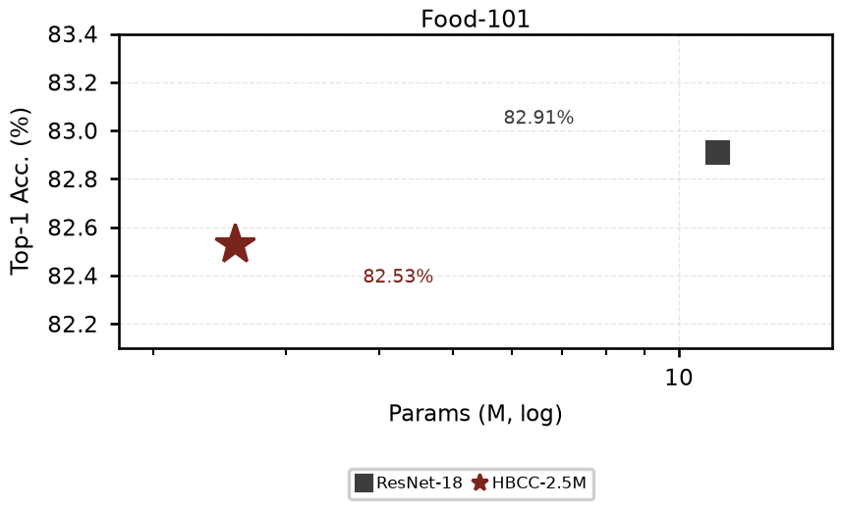
- Fig. 5. Parameter efficiency on Food-101 (parameter axis only). HBCC-2.5M (★) reaches 82.53% with 4.38× fewer parameters than ResNet-18.

2. Latency and Peak Memory Analysis
Latency: Fewer MACs, Yet Slower.
Although HBCC-Medium uses fewer MACs than ResNet-18 (138.9M vs. 556.8M), its batch-1 latency is higher (≈8 ms vs. ≈3 ms). The cause is operator fragmentation: ResNet-18 spends ≈94% of its CUDA time in a single heavily optimized kernel (cudnn_convolution), while HBCC distributes time across many small sequential kernels — 1×1 convolutions, batch matrix multiplication, vector normalization, scatter/gather for clustering assignment. HBCC nevertheless runs 30–35% faster than pure CoC (8 ms vs. 11 ms), demonstrating that the hybrid design materially reduces latency relative to global-only clustering.
Peak Memory: Scatter Buffers Dominate.
HBCC-Medium reaches 481.6 MB — 47% above ResNet-18 (326.7 MB) despite 6.26× fewer parameters. The root cause mirrors the latency bottleneck: scatter/gather aggregation must simultaneously hold a similarity tensor (N×K) and a feature sum (K×C) per stage; with stem_stride=1 these buffers are 4× larger than with stride 2. CoC-baseline (72.0 MB) avoids this via stem_stride=2 and narrower embeddings. Reducing stem_stride or Stage-1 embedding width are the most direct levers to cut both latency and memory.

E. Discussion on Suitability and Application Scope
Across the three benchmarks, HBCC's performance varies in a way that directly reflects the interaction between its hybrid design and the nature of each classification task.
CIFAR-10: when CNN inductive bias dominates.
With 10 classes and 32×32 images, decision boundaries in CIFAR-10 are closely tied to local texture. ResNet-18 benefits from a strong inductive bias toward translation equivariance and local neighbourhood structure — a natural fit for this setting — yielding a 1.12% advantage. This is not a fundamental limitation of hybrid architectures in general; rather, it reflects the fact that when the class space is simple enough, local features alone suffice to discriminate, and context clustering provides no additional discriminative signal. Notably, this 1.12% gap is produced by a model with over 6× more parameters — a trade-off that is entirely acceptable under strict resource constraints.
Tiny-ImageNet-200: where context clustering excels.
With 200 fine-grained semantic categories, the model must relate distant image regions to distinguish visually similar classes. This is precisely where context clustering has a natural advantage: its point-assignment and aggregation mechanism captures inter-region relationships that local convolution misses. HBCC-Medium+KD surpasses the ResNet-18 teacher by 0.32% top-1 with 6.26× fewer parameters — the only dataset in our experiments where the student outperforms the teacher. This confirms that as class-space complexity grows, HBCC's contextual advantage fully compensates for the local inductive bias of CNNs.
Food-101: scalability and balance.
With 101 classes at 224×224 resolution, Food-101 lies between the two extremes: more complex than CIFAR-10, yet food categories still exhibit strong local cues (colour, surface texture). At 224 resolution, feature maps are large enough for clustering to operate effectively and avoid token degeneracy, while the hybrid design preserves local texture information in the early stages. The gap with ResNet-18 narrows to just 0.38% top-1 with 4.38× fewer parameters, confirming that HBCC scales to standard-resolution inputs without sacrificing its parameter efficiency.
When HBCC is the right choice.
Synthesising across all three datasets, HBCC is most appropriate when: (i) the class space is large (≽100 categories), so that inter-class semantic relationships are complex and local features alone are insufficient; (ii) input resolution is high enough to provide each cluster with an adequate number of tokens; and (iii) the parameter budget is tightly constrained while competitive accuracy is still required. Conversely, for few-class tasks with no resource constraints, a standard lightweight CNN remains more efficient, thanks to its inductive bias that naturally matches the regular grid structure of images.
In terms of practical deployment, HBCC targets edge scenarios requiring fine-grained multi-class recognition: food identification, plant disease classification, wildlife species monitoring — tasks that demand fine semantic discrimination while running on constrained hardware. The results on Tiny-ImageNet-200 and Food-101 highlight the promise of this direction; the CIFAR-10 gap simultaneously clarifies where further architectural refinement is needed to close the distance with pure CNNs on simpler classification problems.

V. Conclusion
HBCC is a four-stage hybrid architecture combining Context Cluster with progressive local processing (LBPConv at Stage 1, DWConv at Stage 2, clustering at Stages 3–4), co-designed with stem_stride=1 and stage-shrinking folds to prevent token degeneracy. On small images, HBCC-Medium+KD reaches 95.36% (CIFAR-10) and 58.90% (Tiny-ImageNet-200) — surpassing the ResNet-18 teacher (58.58%) with 6.26× fewer parameters, and widening the gap over CoC-baseline from 7.02 to 9.60 pp as task complexity increases. On Food-101 (224×224), HBCC-2.5M achieves 82.53% top-1 with 4.38× fewer parameters than ResNet-18, demonstrating that the hybrid design scales to standard-resolution classification.
Limitations: narrow margins should be confirmed with multiple seeds; Food-101 results reflect architecture-plus-recipe performance; and operator fragmentation keeps latency and memory above convolutional baselines with comparable MACs. These three directions are the priorities for future work.

References
- [1] K. He, X. Zhang, S. Ren, and J. Sun, "Deep residual learning for image recognition," in IEEE CVPR, 2016, pp. 770–778.
- [2] A. Dosovitskiy et al., "An image is worth 16×16 words: Transformers for image recognition at scale," in ICLR, 2021.
- [3] M. Sandler, A. Howard, M. Zhu, A. Zhmoginov, and L.-C. Chen, "MobileNetV2: Inverted residuals and linear bottlenecks," in IEEE CVPR, 2018, pp. 4510–4520.
- [4] N. Ma, X. Zhang, H.-T. Zheng, and J. Sun, "ShuffleNet V2: Practical guidelines for efficient CNN architecture design," in ECCV, 2018, pp. 122–138.
- [5] X. Ma et al., "Image as set of points," in ICLR, 2023.
- [6] T. Ojala, M. Pietikäinen, and T. Mäenpää, "Multiresolution gray-scale and rotation invariant texture classification with local binary patterns," IEEE Trans. Pattern Anal. Mach. Intell., vol. 24, no. 7, pp. 971–987, 2002.
- [7] G. Hinton, O. Vinyals, and J. Dean, "Distilling the knowledge in a neural network," arXiv:1503.02531, 2015.
- [8] A. Krizhevsky, "Learning multiple layers of features from tiny images," Univ. Toronto, Tech. Rep., 2009.
- [9] L. Bossard, M. Guillaumin, and L. Van Gool, "Food-101 — Mining discriminative components with random forests," in ECCV, 2014, pp. 446–461.
- [10] Y. Le and X. Yang, "Tiny ImageNet visual recognition challenge," Stanford Univ., CS231N, Tech. Rep., 2015.
- [11] E. D. Cubuk, B. Zoph, J. Shlens, and Q. V. Le, "RandAugment: Practical automated data augmentation with a reduced search space," in NeurIPS, 2020.
- [12] H. Zhang, M. Cisse, Y. N. Dauphin, and D. Lopez-Paz, "mixup: Beyond empirical risk minimization," in ICLR, 2018.
- [13] S. Yun et al., "CutMix: Regularization strategy to train strong classifiers with localizable features," in IEEE/CVF ICCV, 2019, pp. 6023–6032.
- [14] Z. Zhong, L. Zheng, G. Kang, S. Li, and Y. Yang, "Random erasing data augmentation," in AAAI, 2020, pp. 13001–13008.

