Nick Videtti

NetID: nvidetti

IST 722 - Data Warehouse

Assignment 6: ETL Part 1 Data Extraction

2/21/2023

**Control Flow**

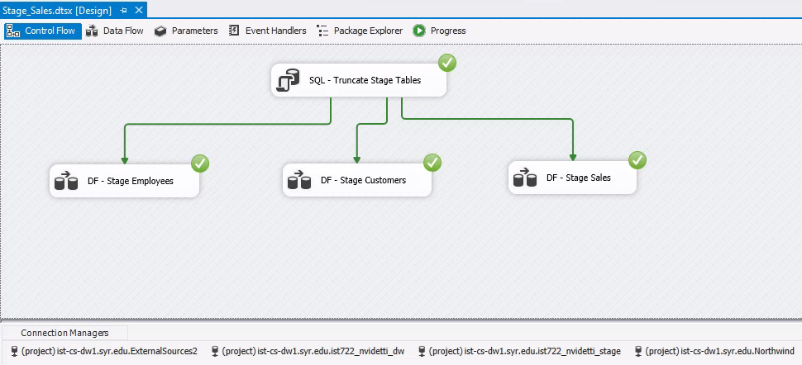

**DF - Stage Employees**

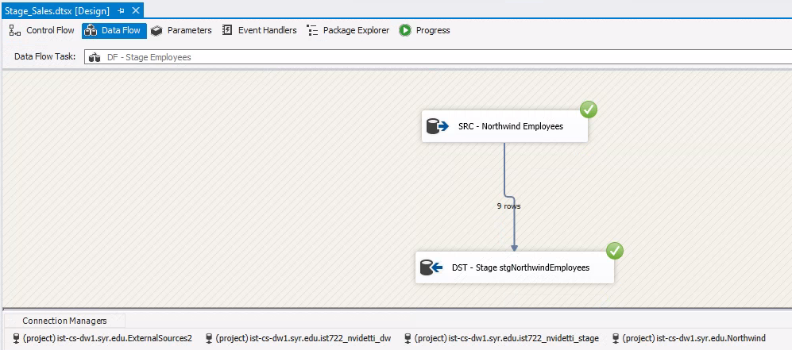

**DF - Stage Customers**

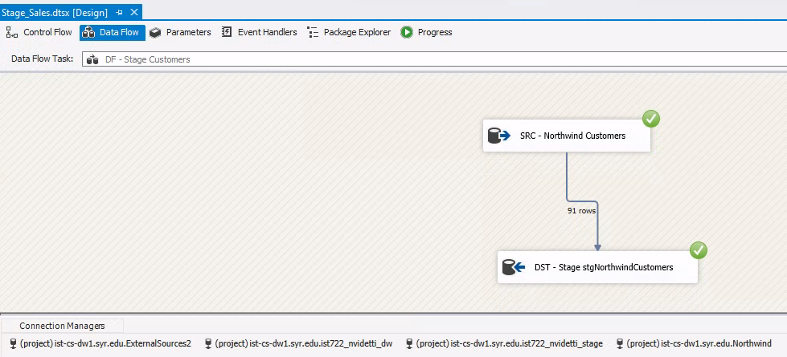

**DF - Stage Sales**

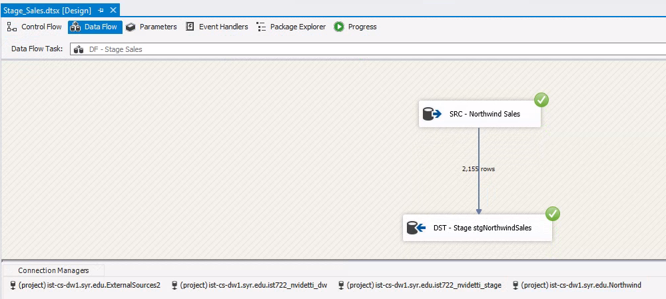

**stgNorthwindEmployees table**

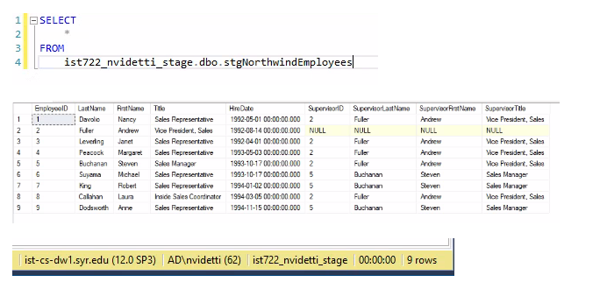

**stgNorthwindCustomers table**

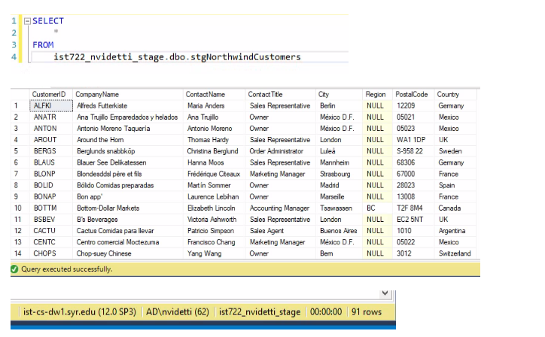

**stgNorthwindSales table**

