Nick Videtti

NetID: nvidetti

IST 722 - Data Warehouse

Assignment 9: Business Intelligence

3/1/2023

**MOLAP Star Schema for Northwind Sales**

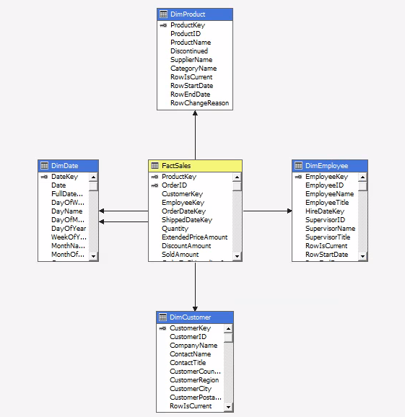

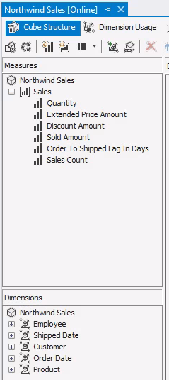

**ROLAP Excel PivotTable Chart - Northwind Sales by Category and Product**

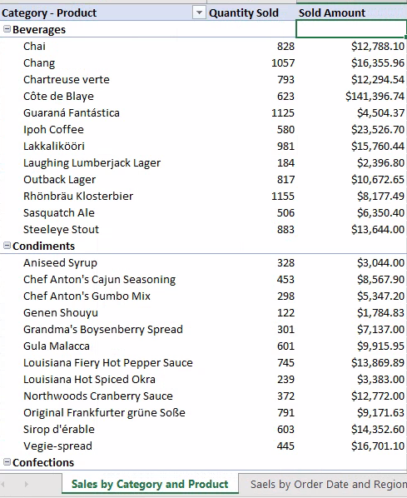

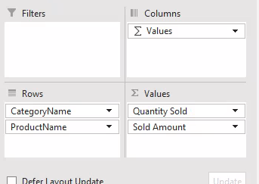

**MOLAP Excel PivotTable Chart - Northwind Sales by Order Date and Region**

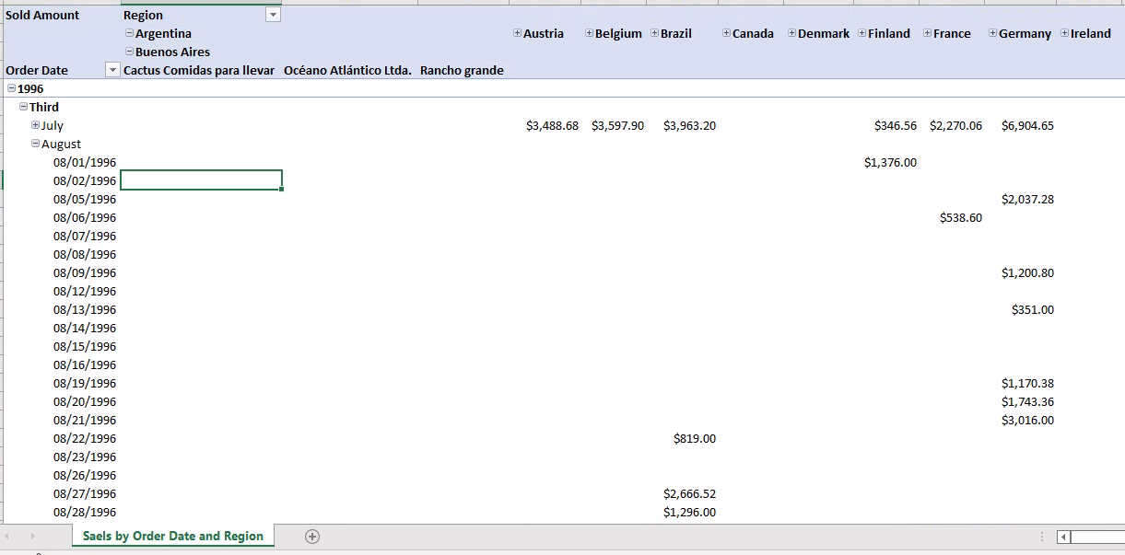

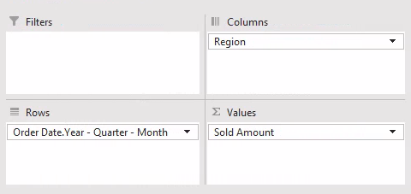

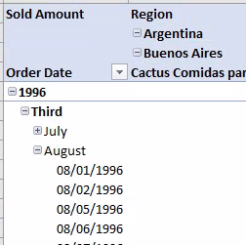

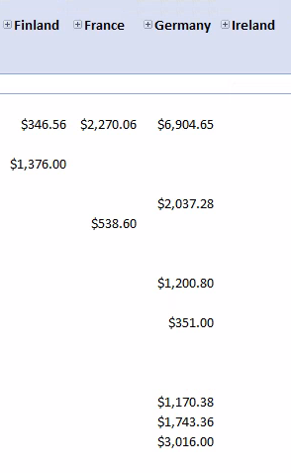

**MOLAP PowerPivot Chart - Number of Sales, Quantity Sold, and Order to Shipped Lag in Days by Supervisor and Employee**

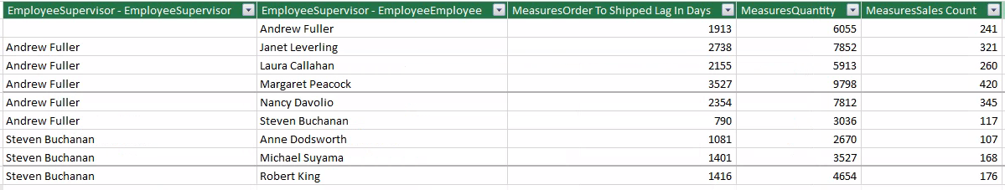

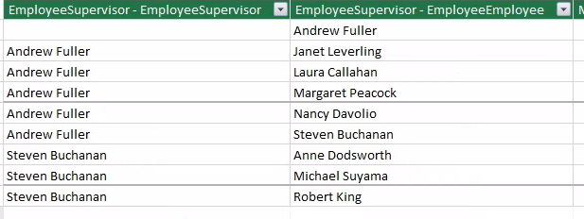

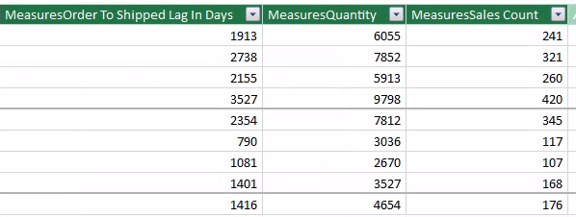

**ROLAP PowerBI Dashboard - Northwind Sales by Country**

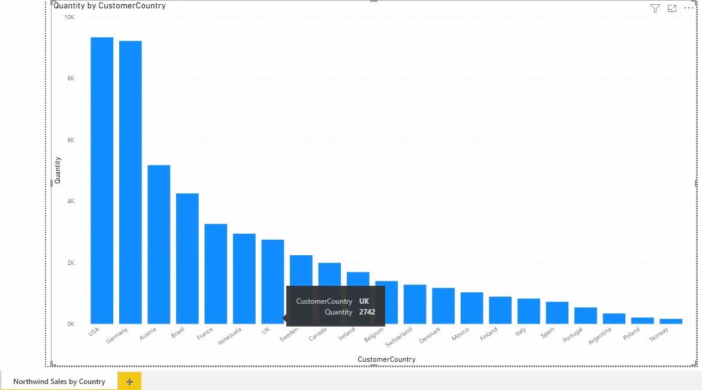

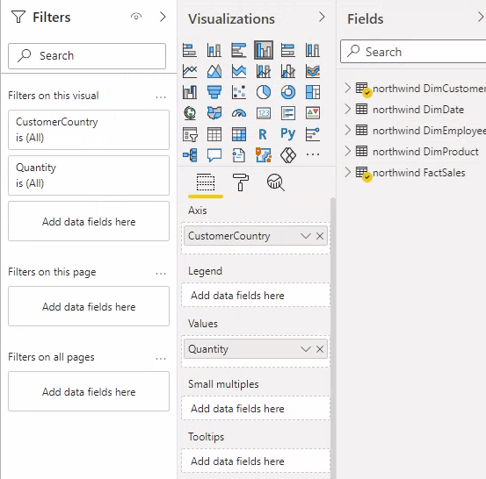

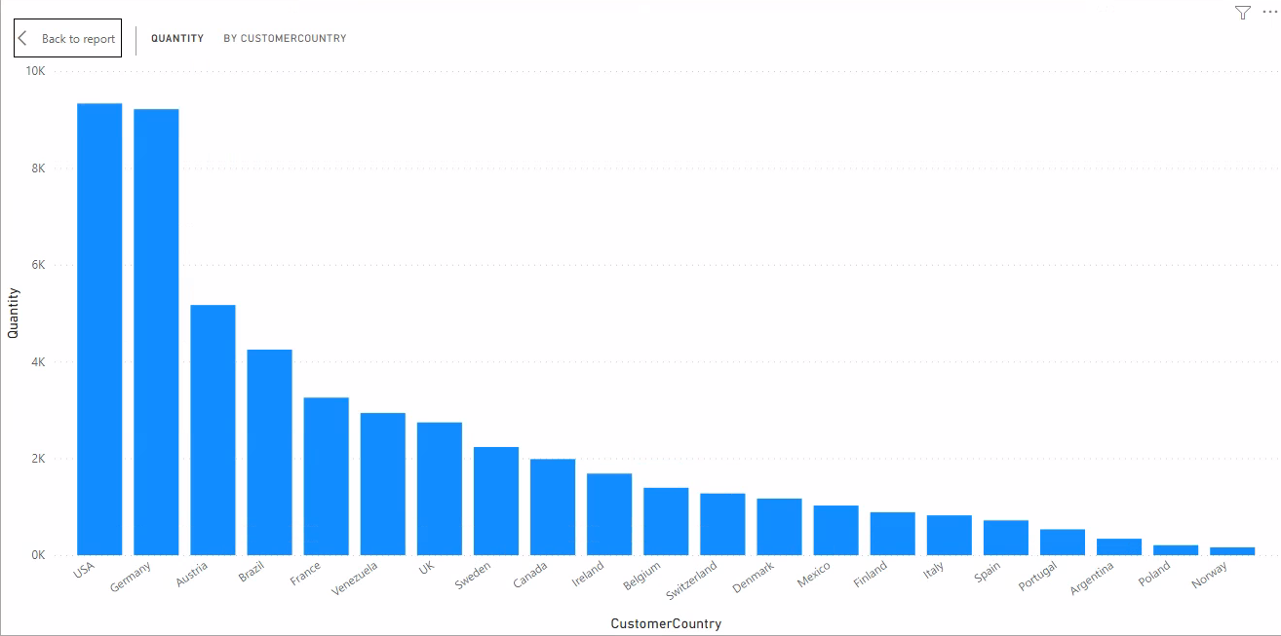

**MOLAP PowerBI Dashboard - Discount Amount by Country**

