Homework Problem Set AB Submission Form

# Overview

| Your Name | Nick Videtti |
| --- | --- |
| Your SU Email | nvidetti@syr.edu |

# Instructions

Put your name and SU email at the top. Answer these questions all from the lab. When asked to include screenshots, please follow the screenshot guidelines from the first homework.

Remember as you complete the homework that it is not only about getting it right/correct. We will discuss the answers in class so it’s important to articulate anything you would like to contribute to the discussion in your answer:

* If you feel the question is vague, include any assumptions you've made.
* If you feel the answer requires interpretation or justification, provide it.
* If you do not know the answer to the question, articulate what you tried and how you are stuck.
* Highlight any doubts or questions you would like me to review.

This how you receive credit for answering questions that might not be correct. In addition, you must complete the reflection portion of the homework assignment for full credit. Since most answers will be similar, this is an important part of your individual submission.

Complete Part II of this document first, then go back and complete the Reflection in Part I.

# Part I: Reflection

Use this section to reflect on your learning. To achieve the highest grade on the assignment, you must be as descriptive and personal as possible with your reflection.

1. As you completed this assignment, identify what you learned.

**This assignment taught me some CLI commands that I was not aware of already, and also taught me the basics of Git and Docker. Git is something I knew existed but was not sure what it was before this exercise, and Docker was a completely foeign topic to me prior to this assignment. Overall, I feel a little better about my knowledge in all 3 of these topics, but I am far from having a deep understanding of Git and Docker.**

1. What barriers or challenges did you encounter while completing this assignment?

**This assignment was pretty straight-forward, but I did need to refer back to the instructions and the YouTube video while answering the questions at the end of the assignment.**

1. How prepared were you to complete this assignment? What can you do to be better prepared?

**I wasn’t fully sure what to expect in this first assignment, but other than that, I do feel I was prepared. Test-running the Azure VM prior to this assignment helped me a lot and made starting it up for this assignment go smoothly. I can’t run the rdp file on my own machine, so I knew to use the Syracuse Remote Lab in order to get the Azure VM to work for me.**

1. Rate your comfort level with this week’s material. Use the rubric provided.

4 ==> I understand this material and can explain it to others.  
**3 ==> I understand this material.**  
2 ==> I somewhat understand the material but sometimes need guidance from others.  
1 ==> I understand very little of this material and need extra help.

# Part II: Questions

Paste your answers to the Exercises found in the lab document. Make sure to include your NetID in any screenshots you provide. If the question asks for commands, only include those commands that are necessary to complete the tasks. Number each answer.

1. Take a screenshot of an open Windows terminal with the current working directory set to the **advanced-databases** folder. Make sure to follow the screenshot guidelines and include your name/NetID in the screenshot.

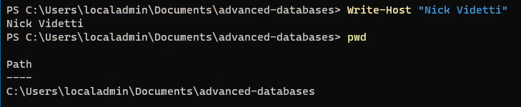

1. Explain the difference between a Docker image and a container. No screenshot necessary.

**A Docker image is where application dependencies are stored. Containers are running instances of an image.**

1. What is the purpose of a Docker volume? No screenshot necessary.

**Volumes will help to retain data in the image from previously stopped or removed containers. Running new containers with these volumes will allow those data from previously stopped or removed containers to be readily available.**

1. Start the Redis and Retwis services with docker-compose. Provide a screenshot of the command you typed and another screenshot showing the two services are running.

**COMMAND**

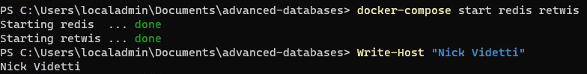

**RUNNING SERVICES (INDICATED BY “Up”)**



**FULL OUTPUT**

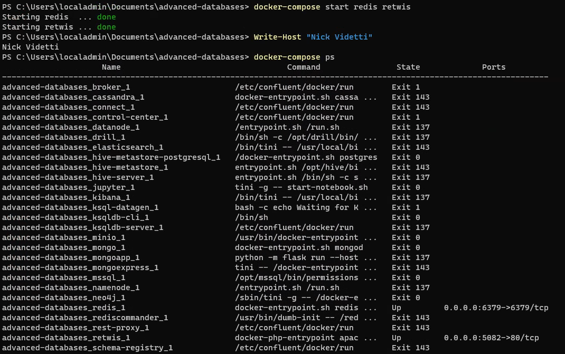

1. What does the last line in the Redis logs say? Provide a screenshot of this message. What command did you have to type to see the Redis logs?

**COMMAND**

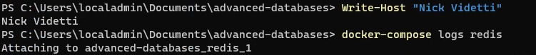

**LAST LINE OF REDIS LOGS**



1. Which ports are being used by the currently running Docker services? How do you know they are running and which ports are being used?

**Running the docker-compose ps command will print all services. For those running, they will show the ports as seen in the screenshots below. It looks like 6379 is the internal port being used by Redis and 5082 is the internal port being used by Retwis.**

**COMMAND**



**RUNNING SERVICES WITH PORTS (PORTS ON FAR RIGHT)**



**PORTS ZOOMED IN**

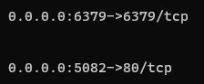

**FULL OUTPUT**

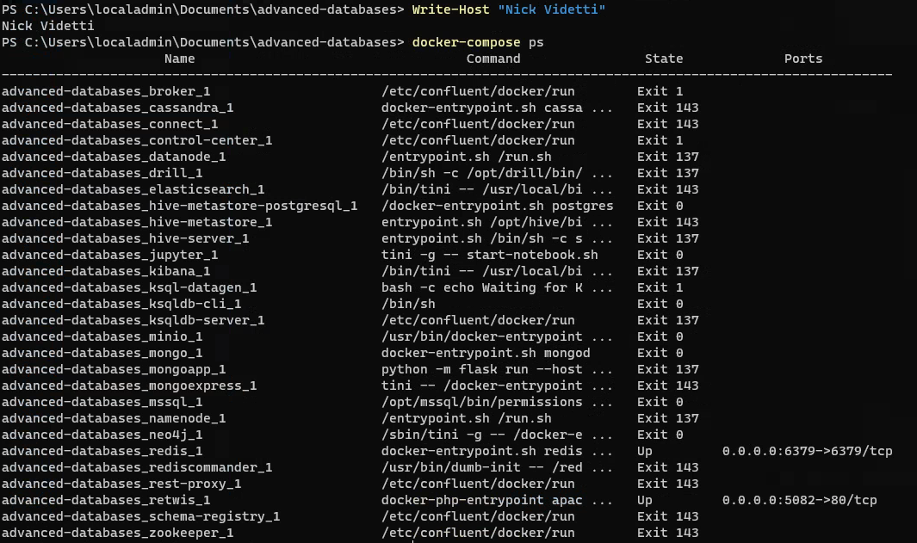

1. What are the volumes created by all the services in the docker-compose file? What command did you type to get this answer? Provide a screenshot of the output.

**We did not create any volumes in the docker-compose file for this exercise, but running the *docker volume ls* command still shows that some Docker volumes do exist on our local driver, as seen in the screenshots below.**

**COMMAND**



**FULL OUTPUT**

