Nick Videtti

IST-659 Week 10 Lab Assignment

**PART 1:**

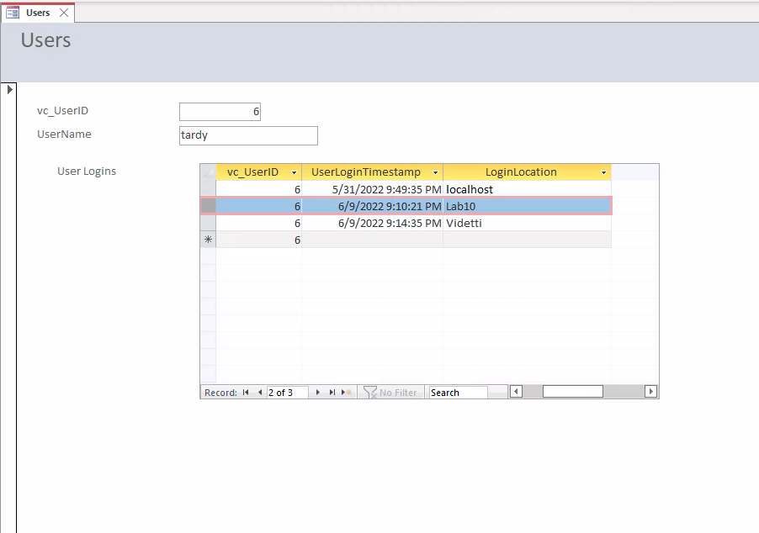

1. If we only provided a value for LoginLocation, how did the software know what to use for vc_UserLoginID and UserLoginTimestamp?

***The vc_UserLoginID has the int identity property in which the system automatically generates its value when a new record is created. UserLoginTimestamp is set up to take the current system date and time when a new record is created.***

2. Based on what the behavior we saw and the form/subform relationship, how did the software know which vc_UserID to use for the vc_UserLogin record?

***We set up the relationship between vc_User and vc_UserLogin on vc_UserID = vc_UserID, which means that if we are in the form for “tardy”, any entries made in the subform will have the same vc_UserID as “tardy”.***

3. What are some pros and cons (at least 2 of each) to using Access to manage SQL Server data?

***Pros: Do not need to know SQL to interact with the database, can use forms and subforms to view one-to-many relationships in what is likely to be considered a more understandable format***

***Cons: Can be too easy to manipulate data if you get “click happy” in the forms. Can manipulate data based on relationships that are not defined at the database level.***

**PART 2:**

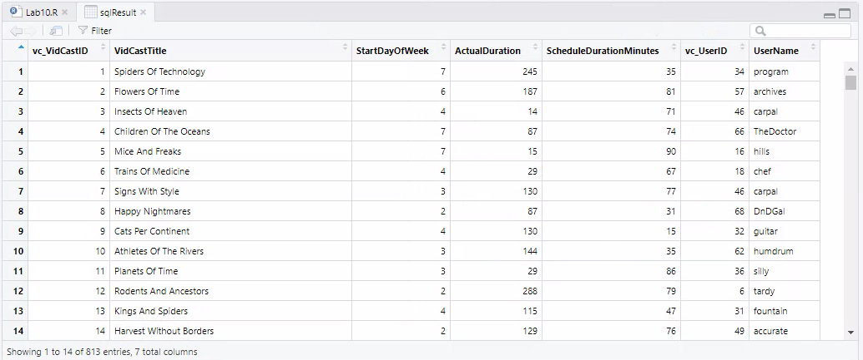

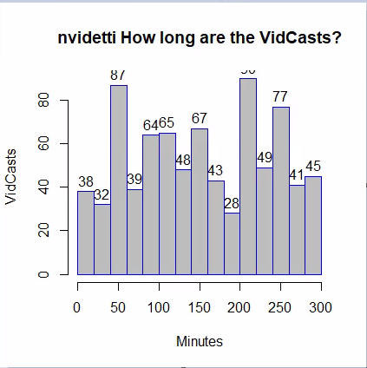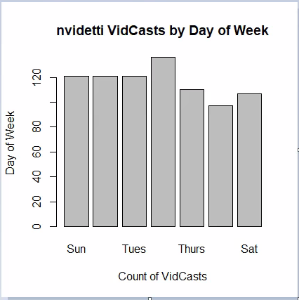

1. In reference to the script in step 4, what does the SQL code on line 13 do?

***The SQL code on line 13 stores a SQL SELECT statement to a variable in R called “sqlSelectStatement”. The SELECT statement itself queries our database, specifically the vc_VidCast and vc_User tables. This pulls all VidCasts and their corresponding User details.***

2. What is one way to simplify lines 14 through 23? (think lab 8…)

***One way to simplify this code would be to alias the table names to something shorter. That way, there would not be the need to type out the full table names each time they are referenced, but rather a much shorter alias, perhaps even a single letter.***