Nick Videtti

IST-659 Week 2 Lab Assignment

**Case Study 1:**

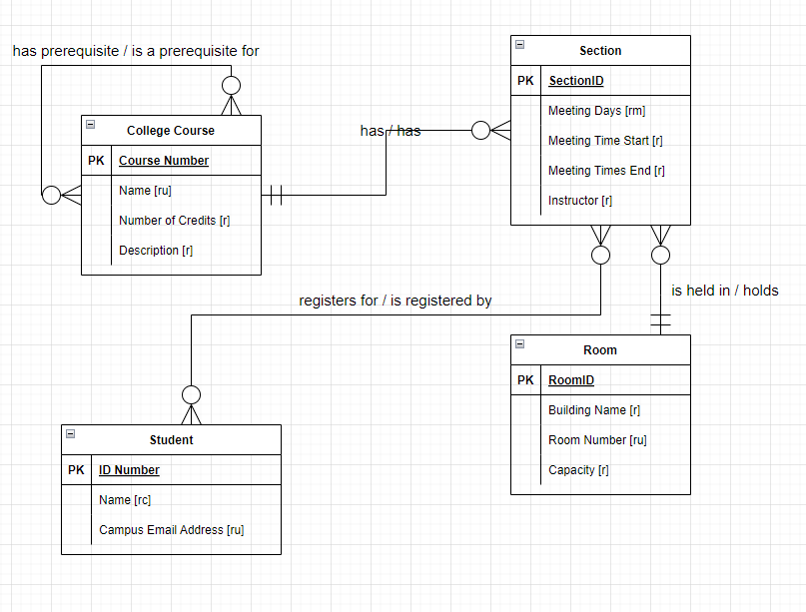

**Case Study 2:**

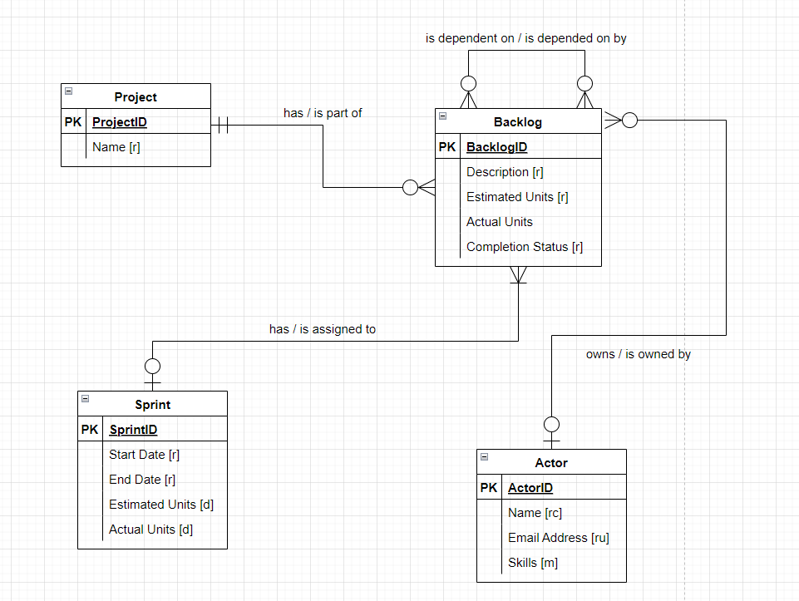

**Case Study 3:**

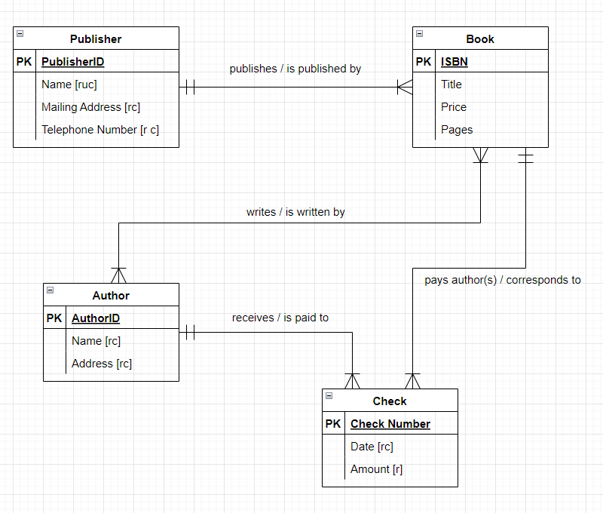

**Part 2:**

