Nick Videtti

IST-659 Week 5 Lab Assignment

**PART 1**

**User Table:**

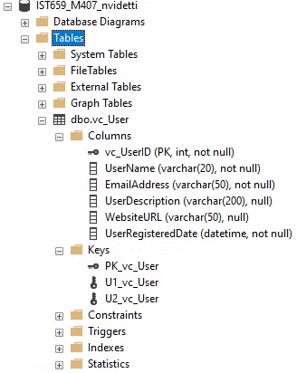

**UserLogin Table:**

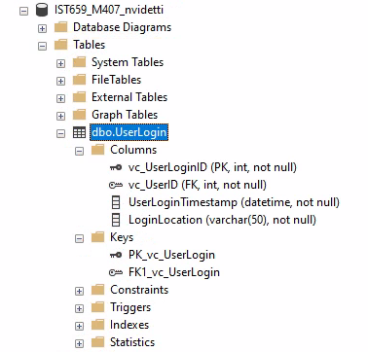

**User Records:**

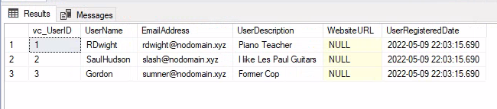

**User Tables:**

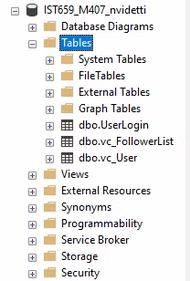

**PART 2**

**VidCast Tables:**

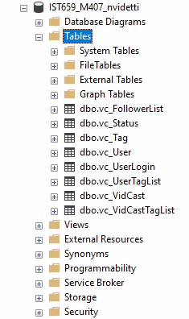

**SQL Code:**

/*

Author : Nick Videtti

Course : IST659 M407

Term : Spring (April - June) 2022

*/

--------PART 1--------

--Creating the User table

CREATE TABLE vc_User(

--Columns for the User table

vc_UserID int identity,

UserName varchar(20) not null,

EmailAddress varchar(50) not null,

UserDescription varchar(200),

WebsiteURL varchar(50),

UserRegisteredDate datetime not null default GetDate(),

--Constraints on the User Table

CONSTRAINT PK_vc_User PRIMARY KEY (vc_UserID),

CONSTRAINT U1_vc_User UNIQUE(UserName),

CONSTRAINT U2_vc_User UNIQUE(EmailAddress)

)

--End Creating the User table

--Creating the UserLogin table

CREATE TABLE vc_UserLogin(

--Columns for the UserLogin table

vc_UserLoginID int identity,

vc_UserID int not null,

UserLoginTimestamp datetime not null default GetDate(),

LoginLocation varchar(50) not null,

--Constraints on the UserLogin table

CONSTRAINT PK_vc_UserLogin

PRIMARY KEY (vc_UserLoginID),

CONSTRAINT FK1_vc_UserLogin

FOREIGN KEY (vc_UserID) REFERENCES vc_User(vc_UserID)

)

--End creating the UserLogin table

--Adding data to the User table

INSERT INTO vc_User(UserName, EmailAddress, UserDescription)

VALUES

('RDwight', 'rdwight@nodomain.xyz', 'Piano Teacher'),

('SaulHudson', 'slash@nodomain.xyz', 'I like Les Paul Guitars'),

('Gordon', 'sumner@nodomain.xyz', 'Former Cop')

SELECT * FROM vc_User

--Creating the FollowerList table

CREATE TABLE vc_FollowerList(

--Columns for the FollowerList table

vc_FollowerListID int identity,

FollowerID int not null,

FollowedID int not null,

FollowerSince datetime not null,

--Constraints on the FollowerList table

CONSTRAINT PK_vc_FollowerList

PRIMARY KEY (vc_FollowerListID),

CONSTRAINT U1_Vc_FollowerList

UNIQUE (FollowerID, FollowedID),

CONSTRAINT FK1_vc_FollowerList

FOREIGN KEY (FollowerID) REFERENCES vc_User(vc_UserID),

CONSTRAINT FK2_vc_FollowerList

FOREIGN KEY (FollowedID) REFERENCES vc_User(vc_UserID)

)

--End creating the FollowerList table

--------PART 2--------

CREATE TABLE vc_Tag(

vc_TagID

INT IDENTITY,

TagText

VARCHAR(20) NOT NULL,

TagDescription

VARCHAR(100),

CONSTRAINT PK_vc_Tag

PRIMARY KEY (vc_TagID),

CONSTRAINT U1_vc_Tag

UNIQUE (TagText)

)

CREATE TABLE vc_Status(

vc_StatusID

INT IDENTITY,

StatusText

VARCHAR(20),

CONSTRAINT PK_vc_Status

PRIMARY KEY (vc_StatusID),

CONSTRAINT U1_vc_Status

UNIQUE (StatusText)

)

CREATE TABLE vc_VidCast(

vc_VidCastID

INT IDENTITY,

VidCastTitle

VARCHAR(50) NOT NULL,

StartDateTime

DATETIME,

EndDateTime

DATETIME,

ScheduledDurationMinutes

INT,

RecordingURL

VARCHAR(50),

vc_UserID

INT NOT NULL,

vc_StatusID

INT NOT NULL,

CONSTRAINT PK_vc_VidCast

PRIMARY KEY (vc_VidCastID),

CONSTRAINT FK1_vc_VidCast

FOREIGN KEY (vc_UserID) REFERENCES vc_User(vc_UserID),

CONSTRAINT FK2_vc_VidCast

FOREIGN KEY (vc_StatusID) REFERENCES vc_Status(vc_StatusID)

)

CREATE TABLE vc_VidCastTagList(

vc_VidCastTagListID

INT IDENTITY,

vc_TagID

INT NOT NULL,

vc_VidCastID

INT NOT NULL,

CONSTRAINT PK_vc_VidCastTagList

PRIMARY KEY (vc_VidCastTagListID),

CONSTRAINT U1_vc_VidCastTagList

UNIQUE (vc_TagID, vc_VidCastID),

CONSTRAINT FK1_vc_VidCastTagList

FOREIGN KEY (vc_TagID) REFERENCES vc_Tag(vc_TagID),

CONSTRAINT FK2_vc_VidCastTagList

FOREIGN KEY (vc_VidCastID) REFERENCES vc_VidCast(vc_VidCastID)

)

CREATE TABLE vc_UserTagList(

vc_UserTagListID

INT IDENTITY,

vc_TagID

INT NOT NULL,

vc_UserID

INT NOT NULL,

CONSTRAINT PK_vc_UserTagList

PRIMARY KEY (vc_UserTagListID),

CONSTRAINT U1_vc_UserTagList

UNIQUE (vc_TagID, vc_UserID),

CONSTRAINT FK1_vc_UserTagList

FOREIGN KEY (vc_TagID) REFERENCES vc_Tag(vc_TagID),

CONSTRAINT FK2_vc_UserTagList

FOREIGN KEY (vc_UserID) REFERENCES vc_User(vc_UserID)

)