Nick Videtti

IST-659 Week 6 Lab Assignment

**PART 1**

**First VidCast:**

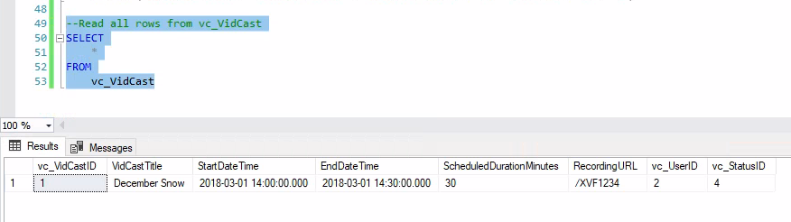

**Saul’s First VidCast:**

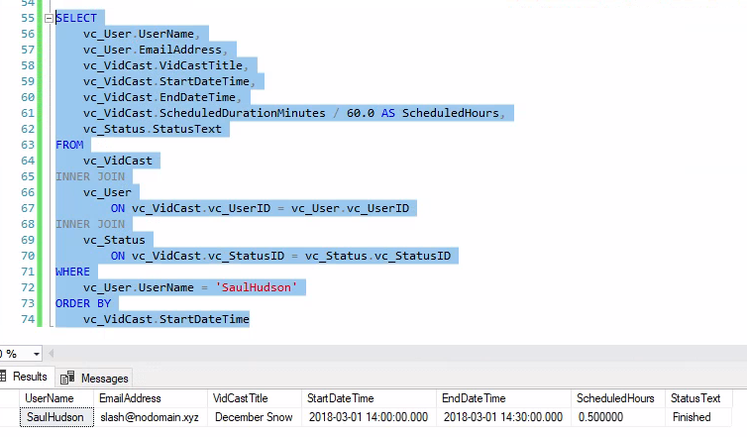

**Update a User:**

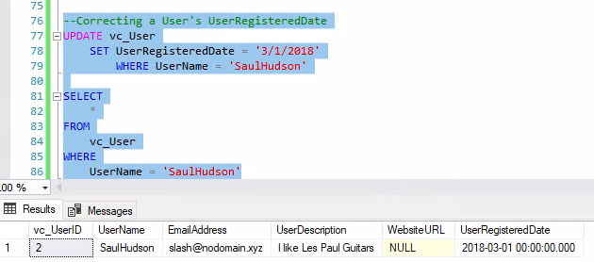

**No more On Time:**

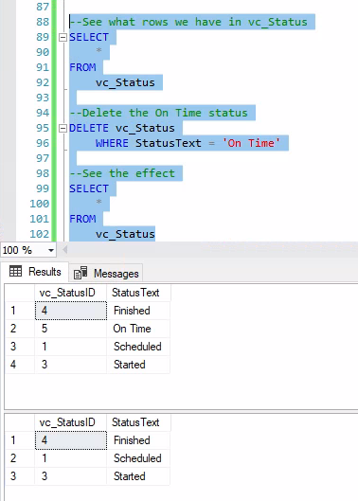

**PART 2**

**Tags:**

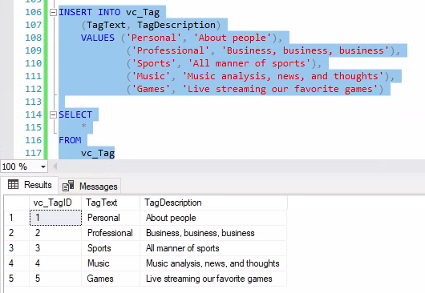

**Users:**

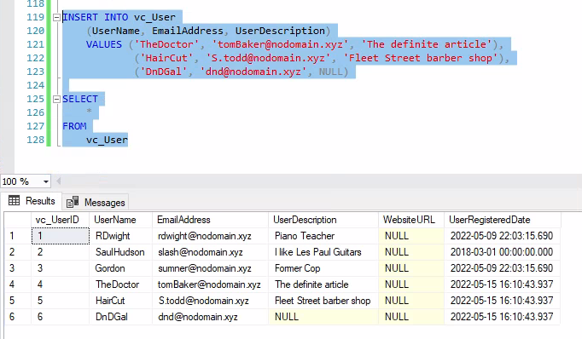

**User Tag List:**

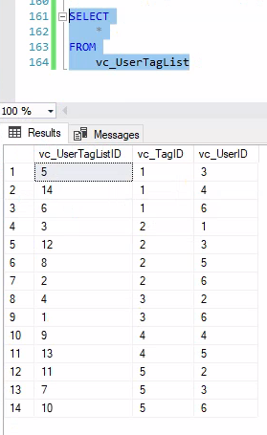

**User Tags Report:**

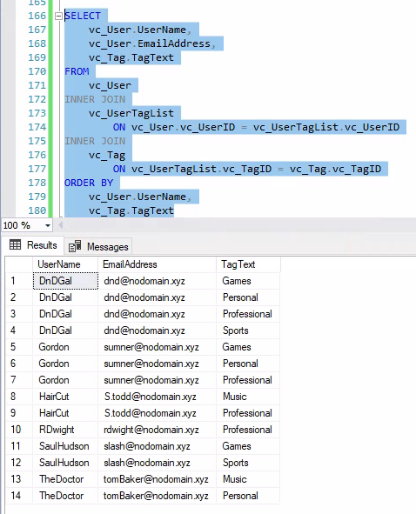

**SQL CODE:**

/*

Author : Nick Videtti

Course : IST659 M407

Term : Spring (April - June) 2022

*/

----------LAB 6----------

-----PART 1-----

--Adding a row to the vc_Status table

INSERT INTO vc_Status (StatusText)

VALUES ('Scheduled')

--The following statement shows all of the rows in vc_Status

SELECT

*

FROM

vc_Status

--Adding three more rows to the vc_Status table

INSERT INTO vc_Status (StatusText)

VALUES ('Started'), ('Finished'), ('On Time')

--The following statement shows all of the rows in vc_Status

SELECT

*

FROM

vc_Status

SELECT

*

FROM

vc_User

WHERE

UserName = 'SaulHudson'

SELECT

*

FROM

vc_Status

WHERE

StatusText = 'Finished'

INSERT INTO vc_VidCast

(VidCastTitle, StartDateTime, EndDateTime, ScheduledDurationMinutes, RecordingURL, vc_UserID, vc_StatusID)

VALUES ('December Snow', '3/1/2018 14:00', '3/1/2018 14:30', 30, '/XVF1234', '2', '4')

--Read all rows from vc_VidCast

SELECT

*

FROM

vc_VidCast

SELECT

vc_User.UserName,

vc_User.EmailAddress,

vc_VidCast.VidCastTitle,

vc_VidCast.StartDateTime,

vc_VidCast.EndDateTime,

vc_VidCast.ScheduledDurationMinutes / 60.0 AS ScheduledHours,

vc_Status.StatusText

FROM

vc_VidCast

INNER JOIN

vc_User

ON vc_VidCast.vc_UserID = vc_User.vc_UserID

INNER JOIN

vc_Status

ON vc_VidCast.vc_StatusID = vc_Status.vc_StatusID

WHERE

vc_User.UserName = 'SaulHudson'

ORDER BY

vc_VidCast.StartDateTime

--Correcting a User's UserRegisteredDate

UPDATE vc_User

SET UserRegisteredDate = '3/1/2018'

WHERE UserName = 'SaulHudson'

SELECT

*

FROM

vc_User

WHERE

UserName = 'SaulHudson'

--See what rows we have in vc_Status

SELECT

*

FROM

vc_Status

--Delete the On Time status

DELETE vc_Status

WHERE StatusText = 'On Time'

--See the effect

SELECT

*

FROM

vc_Status

-----PART 2-----

INSERT INTO vc_Tag

(TagText, TagDescription)

VALUES ('Personal', 'About people'),

('Professional', 'Business, business, business'),

('Sports', 'All manner of sports'),

('Music', 'Music analysis, news, and thoughts'),

('Games', 'Live streaming our favorite games')

SELECT

*

FROM

vc_Tag

INSERT INTO vc_User

(UserName, EmailAddress, UserDescription)

VALUES ('TheDoctor', 'tomBaker@nodomain.xyz', 'The definite article'),

('HairCut', 'S.todd@nodomain.xyz', 'Fleet Street barber shop'),

('DnDGal', 'dnd@nodomain.xyz', NULL)

SELECT

*

FROM

vc_User

INSERT INTO vc_UserTagList (vc_UserID, vc_TagID)

VALUES

((SELECT vc_UserID FROM vc_User WHERE UserName='DnDGal'),

(SELECT vc_TagID FROM vc_Tag WHERE TagText='Sports')),

((SELECT vc_UserID FROM vc_User WHERE UserName='DnDGal'),

(SELECT vc_TagID FROM vc_Tag WHERE TagText='Professional')),

((SELECT vc_UserID FROM vc_User WHERE UserName='RDwight'),

(SELECT vc_TagID FROM vc_Tag WHERE TagText='Professional')),

((SELECT vc_UserID FROM vc_User WHERE UserName='SaulHudson'),

(SELECT vc_TagID FROM vc_Tag WHERE TagText='Sports')),

((SELECT vc_UserID FROM vc_User WHERE UserName='Gordon'),

(SELECT vc_TagID FROM vc_Tag WHERE TagText='Personal')),

((SELECT vc_UserID FROM vc_User WHERE UserName='DnDGal'),

(SELECT vc_TagID FROM vc_Tag WHERE TagText='Personal')),

((SELECT vc_UserID FROM vc_User WHERE UserName='Gordon'),

(SELECT vc_TagID FROM vc_Tag WHERE TagText='Games')),

((SELECT vc_UserID FROM vc_User WHERE UserName='HairCut'),

(SELECT vc_TagID FROM vc_Tag WHERE TagText='Professional')),

((SELECT vc_UserID FROM vc_User WHERE UserName='TheDoctor'),

(SELECT vc_TagID FROM vc_Tag WHERE TagText='Music')),

((SELECT vc_UserID FROM vc_User WHERE UserName='DnDGal'),

(SELECT vc_TagID FROM vc_Tag WHERE TagText='Games')),

((SELECT vc_UserID FROM vc_User WHERE UserName='SaulHudson'),

(SELECT vc_TagID FROM vc_Tag WHERE TagText='Games')),

((SELECT vc_UserID FROM vc_User WHERE UserName='Gordon'),

(SELECT vc_TagID FROM vc_Tag WHERE TagText='Professional')),

((SELECT vc_UserID FROM vc_User WHERE UserName='HairCut'),

(SELECT vc_TagID FROM vc_Tag WHERE TagText='Music')),

((SELECT vc_UserID FROM vc_User WHERE UserName='TheDoctor'),

(SELECT vc_TagID FROM vc_Tag WHERE TagText='Personal'))

SELECT

*

FROM

vc_UserTagList

SELECT

vc_User.UserName,

vc_User.EmailAddress,

vc_Tag.TagText

FROM

vc_User

INNER JOIN

vc_UserTagList

ON vc_User.vc_UserID = vc_UserTagList.vc_UserID

INNER JOIN

vc_Tag

ON vc_UserTagList.vc_TagID = vc_Tag.vc_TagID

ORDER BY

vc_User.UserName,

vc_Tag.TagText