Nick Videtti

IST-659 Week 8 Lab Assignment

**PART 1:**

***SELECT***

***TOP 10 *,***

***dbo.vc_VidCastCount(vc_UserID) VidCastCount***

***FROM***

***vc_User***

***ORDER BY***

***VidCastCount DESC***

This SELECT statement selects the top 10 Users from the vc_User table based on the number of VidCasts they have made. It also orders them by number of VidCasts made, in descending order. The reason that this code knows that the vc_User record with vc_UserID = 20 has 22 vc_VidCast records is because we pass the vc_UserID into the vc_VidCastCount function that we created, which takes a user a returns that number of VidCasts that user has created.

***SELECT dbo.vc_TagIDLookup('Music')***

***SELECT dbo.vc_TagIDLookup('Tunes')***

These statements above call the dbo.vc_TagIDLookup function that we have just created. The first line passes ‘Music’ into the function, returning the vc_TagID that matches the TagText that says ‘Music’. The second line passes ‘Tunes’ into the function, returning the vc_TagID that matches the TagText that says ‘Tunes’. We received a NULL when executing the second line because there is not a record in the vc_Tag table that has a TagText of ‘Tunes’, meaning that there is not a vc_TagID corresponding to a tag whose TagText is ‘Tunes.

***CREATE VIEW vc_MostProlificUsers AS***

***SELECT***

***TOP 10 *,***

***dbo.vc_VidCastCount(vc_UserID) AS VidCastCount***

***FROM***

***vc_User***

***ORDER BY***

***VidCastCount DESC***

***GO***

This code above is creating a view called vc_MostProlificUsers that contains the top 10 records from the vc_User table based on the output from the dbo.VidCastCount function that we created earlier in the lab. The records are also sorted in descending order by the value returned from the dbo.VidCastCount function.

***CREATE PROCEDURE vc_ChangeUserEmail(@userName varchar(20), @newEmail varchar(50))***

***AS***

***BEGIN***

***UPDATE vc_User SET EmailAddress = @newEmail***

***WHERE UserName = @userName***

***END***

***GO***

***EXEC vc_ChangeUserEmail 'tardy', 'kmstudent@syr.edu'***

***SELECT * FROM vc_User WHERE UserName = 'tardy'***

The code above creates a stored procedure called vc_ChangeUserEmail that takes two parameters, the first being the vc_Users UserName and the second being the email address. This procedure changes the passed-in vc_User’s email address to the one that was passed in. Then, we execute the procedure by setting the vc_User’s email address with the UserName ‘tardy’ to ‘[kmstudent@syr.edu](mailto:kmstudent@syr.edu)’. The final line queries the vc_User table for only the vc_User whose UserName is ‘tardy’ and shows us that the email address is indeed ‘[kmstudent@syr.edu](mailto:kmstudent@syr.edu)’.

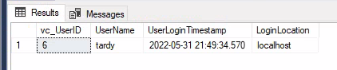

The reason that this UserLogin Timestamp is different from the lab document is that this column is set to be the current system timestamp.

***DECLARE @addedValue INT***

***EXEC @addedValue = vc_AddUserLogin 'tardy', 'localhost'***

***SELECT***

***vc_User.vc_UserID,***

***vc_User.UserName,***

***vc_UserLogin.UserLoginTimestamp,***

***vc_UserLogin.LoginLocation***

***FROM***

***vc_User***

***JOIN***

***vc_UserLogin***

***ON vc_User.vc_UserID = vc_UserLogin.vc_UserID***

***WHERE***

***vc_UserLoginID = @addedValue***

This code could be simplified by using the SCOPE_IDENTITY() function rather than declaring and using the addedValue variable

**PART 2:**

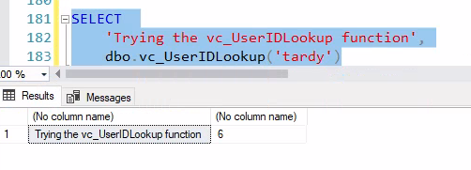

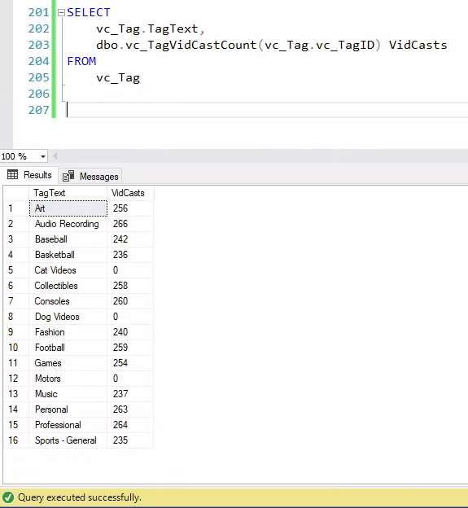

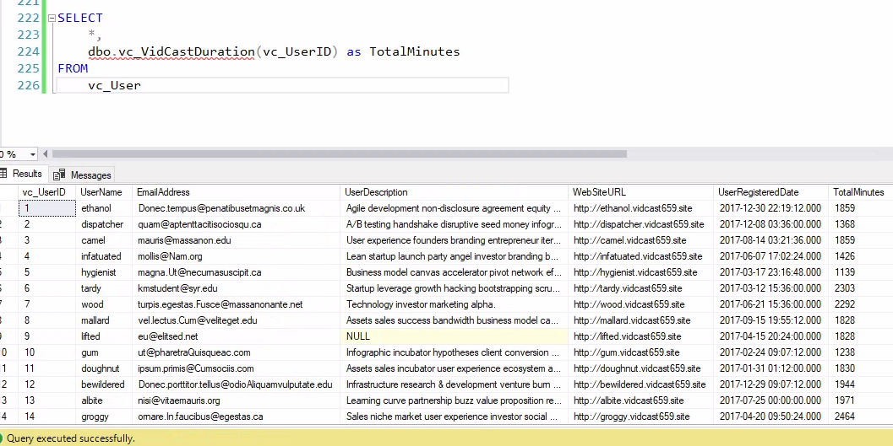

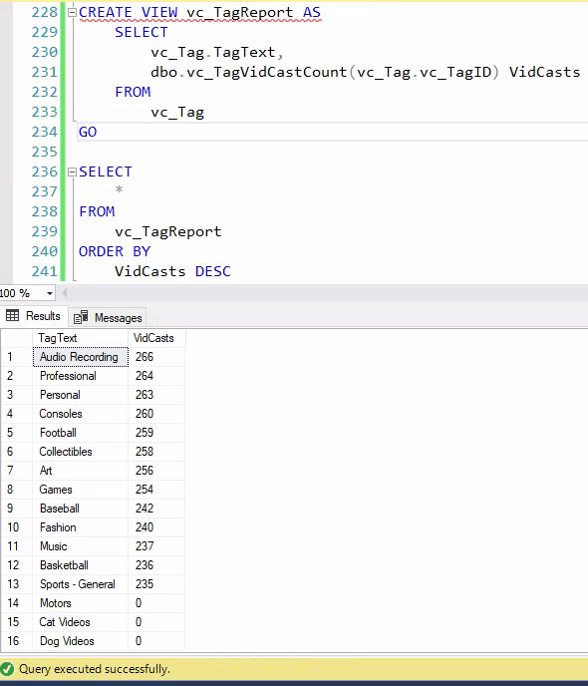

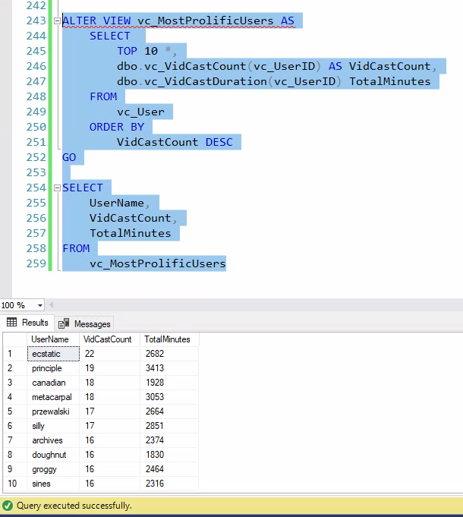

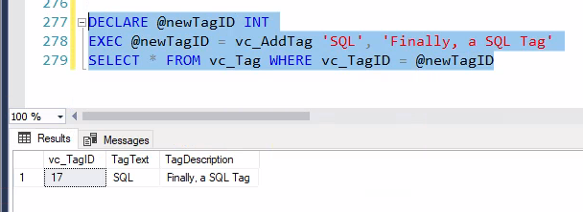

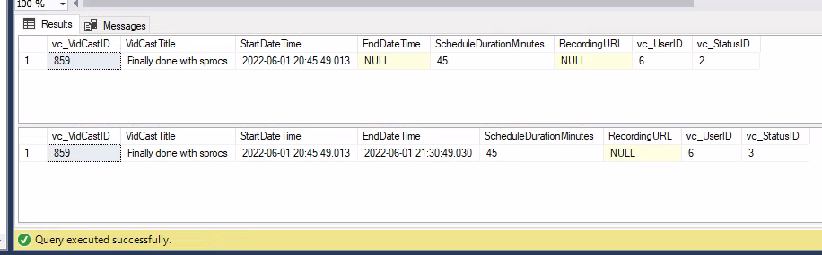

**SQL CODE:**

/*

Author : Nick Videtti

Course : IST659 M407

Term : Spring (April - June) 2022

*/

----------LAB 8----------

-----PART 1-----

--Declare a variable

DECLARE @ISTHISNULL VARCHAR(30) --Starts out as null

SELECT @ISTHISNULL, ISNULL(@ISTHISNULL, 'Yep, it is null')

--Set the variable to something other than NULL

SET @ISTHISNULL = 'Nope. It is not NULL'

SELECT @ISTHISNULL, ISNULL(@ISTHISNULL, 'Yep, it is null')

CREATE FUNCTION dbo.AddTwoInts(@firstnumber INT, @secondnumber INT)

RETURNS INT AS

BEGIN

--First, declare the variable to temporarily hold the result

DECLARE @returnvalue INT --the data type matches the RETURNS clause

--Do whatever needs to be done to se the variable to the correct value

SET @returnvalue = @firstnumber + @secondnumber

--Return the value to the calling statement

RETURN @returnvalue

END

GO

SELECT dbo.AddTwoInts(5,10)

--Function to count the VidCasts made by a specific user

CREATE FUNCTION dbo.vc_VidCastCount(@userID INT)

RETURNS INT AS --COUNT() is an integer value, so return it as an int

BEGIN

DECLARE @returnvalue INT --matches the function's return type

/*Get the count of VidCasts for the provided userID and assign that value to

@returnvalue. Note that we use the @userID parameter in the WHERE clause to

limit our count to that user's VidCast records.*/

SELECT @returnvalue = COUNT(vc_UserID) FROM vc_VidCast

WHERE vc_VidCast.vc_UserID = @userID

--Return @returnvalue to the calling code.

RETURN @returnvalue

END

GO

SELECT

TOP 10 *,

dbo.vc_VidCastCount(vc_UserID) VidCastCount

FROM

vc_User

ORDER BY

VidCastCount DESC

GO

--Function to retrieve the vc_TagID for a given tag's text

CREATE FUNCTION dbo.vc_TagIDLookup(@tagText varchar(20))

RETURNS INT AS --vc_TagID is an int, so we'll match that

BEGIN

DECLARE @returnvalue int --Matches the function's return type

/*Get the vc_TagID of the vc_Tag record whose TagText

matches the parameter and assign that value to @returnvalue.*/

SELECT

@returnValue = vc_TagID

FROM

vc_Tag

WHERE

TagText = @tagText

--Send the vc_TagID back to the caller

RETURN @returnvalue

END

GO

SELECT dbo.vc_TagIDLookup('Music')

SELECT dbo.vc_TagIDLookup('Tunes')

--Create a view to retrieve the top 10 vc_Users and their VidCast counts

CREATE VIEW vc_MostProlificUsers AS

SELECT

TOP 10 *,

dbo.vc_VidCastCount(vc_UserID) AS VidCastCount

FROM

vc_User

ORDER BY

VidCastCount DESC

GO

SELECT

*

FROM

vc_MostProlificUsers

--Create a procedure to update a vc_User's email address

--The first parameter is the user name for the user to change

--The second is the new email address

CREATE PROCEDURE vc_ChangeUserEmail(@userName varchar(20), @newEmail varchar(50))

AS

BEGIN

UPDATE vc_User SET EmailAddress = @newEmail

WHERE UserName = @userName

END

GO

EXEC vc_ChangeUserEmail 'tardy', 'kmstudent@syr.edu'

SELECT * FROM vc_User WHERE UserName = 'tardy'

INSERT INTO vc_Tag (TagText) VALUES ('Cat Videos')

SELECT * FROM vc_Tag WHERE vc_TagID = @@IDENTITY

INSERT INTO vc_Tag (TagTExt) VALUES ('Dog Videos')

SELECT * FROM vc_Tag WHERE vc_TagID = SCOPE_IDENTITY()

/*Create a procedure that adds a row to the UserLogin table.

This procedure should be run when a user logs in.

It will record who they are and from where they're logging in.*/

CREATE OR ALTER PROCEDURE vc_AddUserLogin(@userName varchar(20), @loginFrom varchar(50))

AS

BEGIN

--We have the user name, but we need the user ID for the login table

--First, declare a variable to hold the ID

DECLARE @userID int

SELECT @userID = vc_UserID FROM vc_User

WHERE UserName = @userName

--Now we can add the row using an INSERY statement

INSERT INTO vc_UserLogin (vc_UserID, LoginLocation)

VALUES(@userID, @loginFrom)

--Lastly, return the SCOPE_IDENTITY() so the calling code knows the primary key of the row we just added

RETURN SCOPE_IDENTITY()

END

GO

DECLARE @addedValue INT

EXEC @addedValue = vc_AddUserLogin 'tardy', 'localhost'

SELECT

vc_User.vc_UserID,

vc_User.UserName,

vc_UserLogin.UserLoginTimestamp,

vc_UserLogin.LoginLocation

FROM

vc_User

JOIN

vc_UserLogin

ON vc_User.vc_UserID = vc_UserLogin.vc_UserID

WHERE

vc_UserLoginID = @addedValue

-----PART 2-----

--Create a function to retrieve a vc_UserID for a given user name

CREATE FUNCTION dbo.vc_UserIDLookup(@userName varchar(20))

RETURNS INT AS

BEGIN

DECLARE @returnValue INT

SELECT

@returnValue = vc_UserID

FROM

vc_User

WHERE

UserName = @userName

RETURN @returnValue

END

GO

SELECT

'Trying the vc_UserIDLookup function',

dbo.vc_UserIDLookup('tardy')

CREATE FUNCTION dbo.vc_TagVidCastCount(@vc_TagID INT)

RETURNS INT AS

BEGIN

DECLARE @returnvalue INT

SELECT

@returnvalue = COUNT(DISTINCT vc_VidCastID)

FROM

vc_VidCastTagList

WHERE

vc_TagID = @vc_TagID

RETURN @returnvalue

END

GO

SELECT

vc_Tag.TagText,

dbo.vc_TagVidCastCount(vc_Tag.vc_TagID) VidCasts

FROM

vc_Tag

CREATE FUNCTION vc_VidCastDuration(@vc_UserID INT)

RETURNS INT AS

BEGIN

DECLARE @VCDUR INT

SELECT

@VCDUR = SUM(DATEDIFF(n,StartDateTime,EndDateTime))

FROM

vc_VidCast

WHERE

vc_StatusID = (SELECT vc_StatusID FROM vc_Status WHERE StatusText = 'Finished')

AND vc_UserID = @vc_UserID

RETURN @VCDUR

END

GO

SELECT

*,

dbo.vc_VidCastDuration(vc_UserID) as TotalMinutes

FROM

vc_User

CREATE VIEW vc_TagReport AS

SELECT

vc_Tag.TagText,

dbo.vc_TagVidCastCount(vc_Tag.vc_TagID) VidCasts

FROM

vc_Tag

GO

SELECT

*

FROM

vc_TagReport

ORDER BY

VidCasts DESC

ALTER VIEW vc_MostProlificUsers AS

SELECT

TOP 10 *,

dbo.vc_VidCastCount(vc_UserID) AS VidCastCount,

dbo.vc_VidCastDuration(vc_UserID) TotalMinutes

FROM

vc_User

ORDER BY

VidCastCount DESC

GO

SELECT

UserName,

VidCastCount,

TotalMinutes

FROM

vc_MostProlificUsers

/*Create a stored procedure to add a new Tag to the database

Inputs:

@tagText: the text of the new tag

@description: a brief description of the tag (nullable)

Returns:

@@identity with the value inserted*/

CREATE PROCEDURE vc_AddTag(@tagText varchar(20), @description varchar(100)=NULL) AS

BEGIN

INSERT INTO vc_Tag(TagText,TagDescription)

VALUES (@tagText,@description)

RETURN @@identity

END

GO

DECLARE @newTagID INT

EXEC @newTagID = vc_AddTag 'SQL', 'Finally, a SQL Tag'

SELECT * FROM vc_Tag WHERE vc_TagID = @newTagID

CREATE PROCEDURE vc_FinishVidCast(@VID_CAST_ID INT) AS

BEGIN

UPDATE vc_VidCast

SET

EndDateTime = GETDATE(),

vc_StatusID = (SELECT vc_StatusID FROM vc_Status WHERE StatusText = 'Finished')

WHERE

vc_VidCastID = @VID_CAST_ID

END

GO

DECLARE @newVC INT

INSERT INTO vc_VidCast

(VidCastTitle, StartDateTime, ScheduleDurationMinutes, vc_UserID, vc_StatusID)

VALUES(

'Finally done with sprocs',

DATEADD(n,-45,GETDATE()),

45,

(SELECT vc_UserID FROM vc_User WHERE UserName = 'tardy'),

(SELECT vc_StatusID FROM vc_Status WHERE StatusText = 'Started')

)

SET @newVC = SCOPE_IDENTITY()

SELECT * FROM vc_VidCast WHERE vc_VidCastID = @newVC

EXEC vc_FinishVidCast @newVC

SELECT * FROM vc_VidCast WHERE vc_VidCastID = @newVC