# **Thông tin ip lb and pool**

#######################################

| Role | IP Addres | Hostname | vCPU | RAM | Disk |

|-------------| --------------|------------------------------|---------|-----------|-------|

| Master | 10.48.6.11 | tpc-timescale-rnd-prod-01 | 4vCPU | 8G RAM | 100G |

| Master | 10.48.6.12 | tpc-timescale-rnd-prod-02 | 4vCPU | 8G RAM | 100G |

| Master | 10.48.6.13 | tpc-timescale-rnd-prod-03 | 4vCPU | 8G RAM | 100G |

| VIP IP | 10.48.6.10 | tpc-timescale-read | | | |

#######################################

| Name Pool | IP Addres | Port Extend | Port Internal | Protocol/port | Path | Code |

|-----------------------| --------------|-------------|---------------|-----------------|----------|---------|

| datx-tsdb-pool-write | 10.48.6.10 | 6000 | 5432 | http 8008 | /primary | 200 |

| datx-tsdb-pool-read | 10.48.6.10 | 5000 | 5432 | http 8008 | /replica | 200 |

| datx-tsdb-pool-bouncer| 10.48.6.10 | 7000 | 6432 | http 8008 | /replica | 200 |

Link tham khảo api check : https://patroni.readthedocs.io/en/latest/rest_api.html

# **Load balancer**

# **Pools**

Lưu ý:

HTTP Method không được chọn GET. Nếu không sẽ bị lỗi python của patroni.

Nov 01 19:56:10 datx-tsdb02 patroni[6989]: ConnectionResetError: [Errno 104] Connection reset by peer

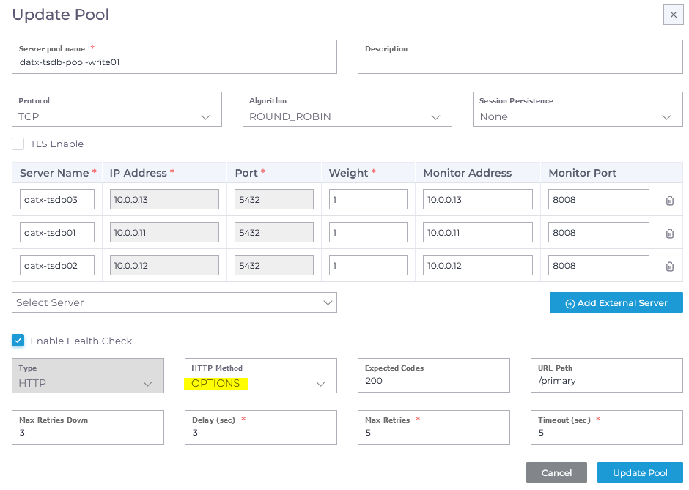

# **Listeners**

