**GLS Technical Exercise**

GLS module has been develop by using backend “**Python with Django Framework and JS”** to display div data in Frontend page by rendering **JSON** data with respective to id and class.

**Objective**:

Objective of the application is to run and display Frontend page by embedding JSON guide with respective div using Python, Django and JS.

**Functional Requirement:**

* Python 3.7
* Django
* JQuery and JavaScript
* Html5 and CSS

**File Structure:**

Oracle/oracle - Project Directory

1. settings.py
2. urls.py
   1. Oracle/oracle/gls - app Directory
      1. views.py
      2. templates
         1. index.html
      3. static
         1. js - player.js,jquery.js
         2. css - gls.css
         3. json - guide.json

**Workflow:**

Download the files from GitHub ("https://github.com/nvijayasekar/oracle.git") and place oracle-master in python specific path where your server run.

Example: "C:\Python\Python37\Scripts\oracle\oracle>"

Once files has been placed successful, please execute the command below to start Django Server,

**"py manage.py runserver".**

After successful server initiate, run the Django application by requesting "http://127.0.0.1:8000/" in any web browsers.

You can see the Frontend page result successfully.

Kindly refer application flow and screenshot below for reference on how application run from end to end.

Thanks.

**Application Flow.**

I have created this application as “Step By Step” sequence where it guides Users to get result by clicking on each div tip instead of displaying all div at one time.

In addition, User can see tooltip info for each “Div. Tip” on mouse hover where its render JSON guide with respective id, class and path.

By Default, Page will render with single tip div where Users can hover on div tip to display tooltip information and clicks to see next Div. tip for end-result.

Kindly refer screenshot for reference below,

Screenshot 1: Start Step 1 when page load initially by loading (<http://127.0.0.1:8000/>) in web browsers.

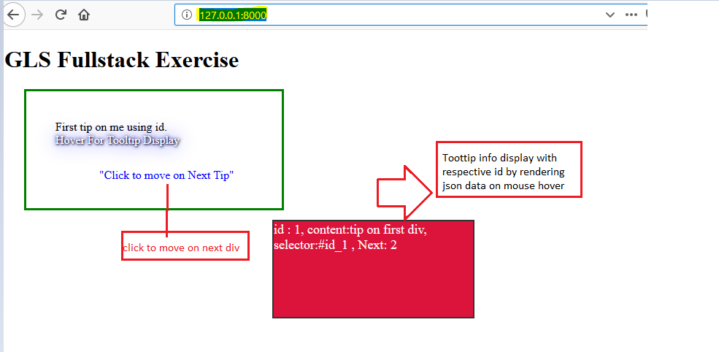

Screenshot 2: Display all div tip guide when customer clicks for step and step by sequence.

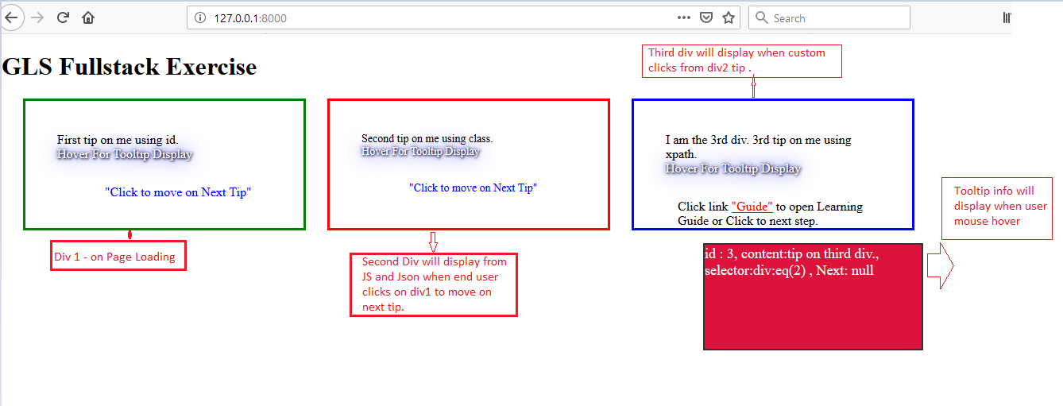

Screenshot 3: Testing Step by adding new test Div. tip.

In this step, added two links for result.

Close: Reset to clear all sub div where user can start to test the page without reloading.

Guide: Redirects to Oracle University Page.

