**Mine Strife**

Well digging the earth has been something man has been doing for centuries. We have dug earth to obtain so many metals, minerals, and even the precious drinking water. So, why not excavate and have fun!?

**Description**:

You have to build a mechanism which moves around on and digs out a mud-covered arena. As you dig , you get to collect the coins buried below. Your mechanism has to scoop out the lightweight coins, carry them, and drop them into a bin beside the arena. The more the number of coins collected the more the points scored.

The mechanism must be a robot which can move around the arena. The lifting and scoop function of the bot must use only hydraulics and pneumatics.

The implementation of the idea is left completely to the participant, provided the participant follows these constraints:

* The maximum length of the bot <35 cm

(From one end of the bot to the other end of the

overhanging arm of the bot)

* The maximum height of the bot’s arm stretched upwards <27cm
* The width of the bot <20cm

**Arena**:

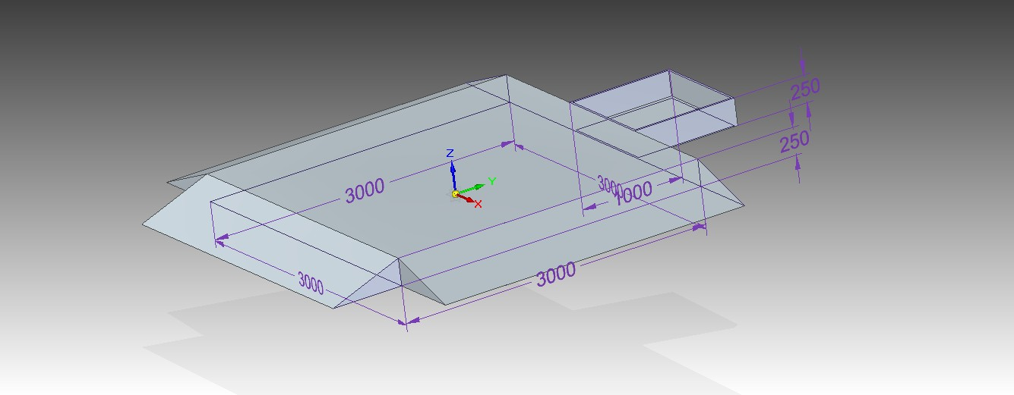

**Rules and Details:**

* Each team can have a maximum of three participants.
* This is a one-round event.
* Each coin collected earns you 1 point.
* Your bot must be lightweight.
* Your mechanism should be completely manually driven. Use of electricity or other driving mechanisms is not allowed. The locomotion of the bot can, however, be electrically controlled with a wired/wireless remote.
* The more efficient and simpler the design, the more the points scored.
* No part of the mechanism should be detachable so as to provide an advantage in lifting the objective material.
* Balls dropped by the bot, while carrying them to the storage container, will not be considered for scoring.
* Decision taken by the judges will be final and binding.