**­­­­**

**Task**

In this event ,the contestants are expected to make to an IC engine powered machine ,that can be controlled remotely using a wireless remote controller, which can race against machines of similar construct on an all-terrain track packed with a number of obstacles.

**Arena**

The a track will be a multi terrain track with many turns and jumps .The cars should be able to race against opponent’s cars overcoming various bumps and rough terrains distributed throughout the track. So it is evident that not only the swiftness but also the stability. The track will be mostly made of mud with certain regions covered with wooden panels and jute mats.

* The track width will be around 8 feet.
* Multiple machines will race on a single track simultaneously.
* A control stance of height approx. 8 feet will be provided all along the track from where and where only , the contestants can control their car
* A ‘lap’ is said to be completed if when the car reaches the start/finish point after a complete run through the circuit.
* The track will consist of the following obstacles :

1. Circular bumps diameter 3 inch with height 1.5 inch above the ground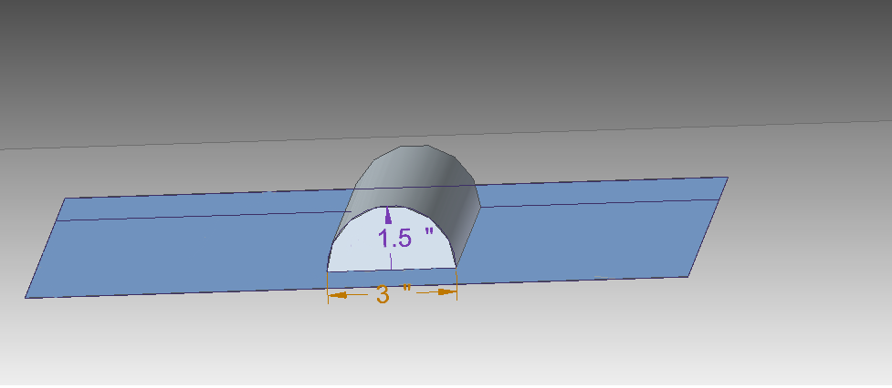
2. Ramps of height 8 inch and length 3 feet. 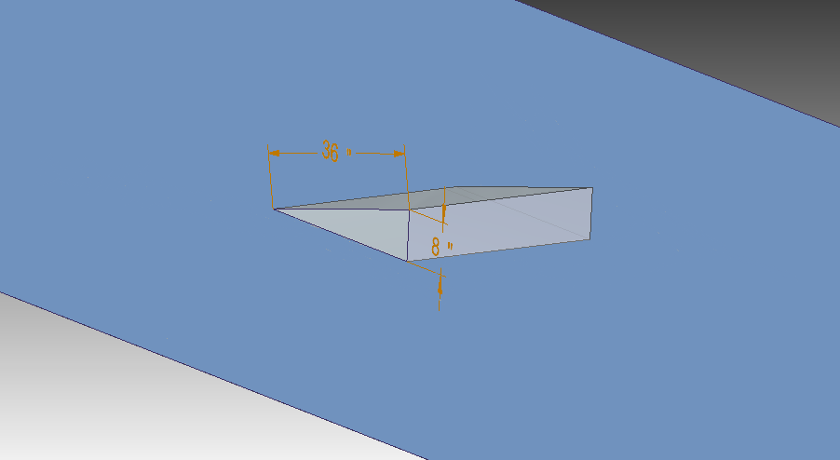
3. Bridges of length 3’4” and length 24’ as shown in figure. 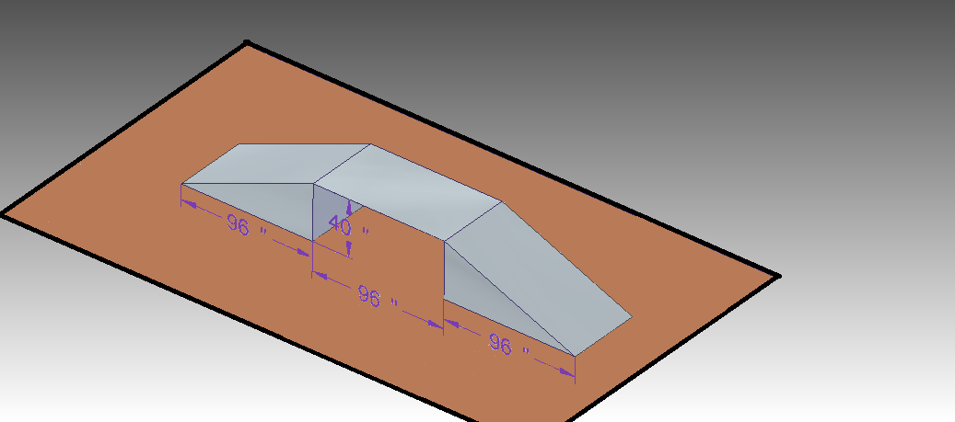
4. Clusters of PVC pipes of diameter 40 mm. 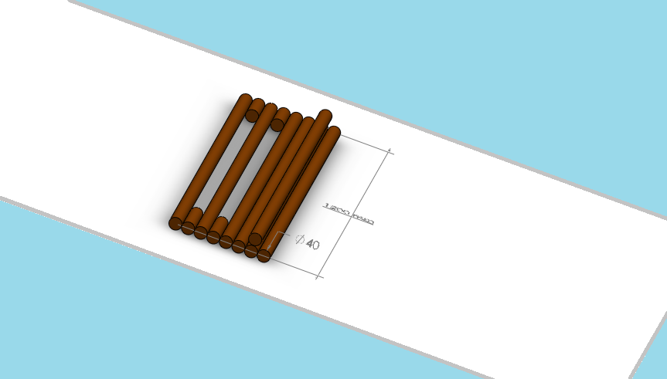

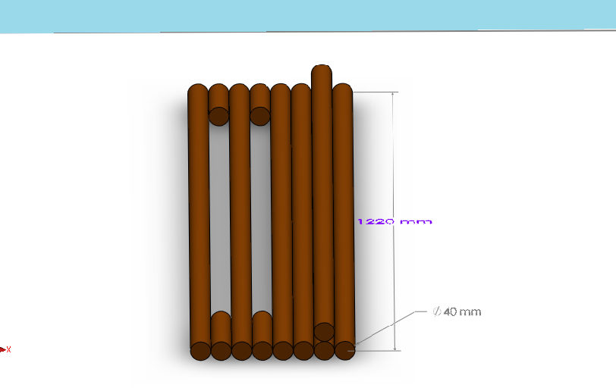

1. Trees of diameter 1’ -2’ will be present in the track, momentarily hindering the view of the driver.

[Contestants please note that there will be tolerance of ± 5 % in the given dimensions]

* Changes in obstacles will be duly notified to the participants via mail
* In spite of the organizer’s efforts to keep the track intact, the track is expected to undergo wear and tear as the race progresses, the car should be fabricated such that its performance is not compromised in a worn track.

**Car Specifications**

* The car should fit in a box of dimensions 700mm x 500mm x 600mm throughout the race; this does not include the dimensions of the wireless controller device used to control the machine
* The machine is to be controlled using a wireless remote controller during the race.
* It is imperative that the machine is constructed by the participants. Any machine found to be fabricated from Lego kits / any other assembly kits or having a readymade chassis will be readily disqualified.
* The machine parts may be roughly classified into structural and functional parts :
* Functional parts: Gears, differential gear, engine, springs, shock absorbers, servo motors (not for propulsion purposes), batteries, wheels and wheel hub can be directly used as available in the market.
* Structural parts: Chassis, steering mechanism, shock towers and suspension (excluding upper suspension arm, suspension spring and shock absorbers) have to be built by the participants themselves.
* Participants are advised to strictly adhere to the above criteria as any machine found to be non-complaint will be immediately disqualified.
* The tires must have a minimum diameter of 3 inch. Contestants are advised to use tires of good width for better performance on off road tracks.
* **Brake Mechanism:** It is necessary to include a braking mechanism in the car. Participants have to fabricate the brake pad as a part of the braking mechanism. Any other part used in braking mechanism (including the brake disk) can be readymade.
* **Wheel Hub**: Any part rigidly attached to the wheel hub will be considered as a part of it and hence can be ready-made. An example here is that of the ball stud
* **Steering Mechanism**: Any part which is connected to steering rod rigidly i.e. has no degrees of freedom with respect to steering rod (example: heim joint http://en.wikipedia.org/wiki/Heim_joint) will be considered as part of steering rod and thus has to be fabricated by participants.
* **Suspension mechanism:** Components rigidly linked to suspension arms or one with no degrees of freedom with respect to suspension arm will have to be fabricated by the participants, except the upper suspension arm. For example both the heim joint for the upper suspension arm and the stud rigidly connected to the wheel hub can be bought from the market.
* If there are parts used in the concerned joint which are neither rigidly connected with suspension or the hub, steering system or hub; they can be used ready-made from the market.
* The above pictures are just sample pictures for you to understand the rules easily.

**Propulsion & Steering**

* The machine must use only mechanical power generated by an internal combustion (IC) engine for propulsion. Only one IC engine should be used in the machine. Use of any other sources such as chemicals, compressed gas, rockets etc. is not allowed.
* Any machine which uses DC Motors for propulsion will be disqualified. However DC motors and servos can be used for steering mechanisms or any other control mechanisms apart from propulsion.
* The machine must have an on-board power supply to run any mechanism requiring electric power.
* The maximum allowed capacity of IC engine to be used is 4.6 cc (i.e. Participants can also use 2.5 cc, 3 cc, 3.5 cc or any other IC engine lower in capacity).
* The electric voltage anywhere in the machine should not exceed 12V at any point of time.
* There shall be a countdown preceding the start of the race. No participant is allowed to touch the machine during the countdown period.
* Providing a clutch mechanism between the engine and the wheel would prove useful, as it would prevent the engine from dying out at any stage of the race.
* Participants are advised to use a proper cooling mechanism to prevent overheating of the engine.
* Participants are advised to use sway bars for better control and stability.
* The participants are advised to use proper air filters as dirt might cause serious problems to the engine.
* Readymade wheels are allowed.
* The machine will be inspected and if found to be dangerous, the team will be disqualified. This decision rests solely with the judges and the organizers.

**Game Rules**

* **Qualifying Round:** In the qualifying round each team will be getting 2 laps out of which the faster lap will be considered. Note that these laps will have to be taken successively. The top teams from the qualifying rounds will make it to the second round.
* **Second Round and Finals:** After the qualifying round, there will be races between multiple cars at a time. So the participants must use a remote control with frequency of band spectrum 2.4 GHz.
* **Checkpoints:** Check points will be provided along the track at regular intervals. If a machine tumbles, halts or goes off the arena at any point on the track, one of the team members is allowed to pick it up and place it at the nearest checkpoint behind that point. The clock shall still be ticking in the meantime.
* **No Touching:** Team members are not permitted to touch either their machines or those of their opponents once the race begins (unless there is need to lift the machine as stated in fourth point). The penalty for doing so is disqualification.
* **Team Members Allowed:** In the qualification round, a maximum of two team members are allowed from a team in the racing arena while in the final round only one of the team member will be in the racing arena except the controller on the stand.
* **No breaking apart:** The machines are not allowed to leave any loose parts on any part of the arena. Any ma-chine disintegrating during the race will be disqualified.
* **No Early Starting:** If any of the machines starts off before the flag is waved, the counter would be restarted and the machines will get a second chance. However, if any machine starts off before the waving of flag (or countdown) for a second time, it will be disqualified. No rematch will be held for the second time.
* **No Violence:** Teams are not allowed to purposefully damage the machine of the opponent's team. If found doing so on track (while racing), the concerned team will be disqualified. Execution of last three rules will be subjective and relies completely on judge’s and organizer’s discretion.