
FPT UNIVERSITY
AI DEPARTMENT

FINAL PROJECT REPORT
COURSE: AI, DS with Python & SQL ( ADY201m )
PROJECT TITLE: ANALYSIS AND PREDICTION OF CREDIT CARD CUSTOMER CHURN
Instructor: Ngô Trường Minh
Class / Section Code: AI2107
Project Group: Group No. 04
Group Members:
1. Nguyễn Văn Kiên - HE200682 (Group Leader)
2. Tống Việt Thảo - HE204303
3. Nguyễn Anh Tới - HE201009
Hanoi, 2026

Table of Contents
I. PROBLEM UNDERSTANDING AND ANALYTICAL APPROACH 3
1. Problem Statement 3
2. Project Objectives 3
3. Analytical Approach 3
II. DATA COLLECTION, EXPLORATION, AND PREPROCESSING 4
1. Data Collection 4
2. Exploratory Data Analysis 6
3. Data Preprocessing and Cleaning 7
III. DATA ANALYSIS USING SQL AND PYTHON 10
1. Advanced Data Mining via SQL Analysis 10
2. Python Data Analysis 17
3. Data Visualization with Python 19
3.1. Graphic Libraries Application 19
3.2. Visualization Catalog and Technical Compliance 19
3.3. Visual Interpretation and Chart Breakdown 20
IV. REGRESSION ANALYSIS AND MACHINE LEARNING PREDICTION 39
1. Model Building 39
2. Model Evaluation 39
3. Translating Mathematics to Business Value 41
4. Analysis Using a Specialized Tool 42
4.1. Tool Application and Dashboard Deployment 42
4.2. Tool Evaluation and Critical Review 43

I. PROBLEM UNDERSTANDING AND ANALYTICAL APPROACH

1. Problem Statement
- Context: Banking sector – credit card services. The BankChurners dataset contains 10,127 customers, with demographic information, level of engagement with the bank, and card usage behavior over 12 months.
- Problem: The bank loses credit card customers (customers who cancel their cards) without being able to detect it in advance. The data contain 1,627 churned customers out of 10,127, which is a churn rate of 16.07%.
- Significance: Early identification of customers who show signs of churn helps the customer care team retain the right customers, instead of spreading its effort across all customers.

2. Project Objectives
- General objective: To build a system that analyzes the behavior of credit card customers and a model that predicts customer churn, and then to propose retention actions.
- Detailed objectives:
- (1) To design a relational database (2 tables) and clean the data.
- (2) To use SQL to find risk thresholds and to build a risk score scale from 0 to 6.
- (3) To use Python (EDA) to identify the factors related to churn and to select the input features for the model.
- (4) To build a Random Forest model and evaluate it with Recall and F1-Score.
- (5) To extract a watchlist of customers who need early care and to deploy a dashboard.

3. Analytical Approach
- Descriptive analysis: Compares the average behavior of the staying group and the churned group (SQL Query 1, EDA section 6).
- Diagnostic analysis: Finds the thresholds and signals that create risk, using churn rate by value range, the correlation matrix, and the risk score (SQL Queries 2–4, EDA sections 3–6).
- Predictive analysis: A Random Forest classification model predicts whether a customer will churn (Chapter IV).
- Justification: The churn label is already available, so supervised learning is suitable. The data are imbalanced (5.22 : 1), so Recall and F1-Score are prioritized over Accuracy.

II. DATA COLLECTION, EXPLORATION, AND PREPROCESSING

1. Data Collection
- Data source: Kaggle – BankChurners dataset (file BankChurners.csv).
Credit Card customers | Kaggle
- Size: 10,127 rows and 23 columns in the original version; 21 columns after cleaning (file BankChurners_clean.csv).
- Database organization: The clean data were loaded into the staging table BankChurners_Staging in SQL Server (database bank_churn), and then split into 2 relational tables: Customers (profile and engagement, 11 columns) and Card_Activity (card activity, 12 columns). The two tables are linked by the foreign key CLIENTNUM.
- Row count: The JOIN of the two tables returns 10,127 customers (8,500 staying + 1,627 churned, SQL Query 1), which means that each customer has exactly one activity row.
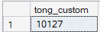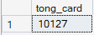

Database Schema
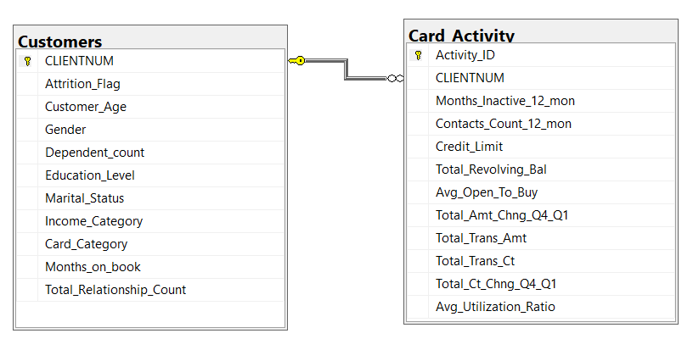
Table | Primary Key (PK) | Foreign Key (FK)
Customers | CLIENTNUM | —
Card_Activity | Activity_ID (IDENTITY) | CLIENTNUM → Customers(CLIENTNUM)

Data Dictionary
Table | Attribute | Data Type | Description
Customers | CLIENTNUM | BIGINT | Customer ID (primary key)
 | Attrition_Flag | TINYINT | Target variable: 1 = churned, 0 = staying
 | Customer_Age | TINYINT | Customer age
 | Gender | VARCHAR(1) | Gender (M/F)
 | Dependent_count | TINYINT | Number of dependents
 | Education_Level | VARCHAR(30) | Education level
 | Marital_Status | VARCHAR(20) | Marital status
 | Income_Category | VARCHAR(20) | Annual income category
 | Card_Category | VARCHAR(20) | Card category (Blue < Silver < Gold < Platinum)
 | Months_on_book | TINYINT | Number of months with the bank
 | Total_Relationship_Count | TINYINT | Number of bank products the customer uses
Card_Activity | Activity_ID | INT | Activity row ID, auto-increment (primary key)
 | CLIENTNUM | BIGINT | Customer ID (foreign key to Customers)
 | Months_Inactive_12_mon | TINYINT | Number of inactive months in 12 months
 | Contacts_Count_12_mon | TINYINT | Number of contacts with the bank in 12 months
 | Credit_Limit | DECIMAL(10,3) | Credit limit
 | Total_Revolving_Bal | INT | Revolving balance (debt not fully paid at the end of the period)
 | Avg_Open_To_Buy | DECIMAL(10,3) | Remaining spendable limit = Credit_Limit − Total_Revolving_Bal
 | Total_Amt_Chng_Q4_Q1 | DECIMAL(6,3) | Change ratio of transaction amount, Q4 vs Q1
 | Total_Trans_Amt | INT | Total transaction amount in 12 months
 | Total_Trans_Ct | INT | Total number of transactions in 12 months
 | Total_Ct_Chng_Q4_Q1 | DECIMAL(6,3) | Change ratio of transaction count, Q4 vs Q1
 | Avg_Utilization_Ratio | DECIMAL(6,3) | Credit utilization ratio = Total_Revolving_Bal / Credit_Limit

2. Exploratory Data Analysis
- Dimensions: The original data have 10,127 rows × 23 columns; the clean data have 10,127 rows × 21 columns. In the database: Customers has 11 columns and Card_Activity has 12 columns.
- Data types: 1 binary target variable (Attrition_Flag), 14 numerical (quantitative) variables, 5 categorical text variables (Gender, Education_Level, Marital_Status, Income_Category, Card_Category), and 1 identifier (CLIENTNUM).
- Data quality: There are no NaN cells and no duplicate rows, and CLIENTNUM is unique.

Descriptive Statistics of Numerical Variables
Variable | Mean | Standard Deviation | Median | Min | Max
Customer_Age | 46.33 | 8.02 | 46 | 26 | 73
Dependent_count | 2.35 | 1.30 | 2 | 0 | 5
Months_on_book | 35.93 | 7.99 | 36 | 13 | 56
Total_Relationship_Count | 3.81 | 1.55 | 4 | 1 | 6
Months_Inactive_12_mon | 2.34 | 1.01 | 2 | 0 | 6
Contacts_Count_12_mon | 2.46 | 1.11 | 2 | 0 | 6
Credit_Limit | 8,631.95 | 9,088.78 | 4,549 | 1,438.3 | 34,516
Total_Revolving_Bal | 1,162.81 | 814.99 | 1,276 | 0 | 2,517
Avg_Open_To_Buy | 7,469.14 | 9,090.69 | 3,474 | 3 | 34,516
Total_Amt_Chng_Q4_Q1 | 0.76 | 0.22 | 0.74 | 0 | 3.40
Total_Trans_Amt | 4,404.09 | 3,397.13 | 3,899 | 510 | 18,484
Total_Trans_Ct | 64.86 | 23.47 | 67 | 10 | 139
Total_Ct_Chng_Q4_Q1 | 0.71 | 0.24 | 0.70 | 0 | 3.71
Avg_Utilization_Ratio | 0.27 | 0.28 | 0.18 | 0 | 1.00

Statistics of Categorical Variables
Variable | Unique Values | Most Frequent Value (Mode) | Frequency | Churn Rate of the Mode
Gender | 2 | F | 5,358 | 17.36%
Education_Level | 7 | Graduate | 3,128 | 15.57%
Marital_Status | 4 | Married | 4,687 | 15.13%
Income_Category | 6 | Less than $40K | 3,561 | 17.19%
Card_Category | 4 | Blue | 9,436 | 16.10%

Initial Observations
- Label imbalance: There are 8,500 staying customers (83.93%) versus 1,627 churned customers (16.07%), a ratio of about 5.22 : 1.
- Right-skewed distributions: Credit_Limit, Avg_Open_To_Buy, Total_Trans_Amt have means that are much larger than their medians, because a group of VIP customers with high limits pulls the mean up. The group comparisons therefore use both the mean and the median.
- Unknown label: Appears in 3 columns: Education, Marital Status, and Income .

3. Data Preprocessing and Cleaning

Handling Missing Values
- Technically, the number of NaN cells is 0. The real missing values are in the Unknown labels of 3 categorical columns.
- Decision: Keep Unknown as a separate category and do not delete any rows, because deleting them would remove more than 30% of the customers and could bias the sample.
Column | Unknown Cells | Percentage | Treatment
Education_Level | 1,519 | 15.00% | Kept as a separate category
Marital_Status | 749 | 7.40% | Kept as a separate category
Income_Category | 1,112 | 10.98% | Kept as a separate category

In total, 3,046 / 10,127 customers (30.08%) have at least 1 Unknown value.

Outlier Detection and Treatment
The group checked the logical value ranges and used the IQR rule (1.5 × IQR) together with the skewness coefficient (Skewness) for the 14 numerical variables:
Variable | Min | Max | Skew | Number of Outliers | Outlier Percentage
Credit_Limit | 1,438.3 | 34,516 | 1.67 | 984 | 9.72%
Avg_Open_To_Buy | 3 | 34,516 | 1.66 | 963 | 9.51%
Total_Trans_Amt | 510 | 18,484 | 2.04 | 896 | 8.85%
Contacts_Count_12_mon | 0 | 6 | 0.01 | 629 | 6.21%
Total_Amt_Chng_Q4_Q1 | 0 | 3.40 | 1.73 | 396 | 3.91%
Total_Ct_Chng_Q4_Q1 | 0 | 3.71 | 2.06 | 394 | 3.89%
Months_on_book | 13 | 56 | −0.11 | 386 | 3.81%
Months_Inactive_12_mon | 0 | 6 | 0.63 | 331 | 3.27%
Customer_Age | 26 | 73 | −0.03 | 2 | 0.02%
Total_Trans_Ct | 10 | 139 | 0.15 | 2 | 0.02%
Total_Relationship_Count | 1 | 6 | −0.16 | 0 | 0.00%
Dependent_count | 0 | 5 | −0.02 | 0 | 0.00%
Total_Revolving_Bal | 0 | 2,517 | −0.15 | 0 | 0.00%
Avg_Utilization_Ratio | 0 | 1 | 0.72 | 0 | 0.00%

- Logic check: There are no negative or infinite values. Credit_Limit = Total_Revolving_Bal + Avg_Open_To_Buy (largest error 0.000000); no customer has a balance above the credit limit; the largest rounding error of Avg_Utilization_Ratio is 0.0005; the youngest age when opening a card is 23.0 (nobody is under 18 years old).
- Decision: Keep 100% of the outliers. The monetary variables (Credit_Limit, Total_Trans_Amt) are right-skewed, with 8.85% – 9.72% of points above the IQR threshold, but these are real VIP customers with high limits and high spending, not data entry errors.

Data Type Conversions
- Attrition_Flag was converted from a string to a binary int8 (Existing Customer → 0, Attrited Customer → 1), which makes the correlation calculation possible and saves memory.
- Two columns Naive_Bayes_Classifier_... were removed to avoid data leakage (they are the predicted probabilities of an external model).
Criterion | Before (df_raw) | After (df_clean)
Number of rows | 10,127 | 10,127
Total number of columns | 23 | 21
Number of duplicate rows | 0 | 0
Number of leakage columns removed (Naive Bayes) | 0 | 2
Data type of the target variable | str | int8
RAM memory (MB) | 2.25 | 1.87

Feature Engineering and Encoding
- New variables in Python: No new variables were created in the cleaning step.
- New variable in SQL: Risk_Score (0–6 points) adds up 6 risk signals: Total_Trans_Ct <= 60, Total_Ct_Chng_Q4_Q1 < 0.5, Total_Revolving_Bal < 500, Months_Inactive_12_mon >= 3, Contacts_Count_12_mon >= 3, Total_Relationship_Count <= 2 (1 point for each signal). In addition, the range group columns (Trans_Ct_Group, Ct_Chng_Q4_Q1_Group, Revolving_Bal_Group) are used for analysis.
- Encoding: Only the target variable is encoded as binary. The five categorical text variables are excluded from the model (the EDA shows that their churn rates are close to 16.07%), so One-Hot Encoding or Label Encoding is not needed.

III. DATA ANALYSIS USING SQL AND PYTHON

1. Advanced Data Mining via SQL Analysis
The queries were run on SQL Server (database bank_churn), using INNER JOIN between Customers and Card_Activity, GROUP BY, aggregate functions (COUNT, SUM, AVG, MIN, MAX), CASE WHEN, CTE, and the Window Function SUM() OVER() to calculate proportions.

Query 1 – Comparing average behavior between the staying group and the churned group
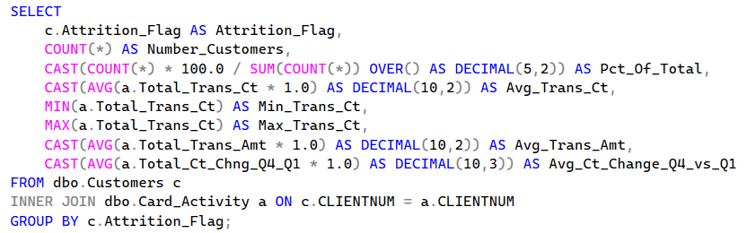
- The overall churn rate is 16.07% (1,627 churned / 8,500 staying).
- Churned customers make far fewer transactions: about 45 transactions and 3,095 USD per year, compared with about 69 transactions and 4,655 USD per year for the staying group.
- The Quarter 4 vs Quarter 1 card swiping momentum of the churned group falls sharply (0.554 compared with 0.742).

Query 2 – Finding the risk threshold by number of card transactions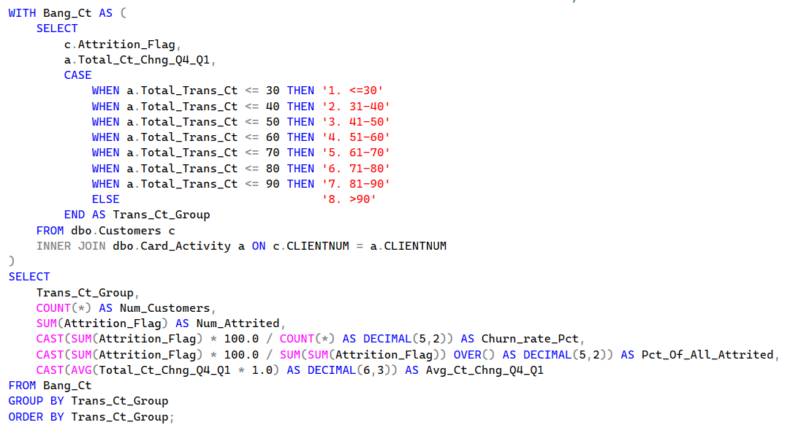
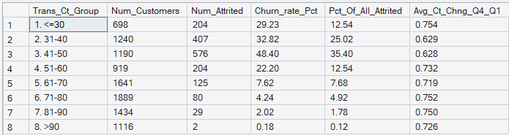
- The churn rate does not rise evenly as the number of card swipes falls: the 41–50 group is the highest (48.40%), higher than the ≤ 30 group (29.23%). The 41–50 group sharply reduces card use at the end of the year (Q4/Q1 = 0.628), while the ≤ 30 group uses the card little but steadily (Q4/Q1 = 0.754).
- The level of 60 swipes per year (about 5 per month) is the boundary: the ≤ 60 range contains 85.50% of all churned customers, while from 61 swipes upward the churn rate is only 3.88%.
- Limitation: if customers are filtered only by ≤ 60 swipes, the actual churn rate reaches only 34.37% (about 2/3 are false alarms), so this must be combined with more variables, as in Query 3.

Query 3 – Testing 5 supporting signals
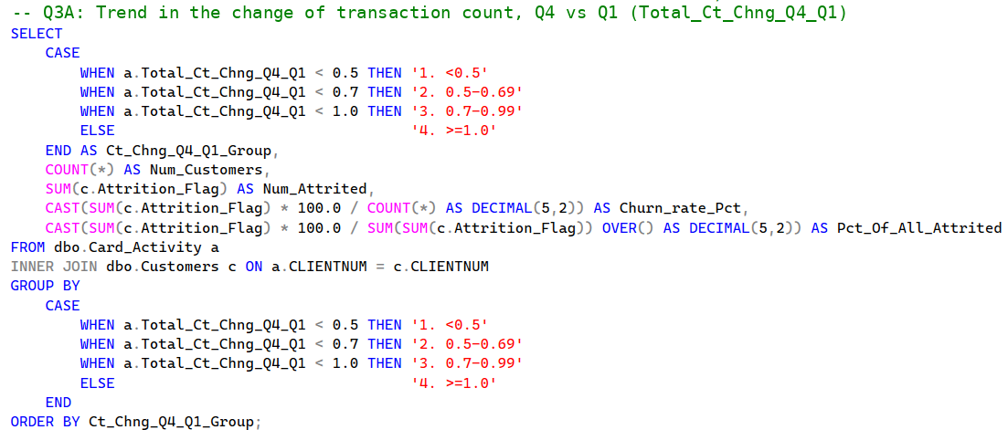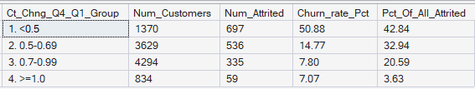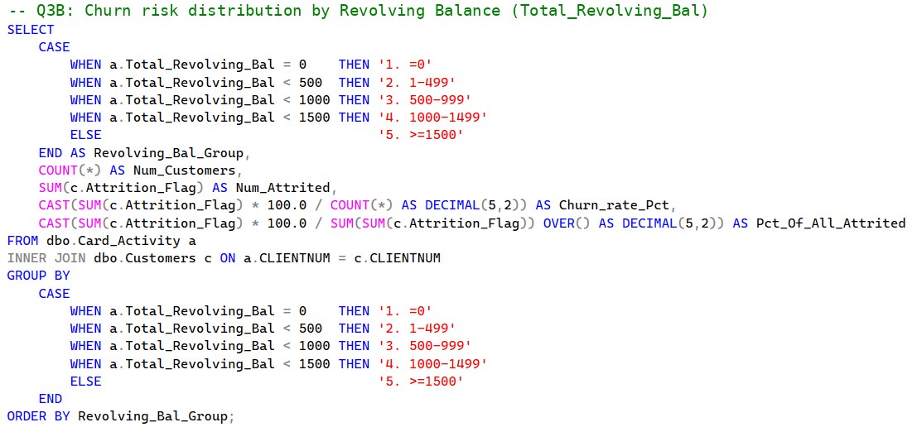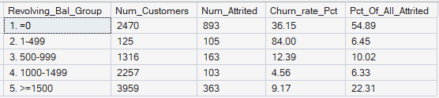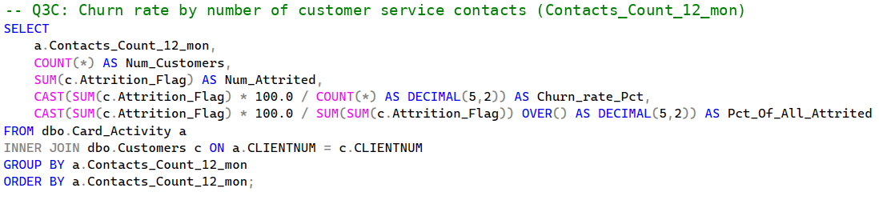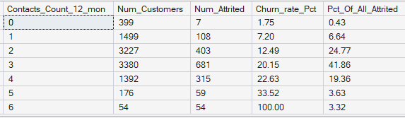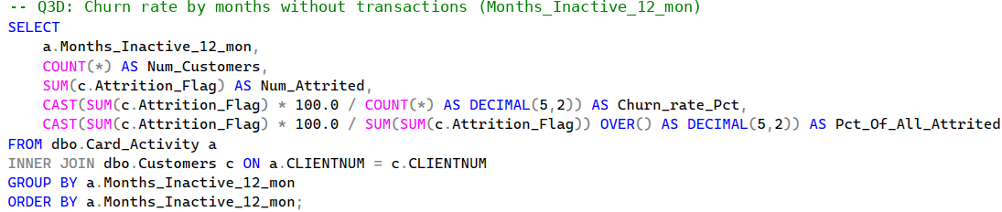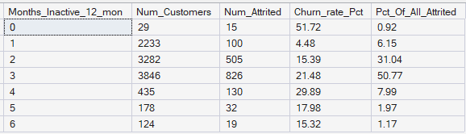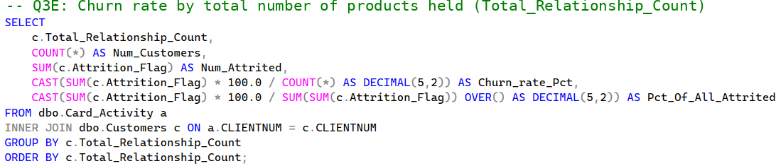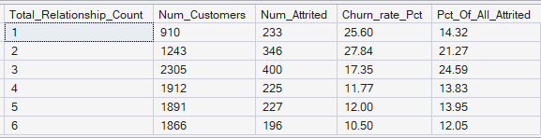

- Decline in transactions Q4/Q1 (3A): The group < 0.5 has a churn rate of 50.88% and accounts for 42.84% of all churned customers; the group ≥ 0.7 is very safe (about 7–8%).
- Revolving balance (3B): The group with a balance < 500 USD accounts for 61.34% of all churned customers. The group with a balance = 0 accounts for 54.89% of all churn cases but has a rate of only 36.15%, because it also includes good customers who pay their debt on time; the group with a small balance of 1–499 USD has a churn rate of 84.00%.
- Number of customer service calls (3C): From ≥ 3 calls, the churn rate rises to about 20% – 33%; all 54/54 customers who called 6 times churned (100%).
- Months without transactions (3D): The risk is concentrated at 3–4 months (58.76% of all churned customers). The level of 0 months (51.72%) has only 29 people, so it is not representative; the level of 6 months drops to 15.32%.
- Number of products used (3E): Customers who use 1–2 products churn more often (25.6% – 27.8%); from 3 products upward, the rate falls to 10.5% – 17.3%.

Query 4 – Overall risk scoring (Risk Score 0–6)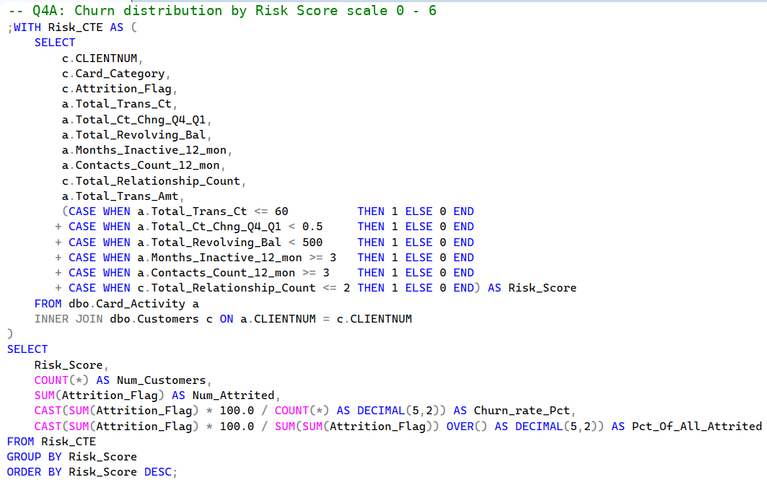
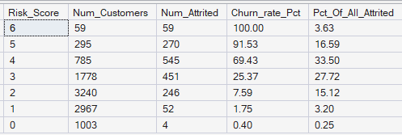
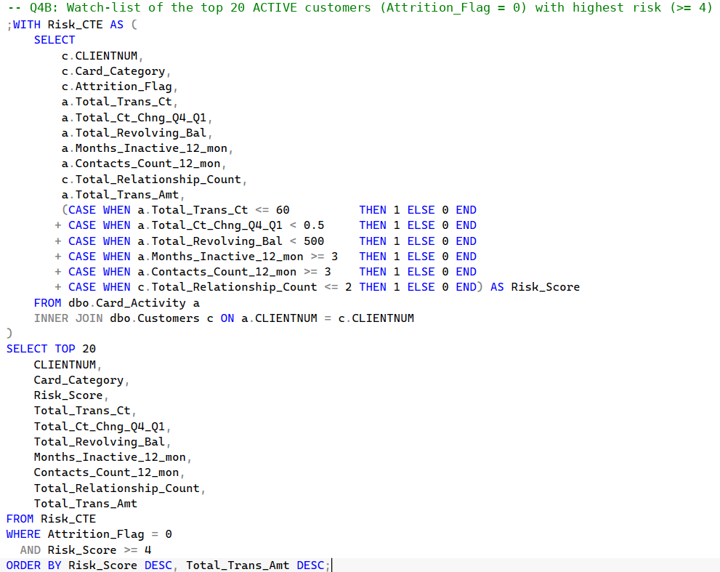
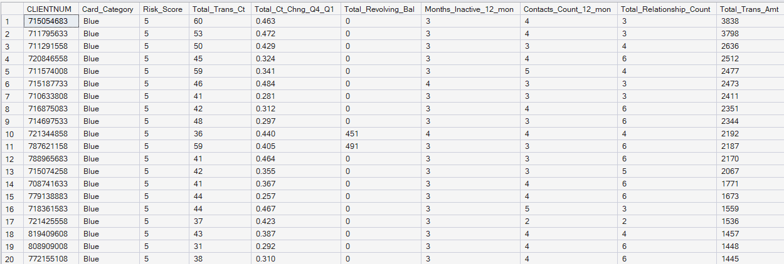
- The higher the score, the more clearly the real churn rate rises: below 2% at 0–1 points and 85% – 100% at 5–6 points. The score scale solves the problem of false alarms that occurs when only one variable is considered.
- Business meaning: the group with ≥ 4 points is a priority for customer care calls (Query 4B sorts them by the largest spending); the group with 3 points receives automatic offers; the group with ≤ 2 points keeps normal care.

2. Python Data Analysis
The group used Pandas (groupby, agg, corr, value_counts) and NumPy (checking for finite values) in data_clean.ipynb and EDA.ipynb.

Key Findings
Comparison of the two customer groups (groupby Attrition_Flag, combining mean/median):
Variable | Staying – Mean | Staying – Median | Churned – Mean | Churned – Median
Total_Trans_Ct | 68.67 | 71 | 44.93 | 43
Total_Trans_Amt | 4,654.66 | 4,100 | 3,095.03 | 2,329
Total_Ct_Chng_Q4_Q1 | 0.74 | 0.72 | 0.55 | 0.53
Total_Amt_Chng_Q4_Q1 | 0.77 | 0.74 | 0.69 | 0.70
Total_Revolving_Bal | 1,256.60 | 1,364 | 672.82 | 0
Avg_Utilization_Ratio | 0.30 | 0.21 | 0.16 | 0.00
Credit_Limit | 8,726.88 | 4,643.5 | 8,136.04 | 4,178
Total_Relationship_Count | 3.91 | 4 | 3.28 | 3
Months_Inactive_12_mon | 2.27 | 2 | 2.69 | 3
Contacts_Count_12_mon | 2.36 | 2 | 2.97 | 3

Pearson correlation with Attrition_Flag (correlation matrix of 14 numerical variables):
Variable | Coefficient r | Direction of Effect
Total_Trans_Ct | −0.3714 | More transactions, less churn
Total_Ct_Chng_Q4_Q1 | −0.2901 | The more end-of-year transactions decline, the more likely to churn
Total_Revolving_Bal | −0.2631 | The lower the balance, the more likely to churn
Avg_Utilization_Ratio | −0.1784 | The less of the limit is used, the more likely to churn
Total_Trans_Amt | −0.1686 | The lower the spending, the more likely to churn
Total_Relationship_Count | −0.1500 | More products used, less churn
Total_Amt_Chng_Q4_Q1 | −0.1311 | A decline in end-of-year spending increases churn
Months_Inactive_12_mon | +0.1524 | The longer the card is not used, the more likely to churn
Contacts_Count_12_mon | +0.2045 | The more calls to the call center, the more likely to churn
Credit_Limit / Avg_Open_To_Buy | −0.0239 / −0.0003 | Almost unrelated
Customer_Age / Months_on_book / Dependent_count | +0.0182 / +0.0137 / +0.0190 | Almost unrelated

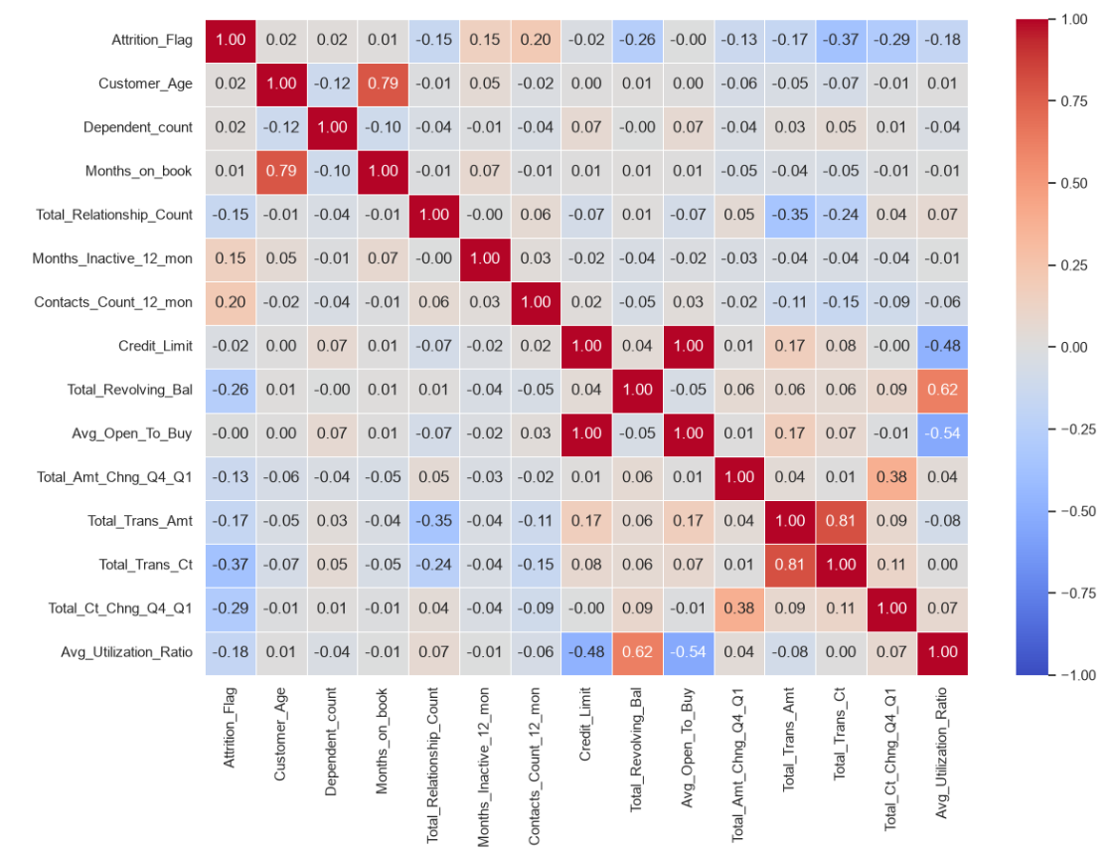

Non-obvious Insights
- Averages hide the difference: The median revolving balance of the churned group is 0 USD compared with 1,364 USD for the staying group; this difference is much clearer than the difference in means (672.82 compared with 1,256.60 USD).
- The churn rate is not monotonic: The group with 41–50 swipes churns more than the group with ≤ 30 swipes (48.40% compared with 29.23%); the level of 6 months without transactions is lower than the level of 3–4 months. The risk comes from customers who are reducing their card use, not from customers who have always used the card little.
- The credit limit does not predict churn: Credit_Limit (r = −0.02) and Avg_Open_To_Buy (r = −0.00) are almost unrelated to churn, while card usage behavior has a clear correlation.
- Demographics are not the cause: Age, months on book, number of dependents, gender, education, marital status, income, and card category all stay close to the level of 16.07%.
- Cross-correlation: Total_Trans_Ct and Total_Trans_Amt have r = 0.81. The group keeps both variables for the tree-based model so that it can distinguish the average spending per card swipe.

3. Data Visualization with Python

3.1. Graphic Libraries Application
- Static visualization: Seaborn (countplot, barplot, kdeplot, scatterplot, heatmap) and Matplotlib (titles, reference lines, formatting) in EDA.ipynb and ML.ipynb.

3.2. Visualization Catalog and Technical Compliance
Figure | Chart Type | Content | Source
1 | Bar (countplot) | Distribution of Attrition_Flag | EDA.ipynb
2 | Bar ×5 + 16.07% reference line | Churn rate by Gender, Education_Level, Marital_Status, Income_Category, Card_Category | EDA.ipynb
3 | Heatmap | Correlation matrix of 14 numerical variables + Attrition_Flag | EDA.ipynb
4 | KDE ×2, Bar | Customer_Age, Months_on_book (KDE); Dependent_count (Bar) | EDA.ipynb
5 | KDE (distribution) | Total_Trans_Ct by churned/staying group | EDA.ipynb
6 | Scatter | Total_Trans_Ct and Total_Trans_Amt, colored by Attrition_Flag | EDA.ipynb
7 | KDE | Total_Ct_Chng_Q4_Q1 by group | EDA.ipynb
8 | KDE | Total_Revolving_Bal by group | EDA.ipynb
9 | Bar ×3 | Churn rate by Contacts_Count_12_mon, Months_Inactive_12_mon, Total_Relationship_Count | EDA.ipynb
10 | Heatmap | Confusion matrix of Random Forest | ML.ipynb
11 | Horizontal Bar | Importance of the 9 features | ML.ipynb

The group used KDE (density distribution) instead of Histogram, and did not use a Line Chart because the data do not contain a continuous time series. Charts split by Attrition_Flag use the color pair blue = staying (0) and orange = churned (1).

3.3. Visual Interpretation and Chart Breakdown

Figure 1 – Distribution of staying and churned customers
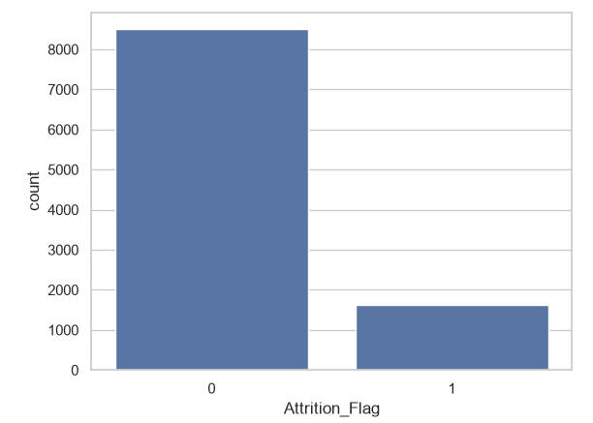
There are 8,500 staying customers (83.93%) and 1,627 churned customers (16.07%), a ratio of 5.22 : 1. A model that predicts "staying" for everyone would still reach 83.93% Accuracy but would miss 100% of the customers who cancel their cards. For this reason, the group evaluates the model with Recall and F1-Score. The chart shows the real scale of the problem in Chapter I: about 1 in every 6 customers churns.

Figure 2 – Churn rate by categorical attributes
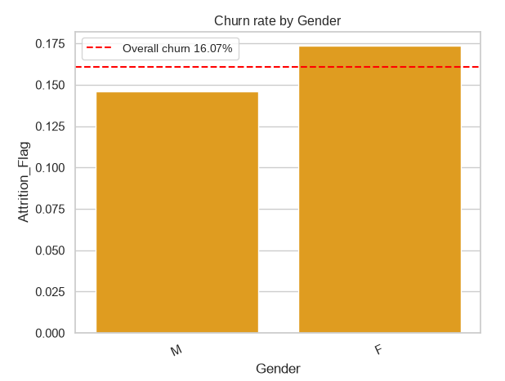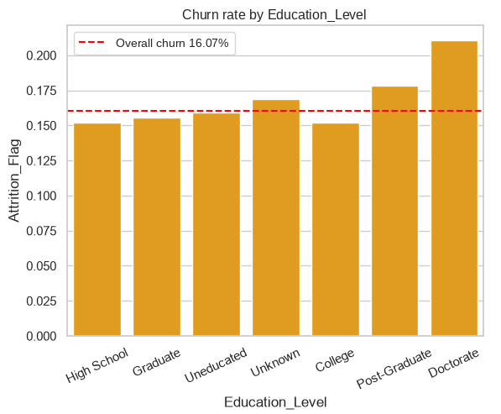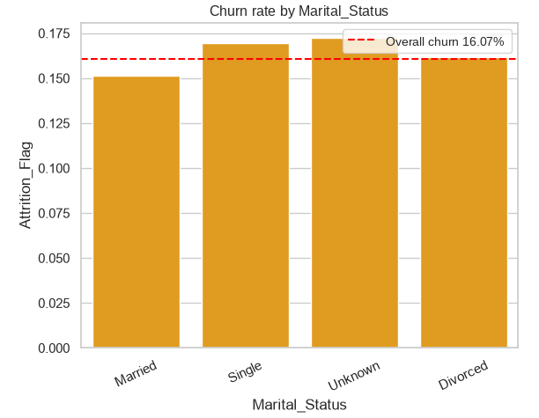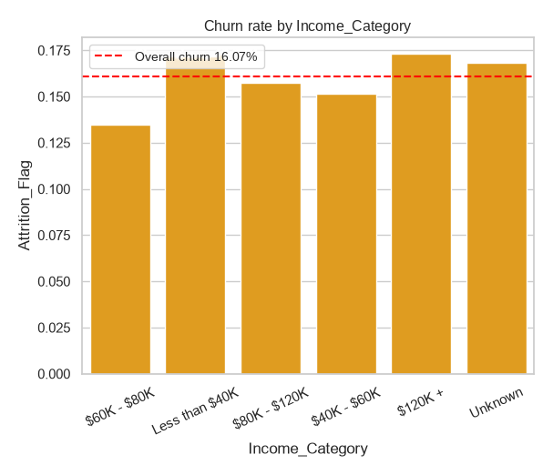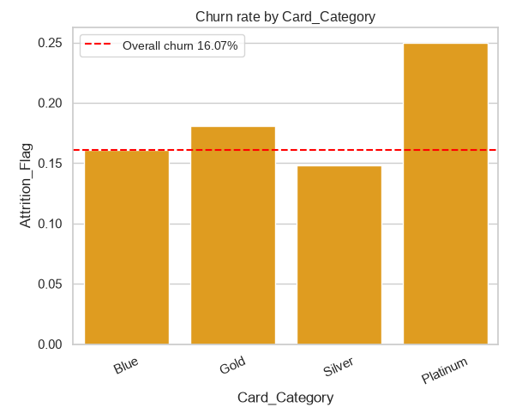
The churn rate of most groups stays close to the average line of 16.07%: Female 17.36% compared with Male 14.62%; marital status 15.13% – 17.22%; income below 40K USD (17.19%) and above 120K USD (17.33%) are almost equal. The Platinum category reaches 25% but has only 20 customers (5 churned), so it is not representative. These variables do not help to distinguish customers who are about to cancel their cards, so the group removed the 5 categorical variables from the model. The cause of churn therefore lies in card usage behavior, not in the customer profile.

Figure 3 – Correlation matrix
The strongest negative correlations with churn are Total_Trans_Ct (−0.37), Total_Ct_Chng_Q4_Q1 (−0.29), Total_Revolving_Bal (−0.26), and Avg_Utilization_Ratio (−0.18); the positive correlations are Contacts_Count_12_mon (+0.20) and Months_Inactive_12_mon (+0.15). Age, months on book, and number of dependents have |r| < 0.02. The churn signal lies in the intensity of card use and the decline in card use, so the bank needs to monitor these behavior variables instead of demographics.

Figure 4 – Demographic variables
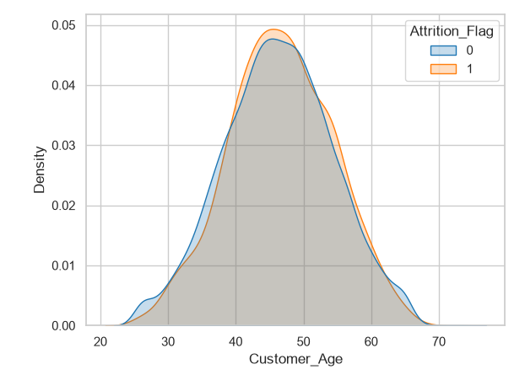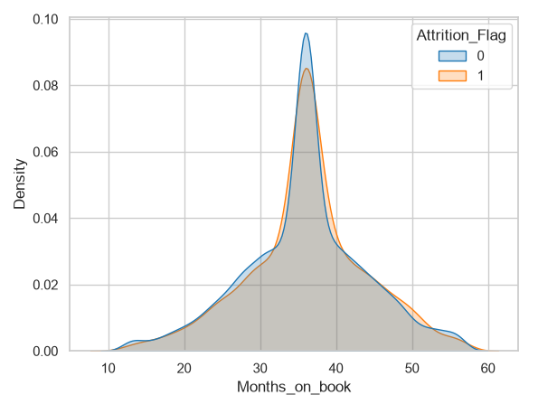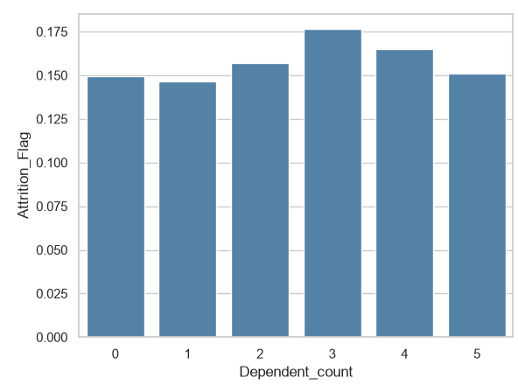
The age distributions of the two groups overlap closely (median 46 compared with 47 years), months on book have the same median of 36 months, and the churn rate by number of dependents varies around 15% – 17%. These three variables do not increase or decrease the risk of card cancellation. This is the basis for the group to remove all 3 variables from the machine learning model and to keep the behavior variables that are directly related to the churn problem.

Figure 5 – Distribution of total card transactions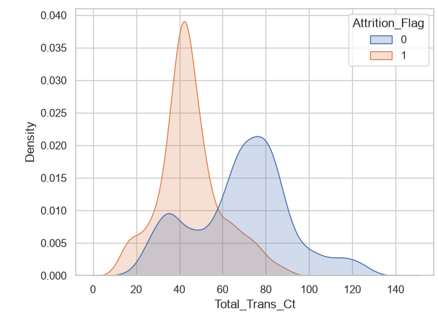

The churned group is concentrated in the range of 40–45 swipes per year (median 43), clearly lower than the staying group (median 71); the two distribution curves cross close to 60 swipes per year (about 5 per month). SQL Query 2 confirms that the ≤ 60 range contains 85.50% of all churned customers. The level of 60 swipes per year can be used as an early warning threshold for the customer retention problem.

Figure 6 – Number of card transactions and total spending
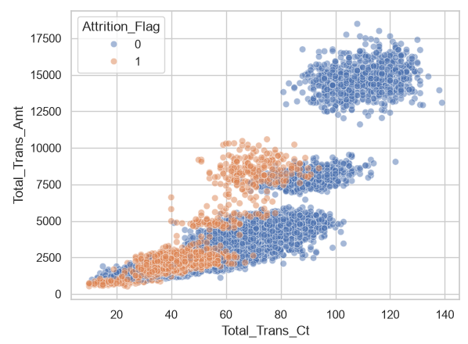
The data split into 3 spending clusters: below 5,000 USD, 5,000–10,000 USD, and above 10,000 USD. Most of the orange points (churned customers) are in the lower left corner: ≤ 60 swipes and spending ≤ 5,000 USD; almost no customer with more than 80 swipes and spending above 10,000 USD cancels the card. High-spending customers stay with the bank, so retention resources should focus on the group with low transactions.

Figure 7 – Change in number of card transactions, Quarter 4 vs Quarter 1
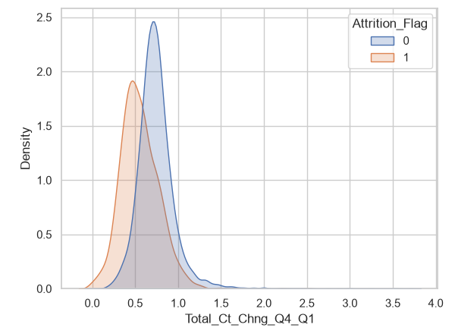
The distribution of the churned group is skewed to the left with a peak around 0.53 (mean 0.55), while the staying group peaks around 0.72 (mean 0.74). SQL Query 3A shows that the group < 0.5 has a churn rate of 50.88% and accounts for 42.84% of all churned customers. Customers who sharply reduce their card swiping during the year show a warning sign before canceling the card, so the bank has time to intervene.

Figure 8 – Distribution of revolving balance
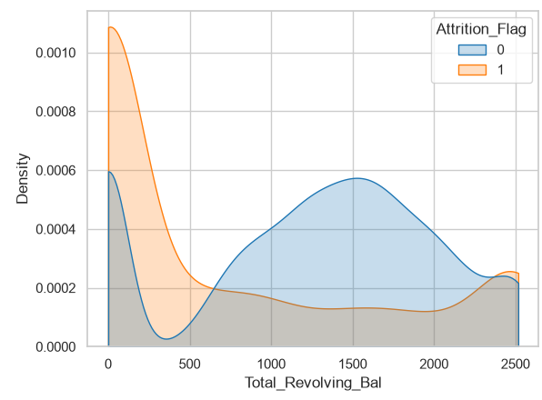
The churned group rises very high at 0 USD (median 0 USD) and is low above 500 USD; the staying group is concentrated at 800–1,800 USD (median 1,364 USD). The group with a balance < 500 USD accounts for 61.34% of churned customers, which reflects the settling of debt before canceling the card. However, the group with a balance = 0 has a churn rate of only 36.15% because it also includes customers who pay their debt on time, so this variable must be combined with other variables (such as the Risk Score).

Figure 9 – Number of customer service calls, months of inactivity, and number of products used
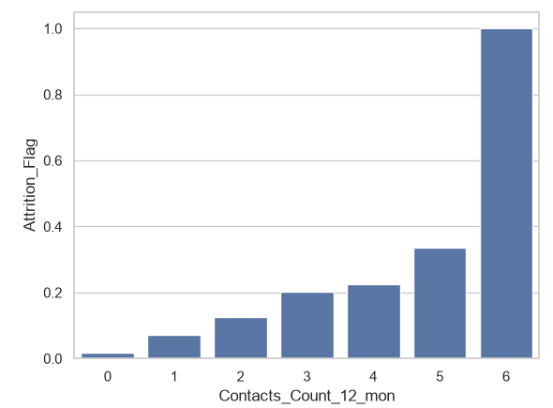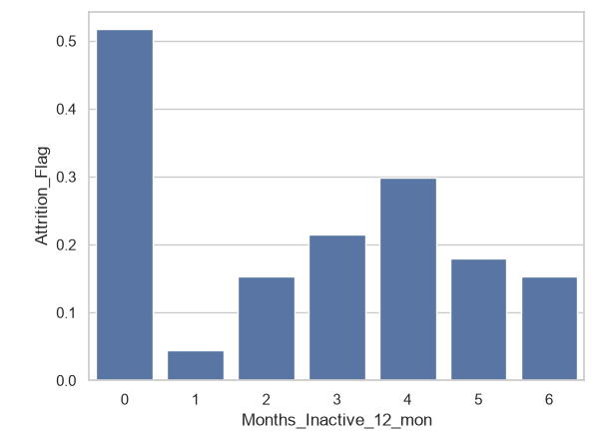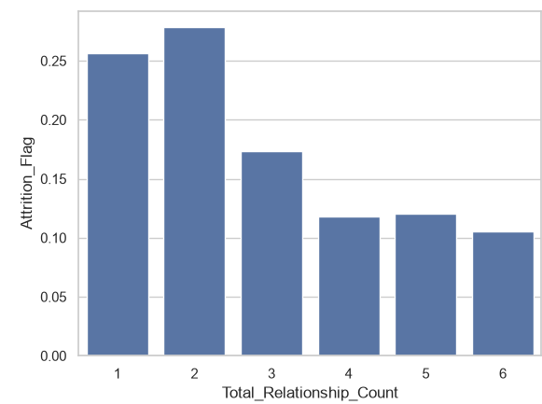
Customers who called the call center 3 or more times have a churn rate above 20% – 33%, and all 54/54 customers who called 6 times canceled their cards. Customers who stopped using the card for 3–4 months have a churn rate of 21.48% – 29.89% and account for 58.76% of all churn cases. Customers who use 1–2 products churn at 25.60% – 27.76%, compared with 10.56% – 17.35% when they use 3 or more products. Frequent calls to the call center, card inactivity, and a low number of products are warning signals that customer care can monitor immediately.

IV. REGRESSION ANALYSIS AND MACHINE LEARNING PREDICTION

1. Model Building
- Algorithm: Random Forest Classifier (a binary classification problem: churn = 1, staying = 0), using the scikit-learn library.
- Data split: Train/Test = 80/20, stratify=y, random_state=42. The Train set has 8,101 customers (churn rate 16.07%); the Test set has 2,026 customers (churn rate 16.04%).
- Hyperparameters: n_estimators=200 (200 trees), max_depth=8 (limit on tree depth), class_weight="balanced" (handles the imbalance of 5.22 : 1).

Input Features (9 Features) and Selection Rationale
Variable | r with Target | Reason for Keeping
Total_Trans_Ct | −0.3714 | Strongest correlation; 60 swipes per year is the risk boundary
Total_Trans_Amt | −0.1686 | Reflects spending; kept together with Total_Trans_Ct (r = 0.81) so that the decision trees can separate the average spending per swipe
Total_Ct_Chng_Q4_Q1 | −0.2901 | End-of-year decline in transactions
Total_Amt_Chng_Q4_Q1 | −0.1311 | End-of-year change in spending amount
Total_Revolving_Bal | −0.2631 | A low or zero balance is linked to settling the debt before canceling the card
Avg_Utilization_Ratio | −0.1784 | Credit limit utilization
Total_Relationship_Count | −0.1500 | Product engagement level
Months_Inactive_12_mon | +0.1524 | Time of card inactivity; high risk at 3–4 months
Contacts_Count_12_mon | +0.2045 | Number of call center calls; risk rises from 3 calls

11 removed columns: CLIENTNUM (identifier); Credit_Limit and Avg_Open_To_Buy (correlation close to 0); the 5 categorical text variables and 3 numerical demographic variables (Customer_Age, Dependent_count, Months_on_book) because they cannot distinguish the two groups (see Figures 2, 3, and 4).

2. Model Evaluation
The evaluation is performed on the Test set (2,026 customers, of which 325 actually churned):
 | Predicted: Staying (0) | Predicted: Churned (1)
Actual: Staying (0) | 1,601 (TN) | 100 (FP)
Actual: Churned (1) | 28 (FN) | 297 (TP)

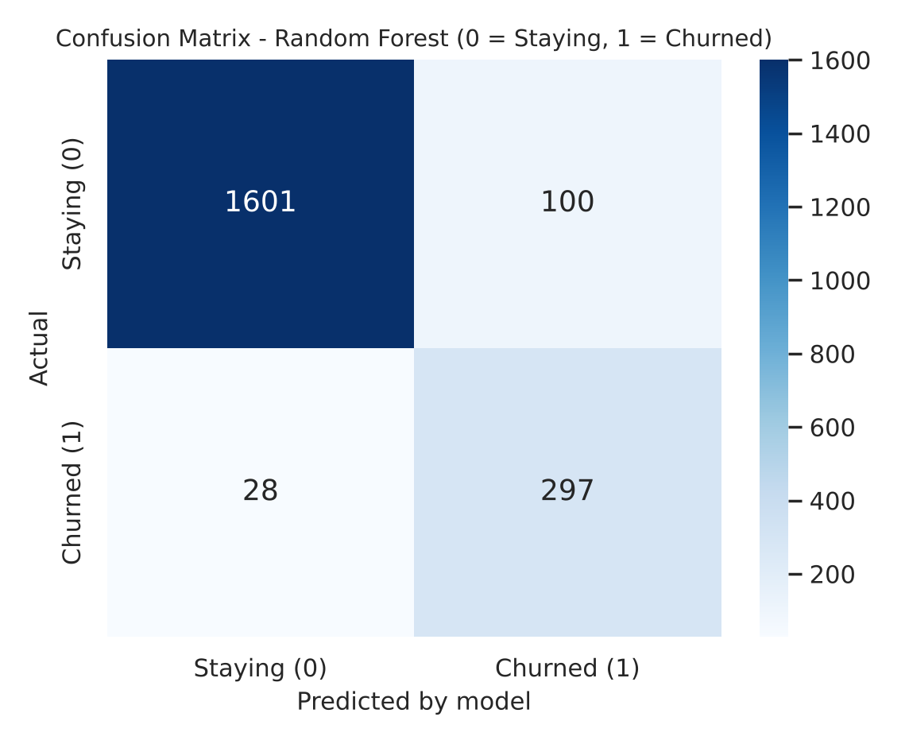
Metric | Value | Description
Accuracy | 93.68% | Correctly predicts 1,898 / 2,026 customers (1,601 staying + 297 churned), wrong for 128 customers
Precision | 74.81% | Of the 397 customers flagged as churn, 297 really churned and 100 stayed
Recall | 91.38% | Correctly catches 297 / 325 churned customers, misses 28
F1-Score | 82.27% | Balance between Precision and Recall

Feature Importance
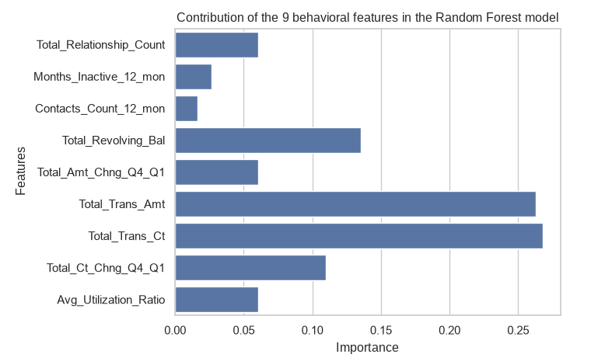
- Total_Trans_Ct and Total_Trans_Amt have the largest contribution, followed by Total_Revolving_Bal and Total_Ct_Chng_Q4_Q1.
- Total_Relationship_Count, Total_Amt_Chng_Q4_Q1, Avg_Utilization_Ratio contribute at a medium level; Months_Inactive_12_mon and Contacts_Count_12_mon contribute the least.
- This order matches the EDA: transaction behavior is the strongest signal.

3. Translating Mathematics to Business Value
- How to read the model: Random Forest has no regression coefficients; the effect of each variable is read through Feature Importance (section IV.2) combined with the thresholds from the EDA/SQL. Customers with few card swipes (≤ 60 per year), a Q4/Q1 swiping momentum < 0.5, and a balance < 500 USD have the highest risk of churn.
- Practical value of the model: It catches 297 / 325 churned customers (Recall 91.38%) and misses only 28. The cost is 100 false alarms; this cost is low if the retention action is an automatic offer.
- Early warning list (watchlist): In the Test set, 100 existing customers are predicted by the model to churn, sorted with the lowest number of card swipes at the top so that customer care can call them first.
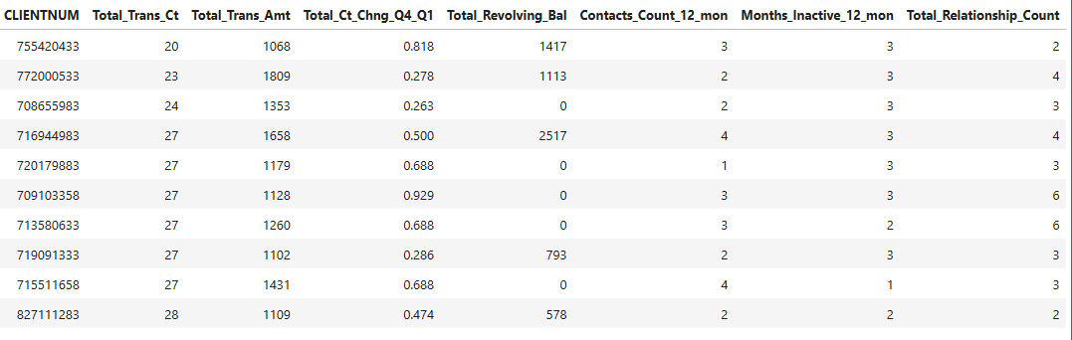
Recommended actions for managers (combined with the Risk Score scale of SQL Query 4):
Group | Condition | Action
Critical | Risk_Score ≥ 4 points or in the watchlist | Customer care calls directly; priority for high-spending customers (Query 4B)
Early warning | Risk_Score = 3 points | Send automatic offers (cashback, annual fee waiver) to encourage customers to use the card again
Safe | Risk_Score ≤ 2 points | Keep the normal reward points program to save cost

- Q4 vs Q1 transactions and months without transactions are early indicators: they should be monitored every month so that the bank can intervene before customers cancel their cards.
- Customers who use 1–2 products churn more (25.6% – 27.8%): it is recommended to encourage customers to use more products (from 3 products upward, the churn rate falls to 10.5% – 17.3%).
- Customers who have called the call center 3 or more times should receive priority complaint handling.

4. Analysis Using a Specialized Tool

4.1. Tool Application and Dashboard Deployment
- Tool selected by the group: Looker Studio.
- Link dashboard: https://datastudio.google.com/reporting/fd74cc8c-6c51-49e4-9766-d792affd1399
- Input data: File BankChurners_clean.csv (10,127 customers after cleaning).
- Components of the "Credit Card Churn Dashboard":
- Filters (dropdown): Months_Inactive_12_mon and Total_Relationship_Count, which allow the whole dashboard to be filtered by months of inactivity and number of products used.
- 4 scorecards: Record Count = 10,127 customers; average Total_Trans_Ct = 64.86; average Total_Revolving_Bal = 1,162.81; Attrition_Flag = 16.07% (churn rate).
- Bar chart of Total_Trans_Ct by Attrition_Flag group: the staying group (0) is clearly higher than the churned group (1).
- Donut chart of customer proportions: 83.9% staying and 16.1% churned.
- Bar chart of churn rate by level of Contacts_Count_12_mon from 0 to 6: the rate rises with the level and reaches 100% at level 6.
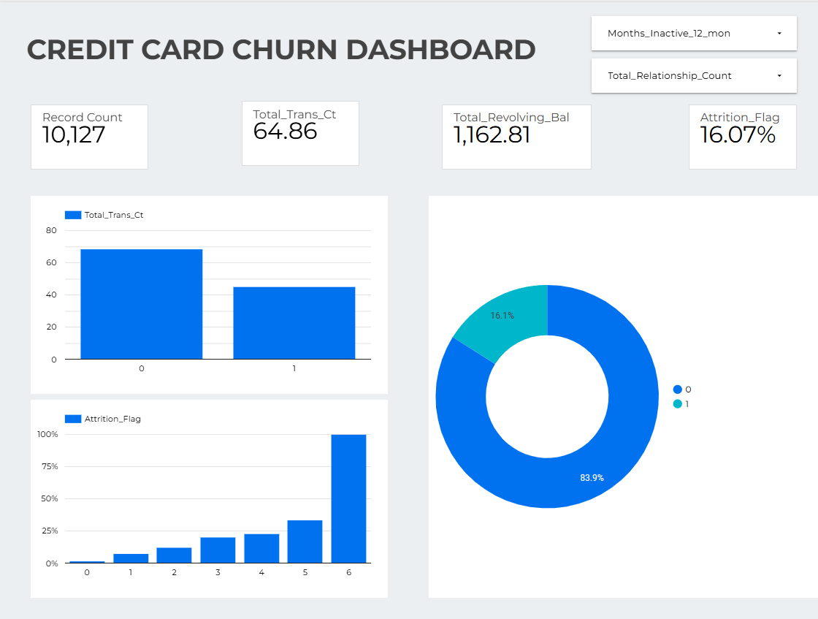
Figure 12 – Credit Card Churn dashboard on Looker Studio
The numbers on the dashboard match the results from Python: 10,127 customers, a churn rate of 16.07%, proportions of 83.93% / 16.07%, and averages of Total_Trans_Ct 64.86 and Total_Revolving_Bal 1,162.81 (EDA sections 1 and 2). In the Total_Trans_Ct bar chart, the staying group is higher than the churned group, which is consistent with the EDA result (68.67 compared with 44.93 transactions). Managers can use the two filters to quickly see the churn rate of each customer group.

4.2. Tool Evaluation and Critical Review
- Usability: Looker Studio runs in the browser, connects directly to CSV files, and creates charts by drag and drop without writing code. The dropdown filters help non-programmers to explore the data by themselves.
- Strengths: Dashboards can be built quickly, the interface is intuitive, and it has interactivity (filtering and hovering to see values) that a static Python notebook does not have. The dashboard is easy to share by link with managers and the customer care team.
- Limitations: The tool is suitable only for displaying and summarizing data; it cannot train the Random Forest model or extract the watchlist. The binary variable Attrition_Flag must have its aggregation type set to average to obtain the churn rate, so the correct aggregation type must be configured for each metric. Its ability to handle complex calculations and to customize charts is also less flexible than Python code.
- Comparison with pure coding (Python/SQL): Python/SQL is more flexible and reproducible, and it is where all the analysis and modeling are carried out. Looker Studio adds value at the presentation step: the results already produced by code are put on a dashboard for end users to view.

