LAB REPORT
Software Project Management



Student Name: Nguyễn Văn Minh
ID: 22003405
Class: DHKTPM18
Course: 2025-2026

Contents
Module 1: 3
Exercise 1: Creating a link 3
Exercise 2: Setting duration 3
Exercise 3: Creating phases 5
Exercise 4: Noah - Linking 7
Exercise 5: Pyramid - Multi level grouping 9
Exercise 6: Creating a plan for Staff Training 11
Exercise 7: Recurring Tasks 13
Exercise 8: Travelling – tasks calendar 14
Module 2: CALENDARS AND SCHEDULING 17
Exercise 1: Part Time - creating new calendar 17
Exercise 2: Changing Working Time 20
Exercise 3: Changing Working Time 24
Exercise 4: Changing Working Time 26
Exercise 5: Create the private Time for a project 28
Exercise 6: My project 31
Module 3: Working with Tasks 33
Exercise 1: Changing Working Time (Start Date Feb 2st 2026) 33
Exercise 2: Changing Working Time (Start Date Feb 2rd 2026) 35
Exercise 3: Scheduling – Task dependencies 37
Module 4: 41
Exercise 1: updating … 41

Module 1:

Exercise 1: Creating a link
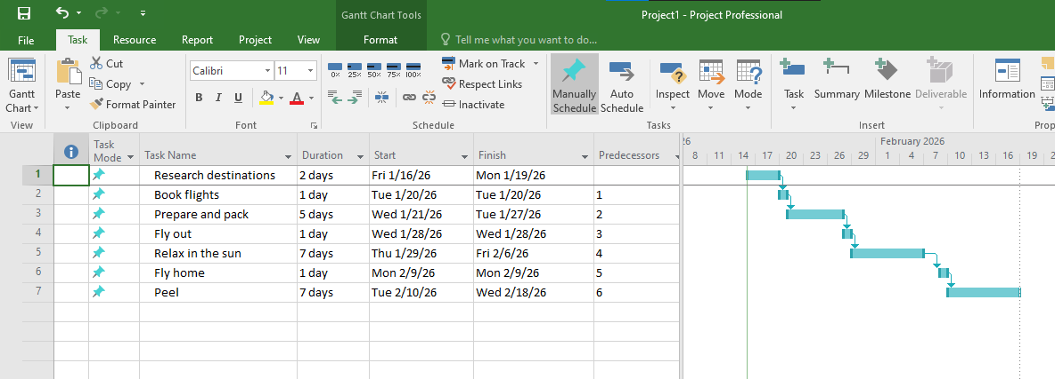

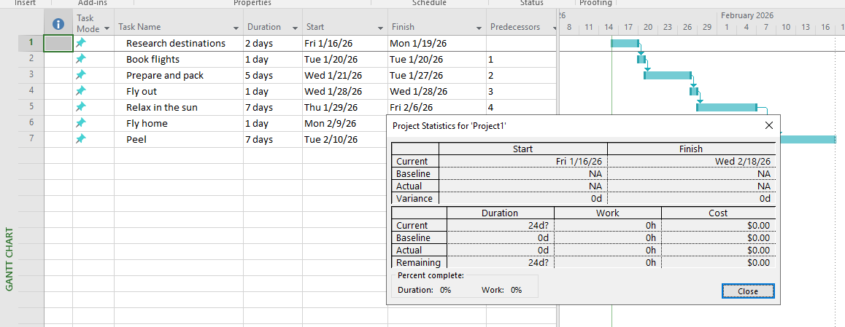
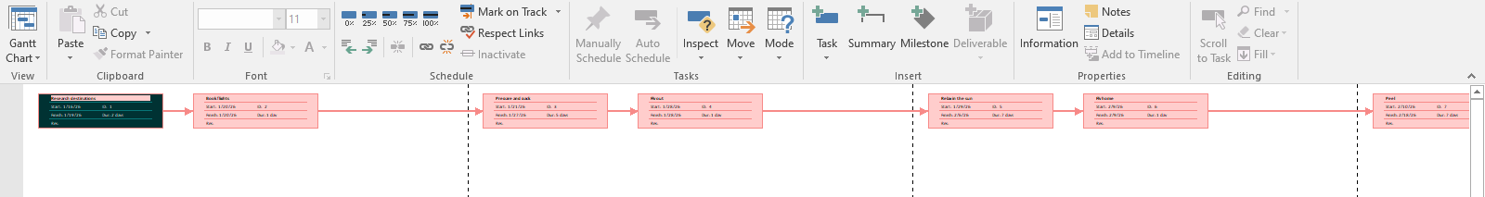

Exercise 2: Setting duration
S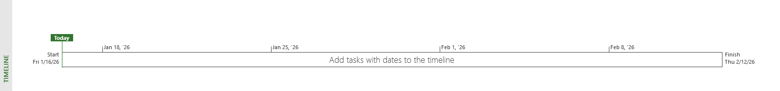

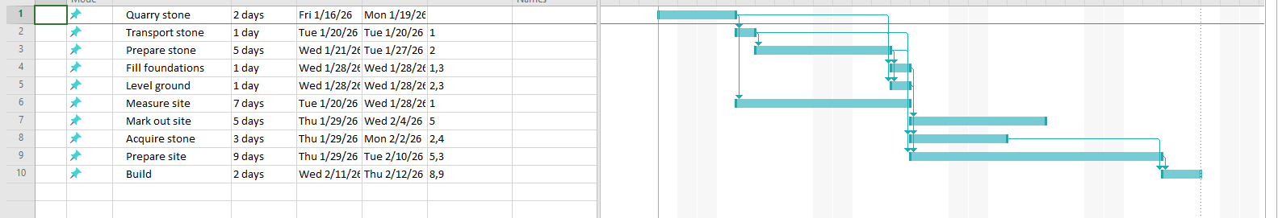
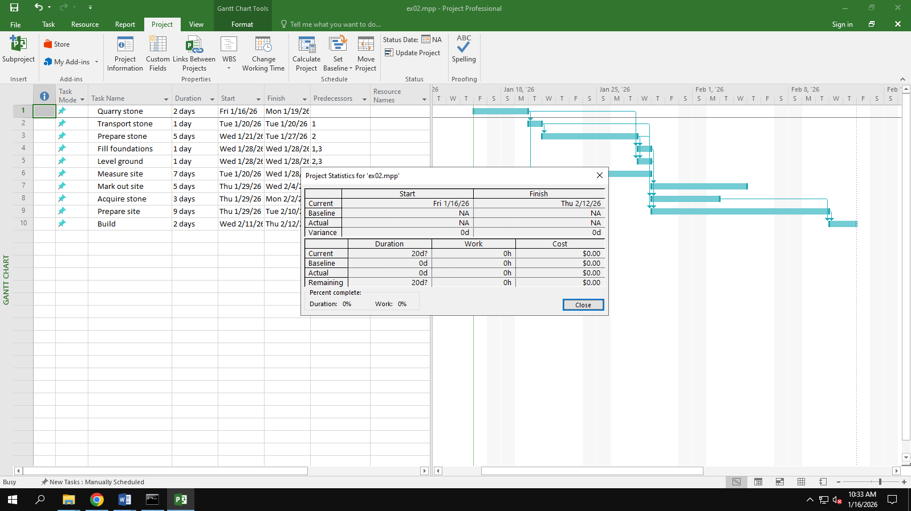
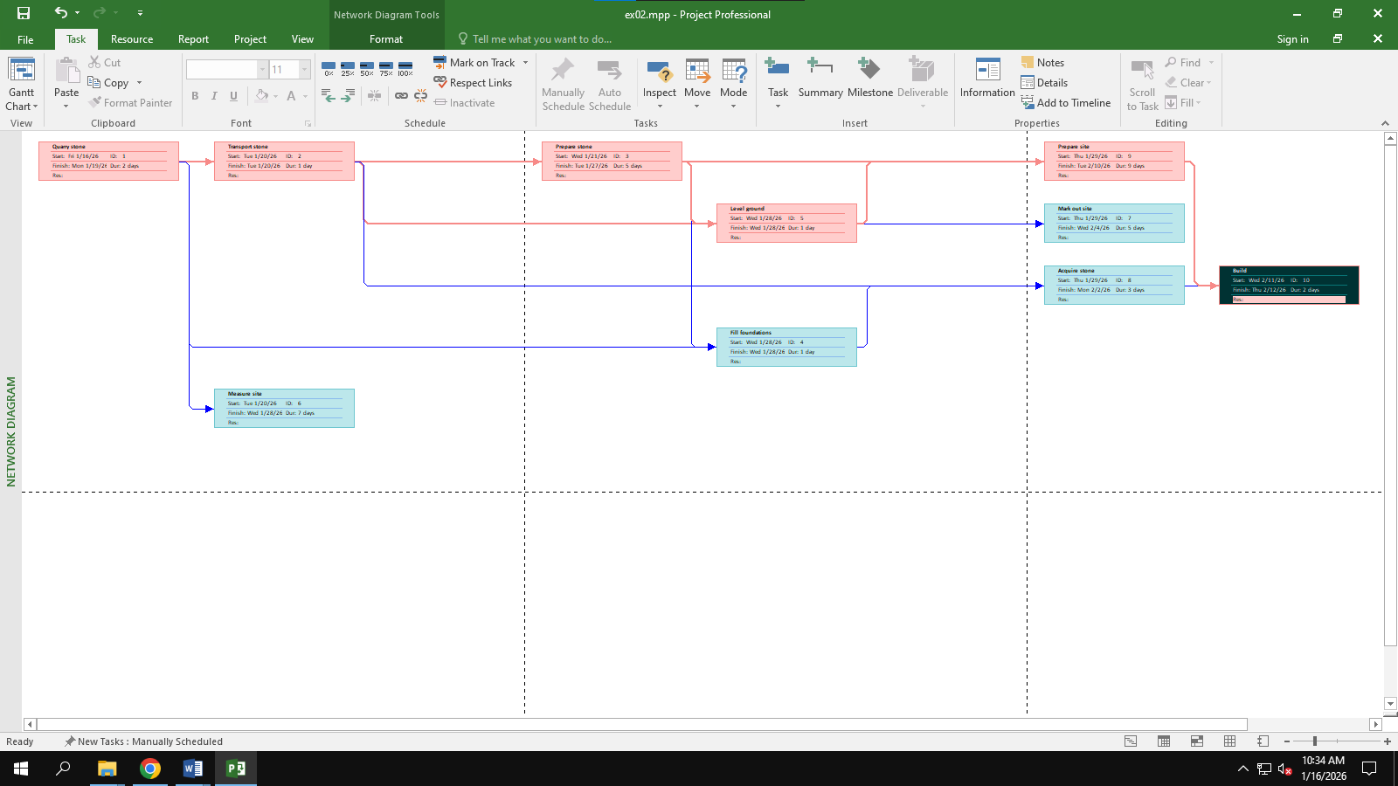

Exercise 3: Creating phases
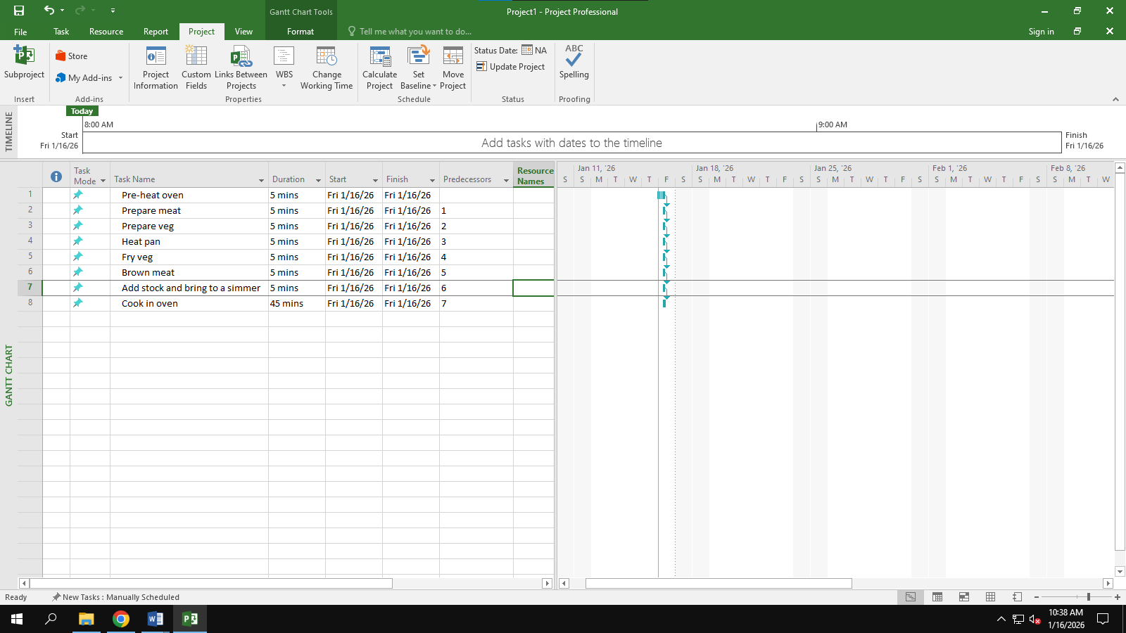
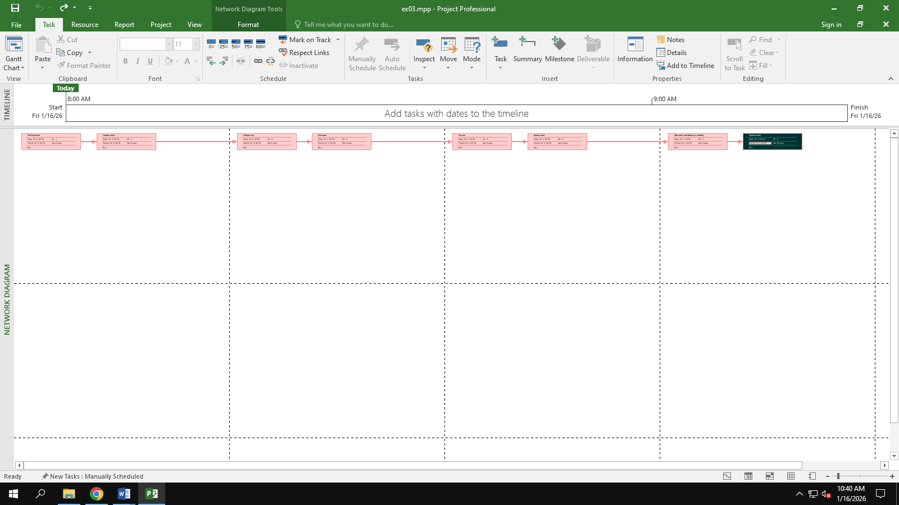
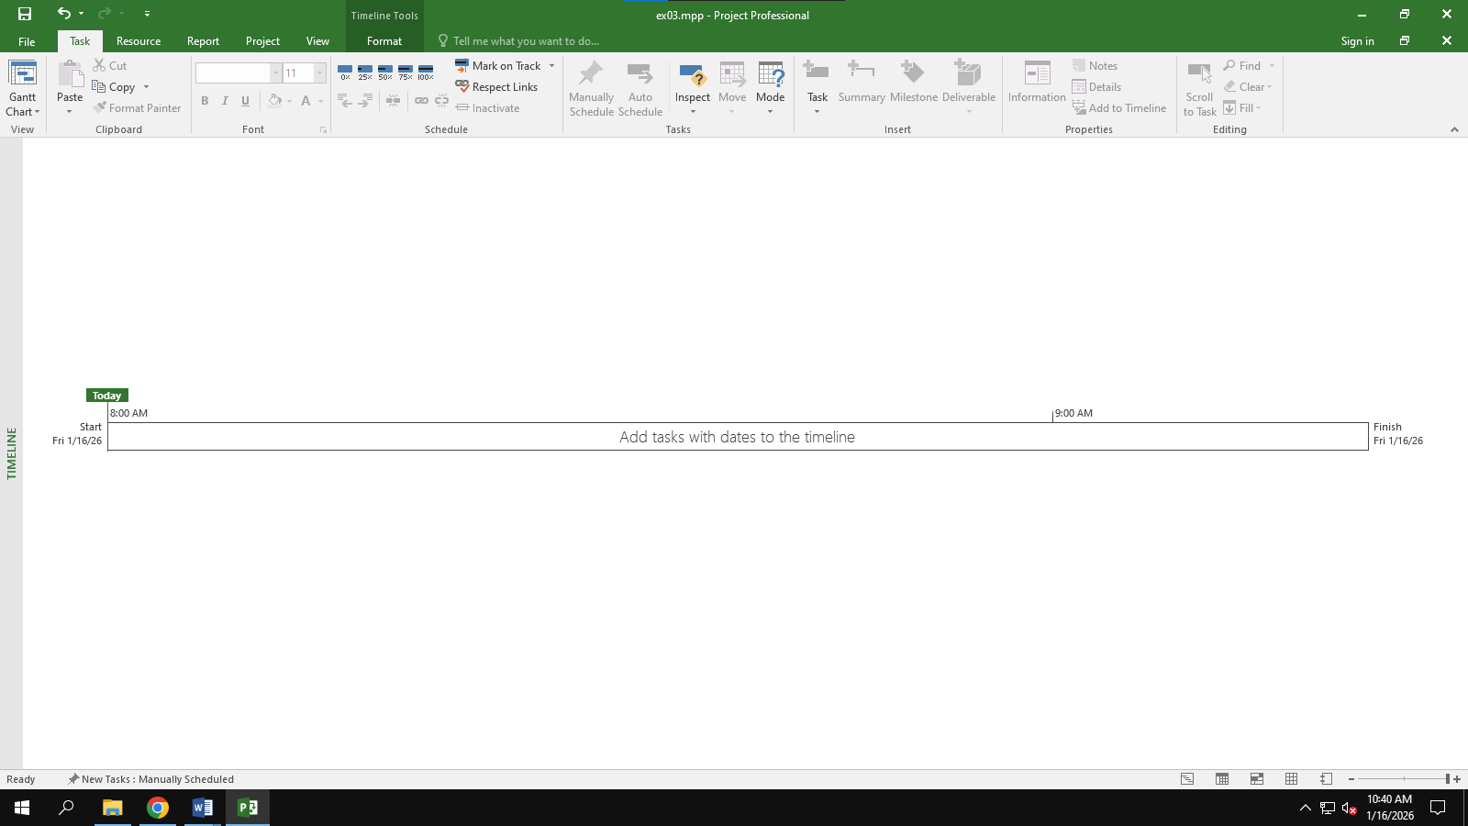
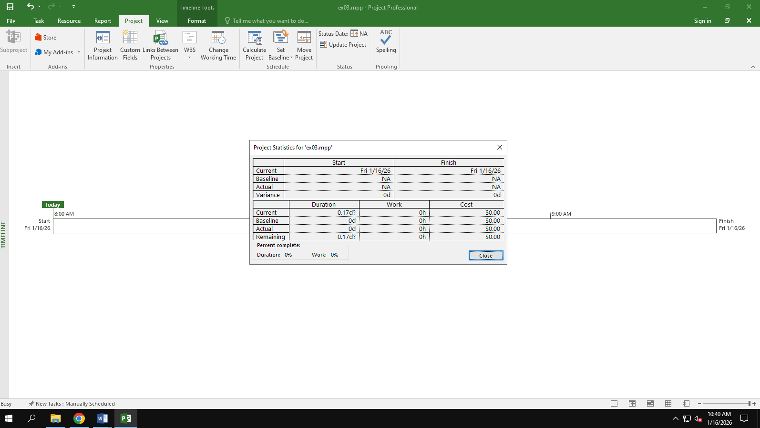

Exercise 4: Noah - Linking
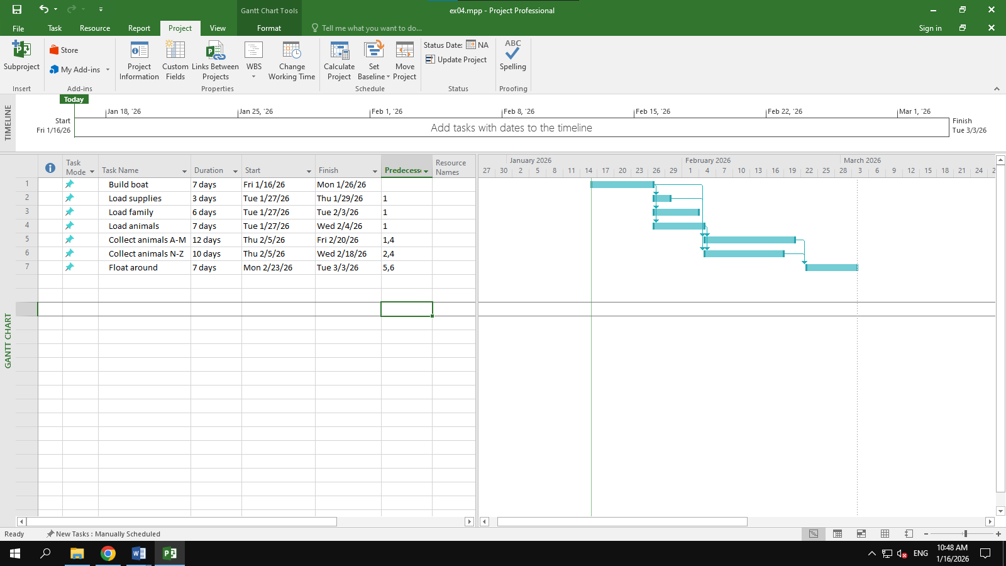
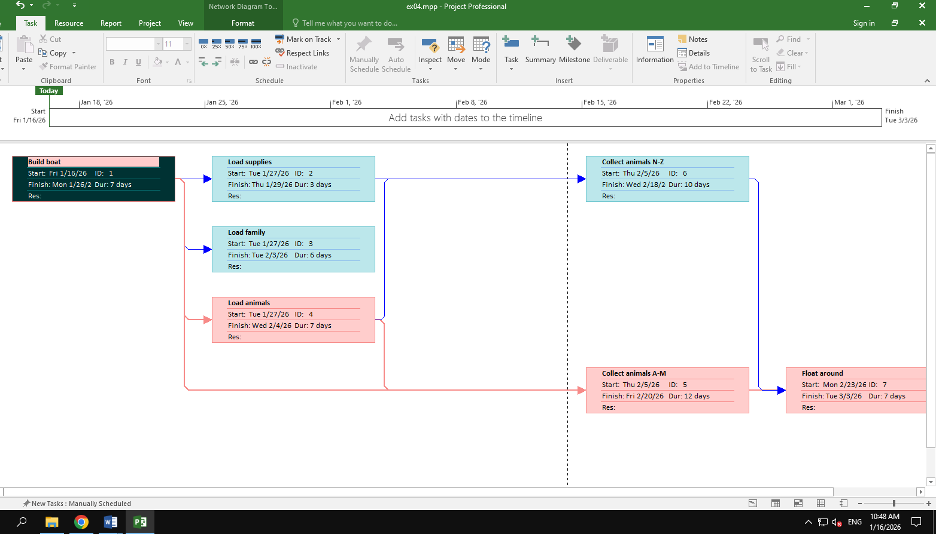
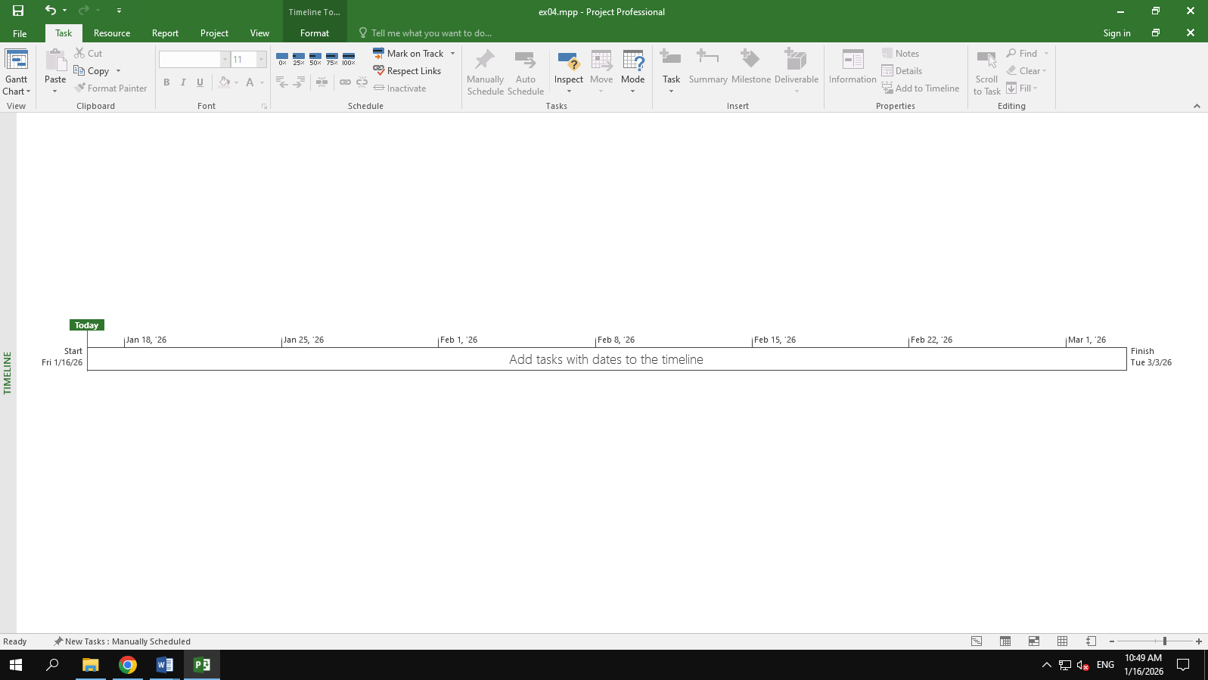
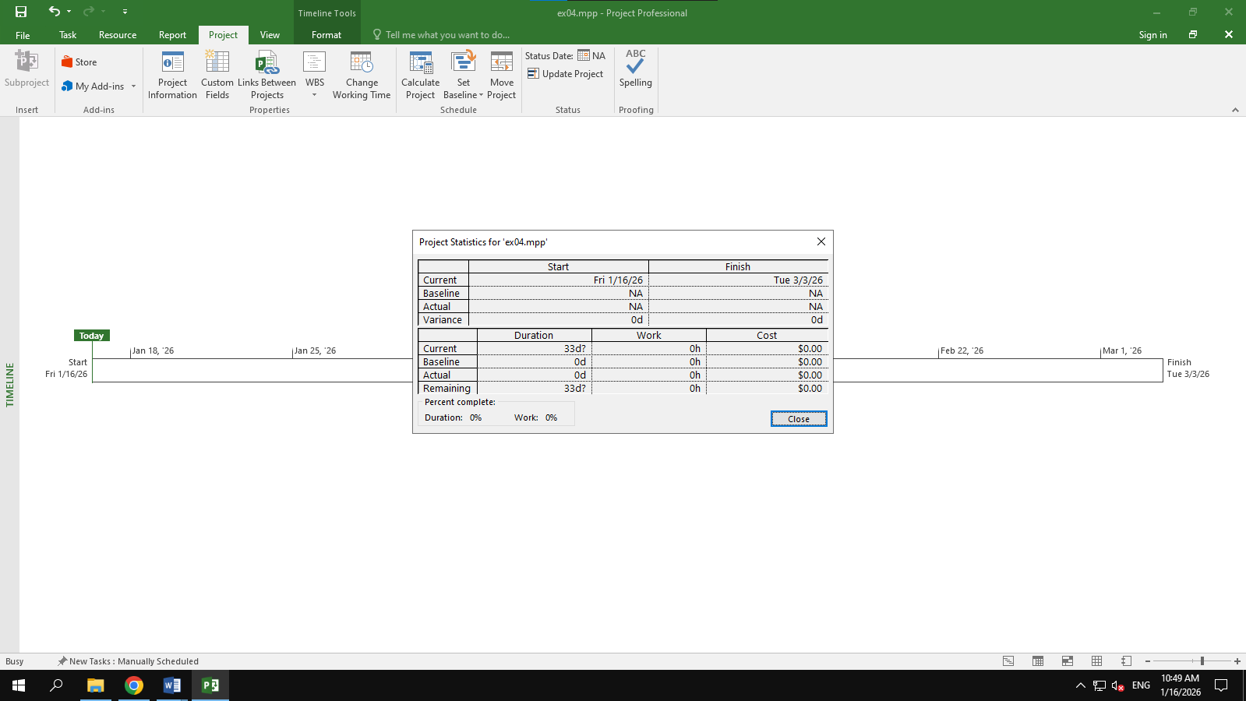

Exercise 5: Pyramid - Multi level grouping
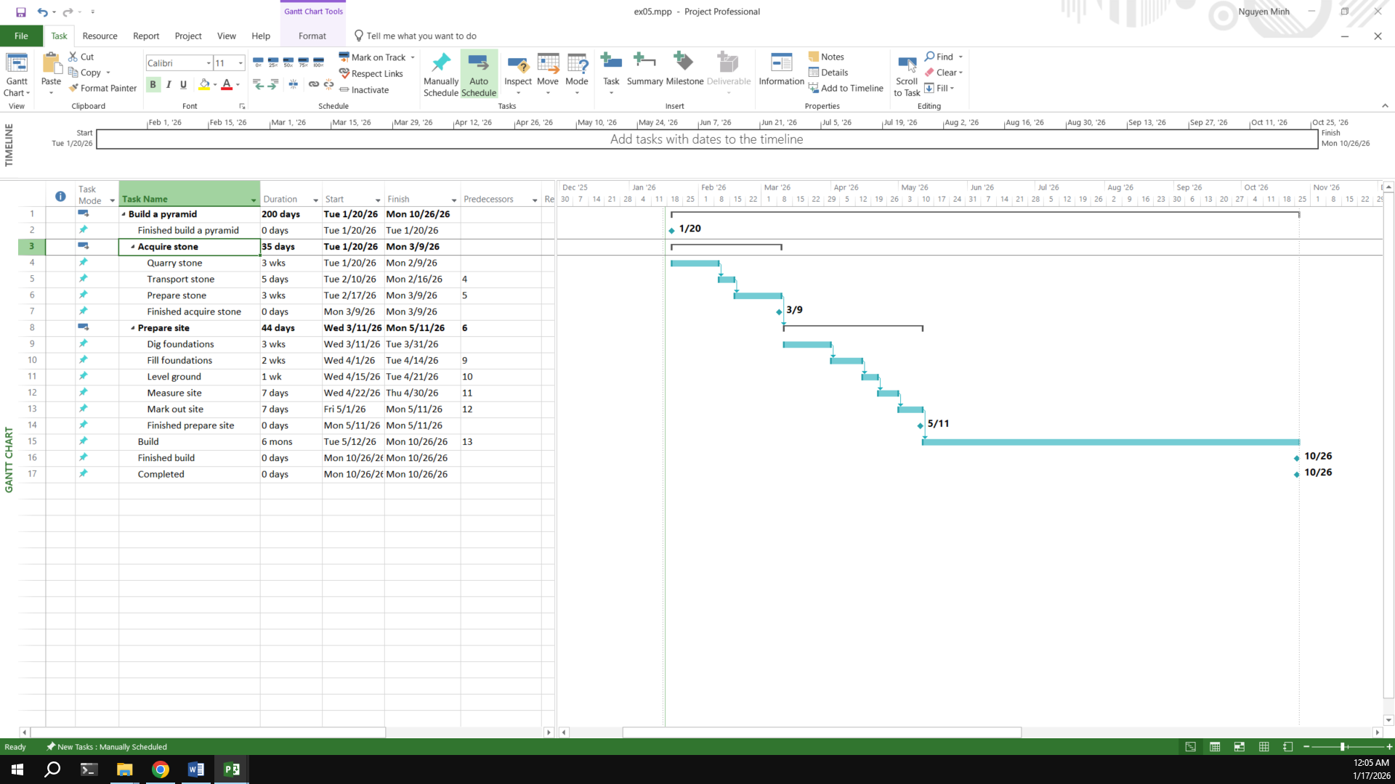
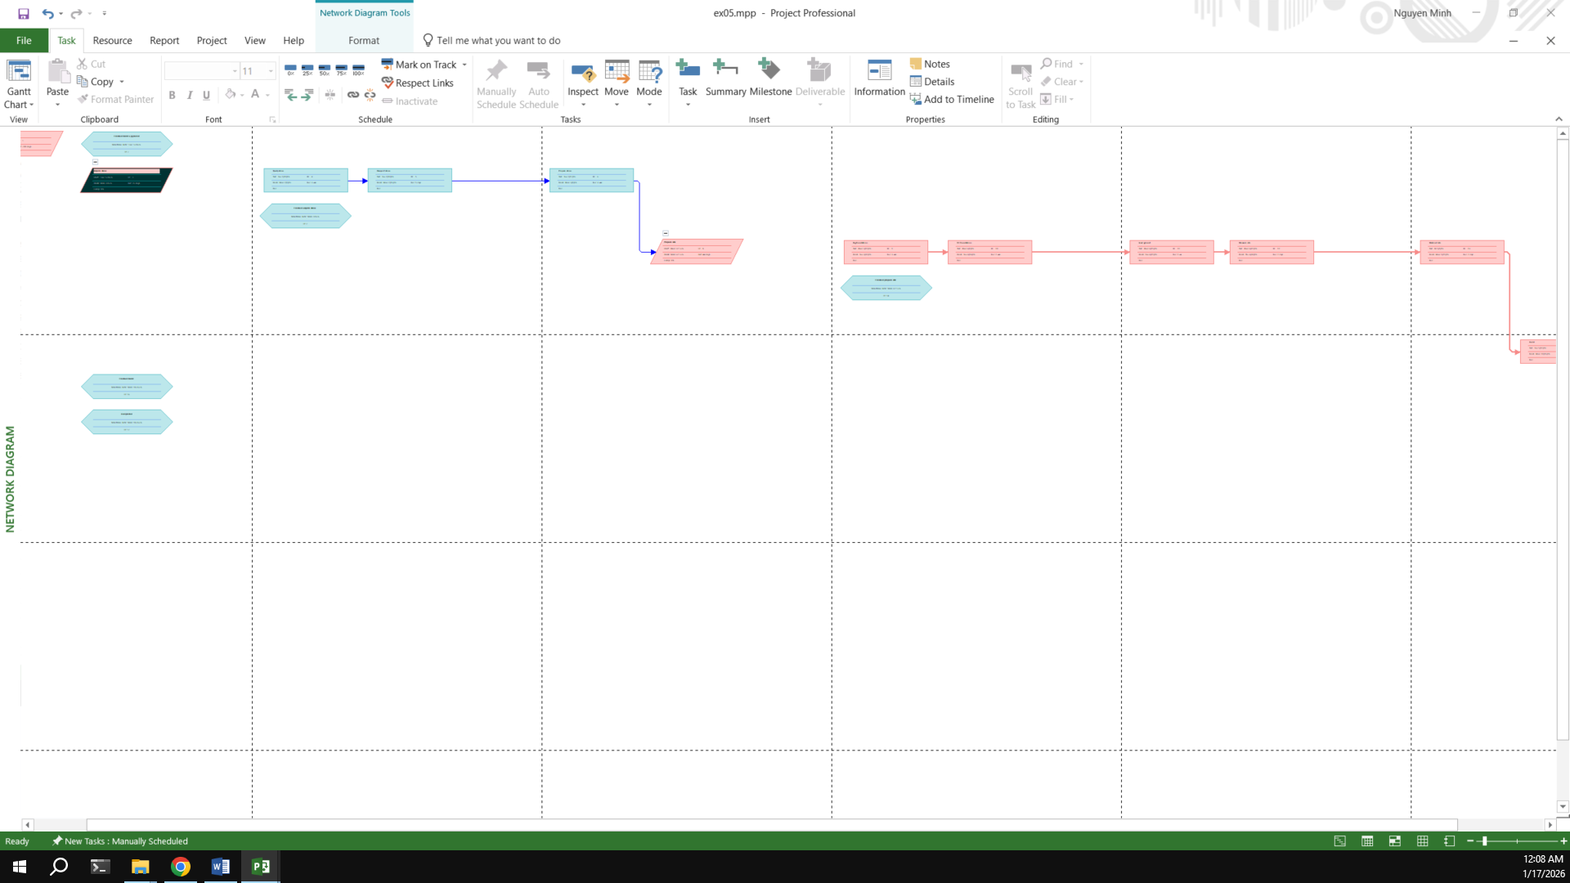
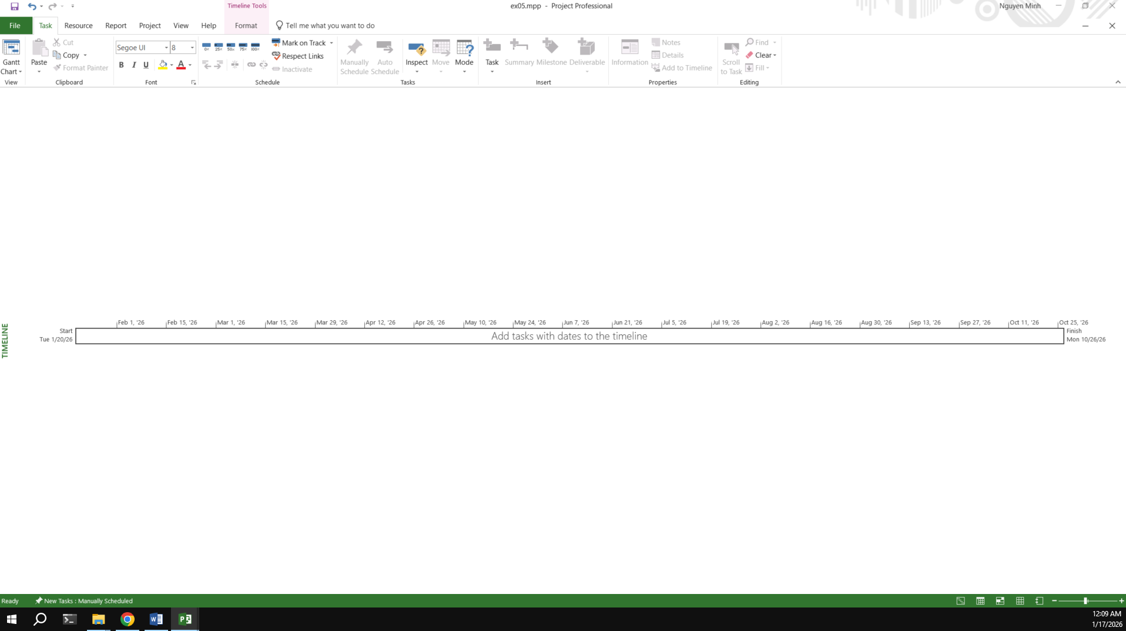
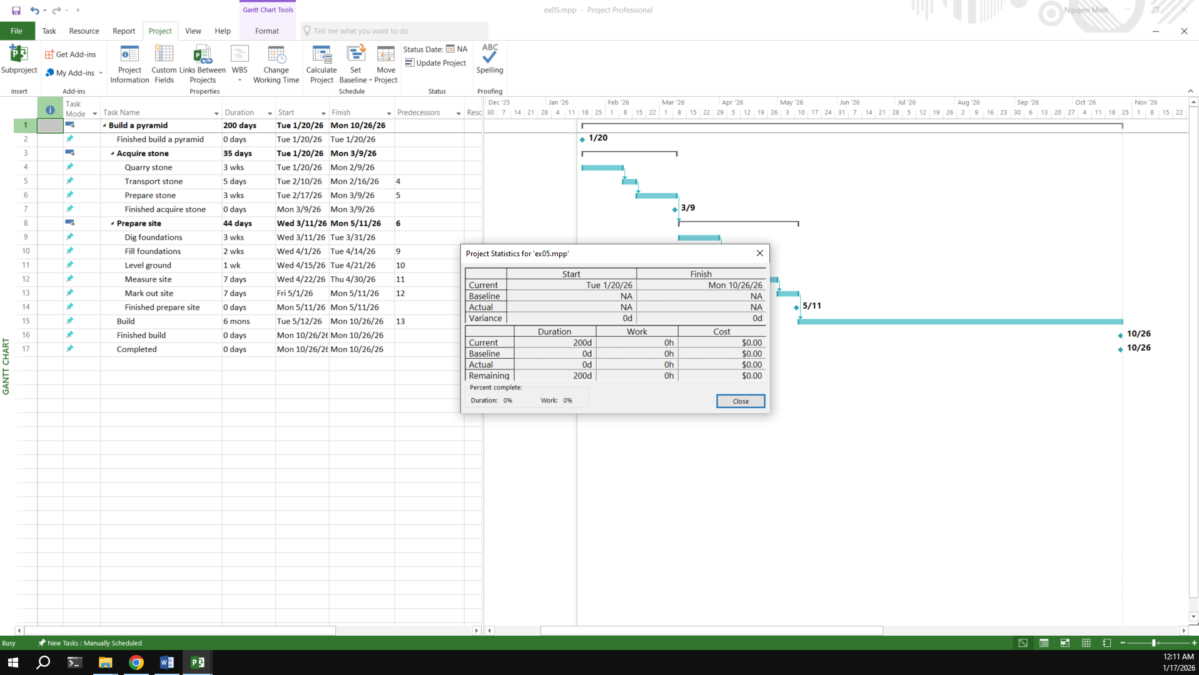

Exercise 6: Creating a plan for Staff Training
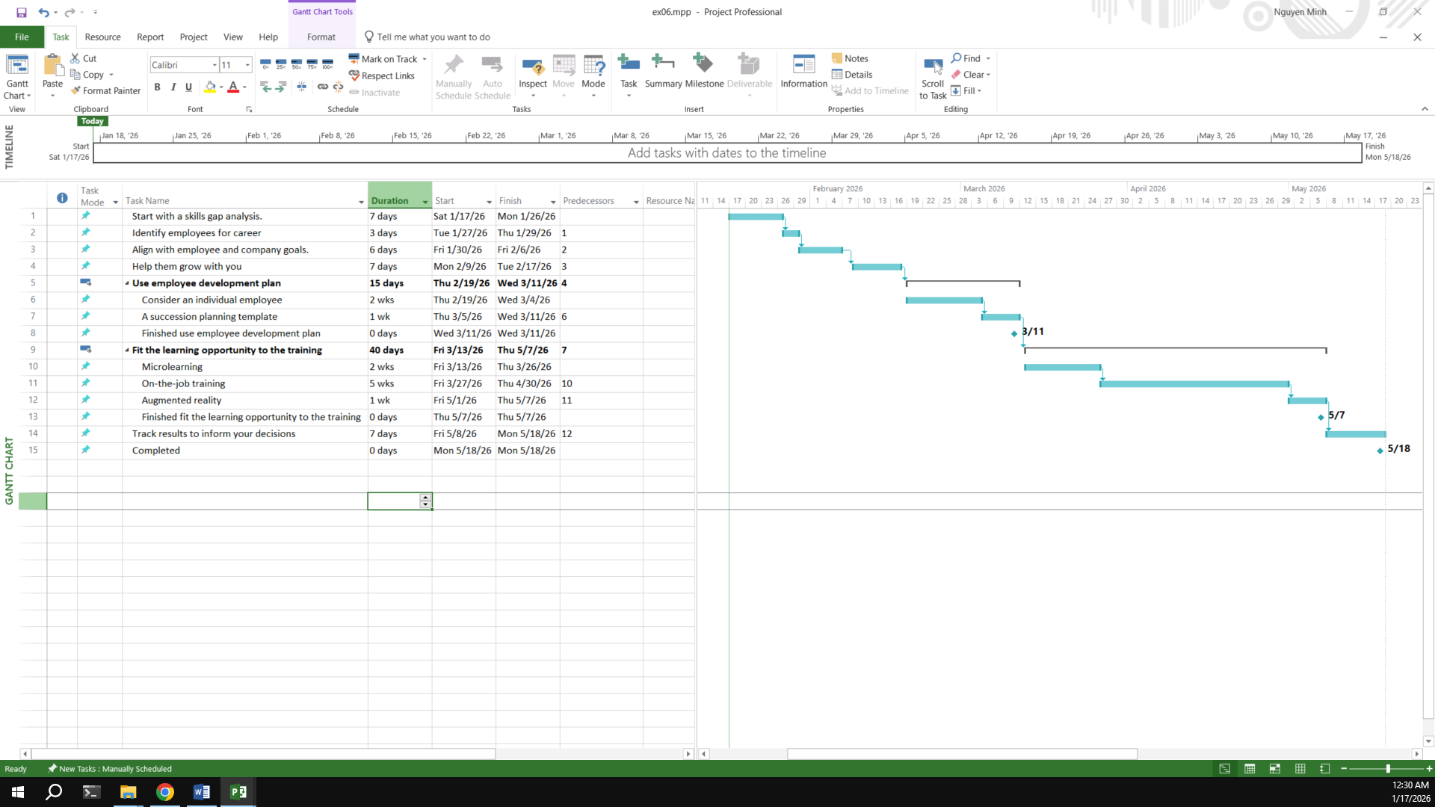
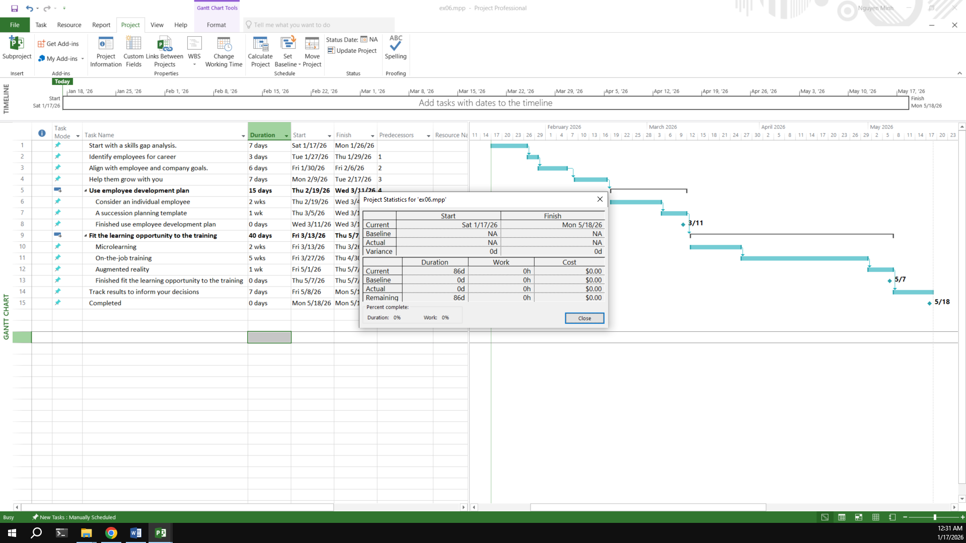
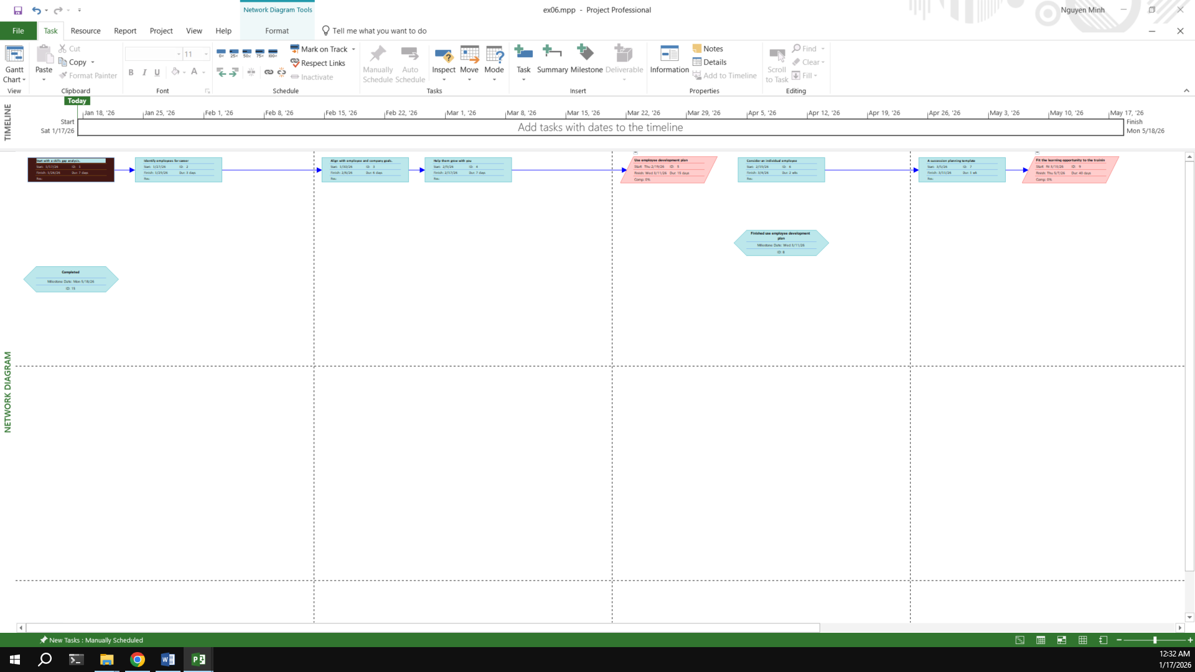
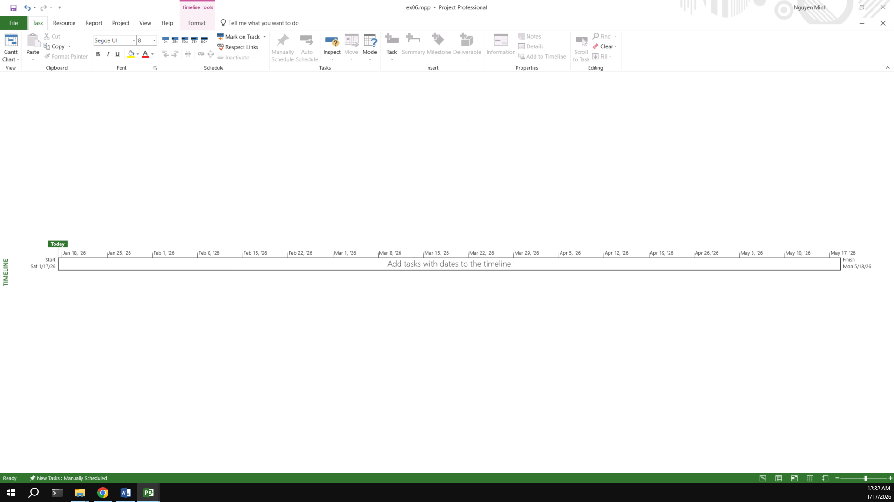

Exercise 7: Recurring Tasks
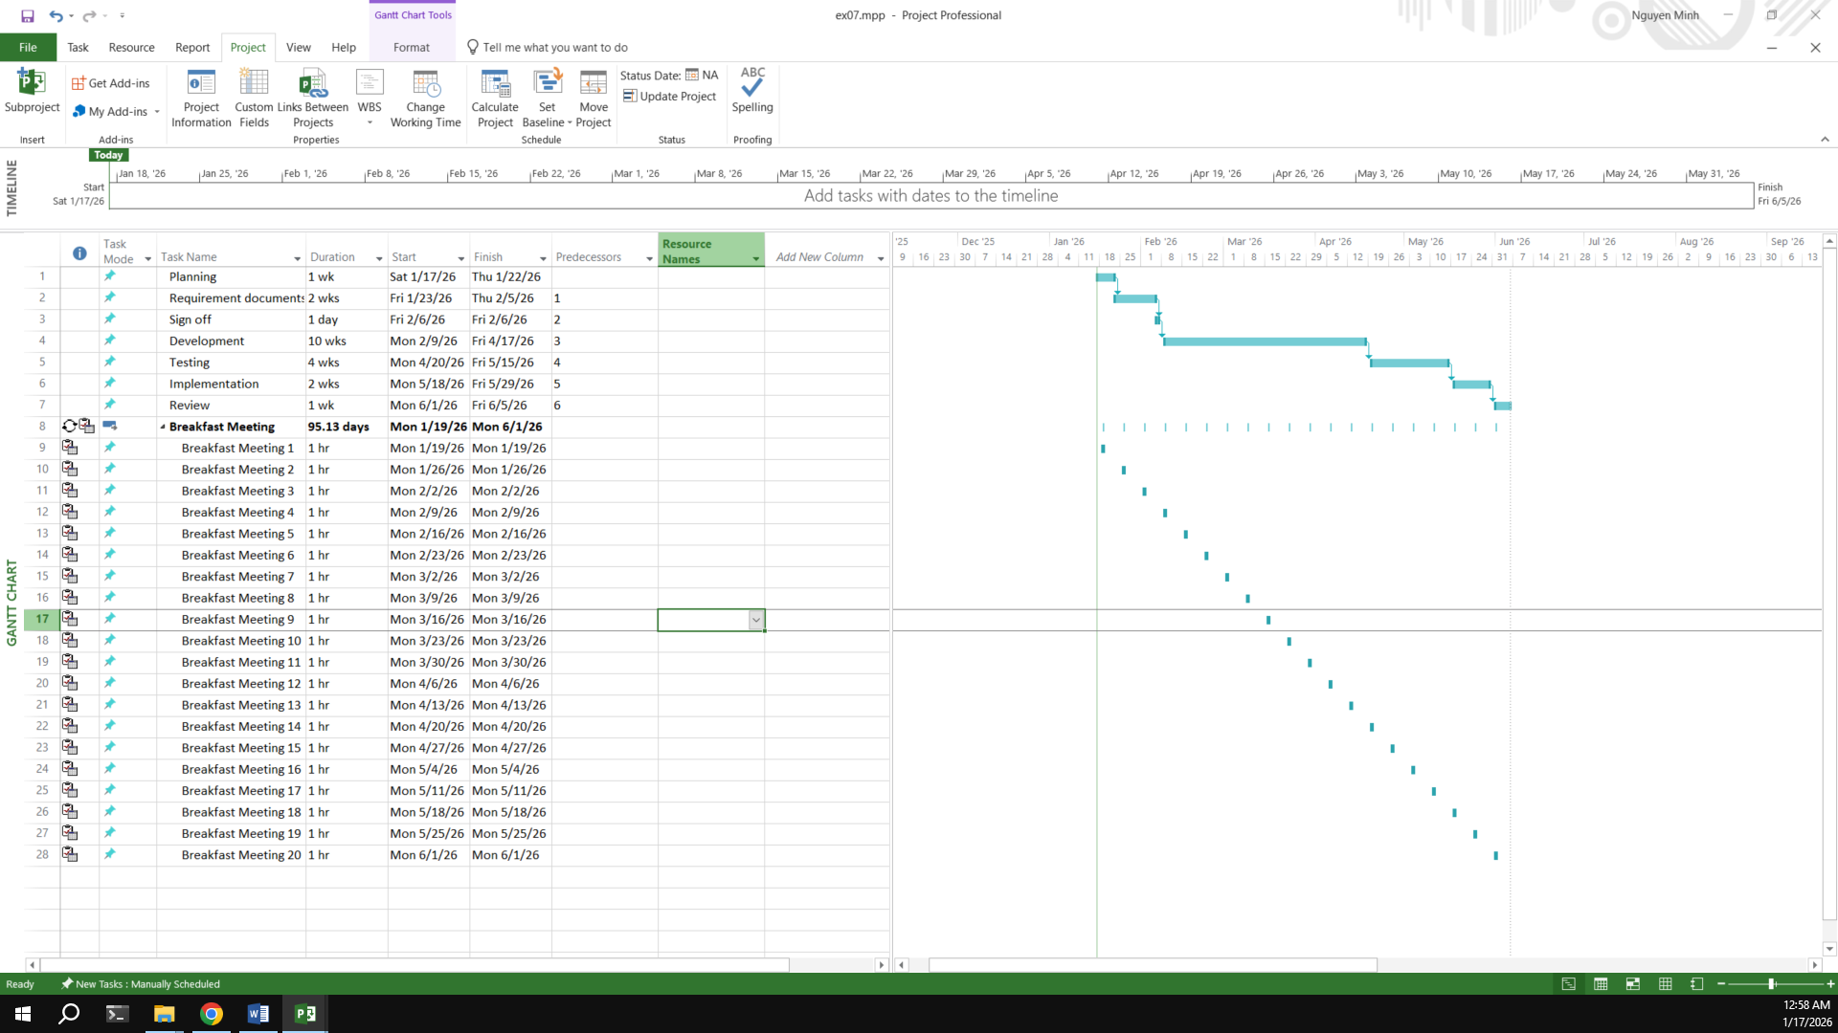

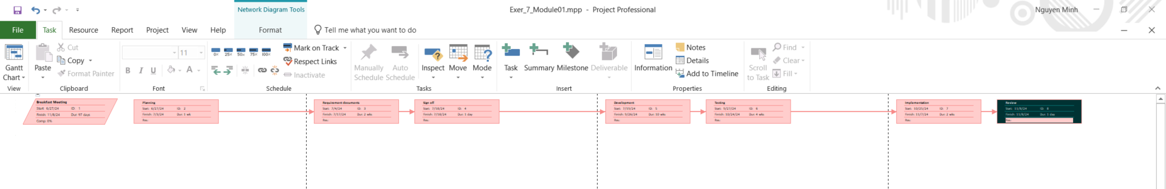
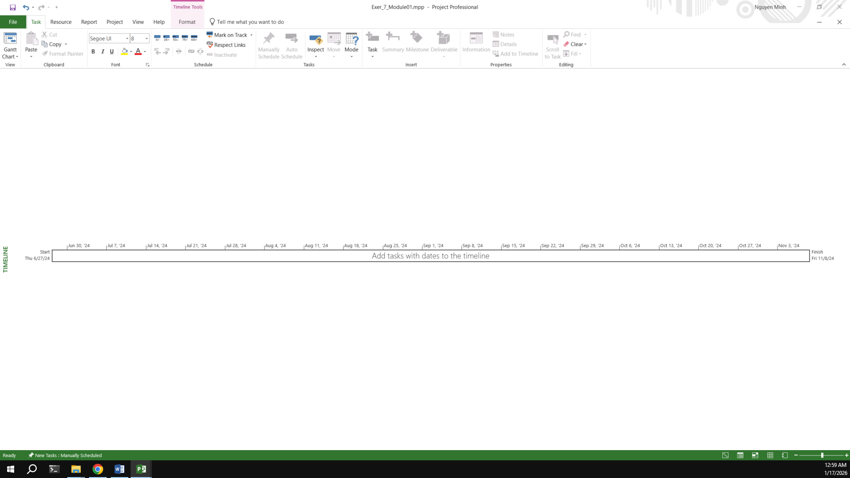
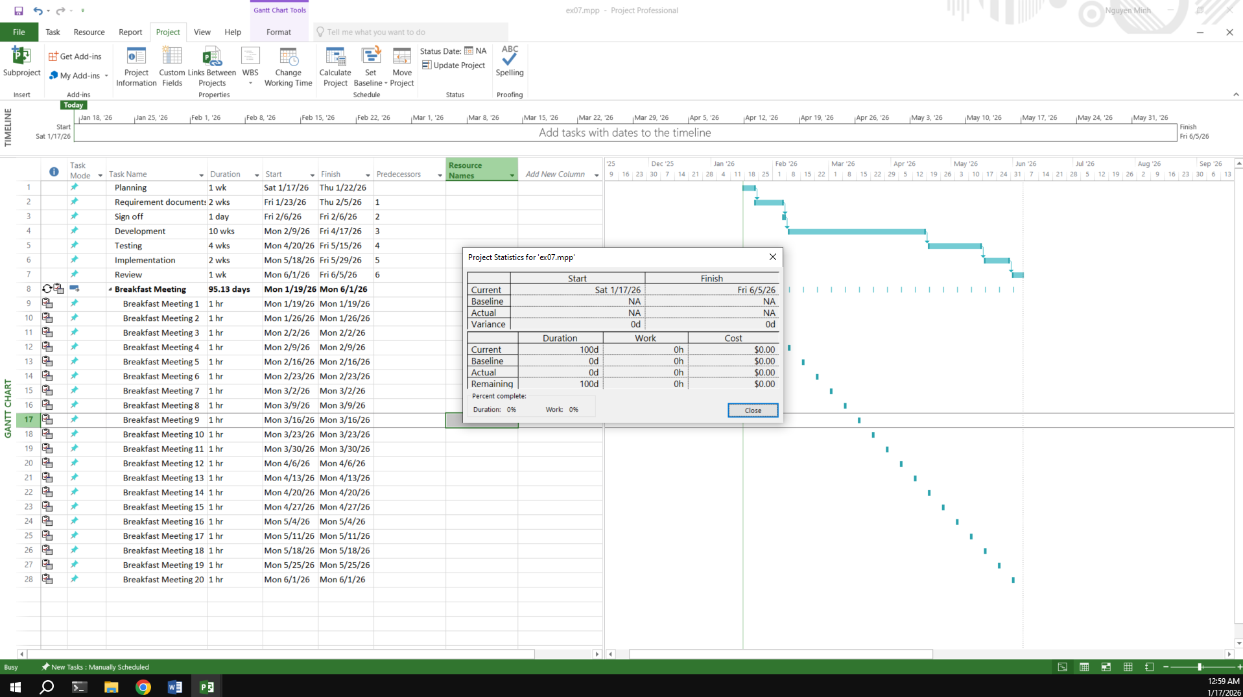

Exercise 8: Travelling – tasks calendar
Travelling – task calendar You intend to travel from HCM to Kuala Lumpur, Bangkok and then, come back to HCM. Creating a plan for your trip.
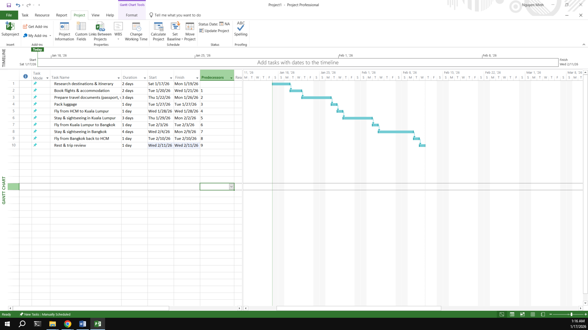
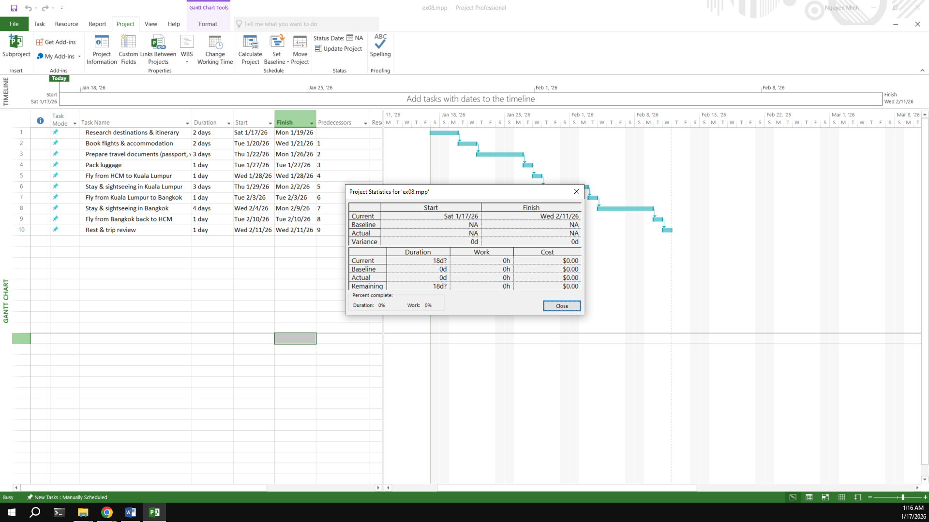
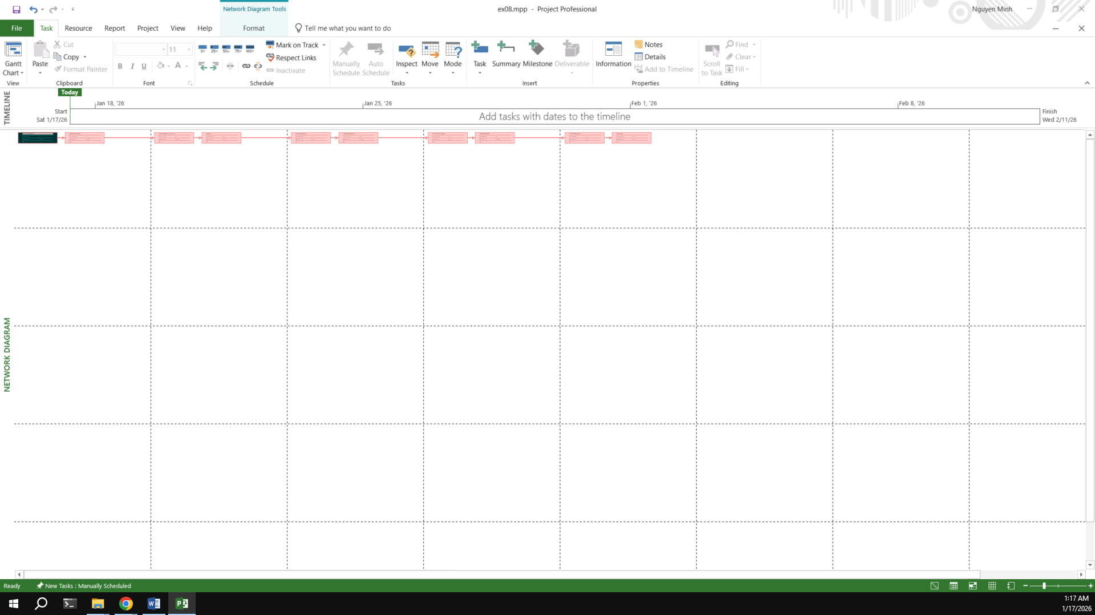
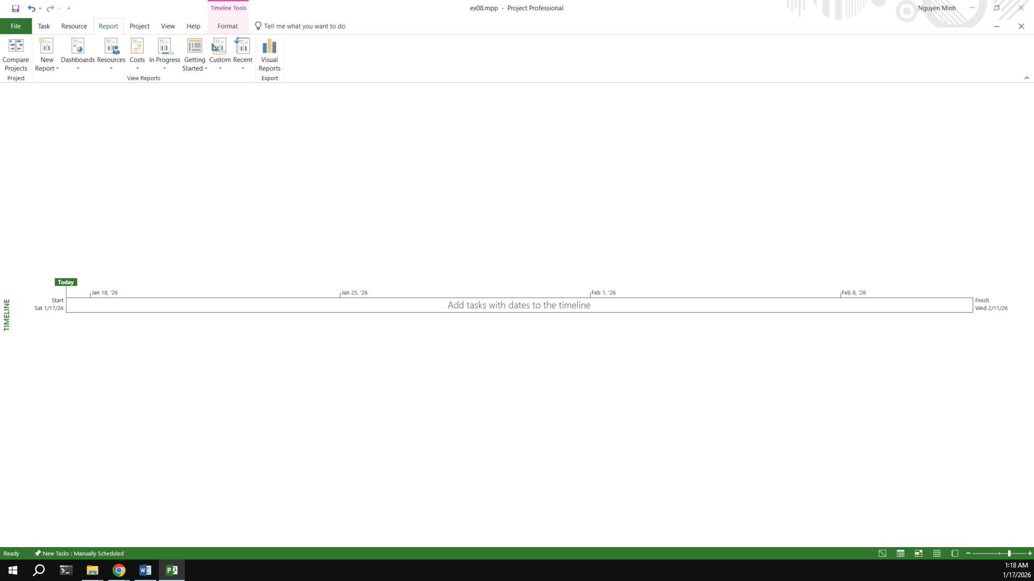

- End Module 01 -

Module 2: CALENDARS AND SCHEDULING

Exercise 1: Part Time - creating new calendar
Part Time - creating new calendar
Open project file Ex2 (Module 1), Use the Project Information dialog box to:
A part-time worker will be used on this project. Go to the Change Working Time dialog box and create a new copy of the Standard calendar, calling it "Part Time".
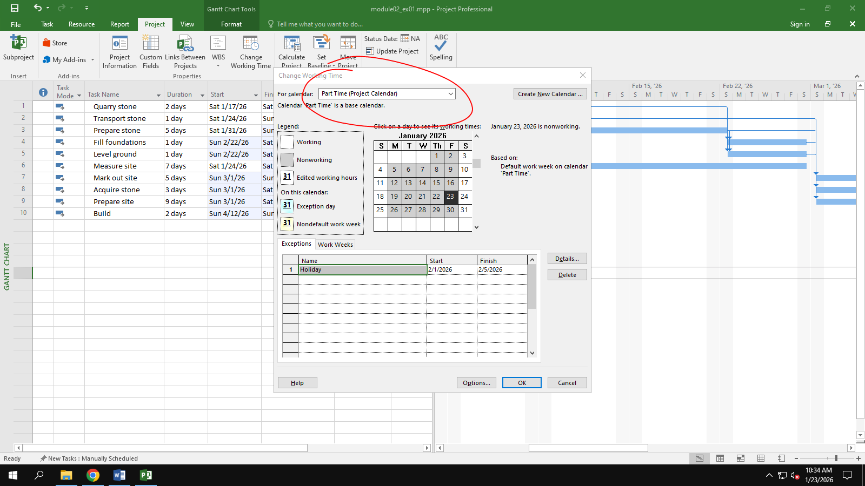
Update the working time of your new calendar so that:
¬ Mondays to Fridays are nonworking time
¬ The remaining 2 weekdays have working time of 10:00 to 16:00 ( no breaks)

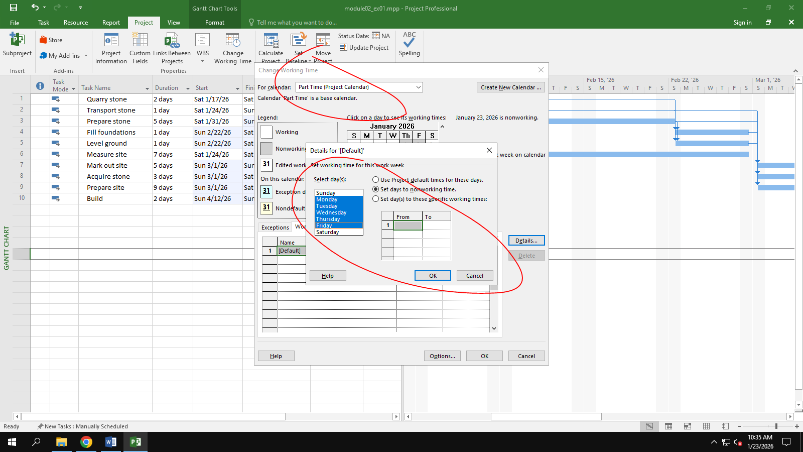
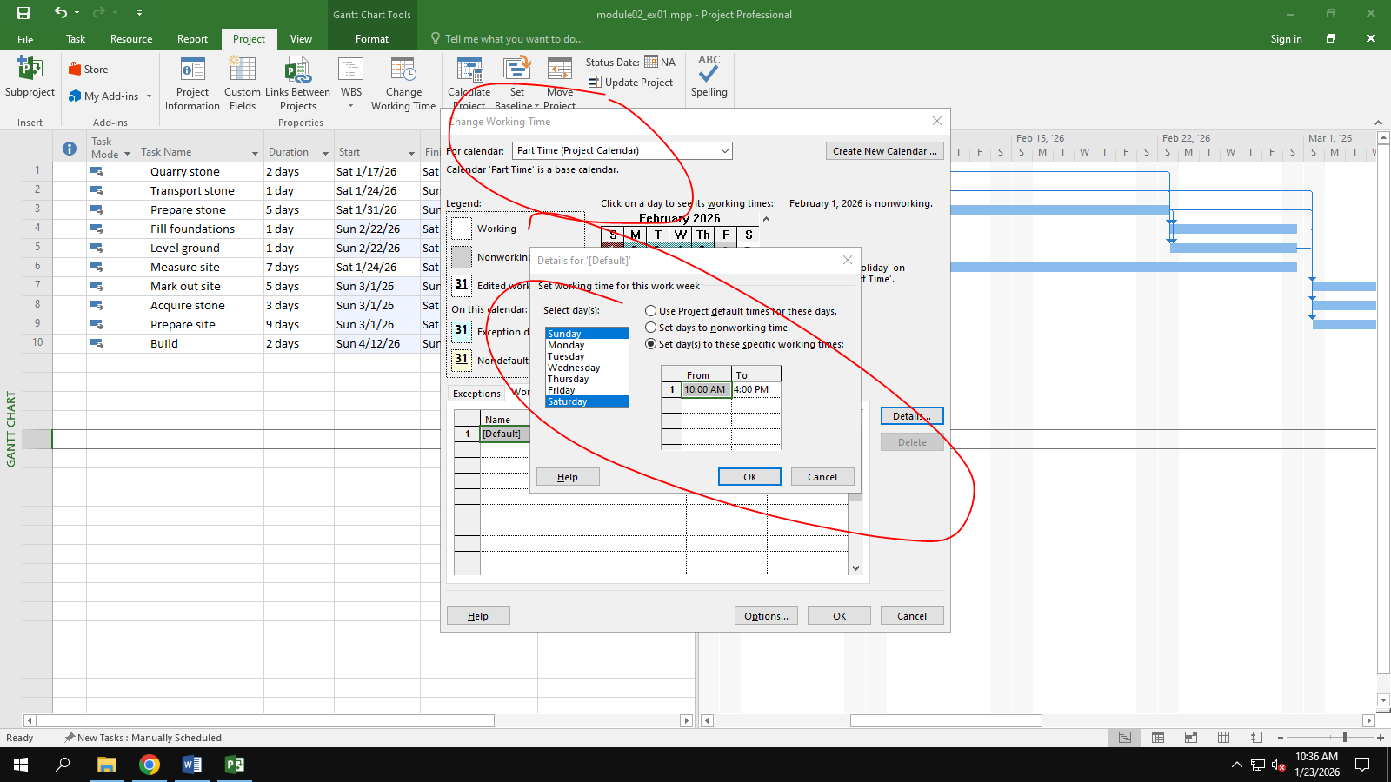

The Part time has also booked a holiday from 1st to Feb 5th . Create an Exception to their calendar with a Holiday name and these days as nonworking
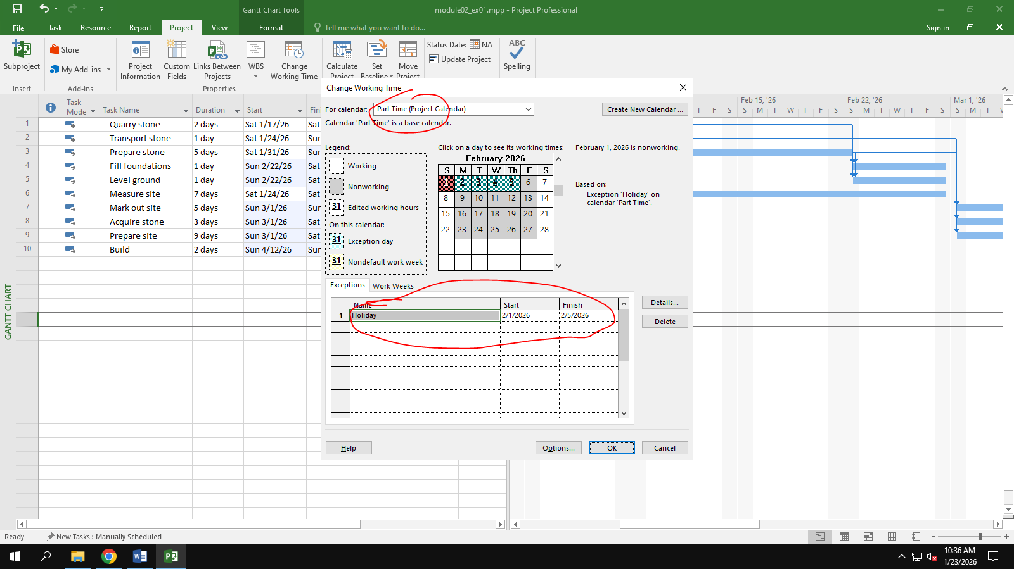
Display the Project Information.
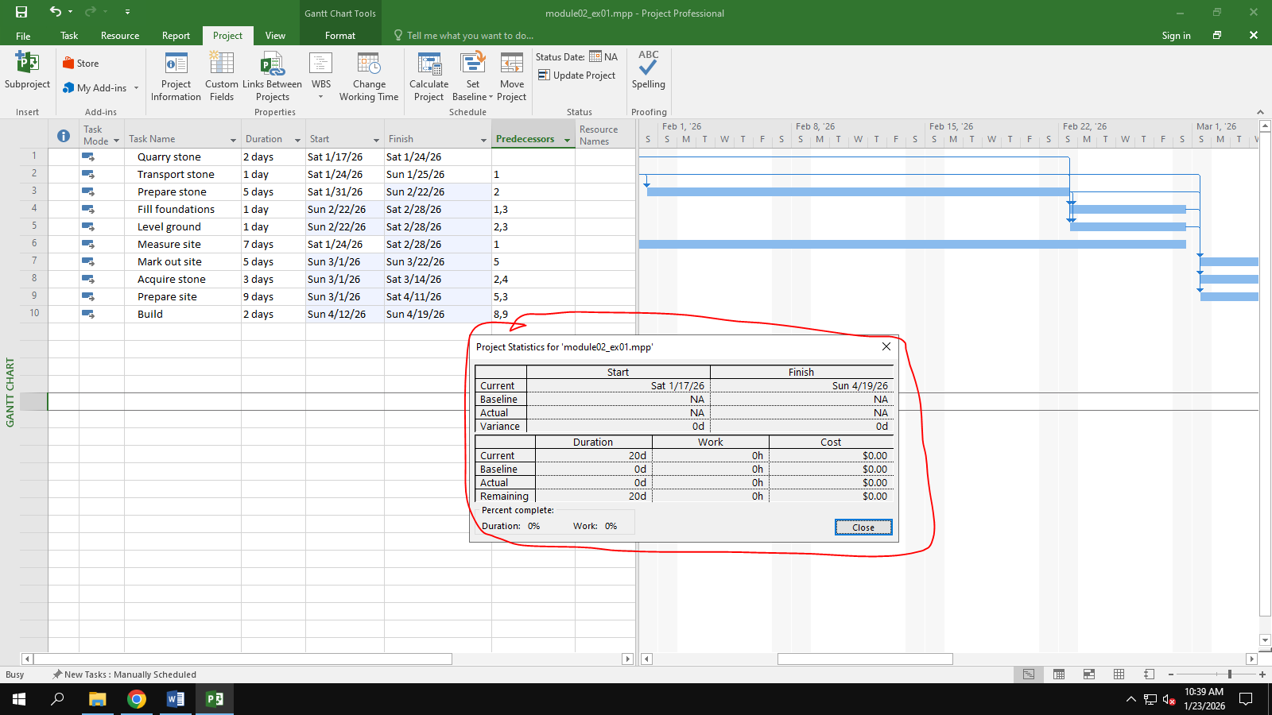
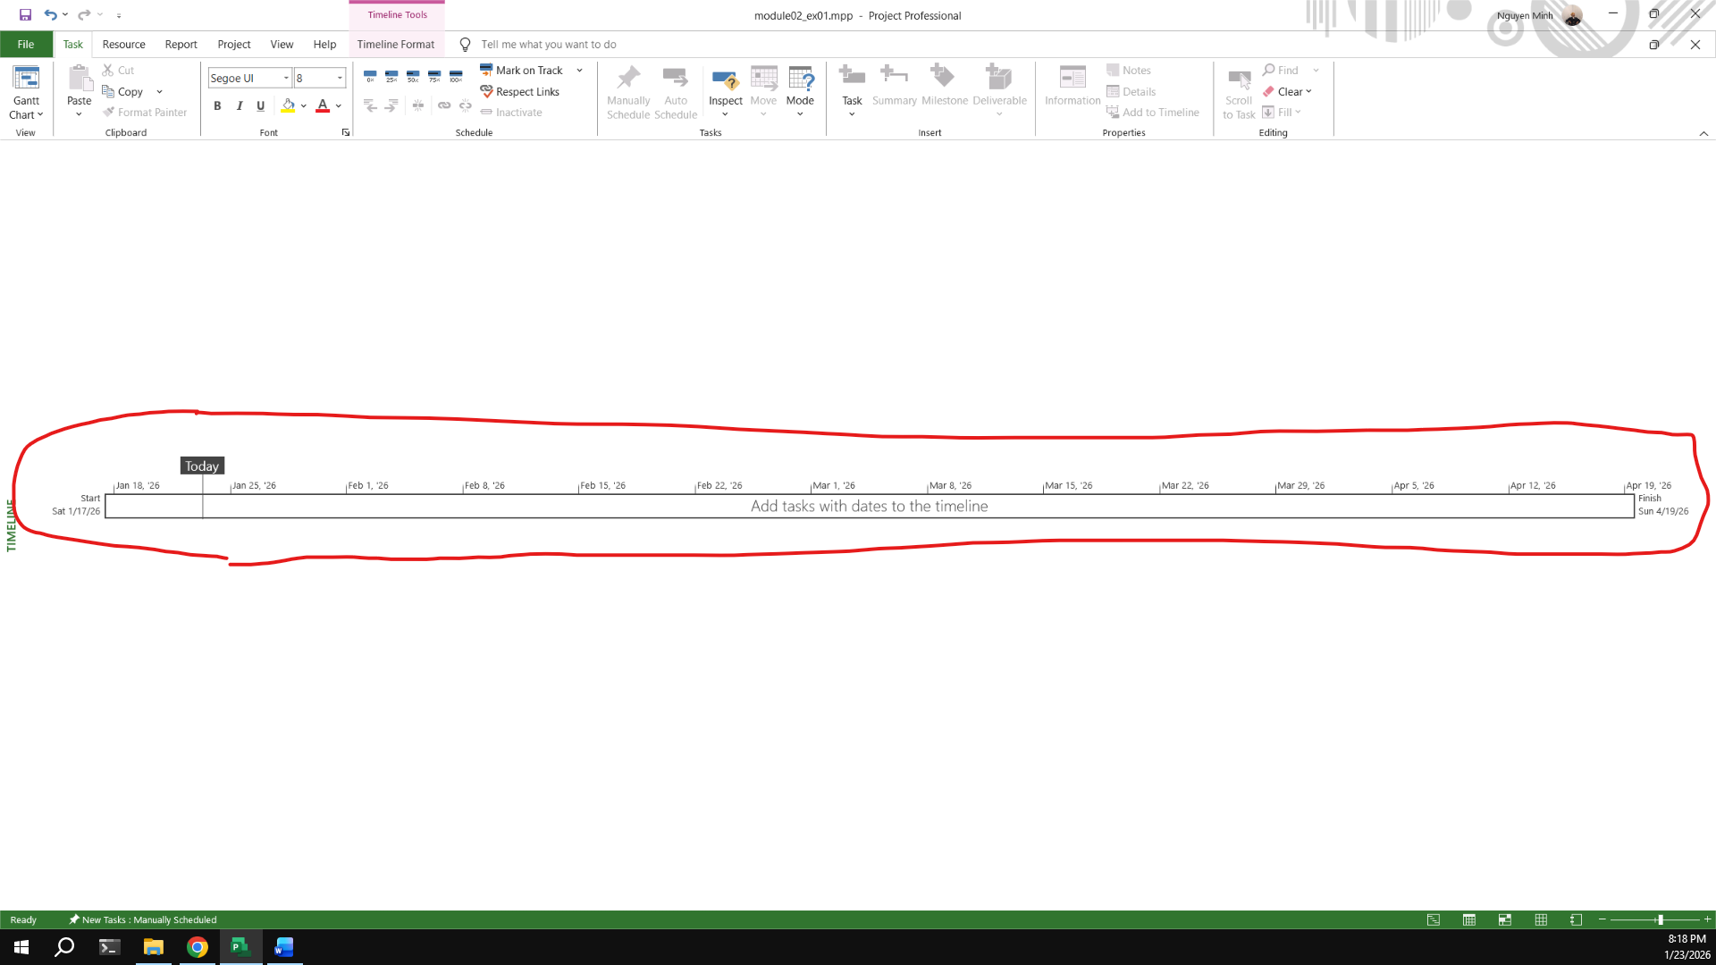

Exercise 2: Changing Working Time
Changing Working Time
Open project file Ex4 (Module 1) Use the Project Information dialog box to:
Start Date: Nov 20th 2025
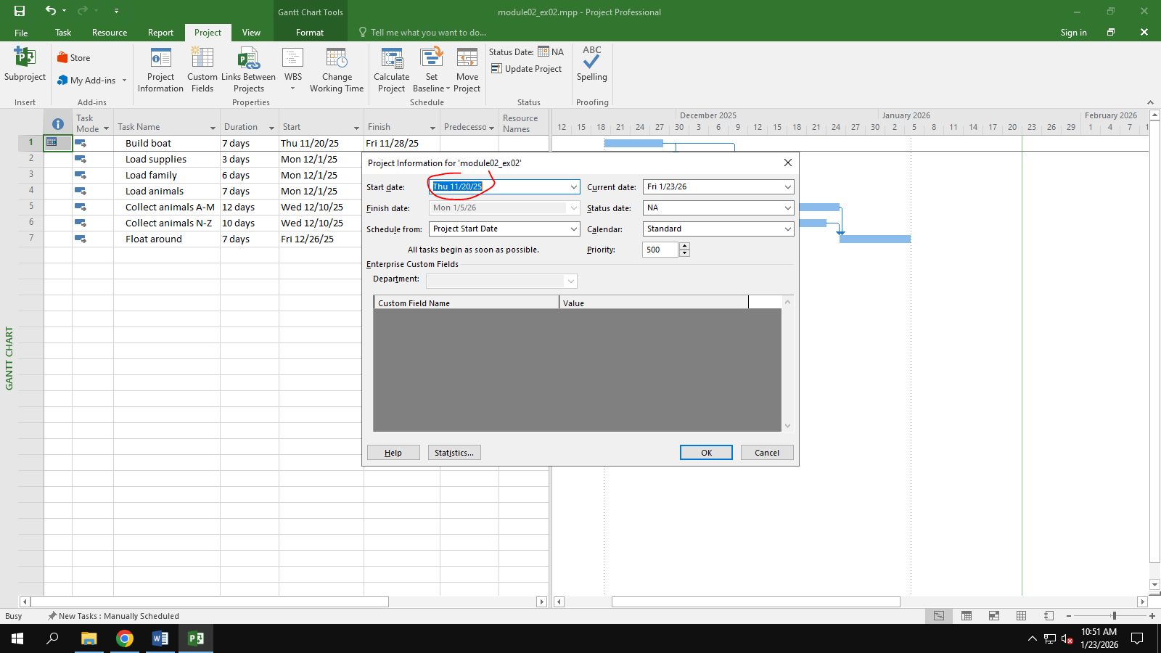
Go to the Change Working Time dialog box and create an Exception called "Tet Holidays" during from Dec 24th 2026 to Jan 5th 2026 into nonworking time.
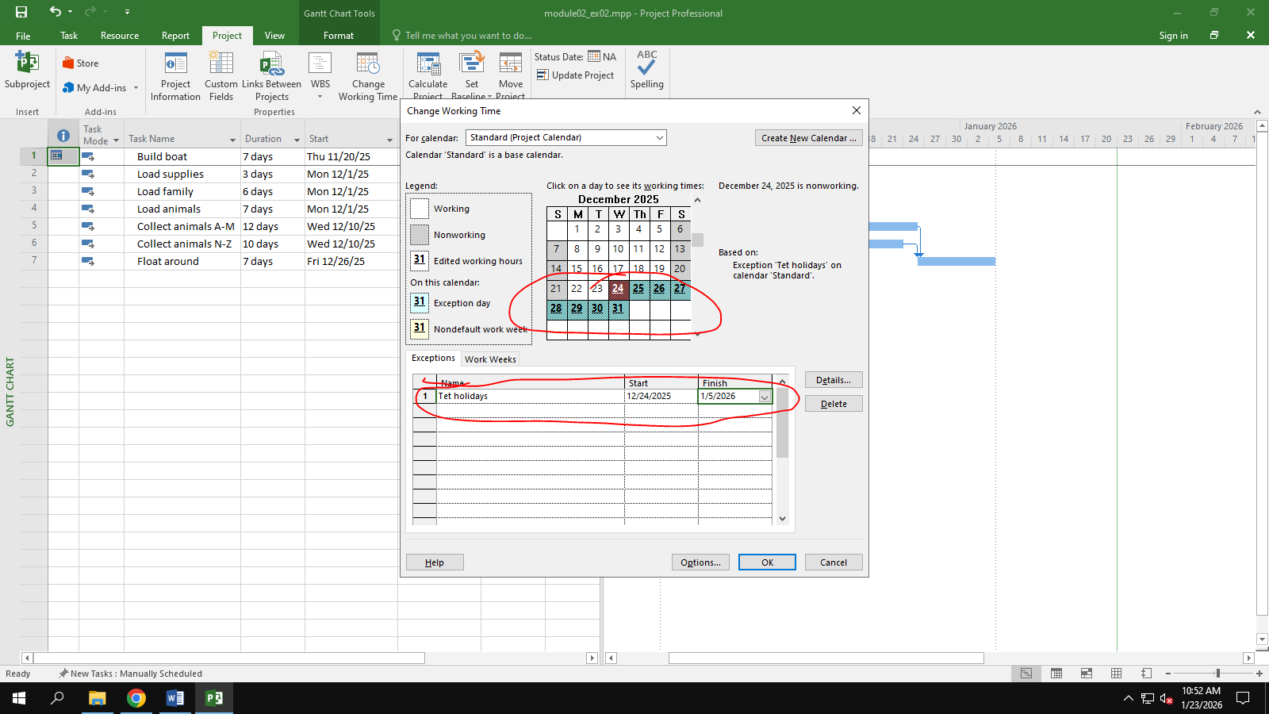
Change Work Weeks time of Standard calendar's default working week. This project's standard working time are:
¬ 08:30 to 17:30 Monday to Thursday (no lunch break)
¬ 08:30 to 16:00 on Fridays (no lunch break)
¬ Add a new Work Week to the Standard calendar named "Xmas Slowdown". Use this to model a 12:30 finish on every weekday from Dec 10th 2025 to Dec 23rd 2025.
¬ Capture the Work weeks time
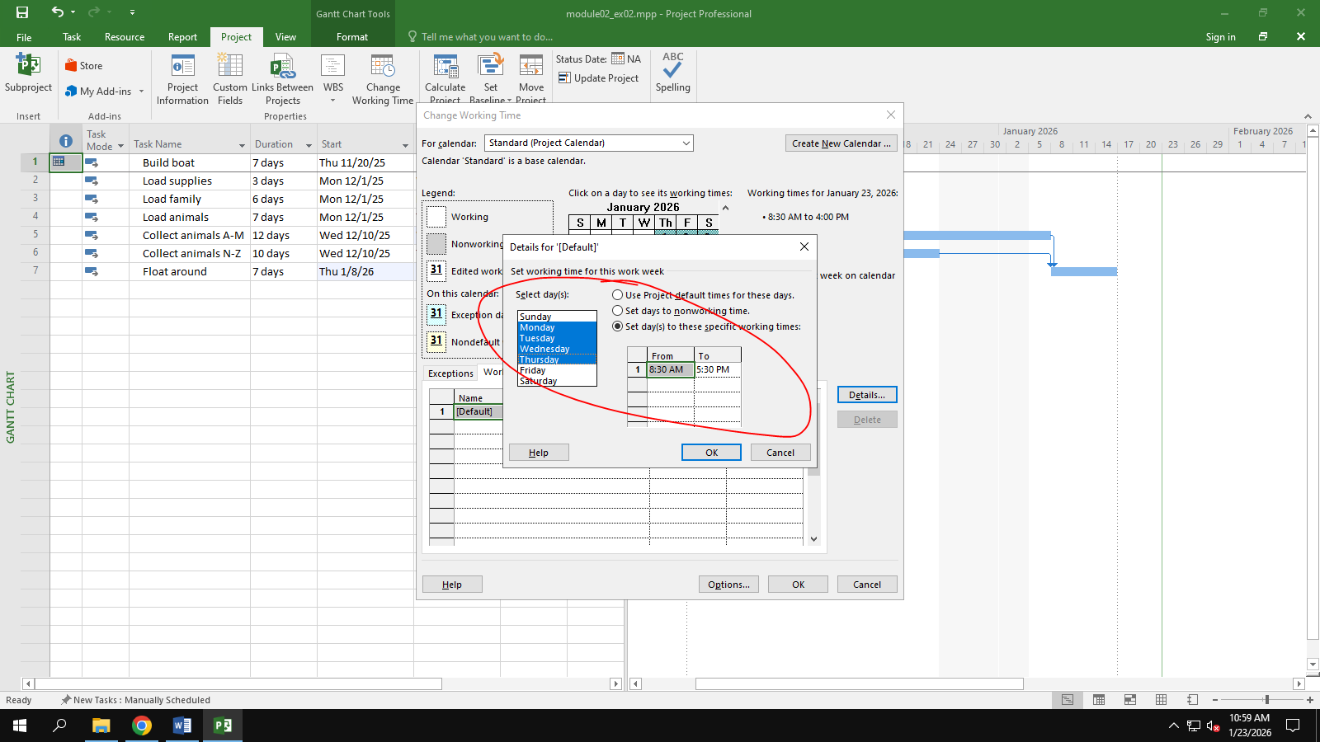
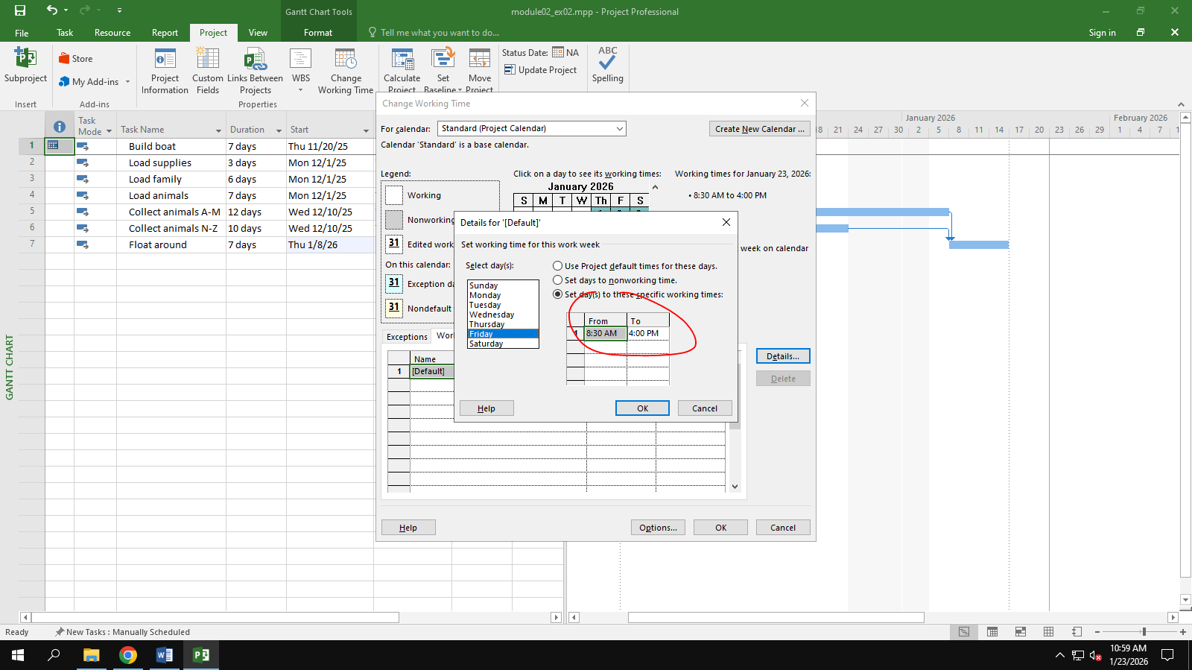
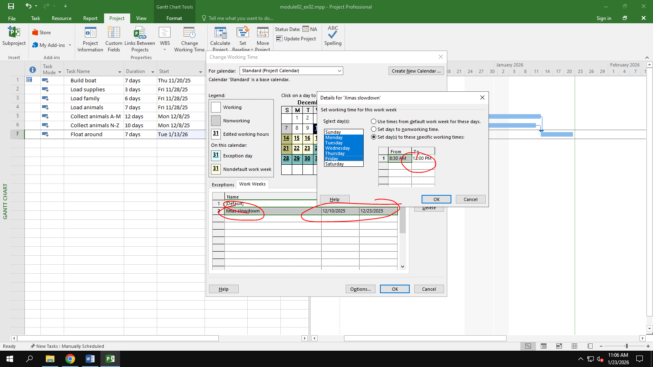
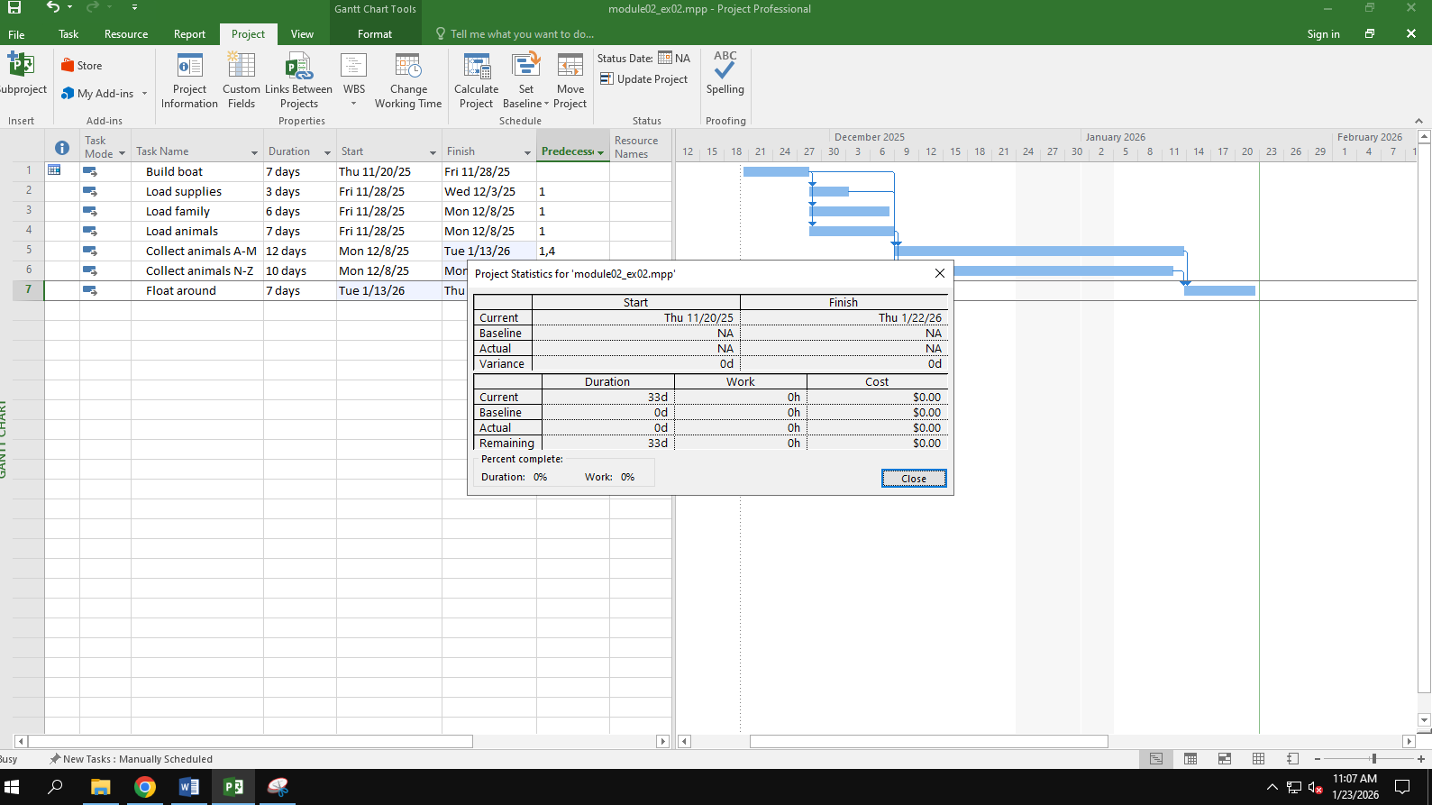
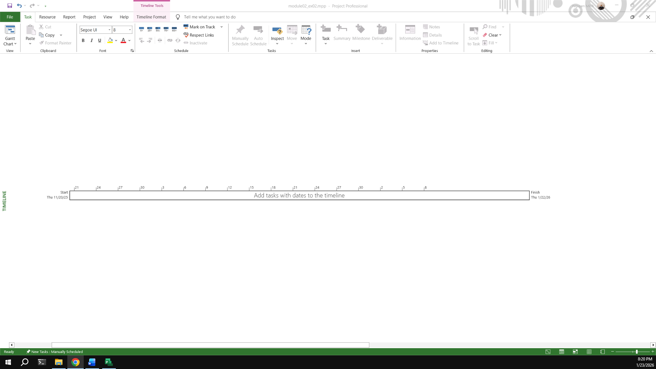

Exercise 3: Changing Working Time
Open project file Ex5 (Module 1), Use the Project Information dialog box to:
Star Date: Apr 5th 2026

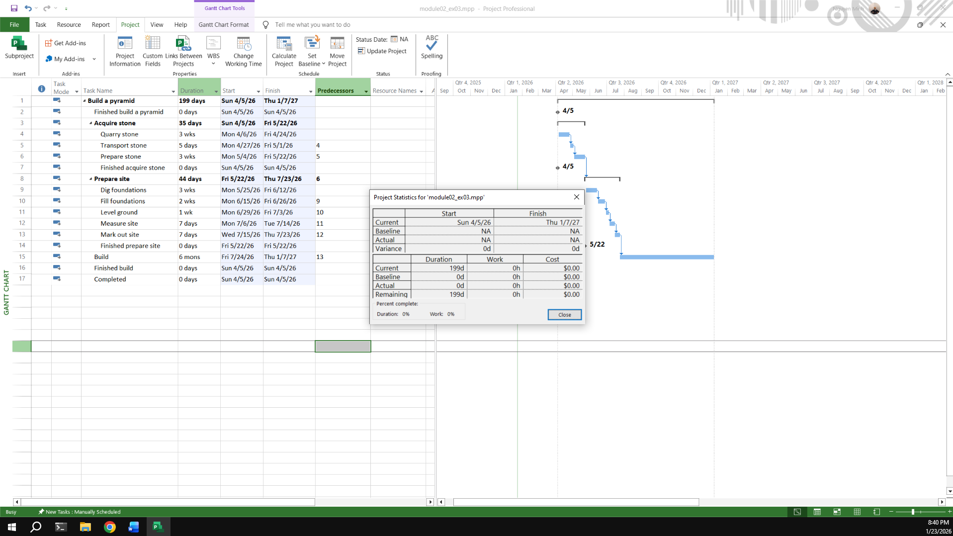
The office will shut down for 2 weeks in the summer. Use the Change Working Time dialog box to create an Exception called "Summer Shutdown" and make the first 14 workdays of August nonworking time
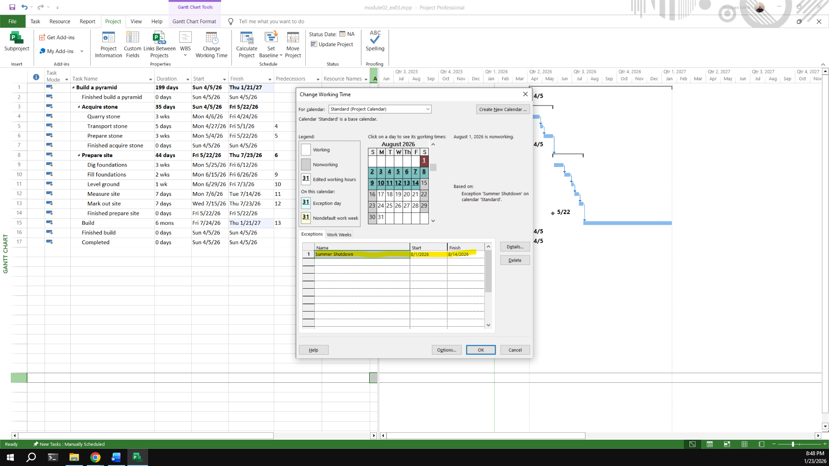
Create an Exception called “Independence Days” is 2 Sep nonworking time.
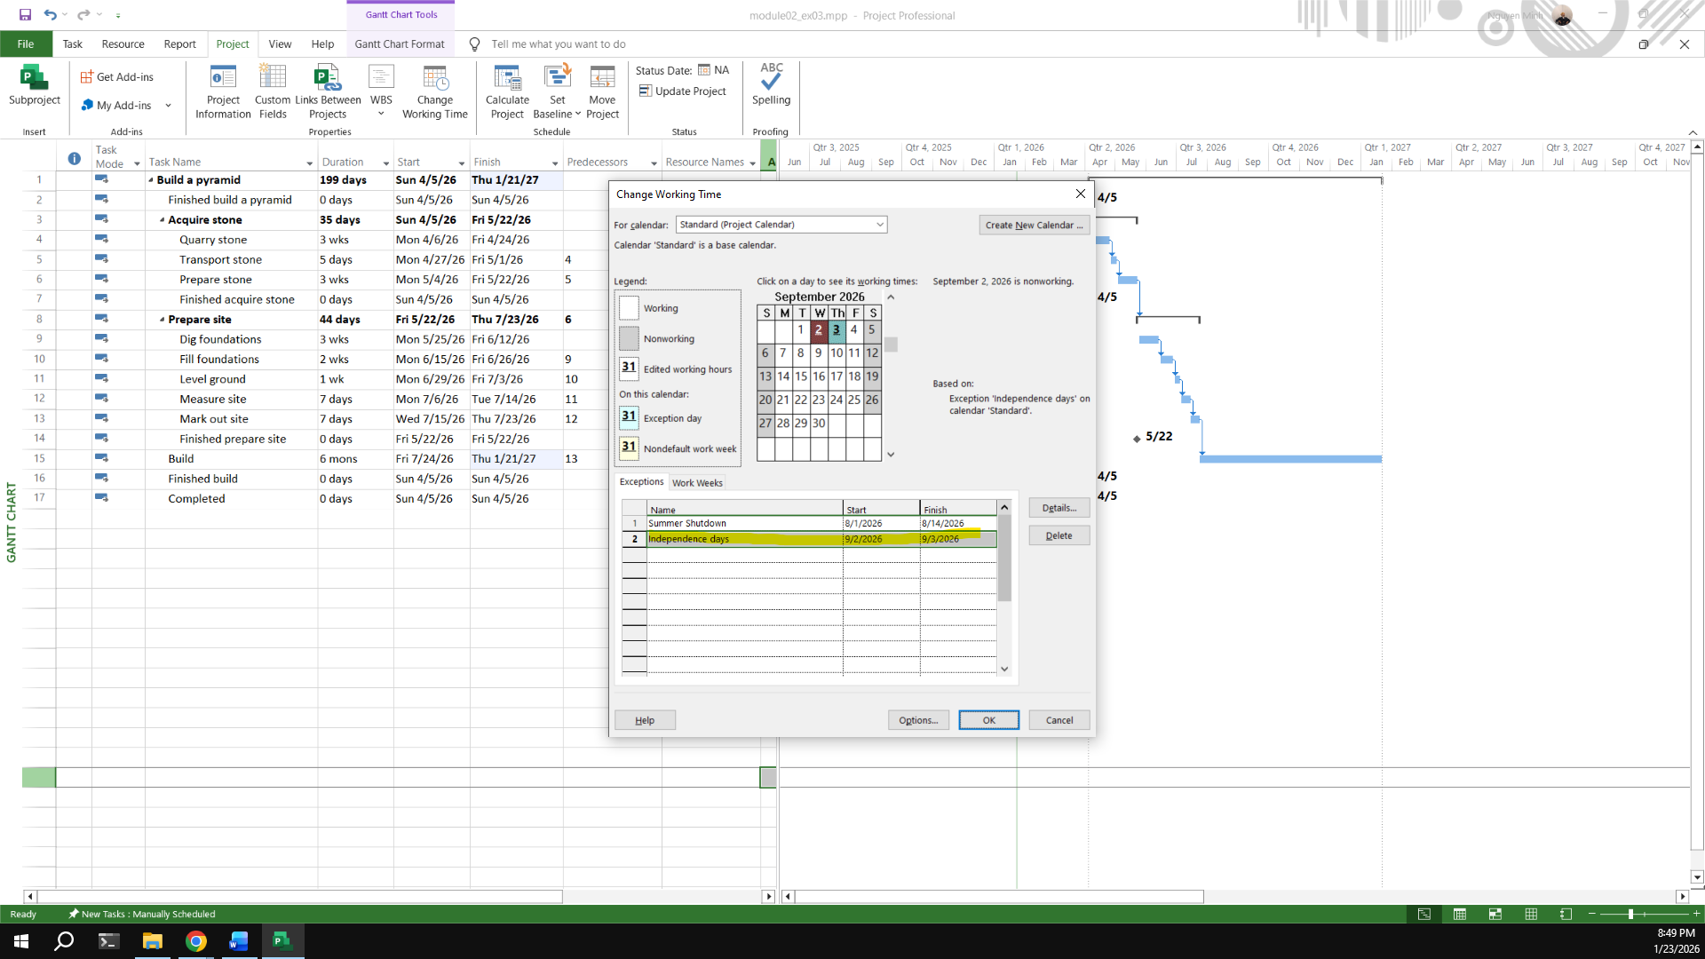
Create an Exception called “International Labor days” is Apr 30th and May 1st nonworking time
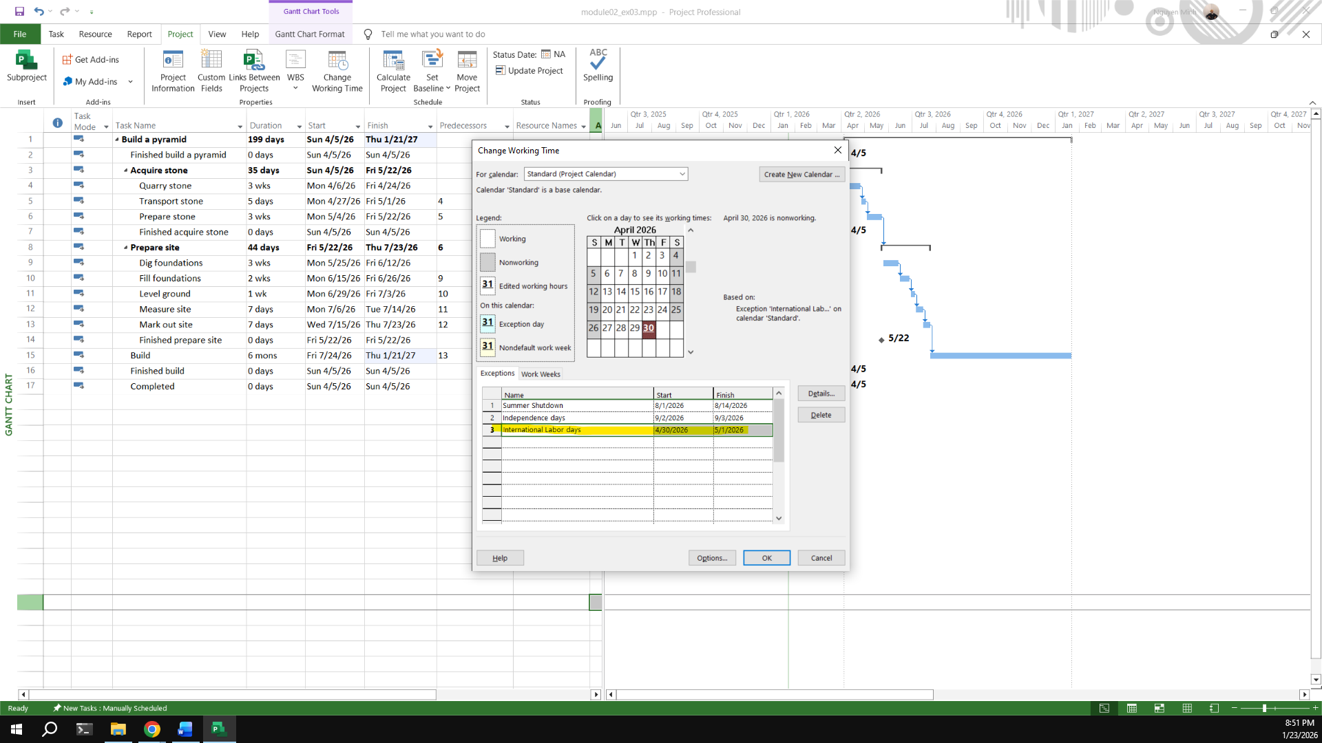
Display the Project Information
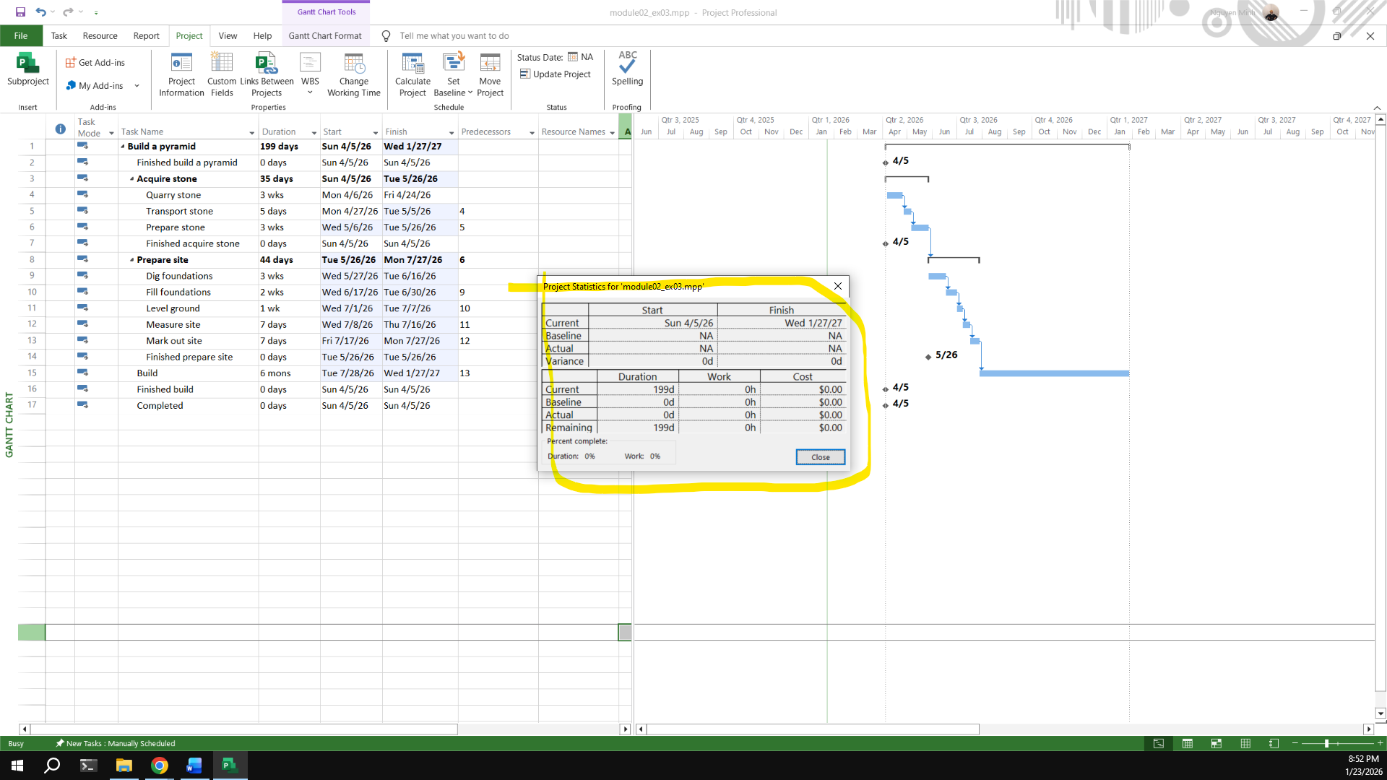

Exercise 4: Changing Working Time
Open project file Ex6 (Module 1), Use the Project Information dialog box to:
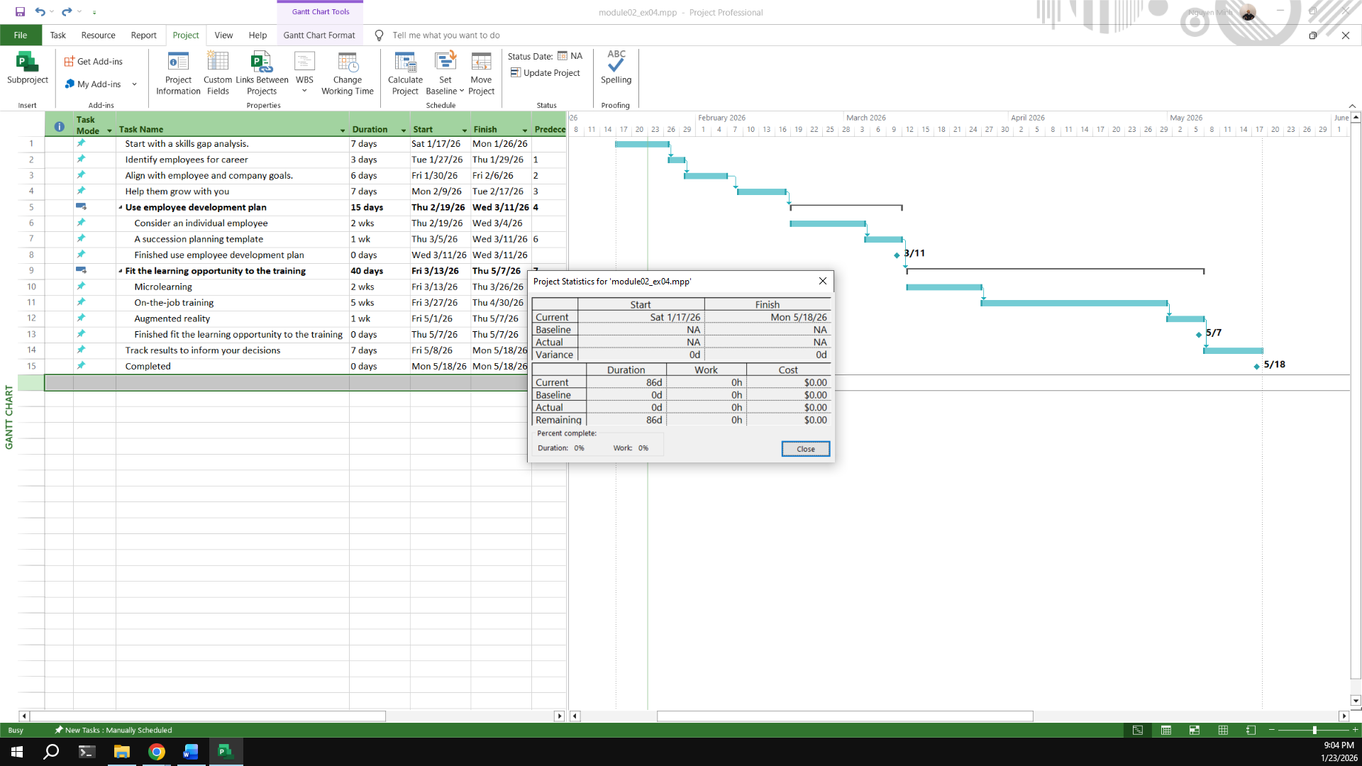
Modify the Standard calendar and change the [Default] work week to use the hours shown below:
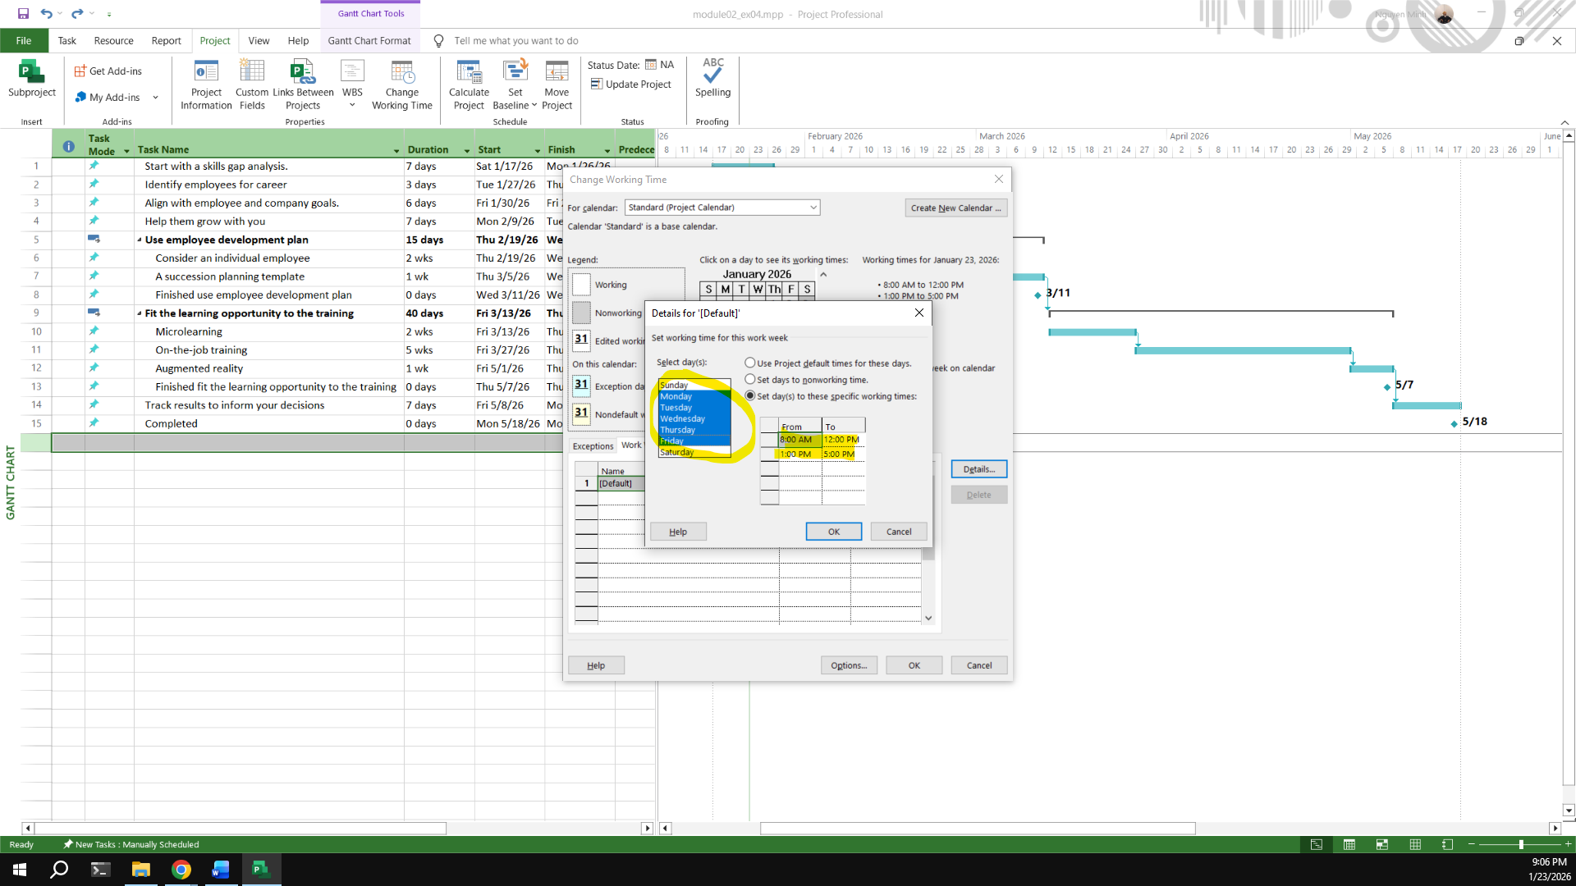
Add an exception in the Standard calendar called Recovery with in 7 lates workdays of March is non-working days.
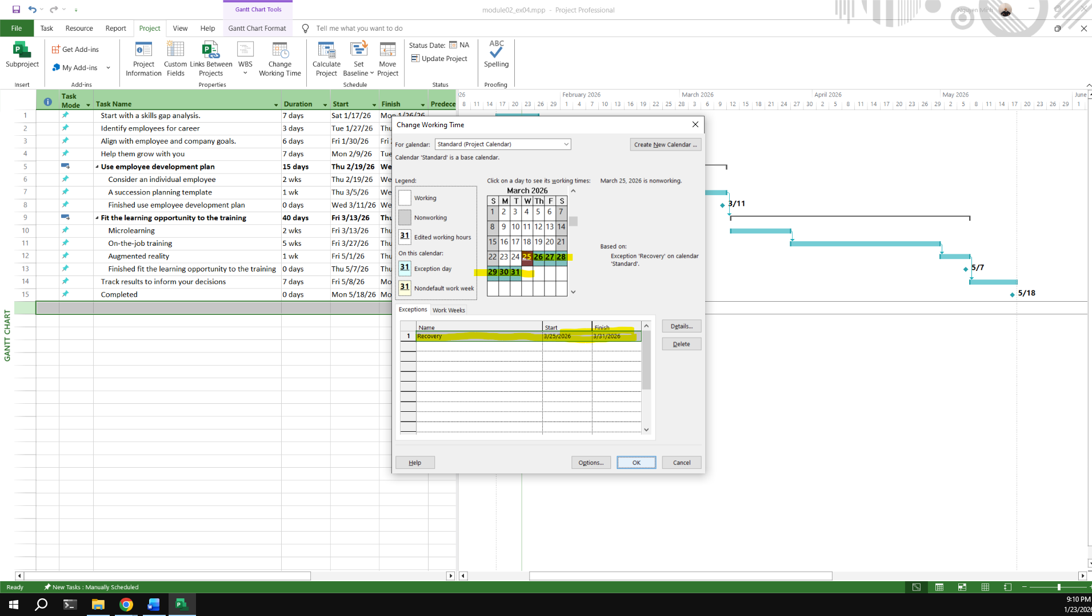
Display the Project Information.
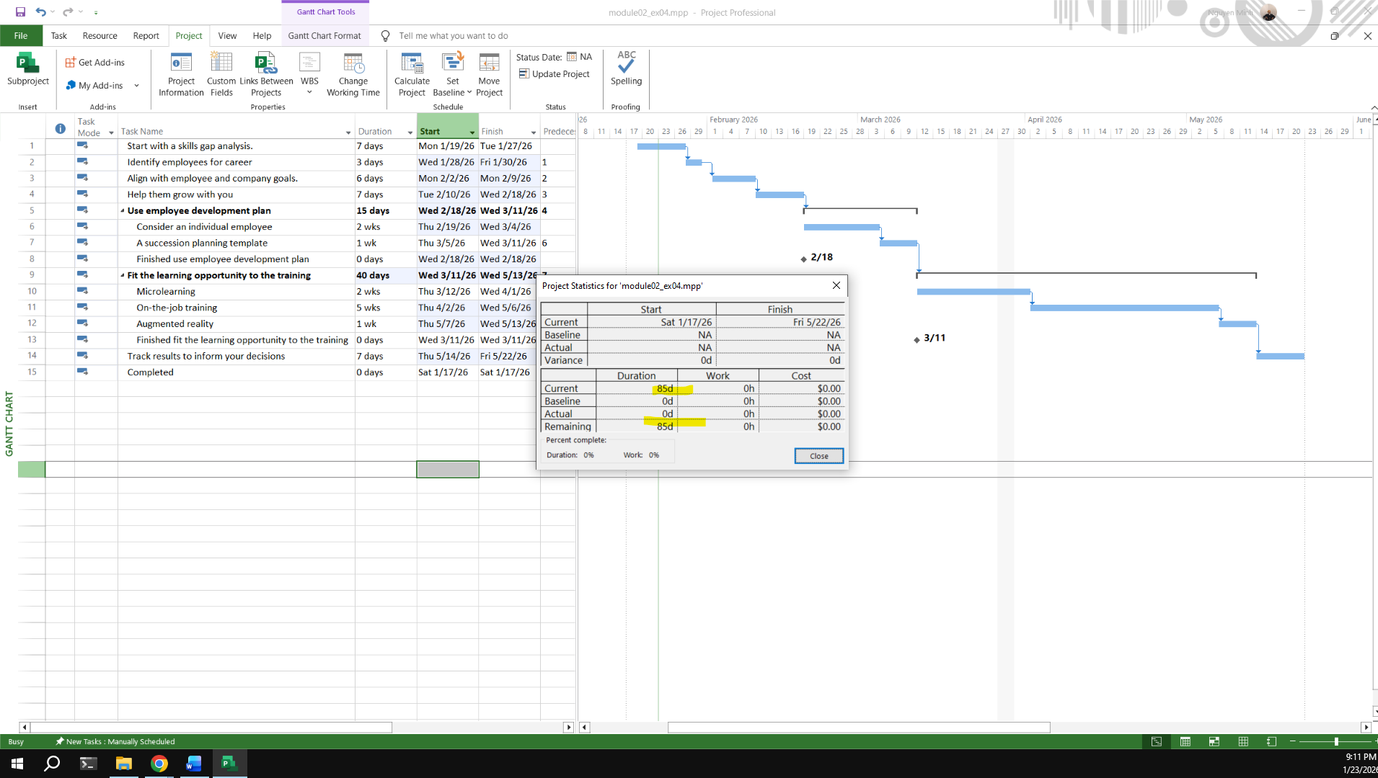

Exercise 5: Create the private Time for a project
Open project file Ex7 (Module 1), Use the Project Information dialog box to:

Create the new Time Work for your project.
[NameTimeProject] {Name: Your Name - Ex: MinhTimeProject}
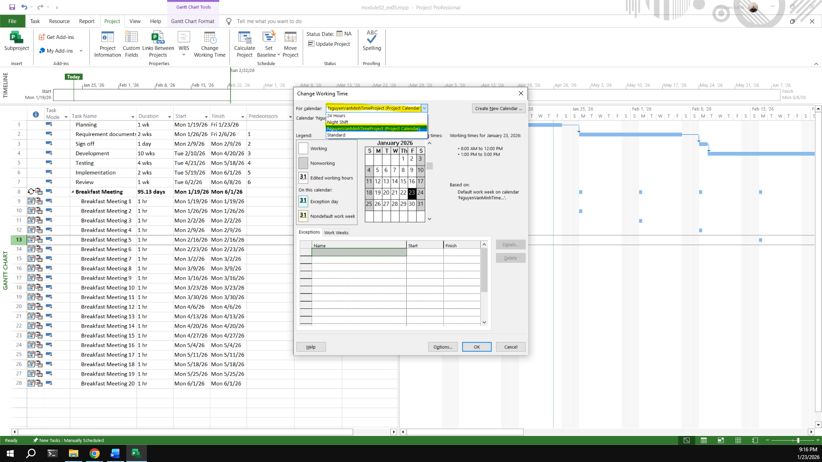
Change Work Weeks time of Standard calendar's default working week. This project's standard working time are:
08:00 to 12:00 on Mon, Wed, Fri
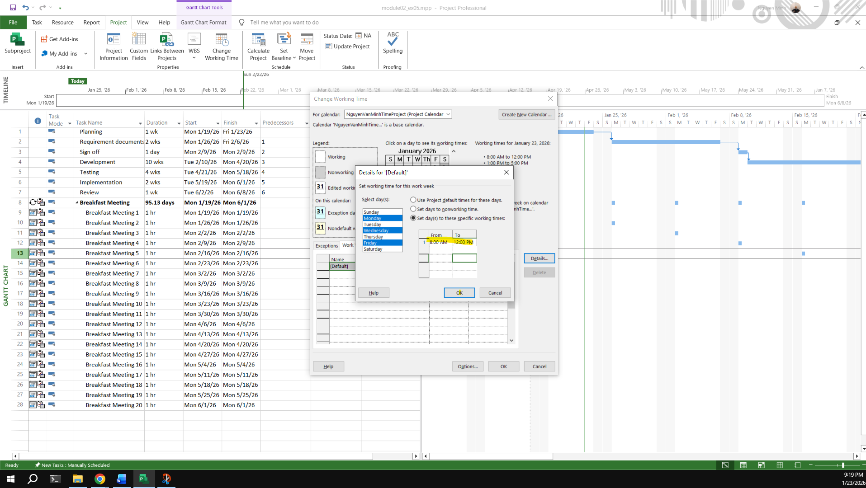
13:00 to 16:00 on Tue, Thu, Sat
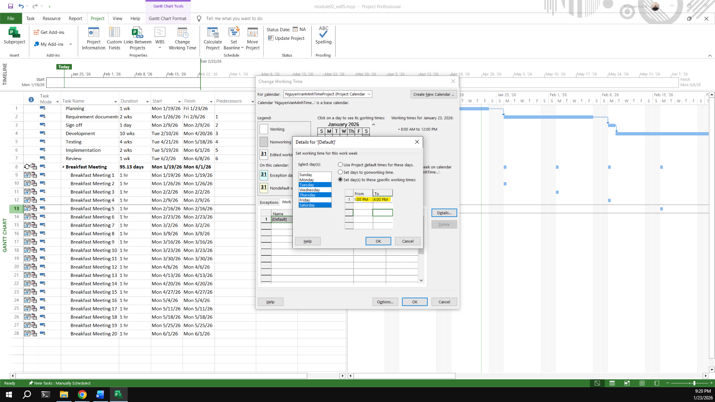
Create an Exception called “International Labor days” is Apr 30th and May 1st nonworking time
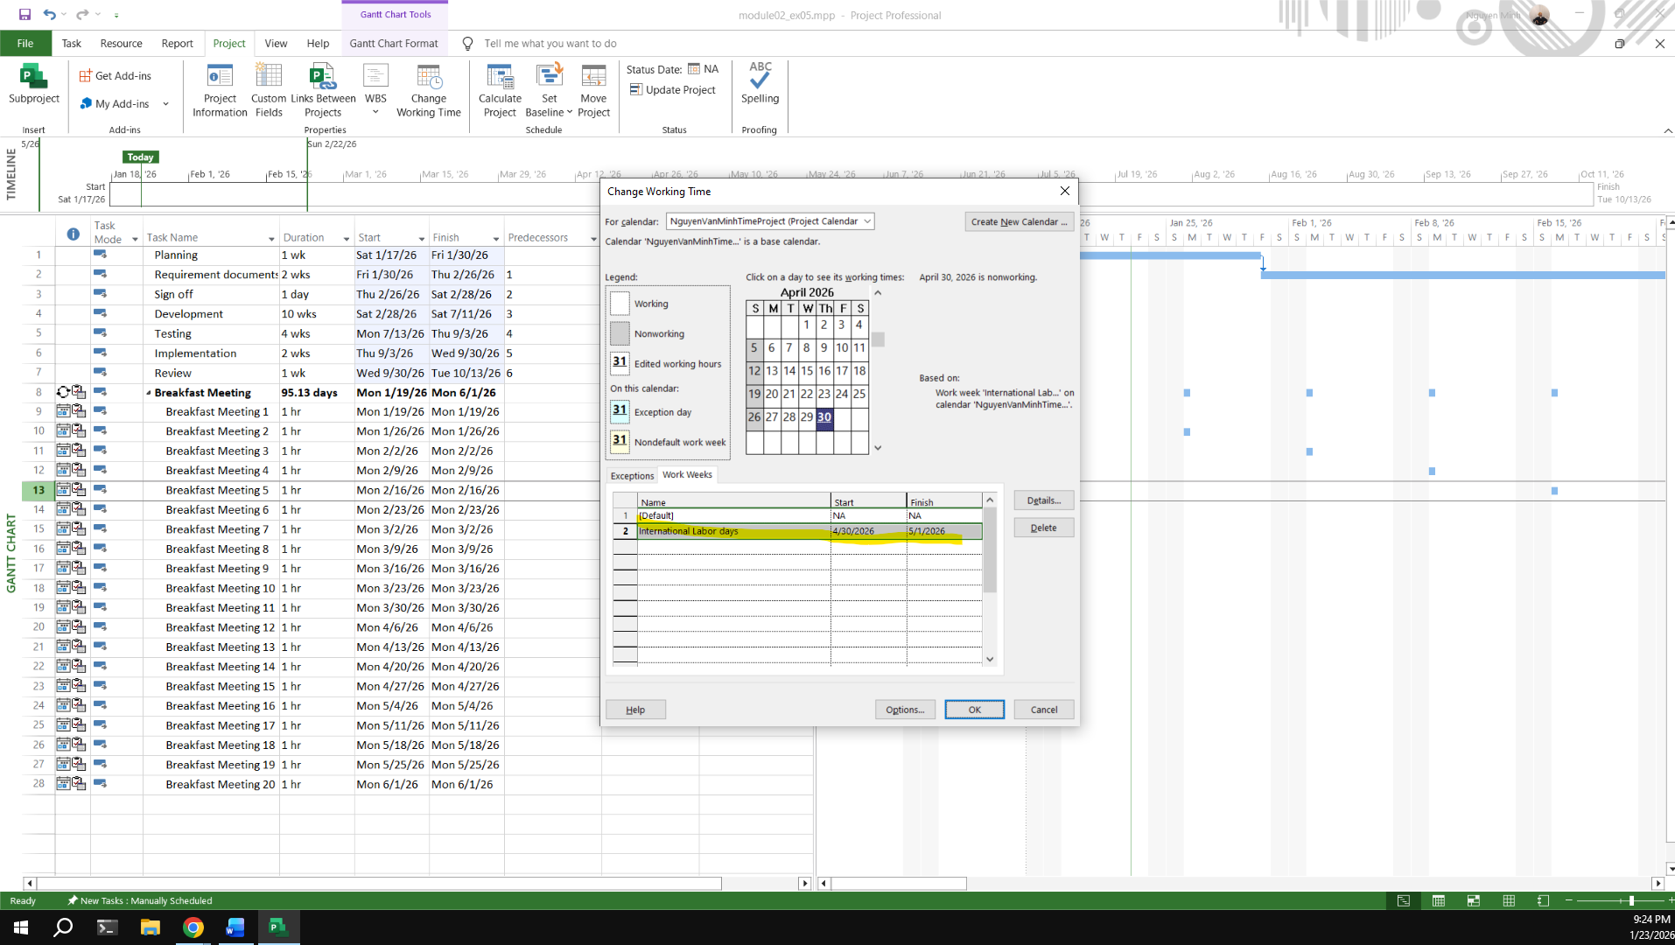
Capture the Work weeks time
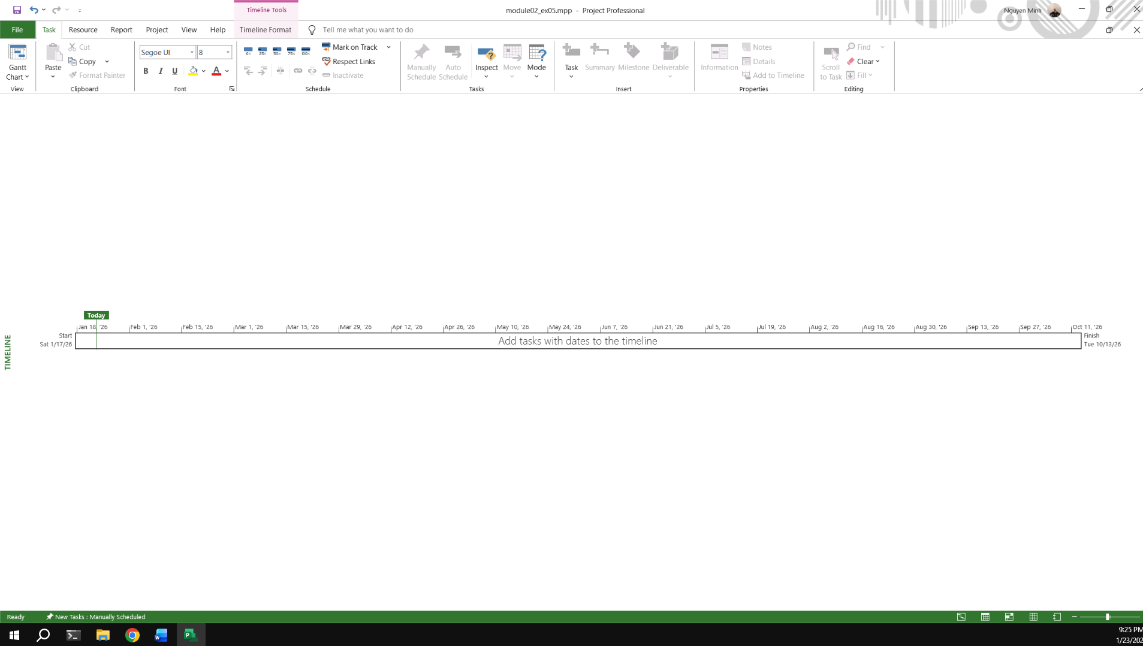
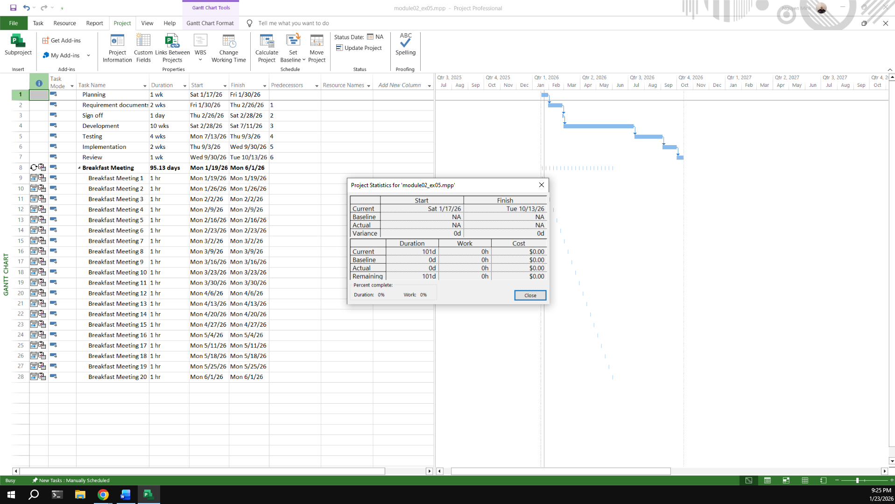

Exercise 6: My project
Create your plan from Monday to Sunday. It will list all of your activities, your time you spend and resources joining in each task.
Create a new calendar called Student based on the Standard calendar.
Change the [Default] work week so that the hours match to your calendar everyday
Using Note function in MP 2010 to take note for important tasks in your plan.
Kế hoạch công việc tháng (Programmer Monthly Plan)
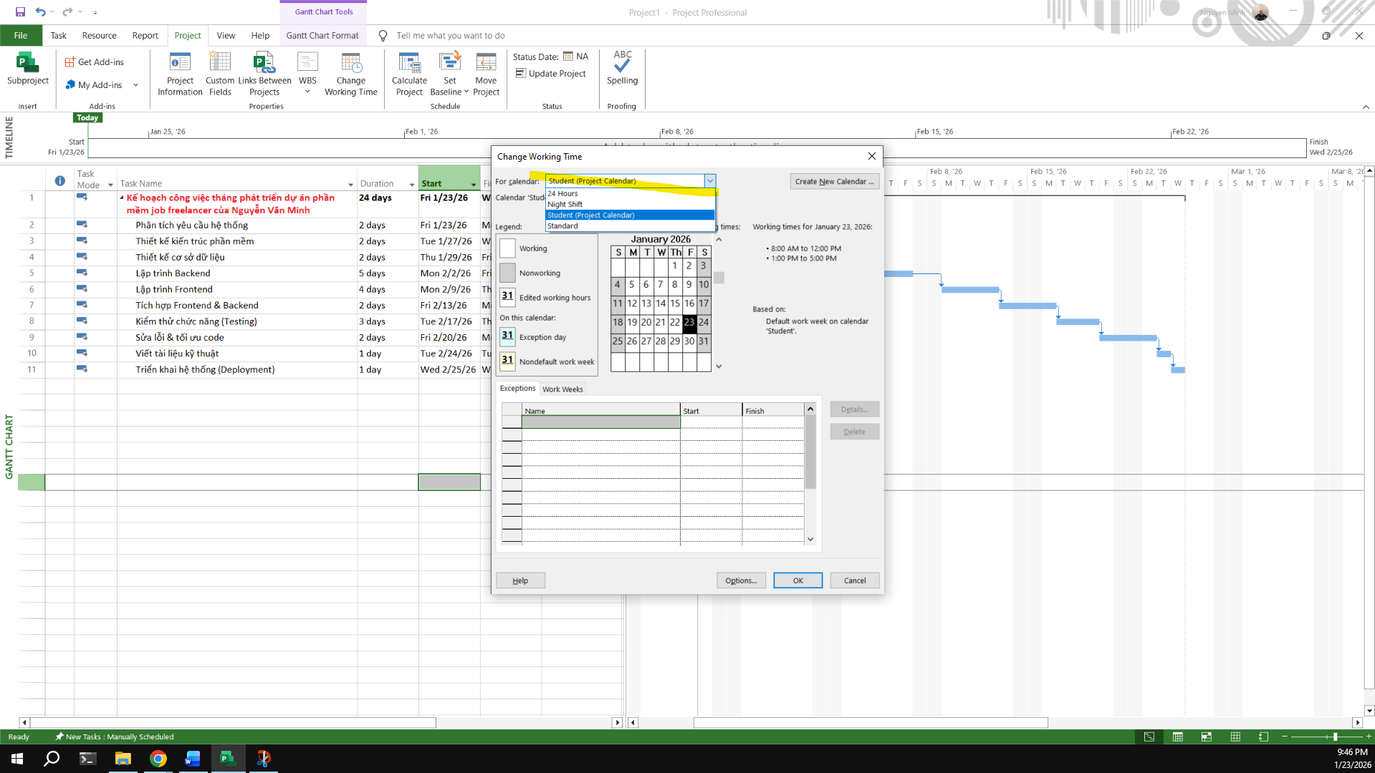
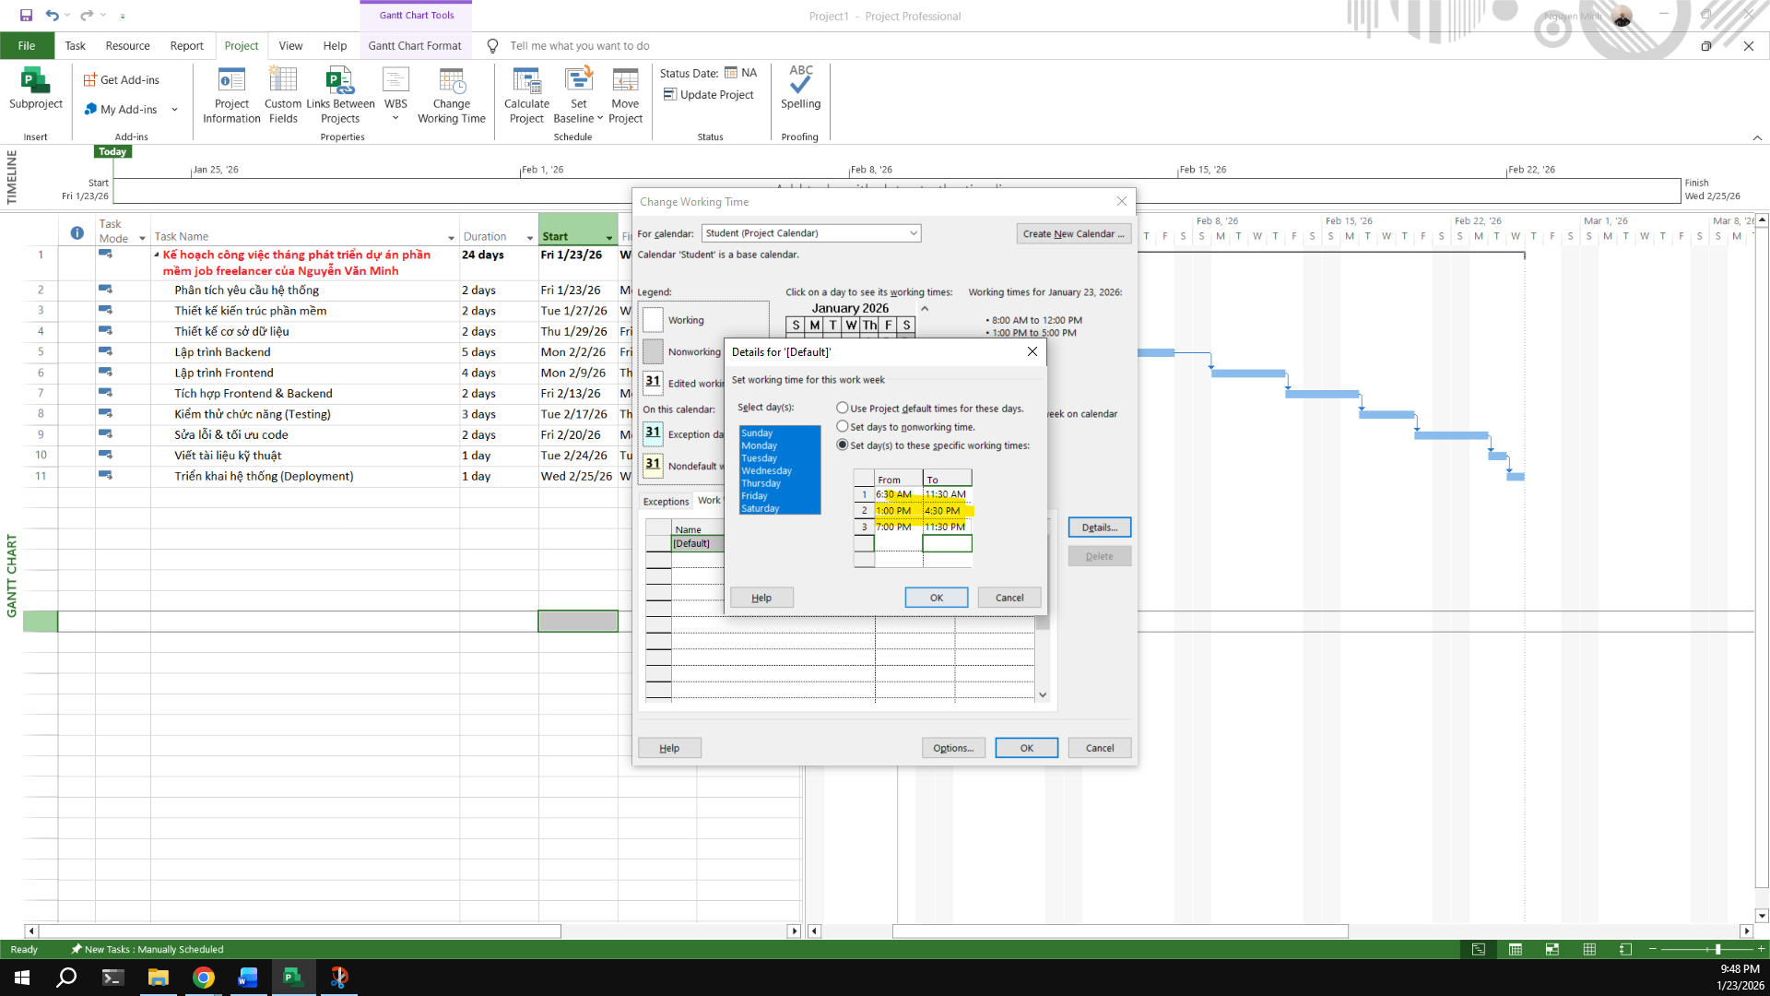
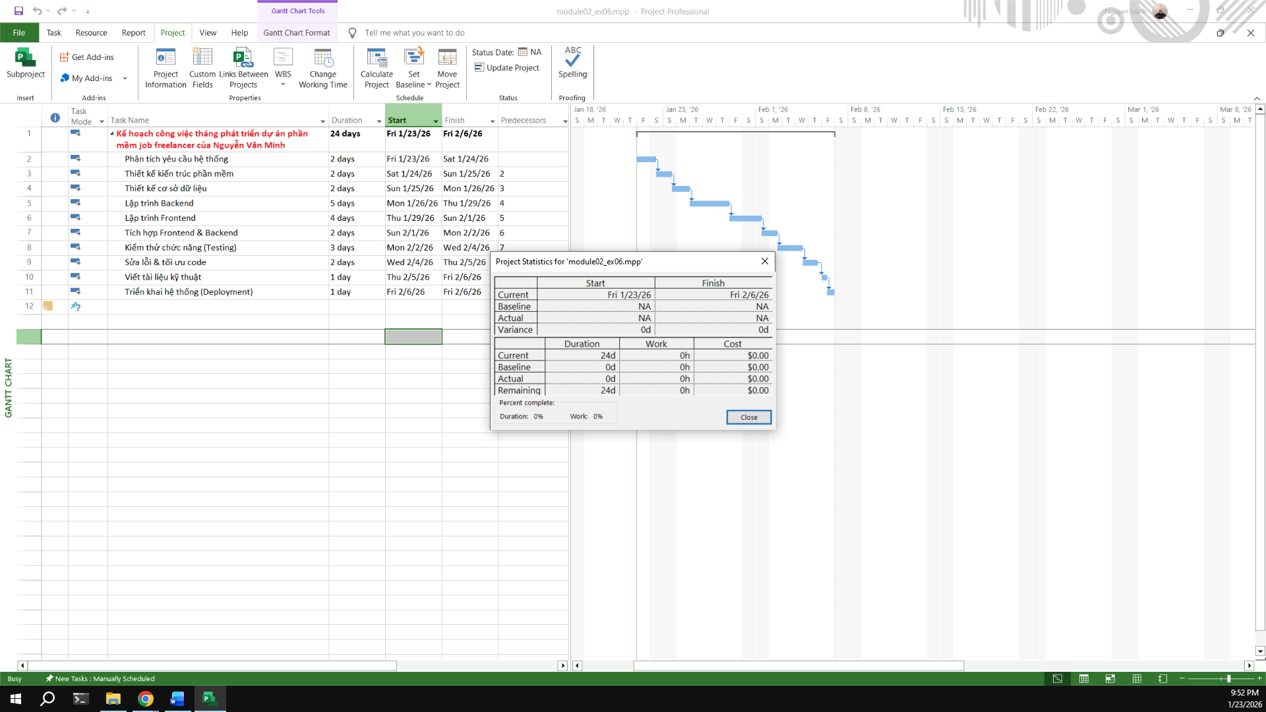

Module 3: Working with Tasks

Exercise 1: Changing Working Time (Start Date Feb 2st 2026)
Display the Project Information.
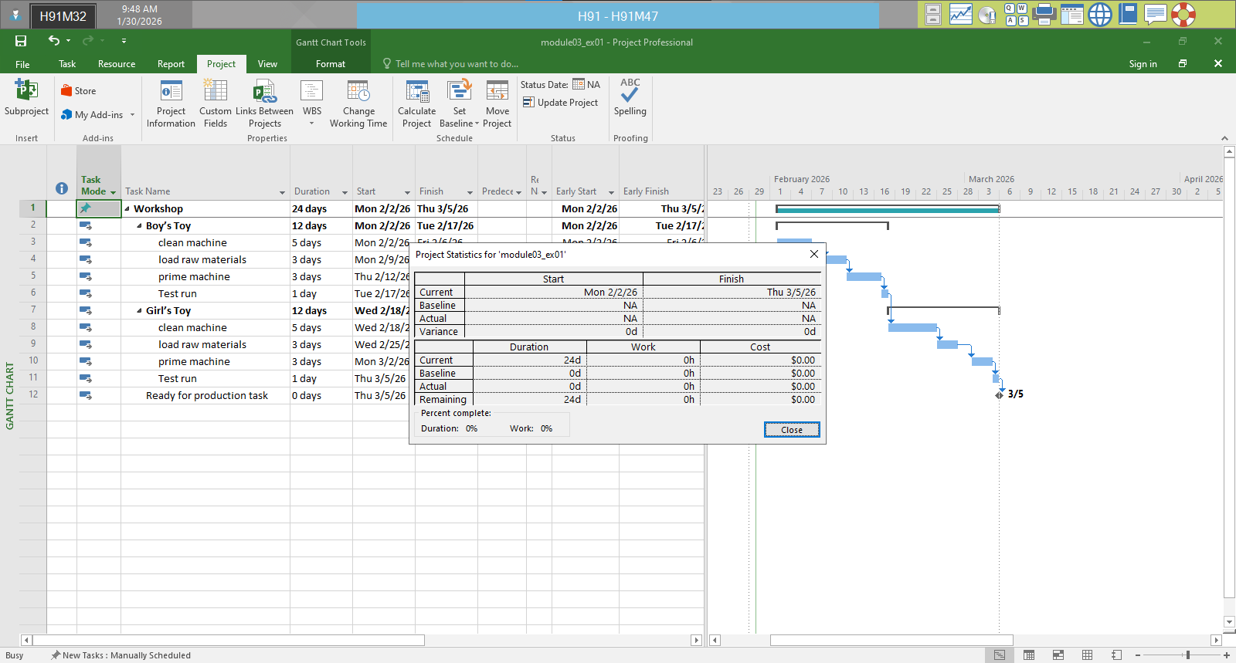
View Project Timeline
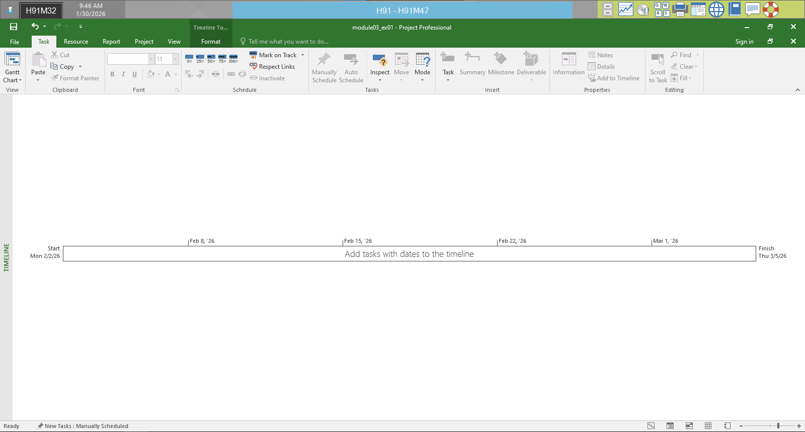
Gantt Chart
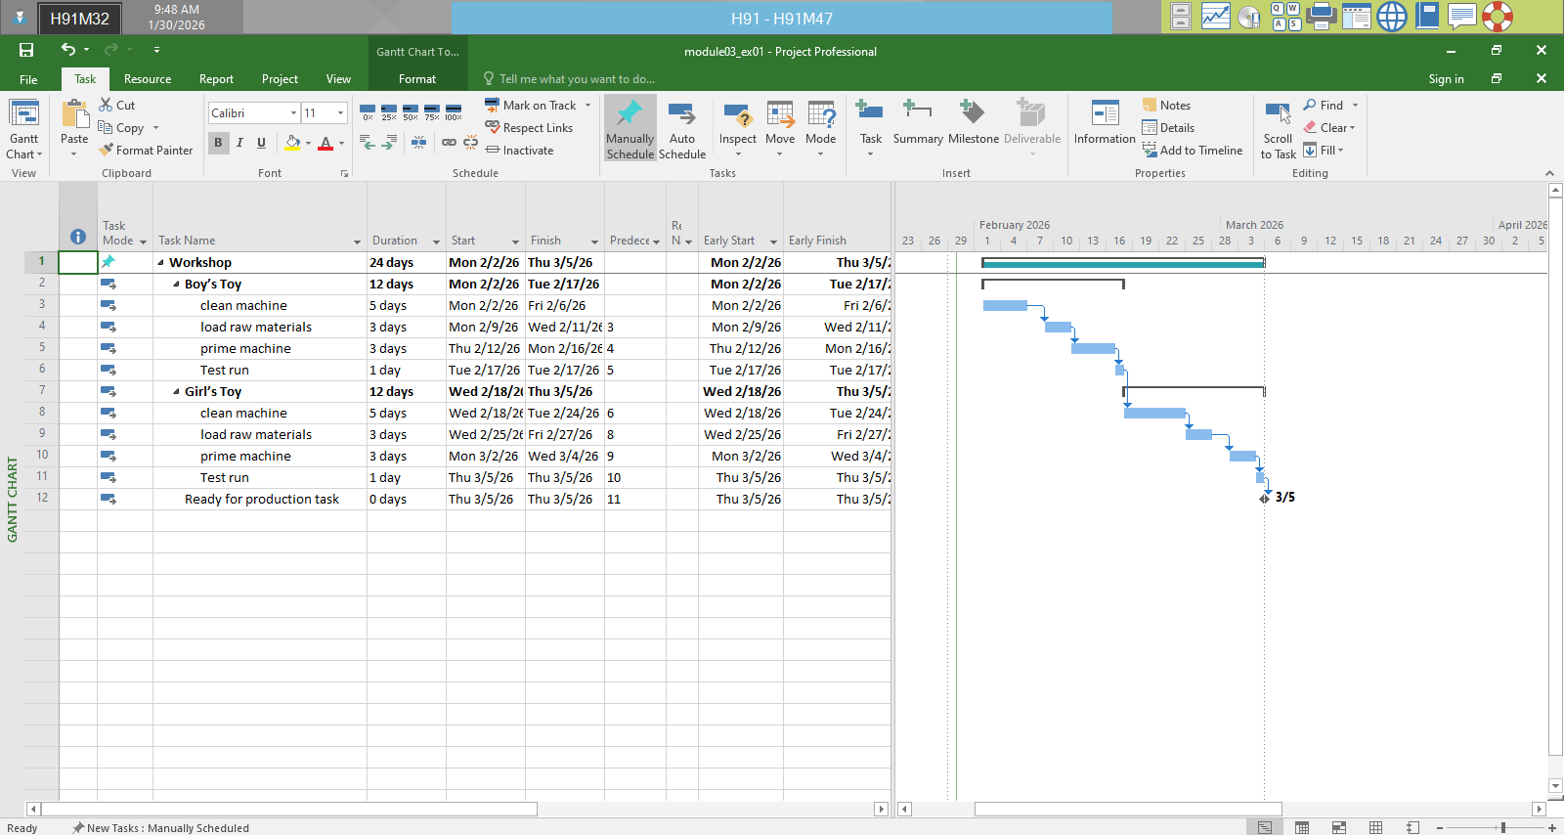
view CP
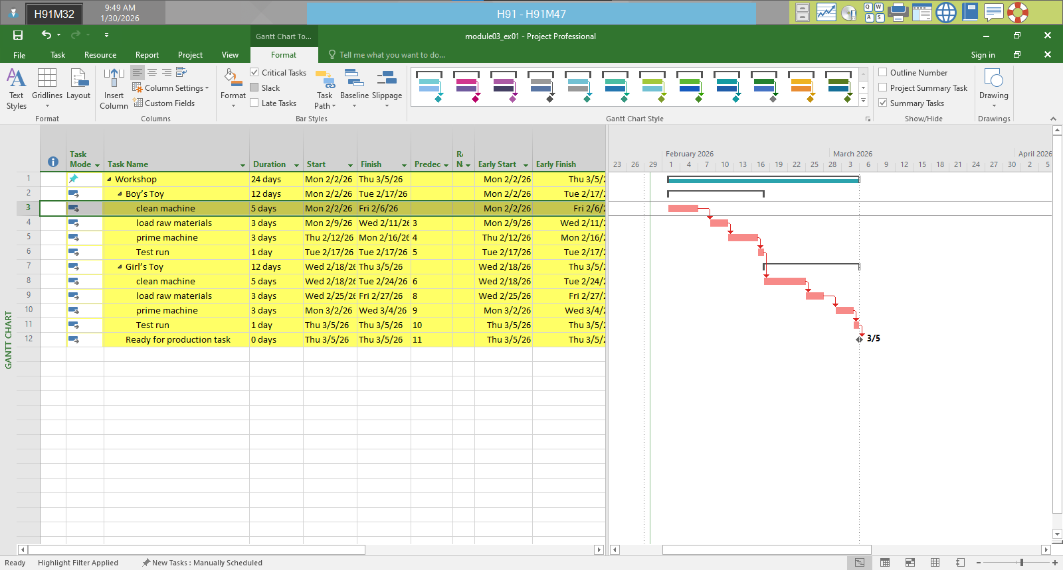
Total Slack
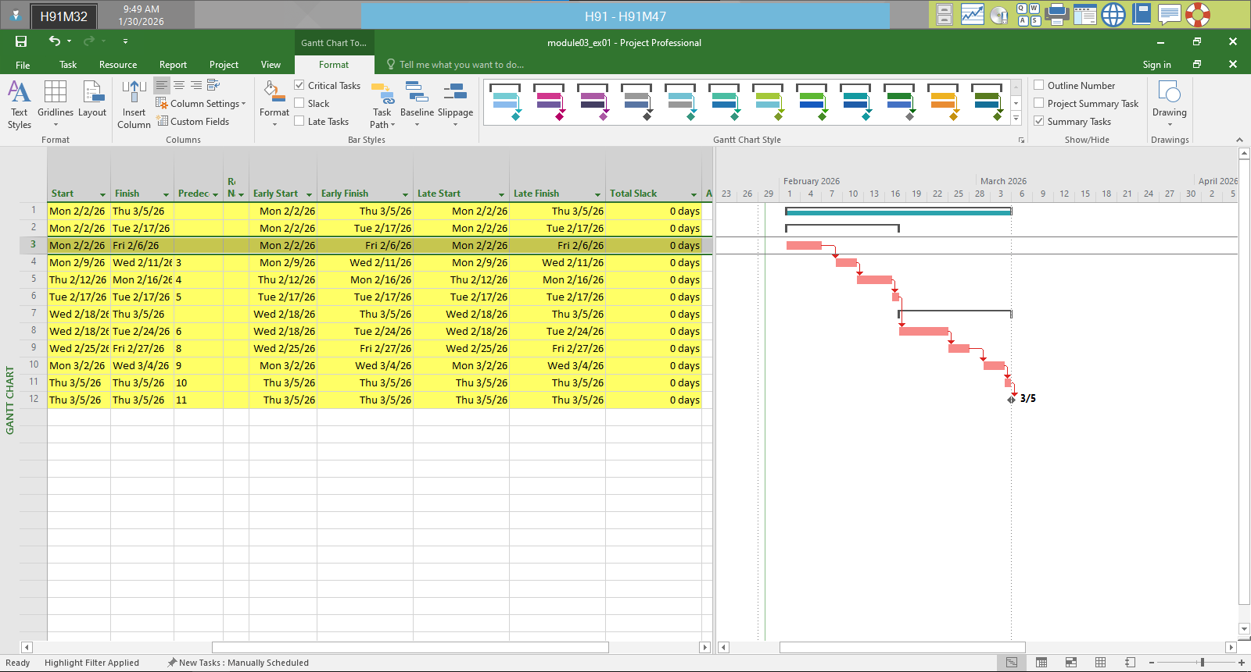

Exercise 2: Changing Working Time (Start Date Feb 2rd 2026)
Timeline
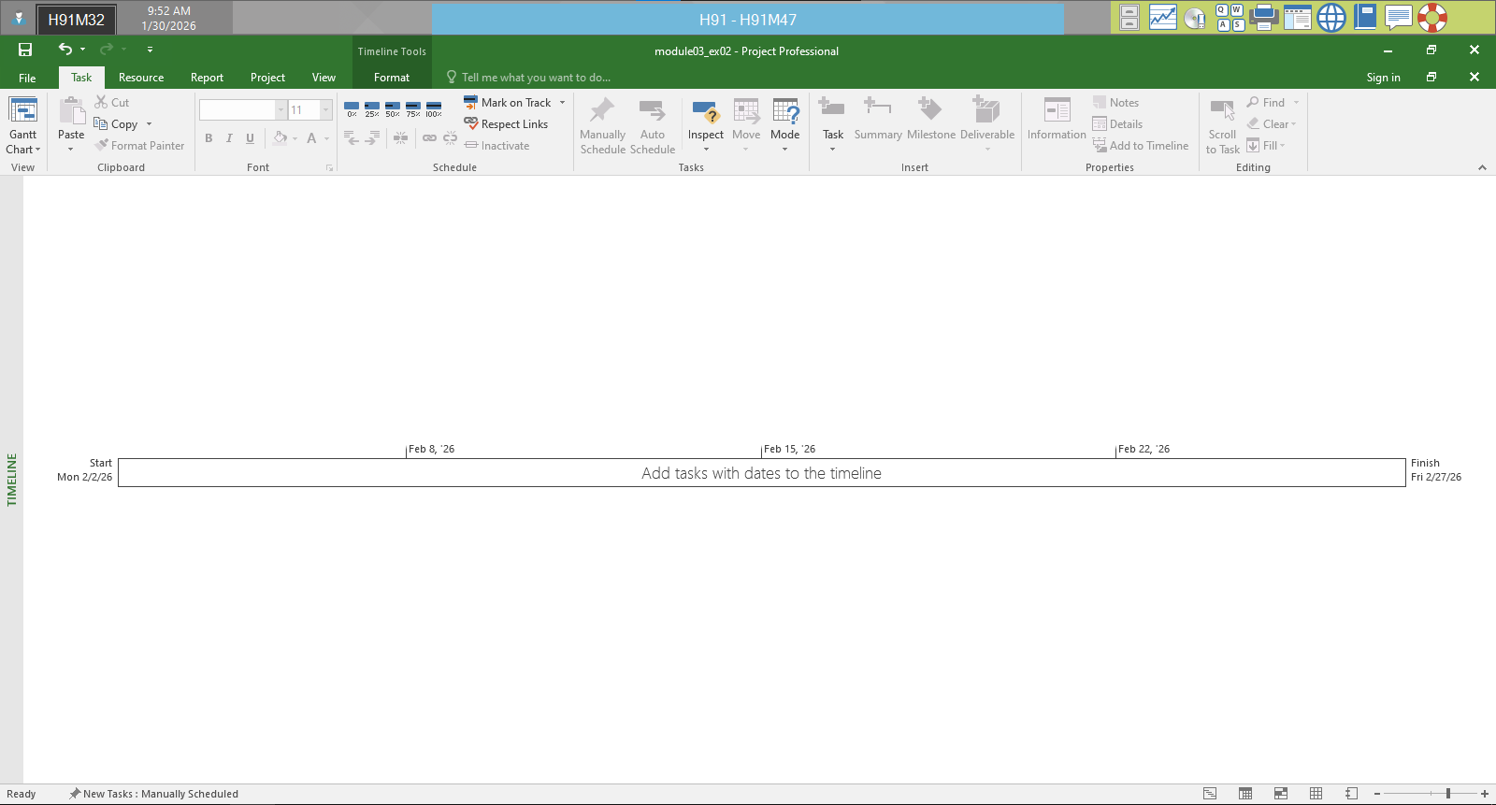
Gantt Chart
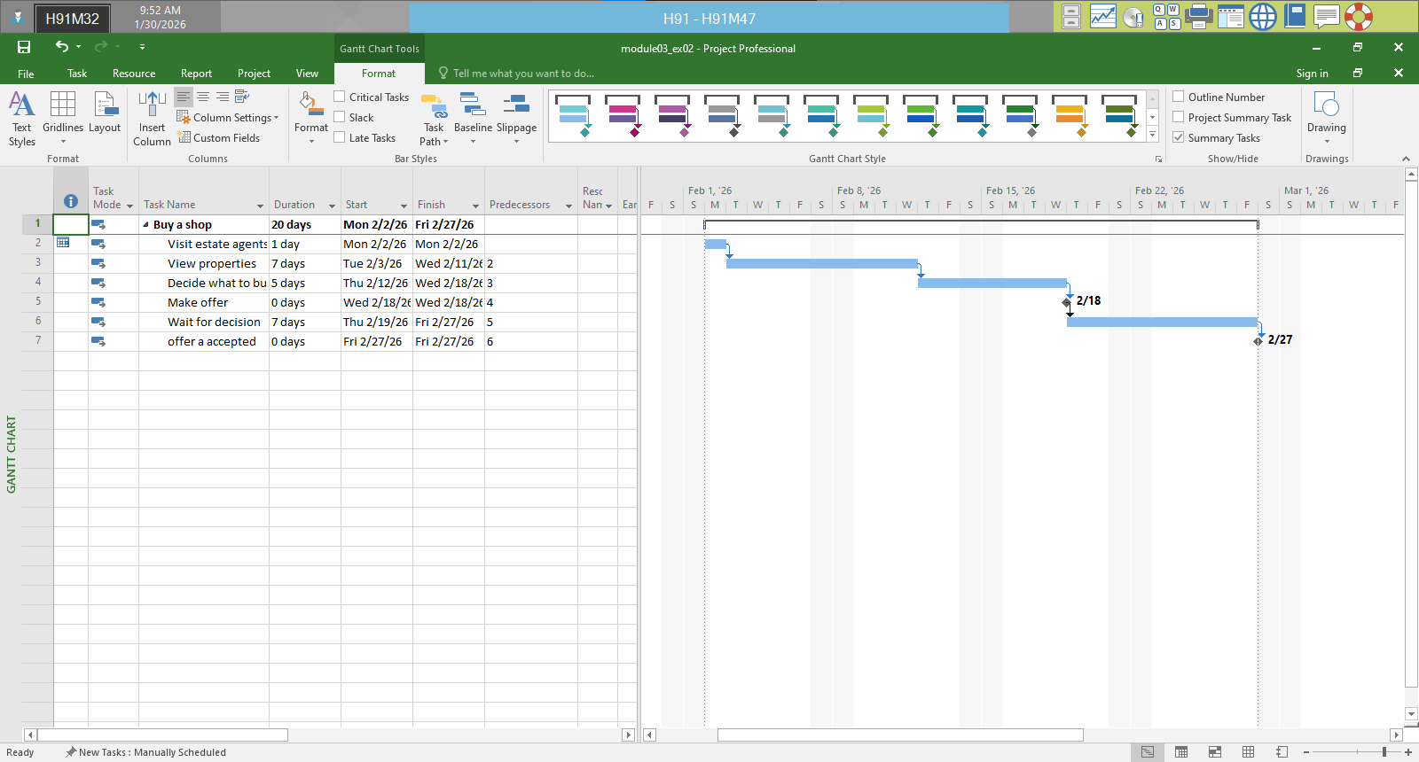
view CP
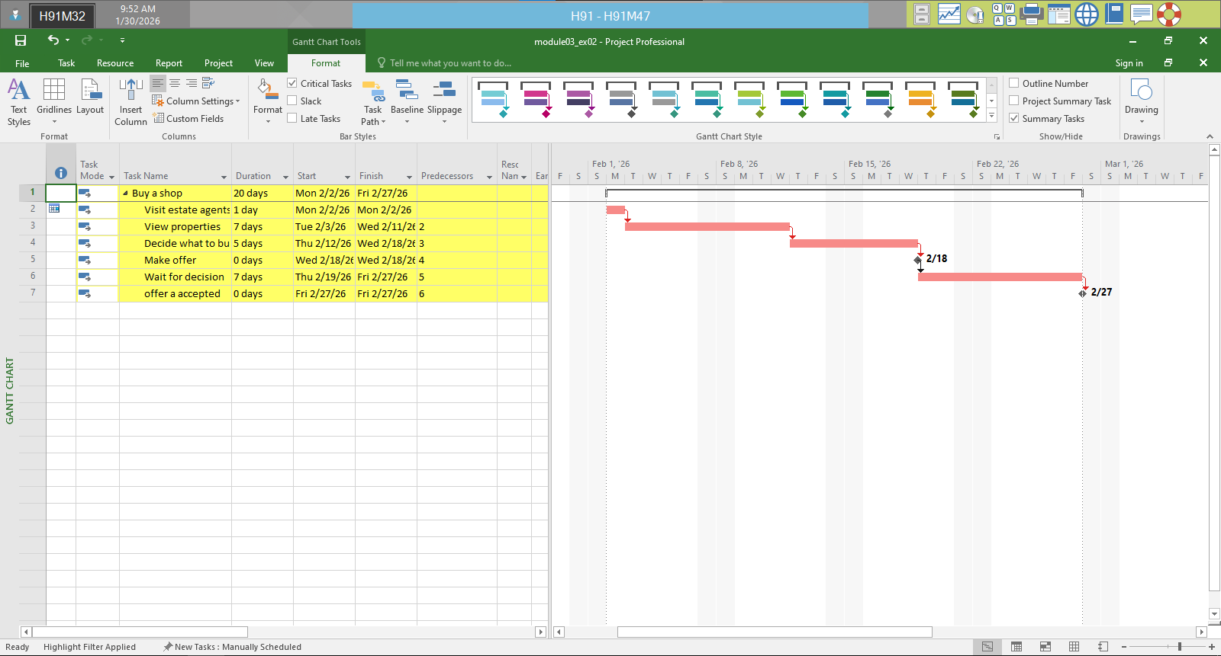
Total Slack
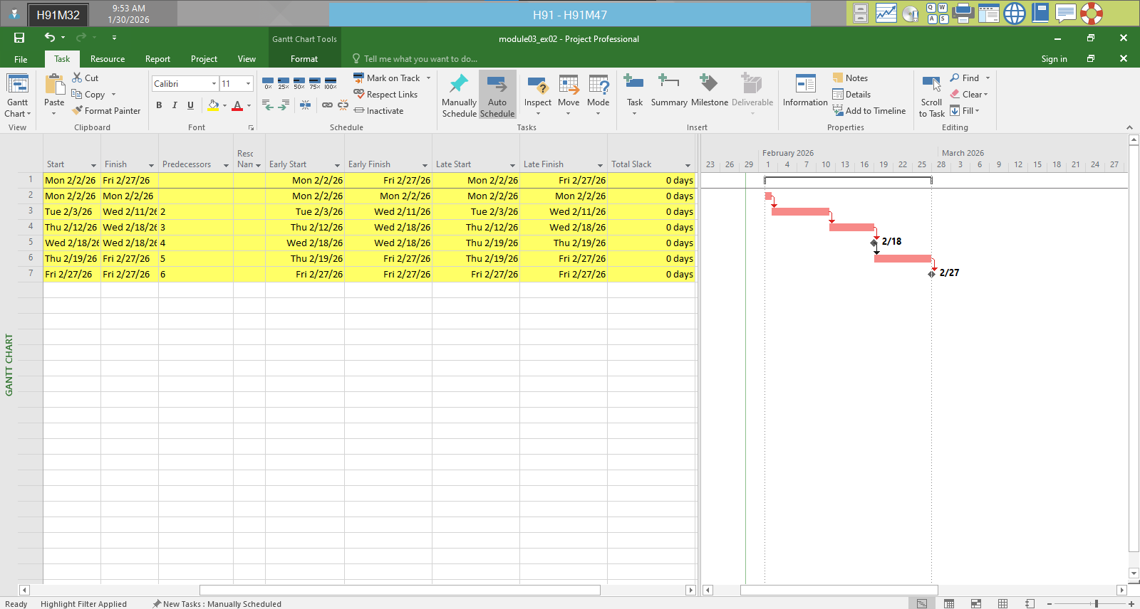

Exercise 3: Scheduling – Task dependencies
Display the Project Information.
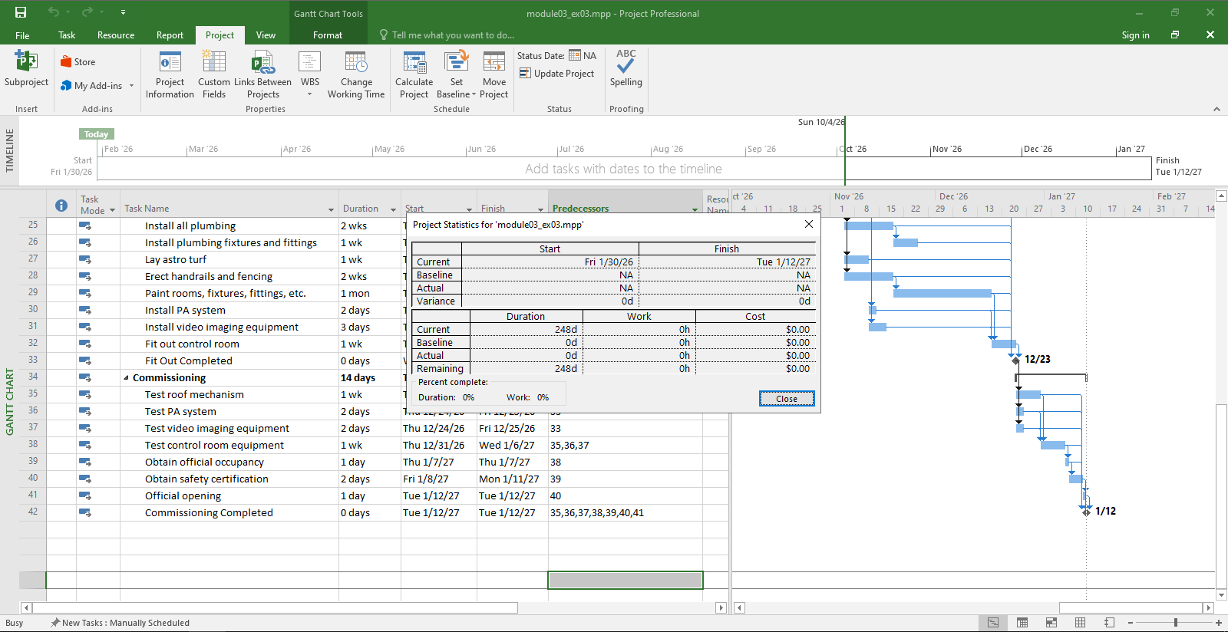
View the project in Gantt Chart and define CP and Project Slack
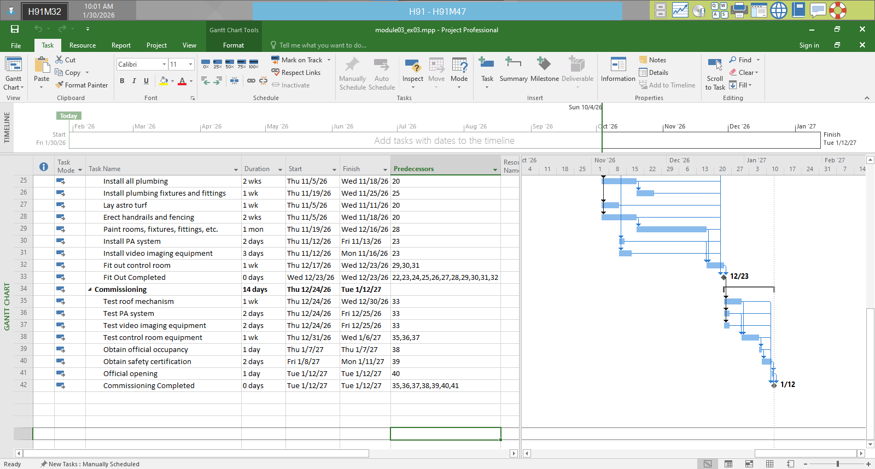
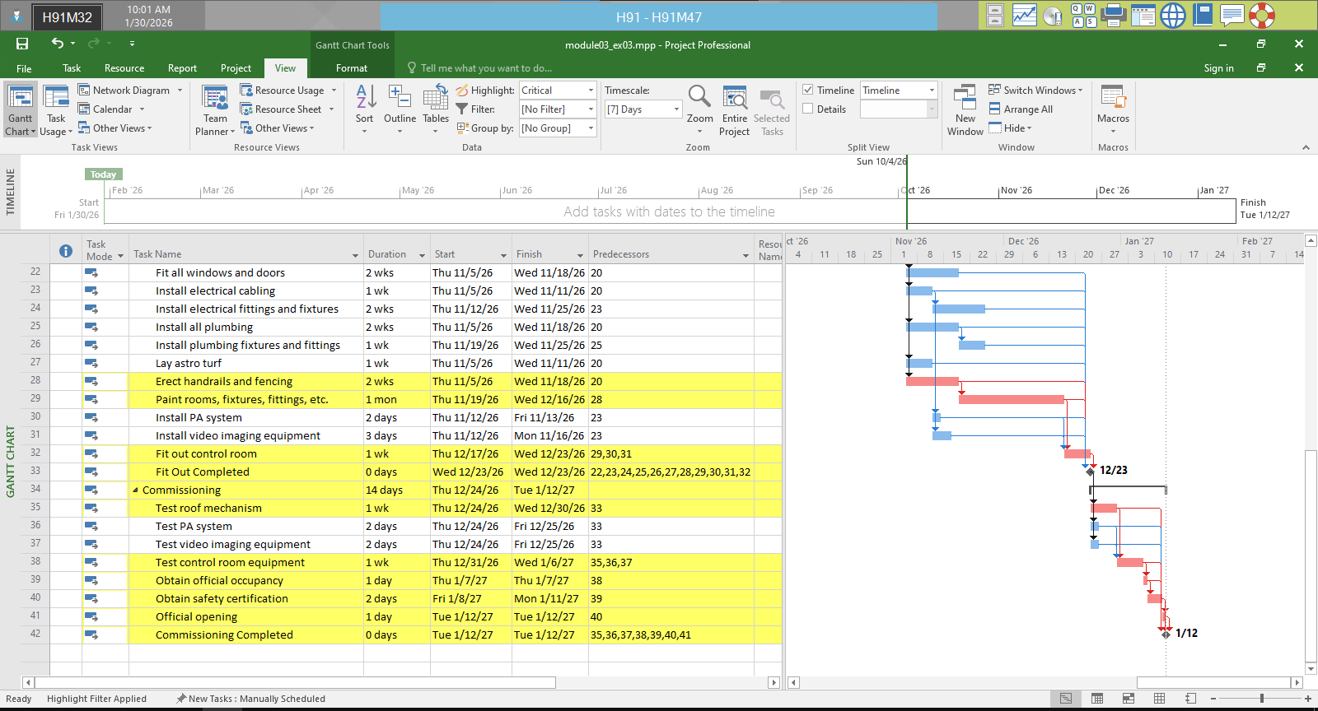
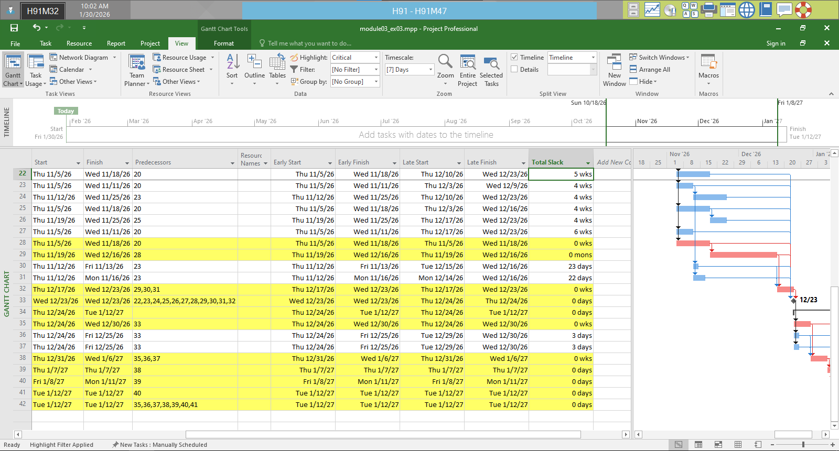
Choose Gantt Chart Format tab ◊ check on Critical Tasks in Bar Styles.
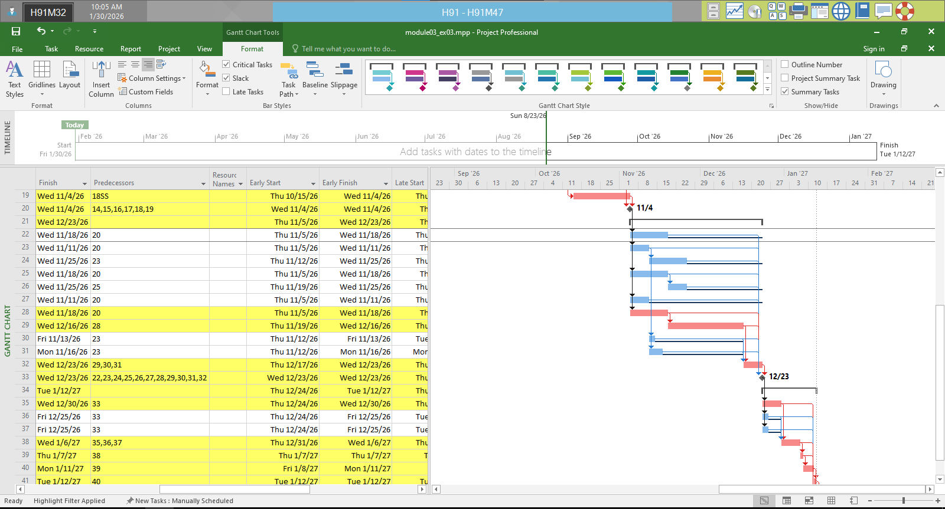
On the table data Add column Late Start, Late Finish, Total Slack
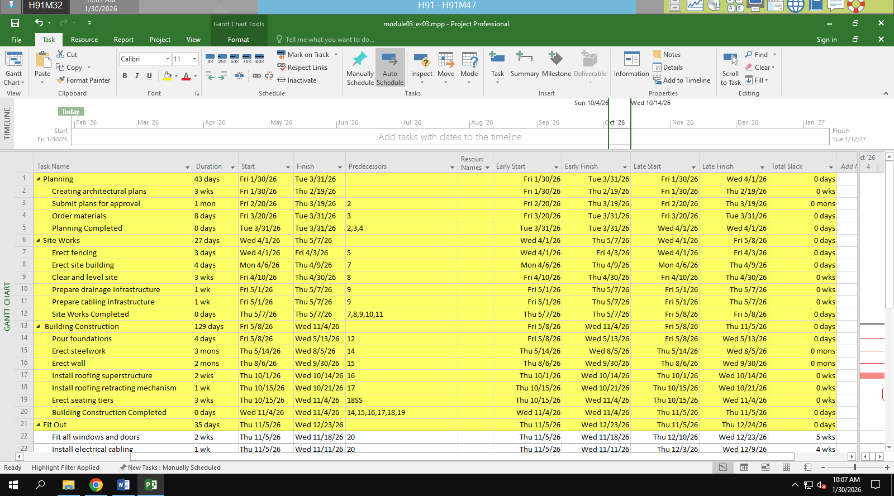
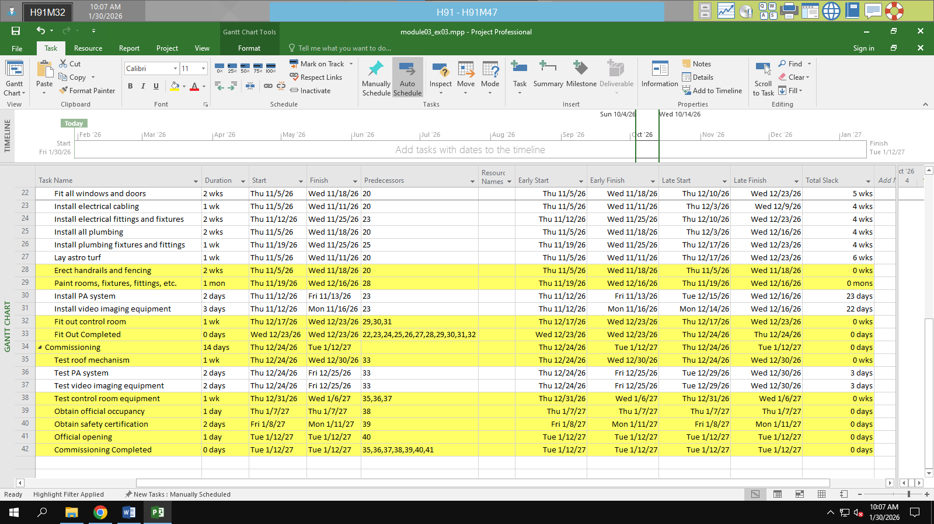

Module 4:

Exercise 1: updating …

