Trắc nghiệm thường kỳ QLDA

Chapter 01: Introduction to Project Management Learning Objectives 2
1.1. Câu hỏi 2
1.2. Đáp án & giải thích từ các chuyên gia AI lỏ 4
Chapter 02: The Project Management and Information Technology Context Learning Objectives 8
2.1. Câu hỏi 8
2.2. Đáp án & giải thích từ các chuyên gia AI lỏ 10
Chapter 04: Project Integration Management Learning Objectives 14
4.1. Câu hỏi 14
4.2. Đáp án & giải thích từ các chuyên gia AI lỏ 16
Chapter 05:Project Scope Management Learning Objectives 20
5.1. Câu hỏi 20
5.2. Đáp án & giải thích từ các chuyên gia AI lỏ 22
Chapter 06: Project Schedule Management Learning Objectives 27
6.1. Câu hỏi 27
6.2. Đáp án & giải thích từ các chuyên gia AI lỏ 30

Chapter 01: Introduction to Project Management Learning Objectives

1.1. Câu hỏi

1. By 2027, employers will need over ___ million individuals working in project management–oriented roles.
a. 27
b. 47
c. 67
d. 87

2. Which of the following is not a potential advantage of using good project management?
a. Shorter development times
b. Higher worker morale
c. Lower cost of capital
d. Higher profit margins

3. A ___ is a temporary endeavor undertaken to create a unique product, service, or result.
a. program
b. process
c. project
d. portfolio

4. Which of the following is not an attribute of a project?
a. Projects are unique.
b. Projects are developed using progressive elaboration.
c. Projects have a primary customer or sponsor.
d. Projects involve little uncertainty.

5. Which of the following is not part of the triple constraint of project management?
a. Meeting scope goals
b. Meeting time goals
c. Meeting communications goals
d. Meeting cost goals

6. ___ is the application of knowledge, skills, tools, and techniques to project activities to meet project requirements.
a. Project management
b. Program management
c. Project portfolio management
d. Requirements management

7. Project portfolio management addresses ___ goals of an organization, while project management addresses ___ goals.
a. strategic, tactical
b. tactical, strategic
c. internal, external
d. external, internal

8. Several application development projects done for the same functional group might best be managed as part of a ___.
a. portfolio
b. program
c. investment
d. collaborative

9. Which of the following is not true?
a. Most American companies have a project management office.
b. You can earn an advanced degree in project management from hundreds of colleges and universities.
c. Employers are looking for project management skills in new graduates.
d. PMI’s talent triangle includes leadership and information technology skills along with project management.

10. What is the name of one of the popular certifications provided by the Project Management Institute?
a. Certified Project Manager (CPM)
b. Project Management Professional (PMP®)
c. Project Management Expert (PME)
d. Project Management Mentor (PMM)

1.2. Đáp án & giải thích từ các chuyên gia AI lỏ

NotebookLM + Search docs
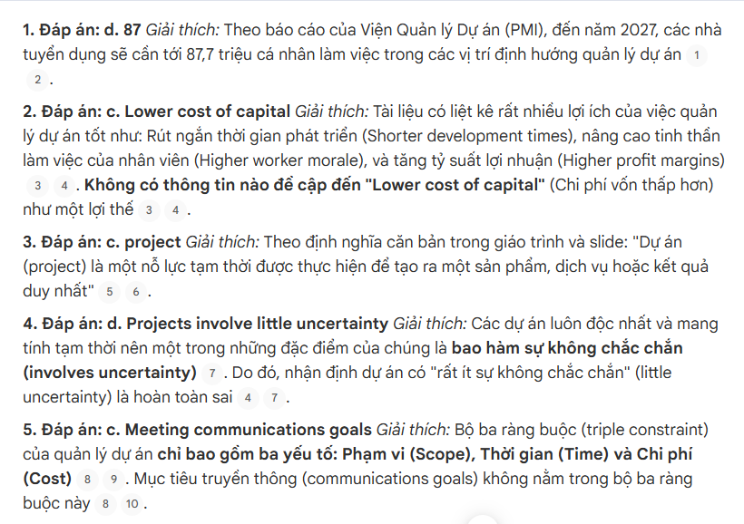
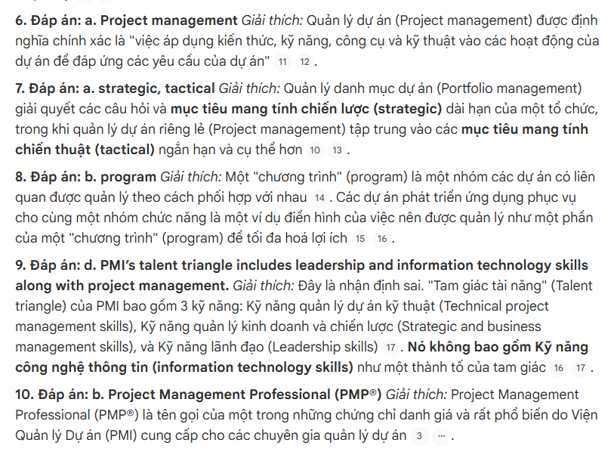

ChatGPT Go + Thinking
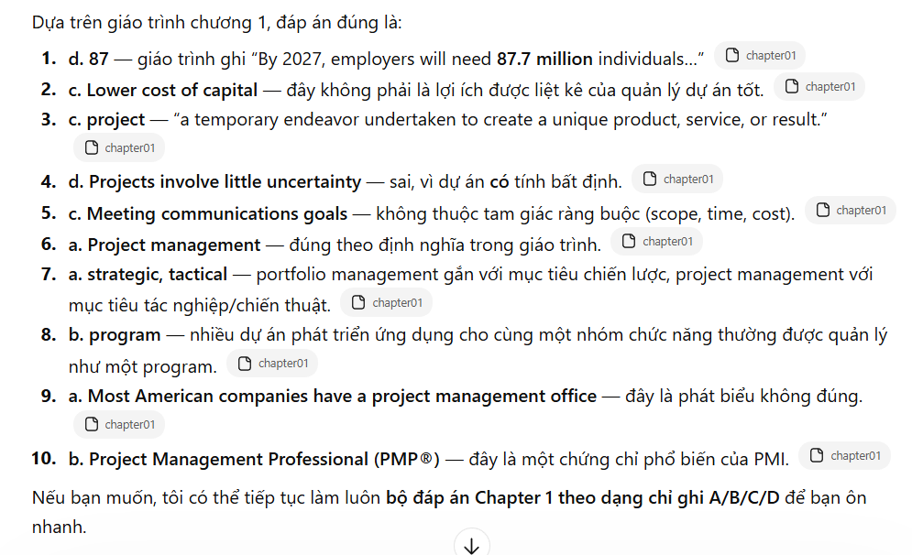

Gemini Pro + Thinking
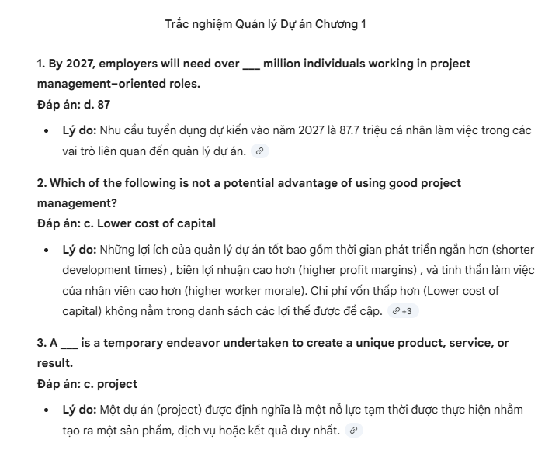
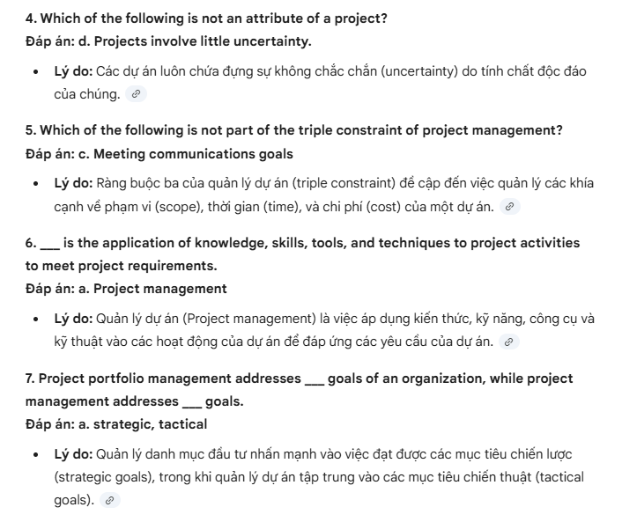
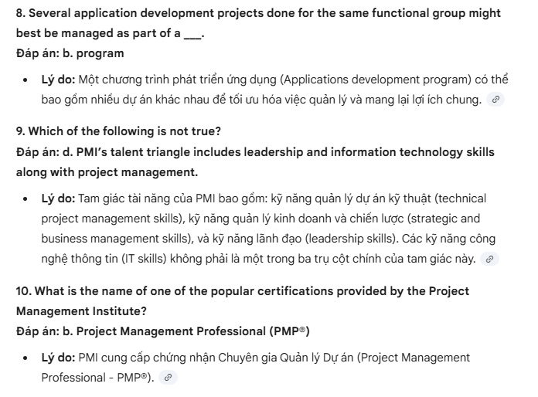

Claude Sonet 4.6 + Extended
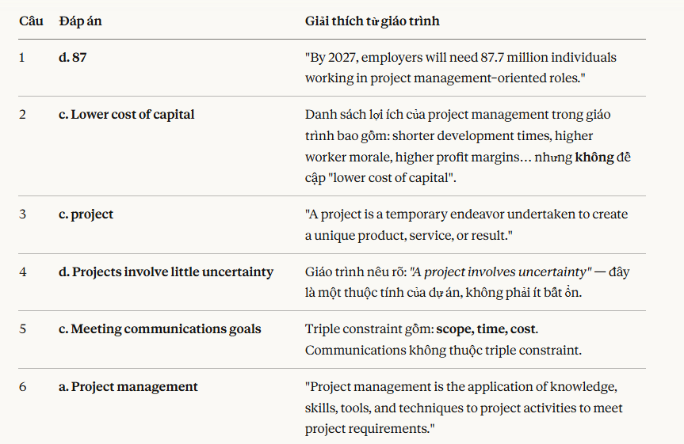
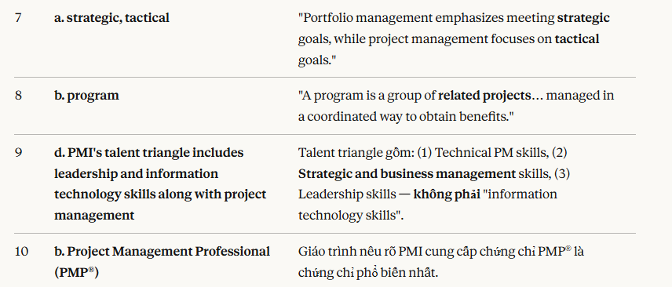

Chapter 02: The Project Management and Information Technology Context Learning Objectives

2.1. Câu hỏi

1. Which of the following is not part of the three-sphere model for systems management?
a. Business
b. Information
c. Technology
d. Organization

2. Which of the four frames of organizations addresses how meetings are run, employee dress codes, and expected work hours?
a. Structural
b. Human resources
c. Political
d. Symbolic

3. Personnel in a ___ organizational structure often report to two or more bosses.
a. functional
b. project
c. matrix
d. hybrid

4. Project work is most successful in an organizational culture where all of the following characteristics are important except ___.
a. member identity
b. group emphasis
c. risk tolerance
d. control

5. A ___ is a product or service, such as a technical report, a training session, or hardware, produced or provided as part of a project.
a. deliverable
b. product
c. work package
d. tangible goal

6. Which of the following statements is false?
a. An analysis project life cycle is a collection of project phases.
b. A product life cycle is the same as a project life cycle.
c. The waterfall approach is an example of a predictive life cycle model.
d. Agile is an example of an adaptive life cycle model.

7. Which of the following terms describes a framework of the phases involved in developing information systems?
a. Systems development life cycle
b. Rapid application development
c. Predictive life cycle
d. Extreme programming

8. The nature of IT projects is different from the nature of projects in many other industries because they are very ___.
a. expensive
b. technical
c. diverse
d. challenging

9. What term describes an organization’s acquisition of goods and services from an outside source in another country?
a. Globalization
b. Offshoring
c. Exporting
d. Global sourcing

10. ___ is the leading agile development method.
a. Extreme programming
b. Sprint
c. Kanban
d. Scrum

2.2. Đáp án & giải thích từ các chuyên gia AI lỏ

NotebookLM + Search docs
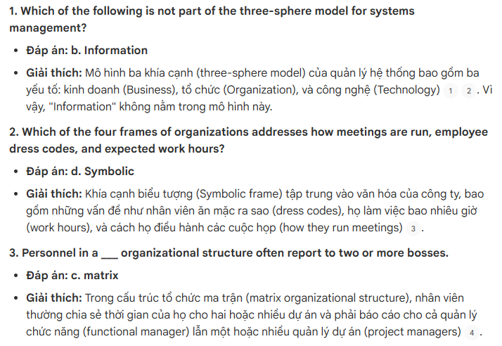
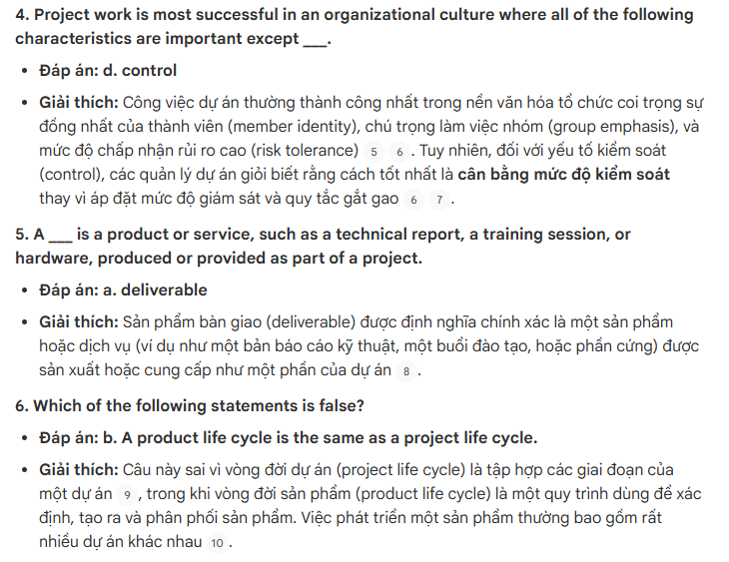
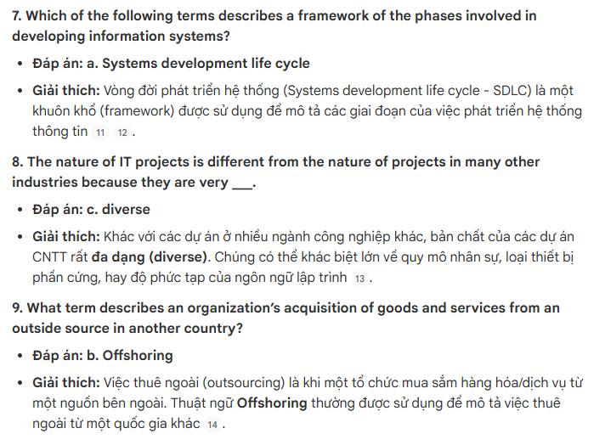
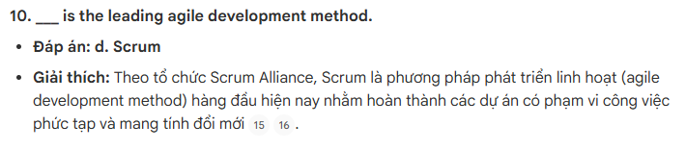

ChatGPT Go + Thinking
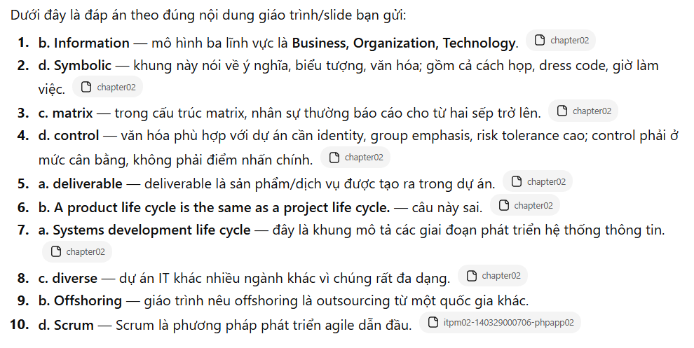

Gemini Pro + Thinking
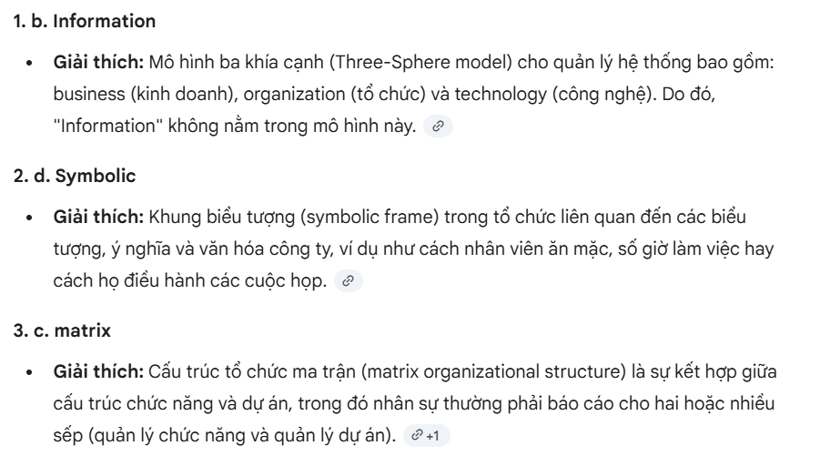
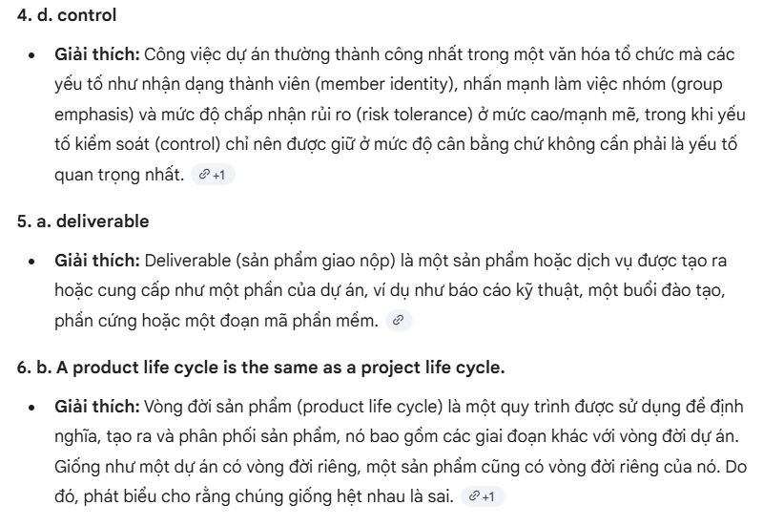
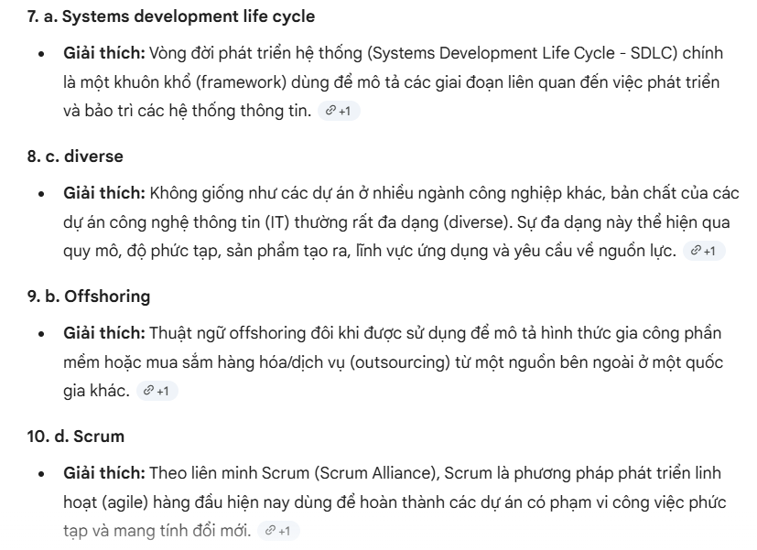

Claude Sonet 4.6 + Extended
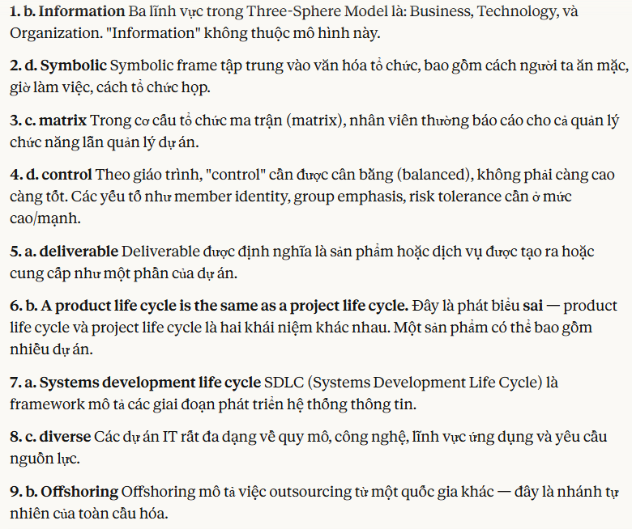

Chapter 04: Project Integration Management Learning Objectives

4.1. Câu hỏi

1. Which of the following processes is not part of project integration management?
a. Developing the project business case
b. Developing the project charter
c. Developing the project management plan
d. Closing the project or phase

2. What is the last step in the four-stage planning process for selecting IT projects?
a. IT strategy planning
b. Business area analysis
c. Mind mapping
d. Resource allocation

3. Which of the following is not a best practice for new product development projects?
a. Aligning projects and resources with business strategy
b. Selecting projects that will take less than two years to provide payback
c. Focusing on customer needs in identifying projects
d. Assigning project managers to lead projects

4. A new government law requires an organization to report data in a new way. Which of the following categories would include a new information system project to provide this data?
a. Problem
b. Opportunity
c. Directive
d. Regulation

5. If estimates for total discounted benefits for a project are $120,000 and total discounted costs are $100,000, what is the estimated return on investment (ROI)?
a. $20,000
b. $120,000
c. 20 percent
d. 120 percent

6. A ___ is a document that formally recognizes the existence of a project and provides direction on the project’s objectives and management.
a. project charter
b. contract
c. business case
d. project management plan

7. Which of the following items is not normally included in a project charter?
a. The name of the project manager
b. Budget information
c. Stakeholder signatures
d. A Gantt chart

8. ___ ensures that the descriptions of the project’s products are correct and complete.
a. Configuration management
b. Integrated change control
c. Integration management
d. A change control board

9. Which of the following is not a suggestion for performing integrated change control?
a. Use good configuration management.
b. Minimize change.
c. Establish a formal change control system.
d. View project management as a process of constant communication and negotiation.

10. What tool and technique is used for all processes of project integration management?
a. Project management software
b. Templates
c. Expert judgment
d. All of the above

4.2. Đáp án & giải thích từ các chuyên gia AI lỏ

NotebookLM + Search docs
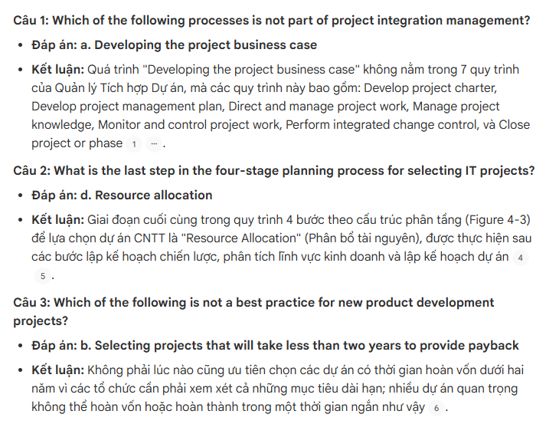
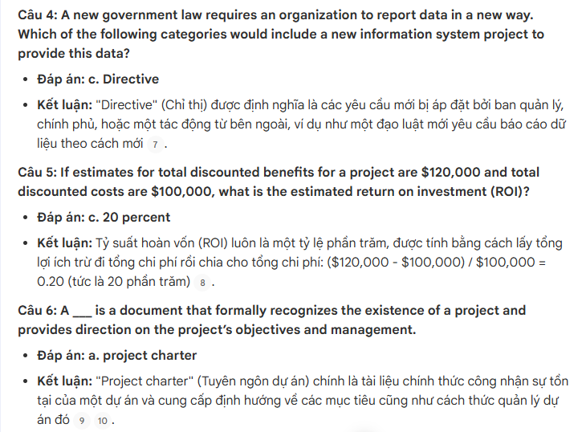
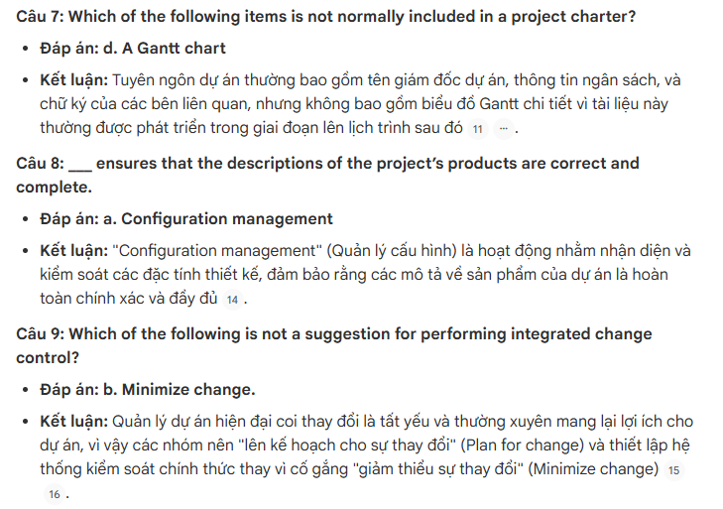
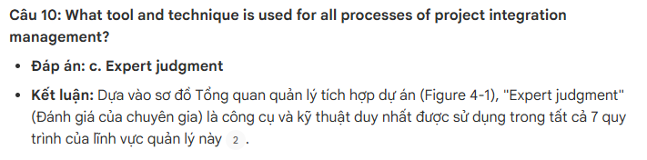
ChatGPT Go + Thinking
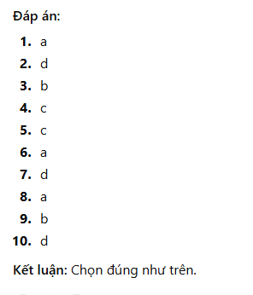
Gemini Pro + Thinking
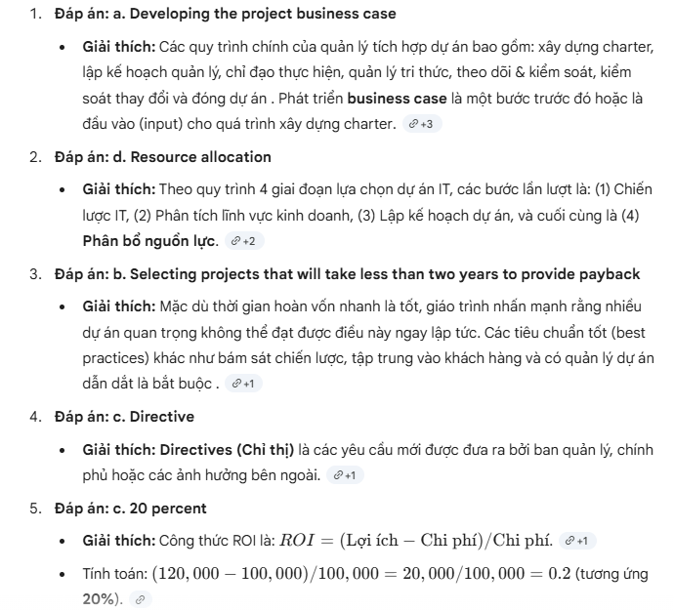
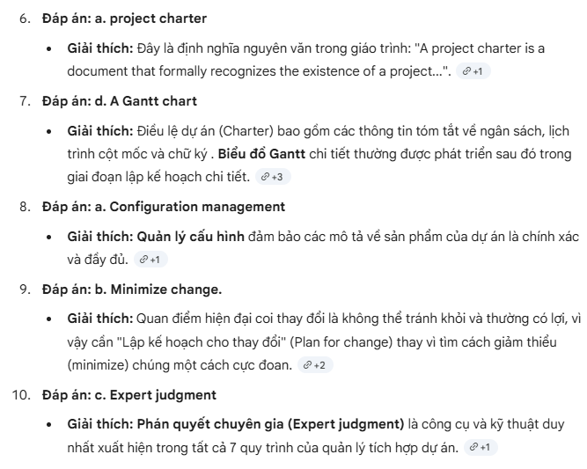

Claude Sonet 4.6 + Extended
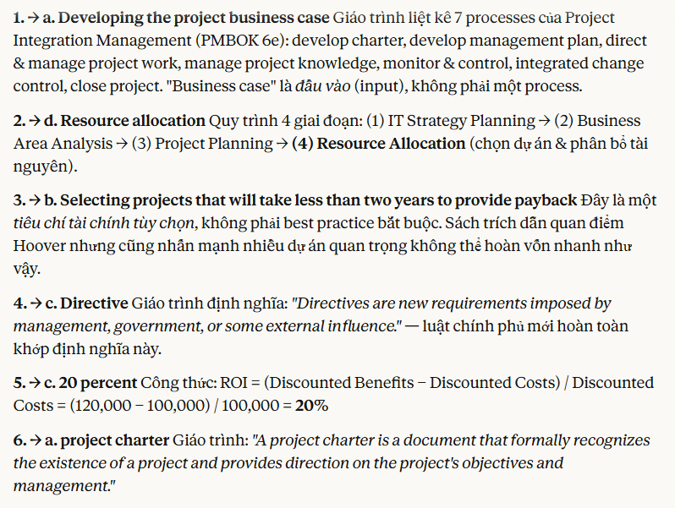
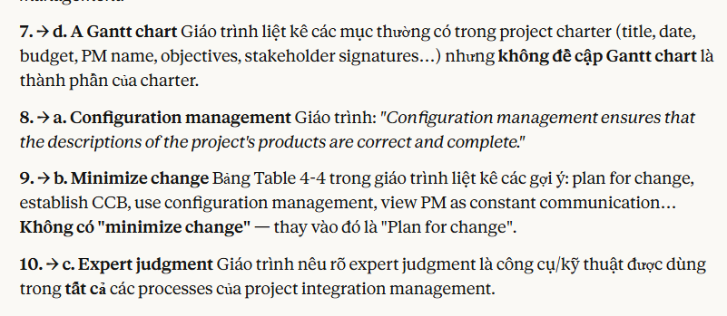

Chapter 05:Project Scope Management Learning Objectives

5.1. Câu hỏi

1. ___ refer(s) to all the work involved in creating the products of the project and the processes used to create them.
a. Deliverables
b. Milestones
c. Scope
d. Product development

2. Which tool or technique for collecting requirements is often the most expensive and time consuming?
a. Interviews
b. Focus groups
c. Surveys
d. Observation

3. A ___ is a deliverable-oriented grouping of the work involved in a project that defines its total scope.
a. scope statement
b. WBS
c. WBS dictionary
d. work package

4. What approach to developing a WBS involves writing down or drawing ideas in a nonlinear format?
a. Top-down
b. Bottom-up
c. Analogy
d. Mind mapping

5. Assume that you have a project with major categories called planning, analysis, design, and testing. What level of the WBS would these items fall under?
a. 0
b. 1
c. 2
d. 3

6. Which of the following is not a best practice that can help in avoiding scope problems on IT projects?
a. Keep the scope realistic.
b. Use off-the-shelf hardware and software whenever possible.
c. Follow good project management processes.
d. Don’t involve too many users in scope management.

7. What constitutes requirements for agile projects?
a. The Scrum
b. The backlog
c. The sprints
d. The requirements list

8. Scope ___ is often achieved by a customer inspection and then sign-off on key deliverables.
a. acceptance
b. validation
c. completion
d. close-out

9. Which of the following is not a suggestion for improving user input?
a. Develop a good project selection process for IT projects.
b. Have users on the project team.
c. Co-locate users with developers.
d. Only have meetings as needed, not on a regular basis.

10. Project management software helps you develop a ___, which serves as a basis for creating Gantt charts, assigning resources, and allocating costs.
a. project plan
b. schedule
c. WBS
d. deliverable

5.2. Đáp án & giải thích từ các chuyên gia AI lỏ

NotebookLM + Search docs
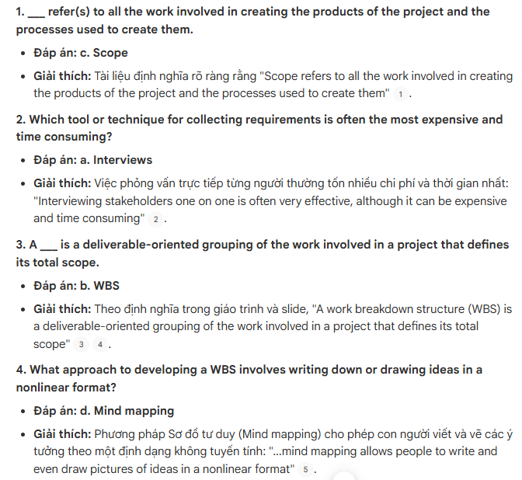
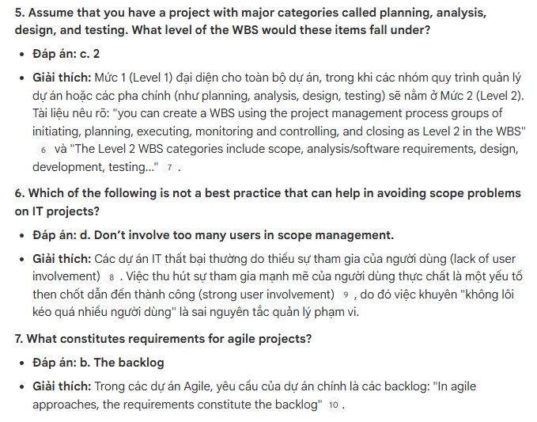
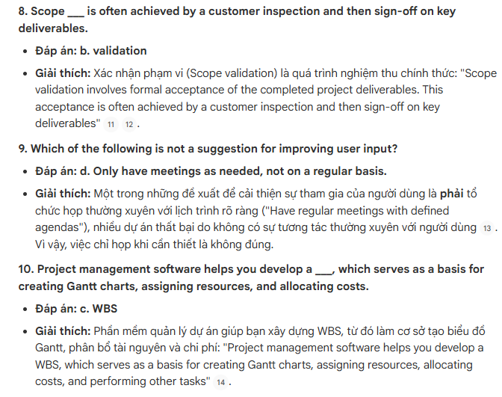

ChatGPT Go + Thinking
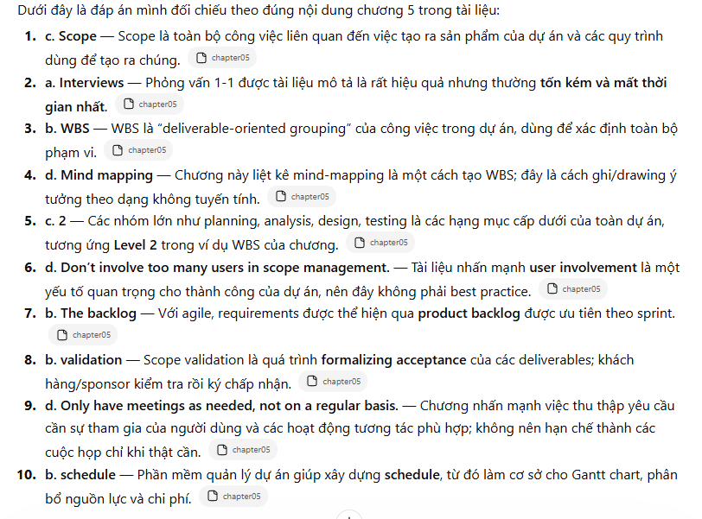

Gemini Pro + Thinking
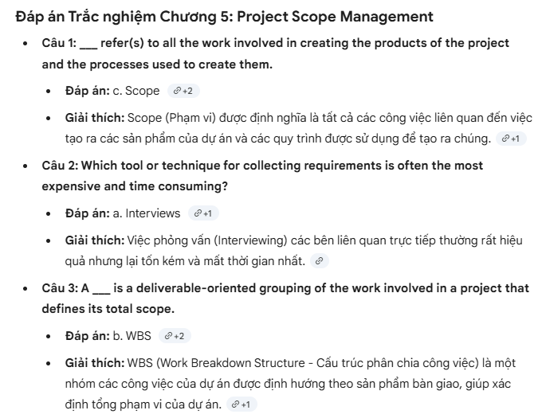
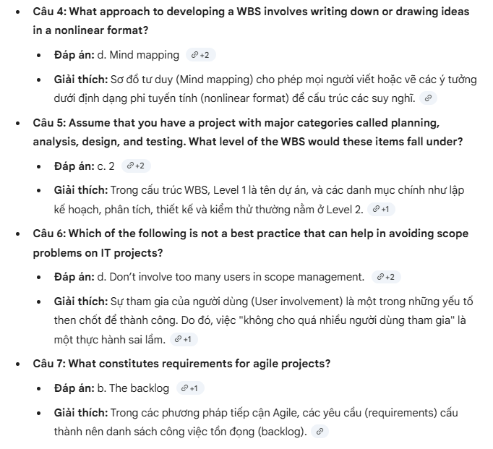
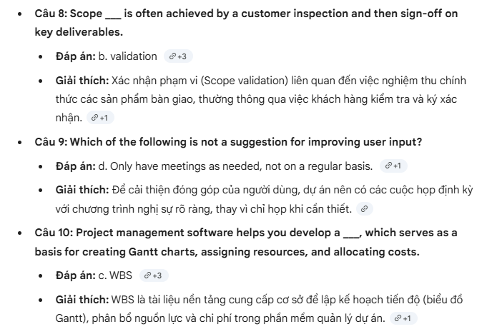

Claude Sonet 4.6 + Extended
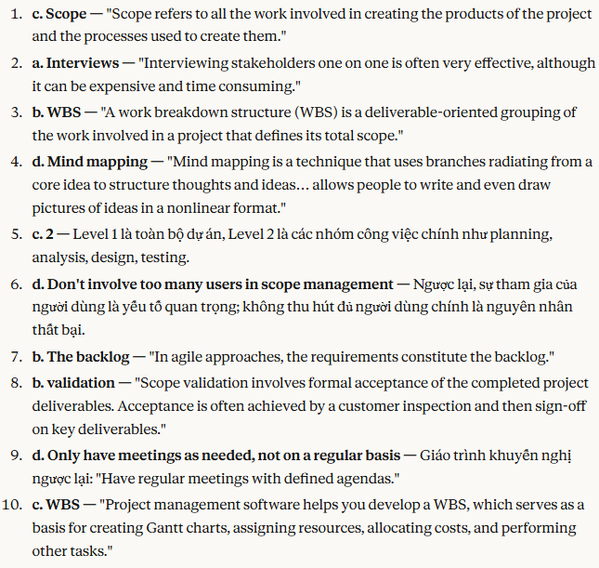

Chapter 06: Project Schedule Management Learning Objectives

6.1. Câu hỏi

1. Which of the following processes involves determining the policies, procedures, and documentation that will be used for planning, executing, and controlling the project schedule?
a. Planning schedule management
b. Defining activities
c. Estimating activity resources
d. Activity sequencing

2. Predecessors, successors, logical relationships, leads and lags, resource requirements, constraints, imposed dates, and assumptions are all examples of ___.
a. items in an activity list
b. items on a Gantt chart
c. milestone attributes
d. activity attributes

3. As the project manager for a software development project, you are helping to develop the project schedule. You decide that writing code for a system should not start until users sign off on the analysis work. What type of dependency is this?
a. Technical
b. Mandatory
c. Discretionary
d. External

4. You cannot start editing a technical report until someone else completes the first draft. What type of dependency does this represent?
a. Finish-to-start
b. Start-to-start
c. Finish-to-finish
d. Start-to-finish

5. Which of the following statements is false?
a. A burndown chart is a tool for schedule control.
b. Duration and effort are synonymous terms.
c. A three-point estimate includes an optimistic, a most likely, and a pessimistic estimate.
d. A Gantt chart is a common tool for displaying project schedule information.

6. What symbol on a Gantt chart represents a slipped milestone?
a. A black arrow
b. A white arrow
c. A black diamond
d. A white diamond

7. What type of diagram shows planned and actual project schedule information?
a. A network diagram
b. A Gantt chart
c. A Tracking Gantt chart
d. A milestone chart

8. ___ is a network diagramming technique used to predict total project duration.
a. PERT
b. A Gantt chart
c. Critical path method
d. Crashing

9. Which of the following statements is false?
a. Growing grass was on the critical path for a large theme park project.
b. The critical path is the series of activities that determine the earliest time by which a project can be completed.
c. A forward pass through a project network diagram determines the early start and early finish dates for each activity.
d. Fast tracking is a technique for making cost and schedule trade-offs to obtain the greatest amount of schedule compression for the least incremental cost.

10. ___ is a method of scheduling that considers limited resources when creating a project schedule and includes buffers to protect the project completion date.
a. Parkinson’s Law
b. Scrum
c. Critical path analysis
d. Critical chain scheduling

6.2. Đáp án & giải thích từ các chuyên gia AI lỏ

NotebookLM + Search docs
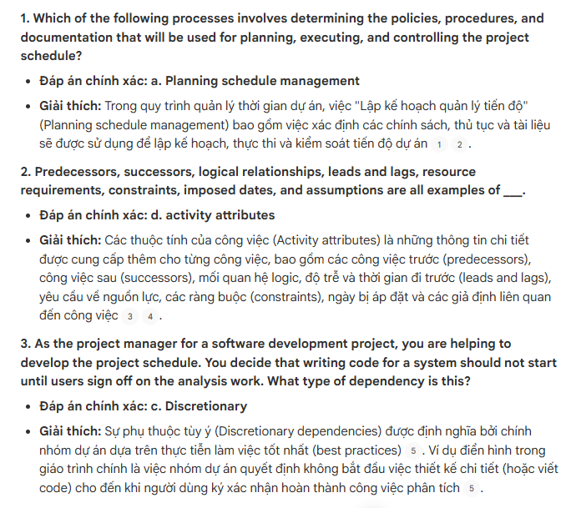
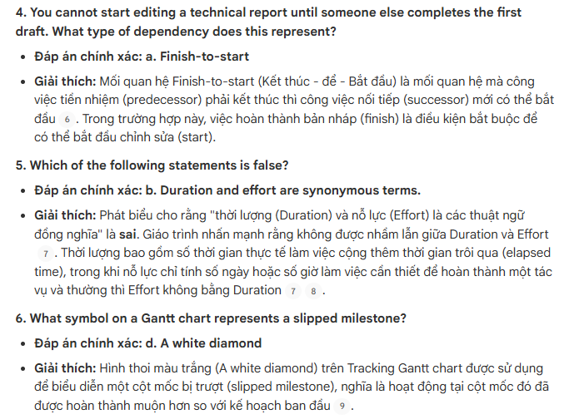
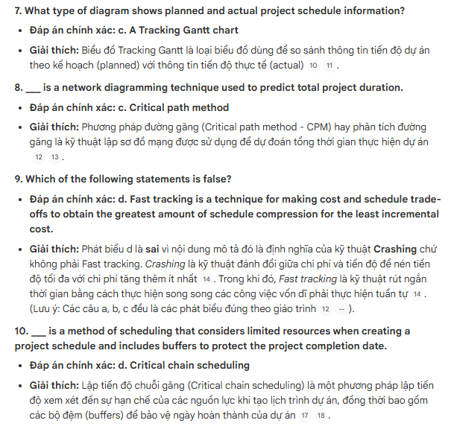

ChatGPT Go + Thinking
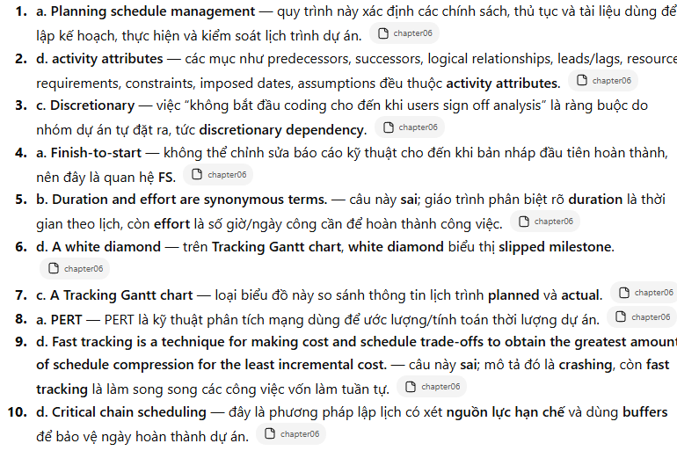

Gemini Pro + Thinking
