**Admin** update Shop  
1/ Edit Shop Detail Page

**\* Update fields for Shop:**

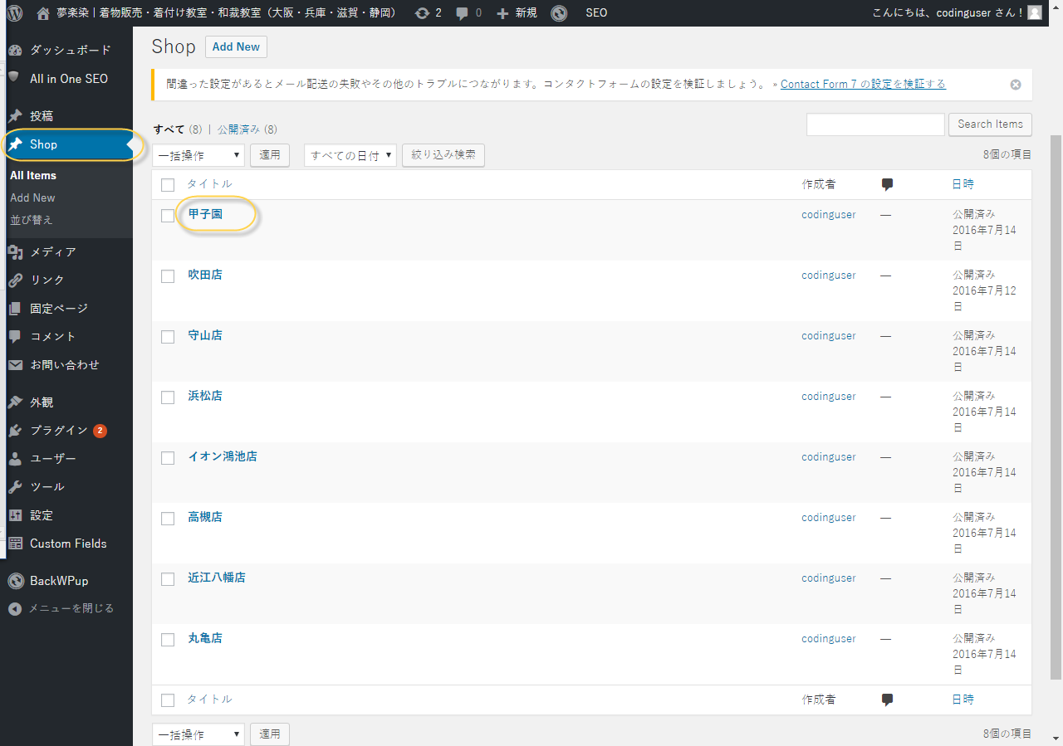

**1.1/Shop Information:**

**+ Choose the Shop user ( choose one of user account – who you setup)**

**This option will display all news from that Shop user**

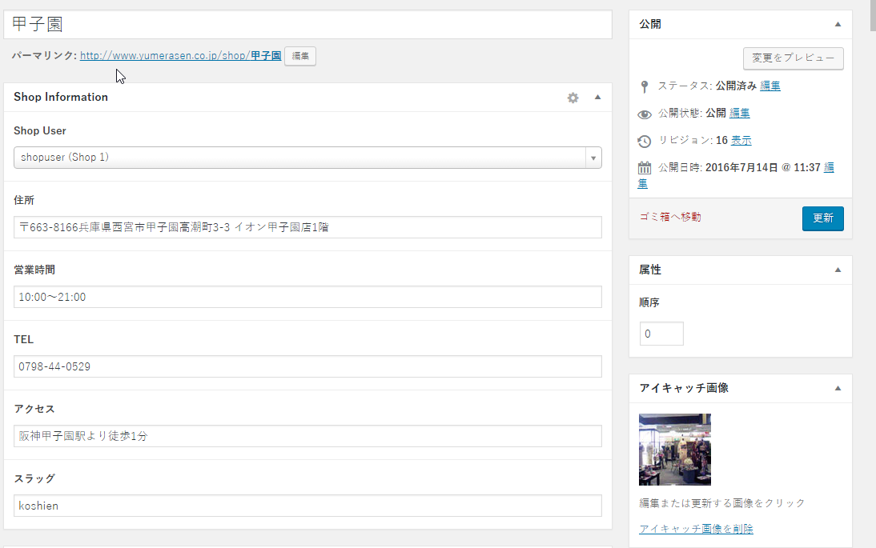

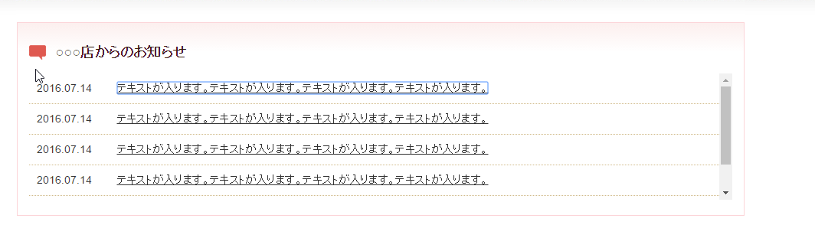

**+ Information will be used in:**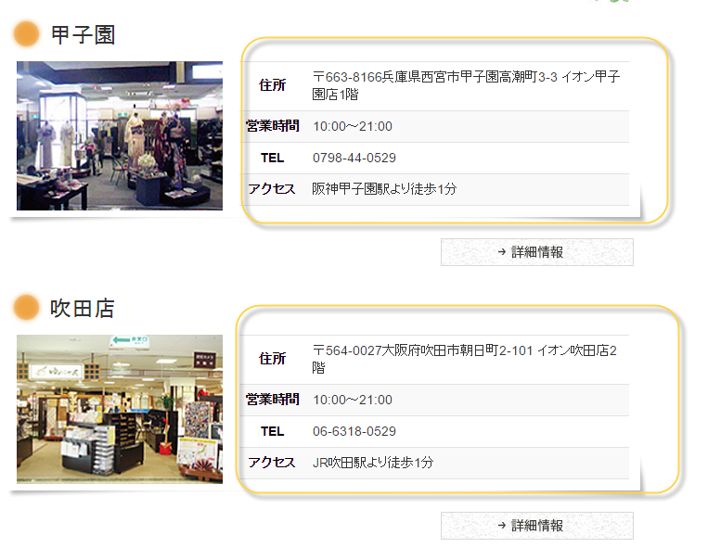

**And in Google Map**

**+ Slug will be used in**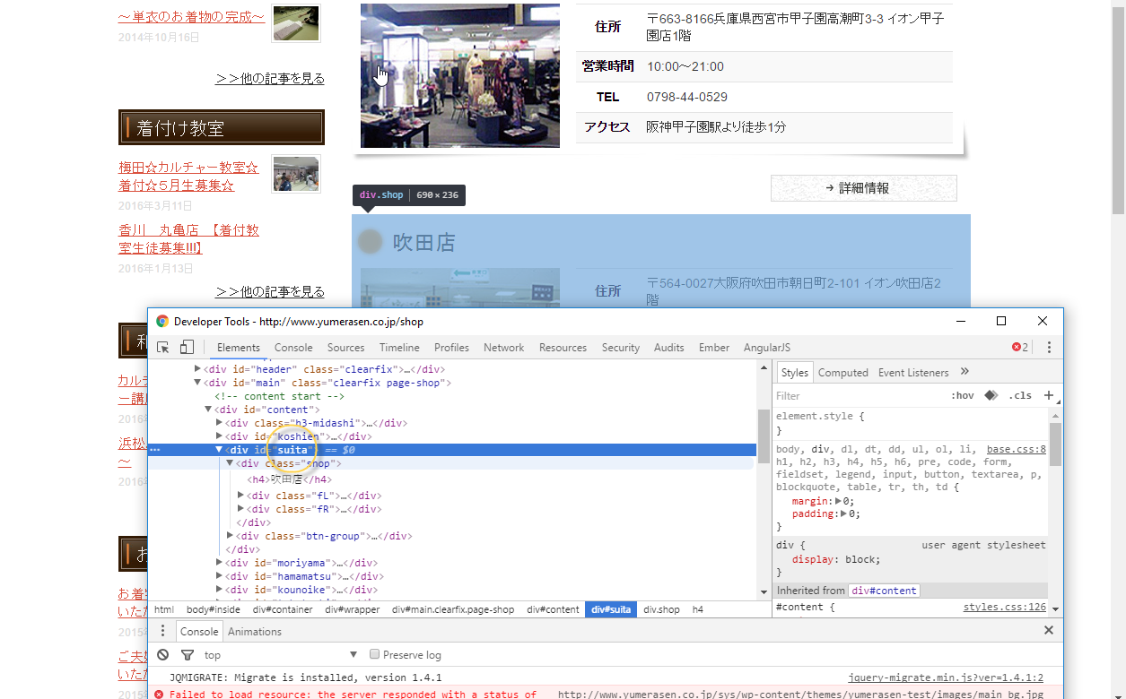

**1.2/Shop Picture:**

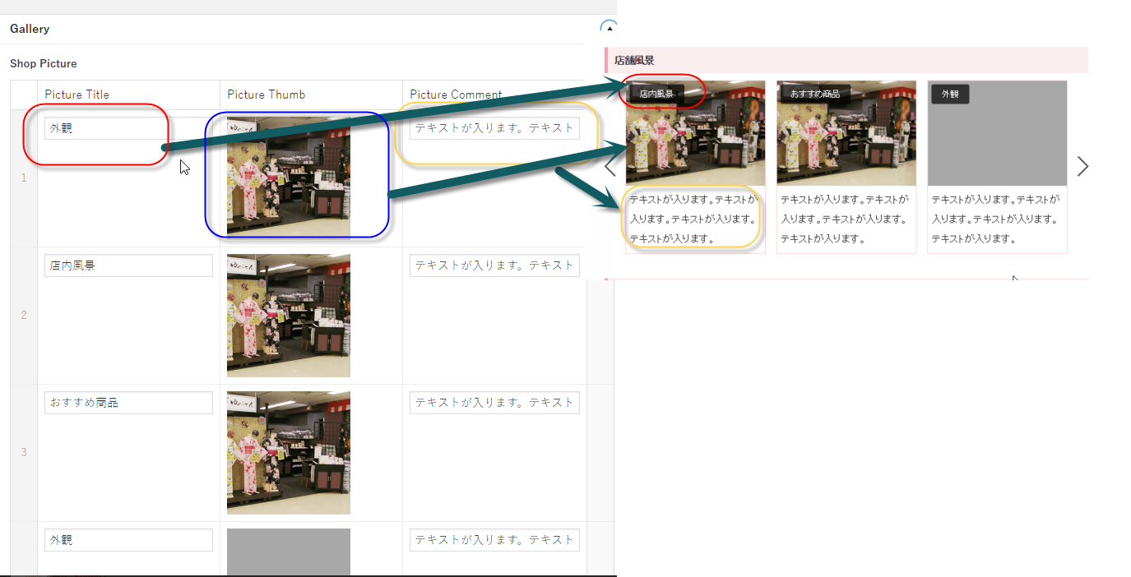

**1.3/Owner Information:**

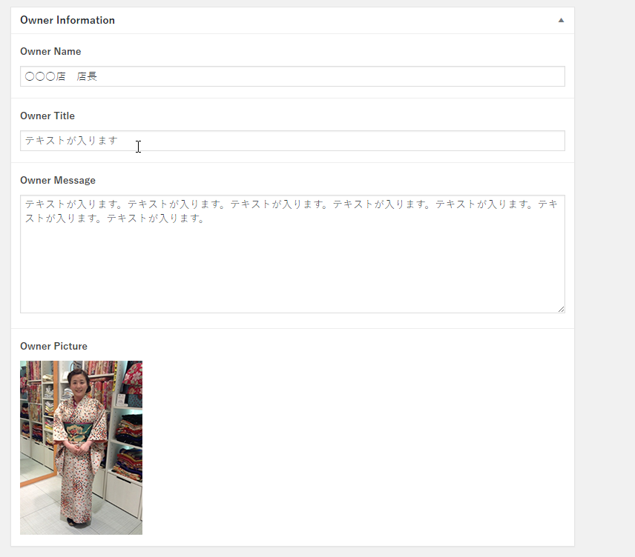

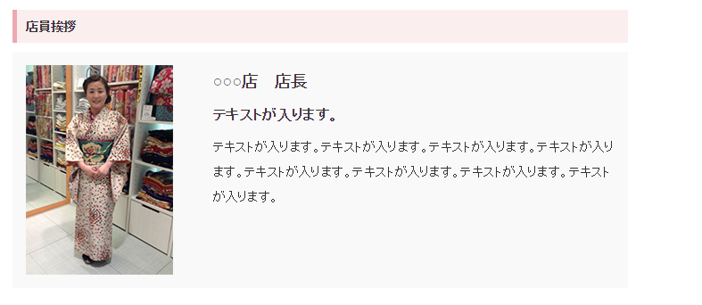

**1.4/Google Map information:**

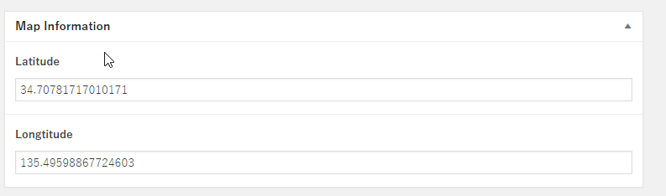

**Update Location for shop with (Latitude,Longtitude)**

**2/ Move/update position of each shop:**

Using Mouse drag up/down for updating position of shop.

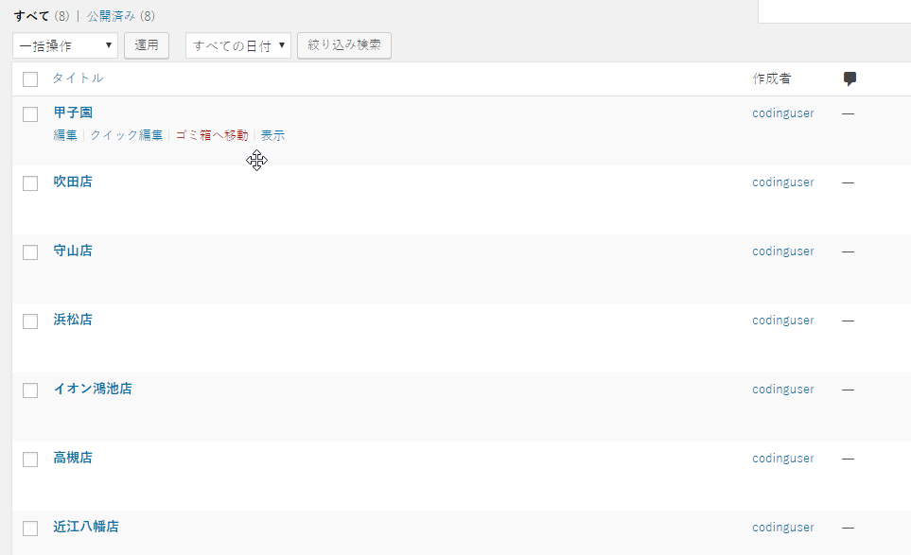

**User** update Shop

+ Login as user of a shop

+ Post posts under **店舗ニュース** cateory

