
International School

Capstone Project 1
CMU-SE 450/CMU-IS 450/CMU-CS450

Project Proposal
Version 1.2
Date: August 17, 2020

UNIVERSITY REVIEWS

Submitted by

Nguyen Van Minh Toi
Nguyen Huu Thien
Ho Xuan Sang
Huynh Thi Quy Thuong

Approved by
Dr.Ha Thi Nhu Hang
Proposal Review Panel Representative:

Name Signature Date

Capstone Project 1- Mentor:

Name Signature Date

PROJECT INFORMATION

Project acronym | URs
Project Title | University reviews
Start Date | August 13, 2020 | End Date | December 02, 2020
Lead Institution | International School, Duy Tan University
Project Mentor &contact details | Dr. Ha Thi Nhu Hang  Email: hatnhuhang@duytan.edu.vn  Tel: 0707121301
Product Owner | Toi, Nguyen Van Minh  Email: minhtoi2799@gmail.com  Tel: 0902257132
Scrum Master | Thien, Nguyen Huu  Email: huuthiennguyen1999@gmail.com  Tel: 0783533812
Team members | Name | Email | Tel
Team members | Toi, Nguyen Van Minh | minhtoi2799@gmail.com | 0902257132
Team members | Thien, Nguyen Huu | huuthiennguyen1999@gmail.com | 0783533812
Team members | Sang, Ho Xuan | hsang19999@gmail.com | 0362982905
 | Thuong, Huynh Thi Quy | quythuong0405@gmail.com | 0333633770

REVISION HISTORY
Version | Date | Comments | Author | Approval
1.0 | August 15, 2020 | Initial Release | C1SE.04 Team
1.1 | August 18,2020 | Updated from mentor's comment | C1SE.04 Team
1.2 | August 19,2020 | Updated from mentor's comment | C1SE.04 Team

University Reviews

1. Introduction
University Reviews is a website that provides useful information about universities in Vietnam to help students make the right decisions when choosing schools and majors. The features of this website are designed based on the decentralization of usage rights of each different object:
- Admin: Managing general information of all users, updating accounts.
- Student (Including high school students and university students): search majors, universities, and learn about graduate programs, doctoral degrees, masters... Also, learn about jobs related to the profession you are studying after graduation.
- University: Provides admission information about the school, an overview of the school, and provides information about the school's programs and career information.

2. Problem Definition
For students who intend to apply to college or university:
- According to statistics from kenh14.vn and giaoduc.net. Every year, more than 640,000 candidates register to enter the university. Currently, Vietnam has about 224 universities.
- With a huge number of candidates, and so many universities, it is difficult for a candidate to choose a major into the desired school. The information is not integrated. Students who want to know information about any school must immediately go to that school. They only talk generally about the school, little mention about issues such as facilities, the feeling of students studying at that school...
- Many university and college students still cannot succeed because they choose a major that is not in the right forte, with the right interest. According to the survey by the career-oriented admissions department of the schools, there are 15-20% of new graduates know they choose the wrong career.
For students at the school:
- The students at the school mainly study at school to get the basic knowledge, but many of them still do not have the ability to self-improve, have no direction in the majors, or do not understand the subject they choose. How, what are my strengths ...
To solve the above problems, we created a website review of all the universities across the country.
When a candidate chooses a major, our website will:
o Provide all subject information.
o Compile a list of all schools with that discipline and organized by region (North, Central, South or province / city) or tuition rate, rating. And each will provide the following information:
- Benchmark entry, tuition in the last 3 years.
- About the school.
- There are video interviews with students and facilities at that school.
- There are topics about the school, a place to exchange and answer questions between students who have been studying at the school and candidates.
3. Current Status of Art
Studying at university is now very popular, almost all high school students after graduation want to study further at universities, along with the need to choose the right school to the study. That student wants to listen to the practical experiences of other students who have learned through.
Recognize the importance, our team has designed the website with an easy interface, use, and access, to meet the needs. it helps students in supporting decision making, in addition to helping students have the most overview of the university environment.

Function | TAIWAN STUDY IN | Edu2Review | University Reviews
Search school | X | X | X
By majors | (Show only school names whose names match the keywords) | X | X
According to the region | X | X | X
Tuition |  |  | X
Sorted by rating |  | X | X
View benchmarks and tuition |  |  | X
View information about majors |  | X | X
University introduction | Basic information | X | X
Video interviewing the students are studying and facilities at the school. |  |  | X
Post topics about the school such as tuition fees, subjects, learning experience, .... . |  |  | X
Arrange topics according to each topic |  |  | X
Arrange topics according to evaluate |  |  | X
Comment |  | X | X
Evaluate |  | X | X

4. Engineering Approach (including solution alternatives)
4.1 System context diagram:
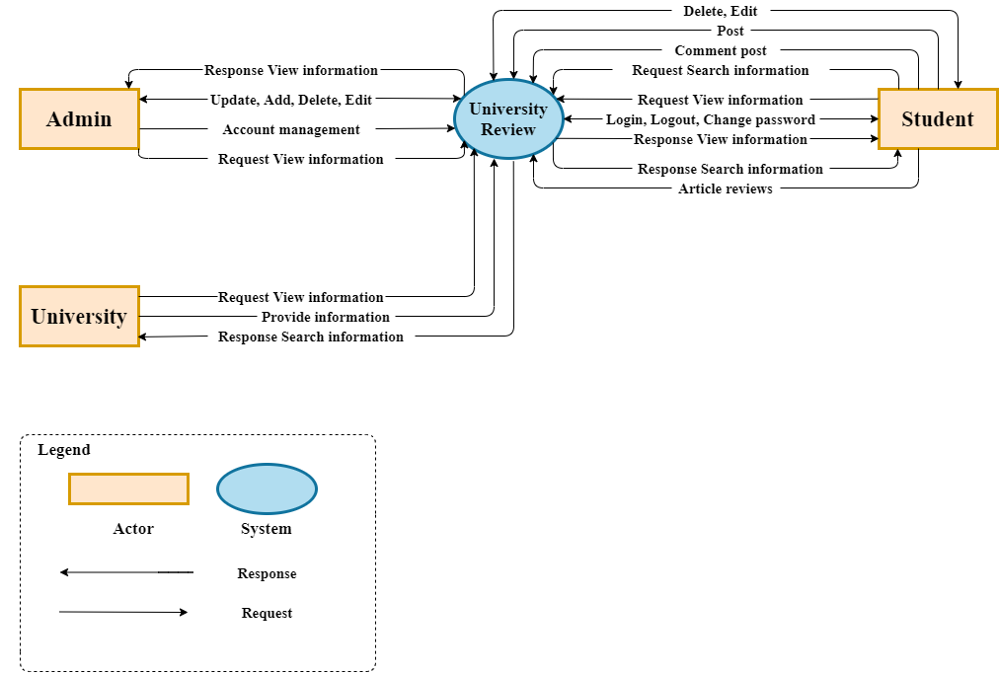
Figure 1: System Context Overview

4.2 System context description
Role | System context | Description
Student | Request | Users can login, log out, change passwords, view information, search all information, post articles, comment, delete, edit your articles and rate other articles.
Admin | Request | Admin can manage general information of all users, update, add, delete, edit all of topic and view information.
University | Request | University can provides all information about universities, careers and programs, view information about their university .

4.3 Technical Constraints
To increase performance, and reduce weight for team site using the latest frameworks in web development:
  - Programming languages ​​and supporting libraries: JavaScript, React JS, Redux-saga, axios.
  - CMS: Keystone JS.
  - Database: noSQL (MongoDB).

5. Tasks and Deliverables
5.1 Task:

No | Task Name | Duration | Start | Finish
1 | Initial | 6 | 13-August-20 | 18-August-20
1.1 | Create Proposal Document | 6 | 13-August-2020 | 18-August-2020
2 | Start Up | 10 | 19-8-20 | 28-8-20
2.1 | Project’s Kick-off Meeting | 1 | 19-August-20 | 19- August -20
2.2 | Discuss about project ideal | 2 | 20- August -20 | 21- August -20
2.3 | Create documents for project | 7 | 22- August -20 | 28- August -20
3 | Development | 95 | 29- August -20 | 28-November-20
3.1 | Sprint 1 | 25 | 29- August -20 | 22-September-20
3.2 | Sprint 2 | 25 | 23- September -20 | 12-October-20
3.3 | Sprint 3 | 25 | 13- October -20 | 7- November -20
3.4 | Sprint 4 | 20 | 8- November -20 | 28- November -20
4 | Project Meeting | 2 | 29- November -20 | 30- November -20
5 | Final Release | 2 | 01-December-20 | 02- December -20
 | Duration | 115

5.2 Deliverables:
Document:
Name Document | Responsible
Proposal | Thien , Thuong, Sang, Toi
Project plan | Thien, Thuong
Design UI | Thien, Thuong
SRS | Thien, Thuong, Sang, Toi
Test plan | Sang, Toi

Sotfware:
Phase | Responsible
Sprint 1 | Thuong, Sang, Thien
Sprint 2 | Thuong, Sang, Thien
Sprint 3 | Thien, Toi
Sprint 4 | Sang, Toi
Final | Toi

6. Project Management
6.1 Scrum process:
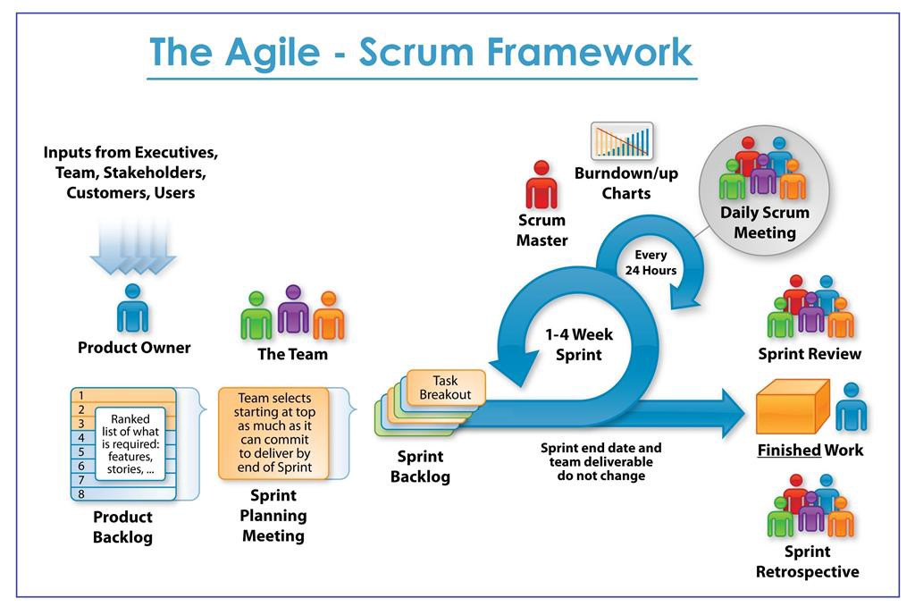

- Scrum is an iterative and incremental agile software development framework for managing software projects and product or application development.
- Scrum focuses on project management institutions where it is difficult to plan ahead.
- Mechanisms of empirical process control, where feedback loops that constitute the core management technique are used as opposed to traditional command-and-control management.
- Its approach to planning and managing projects is by bringing decision-making authority to the level of operation properties and certainties.
- Benefit of the methodology:
  - Project can respond easily to change.
  - Problems are identified early.
  - Customer gets most beneficial work first.
  - Work done will better meet the customer’s needs.
Improved productivity. Ability to maintain a predictable schedule for delivery.

6.2 Human Resource:
Full name | Phone | Email | Position
Hang, Ha Thi Nhu | 0707121301 | hatnhuhang@duytan.edu.vn | Mentor
Toi, Nguyen Van Minh | 0902257132 | minhtoi2799@gmail.com | Product Owner
Thien, Nguyen Huu | 0783533812 | huuthiennguyen1999@gmail.com | Scrum Master
Sang, Ho Xuan | 0362982905 | hsang19999@gmail.com | Member
Thuong, Huynh Thi Quy | 0333633770 | quythuong0405@gmail.com | Member

6.3 Sprint backlog

Sprint | Story Name (Coding) | Name Of Developer
Sprint 1 | Login user | Thuong
Sprint 1 | Forgot password | Thuong
Sprint 1 | Registration | Thuong
Sprint 1 | Design main page | Thien
Sprint 1 | See the post (read and review) | Sang
Sprint 1 | Test | Sang
Sprint 2 | Design form | Thuong
Sprint 2 | Detail topic(add, update, delete) | Thien
Sprint 2 | Comment (delete, add, rating) | Sang
Sprint 2 | Test | Sang
Sprint 3 | Edit personal information | Thien
Sprint 3 | + Anonymity or identity | Toi
Sprint 3 | + edit personal information | Thien
Sprint 3 | Create link "MBTI Test" | Toi
Sprint 3 | Test | Toi
Sprint 4 | Filter, search the post | Sang
Sprint 4 | search by name | Sang
Sprint 4 | filtered by degree | Toi
Sprint 4 | filter by tuition | Toi
Sprint 4 | Filtered by update time | Toi
Sprint 4 | Test | Toi

6.4 Cost Estimate
No | Criteria | Milestone | Working hours | Cost(2.3$/hour)
1 | Initial | INI | 72 | $165.6
2 | Start Up | STU | 120 | $176
3 | Development |  | (4hour/day)
3.1 | Sprint1 | SPR1 | 100 | $230
3.2 | Sprint2 | SPR2 | 100 | $230
3.3 | Sprint3 | SPR3 | 100 | $230
3.4 | Sprint4 | SPR4 | 80 | $184
4 | Other Cost | OTH |  | $200
5 | Project Meeting | PM | 24 | $55.2
6. | Final Release | FR | 24 | $55.2
 | TOTAL |  | 620 | $1626

- Description:
Description | Amount | Unit
Number of members | 4 | Person
Number of working hour per day | 4 | Hour
The cost per hour | $2.3 | USD

- Explain:

- Working hours = Number of working hour per day * Number of members * Number of days.
= 4 * 4 * Number of days

*Number of days: Initial: 8
Start Up: 10
Development (SPR1): 25
Development (SPR2): 25
Development (SPR3): 25
Development (SPR4): 20
Project meeting: 2
Final release: 2
- Cost = Working hours * The cost per member per hour.
= Working hours * 2.3

7. Conclusion
Identify students wishing to consult and listen to real feelings and opinions from students or alumni who have been studying at universities, to help guide careers, as well as support to make the final decision for the most suitable university for students nationwide.
In order to meet that need, the CSE.04 team came up with the idea of ​​building a website to synthesize common topics, school events that students in the school want to share, along with a review of summary information. about the school such as the scores over the current years, the facilities - infrastructure, the staff, the faculty ... of all universities in Vietnam.
The users of the website here are not only students, but also faculty staff, parents, or anyone interested in activities in the school.
And the ultimate purpose of the website is to help users get the most overview of the fields and universities they are wondering, help connect students together, improve the quality of teaching, and bring the mission. from each university to students from many different regions.
The team has planned this project, the product will be officially launched within 3 months, the total cost for the whole project as mentioned above is 1626 $, with the current web assist technologies to increase performance in UX / UI, bringing the most convenience to users.

8. References
9. Attachment: Final Design Requirement Form

