|  |  |
| --- | --- |
| **C:\Users\Naveen Hegde\Desktop\NvnTest\Resources\Icons\NvnTest-48.bmp** | **NvnTest** |

**Candidate guide**

(Note: domain nvntest.com is used in the document for ease of explanation.)

**System Requirements**

1. .Net Framework 2.0

Please download and install from Microsoft website.

2. Supported Operating Systems

Windows 2000 Service Pack 3; Windows 98; Windows 98 Second Edition; Windows ME; Windows Server 2003; Windows XP Service Pack 2, Windows Vista, Windows 7

1. Required Software

Windows Installer 3.0 (except for Windows 98/ME, which require Windows Installer 2.0 or later). Windows Installer 3.1 or later.

IE 5.01 or later: You must also be running Microsoft Internet Explorer 5.01 or later for all installations of the .NET Framework.

1. Disk Space Requirements

NvnTest.Candidate: 5MB, .Net Framework: 280 MB (x86), 610 MB (x64)

**Getting started**

You can start NvnTest.Candidate by clicking link provided in email sent to you or directly pasting URL in any well known browser. You can also launch NvnTest.Candidate from our website.

1. Visit <http://www.nvntest.com>. Click  button as shown in the following image.

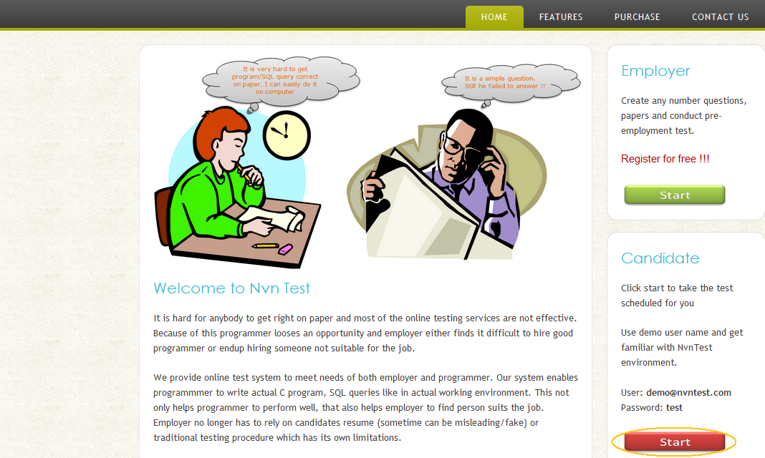

1. NvnTest.Candidate is directly started if you are using latest Internet explorer. A small size executable named **NvnTest.Candidate.exe** is downloaded if you are using any other browser like Chrome, Mozilla. As you are executing file downloaded from internet, windows shows security warning whether you like to run the application. Click **Run** to continue with installation.

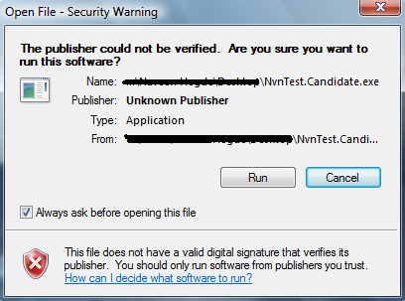

1. If you are running NvnTest.Candidate for the first time, windows again ask whether you like to this run.

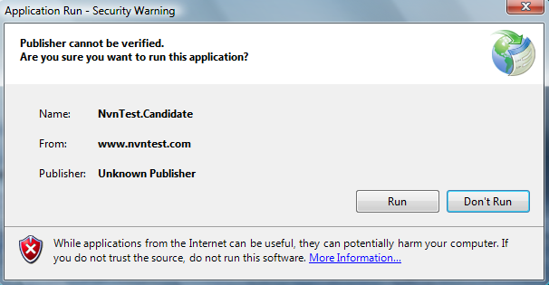

1. Click **Run**. NvnTest.Candidate is downloaded and login screen is shown as shown below.

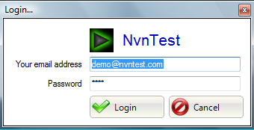

**Using demo user**

Use demo user account to get yourself familiar with NvnTest.Candidate environment. Demo test comes with fixed set of questions. All features are same as actual test except that anybody can access demo test and it never expires.

**Demo user name** : demo@nvntest.com

**Password** : demo

Demo user name is set as default user name and password. You need to enter correct user name and password while taking actual test

**Login with your user name**

User name and auto generated password is sent to your email address when any employer assign you a test.

Please note that you can take test only once. Test is considered as taken when you click  button in instruction window.

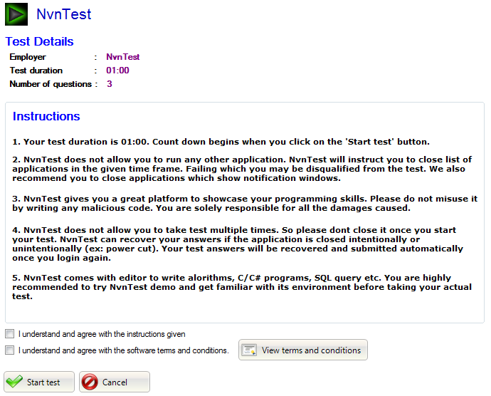

You cannot login or access your test again once it is taken.

Please try to login with your user name and password. Ask respective company to reassign test to you if you are not able to log in. As given above test is considered as taken only when you click **Start Test** button. So you can try to login before taking test

**Closing applications**

NvnTest.Candidate does not allow you to run any application while taking your test. Following window is shown with list of applications to be closed. You cannot proceed with your test unless listed applications are closed.

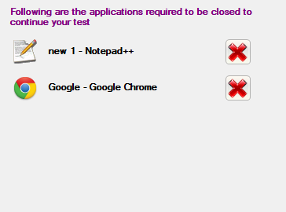

You can close application by clicking  or by using task manager or from taskbar. Please close applications which shows notification windows.

**Viewing list of questions**

Complete list of question is displayed when you start your test. You can view list of questions again by clicking  while answering any question or when you are in submit preview screen. Please note that only first 3 or 4 lines of the question is displayed. Hover your mouse on any question to get complete preview of question if it is not completely displayed.

NvnTest.Candidate shows graphical images in question list screen and submit preview to quickly identify question type

|  |  |
| --- | --- |
| C:\Users\Naveen Hegde\Desktop\NvnTest\Resources\Icons\objective.png | Objective questions |

|  |  |
| --- | --- |
| C:\Users\Naveen Hegde\Desktop\NvnTest\Resources\Icons\algo.png | Programming questions |
| C:\Users\Naveen Hegde\Desktop\NvnTest\Resources\Icons\database.png | SQL questions |
| C:\Users\Naveen Hegde\Desktop\NvnTest\Resources\Icons\internet.png | Web programming questions |

**View and answer questions**

* **Programming questions**

NvnTest.Candidate provides editor to write C and C# programs. Sample screenshot of C# program editor is as shown below.

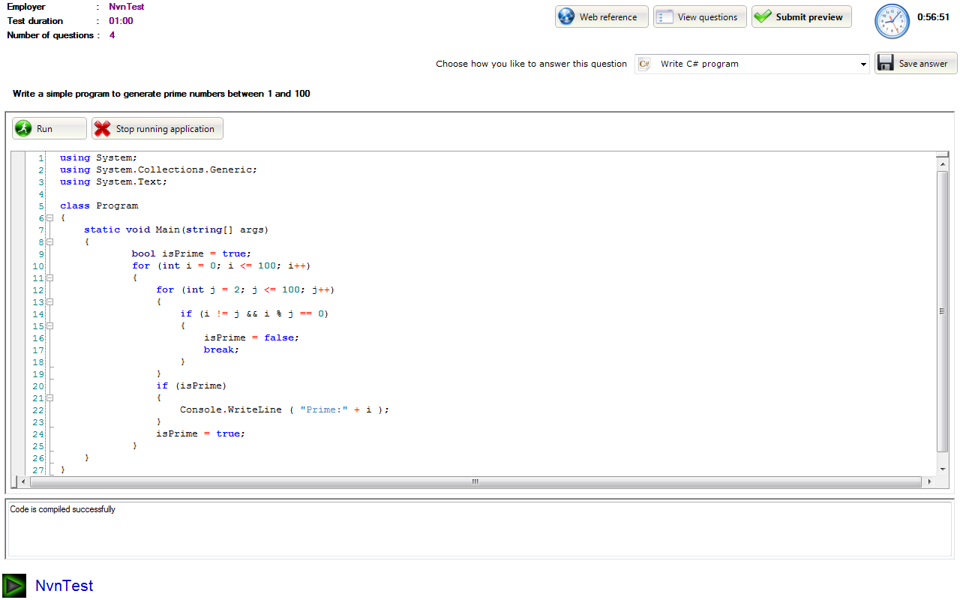

Click  to compile and execute your code. A console (DOS window) is displayed showing output messages. You can also interactively enter data and test your code.

Click  close all application which you started from C#/C code editor.

You may also choose to write to simple algorithm or give descriptive answer instead of writing C or C# code.

Please do not misuse our service by writing malicious code. Your code is compiled and executed locally. You may corrupt your own system because of your own code.

* **SQL questions**

NvnTest.Candidate provides simple editor to write and test SQL queries. Sample screenshot of SQL query editor is as shown below.

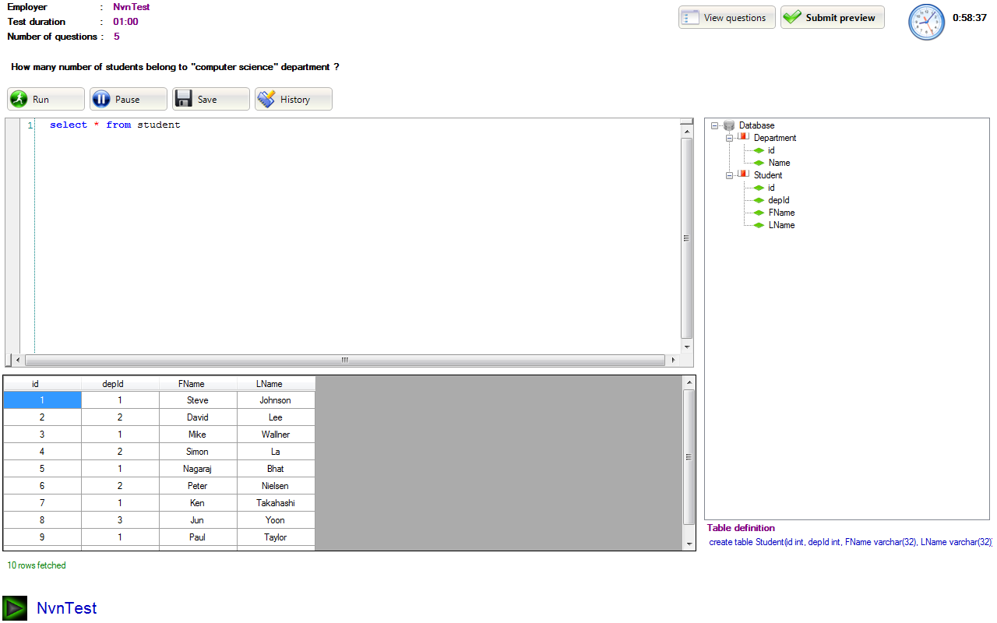

Every SQL question can have one or more tables defined. You may have to use either use few or all tables to answer respective question. All tables are shown at right side of the editor.

Select any table or any of its column to see corresponding table definitions. Table definition is the standard SQL statement using which table is created.

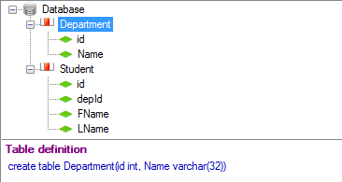

Write SQL query in the editor and click  to execute SQL query. Editor allows you to keep any number of SQL queries delimited by ";". Please select single query if editor contains more than one query and no need to select if editor contains only one query.

SQL query editor currently supports syntax highlighting only queries in small case.

Please note that you cannot delete/edit any table or its data.

NvnTest.Candidate also maintains history of successfully executed queries. You can use history either to revert back or to analyze changes you made. Click  view SQL query history of the respective question.

* **Objective questions**

Objective contains question description and list of options. Read questions carefully and check correct answer(s)

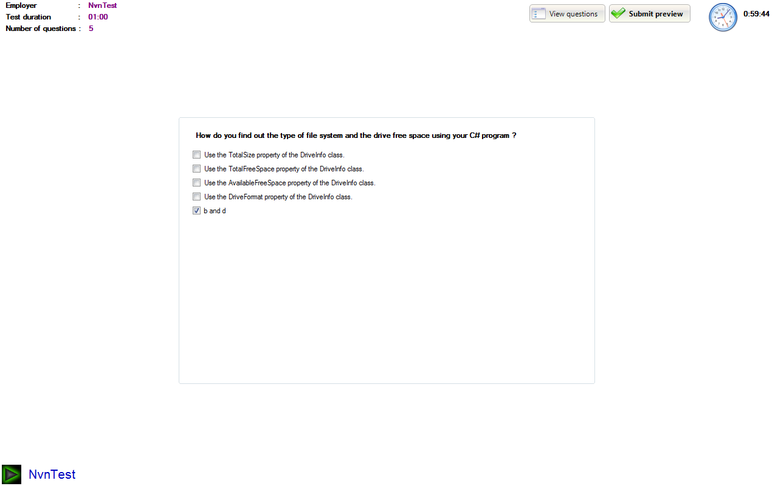

* **Web programming questions**

Click on  to view web pages in the browser. All the web pages are uploaded and rendered from the remote server. As the web pages are not loaded as separate web application, you always need to use relative file reference in your web pages.

Currently we support following type of web pages

* HTML
* CSS
* JavaScript
* ASP.NET

Use context menu add, delete, rename folders and web pages. Files and folders are listed in the right side of the editor. All available menu options are shown in the following picture.

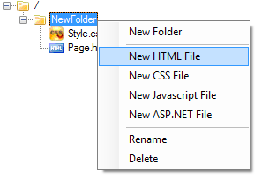

Following is the sample screenshot web programming editor.

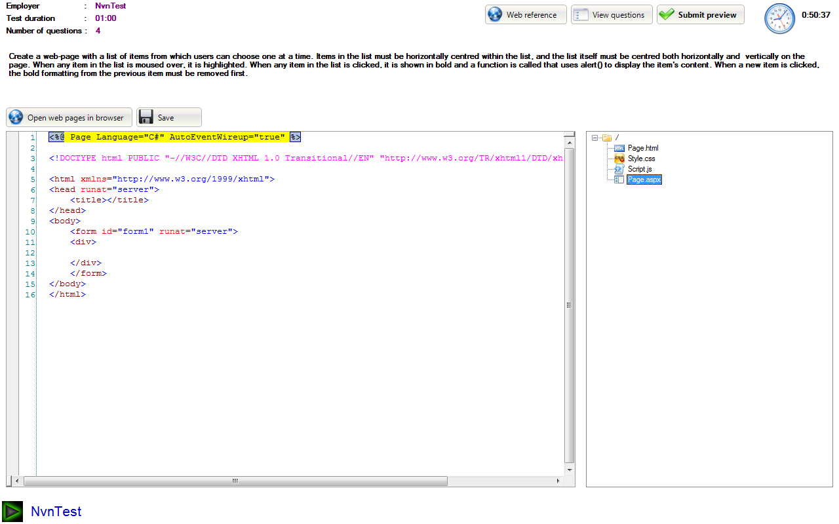

**Submit preview**

You can view all questions and your answers consolidated in submit preview window. Click  while viewing list of questions or while editing any of your answer. Click C:\Users\Naveen Hegde\Desktop\NvnTest\Resources\Icons\edit.png to edit respective question directly from submit preview screen.

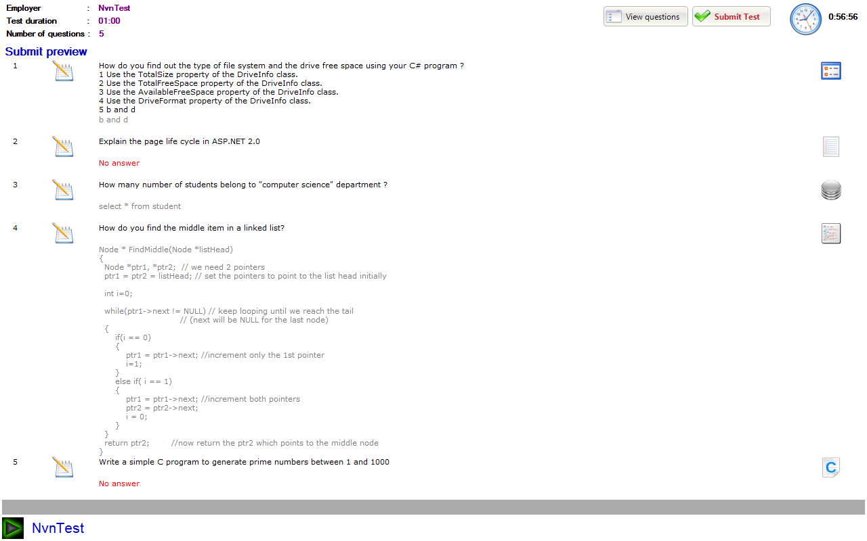

Please not that your answers are submitted only when you click  in submit preview screen

**Submitting test answers**

Click  to go to submit preview screen. Review all your test answers and click . Following confirmation message is displayed to confirm whether you want to submit. click  to submit your answers.

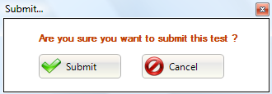

**Recovering test answers**

As mentioned before, you can take test only once. NvnTest.Candidate does not allow you login again with your email address and auto generated password if it is close intentionally or unintentionally. But login again with your email address and auto generated password to recover your test answers. NvnTest.Candidate automatically submit your answers saved locally.

NvnTest.Candidate displays following message and ask you to save file if recovery fails. Please save as text file (for example: answers.txt) and send it to [support@nvntest.com](mailto:support@nvntest.com)

