|  |  |
| --- | --- |
| **C:\Users\Naveen Hegde\Desktop\NvnTest\Resources\Icons\NvnTest-48.bmp** | **NvnTest** |

**Employer guide**

(Note: domain nvntest.com is used in the document for ease of explanation.)

**System Requirements**

1. .Net Framework 2.0

Please download and install from Microsoft website.

2. Supported Operating Systems

Windows 2000 Service Pack 3; Windows 98; Windows 98 Second Edition; Windows ME; Windows Server 2003; Windows XP Service Pack 2, Windows Vista, Windows 7

1. Required Software

Windows Installer 3.0 (except for Windows 98/ME, which require Windows Installer 2.0 or later). Windows Installer 3.1 or later.

IE 5.01 or later: You must also be running Microsoft Internet Explorer 5.01 or later for all installations of the .NET Framework.

1. Disk Space Requirements

NvnTest.Employer: 2MB, .Net Framework: 280 MB (x86), 610 MB (x64)

**Get started**

NvnTest is a smart client application developed using cutting edge technologies. You can start using NvnTest clicking links available in our website.

Steps to start NvnTest.Employer

1. Visit <http://www.nvntest.com>. Click link as shown in the following image. Click **Start** to download a tiny file of size less than 1 KB.

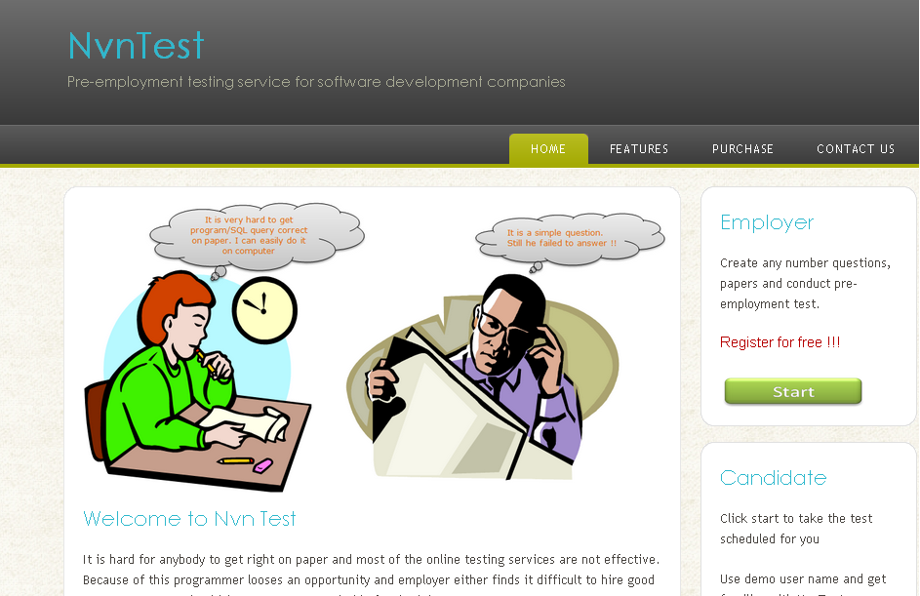

1. Double click on the file downloaded. As file is downloaded from internet, windows shows security message whether you want to run it or not. Click **Open** to continue with installation.

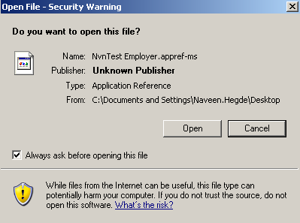

1. Now windows prompt whether you want to install NvnTest. Click **Install** to download and install NvnTest.Employer in your system.

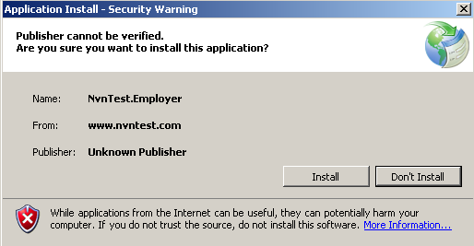

You can uninstall NvnTest.Employer anytime from "Add\remove programs" like any other software in windows

**Create an account**

1. Start NvnTest.Employer

2. Click  link

3. Enter your email address and check whether it is available. Message is displayed if user name is not available.

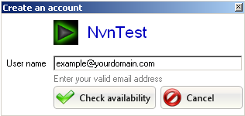

1. Please enter details asked in the form and click **Create user** button.

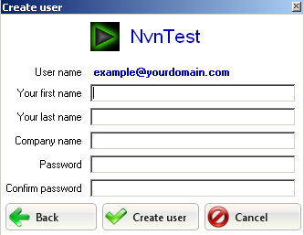

1. Now server is requested to create a new account for you. An email will be sent to your email address once your registration is successful. Error message will be displayed in your input is not is the expected format.
2. You need to correctly enter verification code sent to your email address, only then you can access all features available in [app]

**Forgot password**

1. Start NvnTest.Employer
2. Click on **Forgot your password ?** link.

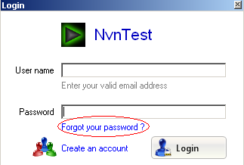

1. Enter your email address and click **Reset password** button. Your request will be processed by our server and a new password is sent to your email address.

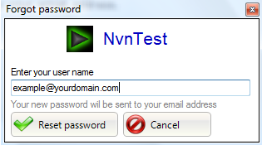

1. Try login again with user name and new auto generated password.

**Change password**

Steps to change your password

1. Start NvnTest.Employer and login with your user name, password
2. Click  link at the bottom right of the application
3. Enter new password and save.

**Questions**

NvnTest supports following type of questions

* Objective
* SQL
* Programming
* Web programming

**Creating questions**

* **Objective question**

Steps to create a new objective type of question

1. Start NvnTest.Employer and login with you user name and password
2. Select **Questions** tab
3. Click  button
4. Enter question description
5. Click  button to add a new option for your question
6. Enter option description.



1. Click **Clear** if you like to remove option description
2. Click **Delete Option** if you like to remove respective option completely
3. Check "**This is correct answer?**" if the respective option is correct answer of the question. You also need to enter *numeric* marks if you choose an option as a correct answer.

Repeat steps to add, remove any number of options.

1. Click  button to complete adding a new question. Error message is displayed if input is not in expected format.

* **SQL question**

Steps to create a new SQL type of question

1. Start NvnTest.Employer and login with you user name and password
2. Select **Questions** tab
3. Click  button
4. Enter question description
5. Add table

* Click 
* Enter valid create table SQL statement. *Ex: CREATE TABLE test(id int)*
* Enter valid INSERT statements separated by new line to add test data to the respective table.
* Click  to add a new table. Error message is displayed if input is not in expected format.

1. Repeat step 5 to add any number of tables
2. Click  button to complete adding a new question. Error message is displayed if input is not in expected format or if no table added.

* **Programming question**

Steps to create a new programming type of question

1. Start NvnTest.Employer and login with you user name and password

2. Select **Questions** tab

3. Click  button

4. Enter question description

5. Click  button to complete adding a new question. Error message is displayed if input is not in expected format.

* **Web programming question**

Steps to create a new web programming type of question

1. Start NvnTest.Employer and login with you user name and password

2. Select **Questions** tab

3. Click  button

4. Enter question description

5. Click  button to complete adding a new question. Error message is displayed if input is not in expected format.

**Editing questions**

You can edit any question by clicking. A window is shown with all input pre-populated with the question data. Edit any information and save it. A warning message is shown if you are editing any question which was already answered by a candidate. Result window of respective test displays a warning message if you choose to edit such questions.

**Remove questions**

You can delete any question by clicking. Please not that question will be deleted permanently if you choose to delete it!

A warning message is shown if you are deleting any question which was already answered by a candidate. Result window of respective test displays a warning message if you choose to delete such questions

**Papers**

You need to create a paper before assigning any test. Paper is nothing but grouping set of questions.

Steps to create papers

1. Select **Paper** tab
2. Click  button
3. Enter paper name and description.
4. Check questions shown in the window.
5. Click  button. Now NvnTest updates server database and item is added to the grid once update is successful. Error message is show if input is not available or in unexpected format.

**Schedules**

In schedule tab you can assign, edit, remove test schedules.

**Assigning test to yourself**

You can assign test to yourself and try all features available in NvnTest. Assigning test to yourself work exactly same as actual test except that you cannot edit email address which will be fixed to your own email address. You need purchase tests only if you want to assign test to somebody.

Steps to assign test to you

1. Start NvnTest.Employer and login with your user name and password. NvnTest.Employer opens with schedule tab selected as default.

2. Click.

3. You can change all pre-populated fields except your email address.

4. Click  button. Now NvnTest.Employer adds new test schedule. You will receive an email exactly how candidate will receive when you assign it. Error messages are shown if input values are not in expected format.

Now you can take actual test like candidate by follow the instruction given in email. Take the test, submit it and view your result!

**Create new test schedule**

You can start assigning tests once you have purchased from our ShareIt! Please refer **Purchasing test** to get detailed steps to purchase tests

Steps to create a test schedule.

1. Start NvnTest.Employer and login with your user name and password.
2. Click 
3. Fill Candidate information like first name, last name, email address
4. Set days limit. Candidate need to take test within the number of days set from the day it is scheduled. Test schedule is considered as expired if test is not taken in the set limit.
5. Days limit should be at least 1 and not more than 10.
6. Set test duration. Test duration should be at least 10 min and not more than 5 hours
7. Choose a test paper for this test. Please refer "**Paper**" to get complete steps to create a new paper.

**Understanding information in grid**

**UTC time**

In order to have consistent time we use UTC time. Please refer more UTC time [here](http://en.wikipedia.org/wiki/Coordinated_Universal_Time).

NvnTest.Employer shows current UTC time based on your system and time zone. So please note that UTC time will be different if your system time is not correct.



**Test status**

|  |  |
| --- | --- |
| Scheduled | Test is scheduled, but test is not taken/submitted and also not expired. |
| Taken | Respective test is taken by the candidate, but is not submitted. This may be because system/application crash or intentionally closed by the candidate. Please ask your candidate to login again to recover his/her answers. |
| Submitted | Respective test is taken by the candidate and submitted. You can view candidate's answers by clicking "View" link |
| Expired | Respective test is scheduled but is not taken by the candidate within the days limit set |

**View result**

You can view candidate's test answers once candidate takes test and submit it.

Result window contains all test information and answers to every question. Marks are calculated only for objective type of questions.

Sample test result view looks like below

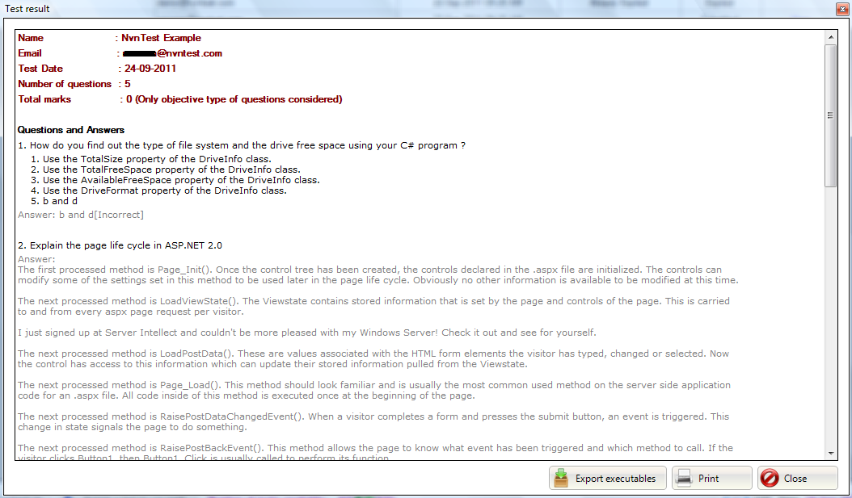

**Running C applications**

You can also run compiled applications of C type of questions. Application will be available only if candidate compiles his code while taking the test

*NvnTest allows last minute saving. So code shown in the report can be different from executable code. Please look for malicious code before executing the application.*

Steps to run executables

1. Click **View** link of the respective test schedule which is taken and submitted by candidate.
2. Click **Run application** link in result window. Link is shown only for C programming questions.
3. Check whether there is any malicious code in the popup window.
4. Click  to launch console application.

Click  in result window to export all C programming questions with its code and executable.

**Editing/Rescheduling a test**

You can edit any test schedule if its status is **scheduled**. Currently you cannot edit any test schedule if its status is Taken, Submitted, and Expired.

Steps to edit a test schedule

1. Start NvnTest.Employer and login with your user name and password.
2. Click **Edit** link of the schedule which you want to edit.
3. Change candidate information, days limit, test duration and choose any paper. But you cannot edit email address. You need to create a new schedule if you like to assign a test to another email address.

**Removing test schedule**

You can remove any test schedule if it is not submitted.

Steps to remove a test schedule

1. Start NvnTest.Employer and login with your user name and password.

2. Click **Delete** link of the schedule which you want to remove. Test cancellation email is sent to candidate if test schedule status is **scheduled**