Method 1: Baseline GPU Inference — Sequential PyTorch Pipeline
Naveen Gokul Nath Velu | CS 5463 – Parallel Computing | March 18, 2026

1. Problem
We process recorded e-scooter ride videos from UTSA’s ScooterLab to detect near-miss events between riders and surrounding road users. The pipeline applies YOLOv12 for object detection followed by Apple’s Depth Pro for monocular metric depth estimation on each frame. The key bottleneck is throughput: processing hundreds of hours of 1280×720 ride footage offline requires maximizing frames per second on available GPU hardware. At the current baseline throughput of ~1.1 FPS, a single 10-minute ride at 10 FPS (6,000 frames) takes nearly 90 minutes to process.
2. Chosen Algorithm/Method
The baseline establishes a performance reference by running both models sequentially in standard PyTorch eager mode on a single GPU (NVIDIA RTX 5000 Ada Generation, 33.8 GB VRAM). YOLOv12-small (attention-centric architecture [1]) detects pedestrians, vehicles, and cyclists at 640×640 input resolution with NMS post-processing. Depth Pro (multi-scale ViT encoder [2]) generates a dense metric depth map from the full 720p frame. Each frame follows a strict decode → detect → depth sequence with no overlap between stages. Both models execute on the default CUDA stream in FP32 precision.
3. Data Structures, Datasets, and Hyperparameters
Dataset: ScooterLab ride video from device SLESP5005 (1280×720 @ 10 FPS, H.264, 463 frames). YOLO hyperparameters: imgsz=640, conf=0.25, iou=0.45, model=yolov12s.pt. Depth Pro: default ViT-L backbone, checkpoint depth_pro.pt, FP32 precision. Data structures: OpenCV VideoCapture for frame I/O; PyTorch CUDA tensors (NCHW float32) for both models; NumPy arrays for post-processing bounding boxes and depth maps. Timing measured via torch.cuda.Event objects with enable_timing=True.
4. Underlying Communication Pattern
The baseline uses a single default CUDA stream. All operations are serialized: CPU decodes a frame from video → transfers to GPU global memory → YOLOv12 forward pass → NMS on GPU → results back to CPU → frame re-uploaded for Depth Pro → depth forward pass → depth map back to CPU. The dominant data movement is CPU→GPU→CPU per stage, with no overlap between computation and transfer. Host-device transfers occur via PCIe (Gen 4 x16). Each 1280×720 RGB frame is ~2.8 MB; the Depth Pro input tensor after preprocessing is larger due to the ViT’s multi-scale cropping.
5. Read/Write Contention and Synchronization Overheads
Since all operations execute on a single CUDA stream, there is zero contention between concurrent kernels—but this is precisely the inefficiency. torch.cuda.synchronize() is called implicitly after each model’s forward pass, causing the CPU to block until the GPU completes. The GPU sits idle during frame decoding (~3.6ms per frame) and CPU-side post-processing. Conversely, the CPU blocks during GPU inference (~886ms). The pipeline achieves approximately 0% overlap between CPU and GPU work. The reserved GPU memory (12,010 MB) is significantly higher than allocated memory (3,875 MB), indicating PyTorch’s caching allocator is holding large memory blocks that could be shared in a multi-stream configuration.
6. Parallel Time Complexity
For N frames on a single GPU with sequential execution, total wall time is: T(N) = N × (T_decode + T_yolo + T_depth). Measured component breakdown per frame: T_decode ≈ 3.6ms (CPU), T_yolo ≈ 6.9ms (GPU), T_depth ≈ 879.6ms (GPU). Communication time: ~5ms/frame in host→device and device→host PCIe transfers (embedded within T_yolo and T_depth measurements). Synchronization time: ~3.6ms/frame CPU idle during decode + implicit sync barriers between stages. Computation time: ~881ms/frame pure GPU kernel execution. Depth Pro dominates at 98.8% of GPU compute time. YOLOv12-s accounts for only 0.8% of total per-frame latency.
7. Timing and Experiment Details
Hardware: NVIDIA RTX 5000 Ada Generation (33.8 GB VRAM), host machine “orion”. Software: PyTorch 2.x with CUDA, Ultralytics (YOLOv12-s), Depth Pro (apple/ml-depth-pro). Parameters varied: 300 frames profiled (first 10 discarded as warmup for CUDA JIT compilation and kernel caching). Video: data-2026-02-11-16-36-13.224686-Scooter-SLESP5005.mp4 from ScooterLab fleet. Instrumentation: CUDA events (torch.cuda.Event with enable_timing=True) for GPU timing; time.perf_counter() for CPU decode; torch.cuda.memory_allocated()/memory_reserved() for memory tracking.
8. Performance Results
Component | Mean (ms) | Std (ms) | Min (ms) | Max (ms) | % of Total
Frame Decode (CPU) | 3.6 | 0.5 | 2.8 | 5.2 | 0.4%
YOLOv12-s Detection | 6.9 | 0.4 | 6.2 | 8.7 | 0.8%
Depth Pro Estimation | 879.6 | 11.3 | 847.9 | 899.9 | 98.8%
Total (end-to-end) | 890.1 | 11.3 | 857.9 | 911.1 | 100%

Throughput: 1.12 FPS | GPU memory: 3,875 MB allocated / 12,010 MB reserved | 290 frames profiled (excl. warmup)

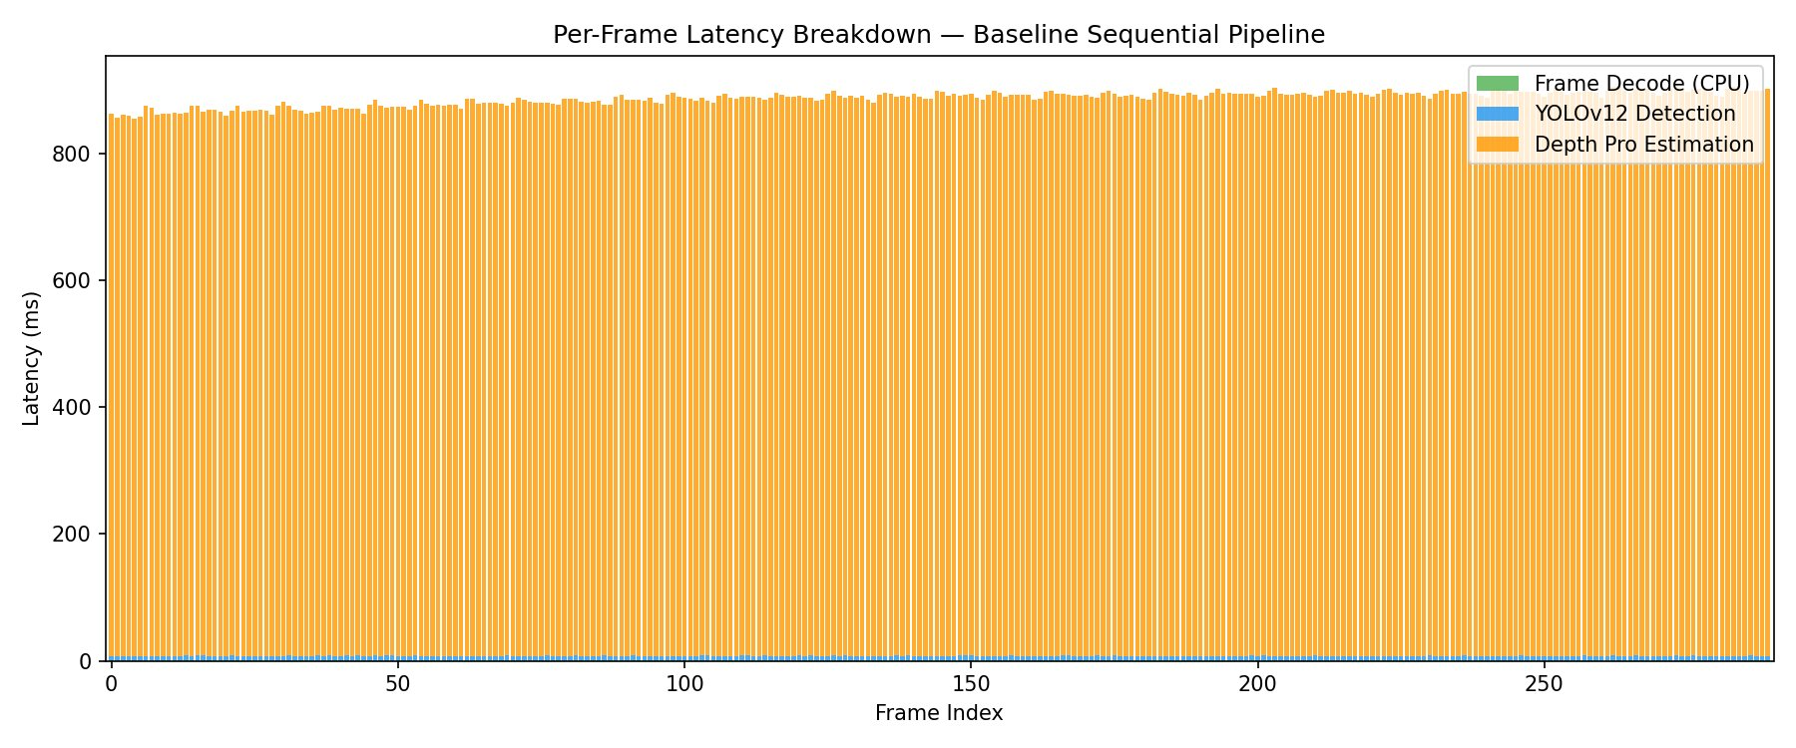
Figure 1: Per-frame latency breakdown. Depth Pro dominates at ~880ms/frame (98.8% of total). YOLO and decode are barely visible.
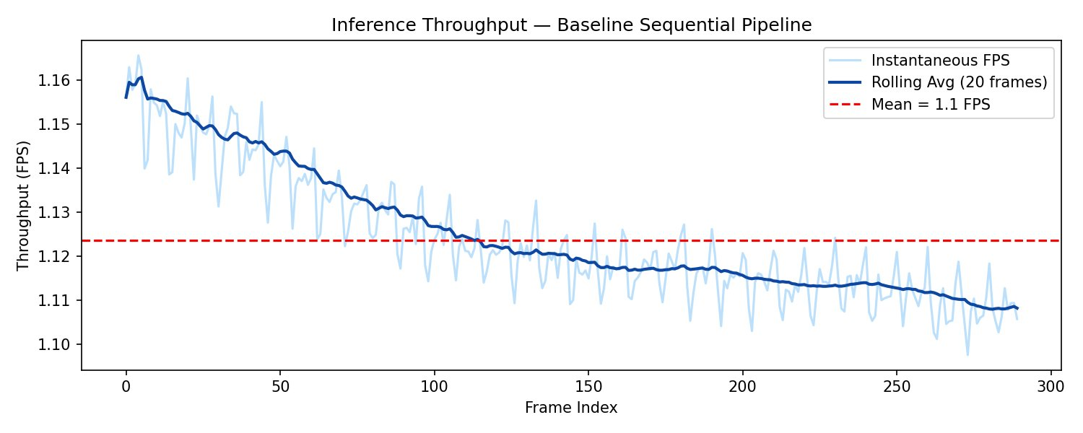
Figure 2: Throughput over time. Mean = 1.12 FPS. Note the gradual decline from ~1.16 to ~1.10 FPS, likely due to GPU thermal throttling over the ~4.5-minute profiling run.
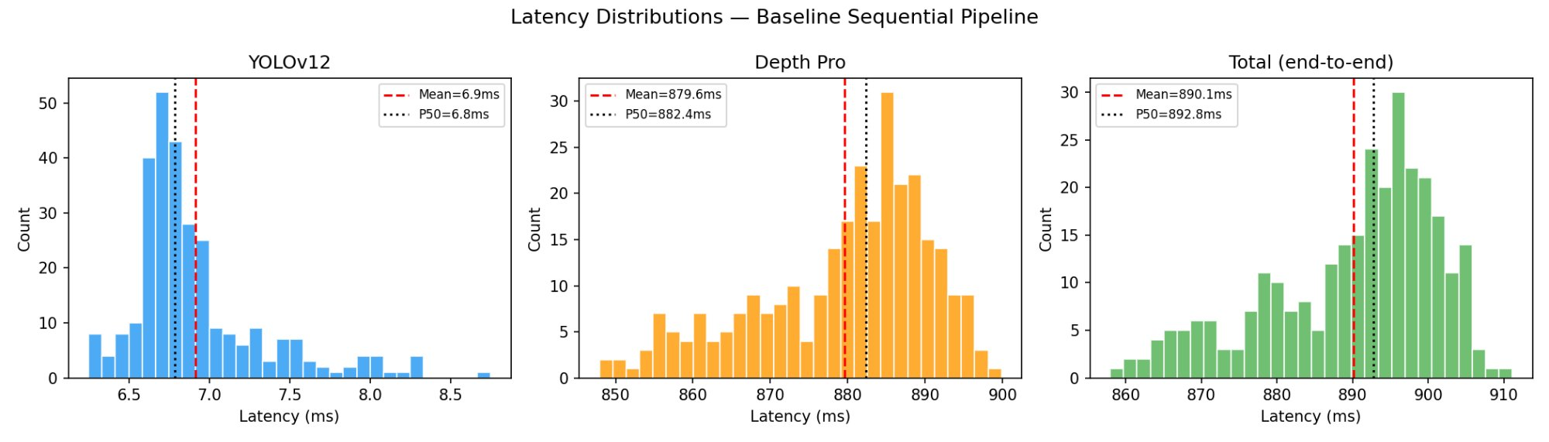
Figure 3: Latency distributions. YOLOv12-s is tightly clustered (6.2–8.7ms). Depth Pro shows wider variance (848–900ms).
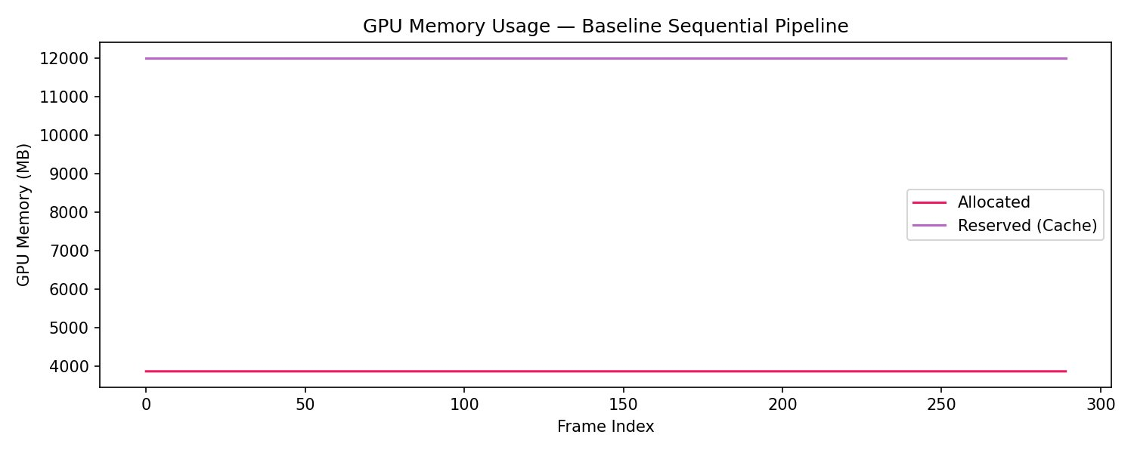
Figure 4: GPU memory is flat — 3,875 MB allocated, 12,010 MB reserved by PyTorch’s caching allocator. Only 11.5% of the RTX 5000’s 33.8 GB VRAM is actively used, leaving significant headroom for multi-stream parallelism.
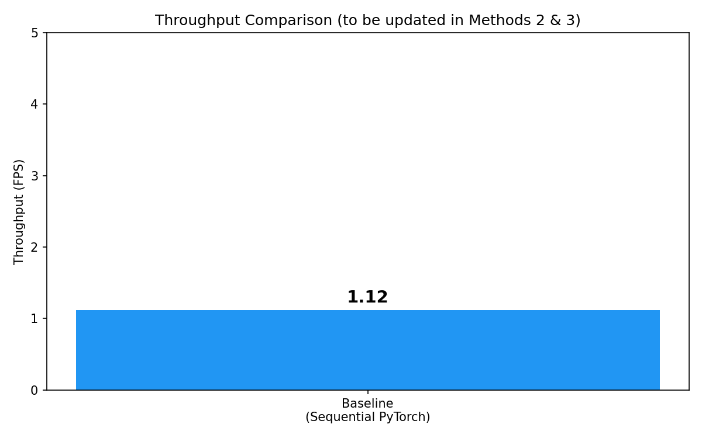
Figure 5: Baseline throughput reference (1.12 FPS). Methods 2 and 3 will add TensorRT and multi-stream results.
9. Conclusions
Key findings: (1) Depth Pro is the overwhelming bottleneck, consuming 98.8% of per-frame time at 879.6ms. YOLOv12-s is extremely fast at just 6.9ms. (2) The sequential pipeline achieves ~0% CPU-GPU overlap—the GPU idles during frame decode and vice versa. (3) Only 3,875 MB of the 33.8 GB VRAM is actively used; the remaining capacity is available for batched/parallel inference. (4) Throughput degrades slightly over time (~1.16 to ~1.10 FPS), suggesting thermal effects over sustained inference. Limitations: Single-stream execution leaves >90% of GPU memory and significant compute capacity unused. Both models run in FP32 with no graph optimization. Frame decoding is single-threaded on CPU. Future improvements (Methods 2 & 3): Method 2 will apply TensorRT with FP16/INT8 quantization, primarily targeting Depth Pro which dominates latency. Even a 2× speedup on Depth Pro alone would more than double overall throughput. Method 3 will use CUDA streams to overlap detection and depth estimation across frames, and batch frame decoding with multi-threaded CPU preprocessing, to push throughput well beyond the current 1.12 FPS baseline.
References
[1] Y. Tian et al., “YOLOv12: Attention-Centric Real-Time Object Detectors,” NeurIPS 2025, arXiv:2502.12524.
[2] A. Bochkovskii et al., “Depth Pro: Sharp Monocular Metric Depth in Less Than a Second,” ICLR 2025, arXiv:2410.02073.
[3] NVIDIA, “CUDA C++ Programming Guide,” docs.nvidia.com/cuda/, 2024.

