Tiffany Kelly-Gray
DICE 3020
June 2nd 2019

Introduction
I have chosen to adapt a children's story. The author is Toon Telligan, a Dutch writer who was most popular in the 1960's. The story I am adapting is Squirrel's birthday. It is one of my daughters favorite stories. All of the characters use him/his/he pronouns.
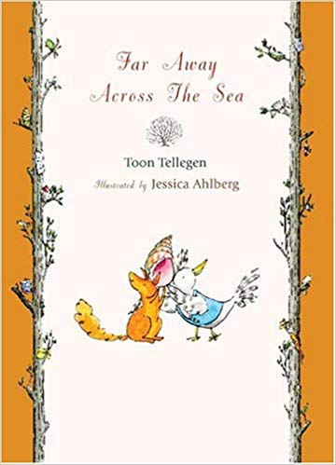
Why I've chosen this text
Toon Telligan has four children's books that are made of collections of short stories. The stories are whimsical and usually feature a squirrel and an elephant. The stories often have philosophical lessons and all the characters in the stories use him/his/he pronouns. In five year old speak “ They are ALL boys! That's not fair!” The majority of children's books feature male protagonist. Usually if there are more than three or four characters one of the lesser characters is female, however that isn't the case in this series. Therefore I've chosen to remaster it with equal representation of hers and his.

