**Intro to JS**

**DEADLINE:** 7/07/2019

**FOLDER STRUCTURE**

|  |  |
| --- | --- |
| FL11_HW6/*     └─ task/      └─ FL11_HW6.docx  └─ homework/*  └─ js/*  └─ task1.js*  └─ task2.js*  └─ task1.html*  └─ task2.html*  └─ .eslintrc.js* | *   – required  https://docs.google.com/drawings/d/sacr32sj3QL4ynvXOijYsjg/image?w=21&h=21&rev=1&ac=1&parent=1Wtv1WPeniXS7OF4sZ_WL11aF6vRJn3Xa7liFYB9Uvgg    – not needed |

**TASK**

**Task 1**. Check whether the dot divides the line by half on Cartesian plane.

App workflow:

1. User input 3 point’s numeric values (*a1, a2, b1, b2, c1, c2*). They correspond to three points: A, B and C. We have line which connecting A and B points. C placed somewhere we doesn’t know. We can have two cases. In first C point divides the segment by half:

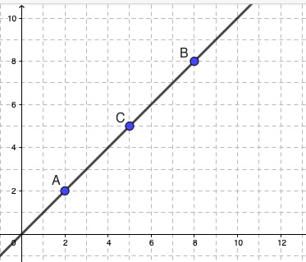

In second case C is not placed in center of AB section. It can be anywhere, even on same line:

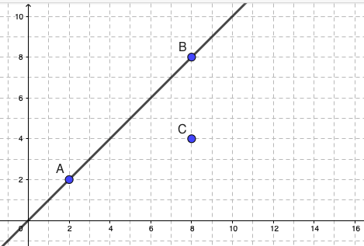 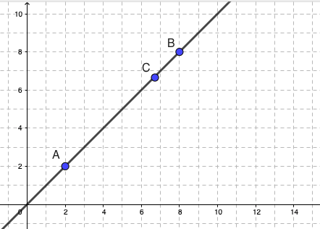

1. Use console.log to show result, variants (use native boolean values, not string):
   * If C divides AB segment by half:

true

* + If C doesn’t devide AB segment by half:

false

**Task 2**. Identify triangle type.

App workflow:

1. User input 3 numbers (a, b, c) for triangle sides length.
2. Check such triangle can exist. If it can’t exit show message ‘Triangle doesn’t exist’.
3. If triangle exist check its type: equivalent (every side is equal), isosceles (two sides are equal) and normal (no sides are equal). All other types we are skipping and say that it is normal triangle (for example we have no needs to check right angled triangle).
4. Use console.log to show result, variants:  
   * If such triangle can’t exist:  
     ‘Triangle doesn’t exist’
   * If triangle has three equal sides:  
     ‘Eequivalent triangle’
   * If triangle has two equal sides, third differs:  
     ‘Isosceles triangle’
   * If triangle has three different sides:  
     ‘Normal triangle’

**RESTRICTIONS**

* No requirements for browser support (should correct work in Google Chrome last version).
* Use prompt for handle user input.
* JS functions are forbidden.

**BEFORE SUBMIT**

* Read requirements and compare to your homework result
* Format the code (remove unnecessary lines of code)
* Remove all unnecessary files that you might have included by mistake
* In order to use npm package manager you should install **nodejs** (https://nodejs.org/ )
* Install **eslint** to check your code (*npm install -g eslint*)
* Open a terminal(or cmd)
* Go to ‘homework’ folder
* Run **eslint** (i.e. *eslint ./js/task1.js*), code should be without ‘errors’
* Please note, that one js file should contain one task

**SUBMIT**

* The folder should be uploaded to github repository “**FL11**” into **master** branch

**USEFUL LINKS**

* <https://developer.mozilla.org/en-US/docs/Web/API/Window/prompt>
* <https://developer.mozilla.org/en-US/docs/Web/JavaScript/Reference/Global_Objects/parseInt>
* <https://developer.mozilla.org/en-US/docs/Web/JavaScript/Reference/Global_Objects/parseFloat>
* <https://developer.mozilla.org/en-US/docs/Web/JavaScript/Reference/Global_Objects/Math>
* <https://en.wikipedia.org/wiki/Midpoint>
* <https://en.wikipedia.org/wiki/Triangle>