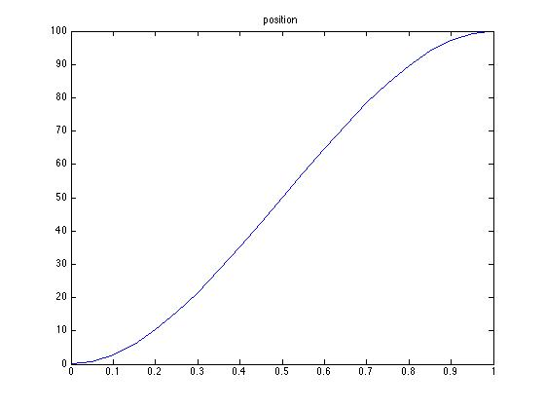

GOAL: Find minimum snap trajectory (d/dt (acceleration))

Learnings: The maximum power of time that you need to express position in is t^6, adding higher power wont result in optimal minimum snap trajectories (T. Flash and N. Hogan).

Moreover the optimal trajectory will remain same for any scaling of time like

T_any = a0(offset) + a1(scaling factor)*t;

So If you find optimal trajectory for time tMin = 0, tMax = 1; then optimal trajectory for any time

TMin = offset, TMax = TMin + a1*tMax will be P(TMin, TMax) = P(0,1/a1).

Note:: The start, end position and velocity should remain same. The only variable factor is time.

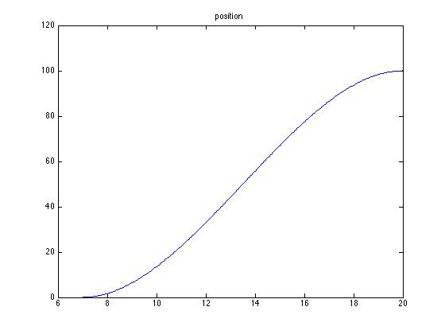

tMin = 7, tMax = 20.

Check proof in thesis.