**1. Specified directory to store libraries package when install new library**

* File => Preferences => Sketchbook location
* Browser to directory you want to store libraries package

**2. Add Boards Manager URLs**

* File => Preferences => Additional Boards Manager URLs

**3. Location position to store 3nd package boards**

* File => Preferences => Click to preference.txt file

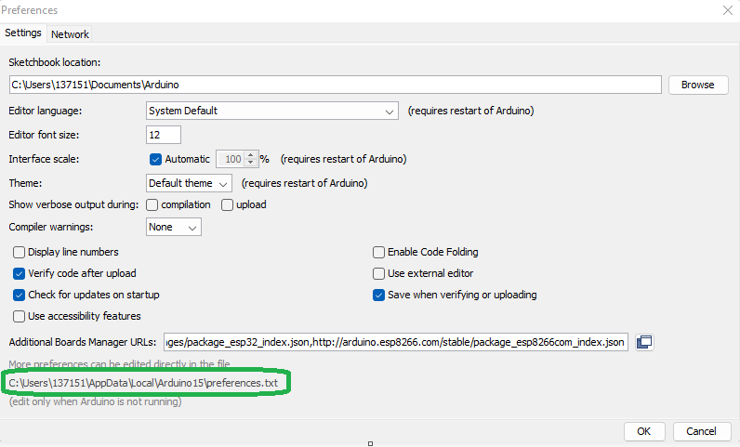

**4.**