**1. Install OpenOCD from source**

* Reference:
  + <https://openocd.org/pages/getting-openocd.html>
* Download OpenOCD source code from Github
  + git clone [git@github.com](mailto:git@github.com):openocd-org/openocd.git

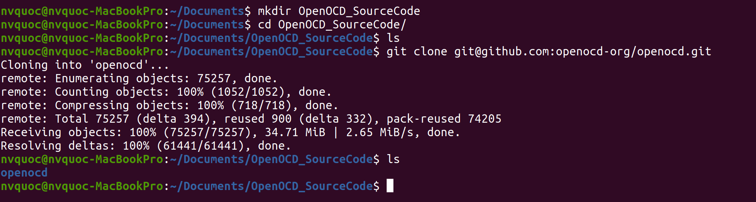

* Build OpenOCD from source code
  + cd openocd
  + ./bootstrap

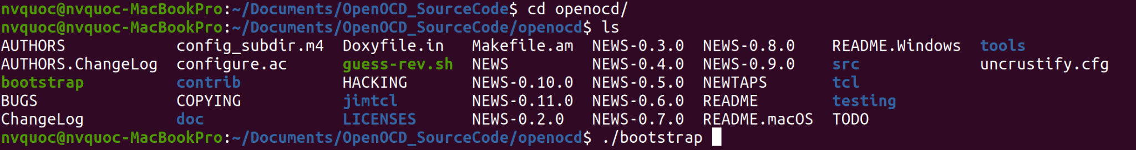

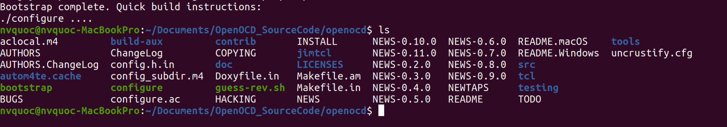

* + ./configure

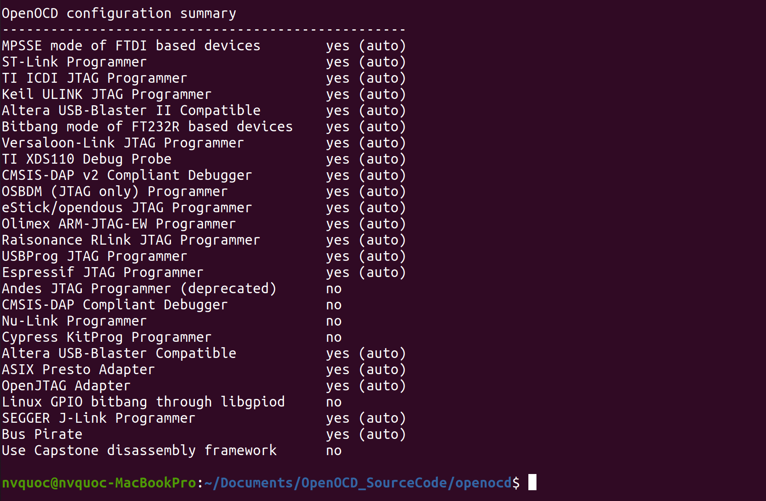

* + make





* + sudo make install

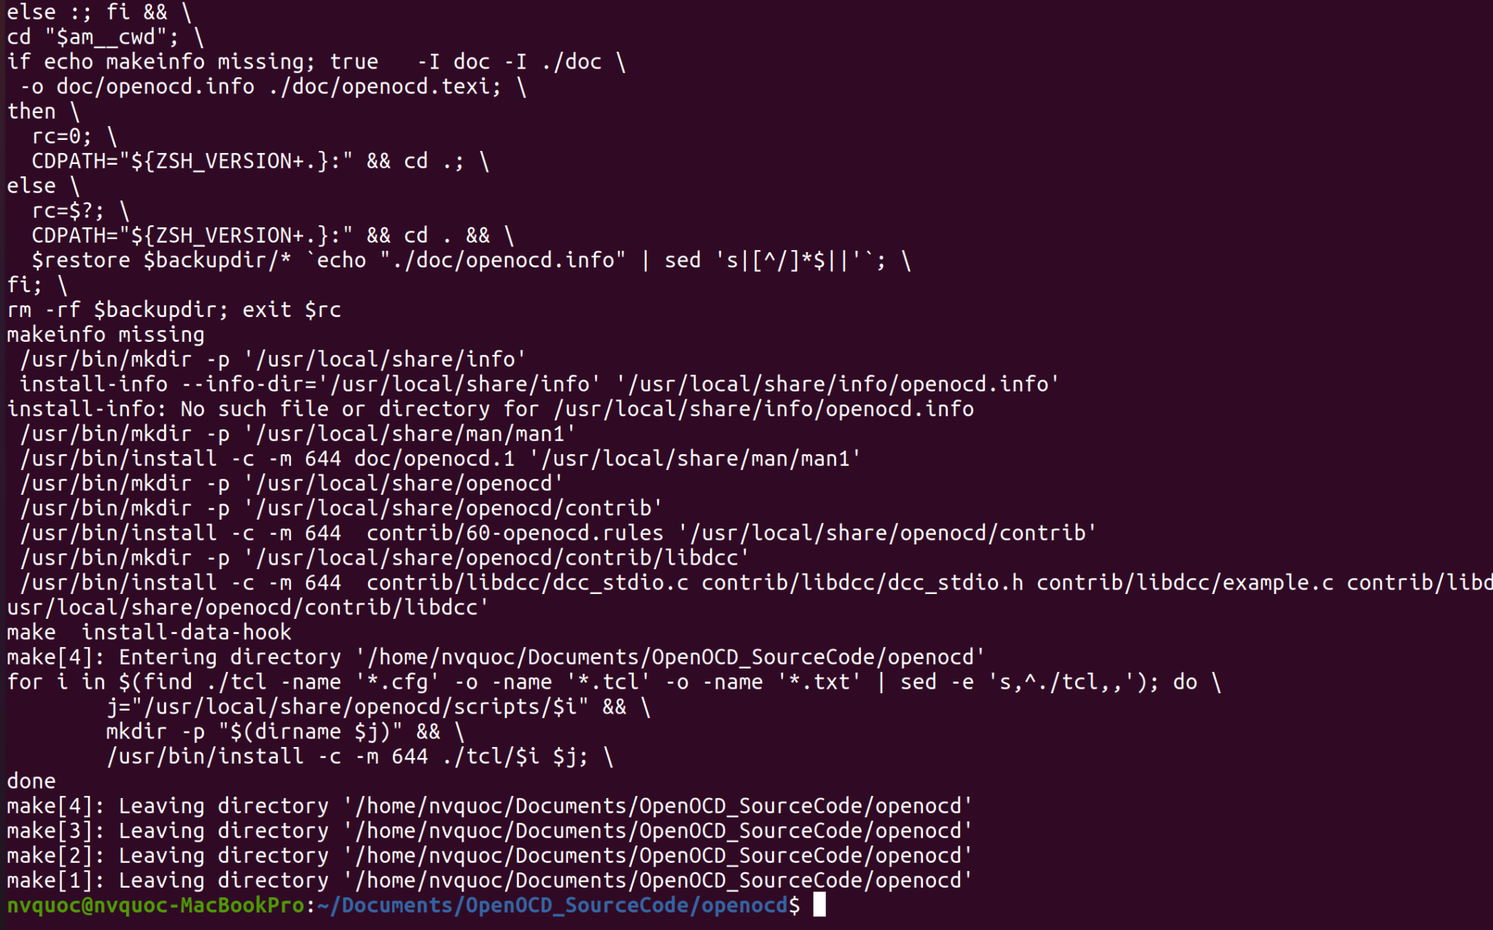

* Check version of OpenOCD
  + openocd --version

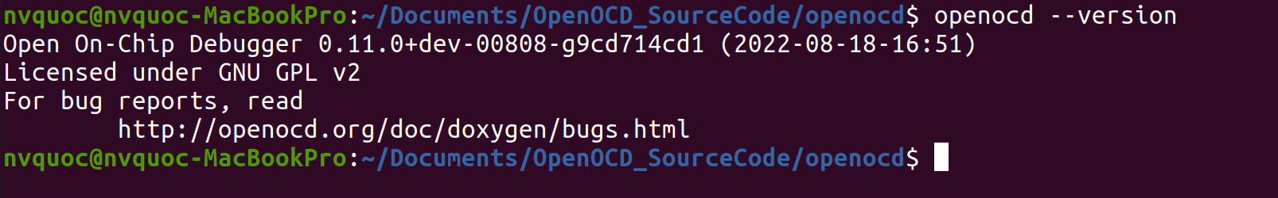

**2.**