**1. Install OpenOCD for ESP32**

* Reference:
  + https://docs.espressif.com/projects/esp-idf/en/v3.3/api-guides/jtag-debugging/setup-openocd-windows.html
* Download OpenOCD for Windows
  + OpenOCD for Windows is available for download from Github: <https://github.com/espressif/openocd-esp32/releases>
* Extract OpenOCD package. Add OpenOCD to path environment.

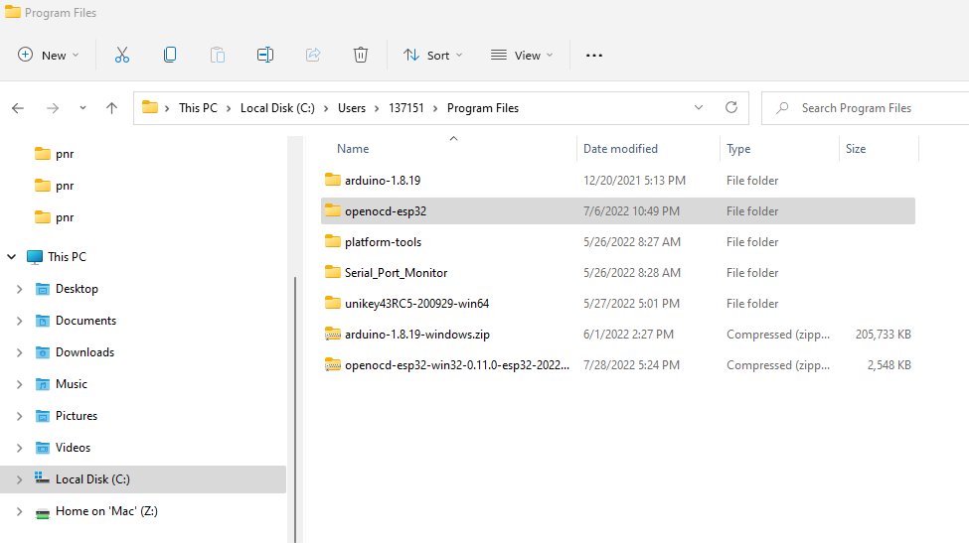

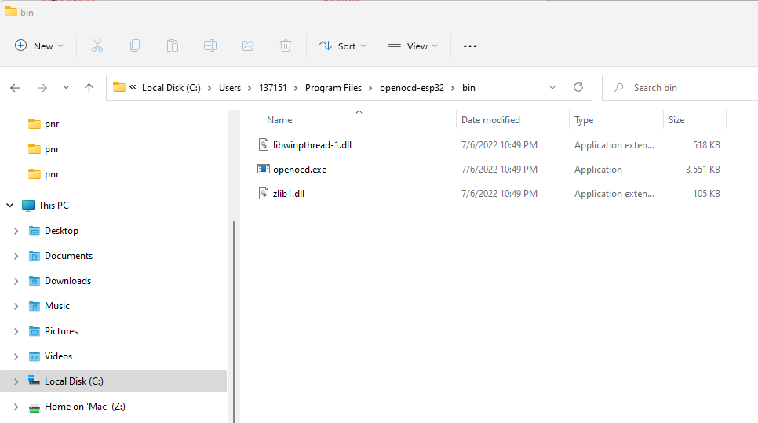

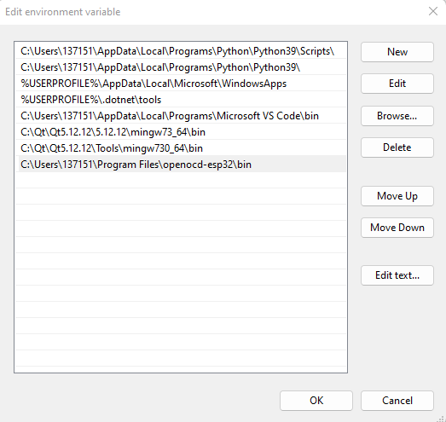

* Check version of OpenOCD
  + openocd.exe –version

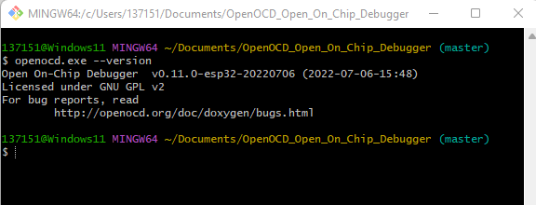

**2. OpenOCD for ESP32 use FT2232 minimodule**

* Reference
  + <https://mcuoneclipse.com/2019/10/20/jtag-debugging-the-esp32-with-ft2232-and-openocd/>
  + [https://docs.espressif.com/projects/esp-idf/en/v3.3/api-guides/jtag-debugging/index.html#jtag-debugging-configuring-esp32-target](https://docs.espressif.com/projects/esp-idf/en/v3.3/api-guides/jtag-debugging/index.html" \l "jtag-debugging-configuring-esp32-target)

**3.**