***PHASE – 5***

***MEDIA***

***STREAMING***

**USING IBM CLOUD**

**SUBMITTED BY:**

**Narapu Reddy Revanth Reddy**

**au723921104026**

[**nvrrnvrr579@gmail.com**](mailto:nvrrnvrr579@gmail.com)

**Project Overview:**

Objective:

Develop a mobile app for tracking personal health and fitness goals to promote a healthier lifestyle.

Design Thinking Process:

Utilize a user-centered design approach to create an intuitive and motivating app that caters to users' individual health and fitness needs.

Development Phases:

Break the project into several phases, each with specific objectives and deliverables.

**Phase 1: Research and Planning**

1.1 User Research: Conduct surveys and interviews with potential users to understand their health and fitness goals, pain points, and preferences.

1.2 Market Analysis: Analyze the competition and identify opportunities for differentiation.

1.3 Define Objectives: Set clear project objectives, including target demographics, key features, and revenue model.

**Phase 2: Design and Prototyping**

2.1 User Interface Design: Create wireframes and mockups of the app's user interface, focusing on simplicity and visual appeal.

2.2 Feature Planning: Define the app's core features, such as goal setting, tracking, social sharing, and health data integration.

2.3 Prototype Development: Develop a clickable prototype for user testing and feedback.

**Phase 3: Development**

3.1 Frontend Development: Build the mobile app's front-end, ensuring a responsive and user-friendly design for various devices.

3.2 Backend Development: Establish the backend infrastructure for user accounts, data storage, and integration with health data sources.

3.3 Mobile Platform Integration: Integrate with health and fitness data sources, like wearable devices or health apps.

3.4 Social Integration: Develop features that allow users to share achievements and connect with friends for added motivation.

3.5 Security Measures: Implement strong security measures to protect user data and maintain privacy.

**Phase 4: Testing and Quality Assurance**

4.1 Functional Testing: Thoroughly test the app's features to identify and fix bugs.

4.2 User Testing: Conduct usability testing with a group of beta testers to gather feedback on the user experience.

4.3 Performance Testing: Ensure the app functions smoothly and responds well under various conditions.

4.4 Security Testing: Perform security assessments to identify and rectify potential vulnerabilities.

**Phase 5: Launch and Optimization**

5.1 App Launch: Release the app to the app stores, initially offering a limited feature set.

5.2 Marketing and Promotion: Develop a marketing strategy to attract users and build brand recognition.

5.3 User Feedback: Continuously gather and analyze user feedback for iterative improvements.

5.4 Feature Expansion: Enhance the app with additional features based on user feedback and industry trends.

5.5 Data Analytics: Implement analytics tools to track user behavior and app performance, enabling data-driven optimizations.

**Platform Features:**

1. User Profiles: Users can create and personalize profiles, set viewing preferences, and track their watch history.

2. Extensive Movie Catalog: The platform offers a vast library of movies spanning various genres, languages, and release years.

3. Search and Recommendations: Users can search for movies, receive personalized recommendations, and discover new content.

4. Social Interaction: The platform enables users to connect with friends, share movie recommendations, and host virtual watch parties.

5. Video Upload Process: Content creators can easily upload their movies, provide metadata, and promotional materials.

6. Streaming Integration: High-quality streaming is facilitated with adaptive bitrate streaming to ensure minimal buffering and high video quality.

7. User Reviews and Ratings: Users can rate and review movies, providing valuable feedback for other viewers.

**User Interface Design:**

The user interface is designed with a focus on simplicity, aesthetics, and ease of navigation. It includes:

1. Home Page: Featuring personalized movie recommendations, trending titles, and user-specific content based on viewing history.

2. Movie Pages: Detailed movie pages with information about the film, including synopsis, cast, reviews, and related content.

3. User Profiles: Customizable user profiles that display watch history, recommendations, and social connections.

4. Search and Discovery: User-friendly search functionality, filters, and easy content discovery.

5. Social Integration: Social features to connect with friends, share recommendations, and schedule virtual watch parties.

6. Playback Controls: Intuitive playback controls with options for subtitles, audio tracks, and video quality adjustments.

7. Content Upload: A dedicated section for content creators to upload and manage their movies.

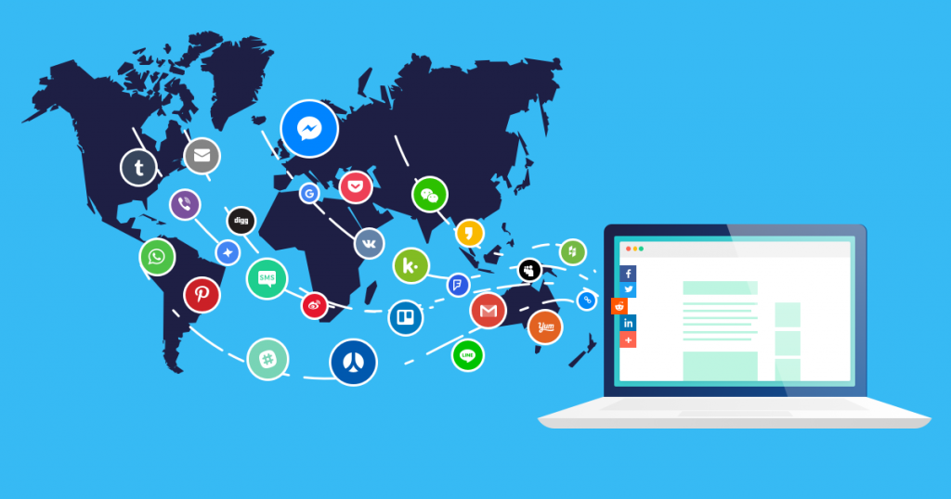

**Video Upload Process:**

Content creators can upload their movies to the platform through a straightforward process:

1. Account Verification: Creators need to register or log in and verify their identity as a content contributor.

2. Metadata Entry: Creators provide essential metadata, including title, genre, description, and release date.

3. Video Upload: Creators can upload their movie files in formats compatible with the platform.

4. Promotional Materials: Creators can include promotional materials such as posters, trailers, and behind-the-scenes content.

5. Content Review: The platform reviews the submitted content to ensure it meets quality and copyright standards.

6. Publishing: Once approved, the movie is added to the platform's catalog, ready for users to discover and enjoy.

**Streaming Integration:**

The platform leverages robust streaming technology to provide a seamless and immersive movie-watching experience:

1. Adaptive Bitrate Streaming: The platform automatically adjusts the video quality to match users' internet connection speeds, minimizing buffering and ensuring uninterrupted playback.

2. Multiple Device Compatibility: Users can access the platform and stream movies on a variety of devices, including smartphones, tablets, smart TVs, and desktop computers.

3. Cross-Platform Sync: The platform offers a synchronized viewing experience, allowing users to start a movie on one device and continue watching on another without losing their place.

4. Streaming Quality: High-definition video and crisp audio ensure a cinematic experience, even on larger screens.

5. Security Measures: Robust security measures, including encryption and digital rights management (DRM), protect content from piracy and unauthorized access.