Lab 6: Layout and application
Code:
package com.example.lab6;
import androidx.appcompat.app.AppCompatActivity;
import android.os.Bundle;
import android.widget.*;
public class MainActivity extends AppCompatActivity {
Spinner spnFrom, spnTo;
EditText edtInput;
TextView txtResult;
Button btnConvert;
String[] units = {
"Hải lý",
"Dặm",
"Kilometer",
"Lý",
"Mét",
"Yard",
"Foot",
"Inches"
};
// Đổi về mét
double[] toMeter = {
1852,
1609.344,
1000,
500,
1,
0.9144,
0.3048,
0.0254
};
@Override
protected void onCreate(Bundle savedInstanceState) {
super.onCreate(savedInstanceState);
setContentView(R.layout.activity_main);
spnFrom = findViewById(R.id.spnFrom);
spnTo = findViewById(R.id.spnTo);
edtInput = findViewById(R.id.edtInput);
txtResult = findViewById(R.id.txtResult);
btnConvert = findViewById(R.id.btnConvert);
// Spinner adapter
ArrayAdapter<String> adapter = new ArrayAdapter<>(
this, android.R.layout.simple_spinner_dropdown_item, units
);
spnFrom.setAdapter(adapter);
spnTo.setAdapter(adapter);
// Convert
btnConvert.setOnClickListener(v -> {
String s = edtInput.getText().toString();
if (s.isEmpty()) {
txtResult.setText("Vui lòng nhập số");
return;
}
double input = Double.parseDouble(s);
int from = spnFrom.getSelectedItemPosition();
int to = spnTo.getSelectedItemPosition();
double meterValue = input * toMeter[from];
double result = meterValue / toMeter[to];
txtResult.setText(input + " " + units[from] + " = " + result + " " + units[to]);
});
}
}
Kết quả:
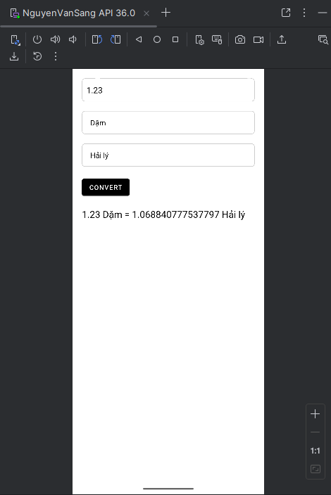
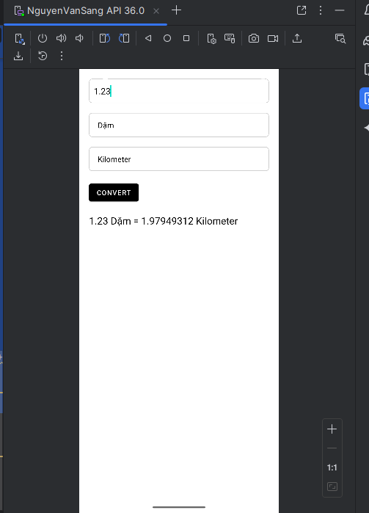
Lab 7: Custom controls
Code:
MainActivity.java
package com.example.lab7;
import androidx.appcompat.app.AppCompatActivity;
import android.app.Dialog;
import android.content.Intent;
import android.os.Bundle;
import android.view.Window;
import android.view.WindowManager;
import android.widget.Button;
import android.widget.EditText;
import android.widget.ImageButton;
import android.widget.Toast;
public class MainActivity extends AppCompatActivity {
Button btnBgSelector, btnBgSelectorDisabled, btnDrawableSelector, btnTxtSelector;
Button btnRoundShape, btnBgShape, btnSelectorShape, btnLoginDialog, btnSeekbar;
ImageButton imgButtonLeft, imgButtonRight;
@Override
protected void onCreate(Bundle savedInstanceState) {
super.onCreate(savedInstanceState);
setContentView(R.layout.activity_main);
addControls();
addEvents();
}
private void addControls() {
btnBgSelector = findViewById(R.id.btnBgSelector);
btnBgSelectorDisabled = findViewById(R.id.btnBgSelectorDisabled);
btnDrawableSelector = findViewById(R.id.btnDrawableSelector);
btnTxtSelector = findViewById(R.id.btnTxtSelector);
btnRoundShape = findViewById(R.id.btnRoundShape);
btnBgShape = findViewById(R.id.btnBgShape);
btnSelectorShape = findViewById(R.id.btnSelectorShape);
btnLoginDialog = findViewById(R.id.btnLoginDialog);
btnSeekbar = findViewById(R.id.btnSeekbar);
// Nếu bạn có 2 emoji → phải đặt 2 id trong XML
imgButtonLeft = findViewById(R.id.imgButtonLeft);
imgButtonRight = findViewById(R.id.imgButtonRight);
}
private void addEvents() {
btnBgSelector.setOnClickListener(v -> showToast("Colored Selector clicked"));
btnBgSelectorDisabled.setOnClickListener(v -> showToast("Disabled button clicked"));
btnDrawableSelector.setOnClickListener(v -> showToast("Drawable selector clicked"));
btnTxtSelector.setOnClickListener(v -> showToast("Text selector clicked"));
btnRoundShape.setOnClickListener(v -> showToast("Round shape clicked"));
btnBgShape.setOnClickListener(v -> showToast("Gradient shape clicked"));
btnSelectorShape.setOnClickListener(v -> showToast("Selector shape clicked"));
imgButtonLeft.setOnClickListener(v -> showToast("Left emoji clicked"));
imgButtonRight.setOnClickListener(v -> showToast("Right emoji clicked"));
btnLoginDialog.setOnClickListener(v -> openLoginDialog());
btnSeekbar.setOnClickListener(v -> {
Intent intent = new Intent(MainActivity.this, SeekBarActivity.class);
startActivity(intent);
});
}
private void showToast(String msg) {
Toast.makeText(this, msg, Toast.LENGTH_SHORT).show();
}
private void openLoginDialog() {
Dialog d = new Dialog(MainActivity.this);
d.setContentView(R.layout.custom_login_dialog);
d.setCancelable(true);
EditText edtUser = d.findViewById(R.id.edtUser);
EditText edtPass = d.findViewById(R.id.edtPass);
Button btnOK = d.findViewById(R.id.btnOK);
Button btnCancel = d.findViewById(R.id.btnCancel);
btnOK.setOnClickListener(v -> {
String u = edtUser.getText().toString().trim();
String p = edtPass.getText().toString().trim();
if (u.equals("admin") && p.equals("123")) {
Toast.makeText(MainActivity.this, "Đăng nhập thành công", Toast.LENGTH_SHORT).show();
d.dismiss();
} else {
Toast.makeText(MainActivity.this, "Sai tài khoản hoặc mật khẩu", Toast.LENGTH_SHORT).show();
}
});
btnCancel.setOnClickListener(v -> d.dismiss());
d.show();
Window window = d.getWindow();
if (window != null) {
window.setLayout(
(int) (getResources().getDisplayMetrics().widthPixels * 0.85),
WindowManager.LayoutParams.WRAP_CONTENT
);
}
}
}
SeekBarActivity.java
package com.example.lab7;
import androidx.appcompat.app.AppCompatActivity;
import android.graphics.Color;
import android.os.Bundle;
import android.widget.SeekBar;
import android.widget.TextView;
import android.view.View;
public class SeekBarActivity extends AppCompatActivity {
SeekBar seekR, seekG, seekB;
TextView txtR, txtG, txtB;
View viewRGB, viewCMY;
@Override
protected void onCreate(Bundle savedInstanceState) {
super.onCreate(savedInstanceState);
setContentView(R.layout.activity_seekbar);
seekR = findViewById(R.id.seekR);
seekG = findViewById(R.id.seekG);
seekB = findViewById(R.id.seekB);
txtR = findViewById(R.id.txtR);
txtG = findViewById(R.id.txtG);
txtB = findViewById(R.id.txtB);
viewRGB = findViewById(R.id.viewRGB);
viewCMY = findViewById(R.id.viewCMY);
updateColor();
SeekBar.OnSeekBarChangeListener listener = new SeekBar.OnSeekBarChangeListener() {
@Override
public void onProgressChanged(SeekBar seek, int value, boolean b) {
txtR.setText("R = " + seekR.getProgress());
txtG.setText("G = " + seekG.getProgress());
txtB.setText("B = " + seekB.getProgress());
updateColor();
}
@Override public void onStartTrackingTouch(SeekBar seekBar) {}
@Override public void onStopTrackingTouch(SeekBar seekBar) {}
};
seekR.setOnSeekBarChangeListener(listener);
seekG.setOnSeekBarChangeListener(listener);
seekB.setOnSeekBarChangeListener(listener);
}
private void updateColor() {
int R = seekR.getProgress();
int G = seekG.getProgress();
int B = seekB.getProgress();
// RGB
viewRGB.setBackgroundColor(Color.rgb(R, G, B));
// CMY
int C = 255 - R;
int M = 255 - G;
int Y = 255 - B;
viewCMY.setBackgroundColor(Color.rgb(C, M, Y));
}
}
Kết quả:
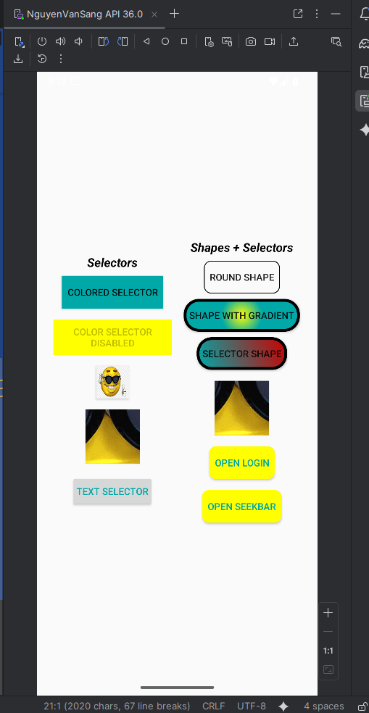
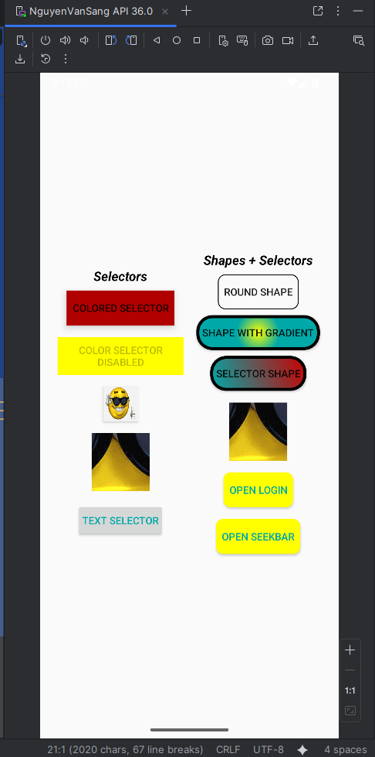
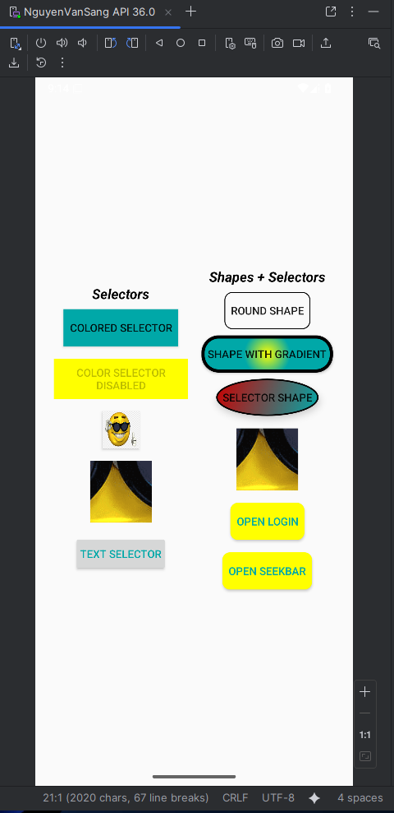
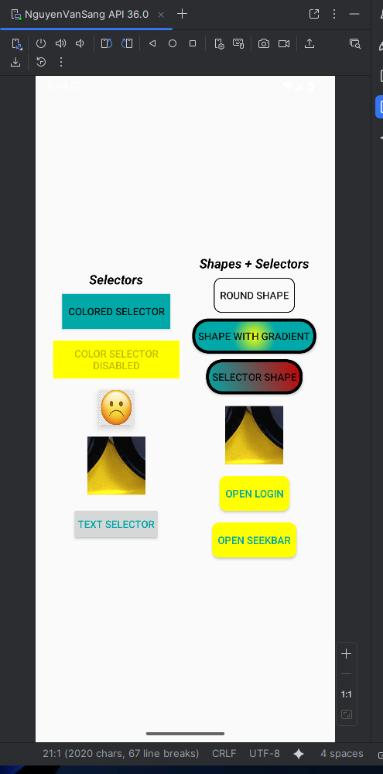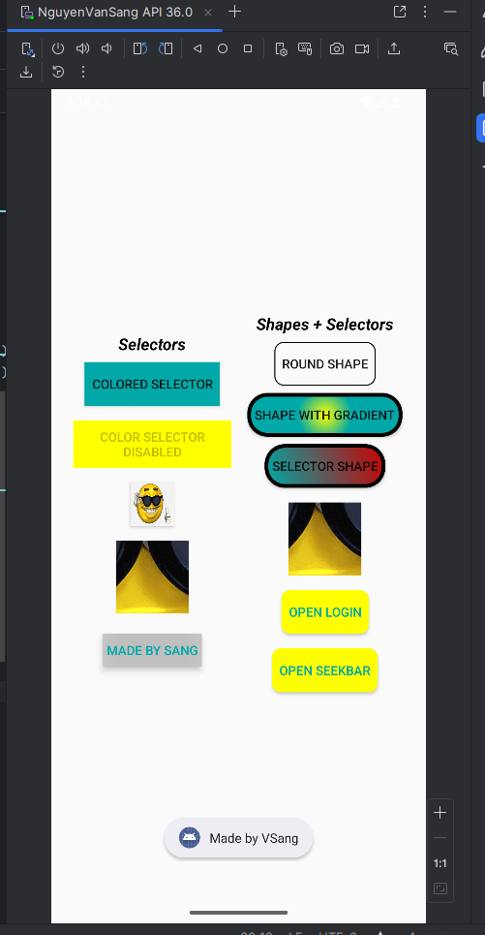
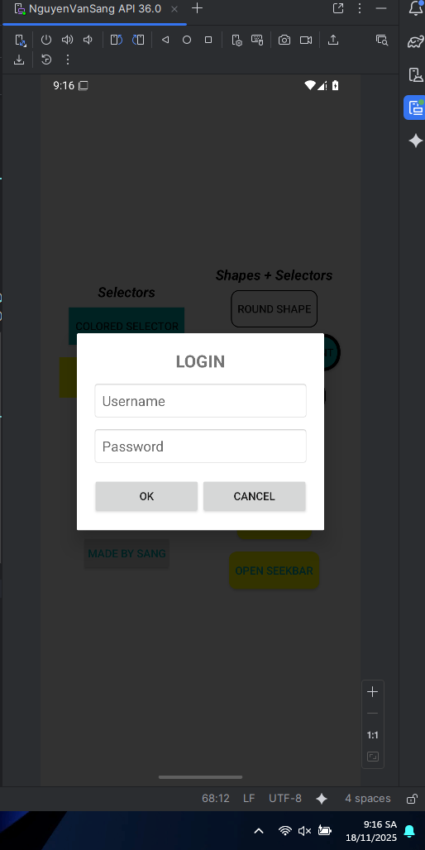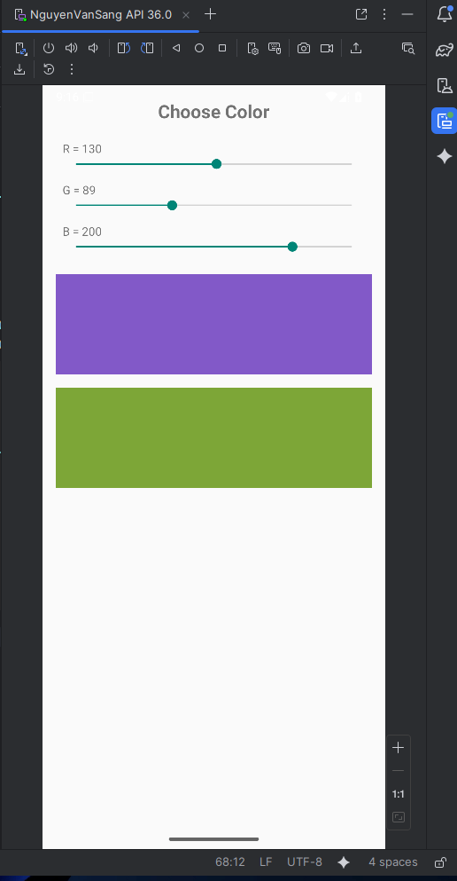
Lab 8: List trong Android
Code:
Contributor.java
package com.example.lab8;
public class Contributor {
public int avatar;
public String name;
public String score;
public Contributor(int avatar, String name, String score) {
this.avatar = avatar;
this.name = name;
this.score = score;
}
}
ContributorAdapter.java
package com.example.lab8;
import android.content.Context;
import android.view.LayoutInflater;
import android.view.View;
import android.view.ViewGroup;
import android.widget.BaseAdapter;
import android.widget.ImageView;
import android.widget.TextView;
import java.util.ArrayList;
public class ContributorAdapter extends BaseAdapter {
Context context;
ArrayList<Contributor> list;
public ContributorAdapter(Context context, ArrayList<Contributor> list) {
this.context = context;
this.list = list;
}
@Override
public int getCount() {
return list.size();
}
@Override
public Object getItem(int i) {
return list.get(i);
}
@Override
public long getItemId(int i) {
return i;
}
@Override
public View getView(int i, View view, ViewGroup parent) {
if (view == null)
view = LayoutInflater.from(context)
.inflate(R.layout.item_contributor, parent, false);
Contributor c = list.get(i);
ImageView img = view.findViewById(R.id.imgAvatar);
TextView txtName = view.findViewById(R.id.txtName);
TextView txtScore = view.findViewById(R.id.txtScore);
img.setImageResource(c.avatar);
txtName.setText(c.name);
txtScore.setText(c.score);
return view;
}
}

Food.java
package com.example.lab8;
public class Food {
private String name;
private String description;
private int price;
private int img;
public Food(String name, String description, int price, int img) {
this.name = name;
this.description = description;
this.price = price;
this.img = img;
}
public String getName() {
return name;
}
public String getDescription() {
return description;
}
public int getPrice() {
return price;
}
public int getImg() {
return img;
}
public void setName(String name) {
this.name = name;
}
public void setDescription(String description) {
this.description = description;
}
public void setPrice(int price) {
this.price = price;
}
}

FoodAdapter.java
package com.example.lab8;
import android.content.Context;
import android.view.LayoutInflater;
import android.view.View;
import android.view.ViewGroup;
import android.widget.BaseAdapter;
import android.widget.ImageView;
import android.widget.TextView;
import java.util.ArrayList;
public class FoodAdapter extends BaseAdapter {
Context context;
ArrayList<Food> list;
public FoodAdapter(Context context, ArrayList<Food> list) {
this.context = context;
this.list = list;
}
@Override
public int getCount() {
return list.size();
}
@Override
public Object getItem(int position) {
return list.get(position);
}
@Override
public long getItemId(int position) {
return position;
}
class ViewHolder {
ImageView imgFood;
TextView txtName, txtDes, txtPrice;
}
@Override
public View getView(int position, View convertView, ViewGroup parent) {
ViewHolder holder;
if (convertView == null) {
convertView = LayoutInflater.from(context)
.inflate(R.layout.item_food, parent, false);
holder = new ViewHolder();
holder.imgFood = convertView.findViewById(R.id.imgFood);
holder.txtName = convertView.findViewById(R.id.txtName);
holder.txtDes = convertView.findViewById(R.id.txtDes);
holder.txtPrice = convertView.findViewById(R.id.txtPrice);
convertView.setTag(holder);
} else {
holder = (ViewHolder) convertView.getTag();
}
Food f = list.get(position);
holder.txtName.setText(f.getName());
holder.txtDes.setText(f.getDescription());
holder.txtPrice.setText(String.valueOf(f.getPrice()));
holder.imgFood.setImageResource(f.getImg());
return convertView;
}
}

GridActivity.java
package com.example.lab8;
import androidx.appcompat.app.AppCompatActivity;
import android.os.Bundle;
import android.widget.GridView;
import java.util.ArrayList;
public class GridActivity extends AppCompatActivity {
GridView grid;
ArrayList<Contributor> arr;
ContributorAdapter adapter;
@Override
protected void onCreate(Bundle savedInstanceState) {
super.onCreate(savedInstanceState);
setContentView(R.layout.activity_grid);
grid = findViewById(R.id.gridContributors);
arr = new ArrayList<>();
arr.add(new Contributor(R.drawable.avatar1, "Maboo", "283,297"));
arr.add(new Contributor(R.drawable.avatar2, "SameOldShawn", "252,433"));
arr.add(new Contributor(R.drawable.avatar3, "Magnitude901", "164,935"));
arr.add(new Contributor(R.drawable.avatar4, "Brandon", "100,466"));
arr.add(new Contributor(R.drawable.avatar5, "Clement_RGF", "93,932"));
arr.add(new Contributor(R.drawable.avatar6, "Nebja", "84,187"));
adapter = new ContributorAdapter(this, arr);
grid.setAdapter(adapter);
}
}

ListActivity.java
package com.example.lab8;
import android.app.Dialog;
import android.os.Bundle;
import android.view.ContextMenu;
import android.view.MenuItem;
import android.view.View;
import android.widget.AdapterView;
import android.widget.Button;
import android.widget.EditText;
import android.widget.ListView;
import androidx.appcompat.app.AppCompatActivity;
import java.util.ArrayList;
public class ListActivity extends AppCompatActivity {
ListView listView;
ArrayList<Food> arrayList;
FoodAdapter adapter;
int selectedIndex = -1; // lưu vị trí item đang nhấn giữ
@Override
protected void onCreate(Bundle savedInstanceState) {
super.onCreate(savedInstanceState);
setContentView(R.layout.activity_list);
listView = findViewById(R.id.listView);
// dữ liệu mẫu
arrayList = new ArrayList<>();
arrayList.add(new Food("Hamburger", "Món Mỹ", 50000, R.drawable.image1));
arrayList.add(new Food("Trà sữa", "Ngọt dễ uống", 35000, R.drawable.image2));
arrayList.add(new Food("Pizza", "Món Ý", 120000, R.drawable.image3));
adapter = new FoodAdapter(this, arrayList);
listView.setAdapter(adapter);
// bật menu khi nhấn giữ
registerForContextMenu(listView);
}
// tạo menu Sửa / Xóa
@Override
public void onCreateContextMenu(ContextMenu menu, View v,
ContextMenu.ContextMenuInfo menuInfo) {
super.onCreateContextMenu(menu, v, menuInfo);
getMenuInflater().inflate(R.menu.food_menu, menu);
AdapterView.AdapterContextMenuInfo info =
(AdapterView.AdapterContextMenuInfo) menuInfo;
selectedIndex = info.position; // lấy vị trí item
}
// xử lý menu Sửa / Xóa
@Override
public boolean onContextItemSelected(MenuItem item) {
if (selectedIndex == -1) return false;
int itemId = item.getItemId();
if (itemId == R.id.mnEdit) {
showEditDialog();
return true;
} else if (itemId == R.id.mnDelete) {
arrayList.remove(selectedIndex);
adapter.notifyDataSetChanged();
return true;
}
return super.onContextItemSelected(item);
}
// dialog sửa món ăn
private void showEditDialog() {
Dialog dialog = new Dialog(this);
dialog.setContentView(R.layout.dialog_food);
EditText edtName = dialog.findViewById(R.id.edtName);
EditText edtDes = dialog.findViewById(R.id.edtDes);
EditText edtPrice = dialog.findViewById(R.id.edtPrice);
Button btnSave = dialog.findViewById(R.id.btnSave);
Button btnCancel = dialog.findViewById(R.id.btnCancel);
Food f = arrayList.get(selectedIndex);
edtName.setText(f.getName());
edtDes.setText(f.getDescription());
edtPrice.setText(String.valueOf(f.getPrice()));
btnSave.setOnClickListener(v -> {
f.setName(edtName.getText().toString());
f.setDescription(edtDes.getText().toString());
f.setPrice(Integer.parseInt(edtPrice.getText().toString()));
adapter.notifyDataSetChanged();
dialog.dismiss();
});
btnCancel.setOnClickListener(v -> dialog.dismiss());
dialog.show();
}
}

MainActivity.java
package com.example.lab8;
import androidx.appcompat.app.AppCompatActivity;
import android.content.Intent;
import android.os.Bundle;
import android.widget.Button;
public class MainActivity extends AppCompatActivity {
Button btnList, btnGrid;
@Override
protected void onCreate(Bundle savedInstanceState) {
super.onCreate(savedInstanceState);
setContentView(R.layout.activity_main);
btnList = findViewById(R.id.btnList);
btnGrid = findViewById(R.id.btnGrid);
btnList.setOnClickListener(v ->
startActivity(new Intent(MainActivity.this, ListActivity.class)));
btnGrid.setOnClickListener(v ->
startActivity(new Intent(MainActivity.this, GridActivity.class)));
}
}

Kết quả:
