Họ và tên: Nguyễn Văn Sang
MSSV: 1150080072
Lớp: 11_DH_THMT
Lab 10 – 11: Ứng dụng truyện cười
Link data set:
C:\Users\nvs15\AndroidStudioProjects\lab11\app\src\main\assets\photo\ RuaVaTho.jpg
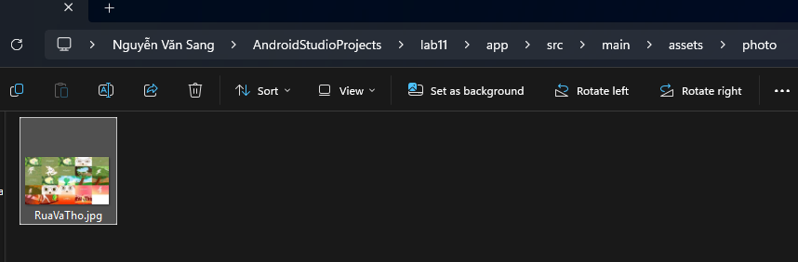
C:\Users\nvs15\AndroidStudioProjects\lab11\app\src\main\assets\story\ truyenngungon.txt
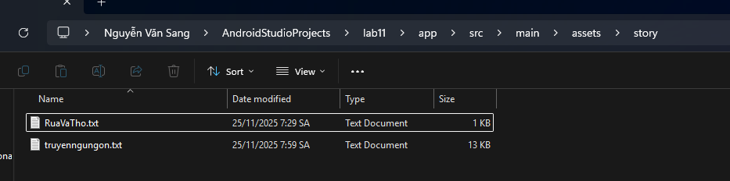
C:\Users\nvs15\AndroidStudioProjects\lab11\app\src\main\res\drawable
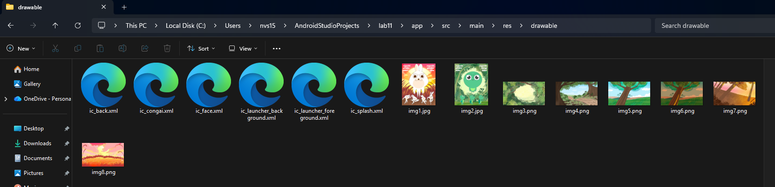
Code:
DetailStoryAdapter.java
package com.example.lab11;
import android.content.Context;
import android.view.LayoutInflater;
import android.view.View;
import android.view.ViewGroup;
import android.widget.TextView;
import androidx.viewpager.widget.PagerAdapter;
import java.util.ArrayList;
public class DetailStoryAdapter extends PagerAdapter {
private final ArrayList<StoryEntity> listStory;
private final Context mContext;
public DetailStoryAdapter(ArrayList<StoryEntity> listStory, Context mContext) {
this.listStory = listStory;
this.mContext = mContext;
}
@Override
public Object instantiateItem(ViewGroup container, int position) {
View view = LayoutInflater.from(mContext).inflate(R.layout.item_detail_story, container, false);
StoryEntity item = listStory.get(position);
TextView tvName = view.findViewById(R.id.tv_name);
TextView tvContent = view.findViewById(R.id.tv_content);
tvName.setText(item.getName());
tvContent.setText(item.getContent());
container.addView(view);
return view;
}
@Override
public int getCount() {
return listStory.size();
}
@Override
public boolean isViewFromObject(View view, Object object) {
return view.equals(object);
}
@Override
public void destroyItem(ViewGroup container, int position, Object object) {
container.removeView((View) object);
}
}
M000SplashFrg.java
package com.example.lab11;
import android.os.Bundle;
import android.os.Handler;
import android.view.LayoutInflater;
import android.view.View;
import android.view.ViewGroup;
import androidx.fragment.app.Fragment;
public class M000SplashFrg extends Fragment {
@Override
public View onCreateView(LayoutInflater inflater, ViewGroup container, Bundle savedInstanceState) {
initViews();
return inflater.inflate(R.layout.m000_frg_splash, container, false);
}
private void initViews() {
new Handler().postDelayed(this::gotoM001Screen, 2000);
}
private void gotoM001Screen() {
((MainActivity) getActivity()).gotoM001Screen();
}
}
M001TopicFrg.java
package com.example.lab11;
import android.content.Context;
import android.os.Bundle;
import android.view.LayoutInflater;
import android.view.View;
import android.view.ViewGroup;
import android.widget.ImageView;
import android.widget.LinearLayout;
import android.widget.TextView;
import androidx.fragment.app.Fragment;
public class M001TopicFrg extends Fragment implements View.OnClickListener {
private Context mContext;
private final int[] storyImages = {
R.drawable.img1,
R.drawable.img2,
R.drawable.img3,
R.drawable.img4,
R.drawable.img5,
R.drawable.img6,
R.drawable.img7,
R.drawable.img8
};
@Override
public View onCreateView(LayoutInflater inflater, ViewGroup container, Bundle savedInstanceState) {
View rootView = inflater.inflate(R.layout.m001_frg_topic, container, false);
initViews(rootView);
return rootView;
}
@Override
public void onAttach(Context context) {
super.onAttach(context);
mContext = context;
}
private void initViews(View v) {
LinearLayout lnMain = v.findViewById(R.id.ln_topic);
lnMain.removeAllViews();
for (int i = 0; i < StoryData.STORY_NAMES.length; i++) {
String storyName = StoryData.STORY_NAMES[i];
View vTopic = LayoutInflater.from(mContext).inflate(R.layout.item_topic, null);
ImageView ivTopic = vTopic.findViewById(R.id.iv_topic);
TextView tvTopic = vTopic.findViewById(R.id.tv_topic);
if (i < storyImages.length) {
ivTopic.setImageResource(storyImages[i]);
}
tvTopic.setText(storyName);
lnMain.addView(vTopic);
LinearLayout.LayoutParams params = (LinearLayout.LayoutParams) vTopic.getLayoutParams();
params.bottomMargin = 5;
vTopic.setLayoutParams(params);
vTopic.setTag(storyName);
vTopic.setOnClickListener(this);
}
}
@Override
public void onClick(View v) {
String storyName = (String) v.getTag();
((MainActivity) getActivity()).gotoM002Screen(storyName);
}
}
M002StoryFrg.java
package com.example.lab11;
import android.content.Context;
import android.os.Bundle;
import android.view.LayoutInflater;
import android.view.View;
import android.view.ViewGroup;
import android.widget.TextView;
import androidx.fragment.app.Fragment;
import androidx.recyclerview.widget.LinearLayoutManager;
import androidx.recyclerview.widget.RecyclerView;
import java.io.BufferedReader;
import java.io.IOException;
import java.io.InputStreamReader;
import java.util.ArrayList;
public class M002StoryFrg extends Fragment {
private Context mContext;
private String topicName;
@Override
public View onCreateView(LayoutInflater inflater, ViewGroup container, Bundle savedInstanceState) {
View rootView = inflater.inflate(R.layout.m002_frg_story, container, false);
initViews(rootView);
return rootView;
}
@Override
public void onAttach(Context context) {
super.onAttach(context);
mContext = context;
}
private void initViews(View v) {
v.findViewById(R.id.iv_back).setVisibility(View.VISIBLE);
v.findViewById(R.id.iv_back).setOnClickListener(v1 -> backToM001Screen());
((TextView) v.findViewById(R.id.tv_name)).setText(topicName);
RecyclerView rv = v.findViewById(R.id.rv_story);
ArrayList<StoryEntity> listStory = readStoryFromFile();
StoryAdapter adapter = new StoryAdapter(listStory, mContext);
rv.setAdapter(adapter);
rv.setLayoutManager(new LinearLayoutManager(mContext));
}
private ArrayList<StoryEntity> readStoryFromFile() {
ArrayList<StoryEntity> listStory = new ArrayList<>();
BufferedReader reader = null;
try {
reader = new BufferedReader(
new InputStreamReader(mContext.getAssets().open("story/truyenngungon.txt"), "UTF-8"));
String line;
while ((line = reader.readLine()) != null) {
if (line.contains("|")) {
String[] parts = line.split("\\|");
String storyName = parts[0].trim();
String pageName = parts[1].trim();
if (storyName.equals(topicName)) {
String content = reader.readLine();
if (content != null) {
content = content.trim();
StoryEntity story = new StoryEntity(storyName, pageName, content);
listStory.add(story);
}
}
}
if (line.equals("---")) {
continue;
}
}
} catch (IOException e) {
e.printStackTrace();
} finally {
if (reader != null) {
try {
reader.close();
} catch (IOException e) {
e.printStackTrace();
}
}
}
return listStory;
}
public void setTopicName(String topicName) {
this.topicName = topicName;
}
private void backToM001Screen() {
((MainActivity) getActivity()).backToM001Screen();
}
}
M003DetailStoryFrg.java
package com.example.lab11;
import android.content.Context;
import android.os.Bundle;
import android.view.LayoutInflater;
import android.view.View;
import android.view.ViewGroup;
import android.widget.TextView;
import androidx.fragment.app.Fragment;
import androidx.viewpager.widget.ViewPager;
import java.util.ArrayList;
public class M003DetailStoryFrg extends Fragment {
private Context mContext;
private ArrayList<StoryEntity> listStory;
private String topicName;
private StoryEntity currentStory;
@Override
public View onCreateView(LayoutInflater inflater, ViewGroup container, Bundle savedInstanceState) {
View rootView = inflater.inflate(R.layout.m003_frg_detail_story, container, false);
initViews(rootView);
return rootView;
}
@Override
public void onAttach(Context context) {
super.onAttach(context);
mContext = context;
}
private void initViews(View v) {
v.findViewById(R.id.iv_back).setVisibility(View.VISIBLE);
v.findViewById(R.id.iv_back).setOnClickListener(v1 -> backToM002Screen());
((TextView) v.findViewById(R.id.tv_name)).setText(topicName);
ViewPager vp = v.findViewById(R.id.vp_story);
DetailStoryAdapter adapter = new DetailStoryAdapter(listStory, mContext);
vp.setAdapter(adapter);
vp.setCurrentItem(listStory.indexOf(currentStory), true);
}
private void backToM002Screen() {
((MainActivity) getActivity()).gotoM002Screen(topicName);
}
public void setData(String topicName, ArrayList<StoryEntity> listStory, StoryEntity currentStory) {
this.currentStory = currentStory;
this.topicName = topicName;
this.listStory = listStory;
}
}
MainActivity.java
package com.example.lab11;
import android.os.Bundle;
import androidx.appcompat.app.AppCompatActivity;
import androidx.fragment.app.Fragment;
import java.util.ArrayList;
public class MainActivity extends AppCompatActivity {
private String topicName;
@Override
protected void onCreate(Bundle savedInstanceState) {
super.onCreate(savedInstanceState);
setContentView(R.layout.activity_main);
showFrg(new M000SplashFrg());
}
private void showFrg(Fragment frg) {
getSupportFragmentManager().beginTransaction().replace(R.id.ln_main, frg, null).commit();
}
public void gotoM001Screen() {
getSupportFragmentManager().beginTransaction().replace(R.id.ln_main, new M001TopicFrg(), null).commit();
}
public void gotoM002Screen(String topicName) {
this.topicName = topicName;
M002StoryFrg frg = new M002StoryFrg();
frg.setTopicName(topicName);
showFrg(frg);
}
public void backToM001Screen() {
gotoM001Screen();
}
public void gotoM003Screen(ArrayList<StoryEntity> listStory, StoryEntity story) {
M003DetailStoryFrg frg = new M003DetailStoryFrg();
frg.setData(topicName, listStory, story);
showFrg(frg);
}
}
StoryAdapter.java
package com.example.lab11;
import android.content.Context;
import android.view.LayoutInflater;
import android.view.View;
import android.view.ViewGroup;
import android.widget.TextView;
import androidx.recyclerview.widget.RecyclerView;
import java.util.ArrayList;
public class StoryAdapter extends RecyclerView.Adapter<StoryAdapter.StoryHolder> {
private final ArrayList<StoryEntity> listStory;
private final Context mContext;
public StoryAdapter(ArrayList<StoryEntity> listStory, Context mContext) {
this.listStory = listStory;
this.mContext = mContext;
}
@Override
public StoryHolder onCreateViewHolder(ViewGroup parent, int viewType) {
View view = LayoutInflater.from(mContext).inflate(R.layout.item_story, parent, false);
return new StoryHolder(view);
}
@Override
public void onBindViewHolder(StoryAdapter.StoryHolder holder, int position) {
StoryEntity item = listStory.get(position);
holder.tvName.setTag(item);
holder.tvName.setText(item.getName());
}
@Override
public int getItemCount() {
return listStory.size();
}
public class StoryHolder extends RecyclerView.ViewHolder {
TextView tvName;
public StoryHolder(View itemView) {
super(itemView);
tvName = itemView.findViewById(R.id.tv_story);
itemView.setOnClickListener(v -> {
((MainActivity) mContext).gotoM003Screen(listStory, (StoryEntity) tvName.getTag());
});
}
}
}
StoryData.java
package com.example.lab11;
public class StoryData {
public static final String[] STORY_NAMES = {
"Rùa và Thỏ",
"Sư tử và chuột",
"Cáo và quạ",
"Kiến và châu chấu",
"Bò và ếch",
"Cậu bé chăn cừu",
"Chó và bóng chó",
"Gà trống và viên ngọc"
};
}
StoryEntity.java
package com.example.lab11;
public class StoryEntity {
private final String topicName;
private final String name;
private final String content;
public StoryEntity(String topicName, String name, String content) {
this.topicName = topicName;
this.name = name;
this.content = content;
}
public String getTopicName() {
return topicName;
}
public String getName() {
return name;
}
public String getContent() {
return content;
}
}
Kết quả:
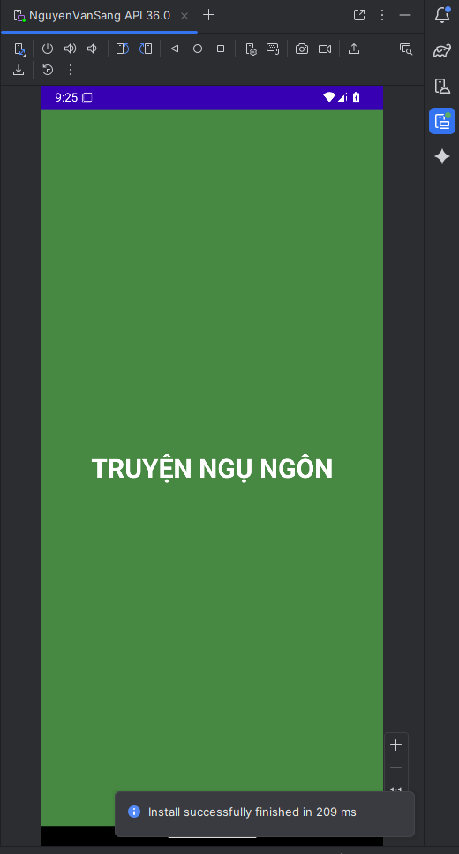
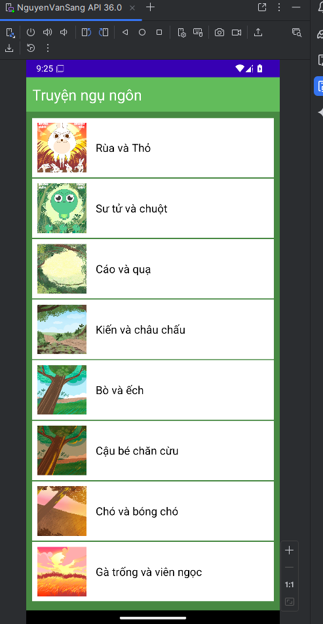
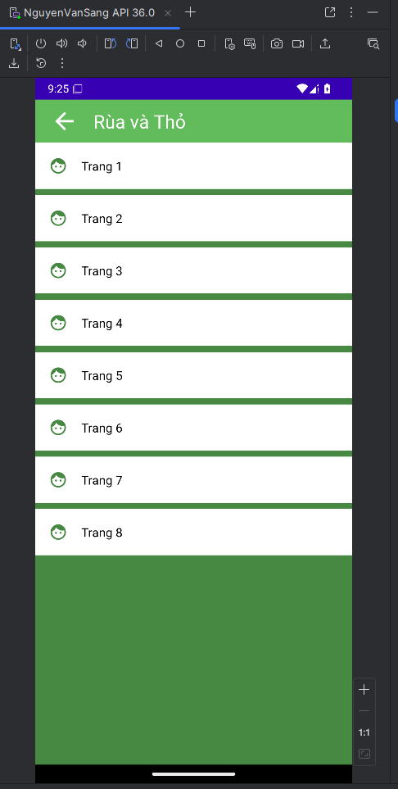
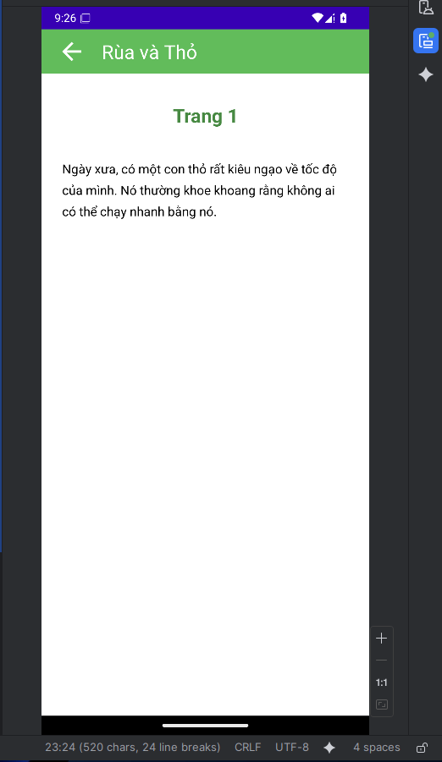
Lab 9: Canvas and MultiThreading
Code:
BarChartActivity.java
package com.example.lab9;
import android.os.Bundle;
import android.view.View;
import android.widget.Button;
import android.widget.EditText;
import android.widget.Toast;
import androidx.appcompat.app.AppCompatActivity;
public class BarChartActivity extends AppCompatActivity {
private BarChartView barChartView;
private EditText etValue1, etValue2, etValue3, etValue4, etValue5;
private Button btnDraw;
@Override
protected void onCreate(Bundle savedInstanceState) {
super.onCreate(savedInstanceState);
setContentView(R.layout.activity_bar_chart);
barChartView = findViewById(R.id.barChartView);
etValue1 = findViewById(R.id.etValue1);
etValue2 = findViewById(R.id.etValue2);
etValue3 = findViewById(R.id.etValue3);
etValue4 = findViewById(R.id.etValue4);
etValue5 = findViewById(R.id.etValue5);
btnDraw = findViewById(R.id.btnDraw);
btnDraw.setOnClickListener(new View.OnClickListener() {
@Override
public void onClick(View v) {
try {
float[] values = new float[5];
values[0] = Float.parseFloat(etValue1.getText().toString());
values[1] = Float.parseFloat(etValue2.getText().toString());
values[2] = Float.parseFloat(etValue3.getText().toString());
values[3] = Float.parseFloat(etValue4.getText().toString());
values[4] = Float.parseFloat(etValue5.getText().toString());
barChartView.setValues(values);
} catch (NumberFormatException e) {
Toast.makeText(BarChartActivity.this, "Vui lòng nhập số hợp lệ", Toast.LENGTH_SHORT).show();
}
}
});
}
}
BarChartView.java
package com.example.lab9;
import android.content.Context;
import android.graphics.Canvas;
import android.graphics.Color;
import android.graphics.Paint;
import android.util.AttributeSet;
import android.view.View;
public class BarChartView extends View {
private float[] values = {100, 200, 80, 180, 250};
private int[] colors = {
Color.rgb(153, 102, 255),
Color.rgb(100, 200, 255),
Color.rgb(128, 128, 128),
Color.rgb(100, 200, 100),
Color.rgb(100, 150, 255),
};
private Paint paint;
public BarChartView(Context context) {
super(context);
init();
}
public BarChartView(Context context, AttributeSet attrs) {
super(context, attrs);
init();
}
private void init() {
paint = new Paint();
paint.setAntiAlias(true);
}
public void setValues(float[] values) {
this.values = values;
invalidate();
}
@Override
protected void onDraw(Canvas canvas) {
super.onDraw(canvas);
if (values == null || values.length == 0) return;
int width = getWidth();
int height = getHeight();
int padding = 50;
int chartHeight = height - 2 * padding;
int chartWidth = width - 2 * padding;
float maxValue = 0;
for (float value : values) {
if (value > maxValue) maxValue = value;
}
int barWidth = chartWidth / values.length;
int barSpacing = barWidth / 5;
int actualBarWidth = barWidth - barSpacing;
for (int i = 0; i < values.length; i++) {
float barHeight = (values[i] / maxValue) * chartHeight;
float left = padding + i * barWidth + barSpacing / 2;
float top = height - padding - barHeight;
float right = left + actualBarWidth;
float bottom = height - padding;
paint.setColor(colors[i % colors.length]);
canvas.drawRect(left, top, right, bottom, paint);
}
}
}
LineChartActivity.java
package com.example.lab9;
import android.os.Bundle;
import android.view.View;
import android.widget.Button;
import android.widget.EditText;
import android.widget.Toast;
import androidx.appcompat.app.AppCompatActivity;
public class LineChartActivity extends AppCompatActivity {
private LineChartView lineChartView;
private EditText etLine1, etLine2, etLine3, etLine4, etLine5, etLine6;
private Button btnDrawLine;
@Override
protected void onCreate(Bundle savedInstanceState) {
super.onCreate(savedInstanceState);
setContentView(R.layout.activity_line_chart);
lineChartView = findViewById(R.id.lineChartView);
etLine1 = findViewById(R.id.etLine1);
etLine2 = findViewById(R.id.etLine2);
etLine3 = findViewById(R.id.etLine3);
etLine4 = findViewById(R.id.etLine4);
etLine5 = findViewById(R.id.etLine5);
etLine6 = findViewById(R.id.etLine6);
btnDrawLine = findViewById(R.id.btnDrawLine);
btnDrawLine.setOnClickListener(new View.OnClickListener() {
@Override
public void onClick(View v) {
try {
float[] values = new float[6];
values[0] = Float.parseFloat(etLine1.getText().toString());
values[1] = Float.parseFloat(etLine2.getText().toString());
values[2] = Float.parseFloat(etLine3.getText().toString());
values[3] = Float.parseFloat(etLine4.getText().toString());
values[4] = Float.parseFloat(etLine5.getText().toString());
values[5] = Float.parseFloat(etLine6.getText().toString());
lineChartView.setValues(values);
} catch (NumberFormatException e) {
Toast.makeText(LineChartActivity.this, "Vui lòng nhập số hợp lệ", Toast.LENGTH_SHORT).show();
}
}
});
}
}
LineChartView.java
package com.example.lab9;
import android.content.Context;
import android.graphics.Canvas;
import android.graphics.Color;
import android.graphics.Paint;
import android.util.AttributeSet;
import android.view.View;
public class LineChartView extends View {
private float[] values = {3, 6, 8, 7, 2, 3};
private Paint linePaint;
private Paint textPaint;
private Paint axisPaint;
public LineChartView(Context context) {
super(context);
init();
}
public LineChartView(Context context, AttributeSet attrs) {
super(context, attrs);
init();
}
private void init() {
linePaint = new Paint();
linePaint.setAntiAlias(true);
linePaint.setColor(Color.CYAN);
linePaint.setStrokeWidth(8f);
linePaint.setStyle(Paint.Style.STROKE);
textPaint = new Paint();
textPaint.setAntiAlias(true);
textPaint.setColor(Color.CYAN);
textPaint.setTextSize(40f);
textPaint.setTextAlign(Paint.Align.CENTER);
axisPaint = new Paint();
axisPaint.setAntiAlias(true);
axisPaint.setColor(Color.WHITE);
axisPaint.setStrokeWidth(3f);
}
public void setValues(float[] values) {
this.values = values;
invalidate();
}
@Override
protected void onDraw(Canvas canvas) {
super.onDraw(canvas);
if (values == null || values.length == 0) return;
int width = getWidth();
int height = getHeight();
int padding = 100;
int chartHeight = height - 2 * padding;
int chartWidth = width - 2 * padding;
float maxValue = 0;
for (float value : values) {
if (value > maxValue) maxValue = value;
}
canvas.drawLine(padding, height - padding, width - padding, height - padding, axisPaint);
canvas.drawLine(padding, padding, padding, height - padding, axisPaint);
float stepX = (float) chartWidth / (values.length - 1);
for (int i = 0; i < values.length - 1; i++) {
float x1 = padding + i * stepX;
float y1 = height - padding - (values[i] / maxValue) * chartHeight;
float x2 = padding + (i + 1) * stepX;
float y2 = height - padding - (values[i + 1] / maxValue) * chartHeight;
canvas.drawLine(x1, y1, x2, y2, linePaint);
canvas.drawText(String.valueOf((int) values[i]), x1, y1 - 20, textPaint);
}
canvas.drawText(String.valueOf((int) values[values.length - 1]),
padding + (values.length - 1) * stepX,
height - padding - (values[values.length - 1] / maxValue) * chartHeight - 20,
textPaint);
textPaint.setTextSize(50f);
canvas.drawText("POWER NOW:", width / 2, 100, textPaint);
textPaint.setTextSize(120f);
canvas.drawText("250W", width / 2, 220, textPaint);
textPaint.setTextSize(30f);
canvas.drawText("USE TODAY: 0.5 kWh", width / 2, 270, textPaint);
}
}
MainActivity.java
package com.example.lab9;
import android.content.Intent;
import android.os.Bundle;
import android.view.View;
import android.widget.Button;
import androidx.appcompat.app.AppCompatActivity;
public class MainActivity extends AppCompatActivity {
@Override
protected void onCreate(Bundle savedInstanceState) {
super.onCreate(savedInstanceState);
setContentView(R.layout.activity_main);
Button btnBarChart = findViewById(R.id.btnBarChart);
Button btnLineChart = findViewById(R.id.btnLineChart);
Button btnPieChart = findViewById(R.id.btnPieChart);
btnBarChart.setOnClickListener(new View.OnClickListener() {
@Override
public void onClick(View v) {
startActivity(new Intent(MainActivity.this, BarChartActivity.class));
}
});
btnLineChart.setOnClickListener(new View.OnClickListener() {
@Override
public void onClick(View v) {
startActivity(new Intent(MainActivity.this, LineChartActivity.class));
}
});
btnPieChart.setOnClickListener(new View.OnClickListener() {
@Override
public void onClick(View v) {
startActivity(new Intent(MainActivity.this, PieChartActivity.class));
}
});
}
}
MyCanvas.java
package com.example.lab9;
import android.content.Context;
import android.graphics.Canvas;
import android.graphics.Color;
import android.graphics.Paint;
import android.util.AttributeSet;
import android.view.View;
public class MyCanvas extends View {
public static int color = Color.YELLOW;
private int drawMode = 0;
public MyCanvas(Context context) {
super(context, null);
}
public MyCanvas(Context context, AttributeSet attrs) {
super(context, attrs, 0);
}
@Override
protected void onDraw(Canvas canvas) {
super.onDraw(canvas);
canvas.drawColor(color);
switch (drawMode) {
case 1:
drawText(canvas, "Thái Duy Quy");
break;
case 2:
drawRect(canvas);
break;
case 3:
drawText(canvas, "Thái Duy Quy");
drawRect(canvas);
break;
}
}
private void drawText(Canvas canvas, String mMessage) {
int viewWidth = getWidth();
int viewHeight = getHeight();
canvas.save();
canvas.translate(viewWidth / 2, viewHeight / 2);
Paint mPaint = new Paint();
mPaint.setColor(Color.RED);
mPaint.setTextSize(60f);
for (int i = 0; i < 10; i++) {
canvas.drawText(mMessage, 0, 0, mPaint);
canvas.rotate(36);
}
canvas.restore();
}
private void drawRect(Canvas canvas) {
int pos = 10;
int viewWidth = getWidth();
int viewHeight = getHeight();
Paint mPaint = new Paint();
mPaint.setColor(Color.BLUE);
canvas.drawRect(pos, viewHeight / 2, pos + viewWidth / 5, viewHeight, mPaint);
mPaint.setColor(Color.RED);
canvas.drawRect(pos * 2 + viewWidth / 5, viewHeight / 2 - 100,
(pos + viewWidth / 5) * 2, viewHeight, mPaint);
}
public void setDrawMode(int mode) {
this.drawMode = mode;
invalidate();
}
}
PieChartActivity.java
package com.example.lab9;
import android.os.Bundle;
import android.view.View;
import android.widget.Button;
import android.widget.EditText;
import android.widget.Toast;
import androidx.appcompat.app.AppCompatActivity;
public class PieChartActivity extends AppCompatActivity {
private PieChartView pieChartView;
private EditText etPie1, etPie2, etPie3, etPie4;
private Button btnDrawPie;
@Override
protected void onCreate(Bundle savedInstanceState) {
super.onCreate(savedInstanceState);
setContentView(R.layout.activity_pie_chart);
pieChartView = findViewById(R.id.pieChartView);
etPie1 = findViewById(R.id.etPie1);
etPie2 = findViewById(R.id.etPie2);
etPie3 = findViewById(R.id.etPie3);
etPie4 = findViewById(R.id.etPie4);
btnDrawPie = findViewById(R.id.btnDrawPie);
btnDrawPie.setOnClickListener(new View.OnClickListener() {
@Override
public void onClick(View v) {
try {
float[] values = new float[4];
values[0] = Float.parseFloat(etPie1.getText().toString());
values[1] = Float.parseFloat(etPie2.getText().toString());
values[2] = Float.parseFloat(etPie3.getText().toString());
values[3] = Float.parseFloat(etPie4.getText().toString());
pieChartView.setValues(values);
} catch (NumberFormatException e) {
Toast.makeText(PieChartActivity.this, "Vui lòng nhập số hợp lệ", Toast.LENGTH_SHORT).show();
}
}
});
}
}
PieChartView.java
package com.example.lab9;
import android.content.Context;
import android.graphics.Canvas;
import android.graphics.Color;
import android.graphics.Paint;
import android.graphics.RectF;
import android.util.AttributeSet;
import android.view.View;
public class PieChartView extends View {
private float[] values = {450, 1230, 200, 400};
private String[] labels = {"450.0", "1230.0", "200.0", "400.0"};
private int[] colors = {
Color.GREEN,
Color.BLUE,
Color.RED,
Color.YELLOW
};
private Paint paint;
private Paint textPaint;
public PieChartView(Context context) {
super(context);
init();
}
public PieChartView(Context context, AttributeSet attrs) {
super(context, attrs);
init();
}
private void init() {
paint = new Paint();
paint.setAntiAlias(true);
paint.setStyle(Paint.Style.FILL);
textPaint = new Paint();
textPaint.setAntiAlias(true);
textPaint.setColor(Color.BLACK);
textPaint.setTextSize(40f);
textPaint.setTextAlign(Paint.Align.LEFT);
}
public void setValues(float[] values) {
this.values = values;
this.labels = new String[values.length];
for (int i = 0; i < values.length; i++) {
labels[i] = String.valueOf(values[i]);
}
invalidate();
}
@Override
protected void onDraw(Canvas canvas) {
super.onDraw(canvas);
if (values == null || values.length == 0) return;
int width = getWidth();
int height = getHeight();
int size = Math.min(width, height) - 200;
int centerX = width / 2;
int centerY = height / 2 - 50;
RectF rectF = new RectF(
centerX - size / 2,
centerY - size / 2,
centerX + size / 2,
centerY + size / 2
);
float total = 0;
for (float value : values) {
total += value;
}
float startAngle = 0;
for (int i = 0; i < values.length; i++) {
float sweepAngle = (values[i] / total) * 360;
paint.setColor(colors[i % colors.length]);
canvas.drawArc(rectF, startAngle, sweepAngle, true, paint);
startAngle += sweepAngle;
}
int legendY = height - 150;
int legendX = 50;
int boxSize = 40;
for (int i = 0; i < values.length; i++) {
paint.setColor(colors[i % colors.length]);
canvas.drawRect(legendX, legendY + i * 50, legendX + boxSize, legendY + i * 50 + boxSize, paint);
canvas.drawText(labels[i], legendX + boxSize + 20, legendY + i * 50 + 30, textPaint);
}
textPaint.setTextAlign(Paint.Align.CENTER);
textPaint.setTextSize(30f);
canvas.drawText("Pie chart key generated via onDrawFinished()", width / 2, height - 30, textPaint);
}
}
Kết quả:
