Thực hành Lab 1 và Lab 2
Họ và tên: Nguyễn Văn Sang
MSSV: 1150080072
Lớp: 11_THMT
Thực Hành:
Lab1:
Lưu ý: phải khai báo <uses-permission android:name="android.permission.CALL_PHONE" /> và
<uses-permission android:name="android.permission.SEND_SMS" /> trong AndroidManifest.xml để có thể gọi và nhắn tin được
Code:
DiceActivity.java
package com.example.firstprogram;
import android.os.Bundle;
import android.view.View;
import android.widget.Button;
import android.widget.ImageView;
import android.widget.TextView;
import androidx.appcompat.app.AppCompatActivity;
import java.util.Random;
public class DiceActivity extends AppCompatActivity {
TextView txtNumber;
ImageView imgDice;
Button btnRoll;
Random random = new Random();
@Override
protected void onCreate(Bundle savedInstanceState) {
super.onCreate(savedInstanceState);
setContentView(R.layout.activity_dice);
txtNumber = findViewById(R.id.txtNumber);
imgDice = findViewById(R.id.imgDice);
btnRoll = findViewById(R.id.btnRoll);
btnRoll.setOnClickListener(new View.OnClickListener() {
@Override
public void onClick(View v) {
int number = random.nextInt(6) + 1;
txtNumber.setText("Number: " + number);
int diceImage = R.drawable.anh1; // Ảnh mặc định
switch (number) {
case 1:
diceImage = R.drawable.anh1;
break;
case 2:
diceImage = R.drawable.anh2;
break;
case 3:
diceImage = R.drawable.anh3;
break;
case 4:
diceImage = R.drawable.anh4;
break;
case 5:
diceImage = R.drawable.anh5;
break;
case 6:
diceImage = R.drawable.anh6;
break;
default:
diceImage = R.drawable.anh6;
break;
}
imgDice.setImageResource(diceImage);
}
});
}
}
PhoneActivity
package com.example.firstprogram;
import android.content.pm.PackageManager;
import android.net.Uri;
import android.os.Bundle;
import android.telephony.SmsManager;
import android.widget.Button;
import android.widget.EditText;
import android.widget.Toast;
import androidx.appcompat.app.AppCompatActivity;
import androidx.core.app.ActivityCompat;
import androidx.core.content.ContextCompat;
import android.content.Intent;
import android.view.View;
public class PhoneActivity extends AppCompatActivity {
EditText txtPhone;
Button btnCall, btnSendSMS;
private static final int REQUEST_CALL_PHONE = 1;
private static final int REQUEST_SEND_SMS = 2;
@Override
protected void onCreate(Bundle savedInstanceState) {
super.onCreate(savedInstanceState);
setContentView(R.layout.activity_phone);
txtPhone = findViewById(R.id.txtPhone);
btnCall = findViewById(R.id.btnCall);
btnSendSMS = findViewById(R.id.btnSendSMS);
btnCall.setOnClickListener(new View.OnClickListener() {
@Override
public void onClick(View v) {
makePhoneCall();
}
});
btnSendSMS.setOnClickListener(new View.OnClickListener() {
@Override
public void onClick(View v) {
sendSMS();
}
});
}
private void makePhoneCall() {
String phoneNumber = txtPhone.getText().toString().trim();
if (phoneNumber.isEmpty()) {
Toast.makeText(this, "Please enter a phone number", Toast.LENGTH_SHORT).show();
return;
}
if (ContextCompat.checkSelfPermission(this, android.Manifest.permission.CALL_PHONE)
!= PackageManager.PERMISSION_GRANTED) {
ActivityCompat.requestPermissions(this,
new String[]{android.Manifest.permission.CALL_PHONE}, REQUEST_CALL_PHONE);
} else {
Intent callIntent = new Intent(Intent.ACTION_CALL);
callIntent.setData(Uri.parse("tel:" + phoneNumber));
startActivity(callIntent);
}
}
private void sendSMS() {
String phoneNumber = txtPhone.getText().toString().trim();
if (phoneNumber.isEmpty()) {
Toast.makeText(this, "Please enter a phone number", Toast.LENGTH_SHORT).show();
return;
}
if (ContextCompat.checkSelfPermission(this, android.Manifest.permission.SEND_SMS)
!= PackageManager.PERMISSION_GRANTED) {
ActivityCompat.requestPermissions(this,
new String[]{android.Manifest.permission.SEND_SMS}, REQUEST_SEND_SMS);
} else {
try {
SmsManager smsManager = SmsManager.getDefault();
smsManager.sendTextMessage(phoneNumber, null, "Hello from Lab1!", null, null);
Toast.makeText(this, "SMS sent", Toast.LENGTH_SHORT).show();
} catch (Exception e) {
Toast.makeText(this, "Failed to send SMS", Toast.LENGTH_SHORT).show();
}
}
}
@Override
public void onRequestPermissionsResult(int requestCode, String[] permissions, int[] grantResults) {
super.onRequestPermissionsResult(requestCode, permissions, grantResults);
if (requestCode == REQUEST_CALL_PHONE) {
if (grantResults.length > 0 && grantResults[0] == PackageManager.PERMISSION_GRANTED) {
makePhoneCall();
} else {
Toast.makeText(this, "Call permission denied", Toast.LENGTH_SHORT).show();
}
} else if (requestCode == REQUEST_SEND_SMS) {
if (grantResults.length > 0 && grantResults[0] == PackageManager.PERMISSION_GRANTED) {
sendSMS();
} else {
Toast.makeText(this, "Send SMS permission denied", Toast.LENGTH_SHORT).show();
}
}
}
}
Kết quả:
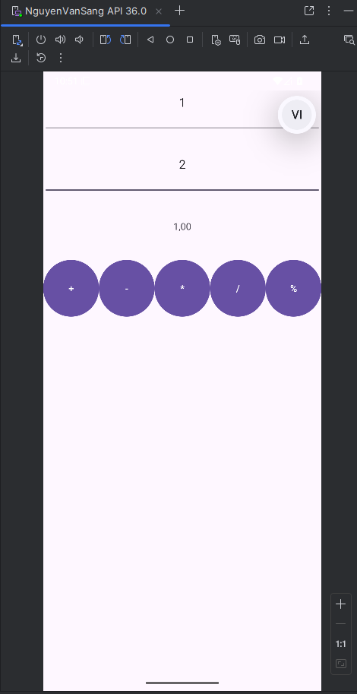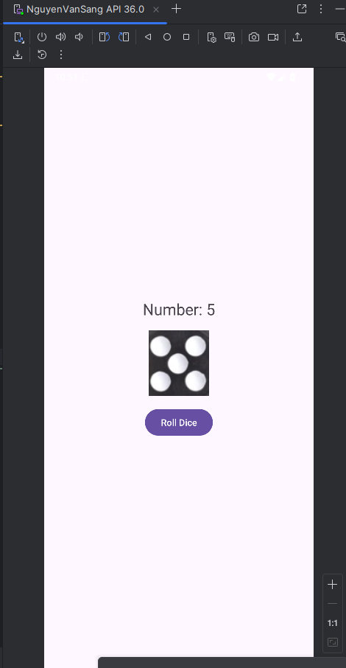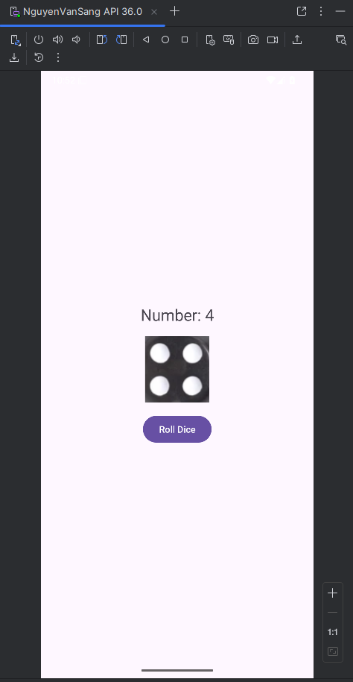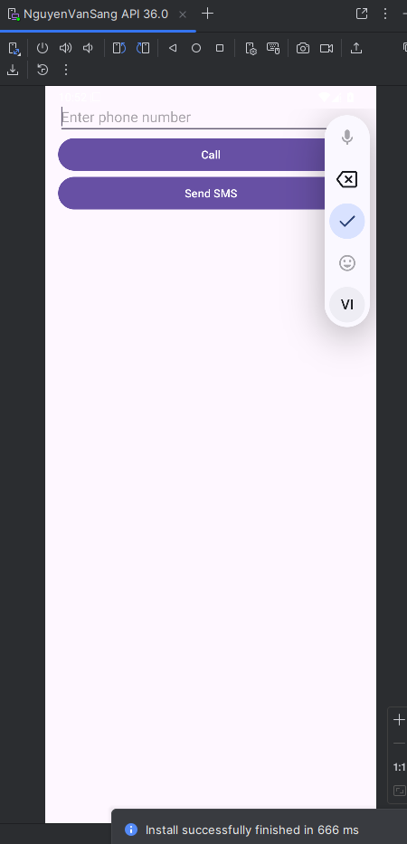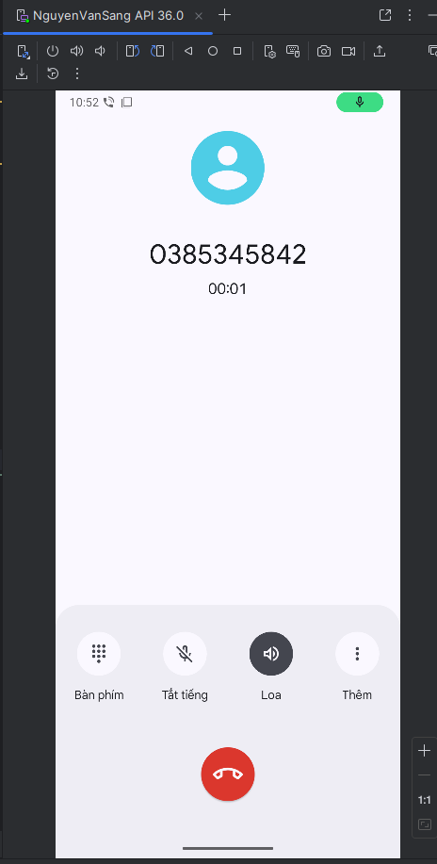
Lab2:
Lưu ý: trong phần AndroidManifest.xml <uses-permission android:name="android.permission.CALL_PHONE" /> để có thể thực hiện được gọi của phần bài tập 2
Code:
M001ActProfile.java
package com.example.lab2;
import android.Manifest;
import android.content.Intent;
import android.content.pm.PackageManager;
import android.net.Uri;
import android.os.Bundle;
import android.widget.ImageView;
import android.widget.TextView;
import android.widget.Toast;
import androidx.appcompat.app.AppCompatActivity;
import androidx.core.app.ActivityCompat;
import androidx.core.content.ContextCompat;
public class M001ActProfile extends AppCompatActivity {
private static final int REQUEST_CALL_PHONE = 1;
private ImageView imgPhone1;
private TextView txtPhone1;
@Override
protected void onCreate(Bundle savedInstanceState) {
super.onCreate(savedInstanceState);
setContentView(R.layout.m001_act_profile);
imgPhone1 = findViewById(R.id.img_phone1);
txtPhone1 = findViewById(R.id.txt_phone1);
imgPhone1.setOnClickListener(v -> makePhoneCall());
}
private void makePhoneCall() {
String phoneNumber = txtPhone1.getText().toString().trim();
phoneNumber = phoneNumber.replaceAll("[^0-9]", "");
if (phoneNumber.isEmpty()) {
Toast.makeText(this, "Phone number is empty", Toast.LENGTH_SHORT).show();
return;
}
if (ContextCompat.checkSelfPermission(this, Manifest.permission.CALL_PHONE)
!= PackageManager.PERMISSION_GRANTED) {
ActivityCompat.requestPermissions(this,
new String[]{Manifest.permission.CALL_PHONE}, REQUEST_CALL_PHONE);
} else {
Intent callIntent = new Intent(Intent.ACTION_CALL);
callIntent.setData(Uri.parse("tel:" + phoneNumber));
try {
startActivity(callIntent);
} catch (SecurityException e) {
Toast.makeText(this, "Call failed: " + e.getMessage(), Toast.LENGTH_SHORT).show();
}
}
}
@Override
public void onRequestPermissionsResult(int requestCode, String[] permissions, int[] grantResults) {
super.onRequestPermissionsResult(requestCode, permissions, grantResults);
if (requestCode == REQUEST_CALL_PHONE) {
if (grantResults.length > 0 && grantResults[0] == PackageManager.PERMISSION_GRANTED) {
makePhoneCall();
} else {
Toast.makeText(this, "Permission DENIED", Toast.LENGTH_SHORT).show();
}
}
}
}
M001ActSplash.java
package com.example.lab2;
import android.Manifest;
import android.content.Intent;
import android.content.pm.PackageManager;
import android.net.Uri;
import android.os.Bundle;
import android.widget.ImageView;
import android.widget.TextView;
import android.widget.Toast;
import androidx.appcompat.app.AppCompatActivity;
import androidx.core.app.ActivityCompat;
import androidx.core.content.ContextCompat;
public class M001ActProfile extends AppCompatActivity {
private static final int REQUEST_CALL_PHONE = 1;
private ImageView imgPhone1;
private TextView txtPhone1;
@Override
protected void onCreate(Bundle savedInstanceState) {
super.onCreate(savedInstanceState);
setContentView(R.layout.m001_act_profile);
imgPhone1 = findViewById(R.id.img_phone1);
txtPhone1 = findViewById(R.id.txt_phone1);
imgPhone1.setOnClickListener(v -> makePhoneCall());
}
private void makePhoneCall() {
String phoneNumber = txtPhone1.getText().toString().trim();
phoneNumber = phoneNumber.replaceAll("[^0-9]", "");
if (phoneNumber.isEmpty()) {
Toast.makeText(this, "Phone number is empty", Toast.LENGTH_SHORT).show();
return;
}
if (ContextCompat.checkSelfPermission(this, Manifest.permission.CALL_PHONE)
!= PackageManager.PERMISSION_GRANTED) {
ActivityCompat.requestPermissions(this,
new String[]{Manifest.permission.CALL_PHONE}, REQUEST_CALL_PHONE);
} else {
Intent callIntent = new Intent(Intent.ACTION_CALL);
callIntent.setData(Uri.parse("tel:" + phoneNumber));
try {
startActivity(callIntent);
} catch (SecurityException e) {
Toast.makeText(this, "Call failed: " + e.getMessage(), Toast.LENGTH_SHORT).show();
}
}
}
@Override
public void onRequestPermissionsResult(int requestCode, String[] permissions, int[] grantResults) {
super.onRequestPermissionsResult(requestCode, permissions, grantResults);
if (requestCode == REQUEST_CALL_PHONE) {
if (grantResults.length > 0 && grantResults[0] == PackageManager.PERMISSION_GRANTED) {
makePhoneCall();
} else {
Toast.makeText(this, "Permission DENIED", Toast.LENGTH_SHORT).show();
}
}
}
}
MainActivity.java
package com.example.lab2;
import android.content.Intent;
import android.os.Bundle;
import android.widget.Button;
import androidx.appcompat.app.AppCompatActivity;
public class MainActivity extends AppCompatActivity {
@Override
protected void onCreate(Bundle savedInstanceState) {
super.onCreate(savedInstanceState);
setContentView(R.layout.activity_main);
Button btnSplash = findViewById(R.id.btn_splash);
Button btnProfile = findViewById(R.id.btn_profile);
btnSplash.setOnClickListener(v -> {
Intent intent = new Intent(this, M001ActSplash.class);
startActivity(intent);
});
btnProfile.setOnClickListener(v -> {
Intent intent = new Intent(this, M001ActProfile.class);
startActivity(intent);
});
}
}
Kết quả:
